Tipp Trainer

A Tipp Trainer program

Zwetti Patrick

3BHIF

|  |  |
| --- | --- |
| **Project title:** | Tipp trainer |
| **Project:** | IT-Project |
| **Project manager:** | Zwetti Patrick |
| **Project owner:** | DI Gernot Loibner |
| **Project duration:** | start: 29.04.2019  end: 27.05.2019 |
| **Benefit from the perspective of the user** | User learns to tip faster on keyboard. User can level up to play harder levels. Every user has his own account, where his results are saved. |
| **Targets:** | |  |  | | --- | --- | | **Partial goals:** | **Results:** | | show scores | * User knows if he gets better | | different levels | * Level for noobs and pros | | show helps | * Helps user to get better | | save account in DB | * Accounts are saved in DB | |
| **Milestones:** | |  |  | | --- | --- | | **Milestones:** | **Date:** | | Design…finished | 1. week | | Functionality…finished | 2. week | | Tests…finished | 3. week | | Project…finished | 4. week | |
| **Constraintsund** | Export/Import, Database, Additional technologies, GUI-Elements |

# Project Application

# Project description (technically)

### Scrum planning

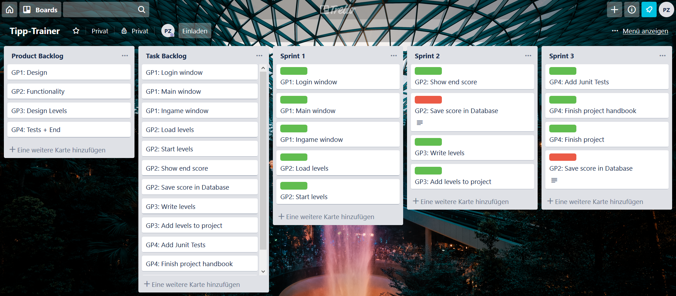

### Class Description

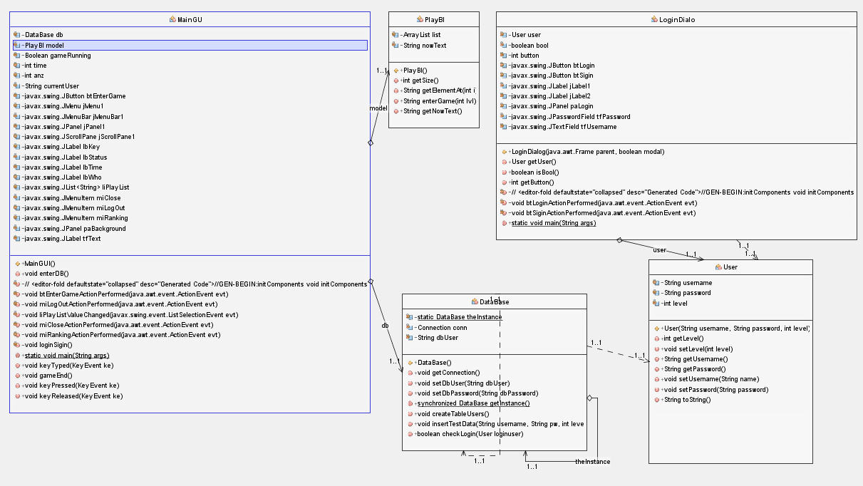

### JavaDoc placed in dist folder!

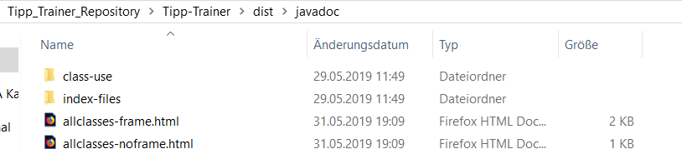

### Database Description

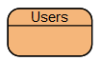

## Statements:

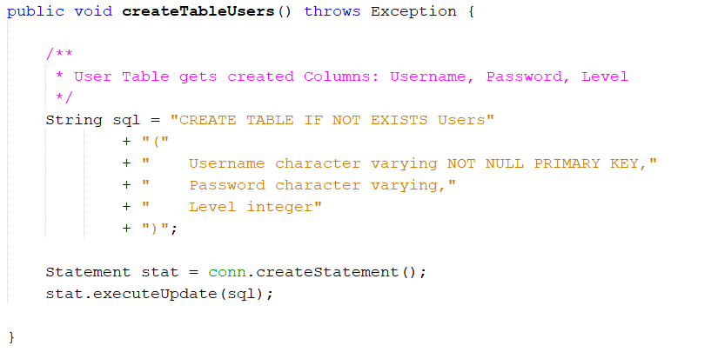

# Project description (user manual)

If the program gets started these two windows come.

The first is for the username of the DB and the second is for the DB password.

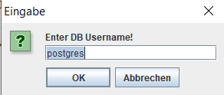 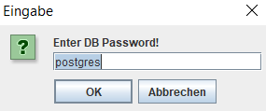

After a sucessful connection the Login Dialog gets opened. If you are already registert you can login with your data. If not, you have to register with a new Username.

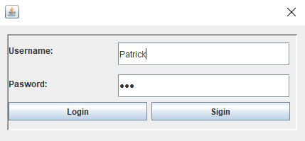

If the login was successfully the main window opens.

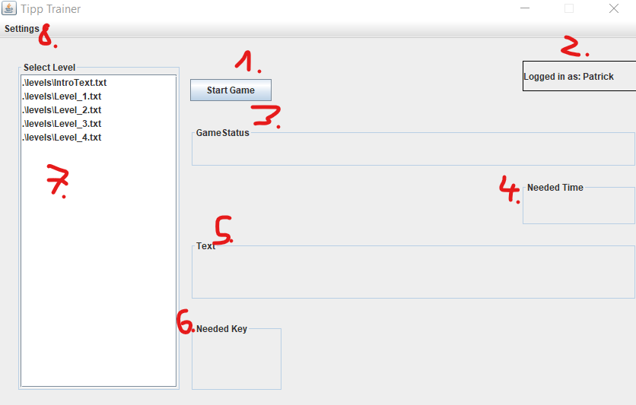

1. To start the game.
2. Shows how is logged in
3. Show the game status. (Game selected/ Game running/ Game finished)
4. Show the time you need for a level
5. Shows the Text you must tip.
6. Shows the next needed Key. (Green-> if you press the right key, else -> red)
7. The list of Levels where you can choose.
8. The settings-menu.
9. 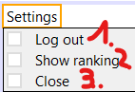Here you can log out and get back to the login dialog.
10. Show ranking. (Not implemented yet!)
11. Close the program.

# Project Tests and GIT

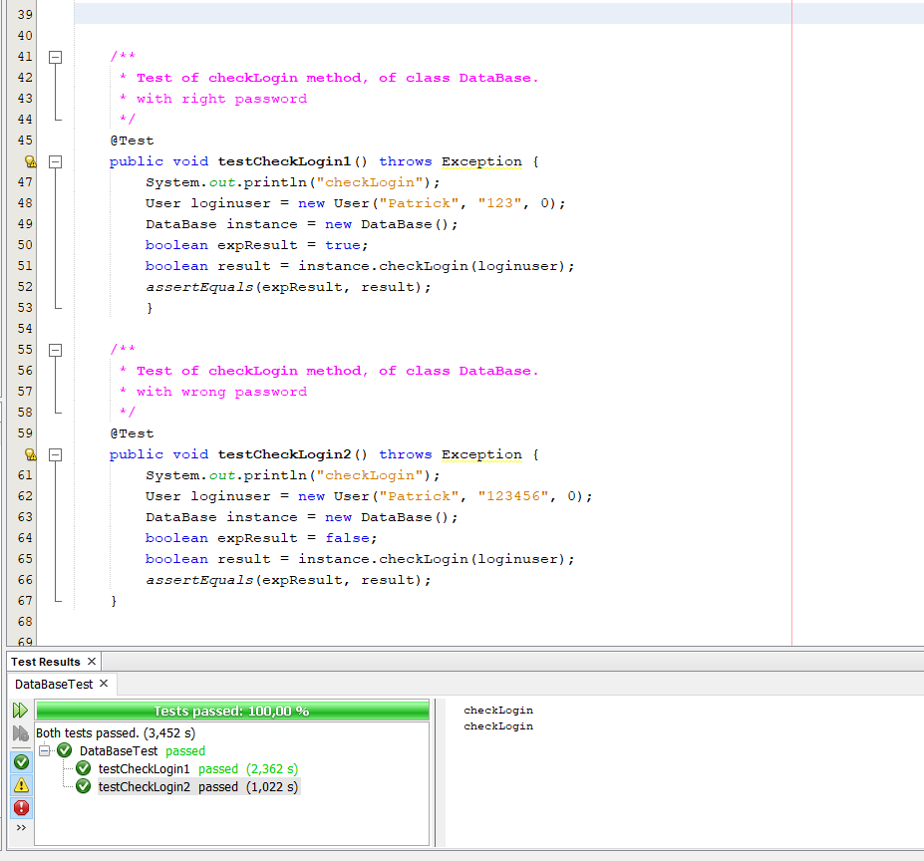

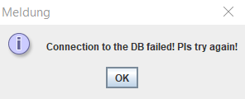**Test 1:** Enters wrong DB User or password.  
Error Message comes and   
Connections-Dialog opens again!

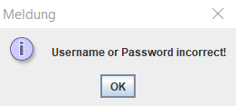

**Test 2:** Enters wrong Username or password when   
he tries to login.  
Error Message comes and Login-Dialog opens again!

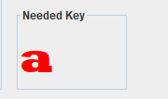**Test 3:** Enters wrong key while he is playing.  
The needed key gets colored red!

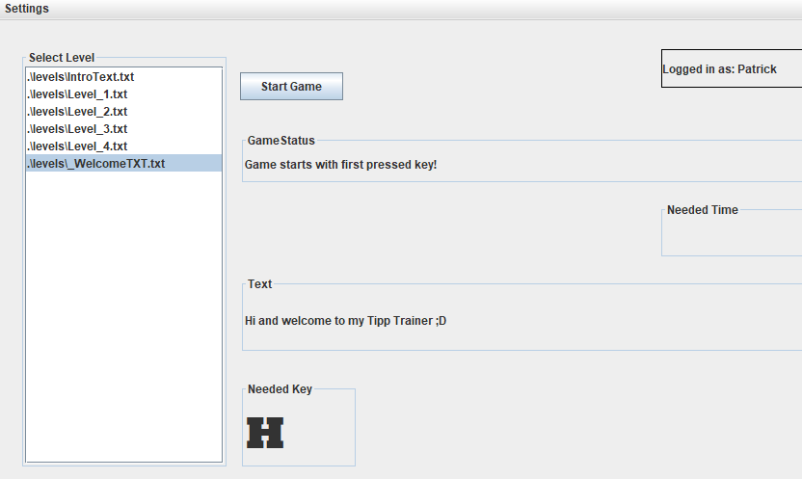**Test 4:** Game gets started.  
Status changes to “Game starts with first pressed key”!  
Text gets shown in the text field!  
First needed key gets showed!

Git History

