# Project: Tipp Trainer

## Story: User wants to login.

After connecting to DB User gets asked for Username and  
Password to login.

### Story:

**Tasks:**1. User enters a username and password.  
2. “Login Button” gets pressed.  
3. Check if User input is right.  
**acceptance test:**If username exists and the password is right, User gets logged in.  
**Negative:**  
If the username or password is wrong, User gets a warning message.

#### Task: Check if User input is right.

1. User input gets read out and a User object gets made.
2. This user gets searched in Database.

## Story: User starts a game.

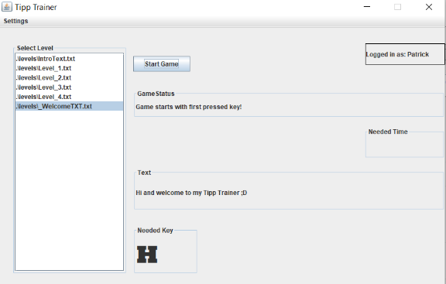After a successful login User wants to start a game.

### Story:

**Tasks:**1. User selects a game in the level-list.  
2. “Start Button” gets pressed.  
3. Information’s are getting displayed   
**acceptance test:**If a level is selected, the game starts after clicking the   
“Start game” button.  
**Negative:**  
If no game is selected a message comes “You have to select a level”.

#### Task: “Start Button” gets pressed.

1. Check if a level is selected.
2. Game status changes to “Game starts with the first key”.
3. Tip Text gets displayed.
4. First needed key gets shown

## Story: User presses a key while playing.

After starting the game user presses a key.

### Story:

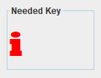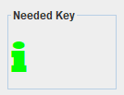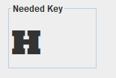 **Tasks:**1. First needed key get displayed in black.  
2. User presses a key on the keyboard.  
**acceptance test:**If User presses the right needed key, it gets colored green and he  
must press the next character of the text.  
**Negative:**  
If User presses wrong key, it gets colored red and he has to tip the right key again.

#### Task: User presses a key on the keyboard

1. Check what key he pressed.
2. Check what key is needed.
3. Compare if these are the same keys.
4. Color the “Needed key” label text.

## Story: Game is finished

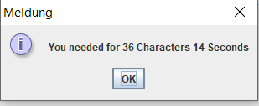After starting a game, User presses the right keys and finish  
the level.

### Story:

**Tasks:**1. User presses all needed keys.  
2. Dialog with and score gets displayed.  
3. Information’s are getting saved in DB.  
**acceptance test:**User presses all needed keys and End-dialog gets displayed.  
**Negative:**  
If no game is selected a message comes “You have to select a level”.

#### Task: Dialog with and score gets displayed.

1. Gets the seconds from beginning.
2. Counts the characters of the text.
3. Shows dialog with needed Seconds + Characters