Group VRG

CW412 FA3

Table of Contents

Introduction 2

1. Purpose of CTU-Buddy website 2

2. Project Scope 2

3. Team Members with Roles and Responsibilities 3

Project Description 4

1. User needs 4

2. Project goals 4

3. Project Purpose 5

System Features and Requirements 6

1. Functional Requirements 6

2. System Features/none functional requirements 7

3. Technologies Used: 8

4. Project Planning 9

Phase 1 9

Phase 2 10

Phase 3 11

# Introduction

## Purpose of CTU-Buddy website

Purpose of CTU-Buddy Website: The purpose of the CTU-Buddy website is to enhance the learning experience for students at City Technical University (CTU). It aims to achieve this by providing a comprehensive and interactive platform that offers various features and functionalities. Specifically:

* **Home Page:** Serves as the central hub, captivating users with images, videos, and animations. It highlights key features of CTU-Buddy.
* **Timetable Page:** Helps students manage their schedules effectively by displaying weekly timetables with date, time, modules, and days of the week.
* **About Us Page:** Provides insights into CTU-Buddy, including its purpose, vision, mission, and information about the development team.
* **Contact Us Page:** Integrates a contact form for inquiries, suggestions, and feedback, along with a map showing the CTU campus location.
* **Share Resources Page:** Enables students to upload and share educational resources in PDF format.
* **Discussion Page:** Facilitates collaborative learning through threaded discussions, user profiles, and moderation tools.

## Project Scope

The project scope includes designing and developing the CTU-Buddy website with the specified pages and features. It also involves ensuring responsive design across different devices, thorough testing, debugging, and refining visual elements and functionalities. Additionally, organizing project files and documentation, including an SRS document, is part of the scope.

## Team Members with Roles and Responsibilities

**Zandré Wepener (20232642)**

* Roles:
  + Leader
  + Project Manager
* Responsibilities:
  + Ensure project conforms to provided standards.
  + Ensure maximum group productivity.
* Assigned Pages:
  + Share Resources Page

**Mzwakhe Khumalo (20232619)**

* Roles:
  + Web Page Designer
  + General Programmer
* Responsibilities:
  + Create the design, styling and logic for assigned Web Pages
* Assigned Pages:
  + Home Page

**Bophelo Malepu (20232645)**

* Roles:
  + Web Page Designer
  + General Programmer
* Responsibilities:
  + Create the design, styling and logic for assigned Web Pages
* Assigned Pages:
  + Discussion Page

**Luzuko Sinxezi (20231300)**

* Roles:
  + Web Page Designer
  + General Programmer
* Responsibilities:
  + Create the design, styling and logic for assigned Web Pages
* Assigned Pages:
  + Timetable Page

# Project Description

## User needs

* **Effective Schedule Management:** Students need a user-friendly timetable (Timetable Page) to access their weekly schedules easily.
* **Connection and Trust:** The About Us Page fosters a sense of connection and trust by providing information about the system and its development team.
* **Inquiries and Feedback:** The Contact Us Page allows users to submit inquiries, suggestions, or feedback.
* **Resource Sharing:** The Share Resources Page enables students to upload and download educational resources.
* **Collaborative Learning:** The Discussion Page encourages collaborative learning by allowing students to post questions and receive responses from peers.

## Project goals

* **Enhanced Learning Experience:** The primary goal of CTU-Buddy is to enhance the learning experience for students at City Technical University (CTU). Achieving this involves creating an engaging and interactive platform.
* **Central Hub (Home Page):** The Home page will serve as the central hub, captivating users with multimedia elements (images, videos, animations). It will showcase relevant information about CTU-Buddy and highlight its key features.
* **Effective Schedule Management (Timetable Page):** The Timetable page aims to help students manage their schedules effectively. By displaying weekly timetables with date, time, modules, and days of the week, it ensures seamless access to their schedules.
* **Foster Connection and Trust (About Us Page):** The About Us page provides insights into CTU-Buddy, including its purpose, vision, mission, and information about the development team. It fosters a sense of connection and trust between users and the platform.
* **User Interaction (Contact Us Page):** The Contact Us page integrates a contact form, allowing users to submit inquiries, suggestions, or feedback. Additionally, a map showcasing the CTU campus location enhances user experience.
* **Resource Sharing (Share Resources Page):** The Share Resources page enables students to upload and share educational resources in PDF format. It facilitates categorization, search functionality, and secure resource handling.
* **Collaborative Learning (Discussion Page):** The Discussion page encourages collaborative learning. Students can post questions related to their studies and receive responses from peers. Features like threaded discussions, user profiles, and moderation tools enhance the learning community.

## Project Purpose

The purpose of the CTU-Buddy project is to enhance the learning experience for students at City Technical University (CTU). By creating a comprehensive and interactive website, CTU-Buddy aims to achieve the following objectives:

**Central Hub (Home Page):**

* Captivate users with multimedia elements (images, videos, animations).
* Showcase relevant information about CTU-Buddy.
* Highlight key features of the system.

**Effective Schedule Management (Timetable Page):**

* Display weekly timetables with date, time, modules, and days of the week.
* Enable seamless access to students’ schedules.

**Foster Connection and Trust (About Us Page):**

* Provide insights into CTU-Buddy’s purpose, vision, mission, and development team.
* Create a sense of connection and trust between users and the platform.

**User Interaction (Contact Us Page):**

* Integrate a contact form for inquiries, suggestions, or feedback.
* Include a map showcasing the CTU campus location.

**Resource Sharing (Share Resources Page):**

* Allow students to upload and share educational resources in PDF format.
* Facilitate resource categorization and search functionality.

**Collaborative Learning (Discussion Page):**

* Encourage students to engage in threaded discussions.
* Provide user profiles and moderation tools for a productive learning community.

CTU-Buddy aims to revolutionize the educational experience by providing a multifunctional platform that enhances learning, fosters academic success, and facilitates effective communication among students, educators, and the system itself.

# System Features and Requirements

## Functional Requirements

**Home Page:**

* Multimedia Elements: Include images, videos, and animations to create an appealing interface.
* Key Features Highlight: Showcase relevant information about CTU-Buddy and highlight its features.

**Timetable Page:**

* Weekly Timetables: Display date, time, modules, and days of the week for effective schedule management.
* Responsive Design: Ensure seamless functionality across different devices.

**About Us Page:**

* System Insights: Provide information about CTU-Buddy’s purpose, vision, mission, and development team.
* Connection Building: Foster a sense of connection and trust between users and the platform.

**Contact Us Page:**

* Inquiry Form: Integrate a contact form for user inquiries, suggestions, or feedback.
* Campus Location Map: Include a visual map showcasing the CTU campus location.

**Share Resources Page:**

* Resource Upload: Enable students to upload educational resources in PDF format.
* Categorization and Search: Implement user-friendly features for resource organization and search.

**Discussion Page:**

* Collaborative Learning Platform: Allow students to post questions and receive responses from peers.
* Threaded Discussions: Facilitate productive discussions.
* User Profiles and Moderation Tools: Enhance the learning community.

**Testing and Debugging:**

* Thoroughly test all functionalities to ensure a seamless user experience.
* Promptly address any identified issues.

**Refinement of Visual Elements:**

* Continuously refine multimedia elements (images, videos, animations) for an engaging interface.

**Documentation and Organization:**

* Organize project files and documentation into a comprehensive folder structure.
* Include an SRS (Software Requirements Specification) document.

**User-Centric Approach:**

* Understand user needs for effective schedule management, resource sharing, and collaborative learning.

These functional requirements collectively contribute to creating a robust and user-friendly CTU-Buddy platform that enhances the educational experience at City Technical University.

## System Features/none functional requirements

**Usability:**

* The website should have an intuitive and user-friendly interface.
* Navigation across pages should be straightforward.

**Performance:**

* Pages should load quickly to prevent user frustration.
* Responsiveness across devices (desktop, tablet, mobile) is essential.

**Security:**

* Secure user data and prevent unauthorized access.
* Safeguard uploaded resources.

**Scalability:**

* The system should handle increasing user traffic without performance degradation.

**Reliability:**

* Minimize downtime and ensure consistent availability.

**Accessibility:**

* Comply with accessibility standards (e.g., WCAG) for users with disabilities.

**Documentation and Maintenance:**

* Maintain comprehensive documentation for future updates and maintenance.
* Organize project files and documentation systematically.

**Testing and Quality Assurance:**

* Rigorous testing and debugging to identify and address issues.
* Ensure a seamless user experience.

**Team Collaboration:**

* Effective communication and collaboration among development team members.
* Clear roles and responsibilities.

These non-functional requirements contribute to creating a robust, reliable, and user-centered CTU-Buddy platform that enhances the educational journey for CTU students.

## Technologies Used:

* [NEXT.JS](https://nextjs.org/) (General Backend)
* [React](https://react.dev/) (General Frontend)
* [TailwindCSS](https://tailwindcss.com/) (Styling)
* [TypeScript](https://www.typescriptlang.org/) (Type Safety)
* [bcrypt](https://www.npmjs.com/package/bcrypt) (Password hashing and comparing)
* [Vercel](https://vercel.com/) ([Blob Storage](https://vercel.com/storage/blob), [PostgreSQL](https://vercel.com/storage/postgres) & Web Hosting)
* [Radix](https://www.radix-ui.com/) (Component Library)
* [NextAuth.js](https://next-auth.js.org/) (Authentication)
* [Zod](https://zod.dev/) (Input Validation)

## Project Planning

Check out the project on [GitHub](https://github.com/zwepener/vrg-cwd412-fa).

### Phase 1

**Start Phase 1 – 20/03**

**Finish by 27/03:**

* Home Page (Assigned to Mzwakhe Khumalo) ✅ Done.
* Timetable Page (Assigned to Luzuko Sinxezi) ✅ Done.
* Discussion Page (Assigned to Bophelo Malepu) ✅ Done.
* Share Resources (Assigned to Zandré Wepener) ✅ Done.

**Finish by 28/03:**

* About Us Page (Assigned to whole group) ✅ Done.
* Contact Us Page (Assigned to whole group) ✅ Done.

**Finish by 31/03:**

* SRS (Software Requirements Specification) [This Document] ✅ Done.
* Conform project folder to submission format (Assigned to Zandré Wepener) ✅ Done.

**Submit Phase 1 – 01/04**

### Phase 2

**Start Phase 2 – 20/04**

**Finish by 22/04:**

* Redo Home Page (Assigned to Mzwakhe Khumalo) ✅ Done.
* Redo Timetable Page (Assigned to Luzuko Sinxezi) ✅ Done.
* Add group members to Contact Us Page (Assigned to Bophelo Malepu) ✅ Done.

**Finish by 23/04:**

* Update SRS Document (Assigned to Zandré Wepener) ✅ Done.
* Conform project folder to submission format (Assigned to Zandré Wepener) ✅ Done.

**Submit Phase 2 – 24/04**

### Phase 3

**Start Phase 3 – 26/04/2024**

**Finish by 28/04:**

* Migrate project to NEXTJS framework. ✅ Done.
* Migrate standard CSS to Tailwind CSS. ✅ Done.

**Finish by 30/04:**

* Decide on a deploy service. ✅ Done (Vercel). Hosted at <https://vrg-cwd412-fa-nextjs.vercel.app>  
  
* Decide on a Database Provider and Type. ✅ Done (Vercel PostgreSQL).  
  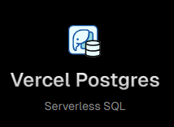
* Design Database Schema. ✅ Done.  
  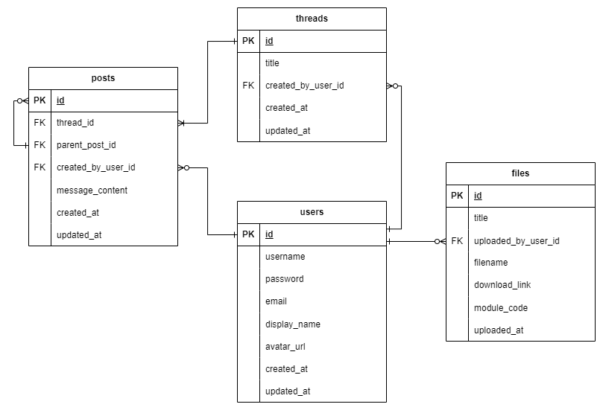
* Decide on a file storage. ✅ Done (Vercel Blob).  
  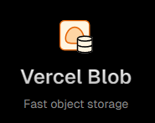
* Identify and address potential obstacles that will impede the implementation of the database schema. ✅ Done.

**Finish by 03/05:**

* Implement Database Schema with Vercel PostgreSQL SDK. ✅ Done.

**Finish by 10/05:**

* Fully Functional Login/Register Page. ✅ Done.
* Fully Functional Share Resources Page. ✅ Done.
* Fully Functional Discussion Page. ✅ Done.
* Fully Functional Account Management Page. ✅ Done.
* Fully Functional Newsletter Subscription Service. ✅ Done.
* Fully Functional Feedback. ✅ Done.

**Finish by 13/05:**

* Identify and fix as much bugs as possible. ✅ Done.
* Optimize where applicable. ✅ Done.

**Finish by 14/05:**

* Complete User Guide. ✅ Done.
* Update SRS Document [This Document] ✅ Done.

**Submit Phase 3 – 15/05**