移植内核（基于 linux-5.0.2）
1 初步配置：
myroot@myroot:~/TQ210N/kernel/linux-5.0.2$ make menuconfig ARCH=arm CROSS_COMPILE=arm-linux-
HOSTCC scripts/basic/fixdep
HOSTCC scripts/kconfig/conf.o
*** Unable to find the ncurses libraries or the
*** required header files.
*** 'make menuconfig' requires the ncurses libraries.
***
*** Install ncurses (ncurses-devel) and try again.
***
/home/myroot/TQ210N/kernel/linux-5.0.2/scripts/kconfig/Makefile:199: recipe for target 'scripts/kconfig/dochecklxdialog' failed
make[1]: *** [scripts/kconfig/dochecklxdialog] Error 1
Makefile:503: recipe for target 'menuconfig' failed
make: *** [menuconfig] Error 2

linux 下安装 ncurses：
路径：TQ210N\doc\kernel\ncurses-6.1.tar.gz
解压和安装：
$tar -zxvf ncurses-6.1.tar.gz
$cd ncurses-6.1
$./configure
$make && make install

注：在ubuntu 16.04版本直接安装成功
首先测试一下：
myroot@myroot:~/TQ210N/linux-5.0.2$ make menuconfig ARCH=arm CROSS_COMPILE=arm-linux-
UPD scripts/kconfig/mconf-cfg
HOSTCC scripts/kconfig/mconf.o
HOSTCC scripts/kconfig/lxdialog/checklist.o
HOSTCC scripts/kconfig/lxdialog/inputbox.o
HOSTCC scripts/kconfig/lxdialog/menubox.o
HOSTCC scripts/kconfig/lxdialog/textbox.o
HOSTCC scripts/kconfig/lxdialog/util.o
HOSTCC scripts/kconfig/lxdialog/yesno.o
LEX scripts/kconfig/zconf.lex.c
/bin/sh: 1: flex: not found
scripts/Makefile.lib:193: recipe for target 'scripts/kconfig/zconf.lex.c' failed
make[1]: *** [scripts/kconfig/zconf.lex.c] Error 127
Makefile:538: recipe for target 'menuconfig' failed
make: *** [menuconfig] Error 2

提示/bin/sh: 1: flex: not found错误
解决：$ sudo apt-get install flex
再次测试：
myroot@myroot:~/TQ210N/linux-5.0.2$ make menuconfig ARCH=arm CROSS_COMPILE=arm-linux-
LEX scripts/kconfig/zconf.lex.c
YACC scripts/kconfig/zconf.tab.h
/bin/sh: 1: bison: not found
scripts/Makefile.lib:207: recipe for target 'scripts/kconfig/zconf.tab.h' failed
make[1]: *** [scripts/kconfig/zconf.tab.h] Error 127
Makefile:538: recipe for target 'menuconfig' failed
make: *** [menuconfig] Error 2
提示：/bin/sh: 1: bison: not found
解决：$ sudo apt install bison
再次测试：
myroot@myroot:~/TQ210N/linux-5.0.2$ make menuconfig ARCH=arm CROSS_COMPILE=arm-linux-
YACC scripts/kconfig/zconf.tab.h
HOSTCC scripts/kconfig/zconf.lex.o
YACC scripts/kconfig/zconf.tab.c
HOSTCC scripts/kconfig/zconf.tab.o
HOSTLD scripts/kconfig/mconf
scripts/kconfig/mconf Kconfig
#
# using defaults found in /boot/config-4.13.0-36-generic
#
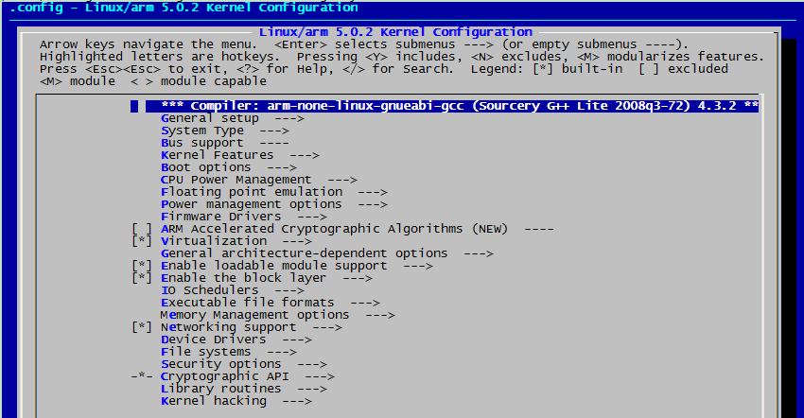
测试通过

然后使用 s5pv210 的默认配置文件来生成默认的.config 配置文件
myroot@myroot:~/TQ210N/linux-5.0.2$ make s5pv210_defconfig ARCH=arm CROSS_COMPILE=arm-linux-
#
# configuration written to .config
#
myroot@myroot:~/TQ210N/linux-5.0.2$
生成了配置文件.config， 现在执行 make menuconfig，先进行初步配置
myroot@myroot:~/TQ210N/linux-5.0.2$ make menuconfig ARCH=arm CROSS_COMPILE=arm-linux-
scripts/kconfig/mconf Kconfig
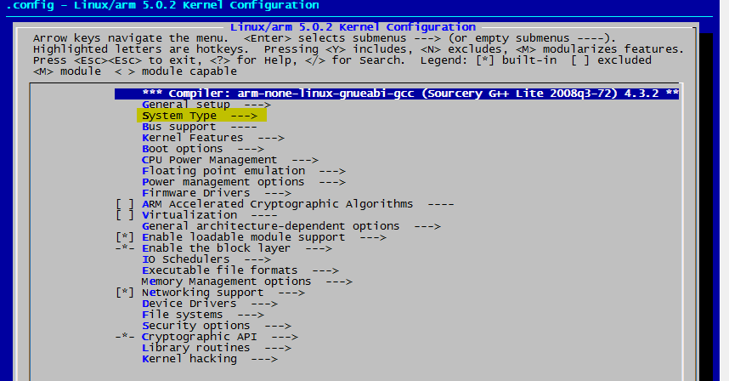
选择System Type --->
(0) S3C UART to use for low-level messages
注意：这里要根据自己的开发板来选择调试串口， TQ210使用的是UART0。 如果配置错误， u-boot
启动内核时会卡在 Starting kernel ...处

