Supporting Information

**Luteolin-Loaded Hyaluronidase Nanoparticles with Deep Tissue Penetration Capability for Idiopathic Pulmonary Fibrosis Treatment**

Bo Pan#, Fangping Wu#, Shanming Lu, Wenwen Lu, Jiahui Cao, Fei Cheng, Mei tong Ou, Youyi Chen, Fan Zhang*, Guolin Wu*, Lin Mei*

1. **Materials and methods**

*1.1 Materials and reagents:* Hyaluronidase (HAase) was purchased from Boehringer Ingelheim (Ingelheim, Germany). Luteolin (Lut) was purchased from KeyGEN Biotech (Nanjing, China). Bleomycin (BLM) was purchased from Nippon Kayaku (Tokyo, Japan). NHS-PEG1000-NHS was purchased from Nanocs Inc. (New York, US). Dulbecco's modified Eagle's medium (DMEM), penicillin-streptomycin and fetal bovine serum (FBS) were obtained from Gibco (California, US). Recombinant human TGF-β1 was purchased from R&D Systems (Minneapolis, MN). 2′,7′-dichlorodihydrofluorescein diacetate (DCFH-DA) was purchased from Solarbio® Life Science (Beijing, China). TGF-β1, IL-6, IL-1β and TNF-α ELISA kits were purchased from Multi Science (Hangzhou, China). Anti-α-smooth muscle actin (α-SMA) and anti-fibronectin (FN) antibody were purchased from Abcam (Cambridge, UK). 4′,6-diamidino-2-phenylindole (DAPI) was purchased from Beyotime (Shanghai, China). Alexa Fluor 488-conjugated goat anti-rabbit IgG was purchased from Servicebio (Wuhan, China). Hematoxylin and Massons trichrome Stain Kit were purchased from BASO (Zhuhai, China).

*1.2 Preparation and characterization of HAase NPs and Lut@HAase:* For the preparation of Lut@HAase, NHS-PEG1000-NHS (0.25 μmol) and luteolin (0.5 μmol) were added to hyaluronidase solution (0.05 μmol) in 500 μL of phosphate-buffered saline (PBS). The mixture was subjected to rotation at 25 ℃ for 1 h followed by ultrafiltration (molecular weight cut-off = 100 kDa; Millipore). The resulting Lut@HAase were washed and stored at 4 °C for further experiments. The HAase NPs were prepared as that of Lut@HAase without luteolin.

*1.3 Characterization of Lut@HAase*: The morphology of Lut@HAase was visualization through a transmission electron microscope (TEM) (JEOL JEM-1400, Tokyo, Japan). The size and polydispersity index (PDI) of Lut@HAase were detected via dynamic light scattering (DLS) (Zeta sizer NanoS90, Malvern, UK). Free radical scavenging abilities of free luteolin and Lut@HAase with equivalent amount of luteolin were assessed using an electron spin resonance (ESR) spectrometer (Bruker E500 spectrometer, Bruker Biospin, GER). To examine the stability, Lut@HAase were incubated in PBS at 4 ℃. The particle sizes of the samples were recorded at predetermined time points. The size and potential of Lut@HAase were measured before and after lyophilization.

*1.4 Cell culture:* Human embryonic lung fibroblast cells (MRC5 cells, ATCC, US) were cultured in DMEM with high glucose content, 100-unit penicillin-streptomycin, and 10% FBS, in a humidified incubator at 37 ℃ with 5% CO2 (HeraCell, Thermo Fisher Scientific, Waltham, MA). MRC5 cells were treated with TGF-β1 (10 ng/mL) for 48 h to simulate IPF *in vitro*.

*1.5 Immunofluorescence of α-SMA and FN in vitro:*MRC5 cells were cultured until approximately 80% confluency was reached, after which they were treated with five different treatments as follows: 1) Control, 2) TGF-β1+PBS, 3) TGF-β1+HAase (HAase: 20 μg/mL), 4) TGF-β1+Lut (Lut: 10 μg/mL), and 5) TGF-β1+Lut@HAase (Lut@HAase: 100 μg/mL). The cells were then washed with PBS, fixed with 4% paraformaldehyde for 10 min, and permeabilized with 0.2% Triton X-100 for 10 min. They were then incubated in 0.1% BSA/1% goat serum for 30 min to block nonspecific protein–protein interactions. Subsequently, the cells were incubated with anti-α-SMA (1: 50) or anti-FN (1: 100) antibodies overnight at 4 ℃. The cells were incubated with fluorescent secondary antibody Alexa Fluor® 488 (1:500 for immunofluorescence) at 25 ℃ for 1 h after washing. DAPI (1:500) was used to label the nuclei. Images were acquired using Confocal laser scanning microscopy (CLSM) (Leica TCS SP8, Germany, version 3.0).

*1.6 Flow cytometric analysis of α-SMA and FN in vitro:* The treated MRC5 cells were detached using a trypsin–EDTA solution and collected in centrifuge tubes. The cells were washed with 2 mL PBS containing 0.1% Triton and centrifuged at 300 g for 5 min; the supernatant was then discarded, and the precipitate was resuspended in PBS. The following antibodies were used for cell staining: anti-α-SMA (1:500) and anti-FN antibody (1:500). After incubation, the cells were washed with PBS to remove unbound antibodies. All samples were analyzed using ﬂow cytometry (Beckman coulter, CytoFLEX).

*1.7 Analysis of cellular inflammatory cytokine:* To detect cellular inflammatory cytokine, MRC5 cells were treated with the indicated formulations as described in Section 1.5. IL-6, IL-1β, and TNF-α levels of the MRC5 cells were measured using the supernatant obtained earlier by an enzyme-linked immunosorbent assay (ELISA) kit with 3 parallel samples of each group.

*1.8 ROS level detection:* To detect intracellular ROS levels, MRC5 cells were treated with the indicated formulations as described in Section 1.5. ROS levels were analyzed using DCFH-DA as free radicals fluorogenic probe and detected through flow cytometry. The ROS levels of lung tissue samples were quantified by the ROS-sensitive fluorophore DCFH-DA using the ROS Assay Kit according to the manufacturer’s protocol.

*1.9 In vivo fluorescence imaging:* C57BL/6 mice were maintained under specific pathogen-free conditions at 50 ± 10% humidity, 20 ± 2 ℃, and 12 h light-dark cycle. Mice aged 6-8 weeks with an average body weight of 20-24 g was sprayed with BLM (2.0 U/kg) via noninvasive inhalation to establish IPF model mice (Committee of The First Affiliated Hospital, Zhejiang University School of Medicine, NO: 1147). IPF model mice were randomly categorized into two groups. DiR-labeled Lut@HAase were intravenously injected (100 μg NPs/mouse, 100 μL) in one group of mice and administered via inhalation (100 μg NPs/mouse, 50 μL) in the other group. Fluorescence imaging was performed at different time intervals using an IVIS imaging system (IVIS® Lumina LT, PerkinElmer, US) with an excitation wavelength of 790 nm and an 830 nm filter. The mice were euthanized at day 5, and the heart, liver, spleen, lungs, and kidneys were extracted. For histological evaluation, dissected tissues were sectioned into 10-μm slices, and the fluorescence images of all sections were acquired using a laser scanning confocal microscope.

*1.10 Penetration of Lut@HAase into MRC5 spheroid model:* MRC5 cell spheroid (MS) was formed in 1% agarose cultured for approximately 4 days until it was approximately 300 μm in diameter and incubated with Cy5 labeled-Lut@HAase or Lut@Haase + glutaraldehyde for 24 h. MSs were collected and fixed in 4% paraformaldehyde for 10 min. Nuclei were stained with DAPI. All samples were imaged using a CLSM.

*1.11 Lung function test:* IPF model mice were established as described in Section 1.9. Five days after the BLM challenge, the animals were randomly allocated to four groups (n = 6/group): PBS, HAase (70 μg/mouse), Lut (20 μg/mouse), and Lut@HAase via inhalation (200 μg/mouse), and the treatments were administered once daily on days 5, 8, 11, 14 and 17. Healthy mice were used as the control group. Pulmonary function of the mice, including lung resistance (RL), forced vital capacity (FVC), dynamic (Cdyn), expiratory reserve volume (ERV), peak expiratory flow (PEF), and forced expiratory volume in the first 0.2 s (FEV0.2) after anesthesia was measured using the Forced Pulmonary Maneuver System (Buxco Respiratory Products, DSI, USA). On day 22, all mice were euthanized, and bronchoalveolar lavage fluid (BALF), blood, and lungs were harvested for subsequent analyses.

*1.12 Hematoxylin and eosin (H&E) and Masson’s trichrome staining:* After euthanizing the mice, whole lungs were removed and fixed in 4% paraformaldehyde. Gradient dehydration was performed according to standard procedures, and the tissues were embedded in paraffin. Thereafter, the tissues were sliced into 3μm slices. After routine dewaxing and hydration, staining was performed with hematoxylin (BA-4097, BaSO, CHN) and eosin (BA-4098, BaSO, CHN) for 7 min each. Masson’s trichrome staining was performed using a Masson’s trichrome staining kit.

*1.13 Immunofluorescence staining of lung tissues*: The lung tissues of mice embedded in paraffin and sectioned in 3-μm sections were used for immunofluorescence staining. An immunohistochemistry kit (SP-9000, ZSGB-BIO, CHN) was used for specific histochemical staining. The concentrations of primary antibodies were anti-α-SMA (1:300). The sections were incubated with a fluorescent secondary antibody at 25 °C for 1 h after incubating with the primary antibody for immunofluorescence staining. DAPI (1:500) was used to label the nuclei. Images were captured using a CLSM.

*1.14 Detection of hydroxyproline and cellular inflammatory cytokine in lungs:* Lung tissues were collected, and the presence of hydroxyproline was detected using a hydroxyproline detection kit. TGF-β1, IL-6, IL-1β, and TNF-α levels of the lung tissues were measured using an ELISA kit with 6 parallel samples of each group.

*1.15 Safety estimation:* To evaluate the safety of Lut@HAase *in vivo*, the heart, liver, spleen, lung, and kidney were collected and sectioned into 10 μm slices for H&E staining at the end of the experiment. The serum levels of urea nitrogen (BUN), lactate dehydrogenase (LDH), alanine amino transferase (ALT), aspartate transaminase (AST) and alkaline phosphatase (ALP) were analyzed.

*1.16 Statistical analysis:* Statistical analysis of the data was performed using with GraphPad Prism 8.0.1 software by one-way ANOVA. All results were expressed as mean ± standard error unless otherwise noted. * p <0.05, ** p < 0.01, *** p< 0.005, **** p < 0.001.

1. **Supporting data**

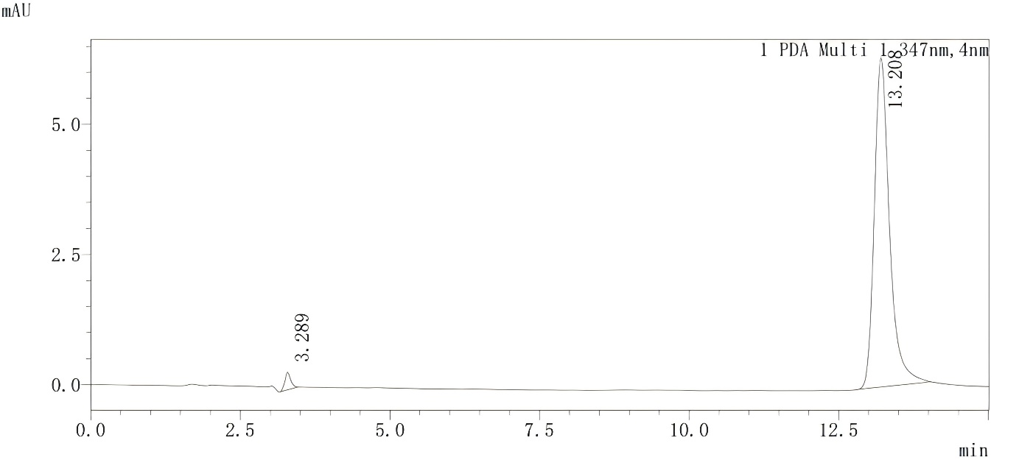

**Figure S1.** The main components of luteolin were determined by HPLC.

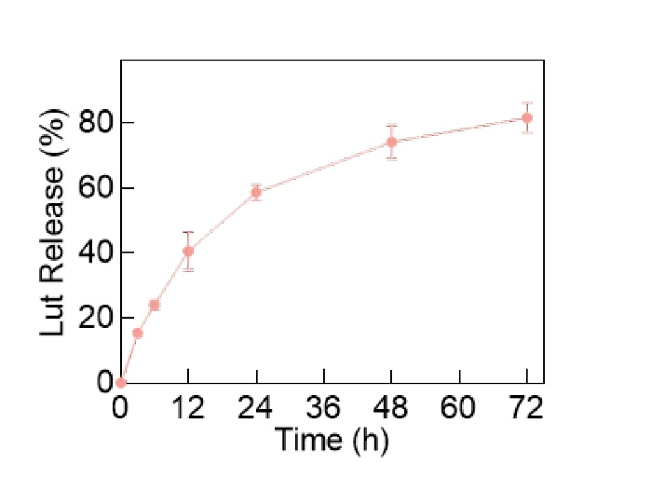

**Figure S2.** The release profile of the Lut from Lut@HAase.

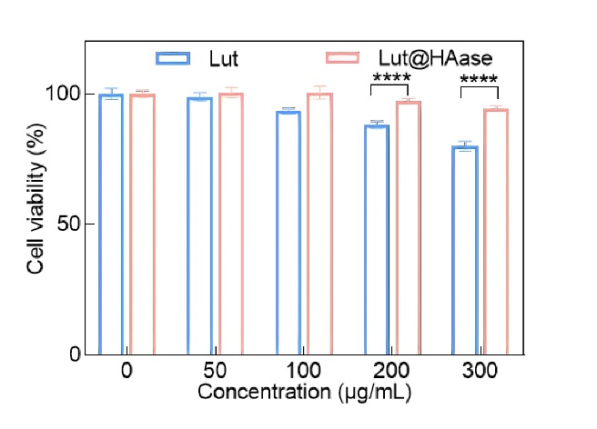

**Figure S3.** The cytotoxicity of luteolin and Lut@HAase on human bronchial epithelial (BEAS2B) cells. Quantitative data are presented as mean ± SD. Statistical significance was assessed using multiple t tests. *p < 0.05, **p < 0.01, ***p < 0.005, ****p < 0.001.

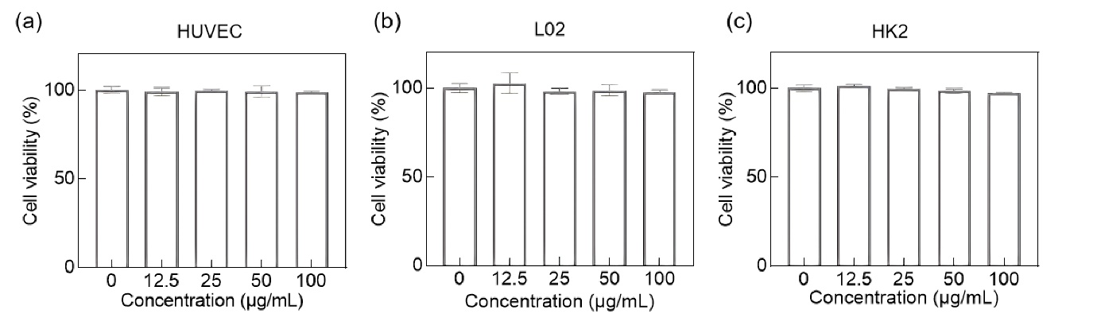

**Figure S4.** Cytotoxic effect of Lut@HAase on (a) HUVEC, (b) L02, and (c) HK2 cells.

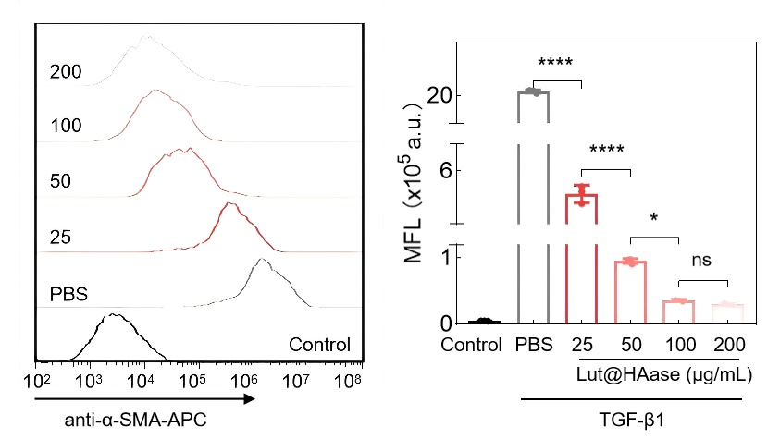

**Figure S5.** The concentration of particles in vitro experiments tasted by flow cytometry. Quantitative data are presented as mean ± SD. Statistical significance was assessed using one-way analysis of variance (ANOVA). *p < 0.05, **p < 0.01, ***p < 0.005, ****p < 0.001.

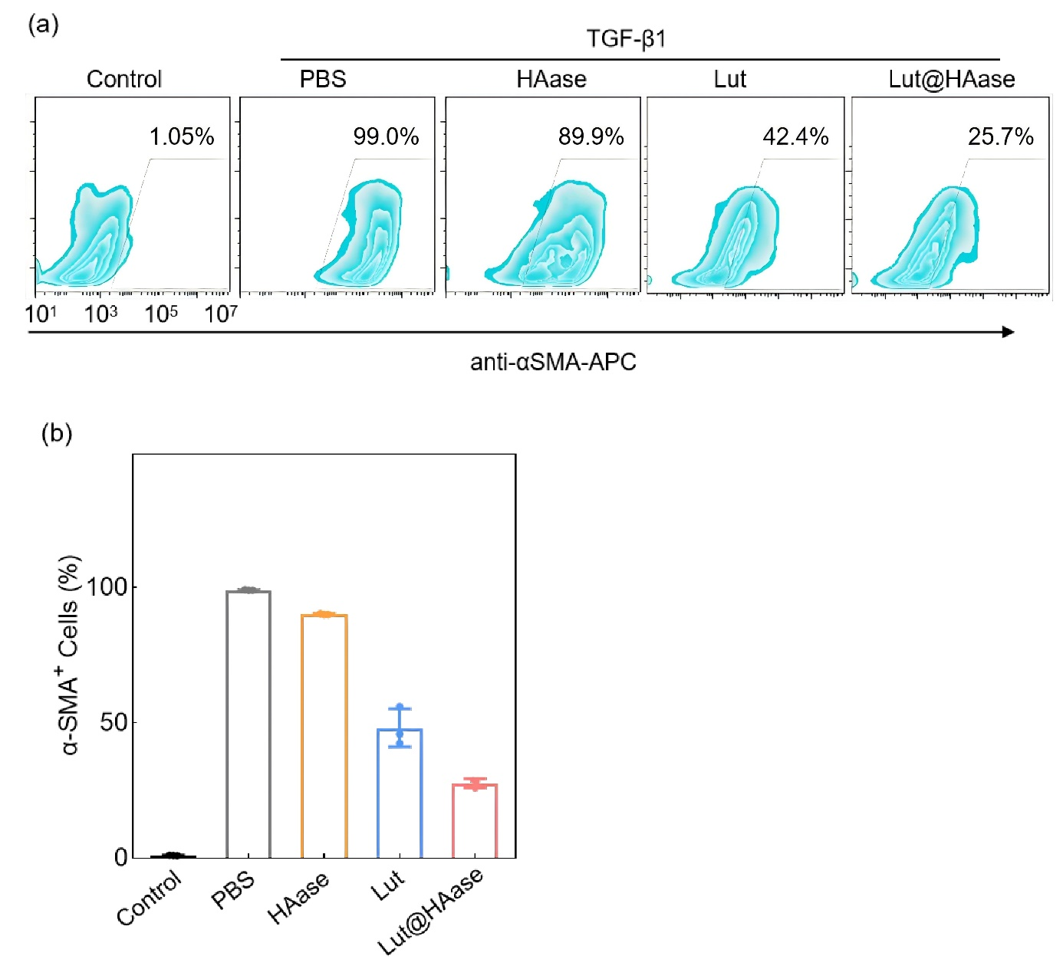

**Figure S6.** (a). The analysis of α-SMA expression by flow cytometry of MRC5 cells with TGF-β1 promoted after different treatments. (b). Corresponding quantitative analysis of α-SMA.

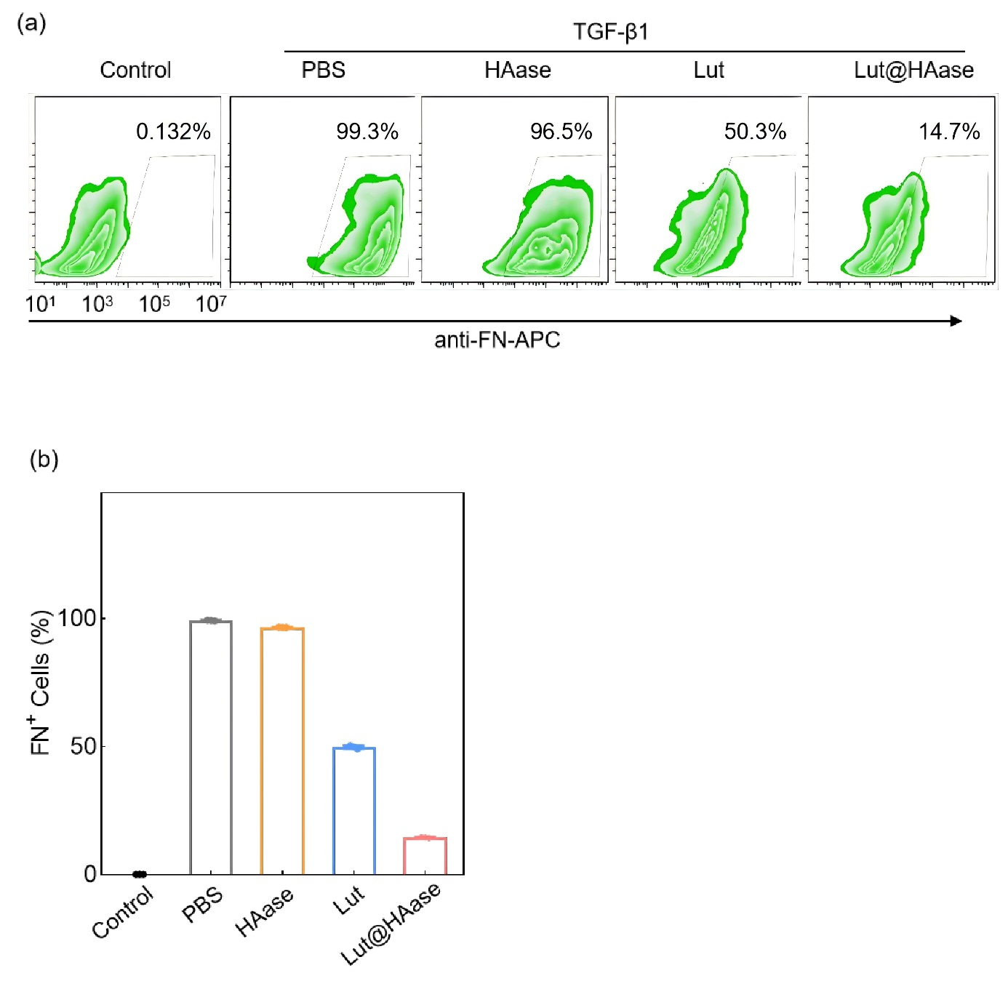

**Figure S7.** (a). The analysis of FN expression by flow cytometry of MRC5 cells with TGF-β1 promoted after different treatments. (b). Corresponding quantitative analysis of FN.

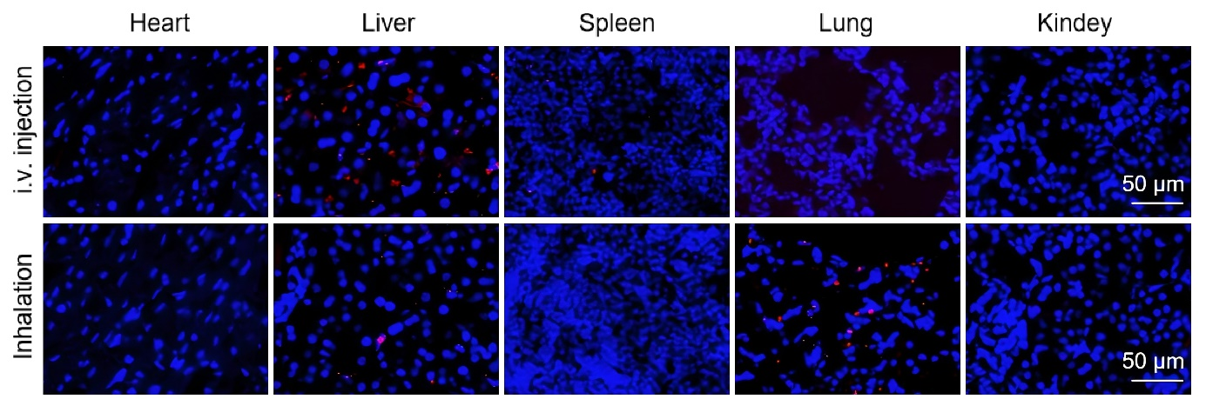

**Figure S8.** Confocal laser scanning microscopy (CLSM) imaging of major organs tissues infiltrated with Lut@HAase at day 5 after i.v. injection or inhalation. (red: Lut@HAase; blue: nucleus; scale bar: 50 μm).

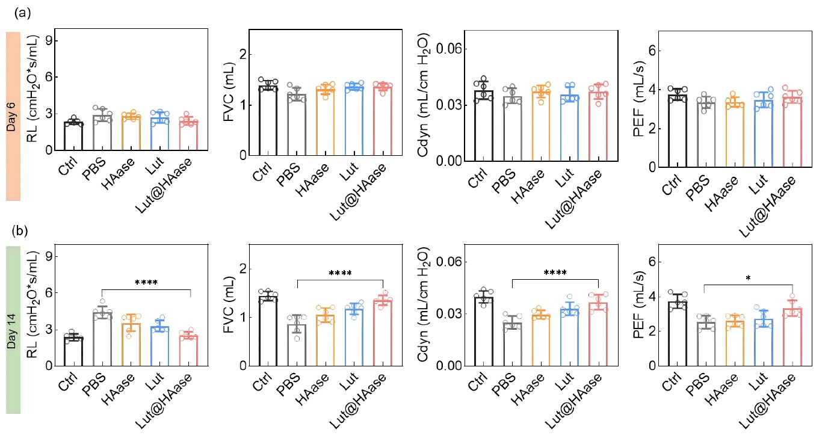

**Figure S9.** Lung function test after administration at day 6 (a) and day 14 (b) (n = 6). Quantitative data in (a) and (b) are presented as mean ± SD. Statistical significance was assessed using one-way analysis of variance (ANOVA). *p < 0.05, **p < 0.01, ***p < 0.005, ****p < 0.001.

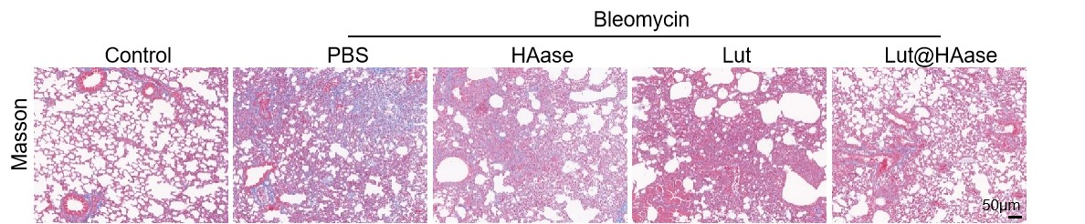

**Figure S10.** Histological analysis, Masson’ s trichrome staining of lung tissues from groups treated with PBS, HAase, Lut or Lut@HAase after BLM challenge (red: muscle fibers and erythrocytes; blue: collagen and nuclei (black-purple); scale bar: 50 μm).

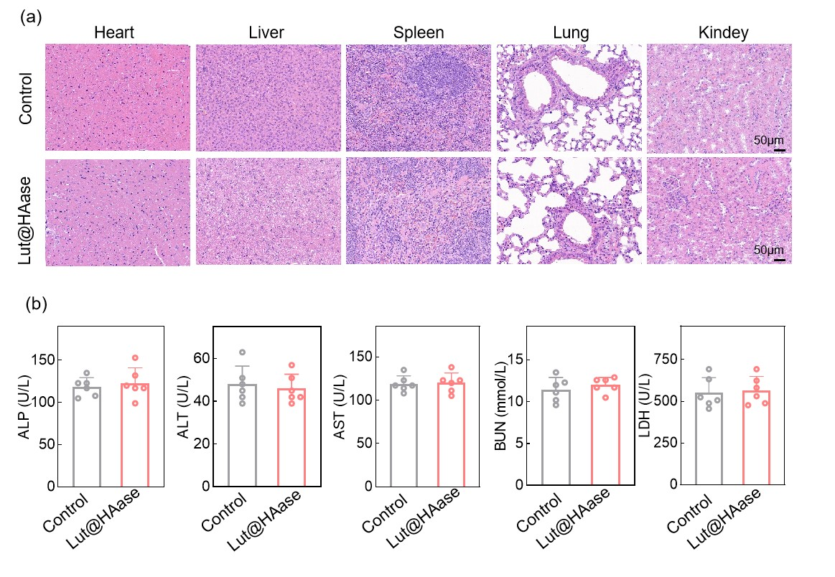

**Figure S11.** Safety estimation. (a). H&E staining of major organs from each group at the end of the experiment (red: cytoplasm and extracellular matrix; blue: nuclei; scale bars: 50 μm). (b). The evaluation on liver function of the model mice including urea nitrogen (BUN), lactate dehydrogenase (LDH), alanine amino transferase (ALT), aspartate transaminase (AST) and alkaline phosphatase (ALP) at the end of the experiment.

**Table S1.** The raw data of the expression levels of inflammatory cytokines of MRC5 cells

|  |  |  |  |  |  |
| --- | --- | --- | --- | --- | --- |
|  | Ctrl | PBS | HA | Lut | HA@Lut |
| IL6 | 0.971 | 1.659 | 2.089 | 1.487 | 1.315 |
|  | 0.885 | 2.175 | 1.659 | 1.745 | 1.229 |
|  | 1.143 | 1.831 | 1.745 | 1.573 | 1.057 |
| IL-1β | 1.034 | 1.642 | 1.338 | 1.338 | 1.135 |
|  | 1.034 | 1.439 | 1.541 | 1.439 | 0.932 |
|  | 0.932 | 1.338 | 1.541 | 1.135 | 1.135 |
| TNF-α | 0.975 | 1.579 | 1.504 | 1.277 | 1.126 |
|  | 1.050 | 1.353 | 1.353 | 1.353 | 1.050 |
|  | 0.975 | 1.428 | 1.353 | 1.277 | 1.050 |