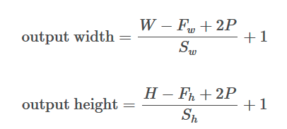
Notes for how CNNs work in Image Processing

- Convolutional Neural Networks for image processing accept the data in a 3D format, the format should be width (number of pixel rows) x height (number of pixel columns) x num channels (RGB).
  - Example: A color image that is 32 x 32 pixels will also have a 3rd dimension (RGB) depth that the image corresponds to. So it has a matrix for each RGB config. That means the “red” configuration will have 1024 features that correspond to that part of the image, “green” and “blue” will also have 1024 features that correspond to those channels.
  - You can think of this 32 x 32 x 3 configuration as a 32 row numpy array with each element of the array being a 32x3 matrix. The three columns correspond to R, G, B pixel values.
- The first layer of a CNN is always a convolutional layer.
- The convolutional layer uses a filter (aka a kernel or neuron) of a specific width x height x depth.
  - The filter is like a flashlight that shines over a “receptive field” of the original image.
  - The filter is an array (matrix) of numbers as well which are the “weights” of the neural network.
  - Since we have a 3D image, it will essentially be treated as 3 different matrices of numbers, and the filter will be applied to all 3 of those matrices as it convolves around the entire image.
  - A filter is meant to learn lower level features in an image, such as edges, curves, etc. The filter will have it’s own values that correspond to the type of lower level feature they are trying to detect.
  - The depth of the filter needs to have the same depth as the input data.
  - As the filter moves across the input data, it performs element-wise multiplication (weights x inputs)
    - e.g. if we had a 32x32x3 filter, then we would have 3072 multiplications per convolution. All of these resulting values are then summed up in the entire convolution and we proceed along convolving the entire input data.
  - The convolution filter is shifted a number of “stride” units to the right and takes another convolution until the entire image has been calcuated. Stride is a hyperparameter that is configurable by the user.
  - This output from this convolutional layer is an “activation map”. If the shape the filter was intending to imitate is not in the that part of the image, then this part of the image will not be activated in the output to the next layer. As you go through the network, filters will begin to represent higher level features in the image such as faces, or specific image features of the input. Think lower level is edges, curves, shapes, and as you go through the network it will begin to identify key parts to the image for classification at the end.

  - The output layer of the convolutional layer will follow formulas for height and width:

  - For example. For output width, if we have a 32x32x3 input size and are using a 5x5x3 filter.
    - W = 32,
    - F_w = 5 (size of filter width)
    - P = 0 (This is the specified padding given to the image, usually chosen to be same as input within tensorflow)
    - S = 1 (Stride length, or how much we move the filter to the right for each convolution).
    - Output width = ((32 – 5 + 2*(0)) / 1) + 1 = 28
  - For example. For output height, if we have a 32x32x3 input size.
    - H = 32,
    - F_h = 5
    - P = 0
    - S = 1
    - Output height = ((32 - 5 + 2*(0)) / 1) + 1 = 28
  - So our output dimension shape for these convolutional hyperparameters will be 28x28x1!
  - If we use multiple filters, the output dimension channels will increase, for example, if we used 2 filters we would have a 28x28x2 output dimension shape

  - An image of the math that is going on in each filter multiplication:
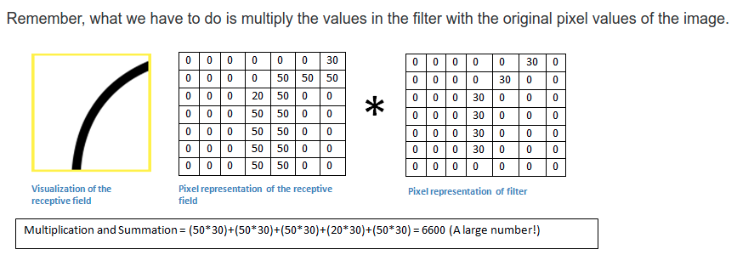
  - The above image has a larger number because it has similar activity in this area of the image to the filter (that is representing a curve like shape). However if we slide this filter to a part of the input that doesn’t have much similarity to the filter shape the number will be much lower like so:
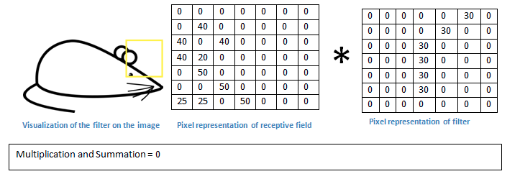
  - Other layers are typically interwoven throughout a CNN such as ReLU activation layers. These are here to preserve dimension and create the nonlinearity aspects of our data (as most real world data is not typically linear).
  - At the end of the network we will attach a fully connected (dense) layer which takes the prior layer’s input dimensions and maps the N classes that you are trying to classify in the image (e.g. labels of the image, dog, cat, and so on).
  - Each number in this N dimensional output vector will represent probabilities for that specific class. This typically is by using a softmax activation function.

  - For backpropagation through the network to adjust weights, we use calculus (gradient) and try to adjust weights to minimize this value.
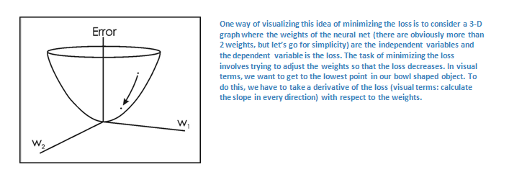
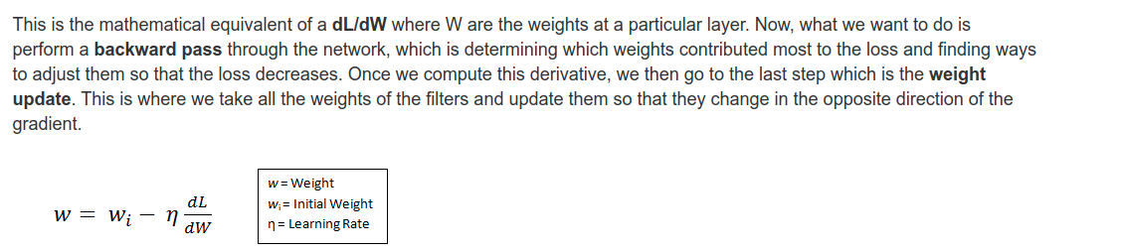

  - The learning rate is another parameter given by the user. The higher the learning rate, the higher the change in weights will be. If the learning rate is too high it can result in too large of weight adjustments and may not be able to find the optimal weight values to minimize the loss function.
  - Now, regarding padding, we can pad with certain numbers (often zeros) to increase the dimension of our input

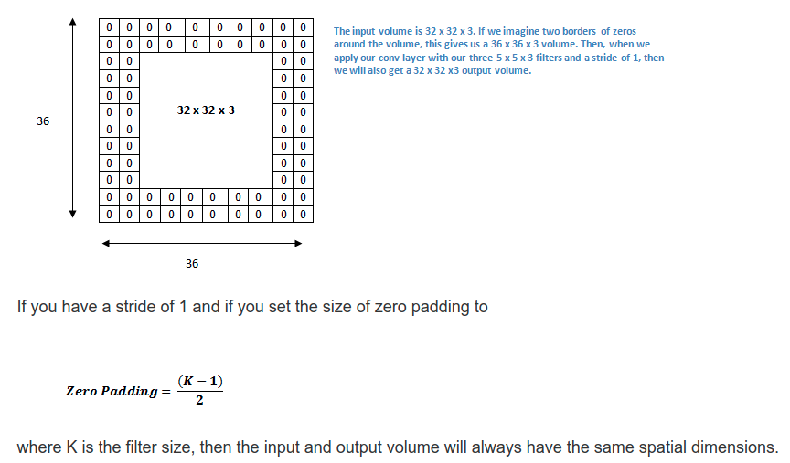

  - Discussion of other various layers commonly used in CNNs

  - ReLU: The main non convolutional layers used in a CNN are ReLU layers which are simply the f(x) = max(0,x). ReLU is preferred in modern days to tanh and sigmoid functions since they help train a model faster and alleviate some pain from the vanishing gradient problem. This is basically the problem that gradients become too small in early layers of Neural nets and the algorithm becomes too slow since the change in gradient becomes exponentially small.
  - Pooling: Maxpooling is usually the most popular choice here but it is essentially a sampling method and is performed as follows:
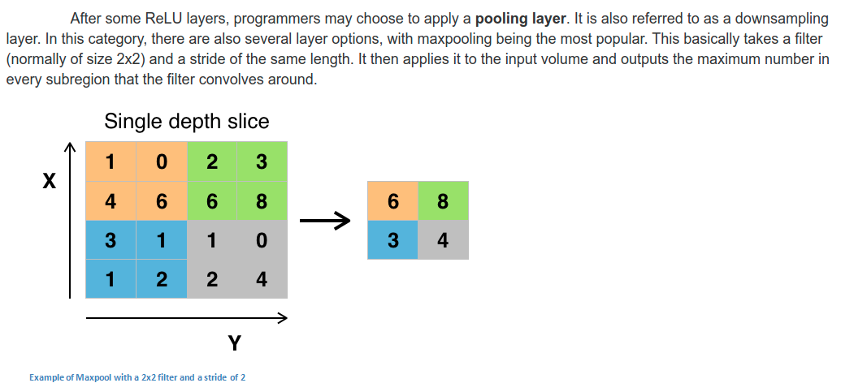
  - Pooling layers are typically used to reduce the width x height of the incoming dimensions as the main features are already extracted with high activation in these subsections. These layers give us faster training as the data’s dimensions will be reduced and also help control overfitting.
  - Dropout: These layers are used to control overfitting. This layer will drop out a random set of activations in that layer by setting them to zero. It basically allows the network the ability to still classify data even if certain random activations are dropped. This helps prevent the network from getting TOO strongly trained on the training data, and will help it perform better on the test data sets.

