*5/4/2025*

Mr. Renato D. Quiambao

Owner

Sofitea

Dear Sir/Madame:

A requirement for the course in WS101- Web Systems and Technologies involves the creation of websites and web applications. It includes front-end development (the user interface and interactions). In this project, the students are expected to design and develop a complete working website for a certain company small or medium-sized business, an enterprise, or an academic institution.

An integral part of the project is data gathering through interviews, surveys, and document analysis. This project is expected to serve as a venue and opportunity for the students to be able to design and develop solutions appropriate to their chosen field of study similar to the industry exercise on web systems design and development.

The following students are heading a team that has expressed their intention to consider your prestigious institution or department for their study:

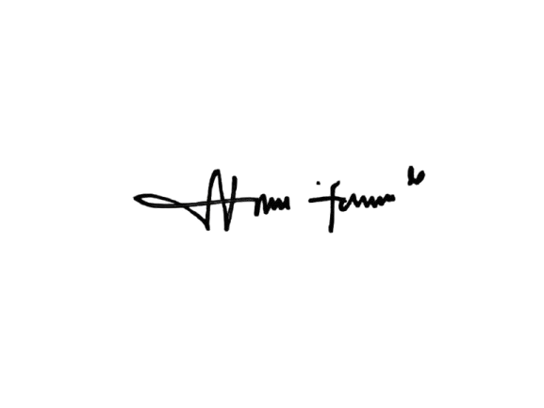Members Full name and Signature:

Andrea Jen M. Quiambao

Jhenlie C. Manuel

Winsleth S. Tamina

Princess Ella Nemeño

Through this letter, I would like to seek your approval for the above undertaking. Please be assured that there are no risks involved in your participation in this academic exercise and students are taught the proper handling and management of any data that will be gathered. The identity and the responses of the participants will be treated with utmost confidentiality in observance of the Data Privacy Act of 2012 and will only be used for this academic purpose.

Thank you very much for your support in our students’ academic growth.

Sincerely,

**MS. MARSHA SUPERIO-LINTAG**

*Instructor*