**IGD Installation and Configuration in BAT**

# Create a Cognos ID to access databases

1. DB2 DBA create a read only Cognos ID to access XMETA and IADB in BAT Environment (ALNXDB91)
2. Grant Reader access to Cognos ID (cdbigd01) on XMETA(DXMEB011) and IADB(DIAB011) in BAT Environment (ALNXDB91)
3. Create schema igdconfg on XMETA database
4. Run **CreateIGDConfigTables_DB2.sql** and **PopulateIGDConfigTables.sql** in the zip file to create and populate IGD config tables on XMETA database (Check with WSIB DBA for any updates or questions on database activities)

Refer to the zip file here for the two sql files.



1. Cataloging in Cognos App Server DAIXAP1X to connect to ALNXDB91 for below DBs under /db2home/ina1ap1x

XMETA DB - port 25771

IADB - port 25791

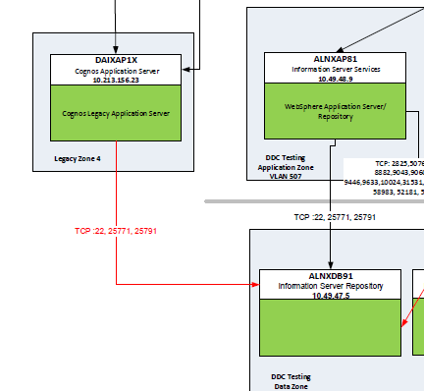

Related SRs:

[REQ0259914](https://urldefense.com/v3/__https:/wsib.service-now.com/sc_request.do?sys_id=61b00e861bc3a4107257da01ec4bcb79&sysparm_stack=sc_request_list.do*sysparm_query=active=true__;Pw!!AaIhyw!7IZc9z7IzOS8dof0vC_76sQ0X_Vbaq0XUVnlbCwe6gIecSLN557e9RiMHGlI-LUC$) > [RITM0278518](https://urldefense.com/v3/__https:/wsib.service-now.com/sc_req_item.do?sys_id=a5b00e861bc3a4107257da01ec4bcb79&sysparm_stack=sc_req_item_list.do*sysparm_query=active=true__;Pw!!AaIhyw!7IZc9z7IzOS8dof0vC_76sQ0X_Vbaq0XUVnlbCwe6gIecSLN557e9RiMHKRq-zrR$) > TASK0486442

[REQ0261099](https://wsib.service-now.com/sc_request.do?sys_id=d91fdc841b5324107257da01ec4bcb75&sysparm_stack=sc_request_list.do?sysparm_query=active=true) > [RITM0279791](https://wsib.service-now.com/sc_req_item.do?sys_id=611fdc841b5324107257da01ec4bcb76&sysparm_stack=sc_req_item_list.do?sysparm_query=active=true) > TASK0488333

# Configure Cognos application firewall to accept URLs

1. Take a backup of file Cognos Home/configuration/cogstartup.xml
2. Stop Cognos service
3. Launch Cognos Configuration
4. In Explorer window, select **Security** > **IBM Cognos Application Firewall**.
5. In Properties window, set the value of the **Enable CAF validation** property to true.
6. For the **Valid domains and hosts** property, select the value, and then click **Edit**.
7. In the Value - Valid domains or hosts dialog box, click **Add** and enter the following values and then click **OK** once completed.

<https://10.49.48.9:9446/ibm/iis/igc/>

<https://10.49.48.9:9446/ibm/iis/events#subscriptions>

<https://10.49.48.9:9446/ibm/iis/dqec#exceptionmanager>

<https://10.49.48.9:9446/ProcessPortal>

1. In the Properties window, click **File** > **Save**.
2. Start up Cognos service

# Deploy Cognos packages to portal

1. Copy IGD_Deployment_Archive.zip to Cognos Home/deployment
2. Go to Cognos portal <https://nlxwb21.wsib.on.ca:11080/ibmcognos/cgi-bin/cognos.cgi>
3. Go to Cognos Administration
4. Click on Configuration >> Content Administration >> New Import

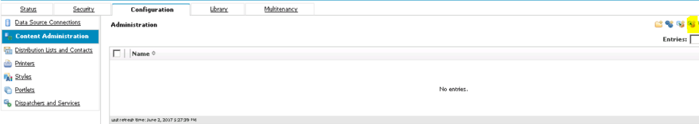

1. Follow the steps below

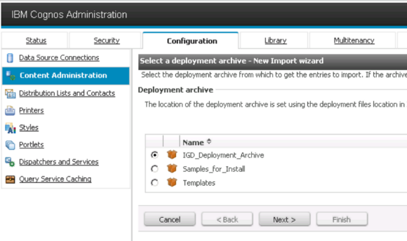

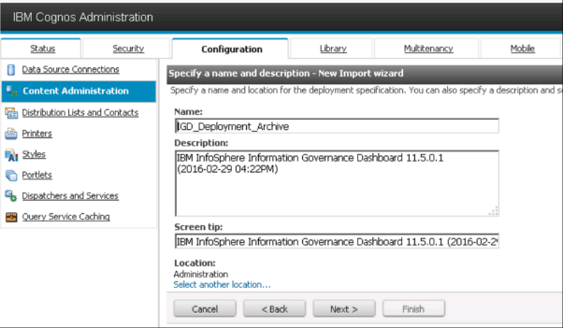

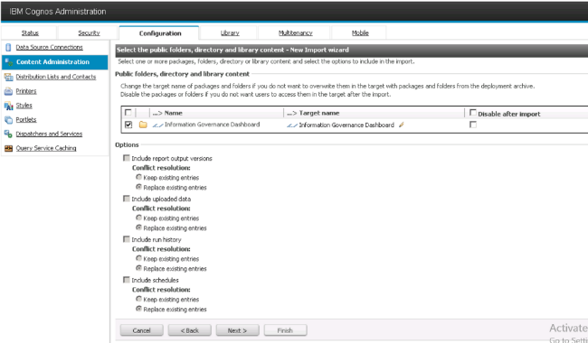

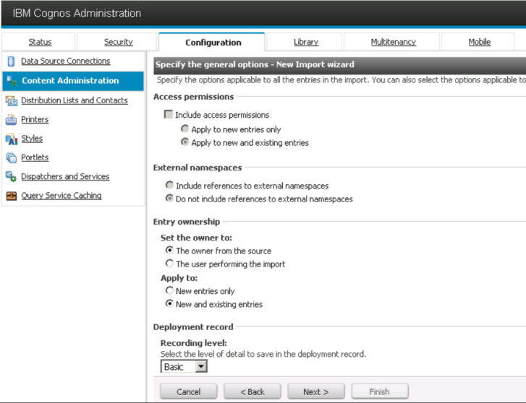

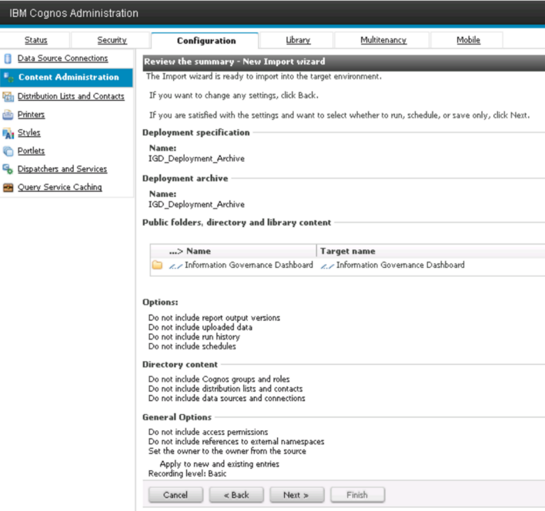

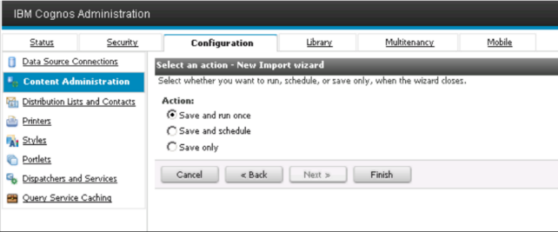

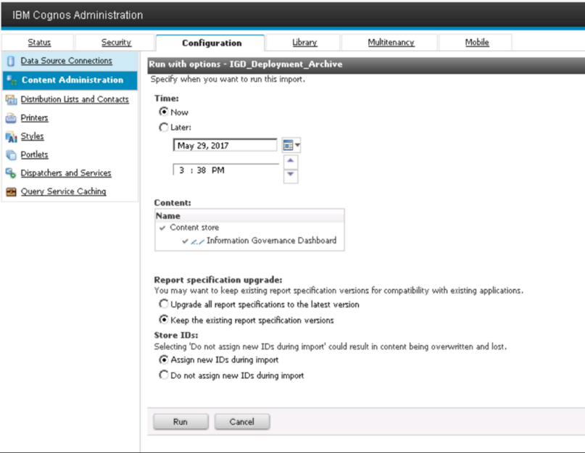

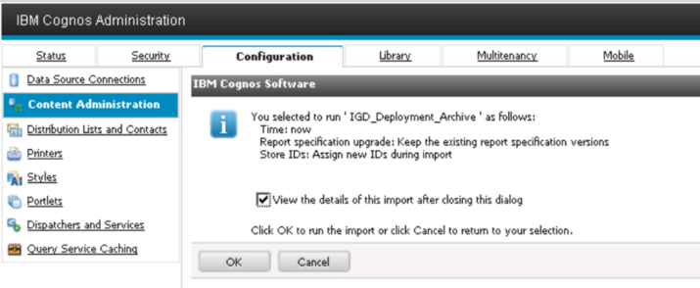

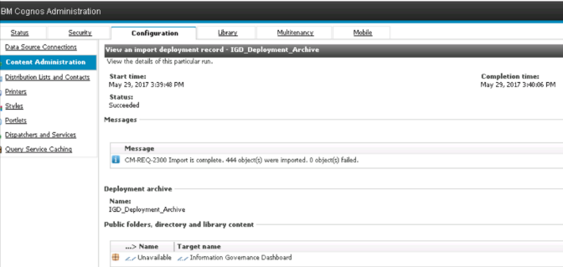

1. Click **Close**

# Define data sources for XMETA and IADB in Cognos

1. Go to Configuration and click on New Data Source

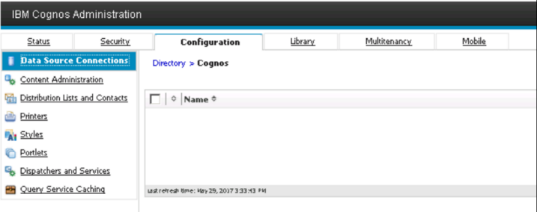

1. Type in XMETA

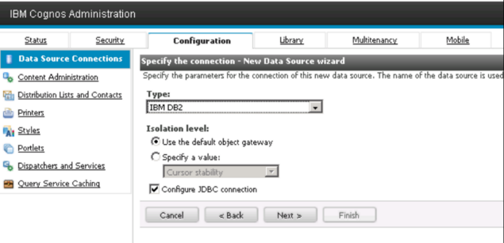

1. Select JDBC

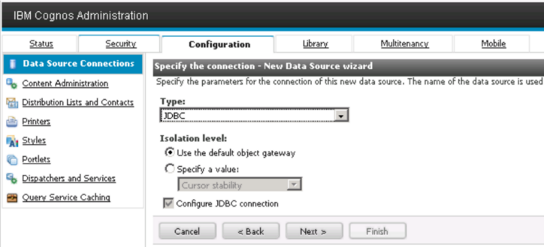

1. DB2 DBA to enter the Cognos ID and credential to the following screenshot

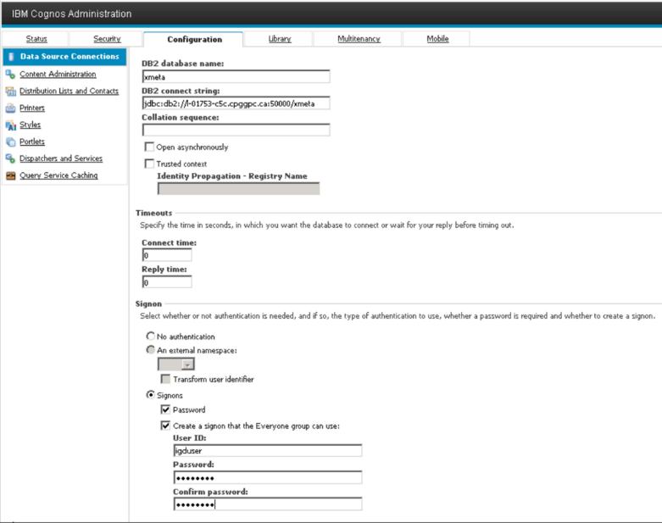

1. Click Close when finish.
2. Repeat the same steps from 1 to 4 for IADB except below

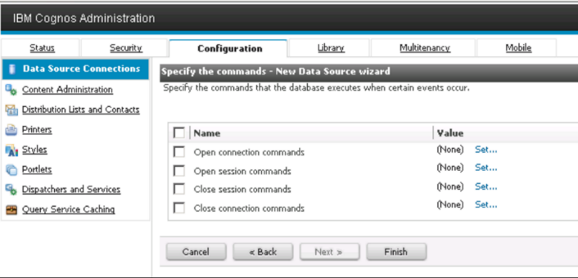

1. Click Set next to Open session commands. Enter below into the field XML database commands

<commandBlock>

<commands>

<sqlCommand>

<sql>SET CURRENT SCHEMA = CDBIFA01</sql>

</sqlCommand>

</commands>

1. </commandBlock>After creation, review the connection:

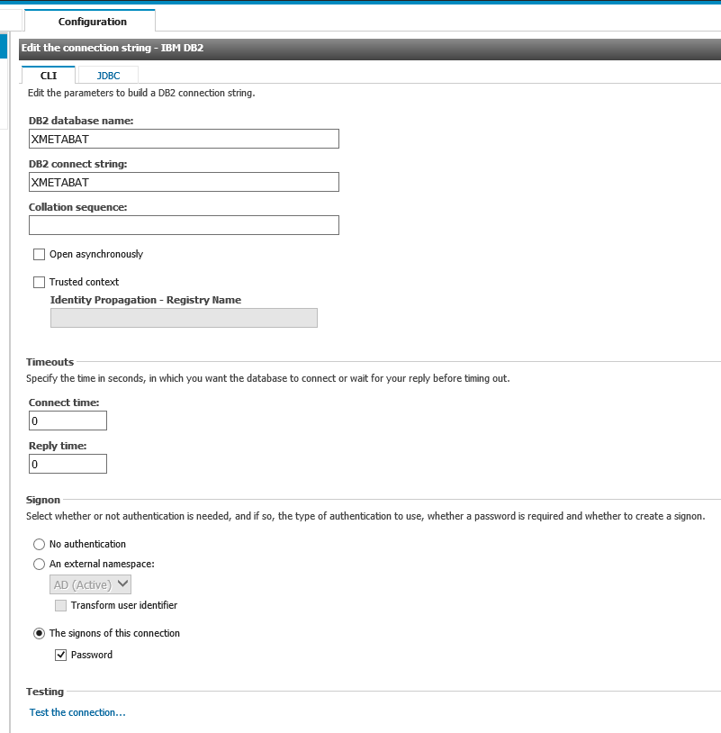

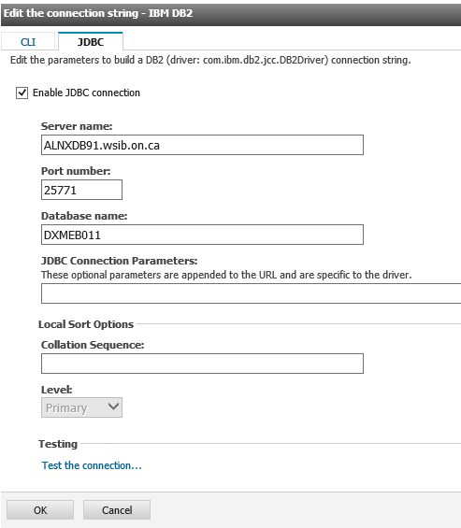

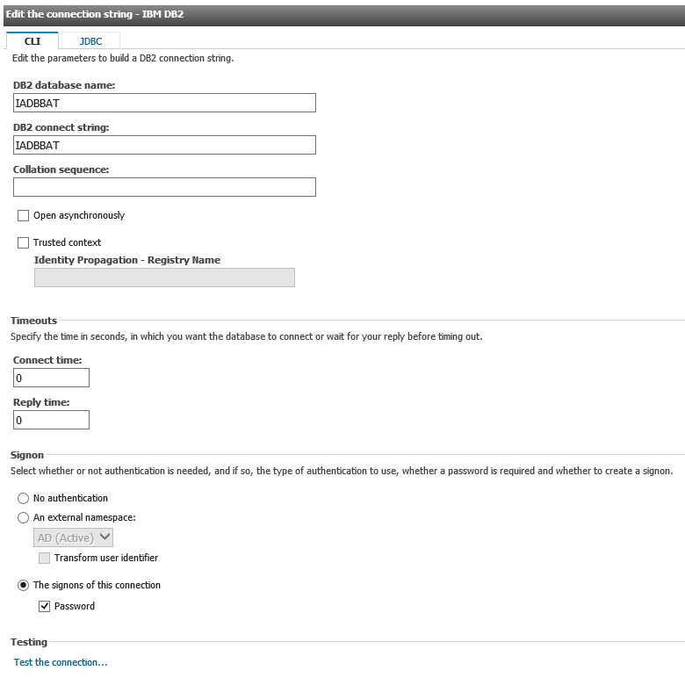 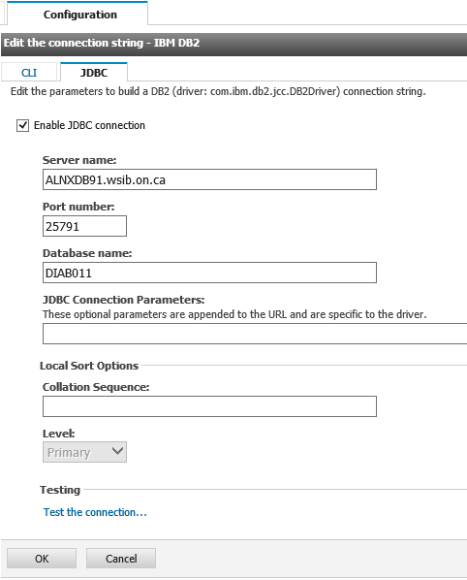

# Copy IGD images folder

Copy **IGD_images** folder to Cognos Home/webcontent folder.

# Update link on IIS Launchpad portal

Ensure you have write access to the file under /IBM/InformationServer/ASBServer /conf/database.properties

Execute command:

/IBM/InformationServer/ASBServer/bin/iisAdmin -set -key "com.ibm.iis.launchpad.application.IGD.url" -value "https://nlnxwb21.wsib.on.ca:11080/ibmcognos/cgi-bin/cognos.cgi?b_action=xts.run&m=portal/main.xts&m_redirect_windowmode=2&m_redirect=%2fibmcognos%2fcgi-bin%2fcognos.cgi%3fb_action%3dxts.run%26m%3dportal%2flaunch.xts%26ui.gateway%3d%252fibmcognos%252fcgi-bin%252fcognos.cgi%26ui.tool%3dDashboardConsole%26ui.action%3dedit%26ui.atompath%3dPublic%252520Folders%252fInformation%252520Governance%252520Dashboard%252fInformation%252520Governance%252520Workspace&m_redirect_uitool=DashboardConsole"

# Restart IGD in WAS console (No need to execute in BAT)

