**Note: The dataset within this folder is considered industrial confidential and is currently only available for review by the journal's reviewers during the manuscript review process.**



This is the trained Flower Model, which can directly diagnose the test set and output the results.



This is the folder containing the test set results after diagnosis. The dataset inside is confidential and cannot be made public, but it can be shown to reviewers to demonstrate the effectiveness. **The filenames of the dynamometer card test results in the images below are explained as follows:**

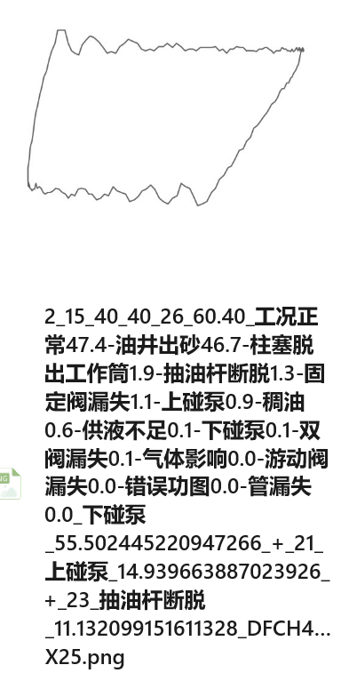

As shown in the figure: "2" is the original ID, "15_40_40_26" is the label array where 15 represents the normal condition label, 40 represents an empty label, and 26 represents the sand production condition label. "60.40" is the area parameter of the current image. The Flower Model's diagnosis results are "正常47.4-油井出砂46.7-柱塞脱出工作筒1.9-抽油杆断脱1.3-固定阀漏失1.1-上碰系0.9-稠油0.6-供液不足0.1-下碰系0.1-双阀漏失0.1-气体影响0.0-游动阀漏失0.0-错误功图0.0-管漏失0.0", where each condition is followed by its percentage of presence. "_下碰泵55.502445220947266_+_21上碰系14.939663887023926+_23_抽油杆断脱11.132099151611328 DFCH4..x25" represents historical information and the well ID (confidential information) and can be directly ignored.

**Below is the table of Chinese names, English names, and numerical labels:**

|  |  |  |
| --- | --- | --- |
| Chinese Name | English Name | Numerical Label |
| 正常工况 | Normal Condition | 15 |
| 供液不足 | Insufficient Liquid Supply | 16 |
| 气体影响 | Gas Influence | 17 |
| 游动阀漏失 | Movable Valve Leakage | 18 |
| 固定阀漏失 | Fixed Valve Leakage | 19 |
| 双阀漏失 | Double Valve Leakage | 20 |
| 上碰泵 | Upper Collision Pump | 21 |
| 下碰泵 | Lower Collision Pump | 22 |
| 抽油杆断脱 | Sucker Rod Break | 23 |
| 柱塞脱出工作筒 | Plunger Out of Cylinder | 24 |
| 稠油 | Thick Oil | 25 |
| 油井出砂 | Sand Production | 26 |
| 管漏失 | Pipe Leakage | 27 |
| 错误功图 | Incorrect Dynamometer Card | 28 |
| 空标签 | |  | | --- | |  |  |  | | --- | | Empty Label | | 30or40 |



This is the test set.



This is the folder containing the trained "stamen" and "petal" model files. Due to the large size of the model folder, it has not been uploaded, and as a result, the accompanying code cannot run properly.

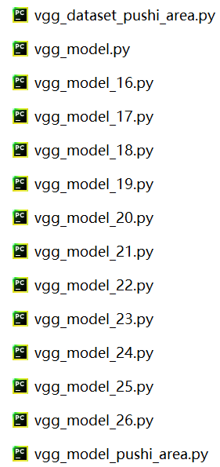

The `vgg_model_pushi_area.py` is the "stamen" model, `vgg_dataset_pushi_area.py` is the dataset code for the "stamen," and `vgg_model_16-26` contains the models for the various petals.