My NCLH short pitch, in plain English
This is the stock pitch I put together for the Citadel competition, rewritten so it makes sense without the finance shorthand. The idea is that Norwegian Cruise Line Holdings (ticker NCLH) is worth less than the market thinks, so I'd bet on the stock going down. That bet is called a short.
The company
NCLH owns three cruise lines. Norwegian (NCL) is the big mass-market one and has most of the ships. Oceania and Regent are the more expensive ones. Altogether it has 35 ships and about 75,000 beds. In 2025 it brought in $9.8B of revenue and made $2.73B of EBITDA, which is profit before interest, taxes and depreciation. It also owes a lot of money: about $14.8B of debt after subtracting cash, which is roughly two-thirds of what the whole company is worth. That turns out to matter a lot.
The number everyone watches
Cruise investors focus on something called net yield. It's basically how much money the company keeps per bed per day, after paying travel agents and the cost of what it sells on board. For NCLH, every 1% change in net yield is worth about $75M of yearly profit. Because the debt stays the same no matter what, that 1% moves the value of the stock by about 9%.
What happened this year
Net yield grew 2.3% in 2025. For 2026 the company now expects it to drop about 5%. A few things went wrong at once. Norwegian moved a lot more ships into the Caribbean before the upgrade to its private island was finished. It started paying travel agents more. Then the Iran war pushed oil above $100. Management cut its forecast twice, the CEO was replaced in February, and the stock fell about 40% over the past year.
What the market expects
Most analysts see this as temporary. Their view is that once the war fades and the new island and new ships are up and running, prices come back in 2027. If you work backward from today's share price, the stock needs about $3.0B of profit a year to be worth what it trades at. That's more than the company made in 2025. Analysts' 2027 forecasts work out to about $2.7B.
Why I think they're wrong, part 1: it's competition, not the war
I collected prices for 4,783 cruises from a public price-tracking website on October 2 and compared each one to its own average over the previous 90 days. If the war were the main problem, I'd expect Norwegian to be discounting Europe, since most of those passengers fly there and airfares are up 23%. Instead it has cut Caribbean cruises for early 2027 by 14.5% and Europe by only 2%. Royal Caribbean and Carnival have barely touched their Caribbean prices.
Out of Port Canaveral, Norwegian is now cheaper per night ($94) than Carnival ($100), and Carnival is supposed to be the budget option. Cruises that stop at Norwegian's newly finished island are cut just as much as the ones that don't, and its two newest ships are cut 22% while Royal's newest are cut 1%. To me that says Norwegian is losing customers to its competitors, and a ceasefire won't fix that.
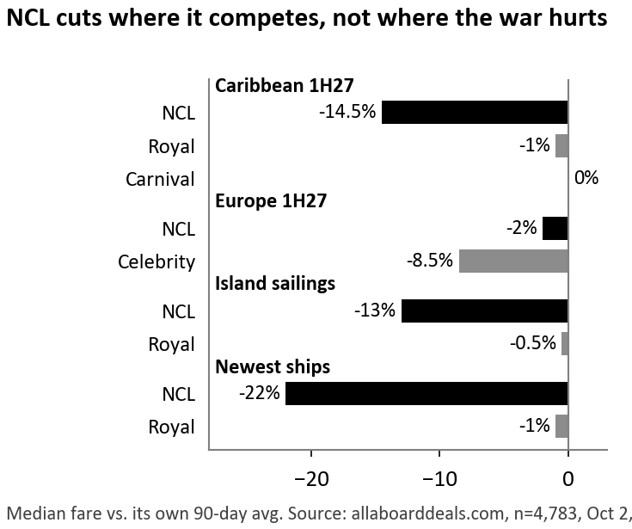
How much each line has cut prices compared with its own 90-day average
Why I think they're wrong, part 2: the price guarantee
Management's plan for late 2027 is to start cruises at lower prices and raise them as ships fill up, the way airlines do. That only works if people book early because they think prices will go up. But Norwegian has a Best Price Guarantee. If the price drops after you book, you can switch to the lower fare, and if you've already paid in full you get an upgrade or a credit toward a future cruise. So there's not much reason to book early. Norwegian also keeps cutting prices late: 77% of its week-long Caribbean cruises this fall were cut 20% or more in the last 90 days. Royal was at 7% and Carnival at 0%.
You can already see it in deposits, the money people pay when they book. Compared with last year, deposits per future bed are down 8.3%. That's the seventh drop in a row, while Royal's and Carnival's deposits are growing.
What my model says
Putting it together, I expect net yield to fall another 1.3% in 2027, while the analyst view has it rising about 1.4%. That gives about $2.44B of profit in 2027 against roughly $2.69B expected, and earnings per share of $0.88 against $1.46 to $1.67. Because so much of the company's value belongs to its lenders, a profit miss of about 10% becomes roughly a 32% drop in what the stock is worth. At today's valuation that comes to about $10.22 a share, compared with $15.05 today.
To be fair to the other side, about a third of the gap comes from my cost assumptions: I have costs rising 1% next year and fuel at $800 a ton, a bit higher than analysts. If I use their cost numbers instead, I still get about $12 a share, around 19% below today.
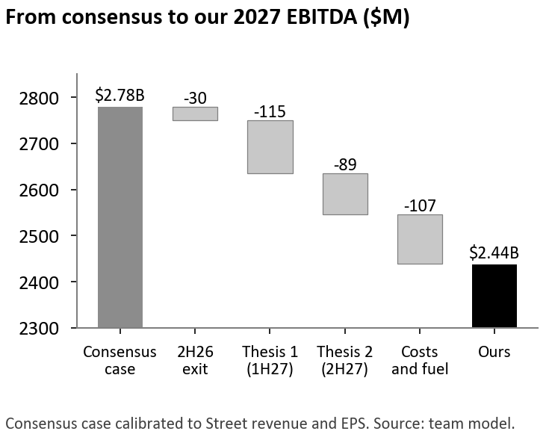
How I get from the analysts' number to mine ($ millions)
I also looked at a good case, a middle case and a bad case. If the analysts are right and investors warm back up to the stock (25% chance), it's worth about $19.78. My main case (50%) is $10.22. If the discounting gets worse (25%), it's about $6.46. Weighting those together gives about $11.67, around 22% below today.
What would prove me right or wrong
On November 4 the company reports its third quarter. Quarterly earnings will probably look fine, but the number I care about is how much customers have prepaid for future cruises as of September 30. I expect about $2.94B. Anything under $2.97B supports my view. If it's $3.11B or more, I'd admit I was wrong and get out. The next big test is in late February, when the company gives its first forecast for 2027.
What could go wrong
A lot of people are already betting against this stock: about 21% of the shares are sold short. When that happens, good news can make the price jump fast, as people rush to buy shares back. It rose 48% in six weeks this spring when oil prices fell. Elliott, an activist investor that owns more than 10%, could also push for changes, and the company could cut costs by more than the $225M it has announced.

