Narrative Summary: The Street trades NCLH on one number, net yield: what NCL keeps per available bed per day after commissions and onboard costs. Net yield fell from +2.4% in 2025 to about −5% guided for 2026, two-thirds from empty cabins and one-third from lower prices. The share price and consensus assume both come back in 2027. We think the cabins come back and the price does not, for two reasons we can see in alternative data before the market can. First, NCL is discounting because it is losing the Caribbean to Royal Caribbean and Carnival, not because of the war, so its new island and ships will not restore pricing. Second, NCL’s own price guarantee means every discount also cuts the price of cabins already sold and is paid for out of future fares, which breaks the pricing plan the 2027 recovery depends on. Our model puts 2027 net yield at −1.3% against +1.4% in a consensus case, EBITDA at $2.44B against ~$2.7B, and EPS at $0.88 against $1.46–1.67: about 32% downside.
Company and Industry: NCLH runs 35 ships (~75,000 berths) under Norwegian Cruise Line (NCL), the mass-market brand with most of the capacity, and the luxury Oceania and Regent brands. A ship costs roughly the same to sail full or empty, so each 1% of net yield is ~$75M of EBITDA, and with $14.8B of net debt (two-thirds of enterprise value) ~9% of equity value. Carnival, Royal, MSC and NCLH carry ~80% of global capacity. Returns diverge: 2025 return on capital was ~16% at Royal, ~12% at Carnival and ~9% at NCLH, roughly its cost of capital. The fight is in the Caribbean, where each leader now owns a private island: Royal’s CocoCay, Carnival’s Celebration Key (opened July 2025, ~2.5M guests in year one) and Royal’s Nassau beach club (December 2025). NCL moved ~40% more capacity into the Caribbean for early 2026, before its own Great Stirrup Cay upgrade was finished (September 2026). John Chidsey (ex-CEO of Subway and Burger King) replaced the CEO in February and is now chairman under an agreement with Elliott, a >10% holder.
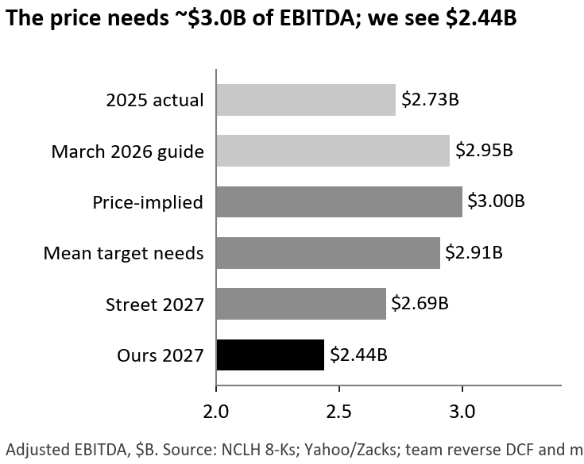
Market Expectations: How the stock got here. NCLH was the cheap catch-up trade a year ago. It fell 17% on November 4, 2025, on that Caribbean-heavy 2026 plan; the CEO left in February; the Iran war sent oil above $100; and management cut the 2026 outlook twice in three months, taking EPS from $2.38 to ~$1.50. The stock is down 44% from its high.
The stock trades on net yield, and the price assumes it fully recovers. Since 2024 NCLH’s EV/EBITDA has an r = 0.87 with net yield growth, and the four days management changed its yield outlook cost the stock 27 points against Royal and Carnival, more than its whole company-specific decline. Working backward from the $21.7B enterprise value at a 9% cost of capital, the price needs ~$3.0B of EBITDA a year, which is management’s March guide before two cuts and net yield back at its 2025 peak. Consensus implies ~$2.7B and the $18.80 mean target ~$2.9B; we see $2.44B.
Sentiment is skeptical, but the numbers are not. Analysts sit at 4 Buy / 15 Hold / 0 Sell (11 / 4 / 0 a year ago) and short interest has nearly tripled since February to 20.7% of float, yet when NCLH guided 2027 interest $0.35 a share above 2026 on September 30, consensus 2027 EPS moved two cents. Analysts anchor on a company that has met or beaten its quarterly yield guide twelve straight times while cutting the full year twice.
Oil explains the swings, not the gap. Bulls call the fall a sector sell-off. Our regression puts 55% of it on the market, oil and other cruise lines, but NCLH is no more sensitive to oil than Carnival. Its company-specific 45% came on six news days and never reversed: when Brent fell 38% in May–June, NCLH rallied 48% but closed only half its gap to peers before the July cut erased it.

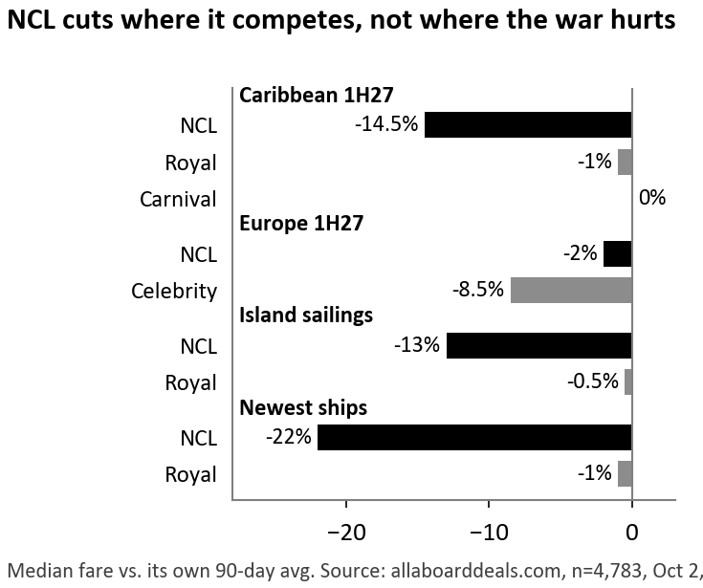
Thesis 1: NCL is not discounting because of the war; it is losing the Caribbean: Management blames “Company-specific execution challenges, as well as the ongoing conflict,” and the Street expects the fixes to work: Wells Fargo stays Overweight, citing the new Great Tides waterpark. Our alternative data says the problem is competitive. A public fare tracker records the lowest price of every cruise itinerary daily, like an airfare tracker. We pulled 4,783 itineraries on October 2 and compared each one’s price with its own average over the previous 90 days. A deep cut means the line had to discount to fill cabins on cruises that sail in the next 3–15 months.
The cuts are where the competition is, not where the war is. If oil and airfares were the cause, NCL would discount Europe, where two-thirds of its guests fly in and US airfares are up 23%. Instead it has cut first-half 2027 Caribbean cruises a median 14.5% and Europe only 2%. Royal and Carnival held the Caribbean (−1%, 0%); their war discounts are in Europe (Celebrity −8.5%).
NCL now prices like a budget line. From Port Canaveral, NCL’s cheapest cabin now costs less per night than Carnival’s, the budget brand, and 71% of its Caribbean itineraries are at record-low prices, against 45% at Royal and Carnival.
It is recent and getting worse. In 2025 NCL cut prices less often than Royal (6% vs 24% of cruises 101–200 days out); now it has 9 of the industry’s 10 biggest monthly price cuts, up from 1 in December, despite the new CEO and the finished island.
The island and new ships earn no premium. Island cruises are cut 13% against 0.5% at Royal. The waterpark is a paid add-on (~$80–100 a person), so it lifts onboard spending (+5.0% per passenger day in 2Q26) while ticket prices fall (−5.6%). NCL’s two newest ships are cut 22% against 1% for Royal’s newest. Like a retailer opening stores too fast, NCL’s new ships take price from its old ones: Prima-class ships go from 11% of NCL berths in 2024 to ~25% in 2027, and older ships on the same routes are cut 39–42%. NCLH’s luxury brands show no cuts on the same method, so this is NCL, not our data.
What we model. About half of first-quarter 2027 cabins were sold before these cuts, so we apply today’s discounts only to the unsold half, on the ~62% of capacity in the Caribbean. That gives 1Q27 net yield of −4.8% and 1H27 of −3.5%, against −0.5% in the consensus case: $115M of 2027 EBITDA.

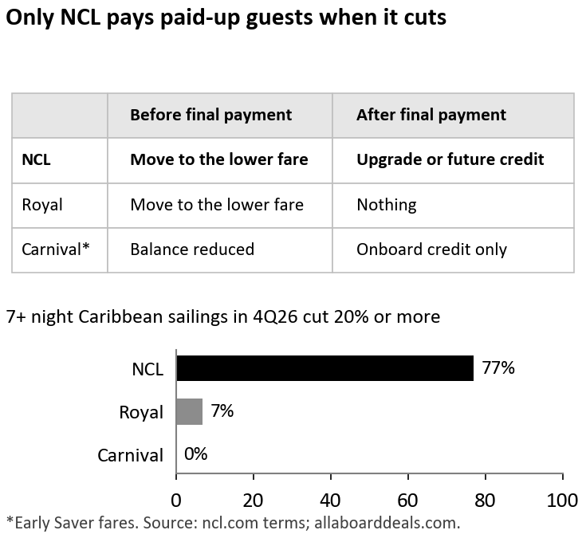
Thesis 2: NCL’s price guarantee turns today’s discounts into tomorrow’s prices: The bull case for 2H27 is base-loading, which Zacks says should “maximize yield across the full booking cycle while maintaining pricing integrity”; management expects improvement “particularly in the second half” of 2027. Base-loading is how airlines sell seats: open cheap, raise prices as the plane fills, so early buyers pay less and late buyers more. It only works if customers fear that waiting will cost them. Chidsey says NCL was “holding price too high, too far out,” which “left us more exposed to close-in discounting.”
NCL’s guarantee removes that fear. Under its Best Price Guarantee, a booked guest can switch to any lower fare on the same sailing until final payment, and a paid-up guest on a 6+ night cruise gets an upgrade or a future-cruise credit for the full difference. Rivals offer far less (chart). So every NCL cut lowers the price of unsold cabins, re-prices booked ones, and creates credits that guests spend on their next cruise.
Why the market cannot see it. The terms sit on ncl.com, not in any filing. A credit looks like a slightly lower ticket price when issued and like a full-price booking paid partly with credit when redeemed in 2027–28. Only fare data shows the exposure in advance: 77% of NCL’s 7+ night Caribbean cruises in 4Q26 were cut 20% or more (median −34%) in the last 90 days, after most guests had paid in full, against 7% at Royal and 0% at Carnival.
The cash shows up first in deposits. Guests pay deposits when they book, months before they sail, so falling deposits today mean lower revenue one to two quarters out. In our back-test of 20 non-COVID quarters, deposits per future berth called the direction of net yield 80% of the time. They are now −8.3%, the seventh negative quarter in a row, while Royal’s and Carnival’s deposits grow; NCL’s first-half deposit build fell 32%. Management concedes it is “below its optimal booked position for the next 12 months.”
NCL has already shown the trade. In 1Q26 it raised occupancy 2.3 points by cutting net revenue per guest 3.2%, and net yield still fell. Paying agents commission on the full fare (bookings since December 26, 2025) costs another ~0.7 points in 2027.
What we model. The ships refill in 2H27 but at the discounted price: net yield +0.9% against +3.2% in the consensus case, $89M of EBITDA. We leave the guarantee leak out of our base case; if one in three eligible guests claims, it costs another ~0.7 points of 2027 net yield, about $0.70 a share.

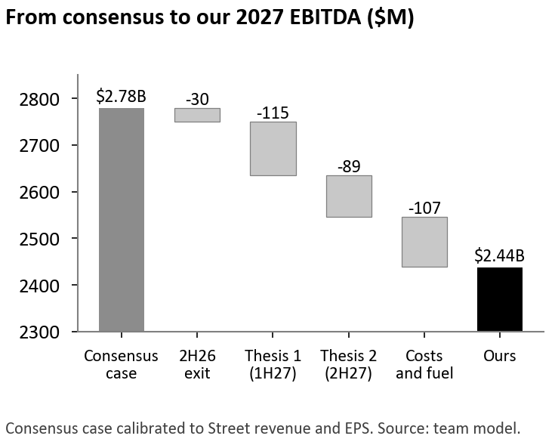
Valuation: Debt turns a 9.5% EBITDA miss into a 32% equity miss. We build net yield each quarter from how full the ships are, what guests pay for tickets and onboard, and what NCL pays agents, with capacity ship by ship and guided costs and interest. 2027 EBITDA is $2.44B and EPS $0.88, below Zacks consensus in every 2027 quarter. At today’s 8.4x forward EV/EBITDA less $15.8B of year-end net debt, that is $10.20; a DCF to 2030 gives ~$7.
Scenario | Prob. | 2027 net yield | 2027 EBITDA | EV / EBITDA | Value | vs. $15.05
Bull: consensus is right and the stock re-rates | 25% | +1.4% | $2.78B | 9.0x | $19.80 | +32%
Base: our view | 50% | −1.3% | $2.44B | 8.4x | $10.20 | −32%
Bear: discounting spreads into 2H27 | 25% | −2.6% | $2.23B | 8.4x | $6.45 | −57%
Probability-weighted |  |  |  |  | $11.70 | −22%

Catalysts and Risks: Two dated tests. On November 4 the 3Q26 10-Q reports September 30 deposits; last year’s June-to-September pattern gives ~$3.0B and the last three quarters’ trend ~$2.88B, so we expect ~$2.94B (−7%) and would cover above $3.11B. The first 2027 guide comes in late February; Chidsey’s 2026 bonus is fixed at $2.9M and his 2027 plan resets, so he has every reason to set a low bar, and we expect net yield at or below flat.
Squeeze risk is real but manageable. 95M shares are short (5.7 days) and the stock rose 48% in six weeks this spring, but shorts were added at ~$18 on average, so forced covering is likelier in the high teens. Because ~55% of NCLH’s moves follow its peers, we would add into an oil- or ceasefire-driven rally, build in thirds around November 4 and February, stop out above $19 (where the average short is underwater and our bull case begins) and hold part in puts. Upside risks: Elliott’s standstill ends in February, and cost cuts could exceed the $225M identified.

Sources: NCLH 8-Ks (Nov 4, 2025–Sep 30, 2026), 10-Ks FY24–25, 2Q26 10-Q and call; ncl.com Best Price Guarantee terms; allaboarddeals.com fares and policy summary (Apr 2026); Carnival 8-K (Sep 29, 2026); Royal Caribbean 2Q26 10-Q; SEC XBRL; Nasdaq/Zacks and Yahoo consensus; Zacks via Yahoo Finance (Oct 2, 2026); Wells Fargo action via news reports (Sep 2026); FINRA short interest; FRED; Kenneth French Data Library; NerdWallet (waterpark pricing). Estimates are the team’s (Excel model). AI disclosure: [team to complete under Rule 10].

