

**MOBILE APP DEVELOPMENT**

**MIDTERM EXAM**

**WINTER 2019**

**TIME: 90 MUNUTES**

**INSTRUCTOR: ALIREZA MOGHADDAM**

**INSTRUCTIONS:**

* **Manage your time carefully.**
* **This is an open book exam and any usage of course material during the exam is allowed.**
* **Do not forget to write your name and sign.**
* **To submit: Show your work to the invigilator once you are done.**

|  |  |
| --- | --- |
| **STUDENT NAME** | Youngmin Ko |
| **STUDENT ID** | 019155159 |
| **SIGNATURE** | Youngmin Ko |
| **EMAIL** | [ymko@myseneca.ca](mailto:ymko@myseneca.ca) |
| **MARK** |  |
| **RE-MARK** |  |

**Before starting the midterm, read the question carefully**

**Manage your time based on the grade weight for each question**

**Think and plan before you start to implement**

**To save time, use your previously built assets as much as possible**

For the midterm, you are requested to develop the “Artillery Duel” Game for iOS devices. To get started faster, watch the first 60 seconds of this video that illustrates the logic of the game: <https://www.youtube.com/watch?v=NsopDPcF7co>

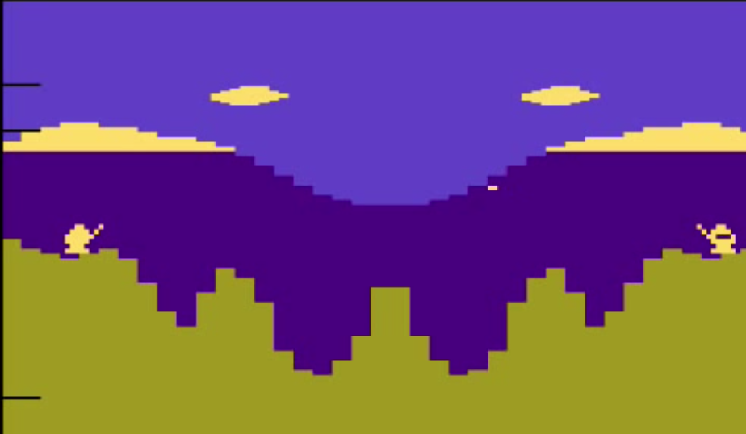

The specifications of the game are as follows:

1. **Game Scene (20 marks):** The background and two players that are standing on two different locations. The location of the players in the game must be randomized every time. Selection of the background image and player character is up to you. **Note:** You are not requested to create any animation for the players (as opposed to what we did in class for Mario).
2. **Turn-based shooting projectiles (30 marks):** When it’s a player’s turn, the player shoots a projectile toward the enemy. The challenge of the game is to find the correct projection parameters to target the other player. The projection parameters must be calculated from the player’s click on the scene. The calculations are up to you.

**Hint:** You may use “applyForce()” function to simulate the projectile.

1. **Damage (10 marks):** If hits,a bullet applies damage with a value that equals to 20% of life of a player.
2. **Player’s health (20 marks):** Display each player’s health on top of the screen
3. **Game Over (20 marks):** Once a player’s health reaches to zero**,** a “Game Over” message is displayed on the screen. When the game is over, none of the players can shoot anymore.

**Submission:**

You are required to submit your work through blackboard.

Write down your name, student ID at the top of this exam book and submit it along with your zipped project folder.