# COSC346 PDFViewer Report

To get start, pen pdfs or notes, use the menu: select 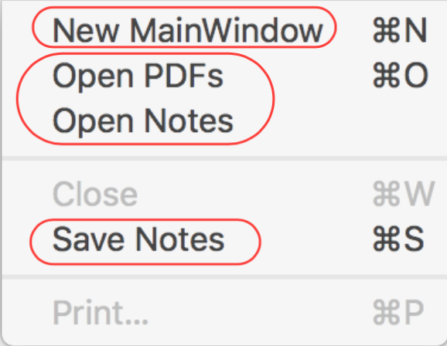.

* This application can only open one MainWindow (shown as below). So if the MainWindow already opened, the MainWIndow select menu will be hidden.
* During the selection of pdfs or notes, you can use multiple selection.
  + When you open a note, the application will automatically to try to open the associated pdf. If it cannot find it. It will pop up an error window to show the details.
  + When you save a note, it will just save notes in the same directory with the pdf. Such as, if the pdf is xxx.pdf. Then the note will be a file named xxx.pdf.note under the same directory with the pdf.
  + When open a pdf, it will also try to load the note at the same time.

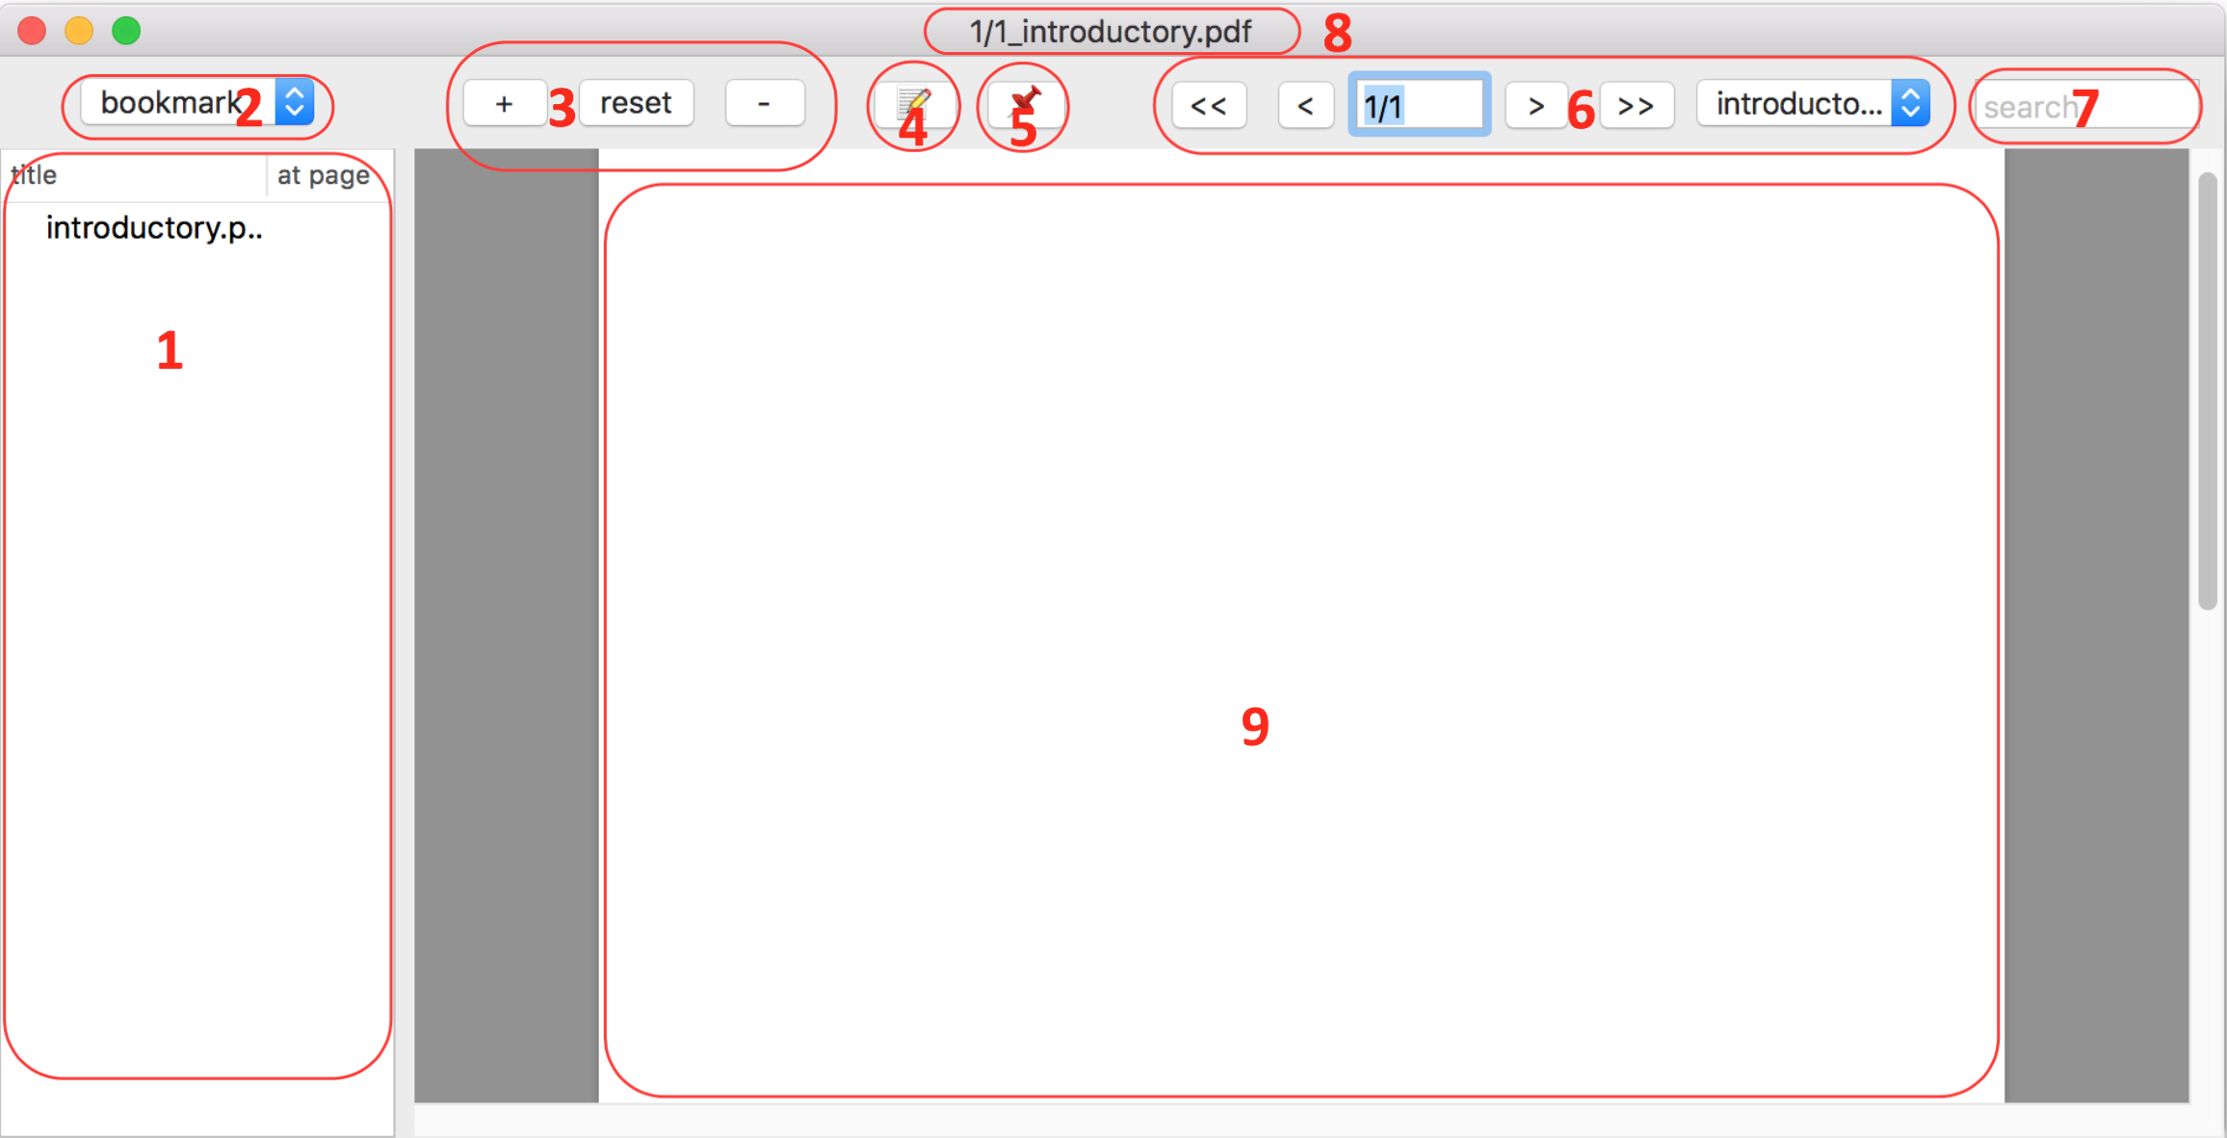

The functionalities I implemented in this application include:

1. Users can navigate between different PDF documents in a set , including moving to the next page, moving to the previous page, and jumping to a given page. Such function is marked **6**.

“<”, “>” means previous, next page.

“<<”, “>>” means previous, next pdf document.

Type a valid number in the range of pages in the text field can move to a given page.

Select a pdf document by using the selection button can move to a given document.

1. Current pdf document info is displayed by window title (**8**) and the text field in **6**.

The window title displays the file name of current pdf, also displays the index of current pdf among the pdf set. The text field shows the current page among total pages of the current pdf.

1. The zoom in, zoom out and reset the pdf display size functions is marked **3**.
2. Because of using auto layout, the application’s controls resize sensibly when its containing window is resized.
3. Users can record brief notes that are related to a particular page of a particular PDF document. This function is marked by **4**.

User can add multiple notes on the same page, as long as the notes have different name.

1. Users can bookmark particular pages within particular PDFs and then later use these bookmarks to jump back to the appropriate page within the given PDF. This function is marked by **5**.

Selecting a bookmark and press “Backspace” will delete the bookmark.

User can only add one bookmark on one page.

1. A “useful” menu structure is implemented. User can use menu button to save PDFs, notes and load notes.
2. An “About” panel is also implemented. User can click the menu button “About” to pop up a window to show the related info.
3. The persistent storage has been implemented by using Archive and Unarchive.
4. User can search the PDF set by input searching String into the “search text field”(**7**). The result will be show in the outline arear(**1**)

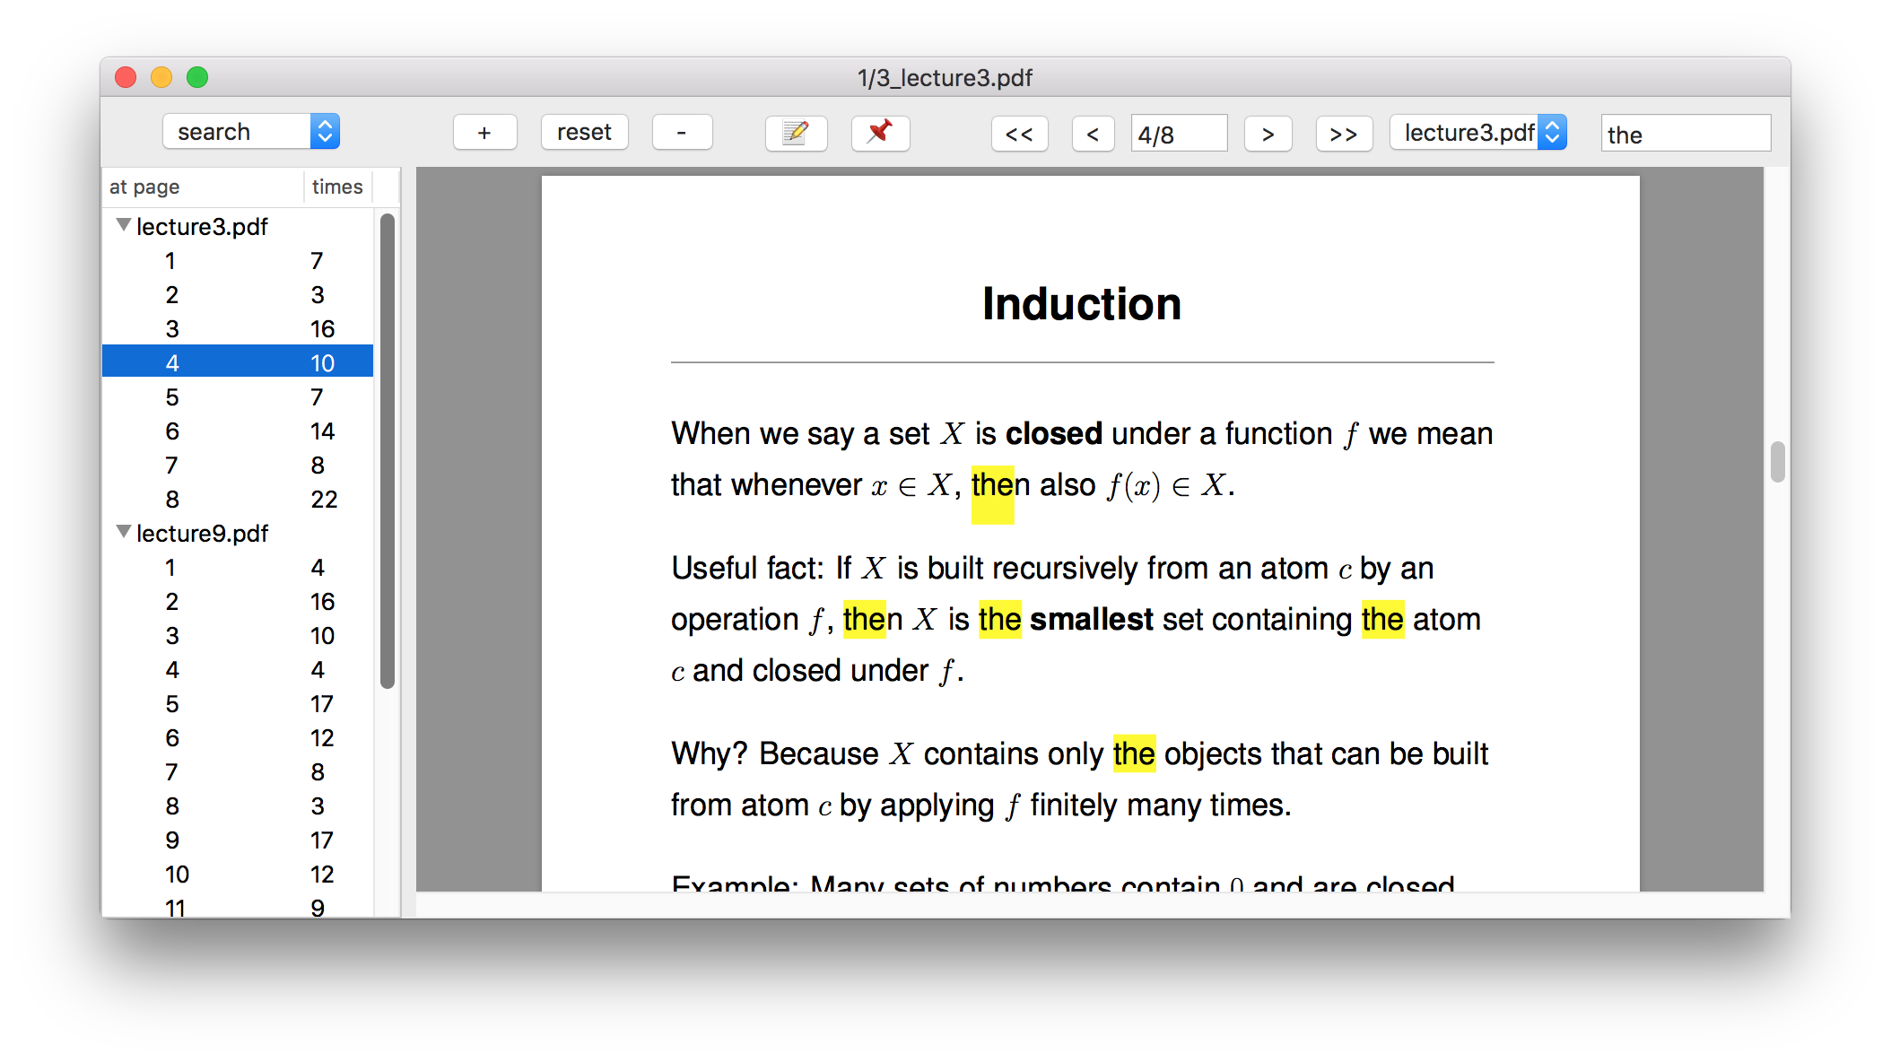

By clicking the outline, it will lead user to the specified page, while highlighting all the matching string on that page. The repeated occurring times in the same page is also shown in column 2