**TELE303 Assignment 1**

[10 Marks]

Answer the following questions.

1. For radio transmission in free space, signal power is reduced in proportion to the square of the distance from the source, whereas in wired transmission, the attenuation is a fixed number of dB per kilometre. [3 marks]
2. Show that by doubling the propagation distance *d*, the attenuation for free-space radio is increased by 6dB.

From SNRdb_0 = 10 Log10(p1/p2) and (p1/p2) = c * (1/d^2) (c is constant)

Then double the distance 2d, we have

New SNRdb_1 = 10 Log10(c*(1/4d^2)) = SNRdb_0 + 10Log10(1/4)

SNRdb_1 = SNRdb_0 + 10*(-0.062)

SNRdb_1 = SNRdb_0 - 6

If it is wired transmission, we have p1/p2 = c*(1/d) (c is constant)

Then double the distance 2d, we have

SNRdb_1 = SNRdb_0 + 10Log10(1/2) = SNRdb_0 - 3

1. Complete the following table:

|  |  |  |
| --- | --- | --- |
| **Distance (km)** | **Radio (dB)** | **Wire (dB)** |
| 1 | ­–6 | –3 |
| 2 | -12 | -6 |
| 4 | -18 | -9 |
| 8 | -24 | -12 |
| 16 | -30 | -15 |

1. Comment on the trend of attenuation results as revealed by the table.

The radio attenuation is worse, is double the attenuation of wired transmission.

1. A standard quality measure for digital communication system performance is *Eb*/*N0*, which is the ratio of signal energy per bit to noise power density per Hertz. The ratio is closely related to SNR:

*Eb*/*N0* = (*S*/*R*) /(*N*/*B*)=*S*/*N* /(*R*/*B*),

where *S* and *N* are the signal power and noise power respectively, *R* is the data rate, and *B* is the bandwidth.

The ratio *R/B*, measured in (bit/s)/Hz, is called “bandwidth efficiency”. The following figure (Figure 7.9, <http://goo.gl/AaaYjB>) gives the relationship between the probability of bit error (BER) and *Eb*/*N0* for a number of encoding schemes.

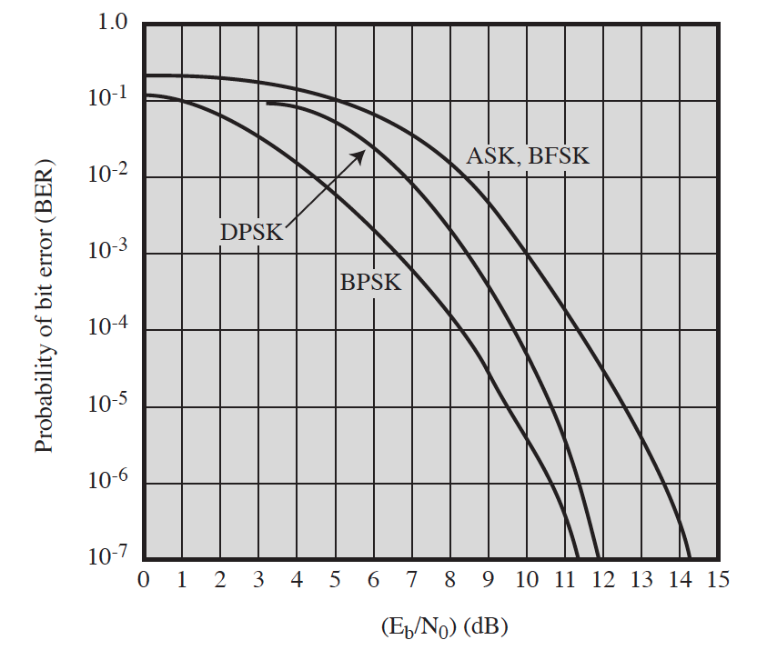

To achieve a bandwidth efficiency of 1.0 for ASK, FSK, and BPSK, and a target BER of 10-6, what SNR ratio is required? [3]

*Tips: For the target BER, measure the necessary Eb*/*N0 from the figure, and work out the SNR using the given formula.*

From BER = 10^-6, get:

For ASK and FSK

Eb/No = 13.5

For BPSK

Eb/No = 10.5

From equation Eb/No = S/N / (R/B)

SNR = 13.5 for ASK and FSK

= 10.5 for BPSK

1. With PCM, quantization of the signal voltage results in a *quantization noise*. Assume *n*-bit quantization is used, it can be proved that the SNR is

SNRdB= 20log10 2*n* + 1.76 dB = 6.02*n* + 1.76 dB

Consider a signal with a spectrum in the range of (400, 4000) Hz. [4]

1. What is the minimum sampling rate needed?

= 2 * 4000 = 8000 (samples/per second)

1. Calculate the SNR if we use 64-level quantization in PCM.

L = 64 , m = log2L = 6 bit, SNRdB = 6.02 * 6 + 1.76 =37.88dB

Then SNR = 6173.62

1. What is the data rate for the PCM signal?

Sampling rate = 8000

Bit rate = 6 * 8000 = 48000 (bps)

1. Bonus problem [1 mark]

Show that the encoded QAM signal *s*(*t*), after going through the demodulation process given on Slide 19, Lecture 4, will reproduce the two signals *d1*(*t*) and *d2*(*t*) (which can be combined to recover the original input signal).

**Submit** a printed *hardcopy* of your solutions to Jeremiah (CO10.13) **by 10:00am Wednesday 23/3**. Show your work.