1 Introduction and Motivation

Finding Words for Intuitions
Predictors、
training、
Type checking allows the reader to sanity 5check whether the equation that they are considering contains inputs and outputs of the correct type, and whether they are mixing different types of objects.
data ：we assume that the data has already been data appropriately converted into a numerical representation。
Models are simplified versions of reality, which capture model aspects of the real world that are relevant to the task。

Let us summarize the main concepts of machine learning:
• We use domain knowledge to represent data as vectors.
• We choose an appropriate model, either using the probabilisitic or optimization view.
• We learn from past data by using numerical optimization methods with the aim that it performs well on unseen data.

Two Ways to Read this Book
Two strategies for understanding the mathematics for machine learning:
• Building up the concepts from foundational to more advanced.
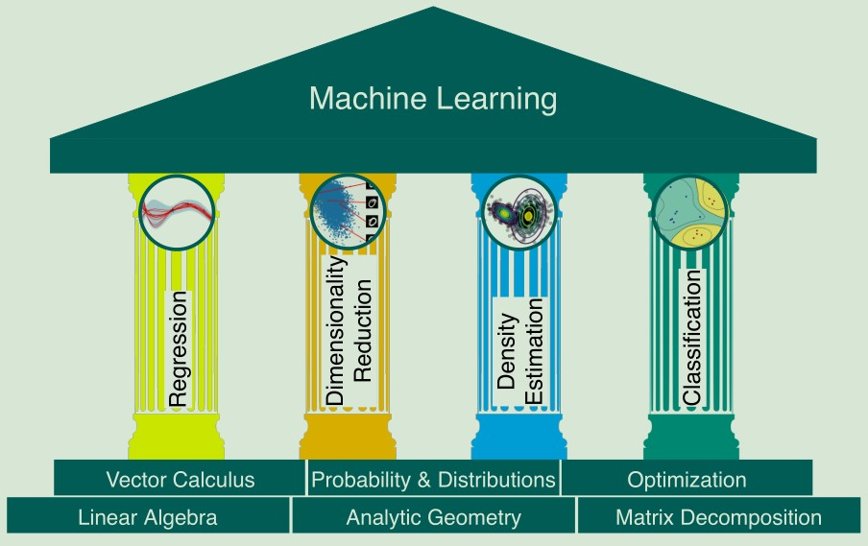
• Drilling down from practical needs to more basic requirements.

Part I is about Mathematics
Chapter 2 linear algebra
Chapter 3 analytic geometry
Chapter 4 matrix decomposition
Chapter 5 calculus
Chapter 6 probability theory
Chapter 7 optimization
Part II is about Machine Learning
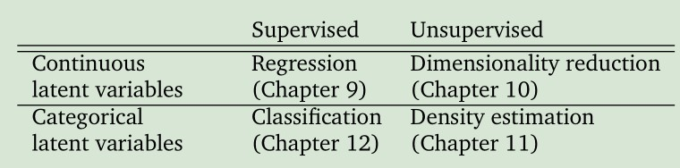
  - Exercises and Feedback

2 Linear Algebra
In general, vectors are special objects that can be added together and multiplied by scalars to produce another object of the same kind. Any object that satisfies these two properties can be considered a vector.
some examples of such vector objects:
Geometric vectors
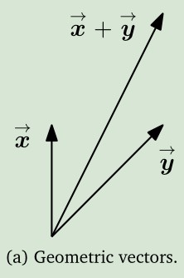
Polynomials are also vectors
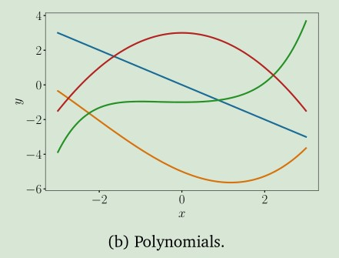
两个重要网站
https://www.youtube.com/playlist?list=PLlXfTHzgMRUKXD88IdzS14F4NxAZudSmv
https://ocw.mit.edu/courses/mathematics/18-06-linear-algebra-spring-2010/video-lectures/

2.1 Systems of Linear Equations
2.2 Matrices
2.2.1 Matrix Addition and Multiplication
2.2.2 Inverse and Transpose
2.2.3 Multiplication by a Scalar
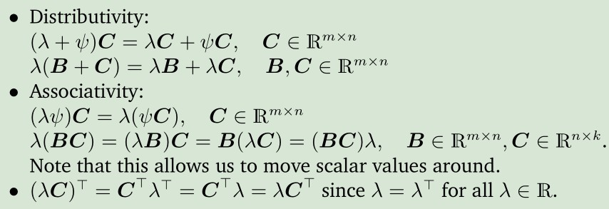
2.2.4 Compact Representations of Systems of Linear Equations
2.3 Solving Systems of Linear Equations
2.3.1 Particular and General Solution
2.3.2 Elementary Transformations
2.3.3 The Minus-1 Trick
2.3.4 Algorithms for Solving a System of Linear Equations
2.4 Vector Spaces
2.4.1 Groups
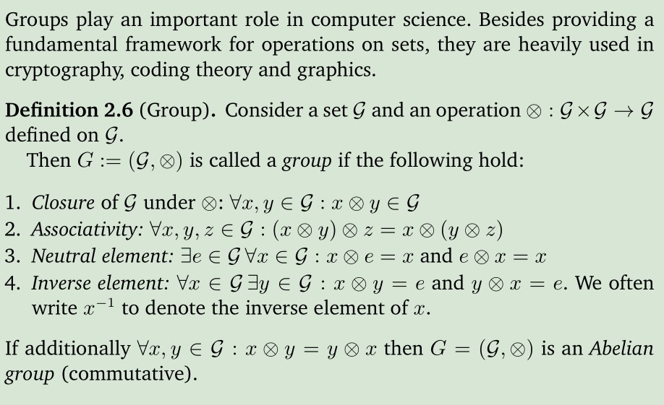
2.4.2 Vector Spaces
2.4.3 Vector Subspaces
2.5 Linear Independence
2.6 Basis and Rank
2.6.1 Generating Set and Basis
2.6.2 Rank
2.7 Linear Mappings
2.7.1 Matrix Representation of Linear Mappings
2.7.2 Basis Change
2.7.3 Image and Kernel
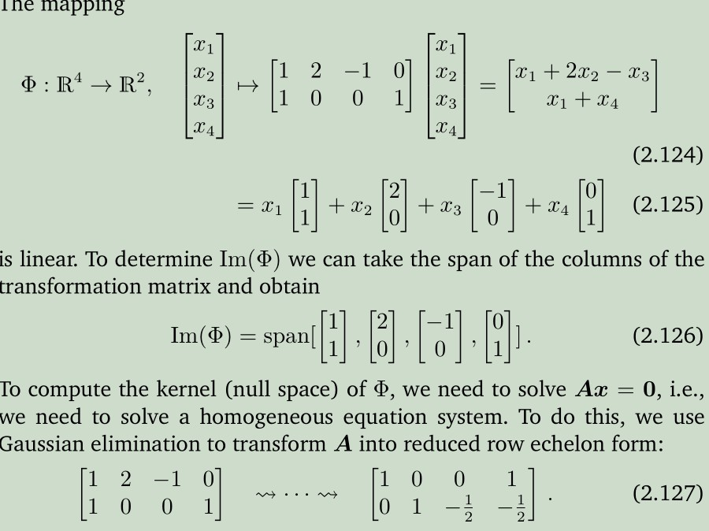
2.8 Affine Spaces
2.8.1 Affine Subspaces
2.8.2 Affine Mappings

3 Analytic Geometry
3.1 Norms
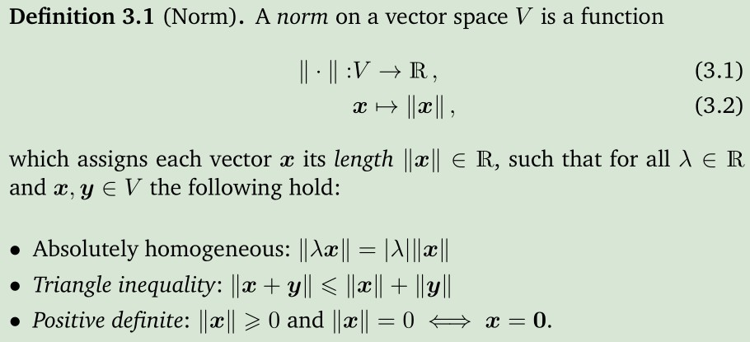
Manhattan Norm
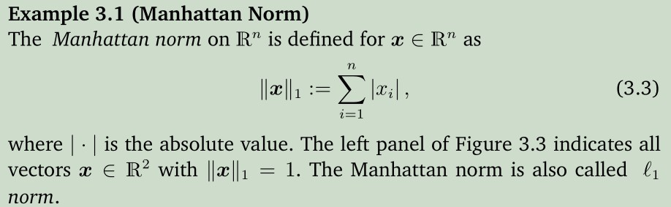
Euclidean Norm
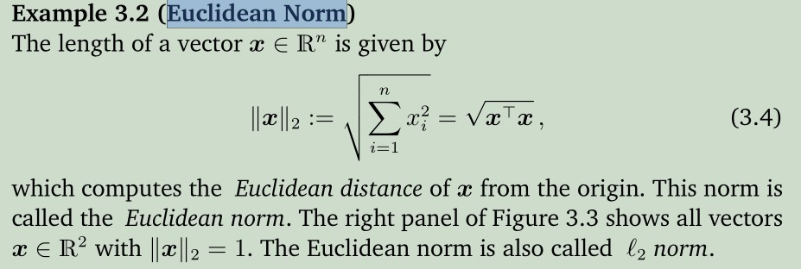
3.2 Inner Products
3.2.1 Dot Product
3.2.2 General Inner Products
3.2.3 Symmetric, Positive Definite Matrices
3.3 Lengths and Distances
3.4 Angles and Orthogonality
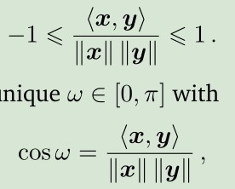
3.5 Orthonormal Basis
3.6 Inner Product of Functions
3.7 Orthogonal Projections
3.8 Rotations *******

4 Matrix Decompositions
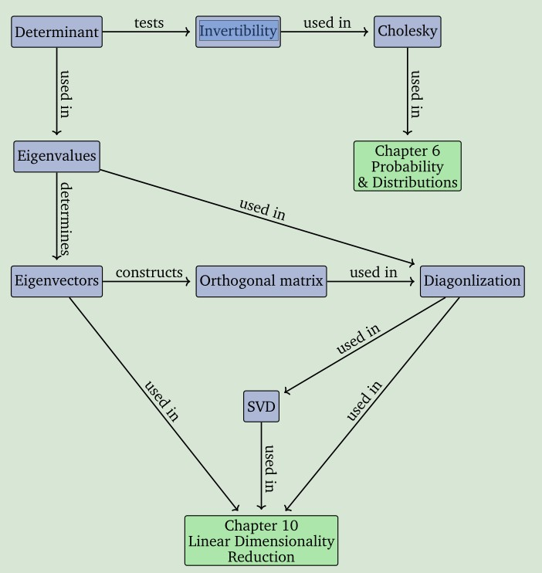

4.1 Determinant and Trace
4.2 Eigenvalues and Eigenvectors
4.3 Cholesky Decomposition
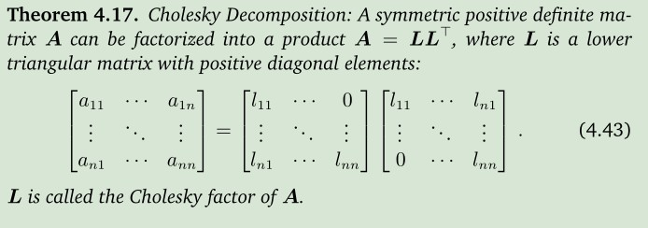
4.4 Eigendecomposition and Diagonalization
4.5 Singular Value Decomposition
4.6 Matrix Approximation
4.7 Matrix Phylogeny

Vector Calculus
5.1 Differentiation of Univariate Functions
5.1.1 Taylor Series
5.1.2 Differentiation Rules
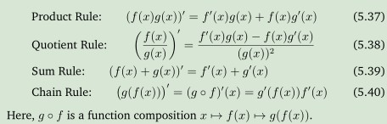
5.2 Partial Differentiation and Gradients
5.2.1 Basic Rules of Partial Differentiation
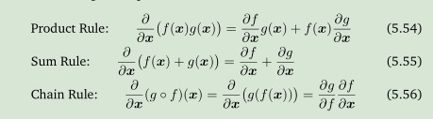
5.2.2 Chain Rule
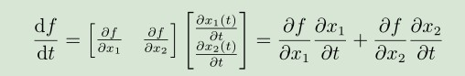

5.3 Gradients of Vector-Valued Functions
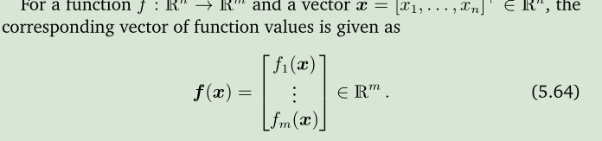
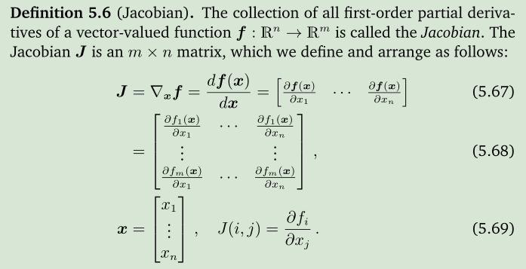
5.4 Gradients of Matrices
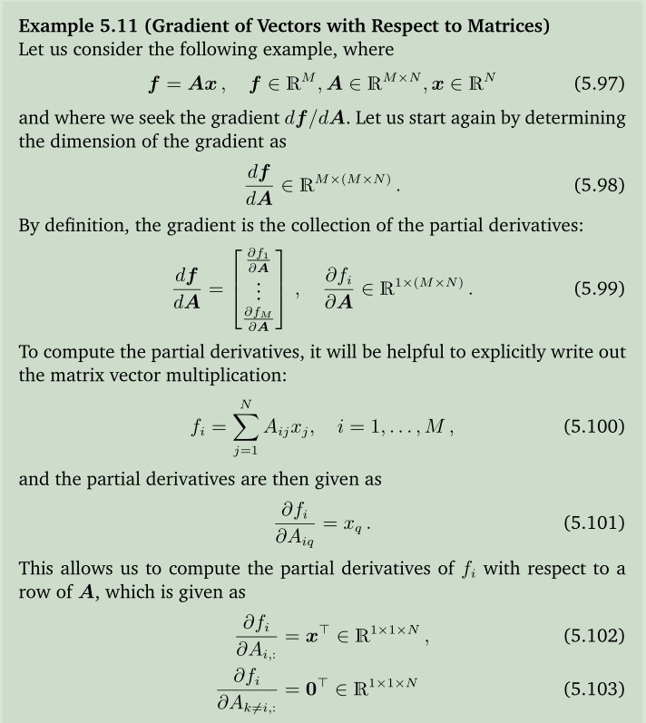
5.5 Useful Identities for Computing Gradients
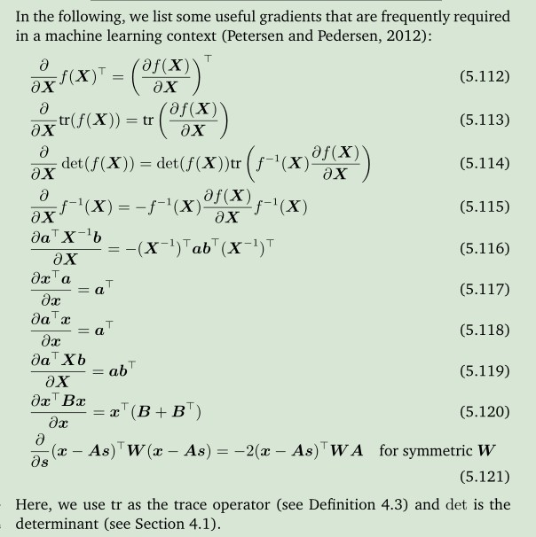
5.6 Backpropagation and Automatic Differentiation
5.6.1 Gradients in a Deep Network
5.6.2 Automatic Differentiation
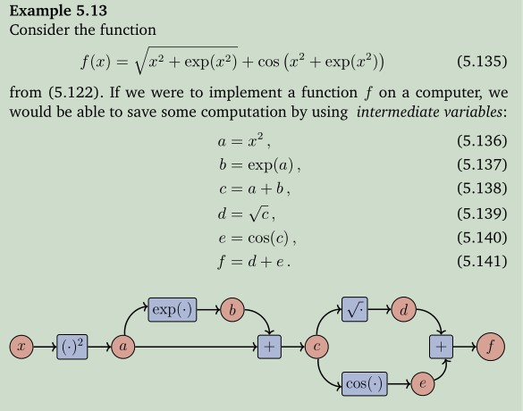
5.7 Higher-order Derivatives
5.8 Linearization and Multivariate Taylor Series

6 Probability and Distributions
6.1 Construction of a Probability Space
6.1.1 Philosophical Issues
6.1.2 Probability and Random Variables

