武汉纺织大学

Java应用开发课程设计

**基于MyBatis的超市收银系统**

**学 院： 数学与计算机学院**

**班 级： 物联网11802**

**姓 名： 周围顺**

**学 号： 1804240910**

**指导老师： 聂刚**

**成 绩：**

**完成日期： 2020年5月22日**

目 录

1 需求分析 1

1.1用户登陆 1

1.2菜单界面 1

1.3各项功能（学生） 1

1.3.1 查课程信息 1

1.3.2 选课 1

1.3.3 成绩查询 2

1.3.4 修改密码 2

1.4各项功能（老师） 1

1.4.1 查看自己担任的课程信息 1

1.4.2 查看课程的选课名单 1

1.4.3 名单导出 2

1.4.4 输入课程的成绩 2

1.4.5 成绩导出 2

1.4.6 个人信息维护 2

1.5各项功能（管理员） 1

1.4.1 用户管理 1

1.4.2 课程管理 1

2 系统设计 3

2.1用户用例图 3

2.2 ER图 4

2.3 UML类图（Class Diagram） 4

2.4 UML时序图（Sequence Diagram） 6

2.4.1 系统登录 6

2.5 UML活动图（Activity Diagram） 6

3 系统实现 8

3.1 项目结构 8

3.2 配置文件 8

3.2.1 log4j.properties文件 8

3.2.2 mybatis-config.xml文件 9

3.3 VO类 9

3.4 DAO接口类 10

3.5 接口映射文件 10

3.6 工具包Util 10

3.7 服务层 12

3.8 用户界面Drvier.java 13

4 系统测试 13

5 系统总结 13

# 1 需求分析

设计一个学生管理系统，分为三个角色，学生，老师和管理员，三种角色对应各自的菜单，学生实现登录，登陆、查看所有课程、选课、成绩查询、修改密码的功能，老师实现登陆、查看自己担任的课程信息，查看课程的选课名单、名单导出、输入课程的成绩、成绩导出、个人信息维护这些功能，其中名单导出和成绩导出又分为导出到TXT和XML,管理员实现用户管理、课程管理两个大功能，然后又分为两个子菜单，用户管理菜单和课程管理菜单。进行对应的增删改查，但是进行DML操作的对象只能是老师或者学生，管理员有系统需要自己分配，不能进行增删改查。

## 1.1用户登陆



当程序运行时，显示“欢迎进入学生管理系统”，提示用户依次输入用户名及其密码，当用户名及密码不正确时，显示提示信息“用户名或密码不正确，请重新输入”，**用户最多可以尝试3次，若输入3次均不正确，则给出提示信息“最多只能尝试3次”**，退出系统；

## 1.2主菜单（学生，老师，管理员）

当用户名及密码正确时，进入系统主界面，如下：

当身份为学生时:

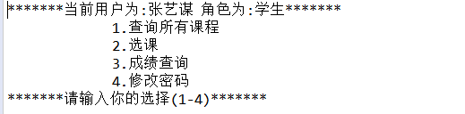

如果输入1-4以外的选择，则显示提示信息“输入无效,请重新输入”后，然后返回主界面。

当身份为老师时:

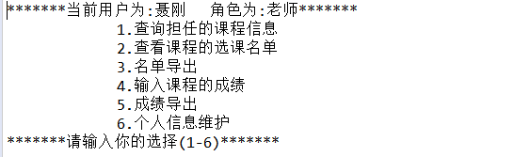

如果输入1-6以外的选择，则显示提示信息“输入无效,请重新输入”后，然后返回主界面。

当身份为管理员时:

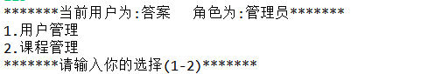

如果输入1-2以外的选择，则显示提示信息“输入无效,请重新输入”后，然后返回主界面。

## 1.3各项功能(学生)

### 1.3.1 查询所有的课程

当选择1时，显示学校所有的课程信息：

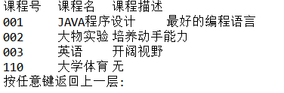

然后按任意键返回主菜单。

### 1.3.2 选课

当选择2时，输入要选的课程号（作为课程表的主键），如果输入的课程号不存在会显示:

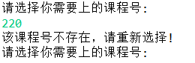

当选择的课程号正确但是已选择该课程时，会显示:

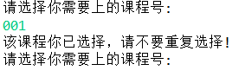

当课程号存在且没有选择时，才会成功选择该课程，并添加到选课表中去。



无论是课程号不对还是已选择该课程都会退出选课界面，进入主菜单界面，需要重新选择选课选项进入。

然后选成功后会问是否继续选课，Y会继续停留在选课界面，N会返回主菜单。

### 1.3.3 成绩查询

当选择3时，会显示该学生所有课程的成绩情况，初始情况成绩为0，由对应的老师进行给分。



然后按任意字母返回主菜单。

### 1.3.4 修改密码

当选择4时，显示“请输入当前用户的原密码：”，若原密码不正确，则提示“原密码输入不正确，请重新输入”，输入正确后，显示“请设置新的密码：”，输入的密码必须满足必要的复杂性，如果不符合要求，则提示“您的密码不符合复杂性要求（密码长度不少于6个字符，至少有一个小写字母，至少有一个大写字母，至少一个数字），请重新输入：”，输入成功后输入成功后，修改数据库中的用户表，并提示“您已成功修改密码，请谨记”。返回主界面。

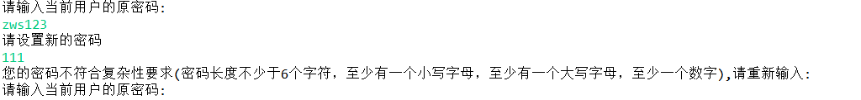

## 1.4各项功能(老师)

### 1.4.1 查询自己担任的课程情况（担任课程门数，对应课程的学生人数）

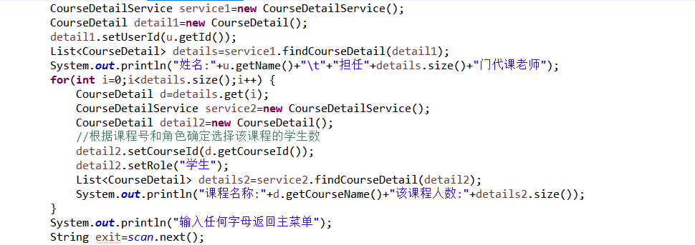



然后按任意键返回主菜单。

### 1.4.2 查询课程选课的学生名单

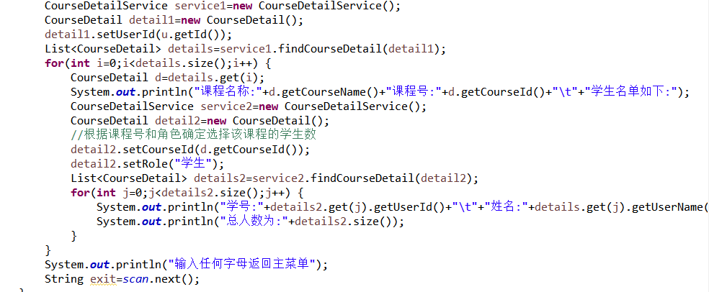

利用嵌套循环遍历显示该老师对应教的所有课程的学生名单，显示学生的学号和姓名。然后按任意键返回主菜单。

### 1.4.3 名单导出

当选择为3是会进入一个子菜单。

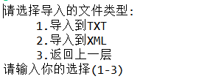

需要选择想导入的文件类型，这边暂时只设置了txt和xml两种类型的文件格式，然后选择3会返回主菜单。导入成功会有提示导入成功。

### 1.4.4 输入课程成绩:

当选择为4时，会先提示你需要给成绩的课程名和课程号，输入正确后会提示你输入学生的学号和姓名，如果没有这条学生的信息，会提示，姓名或学号不存在，没有该学生的信息。

学号错误或者该学生没有选择这门课程都会录入失败。录入成功会显示录入完毕。

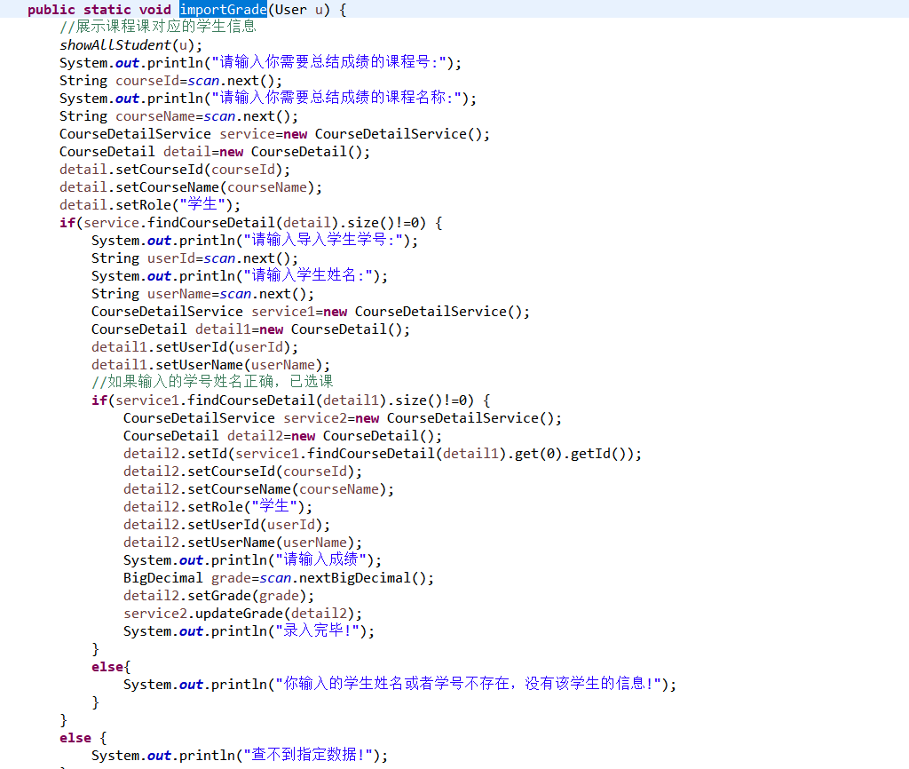

### 1.4.5 成绩导出:

当选择5时，和导出名单一样，会显示一个和他一样的子菜单，需要选择想导入的文件类型，这边暂时只设置了txt和xml两种类型的文件格式，然后选择3会返回主菜单。导入成功会有提示导入成功。

### 1.4.6 个人信息维护:

当选择为6时，会进入个人信息维护的界面：



选择需要修改的字段名，老师没有权利修改学号，只有管理员有资格，老师有资格修改姓名，性别和密码，同时姓名利用了正则，只能是两个或三个汉字，而密码也是设置了如上的复杂度，不满足都会提示修改错误，输入返回会返回主菜单。

## 1.5各项功能(管理员)

### 1.5.1 用户管理:

当选择为1时会进入用户管理菜单:

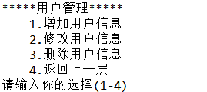

输入1-3会对用户所有的字段进行增删改。但是操作的对象只能是老师或者学生，无法修改管理员的信息，管理员由自己分配，不能对他进行修改操作。具体实现就不在此处列举，详情请看代码的具体实现。

当选择为2时会进入课程管理菜单:

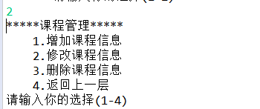

具体功能和上面的一致。

# **2 系统设计**

## 2.1用户用例图

系统分为学生，老师，管理员这三种角色，各角色的功能如下:

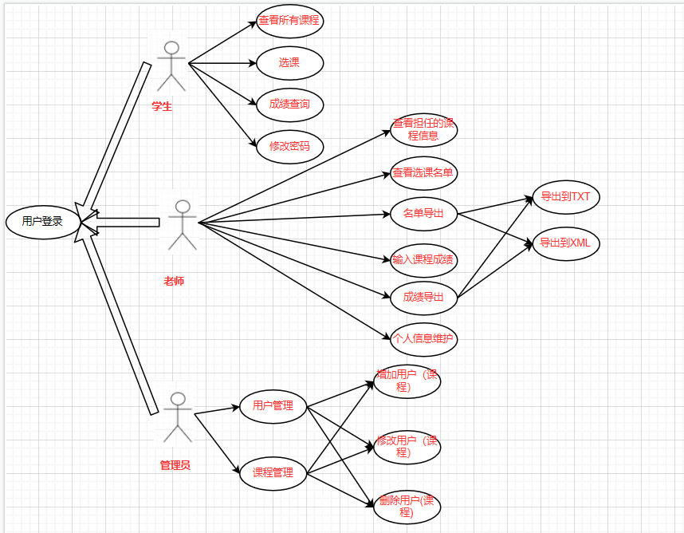

图2-1 用户用例图

## 2.2 ER图

数据库设计3张表，用户表，课程表，选课表，用户表存放所有的用户信息，包括学生，老师和管理员，课程表存放所有存在的课程信息，选课表存放老师带的课和学生的选课情况，对应的ER图如图3-1所示。

%3CmxGraphModel%3E%3Croot%3E%3CmxCell%20id%3D%220%22%2F%3E%3CmxCell%20id%3D%221%22%20parent%3D%220%22%2F%3E%3Cmysql.table%20entity.table.tableName%3D%22uses%22%20label%3D%22uses%22%20id%3D%222%22%3E%3CmxCell%20style%3D%22swimlane%3BfontStyle%3D0%3BchildLayout%3DstackLayout%3Bhorizontal%3D1%3Bhtml%3D1%3BstartSize%3D26%3BfillColor%3D%23b0e3e6%3BhorizontalStack%3D0%3BresizeParent%3D1%3BresizeParentMax%3D0%3BresizeLast%3D0%3Bcollapsible%3D1%3BmarginBottom%3D0%3BswimlaneFillColor%3D%23ffffff%3Balign%3Dcenter%3BfontSize%3D13%3BstrokeColor%3D%230e8088%3Brounded%3D0%3Bshadow%3D1%3Bcomic%3D0%3Bglass%3D0%3BgradientDirection%3Dsouth%3BgradientColor%3D%23ffffff%3B%22%20vertex%3D%221%22%20connectable%3D%220%22%20parent%3D%221%22%3E%3CmxGeometry%20x%3D%2260%22%20y%3D%2250%22%20width%3D%22310%22%20height%3D%22130%22%20as%3D%22geometry%22%2F%3E%3C%2FmxCell%3E%3C%2Fmysql.table%3E%3Cmysql.column%20entity.column.tableName%3D%22uses%22%20entity.column.name%3D%22userName%22%20entity.column.dataType%3D%22VARCHAR%22%20entity.column.PK%3D%22true%22%20label%3D%22%26lt%3Bimg%20title%3D%26quot%3BPrimary%20Key%26quot%3B%20src%3D%26quot%3Bimg%2Fdb%2Fkey1.png%26quot%3B%20width%3D%26quot%3B16%26quot%3B%20height%3D%26quot%3B16%26quot%3B%20align%3D%26quot%3Btop%26quot%3B%26gt%3B%26amp%3Bnbsp%3B%26lt%3Bfont%20size%3D%26quot%3B1%26quot%3B%20face%3D%26quot%3BTahoma%26quot%3B%26gt%3B%26lt%3Bspan%20style%3D%26quot%3Bfont-size%3A%2013px%26quot%3B%26gt%3B%26lt%3Bb%26gt%3Bid%20int%20primary%20key%26lt%3B%2Fb%26gt%3B%26lt%3B%2Fspan%26gt%3B%26lt%3B%2Ffont%26gt%3B%22%20entity.column.oldName%3D%22id%22%20entity.column.datalen%3D%2220%22%20entity.column.decimals%3D%22%22%20entity.column.autoIncreament%3D%22%22%20entity.column.unsigned%3D%22%22%20entity.column.bin%3D%22%22%20entity.column.ascii%3D%22%22%20entity.column.unicode%3D%22%22%20entity.column.unique%3D%22%22%20entity.column.isNotNull%3D%22NOT%20NULL%22%20entity.column.defaultValue%3D%22%22%20entity.column.comment%3D%22%22%20entity.column.enum%3D%22%22%20entity.column.set%3D%22%22%20entity.column.enumSetValue%3D%22%22%20id%3D%223%22%3E%3CmxCell%20style%3D%22text%3Bhtml%3D1%3BstrokeColor%3Dnone%3BfillColor%3Dnone%3BspacingLeft%3D4%3BspacingRight%3D4%3Boverflow%3Dhidden%3Brotatable%3D0%3BportConstraint%3Deastwest%3BfontSize%3D12%3BverticalAlign%3Dmiddle%3B%22%20vertex%3D%221%22%20parent%3D%222%22%3E%3CmxGeometry%20y%3D%2226%22%20width%3D%22310%22%20height%3D%2226%22%20as%3D%22geometry%22%2F%3E%3C%2FmxCell%3E%3C%2Fmysql.column%3E%3Cmysql.column%20entity.column.tableName%3D%22uses%22%20entity.column.name%3D%22chrName%22%20entity.column.datalen%3D%2220%22%20entity.column.dataType%3D%22VARCHAR%22%20label%3D%22%26lt%3Bimg%20title%3D%26quot%3BPrimary%20Key%26quot%3B%20src%3D%26quot%3Bimages%2Fspacer.gif%26quot%3B%20width%3D%26quot%3B16%26quot%3B%20height%3D%26quot%3B16%26quot%3B%20align%3D%26quot%3Btop%26quot%3B%26gt%3B%26amp%3Bnbsp%3B%26lt%3Bfont%20size%3D%26quot%3B1%26quot%3B%20face%3D%26quot%3BTahoma%26quot%3B%26gt%3B%26lt%3Bspan%20style%3D%26quot%3Bfont-size%3A%2013px%26quot%3B%26gt%3B%26lt%3Bb%26gt%3Bname%20varchar(10)%26lt%3B%2Fb%26gt%3B%26lt%3B%2Fspan%26gt%3B%26lt%3B%2Ffont%26gt%3B%22%20entity.column.oldName%3D%22name%22%20entity.column.decimals%3D%22%22%20entity.column.autoIncreament%3D%22%22%20entity.column.unsigned%3D%22%22%20entity.column.bin%3D%22%22%20entity.column.ascii%3D%22%22%20entity.column.unicode%3D%22%22%20entity.column.PK%3D%22false%22%20entity.column.unique%3D%22%22%20entity.column.isNotNull%3D%22%22%20entity.column.defaultValue%3D%22%22%20entity.column.comment%3D%22%22%20entity.column.enum%3D%22%22%20entity.column.set%3D%22%22%20entity.column.enumSetValue%3D%22%22%20id%3D%224%22%3E%3CmxCell%20style%3D%22text%3Bhtml%3D1%3BstrokeColor%3Dnone%3BfillColor%3Dnone%3BspacingLeft%3D4%3BspacingRight%3D4%3Boverflow%3Dhidden%3Brotatable%3D0%3BportConstraint%3Deastwest%3BfontSize%3D12%3BverticalAlign%3Dmiddle%3B%22%20vertex%3D%221%22%20parent%3D%222%22%3E%3CmxGeometry%20y%3D%2252%22%20width%3D%22310%22%20height%3D%2226%22%20as%3D%22geometry%22%2F%3E%3C%2FmxCell%3E%3C%2Fmysql.column%3E%3Cmysql.column%20entity.column.tableName%3D%22uses%22%20entity.column.name%3D%22password%22%20entity.column.datalen%3D%2250%22%20entity.column.dataType%3D%22VARCHAR%22%20label%3D%22%26lt%3Bimg%20title%3D%26quot%3BPrimary%20Key%26quot%3B%20src%3D%26quot%3Bimages%2Fspacer.gif%26quot%3B%20width%3D%26quot%3B16%26quot%3B%20height%3D%26quot%3B16%26quot%3B%20align%3D%26quot%3Btop%26quot%3B%26gt%3B%26amp%3Bnbsp%3B%26lt%3Bfont%20size%3D%26quot%3B1%26quot%3B%20face%3D%26quot%3BTahoma%26quot%3B%26gt%3B%26lt%3Bspan%20style%3D%26quot%3Bfont-size%3A%2013px%26quot%3B%26gt%3B%26lt%3Bb%26gt%3Bname%20varchar(10)%26lt%3B%2Fb%26gt%3B%26lt%3B%2Fspan%26gt%3B%26lt%3B%2Ffont%26gt%3B%22%20entity.column.oldName%3D%22chrName%22%20entity.column.decimals%3D%22%22%20entity.column.autoIncreament%3D%22%22%20entity.column.unsigned%3D%22%22%20entity.column.bin%3D%22%22%20entity.column.ascii%3D%22%22%20entity.column.unicode%3D%22%22%20entity.column.PK%3D%22false%22%20entity.column.unique%3D%22%22%20entity.column.isNotNull%3D%22%22%20entity.column.defaultValue%3D%22%22%20entity.column.comment%3D%22%E5%AF%86%E7%A0%81%22%20entity.column.enum%3D%22%22%20entity.column.set%3D%22%22%20entity.column.enumSetValue%3D%22%22%20id%3D%225%22%3E%3CmxCell%20style%3D%22text%3Bhtml%3D1%3BstrokeColor%3Dnone%3BfillColor%3Dnone%3BspacingLeft%3D4%3BspacingRight%3D4%3Boverflow%3Dhidden%3Brotatable%3D0%3BportConstraint%3Deastwest%3BfontSize%3D12%3BverticalAlign%3Dmiddle%3B%22%20vertex%3D%221%22%20parent%3D%222%22%3E%3CmxGeometry%20y%3D%2278%22%20width%3D%22310%22%20height%3D%2226%22%20as%3D%22geometry%22%2F%3E%3C%2FmxCell%3E%3C%2Fmysql.column%3E%3Cmysql.column%20entity.column.tableName%3D%22uses%22%20entity.column.name%3D%22role%22%20entity.column.datalen%3D%2220%22%20entity.column.dataType%3D%22VARCHAR%22%20label%3D%22%26lt%3Bimg%20title%3D%26quot%3BPrimary%20Key%26quot%3B%20src%3D%26quot%3Bimages%2Fspacer.gif%26quot%3B%20width%3D%26quot%3B16%26quot%3B%20height%3D%26quot%3B16%26quot%3B%20align%3D%26quot%3Btop%26quot%3B%26gt%3B%26amp%3Bnbsp%3B%26lt%3Bfont%20size%3D%26quot%3B1%26quot%3B%20face%3D%26quot%3BTahoma%26quot%3B%26gt%3B%26lt%3Bspan%20style%3D%26quot%3Bfont-size%3A%2013px%26quot%3B%26gt%3B%26lt%3Bb%26gt%3Bname%20varchar(10)%26lt%3B%2Fb%26gt%3B%26lt%3B%2Fspan%26gt%3B%26lt%3B%2Ffont%26gt%3B%22%20entity.column.oldName%3D%22chrName%22%20entity.column.decimals%3D%22%22%20entity.column.autoIncreament%3D%22%22%20entity.column.unsigned%3D%22%22%20entity.column.bin%3D%22%22%20entity.column.ascii%3D%22%22%20entity.column.unicode%3D%22%22%20entity.column.PK%3D%22false%22%20entity.column.unique%3D%22%22%20entity.column.isNotNull%3D%22%22%20entity.column.defaultValue%3D%22%22%20entity.column.comment%3D%22%E8%A7%92%E8%89%B2%22%20entity.column.enum%3D%22%22%20entity.column.set%3D%22%22%20entity.column.enumSetValue%3D%22%22%20id%3D%226%22%3E%3CmxCell%20style%3D%22text%3Bhtml%3D1%3BstrokeColor%3Dnone%3BfillColor%3Dnone%3BspacingLeft%3D4%3BspacingRight%3D4%3Boverflow%3Dhidden%3Brotatable%3D0%3BportConstraint%3Deastwest%3BfontSize%3D12%3BverticalAlign%3Dmiddle%3B%22%20vertex%3D%221%22%20parent%3D%222%22%3E%3CmxGeometry%20y%3D%22104%22%20width%3D%22310%22%20height%3D%2226%22%20as%3D%22geometry%22%2F%3E%3C%2FmxCell%3E%3C%2Fmysql.column%3E%3Cmysql.table%20entity.table.tableName%3D%22product%22%20label%3D%22product%22%20id%3D%227%22%3E%3CmxCell%20style%3D%22swimlane%3BfontStyle%3D0%3BchildLayout%3DstackLayout%3Bhorizontal%3D1%3Bhtml%3D1%3BstartSize%3D26%3BfillColor%3D%23b0e3e6%3BhorizontalStack%3D0%3BresizeParent%3D1%3BresizeParentMax%3D0%3BresizeLast%3D0%3Bcollapsible%3D1%3BmarginBottom%3D0%3BswimlaneFillColor%3D%23ffffff%3Balign%3Dcenter%3BfontSize%3D13%3BstrokeColor%3D%230e8088%3Brounded%3D0%3Bshadow%3D1%3Bcomic%3D0%3Bglass%3D0%3BgradientDirection%3Dsouth%3BgradientColor%3D%23ffffff%3B%22%20vertex%3D%221%22%20connectable%3D%220%22%20parent%3D%221%22%3E%3CmxGeometry%20x%3D%2260%22%20y%3D%22210%22%20width%3D%22310%22%20height%3D%22130%22%20as%3D%22geometry%22%2F%3E%3C%2FmxCell%3E%3C%2Fmysql.table%3E%3Cmysql.column%20entity.column.tableName%3D%22product%22%20entity.column.name%3D%22barcode%22%20entity.column.dataType%3D%22VARCHAR%22%20entity.column.PK%3D%22true%22%20label%3D%22%26lt%3Bimg%20title%3D%26quot%3BPrimary%20Key%26quot%3B%20src%3D%26quot%3Bimg%2Fdb%2Fkey1.png%26quot%3B%20width%3D%26quot%3B16%26quot%3B%20height%3D%26quot%3B16%26quot%3B%20align%3D%26quot%3Btop%26quot%3B%26gt%3B%26amp%3Bnbsp%3B%26lt%3Bfont%20size%3D%26quot%3B1%26quot%3B%20face%3D%26quot%3BTahoma%26quot%3B%26gt%3B%26lt%3Bspan%20style%3D%26quot%3Bfont-size%3A%2013px%26quot%3B%26gt%3B%26lt%3Bb%26gt%3Bid%20int%20primary%20key%26lt%3B%2Fb%26gt%3B%26lt%3B%2Fspan%26gt%3B%26lt%3B%2Ffont%26gt%3B%22%20entity.column.oldName%3D%22id%22%20entity.column.datalen%3D%2210%22%20entity.column.decimals%3D%22%22%20entity.column.autoIncreament%3D%22%22%20entity.column.unsigned%3D%22%22%20entity.column.bin%3D%22%22%20entity.column.ascii%3D%22%22%20entity.column.unicode%3D%22%22%20entity.column.unique%3D%22%22%20entity.column.isNotNull%3D%22NOT%20NULL%22%20entity.column.defaultValue%3D%22%22%20entity.column.comment%3D%22%22%20entity.column.enum%3D%22%22%20entity.column.set%3D%22%22%20entity.column.enumSetValue%3D%22%22%20id%3D%228%22%3E%3CmxCell%20style%3D%22text%3Bhtml%3D1%3BstrokeColor%3Dnone%3BfillColor%3Dnone%3BspacingLeft%3D4%3BspacingRight%3D4%3Boverflow%3Dhidden%3Brotatable%3D0%3BportConstraint%3Deastwest%3BfontSize%3D12%3BverticalAlign%3Dmiddle%3B%22%20vertex%3D%221%22%20parent%3D%227%22%3E%3CmxGeometry%20y%3D%2226%22%20width%3D%22310%22%20height%3D%2226%22%20as%3D%22geometry%22%2F%3E%3C%2FmxCell%3E%3C%2Fmysql.column%3E%3Cmysql.column%20entity.column.tableName%3D%22product%22%20entity.column.name%3D%22productName%22%20entity.column.datalen%3D%2250%22%20entity.column.dataType%3D%22VARCHAR%22%20label%3D%22%26lt%3Bimg%20title%3D%26quot%3BPrimary%20Key%26quot%3B%20src%3D%26quot%3Bimages%2Fspacer.gif%26quot%3B%20width%3D%26quot%3B16%26quot%3B%20height%3D%26quot%3B16%26quot%3B%20align%3D%26quot%3Btop%26quot%3B%26gt%3B%26amp%3Bnbsp%3B%26lt%3Bfont%20size%3D%26quot%3B1%26quot%3B%20face%3D%26quot%3BTahoma%26quot%3B%26gt%3B%26lt%3Bspan%20style%3D%26quot%3Bfont-size%3A%2013px%26quot%3B%26gt%3B%26lt%3Bb%26gt%3Bname%20varchar(10)%26lt%3B%2Fb%26gt%3B%26lt%3B%2Fspan%26gt%3B%26lt%3B%2Ffont%26gt%3B%22%20entity.column.oldName%3D%22name%22%20entity.column.decimals%3D%22%22%20entity.column.autoIncreament%3D%22%22%20entity.column.unsigned%3D%22%22%20entity.column.bin%3D%22%22%20entity.column.ascii%3D%22%22%20entity.column.unicode%3D%22%22%20entity.column.PK%3D%22false%22%20entity.column.unique%3D%22%22%20entity.column.isNotNull%3D%22%22%20entity.column.defaultValue%3D%22%22%20entity.column.comment%3D%22%22%20entity.column.enum%3D%22%22%20entity.column.set%3D%22%22%20entity.column.enumSetValue%3D%22%22%20id%3D%229%22%3E%3CmxCell%20style%3D%22text%3Bhtml%3D1%3BstrokeColor%3Dnone%3BfillColor%3Dnone%3BspacingLeft%3D4%3BspacingRight%3D4%3Boverflow%3Dhidden%3Brotatable%3D0%3BportConstraint%3Deastwest%3BfontSize%3D12%3BverticalAlign%3Dmiddle%3B%22%20vertex%3D%221%22%20parent%3D%227%22%3E%3CmxGeometry%20y%3D%2252%22%20width%3D%22310%22%20height%3D%2226%22%20as%3D%22geometry%22%2F%3E%3C%2FmxCell%3E%3C%2Fmysql.column%3E%3Cmysql.column%20entity.column.tableName%3D%22product%22%20entity.column.name%3D%22price%22%20entity.column.datalen%3D%229%22%20entity.column.dataType%3D%22DECIMAL%22%20label%3D%22%26lt%3Bimg%20title%3D%26quot%3BPrimary%20Key%26quot%3B%20src%3D%26quot%3Bimages%2Fspacer.gif%26quot%3B%20width%3D%26quot%3B16%26quot%3B%20height%3D%26quot%3B16%26quot%3B%20align%3D%26quot%3Btop%26quot%3B%26gt%3B%26amp%3Bnbsp%3B%26lt%3Bfont%20size%3D%26quot%3B1%26quot%3B%20face%3D%26quot%3BTahoma%26quot%3B%26gt%3B%26lt%3Bspan%20style%3D%26quot%3Bfont-size%3A%2013px%26quot%3B%26gt%3B%26lt%3Bb%26gt%3Bname%20varchar(10)%26lt%3B%2Fb%26gt%3B%26lt%3B%2Fspan%26gt%3B%26lt%3B%2Ffont%26gt%3B%22%20entity.column.oldName%3D%22price%22%20entity.column.decimals%3D%222%22%20entity.column.autoIncreament%3D%22%22%20entity.column.unsigned%3D%22%22%20entity.column.bin%3D%22%22%20entity.column.ascii%3D%22%22%20entity.column.unicode%3D%22%22%20entity.column.PK%3D%22false%22%20entity.column.unique%3D%22%22%20entity.column.isNotNull%3D%22%22%20entity.column.defaultValue%3D%22%22%20entity.column.comment%3D%22%22%20entity.column.enum%3D%22%22%20entity.column.set%3D%22%22%20entity.column.enumSetValue%3D%22%22%20id%3D%2210%22%3E%3CmxCell%20style%3D%22text%3Bhtml%3D1%3BstrokeColor%3Dnone%3BfillColor%3Dnone%3BspacingLeft%3D4%3BspacingRight%3D4%3Boverflow%3Dhidden%3Brotatable%3D0%3BportConstraint%3Deastwest%3BfontSize%3D12%3BverticalAlign%3Dmiddle%3B%22%20vertex%3D%221%22%20parent%3D%227%22%3E%3CmxGeometry%20y%3D%2278%22%20width%3D%22310%22%20height%3D%2226%22%20as%3D%22geometry%22%2F%3E%3C%2FmxCell%3E%3C%2Fmysql.column%3E%3Cmysql.column%20entity.column.tableName%3D%22product%22%20entity.column.name%3D%22supply%22%20entity.column.datalen%3D%2220%22%20entity.column.dataType%3D%22VARCHAR%22%20label%3D%22%26lt%3Bimg%20title%3D%26quot%3BPrimary%20Key%26quot%3B%20src%3D%26quot%3Bimages%2Fspacer.gif%26quot%3B%20width%3D%26quot%3B16%26quot%3B%20height%3D%26quot%3B16%26quot%3B%20align%3D%26quot%3Btop%26quot%3B%26gt%3B%26amp%3Bnbsp%3B%26lt%3Bfont%20size%3D%26quot%3B1%26quot%3B%20face%3D%26quot%3BTahoma%26quot%3B%26gt%3B%26lt%3Bspan%20style%3D%26quot%3Bfont-size%3A%2013px%26quot%3B%26gt%3B%26lt%3Bb%26gt%3Bname%20varchar(10)%26lt%3B%2Fb%26gt%3B%26lt%3B%2Fspan%26gt%3B%26lt%3B%2Ffont%26gt%3B%22%20entity.column.oldName%3D%22price%22%20entity.column.decimals%3D%22%22%20entity.column.autoIncreament%3D%22%22%20entity.column.unsigned%3D%22%22%20entity.column.bin%3D%22%22%20entity.column.ascii%3D%22%22%20entity.column.unicode%3D%22%22%20entity.column.PK%3D%22false%22%20entity.column.unique%3D%22%22%20entity.column.isNotNull%3D%22%22%20entity.column.defaultValue%3D%22%22%20entity.column.comment%3D%22%22%20entity.column.enum%3D%22%22%20entity.column.set%3D%22%22%20entity.column.enumSetValue%3D%22%22%20id%3D%2211%22%3E%3CmxCell%20style%3D%22text%3Bhtml%3D1%3BstrokeColor%3Dnone%3BfillColor%3Dnone%3BspacingLeft%3D4%3BspacingRight%3D4%3Boverflow%3Dhidden%3Brotatable%3D0%3BportConstraint%3Deastwest%3BfontSize%3D12%3BverticalAlign%3Dmiddle%3B%22%20vertex%3D%221%22%20parent%3D%227%22%3E%3CmxGeometry%20y%3D%22104%22%20width%3D%22310%22%20height%3D%2226%22%20as%3D%22geometry%22%2F%3E%3C%2FmxCell%3E%3C%2Fmysql.column%3E%3Cmysql.table%20entity.table.tableName%3D%22saleDetail%22%20label%3D%22saleDetail%22%20id%3D%2212%22%3E%3CmxCell%20style%3D%22swimlane%3BfontStyle%3D0%3BchildLayout%3DstackLayout%3Bhorizontal%3D1%3Bhtml%3D1%3BstartSize%3D26%3BfillColor%3D%23b0e3e6%3BhorizontalStack%3D0%3BresizeParent%3D1%3BresizeParentMax%3D0%3BresizeLast%3D0%3Bcollapsible%3D1%3BmarginBottom%3D0%3BswimlaneFillColor%3D%23ffffff%3Balign%3Dcenter%3BfontSize%3D13%3BstrokeColor%3D%230e8088%3Brounded%3D0%3Bshadow%3D1%3Bcomic%3D0%3Bglass%3D0%3BgradientDirection%3Dsouth%3BgradientColor%3D%23ffffff%3B%22%20vertex%3D%221%22%20connectable%3D%220%22%20parent%3D%221%22%3E%3CmxGeometry%20x%3D%22480%22%20y%3D%2280%22%20width%3D%22280%22%20height%3D%22208%22%20as%3D%22geometry%22%2F%3E%3C%2FmxCell%3E%3C%2Fmysql.table%3E%3Cmysql.column%20entity.column.tableName%3D%22saleDetail%22%20entity.column.name%3D%22lsh%22%20entity.column.dataType%3D%22VARCHAR%22%20entity.column.PK%3D%22true%22%20label%3D%22%26lt%3Bimg%20title%3D%26quot%3BPrimary%20Key%26quot%3B%20src%3D%26quot%3Bimg%2Fdb%2Fkey1.png%26quot%3B%20width%3D%26quot%3B16%26quot%3B%20height%3D%26quot%3B16%26quot%3B%20align%3D%26quot%3Btop%26quot%3B%26gt%3B%26amp%3Bnbsp%3B%26lt%3Bfont%20size%3D%26quot%3B1%26quot%3B%20face%3D%26quot%3BTahoma%26quot%3B%26gt%3B%26lt%3Bspan%20style%3D%26quot%3Bfont-size%3A%2013px%26quot%3B%26gt%3B%26lt%3Bb%26gt%3Bid%20int%20primary%20key%26lt%3B%2Fb%26gt%3B%26lt%3B%2Fspan%26gt%3B%26lt%3B%2Ffont%26gt%3B%22%20entity.column.oldName%3D%22id%22%20entity.column.datalen%3D%2220%22%20entity.column.decimals%3D%22%22%20entity.column.autoIncreament%3D%22%22%20entity.column.unsigned%3D%22%22%20entity.column.bin%3D%22%22%20entity.column.ascii%3D%22%22%20entity.column.unicode%3D%22%22%20entity.column.unique%3D%22%22%20entity.column.isNotNull%3D%22NOT%20NULL%22%20entity.column.defaultValue%3D%22%22%20entity.column.comment%3D%22%22%20entity.column.enum%3D%22%22%20entity.column.set%3D%22%22%20entity.column.enumSetValue%3D%22%22%20id%3D%2213%22%3E%3CmxCell%20style%3D%22text%3Bhtml%3D1%3BstrokeColor%3Dnone%3BfillColor%3Dnone%3BspacingLeft%3D4%3BspacingRight%3D4%3Boverflow%3Dhidden%3Brotatable%3D0%3BportConstraint%3Deastwest%3BfontSize%3D12%3BverticalAlign%3Dmiddle%3B%22%20vertex%3D%221%22%20parent%3D%2212%22%3E%3CmxGeometry%20y%3D%2226%22%20width%3D%22280%22%20height%3D%2226%22%20as%3D%22geometry%22%2F%3E%3C%2FmxCell%3E%3C%2Fmysql.column%3E%3Cmysql.column%20entity.column.tableName%3D%22saleDetail%22%20entity.column.name%3D%22barcode%22%20entity.column.datalen%3D%2210%22%20entity.column.dataType%3D%22VARCHAR%22%20label%3D%22%26lt%3Bimg%20title%3D%26quot%3BPrimary%20Key%26quot%3B%20src%3D%26quot%3Bimages%2Fspacer.gif%26quot%3B%20width%3D%26quot%3B16%26quot%3B%20height%3D%26quot%3B16%26quot%3B%20align%3D%26quot%3Btop%26quot%3B%26gt%3B%26amp%3Bnbsp%3B%26lt%3Bfont%20size%3D%26quot%3B1%26quot%3B%20face%3D%26quot%3BTahoma%26quot%3B%26gt%3B%26lt%3Bspan%20style%3D%26quot%3Bfont-size%3A%2013px%26quot%3B%26gt%3B%26lt%3Bb%26gt%3Bname%20varchar(10)%26lt%3B%2Fb%26gt%3B%26lt%3B%2Fspan%26gt%3B%26lt%3B%2Ffont%26gt%3B%22%20entity.column.oldName%3D%22barcode%22%20entity.column.decimals%3D%22%22%20entity.column.autoIncreament%3D%22%22%20entity.column.unsigned%3D%22%22%20entity.column.bin%3D%22%22%20entity.column.ascii%3D%22%22%20entity.column.unicode%3D%22%22%20entity.column.PK%3D%22false%22%20entity.column.unique%3D%22%22%20entity.column.isNotNull%3D%22%22%20entity.column.defaultValue%3D%22%22%20entity.column.comment%3D%22%22%20entity.column.enum%3D%22%22%20entity.column.set%3D%22%22%20entity.column.enumSetValue%3D%22%22%20id%3D%2214%22%3E%3CmxCell%20style%3D%22text%3Bhtml%3D1%3BstrokeColor%3Dnone%3BfillColor%3Dnone%3BspacingLeft%3D4%3BspacingRight%3D4%3Boverflow%3Dhidden%3Brotatable%3D0%3BportConstraint%3Deastwest%3BfontSize%3D12%3BverticalAlign%3Dmiddle%3B%22%20vertex%3D%221%22%20parent%3D%2212%22%3E%3CmxGeometry%20y%3D%2252%22%20width%3D%22280%22%20height%3D%2226%22%20as%3D%22geometry%22%2F%3E%3C%2FmxCell%3E%3C%2Fmysql.column%3E%3Cmysql.column%20entity.column.tableName%3D%22saleDetail%22%20entity.column.name%3D%22productName%22%20entity.column.datalen%3D%2250%22%20entity.column.dataType%3D%22VARCHAR%22%20label%3D%22%26lt%3Bimg%20title%3D%26quot%3BPrimary%20Key%26quot%3B%20src%3D%26quot%3Bimages%2Fspacer.gif%26quot%3B%20width%3D%26quot%3B16%26quot%3B%20height%3D%26quot%3B16%26quot%3B%20align%3D%26quot%3Btop%26quot%3B%26gt%3B%26amp%3Bnbsp%3B%26lt%3Bfont%20size%3D%26quot%3B1%26quot%3B%20face%3D%26quot%3BTahoma%26quot%3B%26gt%3B%26lt%3Bspan%20style%3D%26quot%3Bfont-size%3A%2013px%26quot%3B%26gt%3B%26lt%3Bb%26gt%3Bname%20varchar(10)%26lt%3B%2Fb%26gt%3B%26lt%3B%2Fspan%26gt%3B%26lt%3B%2Ffont%26gt%3B%22%20entity.column.oldName%3D%22productName%22%20entity.column.decimals%3D%22%22%20entity.column.autoIncreament%3D%22%22%20entity.column.unsigned%3D%22%22%20entity.column.bin%3D%22%22%20entity.column.ascii%3D%22%22%20entity.column.unicode%3D%22%22%20entity.column.PK%3D%22false%22%20entity.column.unique%3D%22%22%20entity.column.isNotNull%3D%22%22%20entity.column.defaultValue%3D%22%22%20entity.column.comment%3D%22%22%20entity.column.enum%3D%22%22%20entity.column.set%3D%22%22%20entity.column.enumSetValue%3D%22%22%20id%3D%2215%22%3E%3CmxCell%20style%3D%22text%3Bhtml%3D1%3BstrokeColor%3Dnone%3BfillColor%3Dnone%3BspacingLeft%3D4%3BspacingRight%3D4%3Boverflow%3Dhidden%3Brotatable%3D0%3BportConstraint%3Deastwest%3BfontSize%3D12%3BverticalAlign%3Dmiddle%3B%22%20vertex%3D%221%22%20parent%3D%2212%22%3E%3CmxGeometry%20y%3D%2278%22%20width%3D%22280%22%20height%3D%2226%22%20as%3D%22geometry%22%2F%3E%3C%2FmxCell%3E%3C%2Fmysql.column%3E%3Cmysql.column%20entity.column.tableName%3D%22saleDetail%22%20entity.column.name%3D%22price%22%20entity.column.datalen%3D%229%22%20entity.column.dataType%3D%22DECIMAL%22%20label%3D%22%26lt%3Bimg%20title%3D%26quot%3BPrimary%20Key%26quot%3B%20src%3D%26quot%3Bimages%2Fspacer.gif%26quot%3B%20width%3D%26quot%3B16%26quot%3B%20height%3D%26quot%3B16%26quot%3B%20align%3D%26quot%3Btop%26quot%3B%26gt%3B%26amp%3Bnbsp%3B%26lt%3Bfont%20size%3D%26quot%3B1%26quot%3B%20face%3D%26quot%3BTahoma%26quot%3B%26gt%3B%26lt%3Bspan%20style%3D%26quot%3Bfont-size%3A%2013px%26quot%3B%26gt%3B%26lt%3Bb%26gt%3Bname%20varchar(10)%26lt%3B%2Fb%26gt%3B%26lt%3B%2Fspan%26gt%3B%26lt%3B%2Ffont%26gt%3B%22%20entity.column.oldName%3D%22productName%22%20entity.column.decimals%3D%222%22%20entity.column.autoIncreament%3D%22%22%20entity.column.unsigned%3D%22%22%20entity.column.bin%3D%22%22%20entity.column.ascii%3D%22%22%20entity.column.unicode%3D%22%22%20entity.column.PK%3D%22false%22%20entity.column.unique%3D%22%22%20entity.column.isNotNull%3D%22%22%20entity.column.defaultValue%3D%22%22%20entity.column.comment%3D%22%22%20entity.column.enum%3D%22%22%20entity.column.set%3D%22%22%20entity.column.enumSetValue%3D%22%22%20id%3D%2216%22%3E%3CmxCell%20style%3D%22text%3Bhtml%3D1%3BstrokeColor%3Dnone%3BfillColor%3Dnone%3BspacingLeft%3D4%3BspacingRight%3D4%3Boverflow%3Dhidden%3Brotatable%3D0%3BportConstraint%3Deastwest%3BfontSize%3D12%3BverticalAlign%3Dmiddle%3B%22%20vertex%3D%221%22%20parent%3D%2212%22%3E%3CmxGeometry%20y%3D%22104%22%20width%3D%22280%22%20height%3D%2226%22%20as%3D%22geometry%22%2F%3E%3C%2FmxCell%3E%3C%2Fmysql.column%3E%3Cmysql.column%20entity.column.tableName%3D%22saleDetail%22%20entity.column.name%3D%22count%22%20entity.column.datalen%3D%229%22%20entity.column.dataType%3D%22INT%22%20label%3D%22%26lt%3Bimg%20title%3D%26quot%3BPrimary%20Key%26quot%3B%20src%3D%26quot%3Bimages%2Fspacer.gif%26quot%3B%20width%3D%26quot%3B16%26quot%3B%20height%3D%26quot%3B16%26quot%3B%20align%3D%26quot%3Btop%26quot%3B%26gt%3B%26amp%3Bnbsp%3B%26lt%3Bfont%20size%3D%26quot%3B1%26quot%3B%20face%3D%26quot%3BTahoma%26quot%3B%26gt%3B%26lt%3Bspan%20style%3D%26quot%3Bfont-size%3A%2013px%26quot%3B%26gt%3B%26lt%3Bb%26gt%3Bname%20varchar(10)%26lt%3B%2Fb%26gt%3B%26lt%3B%2Fspan%26gt%3B%26lt%3B%2Ffont%26gt%3B%22%20entity.column.oldName%3D%22price%22%20entity.column.decimals%3D%22%22%20entity.column.autoIncreament%3D%22%22%20entity.column.unsigned%3D%22%22%20entity.column.bin%3D%22%22%20entity.column.ascii%3D%22%22%20entity.column.unicode%3D%22%22%20entity.column.PK%3D%22false%22%20entity.column.unique%3D%22%22%20entity.column.isNotNull%3D%22%22%20entity.column.defaultValue%3D%22%22%20entity.column.comment%3D%22%22%20entity.column.enum%3D%22%22%20entity.column.set%3D%22%22%20entity.column.enumSetValue%3D%22%22%20id%3D%2217%22%3E%3CmxCell%20style%3D%22text%3Bhtml%3D1%3BstrokeColor%3Dnone%3BfillColor%3Dnone%3BspacingLeft%3D4%3BspacingRight%3D4%3Boverflow%3Dhidden%3Brotatable%3D0%3BportConstraint%3Deastwest%3BfontSize%3D12%3BverticalAlign%3Dmiddle%3B%22%20vertex%3D%221%22%20parent%3D%2212%22%3E%3CmxGeometry%20y%3D%22130%22%20width%3D%22280%22%20height%3D%2226%22%20as%3D%22geometry%22%2F%3E%3C%2FmxCell%3E%3C%2Fmysql.column%3E%3Cmysql.column%20entity.column.tableName%3D%22saleDetail%22%20entity.column.name%3D%22operator%22%20entity.column.datalen%3D%2220%22%20entity.column.dataType%3D%22VARCHAR%22%20label%3D%22%26lt%3Bimg%20title%3D%26quot%3BPrimary%20Key%26quot%3B%20src%3D%26quot%3Bimages%2Fspacer.gif%26quot%3B%20width%3D%26quot%3B16%26quot%3B%20height%3D%26quot%3B16%26quot%3B%20align%3D%26quot%3Btop%26quot%3B%26gt%3B%26amp%3Bnbsp%3B%26lt%3Bfont%20size%3D%26quot%3B1%26quot%3B%20face%3D%26quot%3BTahoma%26quot%3B%26gt%3B%26lt%3Bspan%20style%3D%26quot%3Bfont-size%3A%2013px%26quot%3B%26gt%3B%26lt%3Bb%26gt%3Bname%20varchar(10)%26lt%3B%2Fb%26gt%3B%26lt%3B%2Fspan%26gt%3B%26lt%3B%2Ffont%26gt%3B%22%20entity.column.oldName%3D%22count%22%20entity.column.decimals%3D%22%22%20entity.column.autoIncreament%3D%22%22%20entity.column.unsigned%3D%22%22%20entity.column.bin%3D%22%22%20entity.column.ascii%3D%22%22%20entity.column.unicode%3D%22%22%20entity.column.PK%3D%22false%22%20entity.column.unique%3D%22%22%20entity.column.isNotNull%3D%22%22%20entity.column.defaultValue%3D%22%22%20entity.column.comment%3D%22%22%20entity.column.enum%3D%22%22%20entity.column.set%3D%22%22%20entity.column.enumSetValue%3D%22%22%20id%3D%2218%22%3E%3CmxCell%20style%3D%22text%3Bhtml%3D1%3BstrokeColor%3Dnone%3BfillColor%3Dnone%3BspacingLeft%3D4%3BspacingRight%3D4%3Boverflow%3Dhidden%3Brotatable%3D0%3BportConstraint%3Deastwest%3BfontSize%3D12%3BverticalAlign%3Dmiddle%3B%22%20vertex%3D%221%22%20parent%3D%2212%22%3E%3CmxGeometry%20y%3D%22156%22%20width%3D%22280%22%20height%3D%2226%22%20as%3D%22geometry%22%2F%3E%3C%2FmxCell%3E%3C%2Fmysql.column%3E%3Cmysql.column%20entity.column.tableName%3D%22saleDetail%22%20entity.column.name%3D%22saleTime%22%20entity.column.datalen%3D%22%22%20entity.column.dataType%3D%22DATETIME%22%20label%3D%22%26lt%3Bimg%20title%3D%26quot%3BPrimary%20Key%26quot%3B%20src%3D%26quot%3Bimages%2Fspacer.gif%26quot%3B%20width%3D%26quot%3B16%26quot%3B%20height%3D%26quot%3B16%26quot%3B%20align%3D%26quot%3Btop%26quot%3B%26gt%3B%26amp%3Bnbsp%3B%26lt%3Bfont%20size%3D%26quot%3B1%26quot%3B%20face%3D%26quot%3BTahoma%26quot%3B%26gt%3B%26lt%3Bspan%20style%3D%26quot%3Bfont-size%3A%2013px%26quot%3B%26gt%3B%26lt%3Bb%26gt%3Bname%20varchar(10)%26lt%3B%2Fb%26gt%3B%26lt%3B%2Fspan%26gt%3B%26lt%3B%2Ffont%26gt%3B%22%20entity.column.oldName%3D%22count%22%20entity.column.decimals%3D%22%22%20entity.column.autoIncreament%3D%22%22%20entity.column.unsigned%3D%22%22%20entity.column.bin%3D%22%22%20entity.column.ascii%3D%22%22%20entity.column.unicode%3D%22%22%20entity.column.PK%3D%22false%22%20entity.column.unique%3D%22%22%20entity.column.isNotNull%3D%22%22%20entity.column.defaultValue%3D%22%22%20entity.column.comment%3D%22%22%20entity.column.enum%3D%22%22%20entity.column.set%3D%22%22%20entity.column.enumSetValue%3D%22%22%20id%3D%2219%22%3E%3CmxCell%20style%3D%22text%3Bhtml%3D1%3BstrokeColor%3Dnone%3BfillColor%3Dnone%3BspacingLeft%3D4%3BspacingRight%3D4%3Boverflow%3Dhidden%3Brotatable%3D0%3BportConstraint%3Deastwest%3BfontSize%3D12%3BverticalAlign%3Dmiddle%3B%22%20vertex%3D%221%22%20parent%3D%2212%22%3E%3CmxGeometry%20y%3D%22182%22%20width%3D%22280%22%20height%3D%2226%22%20as%3D%22geometry%22%2F%3E%3C%2FmxCell%3E%3C%2Fmysql.column%3E%3CmxCell%20id%3D%2220%22%20value%3D%221..n%22%20style%3D%22edgeStyle%3DentityRelationEdgeStyle%3BfontSize%3D12%3Bhtml%3D1%3BendArrow%3DERoneToMany%3BstrokeWidth%3D2%3BstrokeColor%3D%236c8ebf%3BexitX%3D1%3BexitY%3D0.25%3BentryX%3D0%3BentryY%3D0.5%3B%22%20edge%3D%221%22%20source%3D%224%22%20target%3D%2214%22%20parent%3D%221%22%3E%3CmxGeometry%20relative%3D%221%22%20as%3D%22geometry%22%2F%3E%3C%2FmxCell%3E%3CmxCell%20id%3D%2221%22%20value%3D%221..n%22%20style%3D%22edgeStyle%3DentityRelationEdgeStyle%3BfontSize%3D12%3Bhtml%3D1%3BendArrow%3DERoneToMany%3BstrokeWidth%3D2%3BstrokeColor%3D%236c8ebf%3BexitX%3D1%3BexitY%3D0.5%3BentryX%3D0%3BentryY%3D0.5%3B%22%20edge%3D%221%22%20source%3D%228%22%20target%3D%2216%22%20parent%3D%221%22%3E%3CmxGeometry%20relative%3D%221%22%20as%3D%22geometry%22%2F%3E%3C%2FmxCell%3E%3C%2Froot%3E%3C%2FmxGraphModel%3E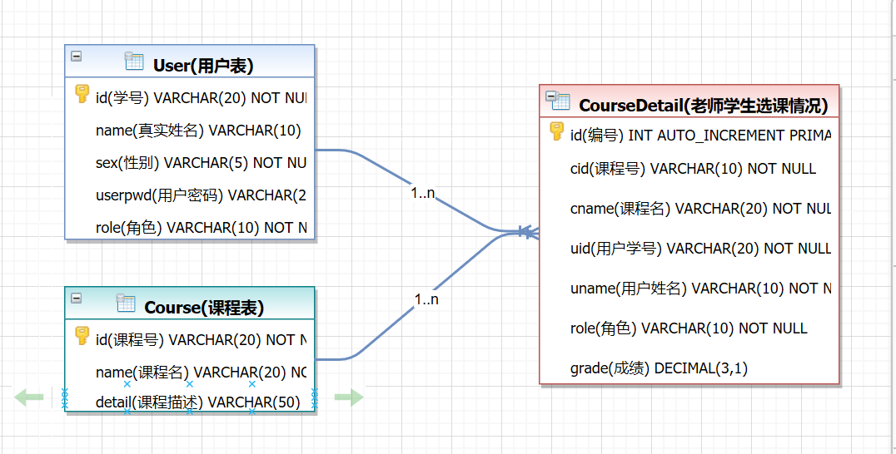

图3-1 数据库ER图

在coursedetail表中，角色只有老师和学生，为学生时，代表选课情况，为老师时，代表代课情况，grade这个字段初始都是为0，角色为老师时，这个字段就是默认为0，为学生时，需要老师进行给分才有成绩。

## 2.3 UML类图（Class Diagram）

### 2.3.1 对于用户功能模块分为6个类:

* VO实体类User：与数据库结构进行映射的类。主要由属性，setter, getter方法组成，VO类中的属性与表中的字段相对应，每一个VO类的对象都表示表中的每一条记录
* DAO接口IUserDAO：主要定义操作的接口，定义一系列数据库的原子性操作，例如增删改查（通常称为CRUD）等。
* DAO实现类UserDAOImpl：DAO接口的真实实现类，主要完成具体数据库操作，但不负责数据库的打开和关闭。
* DAO工厂类DAOFactory：通过工厂类取得一个DAO的实例化对象
* 业务逻辑实现类UserService：对于数据层的原子操作进行整合。还要负责sqlSession对象的打开和关闭。
* GetSession类:获取sqlSession对象操作数据库。

### 2.3.2 对于课程功能模块分为6个类:

* VO实体类Course：与数据库结构进行映射的类。主要由属性，setter, getter方法组成，VO类中的属性与表中的字段相对应，每一个VO类的对象都表示表中的每一条记录
* DAO接口ICourseDAO：主要定义操作的接口，定义一系列数据库的原子性操作，例如增删改查（通常称为CRUD）等。
* DAO实现类CourseDaoImpl：DAO接口的真实实现类，主要完成具体数据库操作，但不负责数据库的打开和关闭。
* DAO工厂类DAOFactory：通过工厂类取得一个DAO的实例化对象
* 业务逻辑实现类CourseService：对于数据层的原子操作进行整合。还要负责sqlSession对象的打开和关闭。
* GetSession类:获取sqlSession对象操作数据库。

### 2.3.3 对于选课信息功能模块分为6个类:

* VO实体类CourseDetail：与数据库结构进行映射的类。主要由属性，setter, getter方法组成，VO类中的属性与表中的字段相对应，每一个VO类的对象都表示表中的每一条记录
* DAO接口ICourseDetailDAO：主要定义操作的接口，定义一系列数据库的原子性操作，例如增删改查（通常称为CRUD）等。
* DAO实现类CourseDetailDaoImpl：DAO接口的真实实现类，主要完成具体数据库操作，但不负责数据库的打开和关闭。
* DAO工厂类DAOFactory：通过工厂类取得一个DAO的实例化对象
* 业务逻辑实现类CourseDetailService：对于数据层的原子操作进行整合。还要负责sqlSession对象的打开和关闭。
* GetSession类:获取sqlSession对象操作数据库。

各类的结构及类之间的关系如图所示，用户：

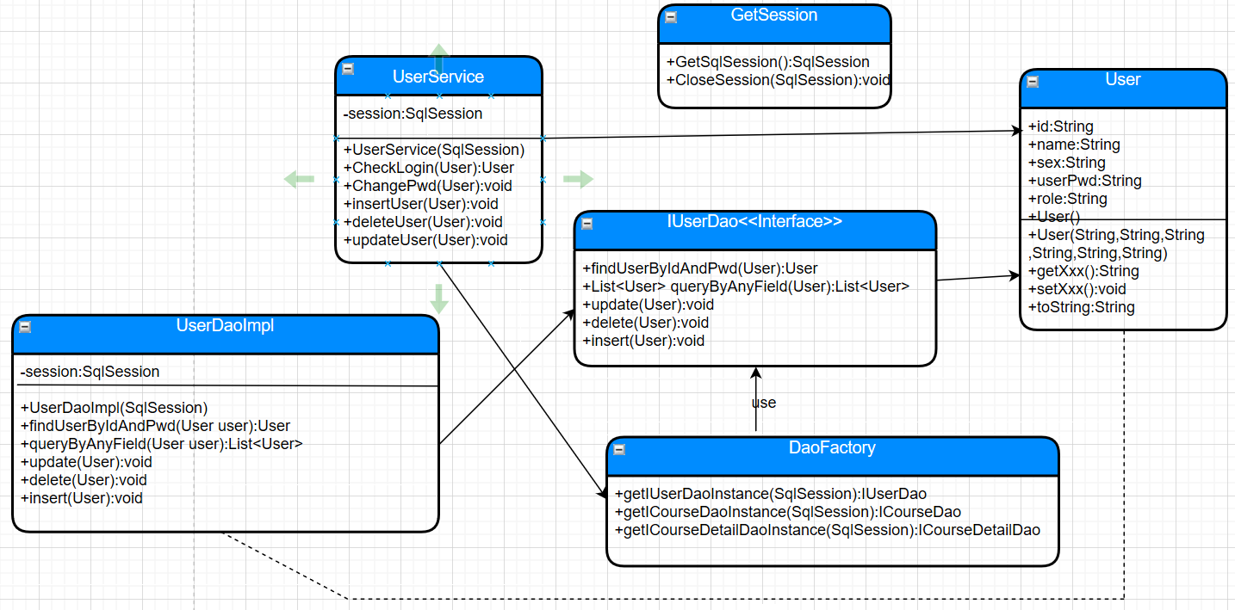

课程类的结构关系如下:

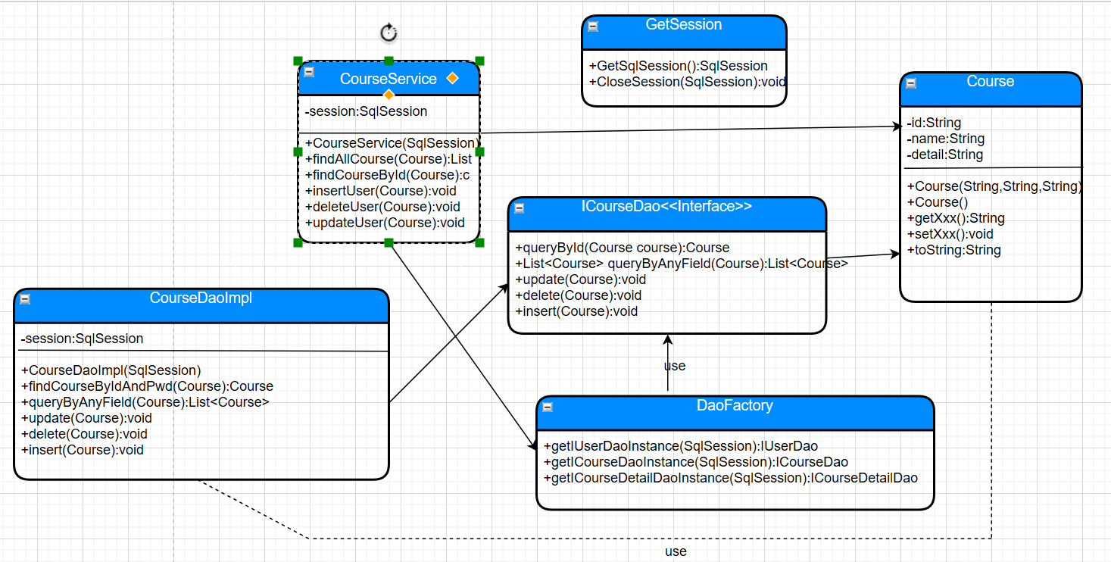

## 2.4 UML时序图（Sequence Diagram）

大致的增删改查的四种类型的时序图在下下面，就不一一都列出来了。

### 2.4.1 系统登录

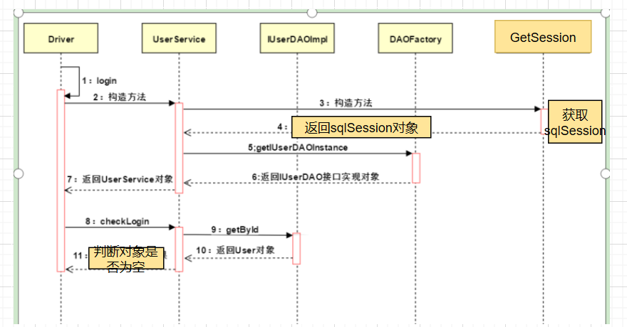

### 2.4.2 查课

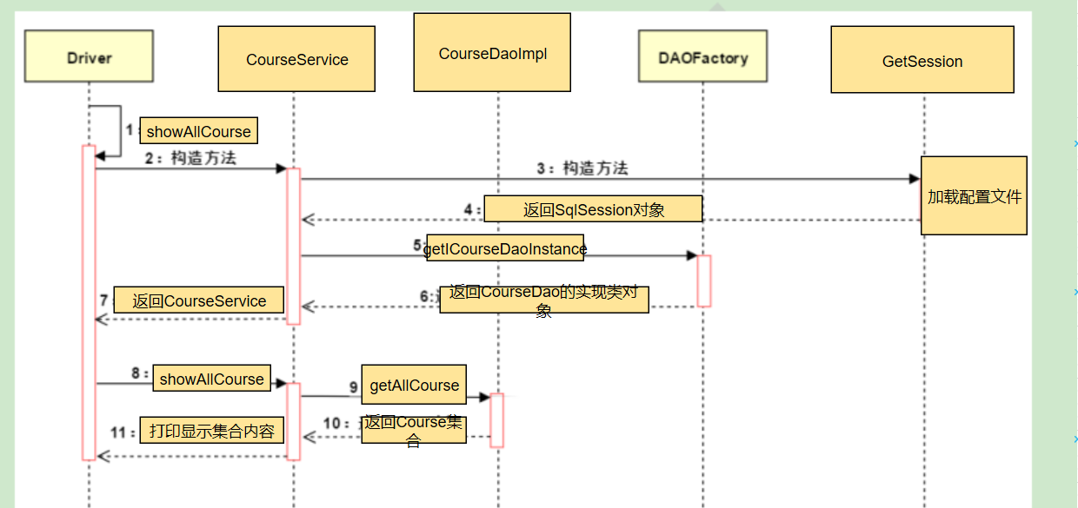

### 2.4.3 选课

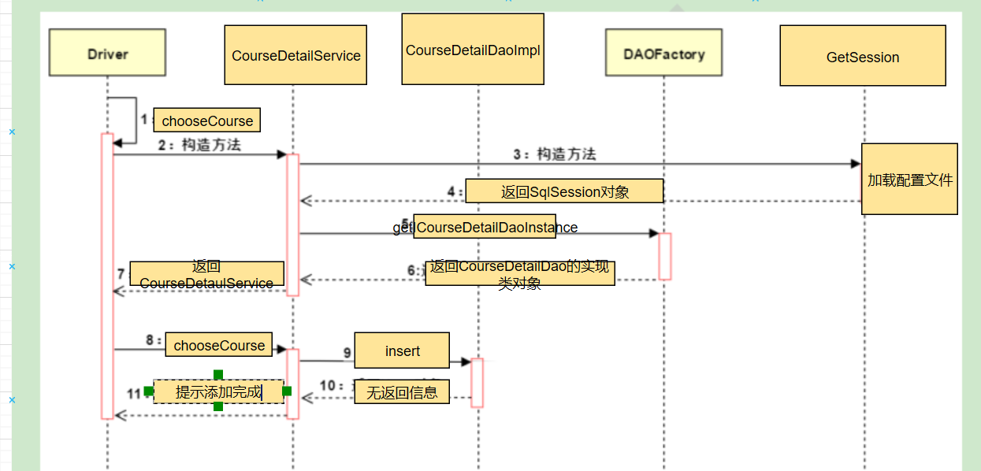

### 2.4.4 查询成绩:

时序图与选课类似，不过进行的是查的操作，选课是进行的增的操作而已

### 2.4.5 修改:

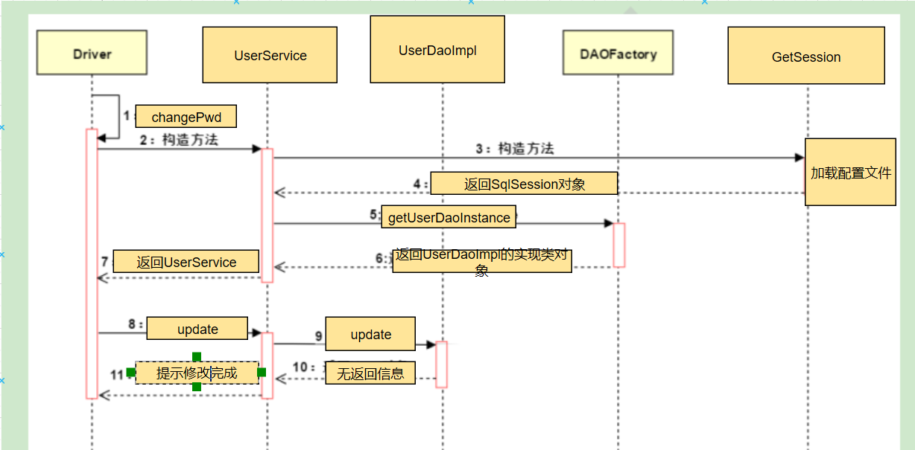

## 2.5 UML活动图（Activity Diagram）,列举几个逻辑比较复杂的功能实现

### 2.5.1 登陆（三种角色均有此操作，且流程一致）

登录操作需要验证用户名，密码，只有当用户名和密码同时存在即用户存在的情况下才能成功登录系统，否则会提示错误信息，具体流程如图所示。

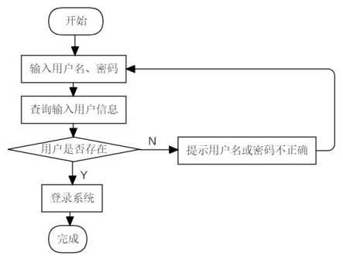

### 2.5.2 选课（角色为学生）

当角色为学生时，选择为2

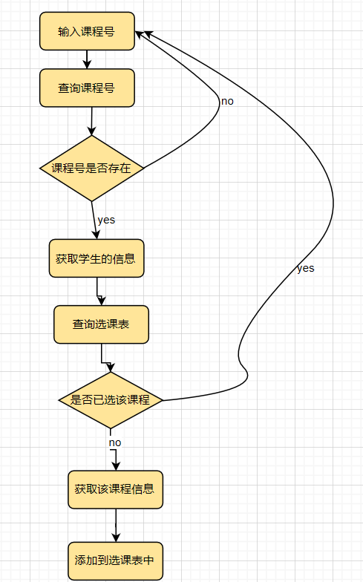

### 2.5.3 修改密码（管理员，老师，学生均如此）

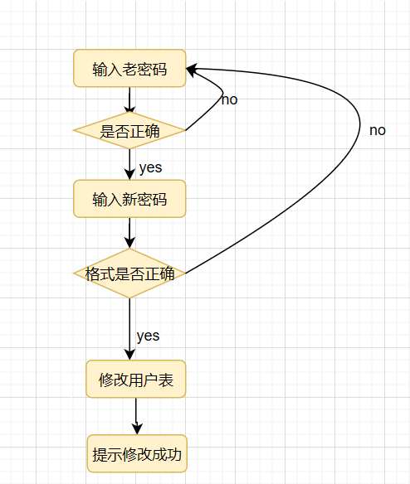

### 2.5.4 输入成绩（角色为老师）

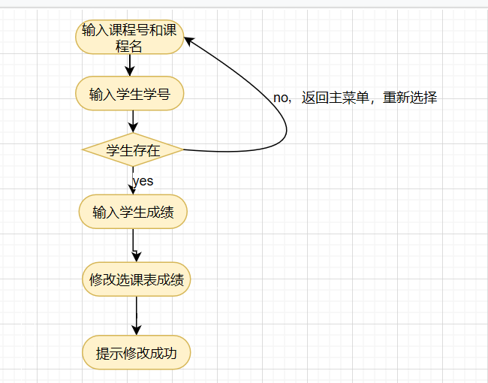

### 2.5.5 修改用户信息（角色为管理员）

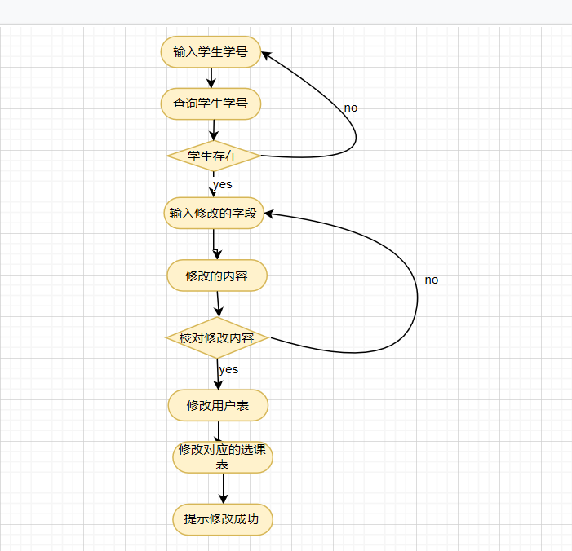

其他的增删改查和这些逻辑几乎一样，就不一一列举了。

# **3 系统实现**

## 3.1 项目结构

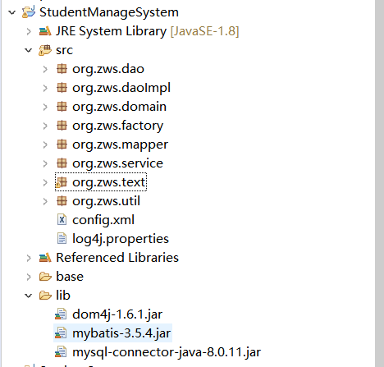

## 3.2 配置文件

### 3.2.1 db.xml文件

该配置文件主要是以文件形式保存数据库的驱动类名称，连接数据库的URL地址，访问数据库的用户名及对应的密码，程序运行时会读取该文件相关信息，避免硬编码，当相关信息发生变化时，只需修改配置文件而不用修改源代码，增加程序的可扩展型。

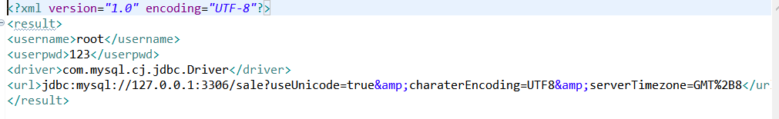

### 3.2.2 log4j.properties文件

描述该文件作用，并对里面的配置进行解释

### 3.2.3 mybatis-config.xml文件

描述该文件作用，并对里面的配置进行解释

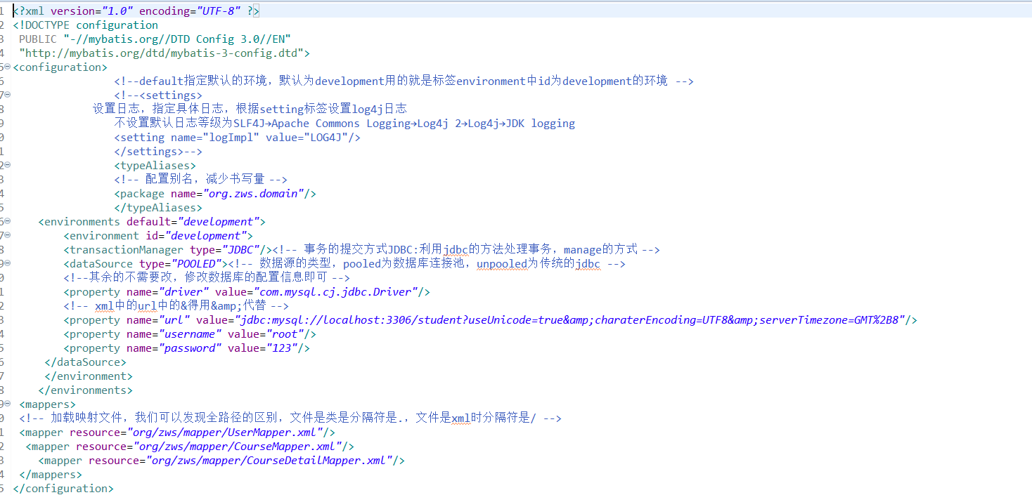

## 3.3 VO类

### 3.3.1 User.java

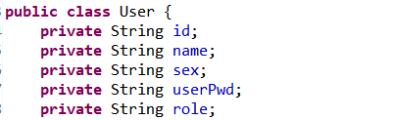

### //构造方法、getter,setter，toString方法,自行补充

### 3.3.2 Course.java

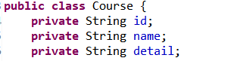

### //构造方法、getter,setter，toString方法,自行补充

3.3.3 CourseDetail.java

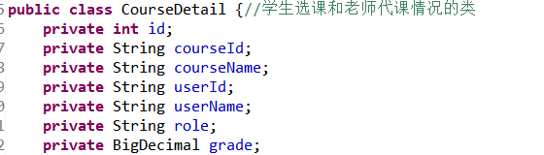

### //构造方法、getter,setter，toString方法,自行补充

## 3.4 DAO接口类

3.4.1 IUserDao.java

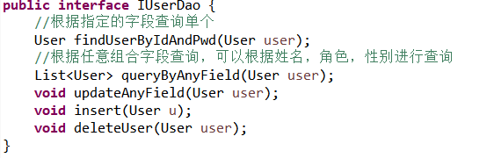

包含五个原子操作，增删改查。

3.4.2 ICourseDao.java

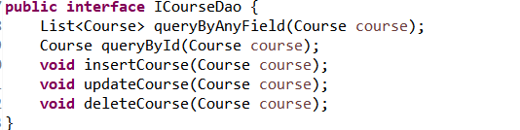

包含五个原子操作，增删改查。

3.4.3 ICourseDetailDao.java

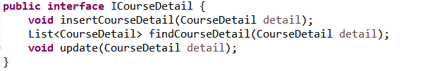

## 3.5 接口映射文件

3.5.1 UserMapper.xml

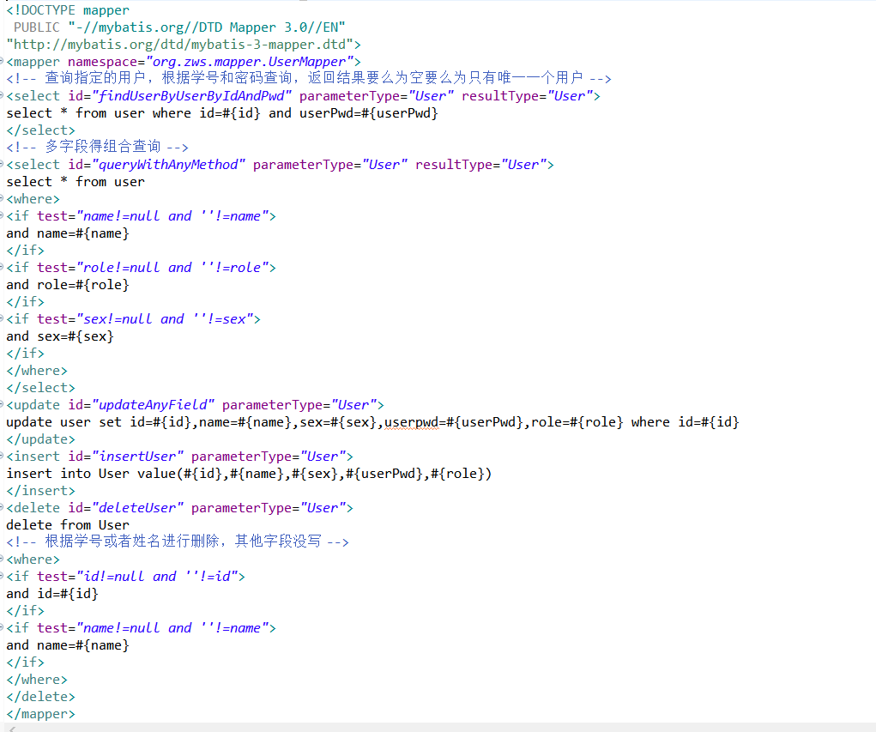

3.5.2 CourseMapper.xml

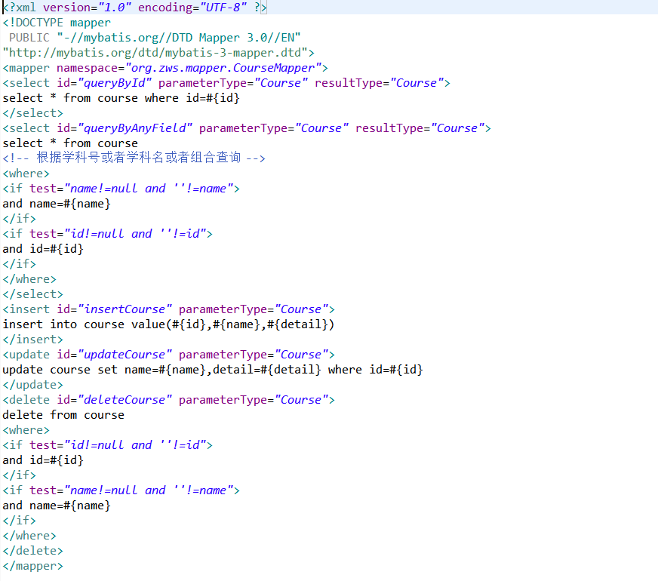

3.5.3 CourseDetailMapper.xml

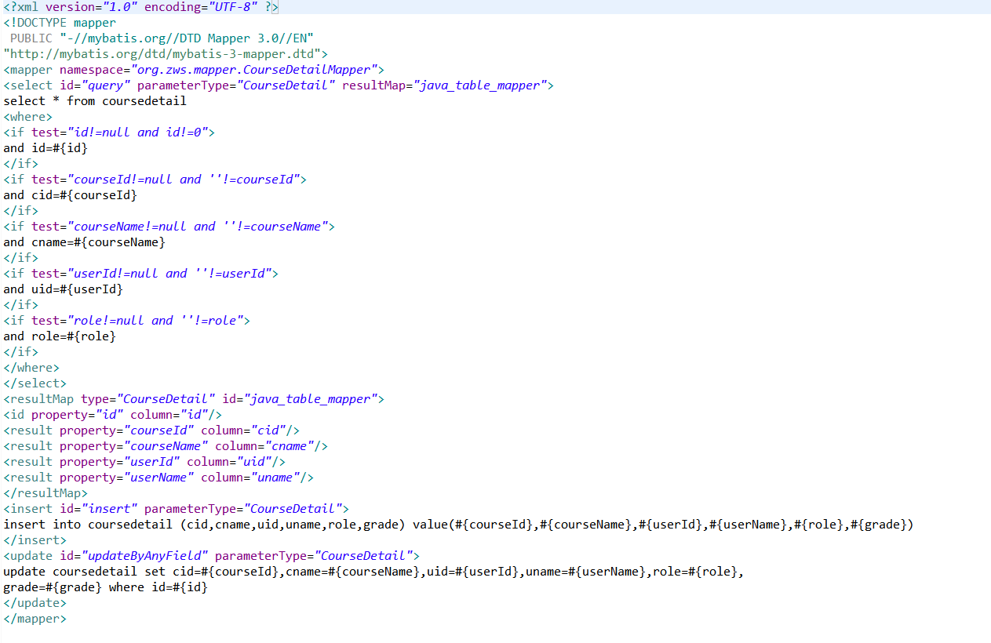

## 3.6 工具包Util

### 3.6.1 GetSession.java

该类主要为服务层提供SqlSession对象

/**

* 为服务层提供sqlSession对象

*/

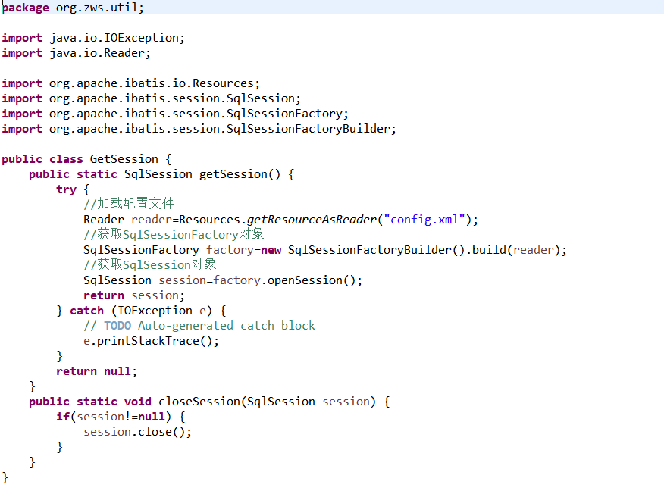

## 3.7 服务层

3.7.1 UserService.java

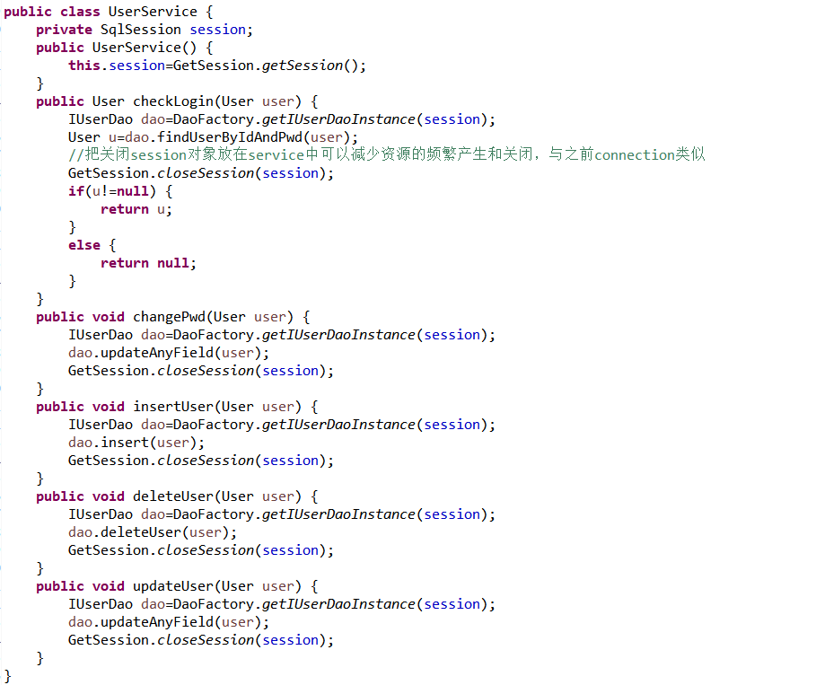

3.7.2 CourseService.java

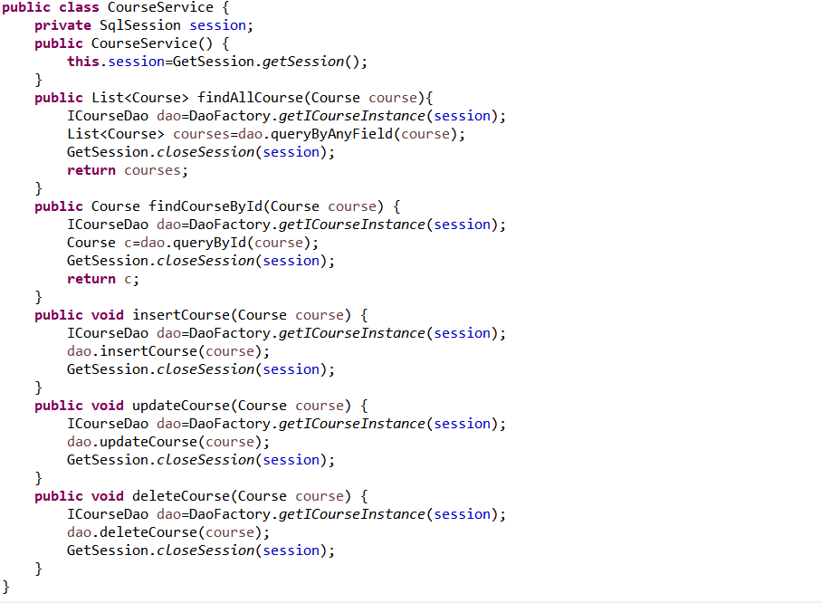

3.7.3 CourseDetailService.java

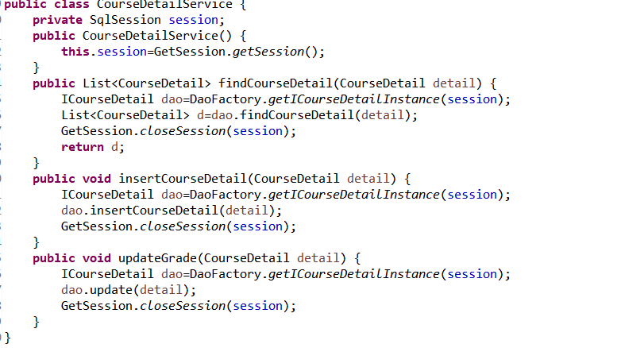

## 3.8 用户界面Drvier.java

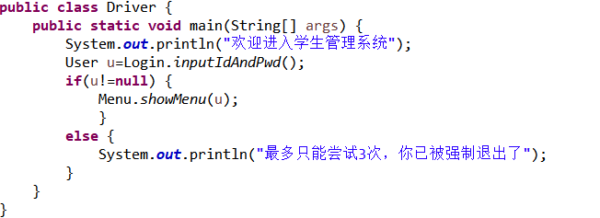

程序的入口。

# **4 系统测试**

每个板块的大致实现结果图，都放在了上面。

# **5 系统总结**

本次系统我觉得收获最大的还是程序的架构方面，现在对这种系统有了明确的分层思想，写代码也写的十分顺手，按功能板块进行逐一击破，感受最深的还是使用框架，mybatis，不想jdbc那样频繁的操作连接对象。语法也比jdbc代码量要少很多。最重要的是表得这方面的设计，这次虽然写出来的系统的目的，但是感觉自己的表设计的很不好，对数据库这方面还是不太敏感，表与表之间都是通过java逻辑进行数据交互，其实可以直接在表上做关联，但由于数据库掌握的知识不太熟练，就没有用，就单独设置了三张不关联的表。下一阶段我会将数据库进行深入了解，不仅局限于增删改查这些基本操作。