The requirement document
----database and administrator interface
- Data discription
We just develop two databases and use two type of data. The first is user
Information, the primary key is its id, which is given by order. Then the other database is about the theatre, its primary key is also given by order.
1.1 data requirement
User information
number | name | type | size | Allow null or not | Max length
1 | Id | Int | 4 | no | 10
2 | username | VarChar | 200 | yes | 255
3 | password | VarChar | 8000 | yes | 255
4 | permission | VarChar | 50 | yes | 255
5 | value | VarChar | 50 | yes | 255
Theatre information
number | name | type | size | Allow null or not | 最大长度
1 | Id | Int | 4 | no | 10
2 | name | VarChar | 200 | yes | 255
3 | Telephone number | VarChar | 8000 | yes | 255
4 | address | VarChar | 50 | 是 | 255
5 | picture | VarChar | 50 | 是 | 255
6 | description | VarChar | 50 | 是 | 255
1.2 data process
1. The server program needs to submit data to the database when the user performs various operations, that is, query and modify the database.
2. The information conveyed by the interface is data encapsulated by the data structure, transmitted between modules in the form of parameter transfer or return value.
1.3 database description
The first database(user) consists of five type of data, they are Id(the primary key), name, password, value, permission(a specific key to identify people’s limits). it uses two kinds of data, the former one is integer, the latter one is varchar. The five various types all have got length limits.
The second database(theatre) consists of six types of data, they are Id(the primary key), name, telephone number, address, picture(information that need to be translated ). it uses two kinds of data, the former one is integer, the latter one is varchar. The six various types all have got length limits.
1.4 database management
The administrator has its own username and password which can help them to access the backstage interface.
Only administrator can access to the database, also operate the database, and view the information. It has got four main functions include: information management, product category management, theater management, order management, user management.
administrator case diagram:
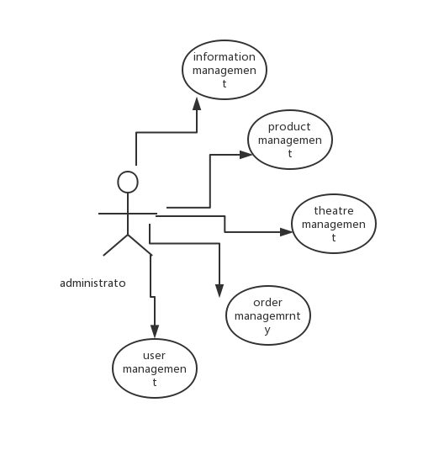
1.5 The idea screen layout
The main screen
after the administrator logs in to the system, the corresponding functional operations can be performed. The functions included include information management, product category management, theater management, order management, and user management.
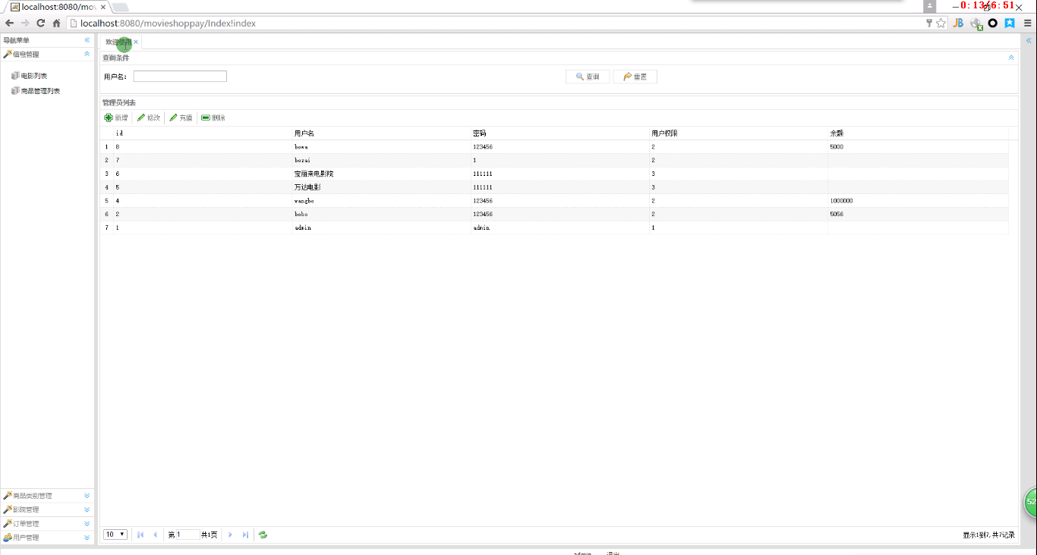
The theatre management
The administrator logs in to the background of the system to update the theater information in real time, which can realize new cinema or modify existing cinema information, so that users can get the latest information.
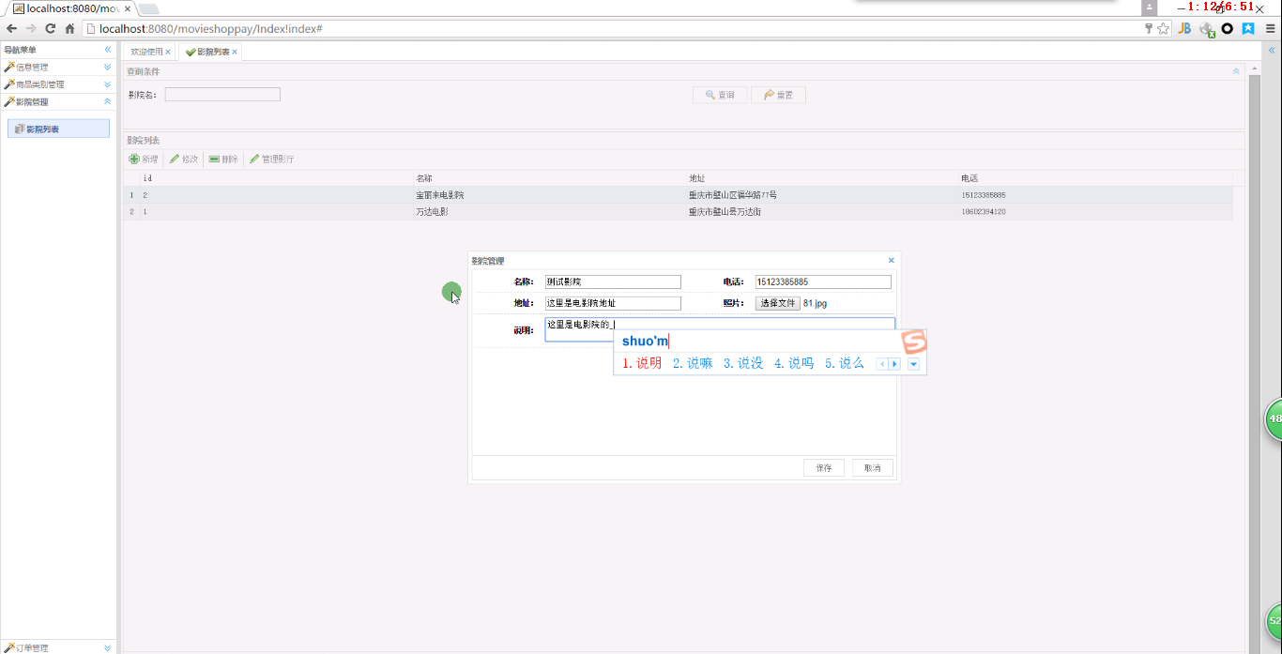
Order Management Function
The administrator can manage the order information and review the order information submitted by the user.



