KVM 1 ERPDB1

IP 172.16.9.245 SQL第一次備份

Teamviewer D:\SQL backup/VPC_DB

700 153 367 **Windows Server 2008 R2**

ERP-DB

KVM 5 DC02

IP 172.16.9.15

Teamviewer

320 077 449

AD Server

**Windows Server 2008 R2**

KVM 7 FS1

IP 172.16.9.19

Teamviewer

122 016 500

File Server

**Windows Server 2008 R2**

KVM 2 VPP02

IP 172.16.9.251

Teamviewer

754 358 211

MRP-新資料

Officescan

VM(ERP-AP)

**Windows Server2012 R2**

KVM 6 IT12

IP 172.16.9.246

Teamviewer

146 991 269

MRP-舊資料

程式在

C:\rmnew

**Win7 Pro**

KVM 4 IT13

IP 172.16.9.242

Teamviewer

189790175

File Server

VM(Compilier)

**Win10 Pro**

KVM 8 IT07

IP 172.16.9.240

Teamviewer

1 176 767 826

File Server

**Windows XP Professional**

KVM 3 透過批次檔從

IP 172.16.9.250 KVM1備份過來 Teamviewer D:\vpc_dbBackUp

1 022 539 904 **Windows Server 2012 R2**

會計系統

8

1

7

3

2

6

5

44

1

KVM 1-8

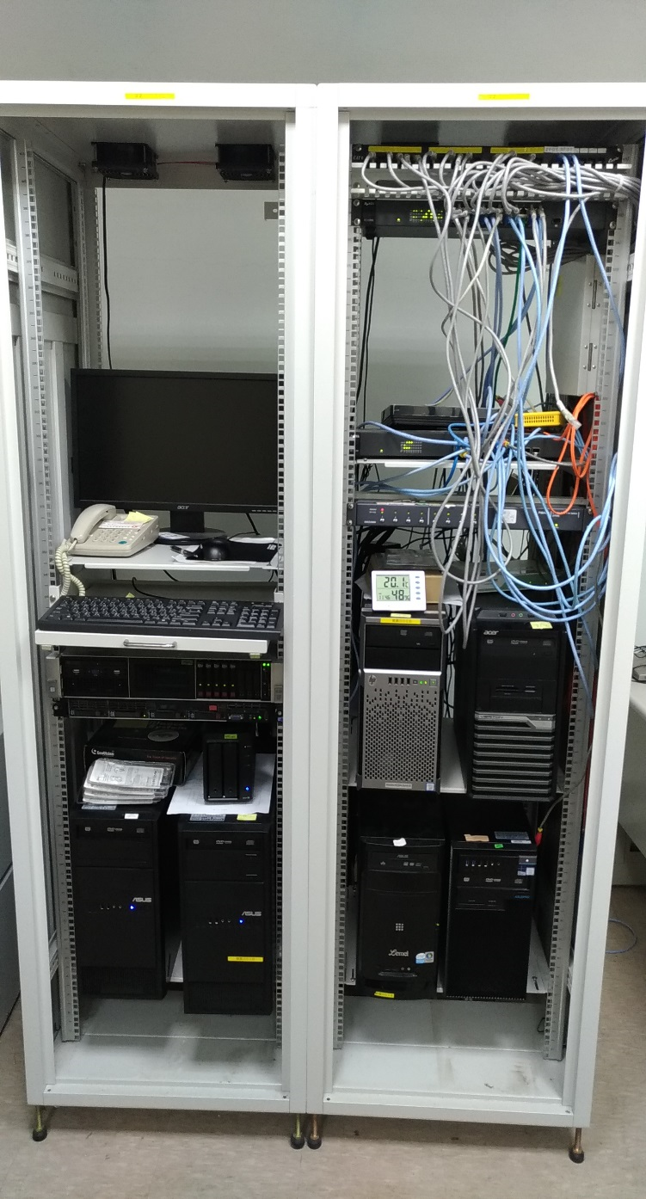

NAS IT07 FS1備份172.16.9.241:5000