

**编译原理与技术大作业报告**



**学 院 智能与计算学部**

**专 业 计算机科学与技术**

**姓 名 卢锐 周翔 向旭 吕鹏程**

**目录**

一.整体概述 4

1.1 整体流程 4

1.2 目录树介绍 4

1.3 源码结构介绍 5

二.词法分析器简介 6

2.1 词法分析器工作流程 6

2.2 设计的NFA 7

2.3 词法分析器类简介 9

2.3.1 lex.entity.DFA: 9

2.3.2 lex.entity.N: 10

2.3.3 lex.entity.State 11

2.3.4 lex.entity.StateList 12

2.3.5 lex.entity.Token 12

2.3.6 lex.implement.LexImpl 13

2.3.7 lex.itf.Lex 13

2.4 词法分析器主要算法 14

2.4.1 NFA的获取 14

2.4.2 NFA的确定化 16

2.4.3 NFA的最小化 20

2.4.4 Token序列的生成 26

2.5 词法分析器输出格式说明 31

2.5.1 符号表lexical.txt说明 31

2.5.2 Token序列说明 32

三. 语法分析器简介 33

3.1 语法分析器工作流程 33

3.2 文法文件与预测分析表 33

3.2.1文法文件 33

3.2.2 预测分析表 36

3.3 语法分析器类简介 40

3.3.1 yacc.entity.Analysis 40

3.3.2 yacc.entity.Rool 41

3.3.3 yacc.entity.Grammar 41

3.3.4 yacc.implement.YaccImpl 43

3.3.5 yacc.itf.Yacc 43

3.4 语法分析器主要算法 43

3.4.1 Rool序列的获取 43

3.4.2 First集合的计算 46

3.4.3 Follow集合的计算 49

3.4.5 预测分析表的计算 54

3.4.5 语法分析过程文件的生成 56

3.5 语法分析器输出格式说明 61

3.5.1 语法分析过程文件yacc.txt格式说明 61

四. 程序检测 61

4.1 实现代码 62

4.2 检测结果 63

4.2.1 测试用例00 63

4.2.2 测试用例01 65

4.2.3 测试用例02 70

4.2.4 测试用例07 77

五. 编译使用说明 81

5.1 编译说明 81

5.2 使用说明 81

六. 贡献说明 81

# 一.整体概述

## 1.1 整体流程

该编译器的demo的整体流程如下所示

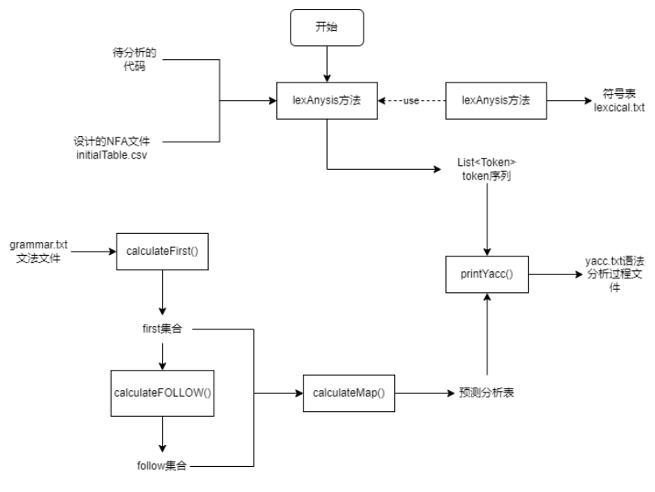

图 1 编译器的demo的整体流程

## 1.2 目录树介绍

项目的目录树如下  
 ├─.idea   
 │ ├─artifacts   
 │ ├─inspectionProfiles   
 │ └─libraries  
 ├─log  
 ├─src  
 │ ├─main  
 │ │ ├─java  
 │ │ └─resources  
 │ └─test  
 │ ├─java  
 │ └─resources  
 └─target

各文件夹的作用如下所示

* .idea: 使用idea的配置文件目录，在本地登录时请删除
* log: 记录错误日志的目录
* src: 源代码和程序所用资源所在的目录
  + main/java: 主体程序源码
  + main/resources: 程序主体所用的资源文件
  + test/java: 测试程序源码
  + test/resources: 测试程序所用的资源文件
* target: 编译后生成文件所在目录

## 1.3 源码结构介绍

主体程序源码结构如下

src  
 ├─lex  
 │ ├─entity  
 │ ├─implement  
 │ └─itf  
 ├─log  
 ├─test  
 ├─utils  
 └─yacc  
 ├─entity  
 ├─implement  
 └─itf

* lex: 词法分析器部分
  + entity：实体类
  + implement: 接口的实现类
  + itf: 对外开放的接口
* log: 日志记录部分
* test: 最终生成的函数入口部分
* utils: 编码时用到的工具
* yacc: 语法分析部分
  + entity：实体类
  + implement: 接口的实现类
  + itf: 对外开放的接口

# 二.词法分析器简介

## 2.1 词法分析器工作流程

词法分析器工作的主要流程由下图所示

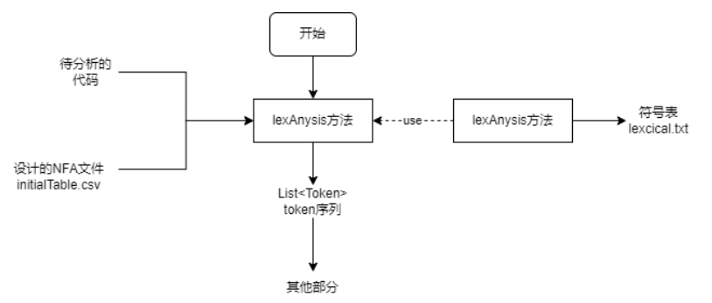

图2-1 词法分析器工作的主要流程图

## 2.2 设计的NFA

NFA的设计图如下所示

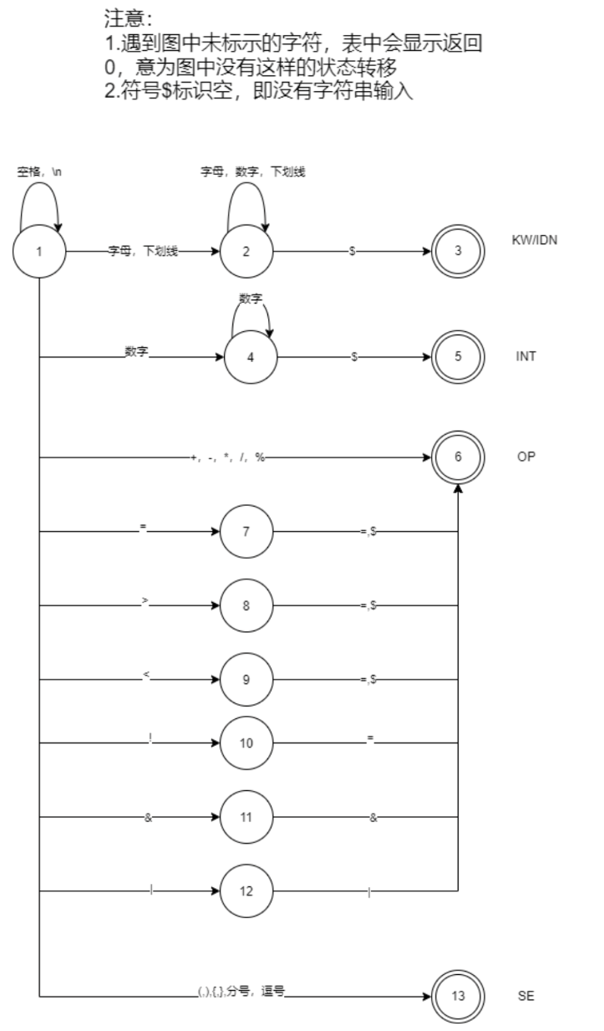

图2-2 NFA的设计图

由此设计出的initialTable如下图所示

|  |  |  |  |  |  |  |  |  |  |  |  |  |  |  |  |  |  |  |  |  |  |  |  |  |  |  |
| --- | --- | --- | --- | --- | --- | --- | --- | --- | --- | --- | --- | --- | --- | --- | --- | --- | --- | --- | --- | --- | --- | --- | --- | --- | --- | --- |
| stateId | start | endSymbol | letter | digit | _ | + | - | * | / | % | = | $ | > | < | ! | & | | | ( | ) | { | } | dot | ; |  | \n | others |
| 1 | TRUE | NOT_END | 2 | 4 | 2 | 6 | 6 | 6 | 6 | 6 | 7 | 0 | 8 | 9 | 10 | 11 | 12 | 13 | 13 | 13 | 13 | 13 | 13 | 1 | 1 | 0 |
| 2 | FALSE | NOT_END | 2 | 2 | 2 | 0 | 0 | 0 | 0 | 0 | 0 | 3 | 0 | 0 | 0 | 0 | 0 | 0 | 0 | 0 | 0 | 0 | 0 | 0 | 0 | 0 |
| 3 | FALSE | KW/IDN | 0 | 0 | 0 | 0 | 0 | 0 | 0 | 0 | 0 | 0 | 0 | 0 | 0 | 0 | 0 | 0 | 0 | 0 | 0 | 0 | 0 | 0 | 0 | 0 |
| 4 | FALSE | NOT_END | 0 | 4 | 0 | 0 | 0 | 0 | 0 | 0 | 0 | 5 | 0 | 0 | 0 | 0 | 0 | 0 | 0 | 0 | 0 | 0 | 0 | 0 | 0 | 0 |
| 5 | FALSE | INT | 0 | 0 | 0 | 0 | 0 | 0 | 0 | 0 | 0 | 0 | 0 | 0 | 0 | 0 | 0 | 0 | 0 | 0 | 0 | 0 | 0 | 0 | 0 | 0 |
| 6 | FALSE | OP | 0 | 0 | 0 | 0 | 0 | 0 | 0 | 0 | 0 | 0 | 0 | 0 | 0 | 0 | 0 | 0 | 0 | 0 | 0 | 0 | 0 | 0 | 0 | 0 |
| 7 | FALSE | NOT_END | 0 | 0 | 0 | 0 | 0 | 0 | 0 | 0 | 6 | 6 | 0 | 0 | 0 | 0 | 0 | 0 | 0 | 0 | 0 | 0 | 0 | 0 | 0 | 0 |
| 8 | FALSE | NOT_END | 0 | 0 | 0 | 0 | 0 | 0 | 0 | 0 | 6 | 6 | 0 | 0 | 0 | 0 | 0 | 0 | 0 | 0 | 0 | 0 | 0 | 0 | 0 | 0 |
| 9 | FALSE | NOT_END | 0 | 0 | 0 | 0 | 0 | 0 | 0 | 0 | 6 | 6 | 0 | 0 | 0 | 0 | 0 | 0 | 0 | 0 | 0 | 0 | 0 | 0 | 0 | 0 |
| 10 | FALSE | NOT_END | 0 | 0 | 0 | 0 | 0 | 0 | 0 | 0 | 6 | 0 | 0 | 0 | 0 | 0 | 0 | 0 | 0 | 0 | 0 | 0 | 0 | 0 | 0 | 0 |
| 11 | FALSE | NOT_END | 0 | 0 | 0 | 0 | 0 | 0 | 0 | 0 | 0 | 0 | 0 | 0 | 0 | 6 | 0 | 0 | 0 | 0 | 0 | 0 | 0 | 0 | 0 | 0 |
| 12 | FALSE | NOT_END | 0 | 0 | 0 | 0 | 0 | 0 | 0 | 0 | 0 | 0 | 0 | 0 | 0 | 0 | 6 | 0 | 0 | 0 | 0 | 0 | 0 | 0 | 0 | 0 |
| 13 | FALSE | SE | 0 | 0 | 0 | 0 | 0 | 0 | 0 | 0 | 0 | 0 | 0 | 0 | 0 | 0 | 0 | 0 | 0 | 0 | 0 | 0 | 0 | 0 | 0 | 0 |

## 2.3 词法分析器类简介

词法分析器主要类如下

lex  
 ├─entity  
 │ DFA.java  
 │ NFA.java  
 │ State.java  
 │ StateList.java  
 │ Token.java  
 │  
 ├─implement  
 │ LexImpl.java  
 │  
 └─itf  
 Lex.java

### 2.3.1 lex.entity.DFA:

是dfa实体，用来描述一个DFA

重要字段:

|  |
| --- |
| FA //所有状态的集合  private List<State> allStates;  //字母表  private String[] alpha;  // 状态转化表，因为是DFA，所以一个输入字符只会对应一个输出,List的序号对应`状态序号 - 1`  private List<Map<String, Integer>> functionList;  //唯一初态  private State startState;  //终止状态集合  private List<State> endStates;  重要方法:  /**  * @param :  * @return DFA 最小化后的DFA  * @author ZhouXiang  * @description 将所给的DFA最小化  * @exception  */  public DFA minimizeDFA() |

### 2.3.2 lex.entity.N:

NFA实体类,用来描述一个NFA

重要字段:

|  |
| --- |
| //所有状态的集合  private List<State> allStates;  //字母表  private String[] alpha;  //状态转化表，因为是NFA，所以一个输入字符可能对应多个输出  private List<Map<String, Integer[]>> functionList;  //初始状态集合  private List<State> startStates;  //终止状态集合  private List<State> endStates;  重要方法:  /**  * @param :fileName 初始设计的NFA表文件所在路径  * @return NFA  * @author ZhouXiang  * @description 获取初始的NFA，从文件中获取nfa  * @exception 文件IO异常  */  public static NFA generateNFA(String fileName) throws IOException; |

### 2.3.3 lex.entity.State

状态的实体类，用来描述状态NFA和DFA中状态的变化

重要字段:

|  |
| --- |
| //状态id  private int stateId;  //是否为起始状态  private boolean start;  //若为结束状态，则为其对应的标识的数组，否则为空数组  private String[] endSymbol;  //状态转换表  private Map<String, Integer[]> moveMap; |

### 2.3.4 lex.entity.StateList

状态集合的实体类，是nfa确定化和dfa最小化的算法中间产生的实体类

重要字段

|  |
| --- |
| //集合中包含的状态  private List<State> states;  //状态集合编号0  private int stateListId;  //标识有没有起始状态  private boolean start;  //若为结束状态，则为其对应的标识的数组，否则为null  private String[] endSymbol;  //key为转移符号，value为转移到的状态集合编号  //注意，这里的状态转移与a弧转换不同，只是简单的将所有状态的状态转移加和，没有算加和的空弧转换  private Map<String, Integer[]> moveMap; |

### 2.3.5 lex.entity.Token

输出Token序列中的Token实体类

重要字段

|  |
| --- |
| //符号种别  private String type;  //符号对应的字符串内容  private String content;  //符号在进行语法分析时的存在形式  private String dealing; |

### 2.3.6 lex.implement.LexImpl

是lex.itf.Lex的实现类，实现了lex.itf.Lex声明的抽象方法

### 2.3.7 lex.itf.Lex

是词法分析器对外声明的接口，声明了词法分析器要实现的两个方法

|  |
| --- |
| /**  * @param input: 输入的字符串  * @return List<Token> 识别出的符号表  * @author ZhouXiang  * @description 将输入的字符串经过词法分析转为对应的token序列，输出Token序列  */  public List<Token> lexAnalysis(String input) throws IOException;  /**  * @param inputFile: 输入文件名  * @param outputFile: 输出文件名  * @return boolean: 是否输出成功  * @author ZhouXiang  * @description 对输入文件的语句进行词法分析，结果输出到输出文件中  */  public boolean lexAnalysisToFile(String inputFile,String outputFile) throws IOException; |

## 2.4 词法分析器主要算法

### 2.4.1 NFA的获取

从initialTable.csv文件中获取NFA主要步骤如下

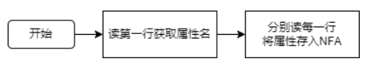

具体实现代码在lex.entity.NFA.generateNFA(String fileName)

|  |
| --- |
| public static NFA generateNFA(String fileName) throws IOException {  List<State> stateList = new ArrayList<>();    InputStream in = ClassLoader.getSystemResourceAsStream(fileName);  Scanner scanner = new Scanner(in);  String[] attribute = null; //存所有状态转移表的所有属性，即initialStateTable的第一行  if(scanner.hasNextLine()){  attribute = scanner.nextLine().split(",");  }  while (scanner.hasNextLine()){  String[] line = scanner.nextLine().split(",");  int stateId = -1;  boolean start = false;  String[] endSymbol = new String[0];  //从表中读除了状态转移以外的数据  for (int i = 0; i < line.length; i++){  switch (attribute[i]){  case "stateId":  stateId = Integer.parseInt(line[i]);  break;  case "start":  if(line[i].equals("TRUE")){  start = true;  }  break;  case "endSymbol":  endSymbol = line[i].split("/");  break;  default:  }  }  //取出状态转移的部分  int attributeNum = 3; //State类中除状态转移Map外的属性数  Integer[][] move = new Integer[line.length - attributeNum][];  for(int i = 0; i < move.length; i++){  String[] moveString = line[i + attributeNum].split("/");  Integer[] moveInteger = new Integer[moveString.length];  for(int j = 0; j < moveInteger.length; j++){  moveInteger[j] = Integer.parseInt(moveString[j]);  }  move[i] = moveInteger;  }  Map<String, Integer[]> moveMap = new HashMap<>();  for(int i = 0; i < move.length; i++){  moveMap.put(attribute[i + attributeNum], move[i]);  }  State state = new State(stateId, start, endSymbol, moveMap);  stateList.add(state);  }  return NFA.getNFAInstance(stateList);  } |

### 2.4.2 NFA的确定化

NFA确定化步骤：

1. 求nfa初始状态的闭包，将其放到转换结果List<StateList> result中去
2. 对于result中的每一个StateList，求其a弧转换，加入到result中去
3. 重复2，直到不再有新的StateList加入result
4. 将result转为对应的DFA

具体代码实现在lex.entity.NFA.determineNFA()

|  |
| --- |
| public DFA determineNFA(){  List<StateList> dfa1 = new ArrayList<>();  StateList beginList = new StateList(startStates).moveWithBlank(this);  dfa1.add(beginList);  dfs(beginList, dfa1);  //将StateList转为State  List<State> dfa = new ArrayList<>();  int cnt = 1;  for(StateList stateList: dfa1){  stateList.setStateListId(cnt);  cnt++;  }  for (StateList stateList: dfa1){  dfa.add(stateList.turn2State(dfa1, this));  }  return DFA.getDFAInstance(dfa);  }  //搜索整个nfa  private void dfs(StateList stateList, List<StateList> result){  List<StateList> tempStateList = new ArrayList<>(); //暂存一行中状态转移的StateList  //求该stateList的所有a弧转换  for(String input: alpha){  //排除空弧转换的情况  if(input.equals("$")){  continue;  }  //当a弧转换找到的结果是什么都没有时，不要加入  StateList temp = stateList.moveWithInput(input, this);  if(!temp.getStates().isEmpty()){  tempStateList.add(temp);  }  }  //判断每一个StateList是否已经在收集的![](../../../../../../文档/初始状态转换图.png)结果里了  for(StateList list: tempStateList){  boolean isRepeat = false;  for(StateList stateList1: result){  if(stateList1.equals(list)){  isRepeat = true;  break;  }  }  if(!isRepeat){  result.add(list);  dfs(list, result);  }  }  } |

在本项目中，NFA确定化后的状态转换图为

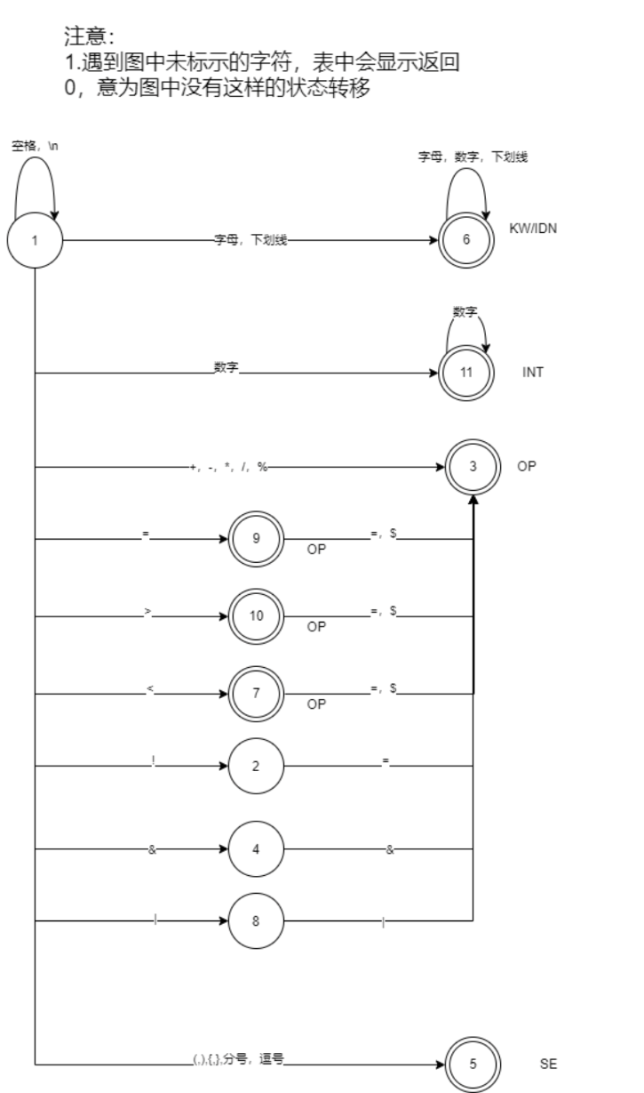

图2-3 NFA确定化后的状态转换图

### 2.4.3 NFA的最小化

NFA最小化步骤：

1. 对NFA中的所有状态，根据endSymbol类型分成不同的组，将分组加入转换结果List<StateList> curList中
2. 对字母表中的每一个字母input，执行划分操作操作：
   1. 将result中的所有StateList加入队列queue中
   2. 从queue中取出一个StateList
   3. 求该StateList中每一个State的a弧转换的结果
   4. 根据每一个State的a弧转换结果是result中的哪一个StateList，将其分为不同的组
   5. 若只有一个分组，将其加入List<StateList> finalList中
   6. 若有多个分组，从curList中删除原分组，加入新分组，并将新分组入队
   7. 重复执行2-5，直到没有新分组入队
3. 对curList进行检查操作:
   1. 存储curList到oldList中，对字母表中的每一个字母input，执行划分操作操作
   2. 比较经过划分操作后的curList和oldList，若相同则进行4，否则继续进行检查操作
4. 将finalList转为对应的DFA

具体代码实现在lex.entity.DFA.minimizeDFA()中

|  |
| --- |
| public DFA minimizeDFA(){  List<StateList> curList = new ArrayList<>();  //根据endSymbol的不同，对State进行第一次划分  //因为java对String[]的比较未重写，所以要将String[]转为String  Map<State, String> map =new HashMap<>();  for (State state: this.allStates){  StringBuilder sb = new StringBuilder();  for(String str: state.getEndSymbol()){  sb.append(str + "_");  }  map.put(state, sb.toString());  }  Set<String> set = new HashSet<>(map.values());  for(String str: set){  List<State> list = new ArrayList<>();  for(Map.Entry<State, String> entry: map.entrySet()){  State key = entry.getKey();  String value = entry.getValue();  if(value.equals(str)){  list.add(key);  }  }  curList.add(new StateList(list));  }  for(String input: alpha){  if(input.equals("$")){  continue;  }  curList = separate(curList, input);  }  List<StateList> result = check(curList);  //将StateList转为State  List<State> dfa = new ArrayList<>();  int cnt = 1;  for(StateList stateList: result){  stateList.setStateListId(cnt);  cnt++;  }  for (StateList stateList: result){  dfa.add(stateList.turn2State(result, this));  }  return DFA.getDFAInstance(dfa);  }  //检查，直到不发生改变  private List<StateList> check(List<StateList> curList){  List<StateList> oldList = curList;  for(String input: alpha){  if(input.equals("$")){  continue;  }  curList = separate(curList, input);  }  if(!oldList.equals(curList)){  check(curList);  }  return oldList;  }  //使用某字母对目前的dfa(List<StateList>)进行一次划分,返回划分后的结果  private List<StateList> separate(List<StateList> curList, String input){  List<StateList> finalStateList = new ArrayList<>();  Queue<StateList> queue = new LinkedList<>();  for (StateList list: curList){  queue.offer(list);  }  List<StateList> oldList = new ArrayList<>(curList);  while (!queue.isEmpty()){  StateList tempStateList = queue.poll();  //调试用  // if(tempStateList.getStates().size() == 4){  // int a = 0;  // }  //根据a弧转换，对tempStateList中的状态进行分类  //tempStateList中的每一个State，会对应到一个StateList  //取StateList为key，若不用划分，应只有一个键值对，否则，就要根据value划分成不同的StateList  Map<StateList, List<State>> map = new HashMap<>();  for(State state: tempStateList.getStates()){  StateList next = state.getMove(this, input);  Pair<StateList, List<State>> pair = personalGetOrDefault(map, next, new ArrayList<>());  List<State> list = pair.getValue();  list.add(state);  map.put(pair.getKey(), list);  }  if(map.size() == 1){//包含在oldList里面，说明是最终分组  finalStateList.add(tempStateList);  }else {//不包含在oldList里面，删除原来的分组，创建新分组，将新分组入队  oldList.remove(tempStateList);  for(List<State> stateList: map.values()){  StateList stateList1 = new StateList(stateList);  oldList.add(stateList1);  queue.add(stateList1);  }  }  }  return finalStateList;  }  //实现getOrDefault功能，用api的无法比较StateList是否相同  private static Pair<StateList, List<State>> personalGetOrDefault(Map<StateList, List<State>> map, StateList testKey, List<State> defaultResult){  for(Map.Entry<StateList, List<State>> entry: map.entrySet()){  StateList key = entry.getKey();  List<State> value = entry.getValue();  if(testKey.equals(key)){  return new Pair<>(key, value);  }  }  return new Pair<>(testKey, defaultResult);  } |

在本项目中，DFA确定化后的状态转换图如下

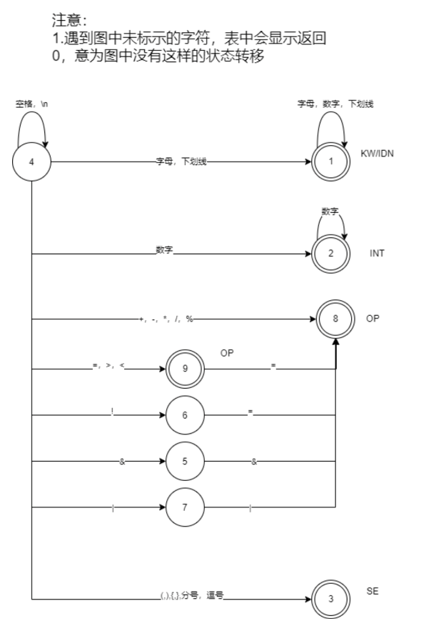

图2-4 DFA确定化后的状态转换图

### 2.4.4 Token序列的生成

根据最小化的DFA，获取待分析代码的Token序列的主要步骤如下:

1. 初始化当前状态为起始状态，初始化firstLetter，curLetter指针为第一个读入的字符，初始创建一个空的List<Token> result
2. 判断curLetter是否超过了input的长度，若超过了，跳到9；若没有，则从curLetter的位置读取一个字符
3. 对读入的字符进行预处理
4. 根据当前状态和遇到的字符，看还有没有下一个状态
5. 若有，则将curLetter + 1，然后跳转到2继续执行
6. 若没有，则判断当前状态是否是终结状态
7. 若是终结状态，读取firstLetter和curLetter之间的部分作为一个Token的content内容，目前State的endSymbol作为Token的type，将firstLetter指针移到curLetter位置，curLetter + 1，然后跳转到2继续执行
8. 若不是终结状态，说明代码存在错误，使用Log.errorLog()记录错误，退出程序
9. 遍历result，根据后面是INT，前面是null || KW || INT || { || (的原则找到要将-和INT合并成INT的位置
10. 遍历result，计算每一个Token的dealing，同时在要合并的地方对-和INT进行合并

具体实现代码在lex.implement.LexImp中

|  |
| --- |
| public List<Token> lexAnalysis(String input) throws IOException {  List<Token> tokens = new ArrayList<>();  //加空格是为了保证能读取最后的token  //当最后的字符的currentState为起始状态时，证明最后是由空格和\n组成的符号串，不该加入tokens，加入" "无影响  //当最后的字符的currentState为非终结状态时，证明到最后了还没读到可判断断词的字符，说明出现错误，加入" "无影响  //当最后的字符的currentState为终结状态时，因为所有终结状态遇到" "都会断词，且不会将最后一个" "读进，加入" "能帮助断词，否则该词就无法读进了  input = input + " ";  //获取dfa  // String fileName = "D:\\大学\\课程\\编译原理\\My大作业\\C--Complier\\complier\\src\\main\\resources\\initialStateTable.csv";  // String fileName = "./src/main/resources/config/initialStateTable.csv";  //generateNFA是静态方法，用的是ClassLoader.getSystemResourceAsStream(fileName)获取输入流，前面不加/  String fileName = "config/initialStateTable.csv";  NFA nfa = NFA.generateNFA(fileName);  DFA dfa = nfa.determineNFA();  dfa = dfa.minimizeDFA();  State currentState = dfa.getStartState(); //字符当前所处的状态  int currentNum = 0; //当前识别到哪一个字符  int startNum = 0; //每个token内容的开始字符  int endNum = 0; //每个token内容的结束字符  while (currentNum < input.length()){  //字符预处理  char currentChar = input.charAt(currentNum);  String currentLetter = "";  if(Character.isDigit(currentChar)){  currentLetter = "digit";  }else if(Character.isLetter(currentChar)){  currentLetter = "letter";  }else if(currentChar == ','){  currentLetter = "dot";  }else {  currentLetter = String.valueOf(currentChar);  }  if(!Arrays.asList(dfa.getAlpha()).contains(currentLetter)){  currentLetter = "others";  }  //找开始位置,会将空格，\n都去除  if(currentState.isStart()){  startNum = currentNum;  }  // if(currentChar == '}'){  // int a = 1;  // }  //找结束位置  State nextState = dfa.move(currentState, currentLetter);  if(nextState == null){  if(currentState.isEnd()){  endNum = currentNum;  String content = input.substring(startNum, endNum);  String type = "";  if(currentState.getEndSymbol().length == 1){  type = currentState.getEndSymbol()[0];  }else {  if(content.equals("int") || content.equals("void") || content.equals("return") || content.equals("const")){  type = "KW";  }else {  type = "IDN";  }  }  Token token = new Token(type, content);  tokens.add(token);  currentState = dfa.getStartState();  }else {  String errorInfo = currentLetter + "不能被识别，它是输入的第" + currentNum + "个字符";  Log.errorLog(errorInfo, logger);  System.exit(1);  }  }else {  currentState = nextState;  //后移currentNum  currentNum++;  }  }  //处理负数  //找到应该合并的位置  List<Integer> list = new ArrayList<>();  for(int i = 0; i < tokens.size(); i++){  Token before = null;  if(i != 0){  before = tokens.get(i - 1);  }  Token cur = tokens.get(i);  Token after = null;  if(i != tokens.size() - 1){  after = tokens.get(i + 1);  }  if(cur.getContent().equals("-") && after != null && after.getType().equals("INT")){  if(before == null || before.getType().equals("KW") || before.getType().equals("OP")){  list.add(new Integer(i));  }else {  if(before.getContent().equals("(") || before.getContent().equals("{")){  list.add(new Integer(i));  }  }  }  }  List<Token> result = new ArrayList<>();  int skip = 0;  for(int i = 0; i < tokens.size() - list.size(); i++){  if(list.contains(i + skip)){  String content = tokens.get(i + skip).getContent() + tokens.get(i + skip + 1).getContent();  Token token = new Token("INT", content);  //加入结果前要计算其在语法分析中的dealing  token.calculateDealing();  result.add(token);  skip++;  }else {  Token token = tokens.get(i + skip);  //加入结果前要计算其在语法分析中的dealing  token.calculateDealing();  result.add(token);  }  }  return result;  } |

## 2.5 词法分析器输出格式说明

### 2.5.1 符号表lexical.txt说明

输出格式为

[待测代码中的单词符号] [TAB] [单词符号种别]

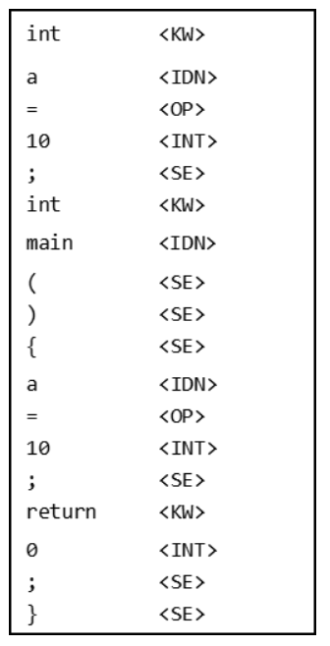

其中，单词符号种别为 KW（关键字）、OP（运算符）、SE（界符）、IDN（标识符）INT（整形数）；单词符号内容第一个维度为其种别，第二个维度为其属性。[TAB]为一个制表符‘\t’

### 2.5.2 Token序列说明

Token序列是一个Token组成的List，即List<Token>，它是lexAnalysis(String input)方法的返回值，将作为参数，传入语法分析器中。

# 三. 语法分析器简介

## 3.1 语法分析器工作流程

语法分析器工作流程如下

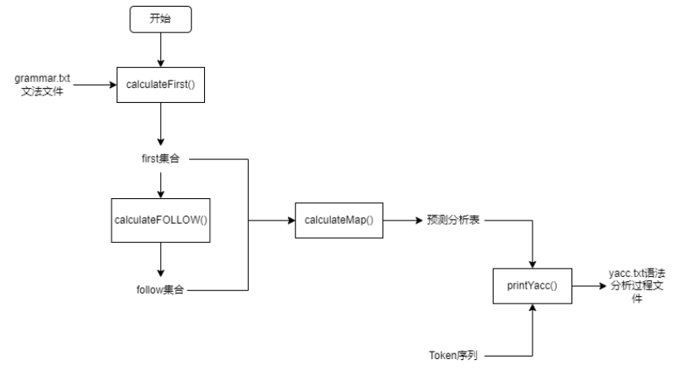

图 3-1 语法分析器工作流程

## 3.2 文法文件与预测分析表

### 3.2.1文法文件

文法文件grammar.txt由助教给出，具体如下：

|  |
| --- |
| program -> compUnit  compUnit -> decl compUnit  compUnit -> funcDef compUnit  compUnit -> $  decl -> constDecl  decl -> varDecl  constDecl -> const bType constDef argConst ;  argConst -> , constDef argConst  argConst -> $  constDef -> IDN = constInitVal  constInitVal -> constExp  constExp -> assignExp  varDecl -> bType varDef argVarDecl ;  argVarDecl -> , varDef argVarDecl  argVarDecl -> $  varDef -> IDN argVarDef  argVarDef -> = initVal  argVarDef -> $  initVal -> exp  bType -> int  funcDef -> funcType IDN ( funcFParams ) block  funcType -> void  funcFParams -> funcFParam argFunctionF  funcFParams -> $  argFunctionF -> , funcFParam argFunctionF  argFunctionF -> $  funcFParam -> bType IDN  block -> { blockItem }  blockItem -> decl blockItem  blockItem -> stmt blockItem  blockItem -> $  stmt -> exp ;  stmt -> ;  stmt -> block  stmt -> return argExp ;  callFunc -> ( funcRParams )  callFunc -> $  funcRParam -> exp  funcRParams -> funcRParam argFunctionR  funcRParams -> $  argFunctionR -> , funcRParam argFunctionR  argFunctionR -> $  argExp -> exp  argExp -> $  exp -> assignExp  assignExp -> eqExp assignExpAtom  assignExpAtom -> = eqExp assignExpAtom  assignExpAtom -> $  eqExp -> relExp eqExpAtom  eqExpAtom -> == relExp eqExpAtom  eqExpAtom -> != relExp eqExpAtom  eqExpAtom -> $  relExp -> addExp relExpAtom  relExpAtom -> < addExp relExpAtom  relExpAtom -> > addExp relExpAtom  relExpAtom -> <= addExp relExpAtom  relExpAtom -> >= addExp relExpAtom  relExpAtom -> $  addExp -> mulExp addExpAtom  addExpAtom -> + mulExp addExpAtom  addExpAtom -> - mulExp addExpAtom  addExpAtom -> $  mulExp -> unaryExp mulExpAtom  mulExpAtom -> * unaryExp mulExpAtom  mulExpAtom -> / unaryExp mulExpAtom  mulExpAtom -> % unaryExp mulExpAtom  mulExpAtom -> $  number -> INT  unaryExp -> number  unaryExp -> IDN callFunc |

### 3.2.2 预测分析表

程序分析过程中产生的预测分析表超链接为：

<程序分析过程中产生的预测分析表.xlsx>

具体内容如下所示：

|  |  |  |  |  |  |  |  |  |  |  |  |  |  |  |  |  |  |  |  |  |  |  |  |  |
| --- | --- | --- | --- | --- | --- | --- | --- | --- | --- | --- | --- | --- | --- | --- | --- | --- | --- | --- | --- | --- | --- | --- | --- | --- |
|  | == | <= | void | const | % | ( | ) | * | + | , | - | INT | int | / | IDN | ; | { | != | < | = | } | return | > | >= |
| argFunctionR |  |  |  |  |  |  | argFunctionR -> $ |  |  | argFunctionR -> , funcRParam argFunctionR |  |  |  |  |  |  |  |  |  |  |  |  |  |  |
| eqExpAtom | eqExpAtom -> == relExp eqExpAtom |  |  |  |  |  | eqExpAtom -> $ |  |  | eqExpAtom -> $ |  |  |  |  |  | eqExpAtom -> $ |  | eqExpAtom -> != relExp eqExpAtom |  | eqExpAtom -> $ |  |  |  |  |
| decl |  |  |  | decl -> constDecl |  |  |  |  |  |  |  |  | decl -> varDecl |  |  |  |  |  |  |  |  |  |  |  |
| constInitVal |  |  |  |  |  |  |  |  |  |  |  | constInitVal -> constExp |  |  | constInitVal -> constExp |  |  |  |  |  |  |  |  |  |
| constDef |  |  |  |  |  |  |  |  |  |  |  |  |  |  | constDef -> IDN = constInitVal |  |  |  |  |  |  |  |  |  |
| compUnit |  |  | compUnit -> funcDef compUnit | compUnit -> decl compUnit |  |  |  |  |  |  |  |  | compUnit -> decl compUnit |  |  |  |  |  |  |  |  |  |  |  |
| funcRParam |  |  |  |  |  |  |  |  |  |  |  | funcRParam -> exp |  |  | funcRParam -> exp |  |  |  |  |  |  |  |  |  |
| addExp |  |  |  |  |  |  |  |  |  |  |  | addExp -> mulExp addExpAtom |  |  | addExp -> mulExp addExpAtom |  |  |  |  |  |  |  |  |  |
| program |  |  | program -> compUnit | program -> compUnit |  |  |  |  |  |  |  |  | program -> compUnit |  |  |  |  |  |  |  |  |  |  |  |
| addExpAtom | addExpAtom -> $ | addExpAtom -> $ |  |  |  |  | addExpAtom -> $ |  | addExpAtom -> + mulExp addExpAtom | addExpAtom -> $ | addExpAtom -> - mulExp addExpAtom |  |  |  |  | addExpAtom -> $ |  | addExpAtom -> $ | addExpAtom -> $ | addExpAtom -> $ |  |  | addExpAtom -> $ | addExpAtom -> $ |
| relExp |  |  |  |  |  |  |  |  |  |  |  | relExp -> addExp relExpAtom |  |  | relExp -> addExp relExpAtom |  |  |  |  |  |  |  |  |  |
| mulExpAtom | mulExpAtom -> $ | mulExpAtom -> $ |  |  | mulExpAtom -> % unaryExp mulExpAtom |  | mulExpAtom -> $ | mulExpAtom -> * unaryExp mulExpAtom | mulExpAtom -> $ | mulExpAtom -> $ | mulExpAtom -> $ |  |  | mulExpAtom -> / unaryExp mulExpAtom |  | mulExpAtom -> $ |  | mulExpAtom -> $ | mulExpAtom -> $ | mulExpAtom -> $ |  |  | mulExpAtom -> $ | mulExpAtom -> $ |
| funcRParams |  |  |  |  |  |  | funcRParams -> $ |  |  |  |  | funcRParams -> funcRParam argFunctionR |  |  | funcRParams -> funcRParam argFunctionR |  |  |  |  |  |  |  |  |  |
| argVarDecl |  |  |  |  |  |  |  |  |  | argVarDecl -> , varDef argVarDecl |  |  |  |  |  | argVarDecl -> $ |  |  |  |  |  |  |  |  |
| initVal |  |  |  |  |  |  |  |  |  |  |  | initVal -> exp |  |  | initVal -> exp |  |  |  |  |  |  |  |  |  |
| number |  |  |  |  |  |  |  |  |  |  |  | number -> INT |  |  |  |  |  |  |  |  |  |  |  |  |
| argConst |  |  |  |  |  |  |  |  |  | argConst -> , constDef argConst |  |  |  |  |  | argConst -> $ |  |  |  |  |  |  |  |  |
| eqExp |  |  |  |  |  |  |  |  |  |  |  | eqExp -> relExp eqExpAtom |  |  | eqExp -> relExp eqExpAtom |  |  |  |  |  |  |  |  |  |
| funcFParams |  |  |  |  |  |  | funcFParams -> $ |  |  |  |  |  | funcFParams -> funcFParam argFunctionF |  |  |  |  |  |  |  |  |  |  |  |
| block |  |  |  |  |  |  |  |  |  |  |  |  |  |  |  |  | block -> { blockItem } |  |  |  |  |  |  |  |
| mulExp |  |  |  |  |  |  |  |  |  |  |  | mulExp -> unaryExp mulExpAtom |  |  | mulExp -> unaryExp mulExpAtom |  |  |  |  |  |  |  |  |  |
| argExp |  |  |  |  |  |  |  |  |  |  |  | argExp -> exp |  |  | argExp -> exp | argExp -> $ |  |  |  |  |  |  |  |  |
| exp |  |  |  |  |  |  |  |  |  |  |  | exp -> assignExp |  |  | exp -> assignExp |  |  |  |  |  |  |  |  |  |
| constExp |  |  |  |  |  |  |  |  |  |  |  | constExp -> assignExp |  |  | constExp -> assignExp |  |  |  |  |  |  |  |  |  |
| funcType |  |  | funcType -> void |  |  |  |  |  |  |  |  |  |  |  |  |  |  |  |  |  |  |  |  |  |
| assignExp |  |  |  |  |  |  |  |  |  |  |  | assignExp -> eqExp assignExpAtom |  |  | assignExp -> eqExp assignExpAtom |  |  |  |  |  |  |  |  |  |
| relExpAtom | relExpAtom -> $ | relExpAtom -> <= addExp relExpAtom |  |  |  |  | relExpAtom -> $ |  |  | relExpAtom -> $ |  |  |  |  |  | relExpAtom -> $ |  | relExpAtom -> $ | relExpAtom -> < addExp relExpAtom | relExpAtom -> $ |  |  | relExpAtom -> > addExp relExpAtom | relExpAtom -> >= addExp relExpAtom |
| constDecl |  |  |  | constDecl -> const bType constDef argConst ; |  |  |  |  |  |  |  |  |  |  |  |  |  |  |  |  |  |  |  |  |
| assignExpAtom |  |  |  |  |  |  | assignExpAtom -> $ |  |  | assignExpAtom -> $ |  |  |  |  |  | assignExpAtom -> $ |  |  |  | assignExpAtom -> = eqExp assignExpAtom |  |  |  |  |
| callFunc | callFunc -> $ | callFunc -> $ |  |  | callFunc -> $ | callFunc -> ( funcRParams ) | callFunc -> $ | callFunc -> $ | callFunc -> $ | callFunc -> $ | callFunc -> $ |  |  | callFunc -> $ |  | callFunc -> $ |  | callFunc -> $ | callFunc -> $ | callFunc -> $ |  |  | callFunc -> $ | callFunc -> $ |
| bType |  |  |  |  |  |  |  |  |  |  |  |  | bType -> int |  |  |  |  |  |  |  |  |  |  |  |
| unaryExp |  |  |  |  |  |  |  |  |  |  |  | unaryExp -> number |  |  | unaryExp -> IDN callFunc |  |  |  |  |  |  |  |  |  |
| argVarDef |  |  |  |  |  |  |  |  |  | argVarDef -> $ |  |  |  |  |  | argVarDef -> $ |  |  |  | argVarDef -> = initVal |  |  |  |  |
| funcFParam |  |  |  |  |  |  |  |  |  |  |  |  | funcFParam -> bType IDN |  |  |  |  |  |  |  |  |  |  |  |
| varDef |  |  |  |  |  |  |  |  |  |  |  |  |  |  | varDef -> IDN argVarDef |  |  |  |  |  |  |  |  |  |
| blockItem |  |  |  | blockItem -> decl blockItem |  |  |  |  |  |  |  | blockItem -> stmt blockItem | blockItem -> decl blockItem |  | blockItem -> stmt blockItem | blockItem -> stmt blockItem | blockItem -> stmt blockItem |  |  |  | blockItem -> $ | blockItem -> stmt blockItem |  |  |
| argFunctionF |  |  |  |  |  |  | argFunctionF -> $ |  |  | argFunctionF -> , funcFParam argFunctionF |  |  |  |  |  |  |  |  |  |  |  |  |  |  |
| varDecl |  |  |  |  |  |  |  |  |  |  |  |  | varDecl -> bType varDef argVarDecl ; |  |  |  |  |  |  |  |  |  |  |  |
| stmt |  |  |  |  |  |  |  |  |  |  |  | stmt -> exp ; |  |  | stmt -> exp ; | stmt -> ; | stmt -> block |  |  |  |  | stmt -> return argExp ; |  |  |
| funcDef |  |  | funcDef -> funcType IDN ( funcFParams ) block |  |  |  |  |  |  |  |  |  |  |  |  |  |  |  |  |  |  |  |  |  |

## 3.3 语法分析器类简介

语法分析器主要的类如下

yacc  
├─entity  
│ Analysis.java  
│ Grammar.java  
│ Rool.java  
│  
├─implement  
│ YaccImpl.java  
│  
└─itf  
 Yacc.java

### 3.3.1 yacc.entity.Analysis

使用预测分析表分析时每一条分析的实体类

主要字段如下

|  |
| --- |
| //操作序号  private String no;  //使用的规则序号  private String roolNo;  //栈顶符号  private String stackSym;  //面对的输入符号  private String faceSym;  //进行的动作  private String action; |

### 3.3.2 yacc.entity.Rool

每一条从grammar.txt中获取的规则的实体类

主要字段如下

|  |
| --- |
| //规则序号  private String no;  //规则左部  private String left;  //规则右部  private String right; |

### 3.3.3 yacc.entity.Grammar

语法实体，一个文法文件对应一个Grammar实体，采用构造工厂模式，只能用getGrammarInstance()方式构建实例

主要字段如下

|  |
| --- |
| //非终结符集合  private List<String> nonEndSymbol;  //终结符集合，此处将$也算在了终结符中  private List<String> endSymbol;  //开始符号  private String startSymbol;  //一条一条单个的规则  private List<Rool> rools;  //一个非终结符对应的一组规则  private Map<String,Set<String>> newRools;  //单个符号的first集合  private Map<String, List<String>> first;  //非终结符的follow集合  private Map<String, Set<String>> nonFollow;  // 存储在查找FOLLOW集合时非终结符的状态,仅在本类中使用  private Map<String, Integer> status;  //预测分析表，第一个String是非终结符，第二个是终结符  private Map<String,Map<String, Rool>> predictMap; |

主要方法如下

|  |
| --- |
| /**  * @param :  * @return Map<String,List<String>>  * @author ZhouXiang  * @description 计算本语法终结符与非终结符的First集  */  private Map<String,List<String>> calculateFirst();    /**  * @param :  * @return void  * @author ZhouXiang  * @description 计算Fowllow集合  */  private void calculateFOLLOW();  /**  * @param :  * @return void  * @author ZhouXiang  * @description 计算预测分析表  */  private void calculateMap(); |

### 3.3.4 yacc.implement.YaccImpl

是yacc.itf.Yacc的实现类，实现了yacc.itf.Yacc中声明的抽象方法

### 3.3.5 yacc.itf.Yacc

是语法分析器对外声明的接口，声明了语法分析器要实现的方法

|  |
| --- |
| /**  * @param tokens: 词法分析产生的序列  * @param filePath: 语法分析产生文件的路径  * @return boolean 语法分析是否成功  * @author ZhouXiang  * @description 根据词法分析的结果，产生语法分析的结果，输入到文件中  */  public boolean printYacc(List<Token> tokens, String filePath) throws IOException; |

## 3.4 语法分析器主要算法

### 3.4.1 Rool序列的获取

获取Rool序列的方法是按行读取grammar.txt文件，解析出每一条Rool的左部和右部

具体实现在yacc.entity.Grammar.getGrammarByFile()方法

|  |
| --- |
| public static Grammar getGrammarByFile(String filePath,String start) throws IOException {  List<Rool> rools = new ArrayList<>();  List<String> nonEndSymbols = new ArrayList<>();  List<String> endSymbols = new ArrayList<>();  String roolStr = "";  InputStream in = ClassLoader.getSystemResourceAsStream(filePath);  Scanner scanner = new Scanner(in);  int cnt = 1; //用于记录规则号  while (scanner.hasNextLine()){  roolStr = scanner.nextLine();  if(roolStr.equals("")){  continue;  }  //获取规则  Rool rool = new Rool();  String roolNo = String.valueOf(cnt);  cnt++;  String content = roolStr;  String left = content.split("->",2)[0].trim();  String right = content.split("->",2)[1].trim();  rool.setNo(roolNo);  rool.setLeft(left);  rool.setRight(right);  rools.add(rool);  //获取非终结符，出现在左边的全是非终结符，且非终结符只会在左边出现  if(!nonEndSymbols.contains(left)){  nonEndSymbols.add(left);  }  //获取终结符，先将右边的符号都放进去，后面进行对右边的符号分割，去除终结符的操作  if(!endSymbols.contains(right)){  endSymbols.add(right);  }  }  //对终结符，进行分割，去除终结符的操作  List<String> realEndSymbols = new ArrayList<>();  Iterator<String> it = endSymbols.iterator();  while (it.hasNext()){  String endSymbol = it.next();  if(endSymbol.equals("{ blockItem }")){  int a = 3;  }  //如果它是非终结符，不用加入  if(nonEndSymbols.contains(endSymbol)){;  continue;  }  String[] endSymbolStr = endSymbol.split(" ");  //进行分割，找终结符  if(endSymbolStr.length != 1){  for(int j = 0;j < endSymbolStr.length;j++){  if(!nonEndSymbols.contains(endSymbolStr[j]) && !realEndSymbols.contains(endSymbolStr[j])){  realEndSymbols.add(endSymbolStr[j]);  }  }  it.remove();  }else {  realEndSymbols.add(endSymbol);  }  }  endSymbols = realEndSymbols;  //对非终结符与终结符去重  Set<String> set = new HashSet<>(nonEndSymbols);  nonEndSymbols.clear();  nonEndSymbols.addAll(set);  set = new HashSet<>(endSymbols);  endSymbols.clear();  endSymbols.addAll(set);  Grammar grammar = new Grammar(nonEndSymbols,endSymbols,start,rools);  return grammar;  } |

### 3.4.2 First集合的计算

计算First集合的规则是：

* 如果x是终结符，FIRST(x)为{x}。
* 如果x是空串，FIRST(x)为{空串}。
* 如果x是非终结符，x->Y1Y2Y3...，逐步地从Y1计算起，如果Y1的FIRST集包含空串，将FIRST(Y1)-空串加入到FIRST(X)，继续计算FIRST(Y2)，... ，如果计算到某个符号Yn不包含空串，就结束计算。如果计算到最后一个符号也包含空串，也就是说Y1Y2Y3...->空串，则加入最后一个符号的FIRST集。

计算某一个符号的First集合的主要步骤如下：

1. 对单个终结符，其First集合是它自身，返回自身所形成的List<String>
2. 对单个非终结符a
   1. 初始化其First集合List<String> result为空
   2. 遍历文法的Rool，找到rool.right中包含a的所有rool.right
   3. 求这些rool.right的First集合，将其加入到result中
   4. 返回result
3. 对所有不止一个的符号S，将S用空格分割成String[] patterns，初始化其First集合List<String> result为空
   1. 若paterns[0]是终结符，result.add(patterns[0])，返回result
   2. 若patterns[0]不是终结符，遍历整个patterns，遍历过程中执行下面的操作
      1. 计算patterns[i]的First集合patternsFirst
      2. 判断patternsFirst是否包含空(在本程序中用$替代)
      3. 若不包含，执行result.addAll(patternsFirst)，结束遍历
      4. 若包含，判断是否是最后一个符号(即i == patterns.length - 1)
      5. 若是最后一个符号，执行result.addAll(patternsFirst)
      6. 若不是最后一个符号，将patternsFirst去掉$，执行result.addAll(patternsFirst)
   3. 返回result

具体代码实现在yacc.entity.Grammar.calculateFirst()中

|  |
| --- |
| private Map<String,List<String>> calculateFirst(){  Map<String,List<String>> result = new HashMap<>();  //终结符，first集合是他本身  for(String endSymbol : this.endSymbol){  List<String> first = new ArrayList<>();  first.add(endSymbol);  result.put(endSymbol,first);  }  //非终结符，first集合要递归地计算  for(String nonSymbol : this.nonEndSymbol){  // if(nonSymbol.equals("querySpecification unionStatements")){  // System.out.println("error");  // }  result.put(nonSymbol,getFirstBySingle(nonSymbol));  }  return result;  }  private List<String> getFirstBySingle(String symbol){  Set<String> result = new HashSet<>();  if(this.endSymbol.contains(symbol)){ //单个终结符，first集合是自身  result.add(symbol);  } else if(this.nonEndSymbol.contains(symbol)){ //单个非终结符，其First集合是其所在的，所有产生该非终结符的规则的右部，的first集合之和  Set<String> rights = this.newRools.get(symbol);  for(String right : rights){  result.addAll(this.getFirstBySingle(right));  }  }else {//处理有几个符号的情况  String[] patterns = symbol.split(" ");  if(this.endSymbol.contains(patterns[0])){  //第一个符号是终结符，其first集合就是这个终结符  result.add(patterns[0]);  } else {  for(int i = 0;i < patterns.length;i++){  List<String> patternsFirst = this.getFirstBySingle(patterns[i]);  if(!patternsFirst.contains("$")){  result.addAll(patternsFirst);  break;  } else {  if(i == patterns.length - 1){  result.addAll(patternsFirst);  }else {  patternsFirst.remove("$");  result.addAll(patternsFirst);  }  }  }  }  }  List<String> realResult = new ArrayList<>(result);  return realResult;  } |

### 3.4.3 Follow集合的计算

计算Follow集合，按以下方式进行处理:

* 对于开始符号S，先将界符加入到其FOLLOW集中。
* 对于A->aBp，如果p不能推导出空串，就将FIRST(p)加入到B的FOLLOW集。
* 如果p能推导出空串，就将FIRST(p)-空串和FOLLOW(A)加入到B的FOLLOW集。

具体的实现在yacc.entity.grammar中

|  |
| --- |
| private void calculateFOLLOW(){  status = new HashMap<>();  nonFollow = new HashMap<>();  for (String character : this.nonEndSymbol) {  // 初始化非终结符的状态  // 状态1表示还没找过  // 状态2表示正在查找  // 状态3表示已经结束查找  status.put(character, 1);  nonFollow.put(character, new HashSet<>());  }  // 首先在开始符号的FOLLOW集中加入界符  Set<String> startFollow = new HashSet<>();  startFollow.add("#");  this.nonFollow.put(this.startSymbol, startFollow);  for (String character : this.nonEndSymbol){  // 如果已经查找完，就跳过  if (status.get(character) == 3){  continue;  }  FOLLOWx(character);  }  }  private Set<String> FOLLOWx(String x){  // 首先置当前查找的非终结符的状态为正在查找  status.put(x, 2);  // 在产生式中搜索所有非终结符出现的位置  for (String character : this.nonEndSymbol){  Set<String> rightSet = this.newRools.get(character);  String[] rightItems = rightSet.toArray(new String[rightSet.size()]);  RightItemLoop:for (String item : rightItems){  // 获取符号列表  List<String> cList = this.disassemble(item);  // 接下来，搜索当前查找的非终结符的位置  for (int i=0; i<cList.size(); i++){  String nonEndChar = cList.get(i);  if (nonEndChar.equals(x)){  // 判断是否处于最右的位置  if (i < cList.size() - 1){  // 如果没在最右边的位置  // 下面循环判断后一个符号是否是非终结符  for (int j=i+1; j<cList.size(); j++){  String nextChar = cList.get(j);  if (this.nonEndSymbol.contains(nextChar)){  // 如果是非终结符，查看其FIRST集是否包含空串  Set<String> nextFirst = this.first.get(nextChar).stream().collect(Collectors.toSet());  // 如果包含空串，并且此时这个符号是最后一个符号  // 就要将其FIRST除去空串的集合加入FOLLOW集，且左部的FOLLOW集加入FOLLOW集  if (nextFirst.contains("$")){  // 判断是否是最后一个符号  if (j == cList.size() - 1){  // 这里首先判断一下要递归查找的非终结符的状态  // 如果为正在查找，就会陷入死循环  // 所以要略过这一条产生式  // 在略过产生式之前，因为直接略过会遗漏掉之前正在查找的非终结符的FOLLOW集中的元素，所以要加上  if (status.get(character) == 2){  Set<String> follow = this.nonFollow.get(character);  if (follow.size() != 0){  addCharsToFOLLOW(follow, x);  }  continue RightItemLoop;  }  Set<String> leftFOLLOW = FOLLOWx(character);  Set<String> nextFirstExceptNULL = new HashSet<>(nextFirst);  nextFirstExceptNULL.remove("$");  addCharsToFOLLOW(leftFOLLOW, x);  addCharsToFOLLOW(nextFirstExceptNULL, x);  } else{  // 如果不是最后一个符号，将FIRST集合加入  Set<String> nextFirstExceptNULL = new HashSet<>(nextFirst);  nextFirstExceptNULL.remove("$");  addCharsToFOLLOW(nextFirstExceptNULL, x);  }  } else{  // 如果不包含空串加入FIRST之后跳出循环  addCharsToFOLLOW(nextFirst, x);  break;  }  } else{  // 如果不是非终结符，把此符号加入到当前查找的非终结符的FOLLOW集中  addCharToFOLLOW(nextChar, nonEndChar);  break;  }  }  }  // 如果在最右边，将FOLLOW（左部）加入到当前非终结符的FOLLOW集合  else{  // 这里首先判断一下要递归查找的非终结符的状态  // 如果为正在查找，就会陷入死循环  // 所以要略过这一条产生式  // 在略过产生式之前，因为直接略过会遗漏掉之前正在查找的非终结符的FOLLOW集中的元素，所以要加上  if (status.get(character) == 2){  Set<String> follow = this.nonFollow.get(character);  if (follow.size() != 0){  addCharsToFOLLOW(follow, x);  }  continue RightItemLoop;  }  Set<String> leftFOLLOW = FOLLOWx(character);  addCharsToFOLLOW(leftFOLLOW, x);  }  }  }  }  }  // 如果return，说明已经查找完  status.put(x, 3);  return this.nonFollow.get(x);  } |

### 3.4.5 预测分析表的计算

计算步骤如下：

1. 将预测分析表M的所有位置置为errorRool
2. 遍历所有的Rool，执行2，3步
3. 求rool.right的First集合，对其中的每一个终结符a，把M[rool.left, a]置为rool
4. 若rool.right的First集合中有$(空)，对rool.left的Follow集合中的每一个终结符b，把M[rool.left, b]置为rool

具体实现在yacc.entity.Grammar.calculateMap()中

|  |
| --- |
| private void calculateMap(){  this.predictMap = new HashMap<>();  Rool error = new Rool("error","error","error");  //初始化，置为error  for (String nonEnd : this.nonEndSymbol){  Map<String,Rool> map = new HashMap<>();  for(String end : this.endSymbol){  if(end.equals("$")){  continue;  }  map.put(end,error);  }  this.predictMap.put(nonEnd,map);  }  //遍历rool来看预测分析表  for (Rool rool : this.rools){  List<String> first = this.getFirstBySingle(rool.getRight()); //右边的first集合  Set<String> follow = this.nonFollow.get(rool.getLeft()); //左边的follow集合，左边必定是非终结符  String non = rool.getLeft();  //在终结符中加#,此时$还包含在endSymbol中  List<String> newSym = new ArrayList<>(this.endSymbol);  newSym.add("#");  if(!first.contains("$")){  for(String end : newSym){  //去掉endSymbol中的$的影响  if(end.equals("$")){  continue;  }  if(first.contains(end)){  editPredictMap(non,end,rool);  }  }  }else {  for(String end : newSym){  if(end.equals("$")){  continue;  }  if(first.contains(end)){  editPredictMap(non,end,rool);  }  }  for(String endB : newSym){  if (endB.equals("$")){  continue;  }  if(follow.contains(endB)){  editPredictMap(non,endB,rool);  }  }  }  }  } |

### 3.4.5 语法分析过程文件的生成

根据Token序列和预测分析表来生成语法分析过程文件yacc.txt的过程如下：

1. 初始化一个stack，将#和开始符号入栈，在Token序列末端加上#，初始化token序列的指针i
2. 判断stack是否为空
3. 若为空，执行14
4. 若不为空，从栈中取出(不移除)栈顶元素now，从token中取出token[i]为face
5. 若now与face相同，判断是不是#，
6. 若都为#，则操作为accept，执行
7. 若不是#，则操作为move，移除栈顶元素，i++
8. 若now与face不同，查找M[now, face]的rool
9. 若rool为error，则说明语法分析遇到错误，记日志，退出程序
10. 若rool不为error，则操作为reduction，如果rool.right是不是为$(空)
11. 若rool.right为$(空)，从stack中移除栈顶元素
12. 若rool.right不为$(空)，从stack中移除栈顶元素，将rool右边的元素入栈
13. 执行2
14. 遍历储存的analysis信息
15. 将每一条analysis信息输出到语法分析过程文件yacc.txt中

具体实现在yacc.implement.YaccImpl.printYacc()中

|  |
| --- |
| public boolean printYacc(List<Token> tokens, String filePath) throws IOException {  String grammarFile = "config/grammar.txt";  Grammar grammar = Grammar.getGrammarByFile(grammarFile, "program");  Stack<String> stack = new Stack<>();  Map<String,Map<String, Rool>> table = grammar.getPredictMap();  stack.push("#");  stack.push(grammar.getStartSymbol());  List<Analysis> analysises = new ArrayList<>();  Token endToken = new Token("#","#");  endToken.calculateDealing();  tokens.add(endToken);  int i = 0;  Integer analysisNo = 1;  while (!stack.empty()){  Token token = tokens.get(i);  Analysis analysis = new Analysis();  analysis.setNo(analysisNo.toString());  analysis.setStackSym(stack.peek());  analysis.setFaceSym(token.getDealing());  String now = analysis.getStackSym();  String face = analysis.getFaceSym();  //调试使用  // if(now.equals("compUnit") && !face.equals("void")){  // int a = 3;  // }  if(now.equals(face)){  if(now.equals("#")){  analysis.setAction("accept");  analysis.setRoolNo("/");  analysises.add(analysis);  break;  }else {  analysis.setAction("move");  analysis.setRoolNo("/");  analysises.add(analysis);  stack.pop();  i++;  }  } else {  Rool rool = this.dictionary(now,face,table);  if(rool.getNo() == "error"){  analysis.setAction("error");  analysis.setRoolNo("/");  analysises.add(analysis);  String info = "语法分析遇到错误, 非终结符: " + now + ", 面临的终结符: " + face;  Log.errorLog(info, logger);  break;  // System.exit(401);  // stack.pop();  // i++;  } else {  analysis.setAction("reduction");  analysis.setRoolNo(rool.getNo());  analysises.add(analysis);  if(rool.getRight().equals("$")){  stack.pop();  }else {  stack.pop();  String[] rights = rool.getRight().split(" ");  for(int j = rights.length - 1; j >= 0; j--){  stack.push(rights[j]);  }  }  }  }  analysisNo++;  }  File file = new File(filePath);  if(!file.exists()){  file.createNewFile();  }  FileWriter fw = new FileWriter(file,false);  BufferedWriter bw = new BufferedWriter(fw);  for(Analysis analysis : analysises){  //将"#"转为EOF  if(analysis.getFaceSym().equals("#")){  analysis.setFaceSym("EOF");  }  if(analysis.getStackSym().equals("#")){  analysis.setStackSym("EOF");  }  String content = "";  content = content + analysis.getStackSym() + "#" + analysis.getFaceSym() + "\t" + analysis.getAction() + "\n";  bw.write(content);  }  bw.close();  return true;  } |

## 3.5 语法分析器输出格式说明

### 3.5.1 语法分析过程文件yacc.txt格式说明

输出格式为

[栈顶符号]#[面临输入符号][TAB][执行动作]

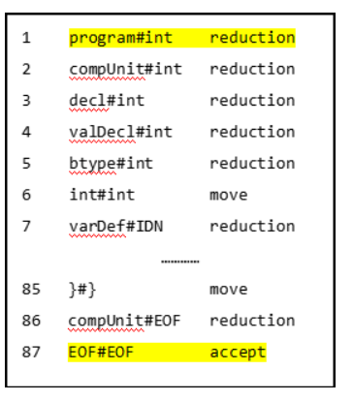

# 四. 程序检测

本程序使用junit进行单元检测，执行mvn test命令会自动执行检测单元，生成检测报告在target/surefire-reports下。

## 4.1 实现代码

检测的实现的代码如下所示。

以下是词法分析器部分的检测：

|  |
| --- |
| public class LexImplTest {   @Test  public void lexAnalysisToFile() throws IOException {  String dir = "./src/test/resources";  Lex lex = new LexImpl();  for(int i = 0; i < 5; i++){  String inputFile = dir + "/" + i + "/" + i + ".txt";  String testFile = dir + "/" + i + "/lexical.txt";  String expectedFile = dir + "/" + i + "/" + i + "_lexical.txt";   lex.lexAnalysisToFile(inputFile, testFile);   Scanner sc = new Scanner(new File(testFile));  StringBuilder testBuilder = new StringBuilder();  while (sc.hasNext()){  String line = sc.nextLine();  testBuilder.append(line + System.lineSeparator());  }  String test = testBuilder.toString();   sc = new Scanner(new File(expectedFile));  StringBuilder expectedBuilder = new StringBuilder();  while (sc.hasNext()){  String line = sc.nextLine();  expectedBuilder.append(line + System.lineSeparator());  }  String expected = expectedBuilder.toString();  assertEquals(expected, test);  }  } } |

以下是语法分析器检测的实现代码

|  |
| --- |
| public class YaccTest {   @Test  public void printYacc() throws IOException {  String dir = "D:\\大学\\课程\\编译原理\\My大作业\\C--Complier\\complier\\src\\test\\resources";  Lex lex = new LexImpl();  Yacc yacc = new YaccImpl();   for(int i = 0; i < 4; i++){  String inputFile = dir + "\\" + i + "\\" + i + ".txt";  String testFile = dir + "\\" + i + "\\grammar.txt";  String expectedFile = dir + "\\" + i + "\\" + i + "_grammar.txt";   String input = Util.readFile(inputFile);  List<Token> tokens = lex.lexAnalysis(input);  yacc.printYacc(tokens, testFile);   String expected = Util.readFile(expectedFile);  String test = Util.readFile(testFile);   Assert.assertEquals(expected, test);  }  } } |

## 4.2 检测结果

使用助教给的样例的检测结果如下所示

### 4.2.1 测试用例00

用例的输入文件00.txt

|  |
| --- |
| void main(){  return 3;  } |

产生的38lex.txt

|  |
| --- |
| void <KW>  main <IDN>  ( <SE>  ) <SE>  { <SE>  return <KW>  3 <INT>  ; <SE>  } <SE> |

产生的38gra.txt

|  |
| --- |
| program#void reduction  compUnit#void reduction  funcDef#void reduction  funcType#void reduction  void#void move  IDN#IDN move  (#( move  funcFParams#) reduction  )#) move  block#{ reduction  {#{ move  blockItem#return reduction  stmt#return reduction  return#return move  argExp#INT reduction  exp#INT reduction  assignExp#INT reduction  eqExp#INT reduction  relExp#INT reduction  addExp#INT reduction  mulExp#INT reduction  unaryExp#INT reduction  number#INT reduction  INT#INT move  mulExpAtom#; reduction  addExpAtom#; reduction  relExpAtom#; reduction  eqExpAtom#; reduction  assignExpAtom#; reduction  ;#; move  blockItem#} reduction  }#} move  compUnit#EOF reduction  EOF#EOF accept |

### 4.2.2 测试用例01

用例的输入文件01.txt

|  |
| --- |
| int a = 3;  int b = 5;  void main(){  int a = 5;  return a + b;  } |

产生的38lex.txt

|  |
| --- |
| int <KW>  a <IDN>  = <OP>  3 <INT>  ; <SE>  int <KW>  b <IDN>  = <OP>  5 <INT>  ; <SE>  void <KW>  main <IDN>  ( <SE>  ) <SE>  { <SE>  int <KW>  a <IDN>  = <OP>  5 <INT>  ; <SE>  return <KW>  a <IDN>  + <OP>  b <IDN>  ; <SE>  } <SE> |

产生的38gra.txt

|  |
| --- |
| program#int reduction  compUnit#int reduction  decl#int reduction  varDecl#int reduction  bType#int reduction  int#int move  varDef#IDN reduction  IDN#IDN move  argVarDef#= reduction  =#= move  initVal#INT reduction  exp#INT reduction  assignExp#INT reduction  eqExp#INT reduction  relExp#INT reduction  addExp#INT reduction  mulExp#INT reduction  unaryExp#INT reduction  number#INT reduction  INT#INT move  mulExpAtom#; reduction  addExpAtom#; reduction  relExpAtom#; reduction  eqExpAtom#; reduction  assignExpAtom#; reduction  argVarDecl#; reduction  ;#; move  compUnit#int reduction  decl#int reduction  varDecl#int reduction  bType#int reduction  int#int move  varDef#IDN reduction  IDN#IDN move  argVarDef#= reduction  =#= move  initVal#INT reduction  exp#INT reduction  assignExp#INT reduction  eqExp#INT reduction  relExp#INT reduction  addExp#INT reduction  mulExp#INT reduction  unaryExp#INT reduction  number#INT reduction  INT#INT move  mulExpAtom#; reduction  addExpAtom#; reduction  relExpAtom#; reduction  eqExpAtom#; reduction  assignExpAtom#; reduction  argVarDecl#; reduction  ;#; move  compUnit#void reduction  funcDef#void reduction  funcType#void reduction  void#void move  IDN#IDN move  (#( move  funcFParams#) reduction  )#) move  block#{ reduction  {#{ move  blockItem#int reduction  decl#int reduction  varDecl#int reduction  bType#int reduction  int#int move  varDef#IDN reduction  IDN#IDN move  argVarDef#= reduction  =#= move  initVal#INT reduction  exp#INT reduction  assignExp#INT reduction  eqExp#INT reduction  relExp#INT reduction  addExp#INT reduction  mulExp#INT reduction  unaryExp#INT reduction  number#INT reduction  INT#INT move  mulExpAtom#; reduction  addExpAtom#; reduction  relExpAtom#; reduction  eqExpAtom#; reduction  assignExpAtom#; reduction  argVarDecl#; reduction  ;#; move  blockItem#return reduction  stmt#return reduction  return#return move  argExp#IDN reduction  exp#IDN reduction  assignExp#IDN reduction  eqExp#IDN reduction  relExp#IDN reduction  addExp#IDN reduction  mulExp#IDN reduction  unaryExp#IDN reduction  IDN#IDN move  callFunc#+ reduction  mulExpAtom#+ reduction  addExpAtom#+ reduction  +#+ move  mulExp#IDN reduction  unaryExp#IDN reduction  IDN#IDN move  callFunc#; reduction  mulExpAtom#; reduction  addExpAtom#; reduction  relExpAtom#; reduction  eqExpAtom#; reduction  assignExpAtom#; reduction  ;#; move  blockItem#} reduction  }#} move  compUnit#EOF reduction  EOF#EOF accept |

### 4.2.3 测试用例02

用例的输入文件02.txt

|  |
| --- |
| void main(){  int a, b0, _c;  a = 1;  b0 = 2;  _c = 3;  return b0 + _c;  } |

产生的38lex.txt

|  |
| --- |
| void <KW>  main <IDN>  ( <SE>  ) <SE>  { <SE>  int <KW>  a <IDN>  , <SE>  b0 <IDN>  , <SE>  _c <IDN>  ; <SE>  a <IDN>  = <OP>  1 <INT>  ; <SE>  b0 <IDN>  = <OP>  2 <INT>  ; <SE>  _c <IDN>  = <OP>  3 <INT>  ; <SE>  return <KW>  b0 <IDN>  + <OP>  _c <IDN>  ; <SE>  } <SE> |

产生的38gra.txt

|  |
| --- |
| program#void reduction  compUnit#void reduction  funcDef#void reduction  funcType#void reduction  void#void move  IDN#IDN move  (#( move  funcFParams#) reduction  )#) move  block#{ reduction  {#{ move  blockItem#int reduction  decl#int reduction  varDecl#int reduction  bType#int reduction  int#int move  varDef#IDN reduction  IDN#IDN move  argVarDef#, reduction  argVarDecl#, reduction  ,#, move  varDef#IDN reduction  IDN#IDN move  argVarDef#, reduction  argVarDecl#, reduction  ,#, move  varDef#IDN reduction  IDN#IDN move  argVarDef#; reduction  argVarDecl#; reduction  ;#; move  blockItem#IDN reduction  stmt#IDN reduction  exp#IDN reduction  assignExp#IDN reduction  eqExp#IDN reduction  relExp#IDN reduction  addExp#IDN reduction  mulExp#IDN reduction  unaryExp#IDN reduction  IDN#IDN move  callFunc#= reduction  mulExpAtom#= reduction  addExpAtom#= reduction  relExpAtom#= reduction  eqExpAtom#= reduction  assignExpAtom#= reduction  =#= move  eqExp#INT reduction  relExp#INT reduction  addExp#INT reduction  mulExp#INT reduction  unaryExp#INT reduction  number#INT reduction  INT#INT move  mulExpAtom#; reduction  addExpAtom#; reduction  relExpAtom#; reduction  eqExpAtom#; reduction  assignExpAtom#; reduction  ;#; move  blockItem#IDN reduction  stmt#IDN reduction  exp#IDN reduction  assignExp#IDN reduction  eqExp#IDN reduction  relExp#IDN reduction  addExp#IDN reduction  mulExp#IDN reduction  unaryExp#IDN reduction  IDN#IDN move  callFunc#= reduction  mulExpAtom#= reduction  addExpAtom#= reduction  relExpAtom#= reduction  eqExpAtom#= reduction  assignExpAtom#= reduction  =#= move  eqExp#INT reduction  relExp#INT reduction  addExp#INT reduction  mulExp#INT reduction  unaryExp#INT reduction  number#INT reduction  INT#INT move  mulExpAtom#; reduction  addExpAtom#; reduction  relExpAtom#; reduction  eqExpAtom#; reduction  assignExpAtom#; reduction  ;#; move  blockItem#IDN reduction  stmt#IDN reduction  exp#IDN reduction  assignExp#IDN reduction  eqExp#IDN reduction  relExp#IDN reduction  addExp#IDN reduction  mulExp#IDN reduction  unaryExp#IDN reduction  IDN#IDN move  callFunc#= reduction  mulExpAtom#= reduction  addExpAtom#= reduction  relExpAtom#= reduction  eqExpAtom#= reduction  assignExpAtom#= reduction  =#= move  eqExp#INT reduction  relExp#INT reduction  addExp#INT reduction  mulExp#INT reduction  unaryExp#INT reduction  number#INT reduction  INT#INT move  mulExpAtom#; reduction  addExpAtom#; reduction  relExpAtom#; reduction  eqExpAtom#; reduction  assignExpAtom#; reduction  ;#; move  blockItem#return reduction  stmt#return reduction  return#return move  argExp#IDN reduction  exp#IDN reduction  assignExp#IDN reduction  eqExp#IDN reduction  relExp#IDN reduction  addExp#IDN reduction  mulExp#IDN reduction  unaryExp#IDN reduction  IDN#IDN move  callFunc#+ reduction  mulExpAtom#+ reduction  addExpAtom#+ reduction  +#+ move  mulExp#IDN reduction  unaryExp#IDN reduction  IDN#IDN move  callFunc#; reduction  mulExpAtom#; reduction  addExpAtom#; reduction  relExpAtom#; reduction  eqExpAtom#; reduction  assignExpAtom#; reduction  ;#; move  blockItem#} reduction  }#} move  compUnit#EOF reduction  EOF#EOF accept |

### 4.2.1 测试用例07

用例的输入文件07.txt

|  |
| --- |
| void main(){  const int a = 10, b = 5;  return b;  } |

产生的38lex.txt

|  |
| --- |
| void <KW>  main <IDN>  ( <SE>  ) <SE>  { <SE>  const <KW>  int <KW>  a <IDN>  = <OP>  10 <INT>  , <SE>  b <IDN>  = <OP>  5 <INT>  ; <SE>  return <KW>  b <IDN>  ; <SE>  } <SE> |

产生的38gra.txt

|  |
| --- |
| program#void reduction  compUnit#void reduction  funcDef#void reduction  funcType#void reduction  void#void move  IDN#IDN move  (#( move  funcFParams#) reduction  )#) move  block#{ reduction  {#{ move  blockItem#const reduction  decl#const reduction  constDecl#const reduction  const#const move  bType#int reduction  int#int move  constDef#IDN reduction  IDN#IDN move  =#= move  constInitVal#INT reduction  constExp#INT reduction  assignExp#INT reduction  eqExp#INT reduction  relExp#INT reduction  addExp#INT reduction  mulExp#INT reduction  unaryExp#INT reduction  number#INT reduction  INT#INT move  mulExpAtom#, reduction  addExpAtom#, reduction  relExpAtom#, reduction  eqExpAtom#, reduction  assignExpAtom#, reduction  argConst#, reduction  ,#, move  constDef#IDN reduction  IDN#IDN move  =#= move  constInitVal#INT reduction  constExp#INT reduction  assignExp#INT reduction  eqExp#INT reduction  relExp#INT reduction  addExp#INT reduction  mulExp#INT reduction  unaryExp#INT reduction  number#INT reduction  INT#INT move  mulExpAtom#; reduction  addExpAtom#; reduction  relExpAtom#; reduction  eqExpAtom#; reduction  assignExpAtom#; reduction  argConst#; reduction  ;#; move  blockItem#return reduction  stmt#return reduction  return#return move  argExp#IDN reduction  exp#IDN reduction  assignExp#IDN reduction  eqExp#IDN reduction  relExp#IDN reduction  addExp#IDN reduction  mulExp#IDN reduction  unaryExp#IDN reduction  IDN#IDN move  callFunc#; reduction  mulExpAtom#; reduction  addExpAtom#; reduction  relExpAtom#; reduction  eqExpAtom#; reduction  assignExpAtom#; reduction  ;#; move  blockItem#} reduction  }#} move  compUnit#EOF reduction  EOF#EOF accept |

# 五. 编译使用说明

## 5.1 编译说明

本项目是maven项目，只要在安装了maven的情况下，在工程根目录(pom.xml所在目录)下执行mvn package，文件将自动编译并打包，编译后的文件都会输出到target文件夹下

## 5.2 使用说明

在打包完成后，进入target文件夹，其中的complier-1.0-SNAPSHOT-jar-with-dependencies.jar就是带所有依赖的jar包，此时执行java -jar ./complier-1.0-SNAPSHOT-jar-with-dependencies.jar即可执行程序。

# 六. 贡献说明

|  |  |
| --- | --- |
| 任务 | 贡献者 |
| 词法分析器 | 周翔 |
| 语法分析器 | 周翔 |
| junit单元检测 | 周翔 |
| 联合调试 | 周翔 吕鹏程 |
| 开发文档 | 周翔 吕鹏程 |
| PPT制作 |  |