- 调整贝利余额：
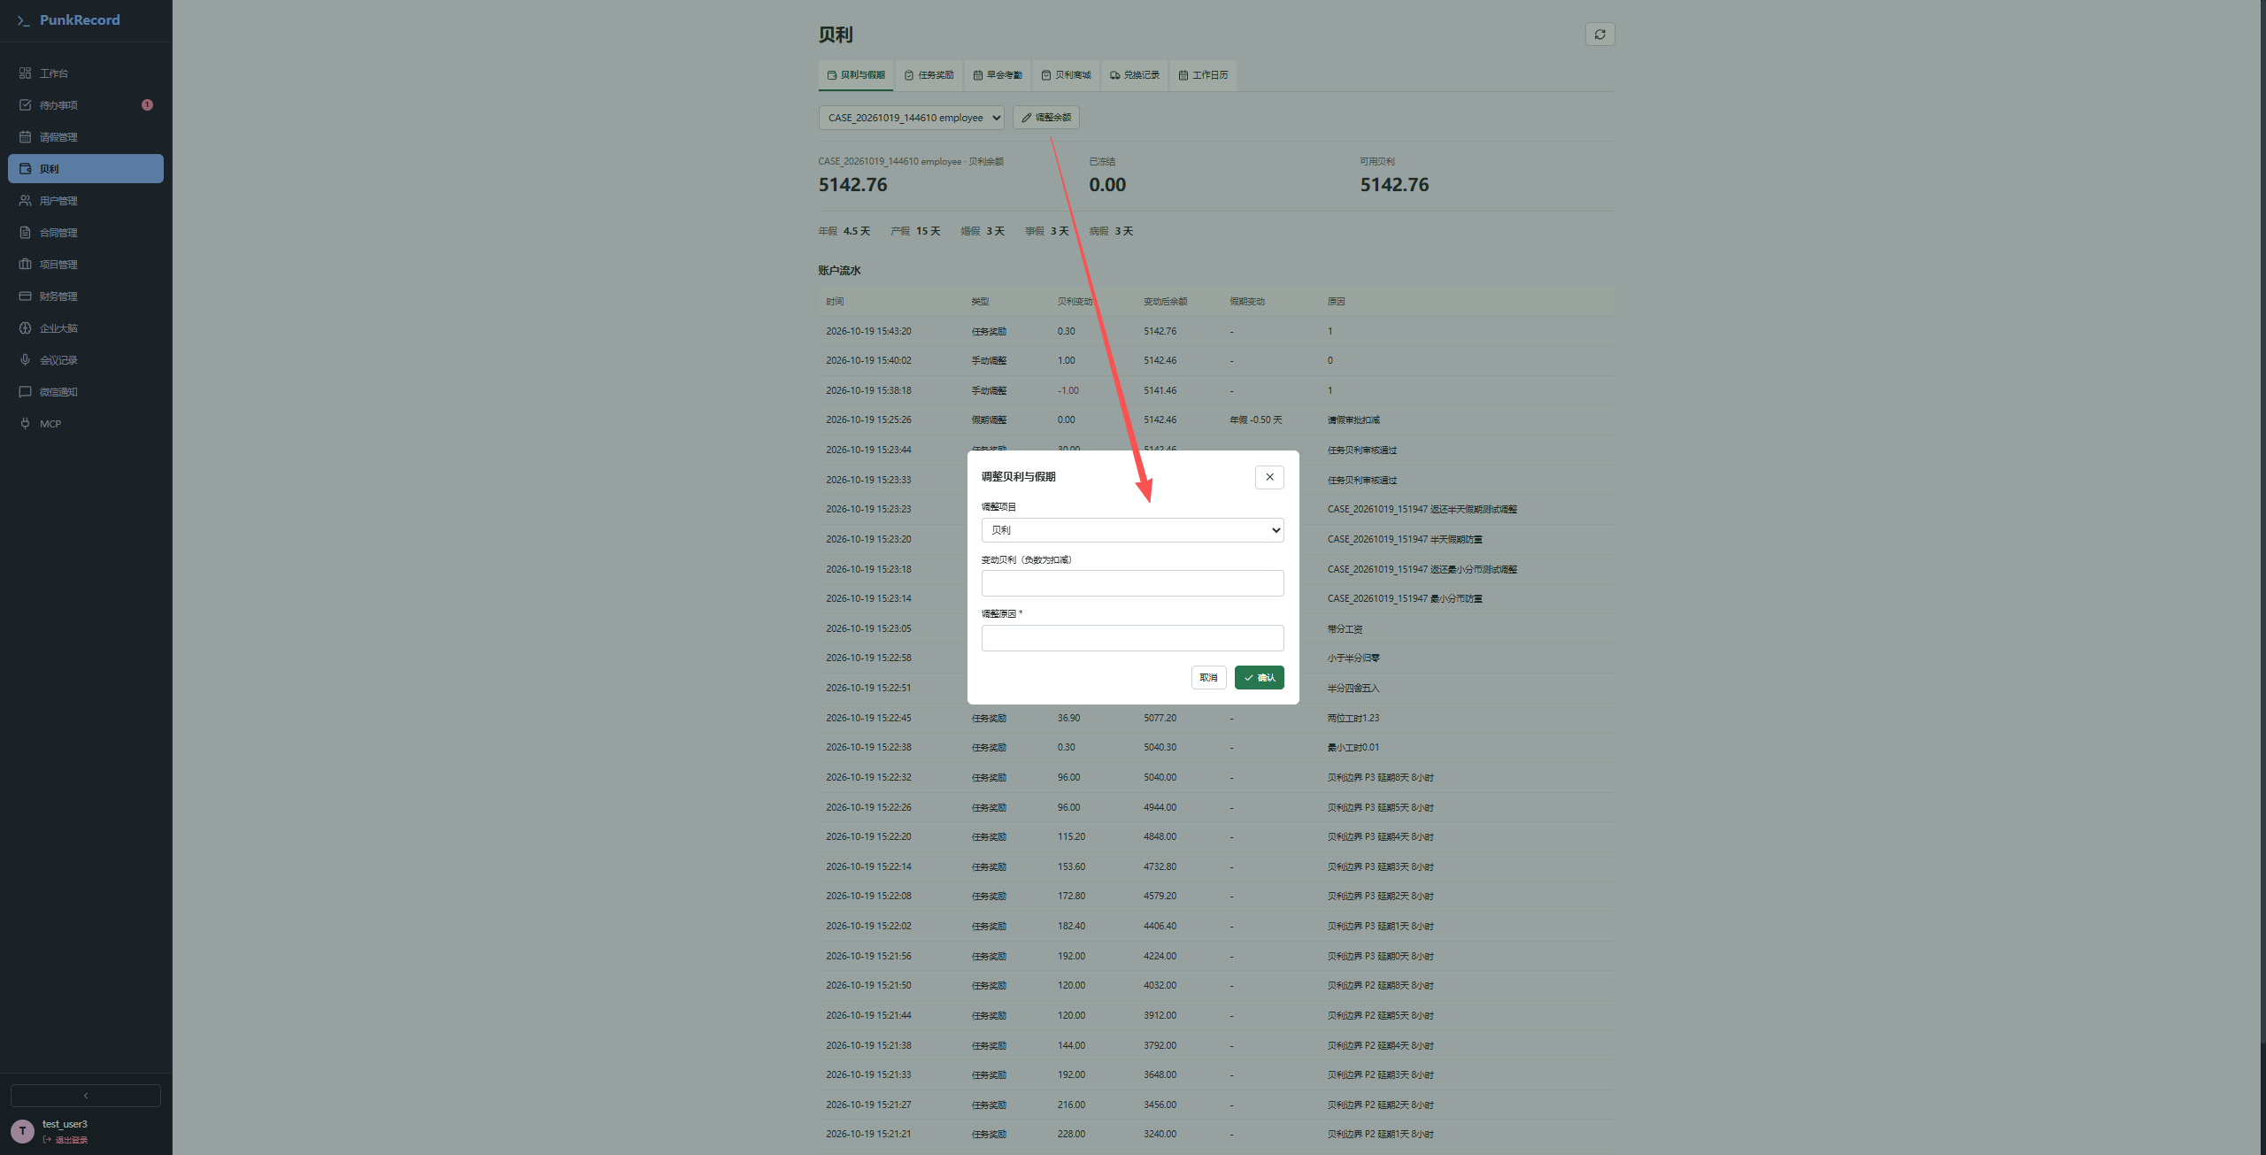
变动贝利为0 --》提示请选择非 L0 员工，填写调整金额及原因，页面应该提示不能为0；
-9999999999999、999999999999999999、0.003--》返回422；页面输入框建议设置输入最大值、最小值限制、分数限制
- 新增商品
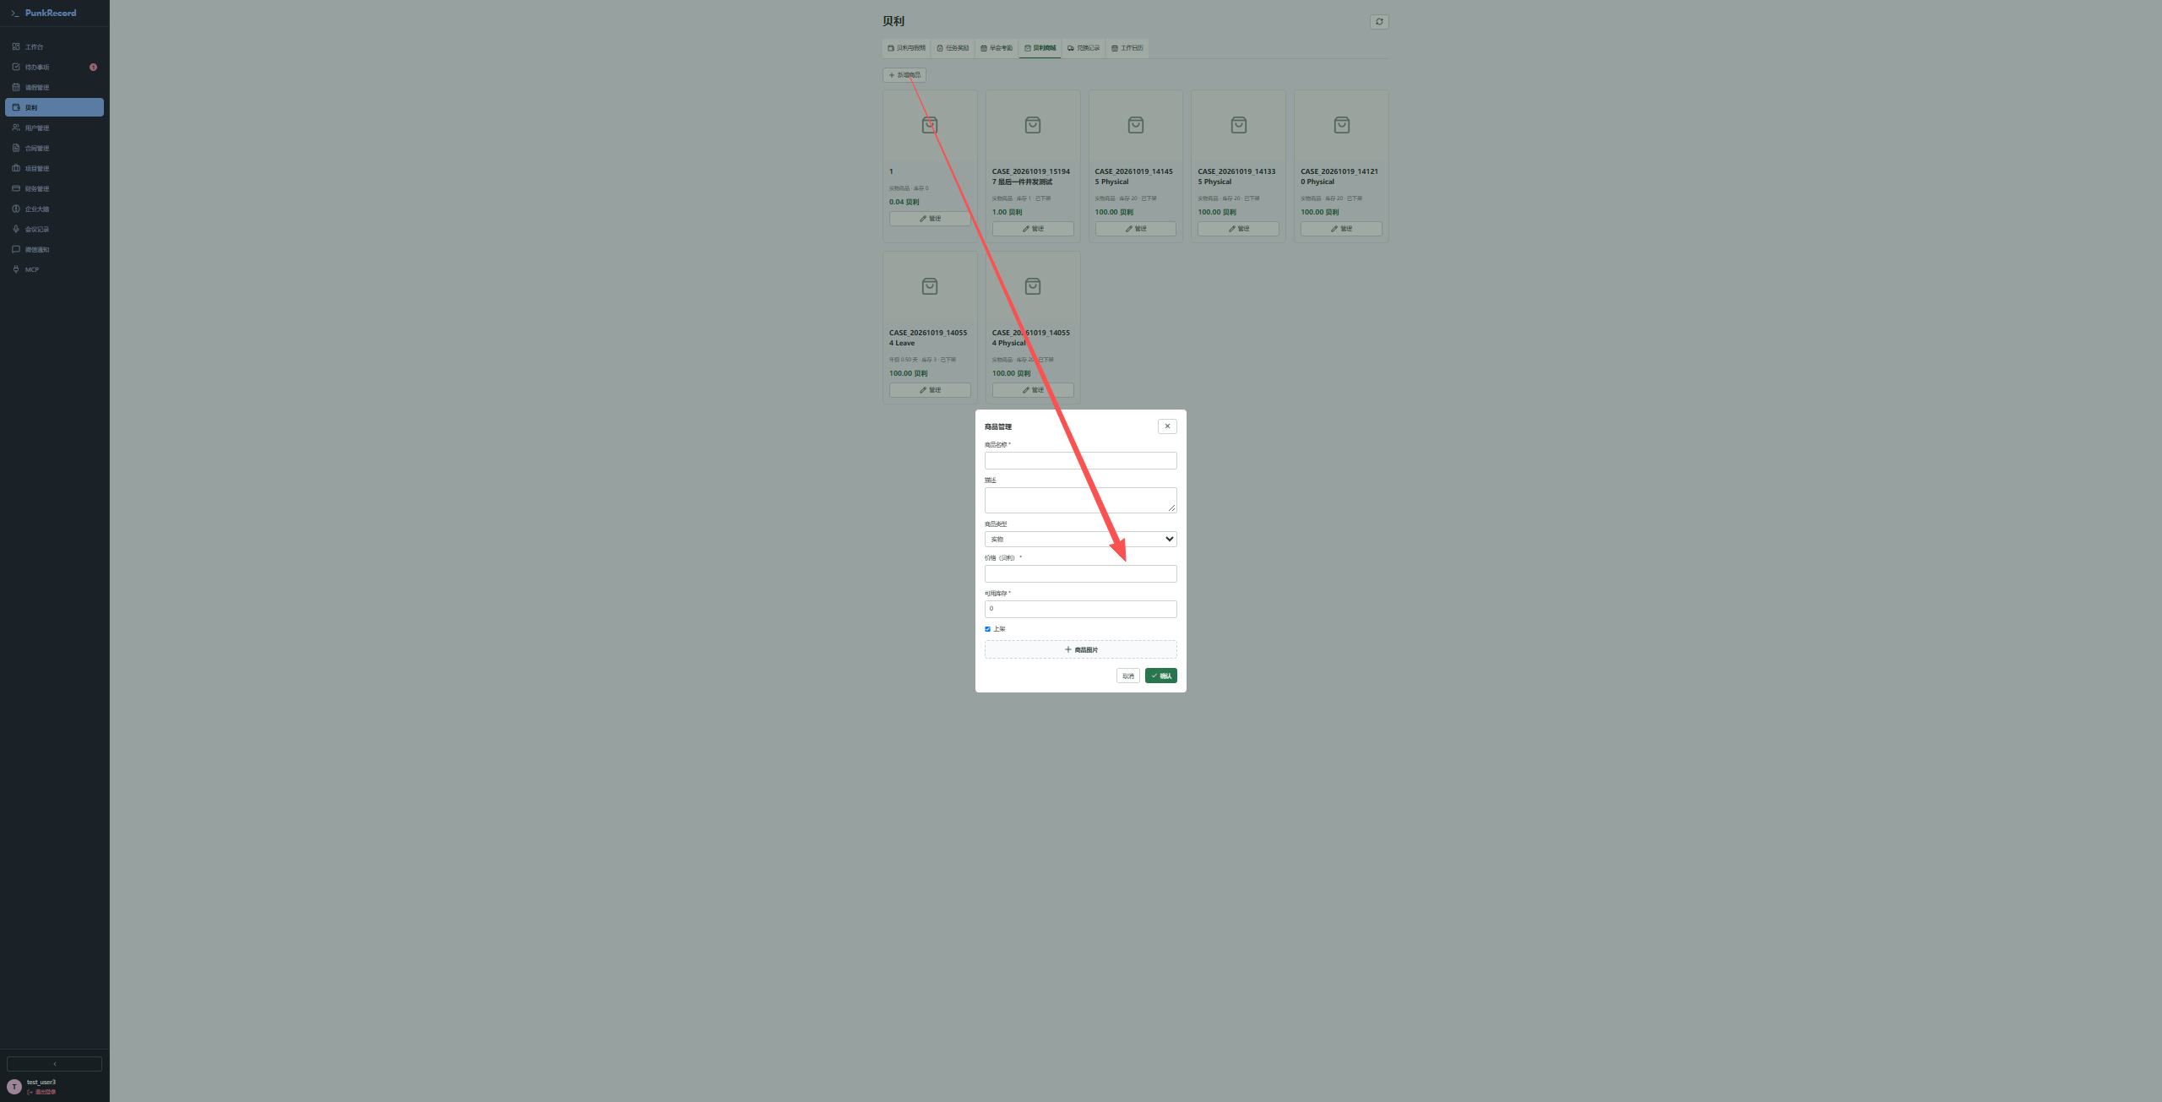
价格贝利为999999999999--》返回422；页面输入框设置最大值限制
商品卡片样式优化：商品名称过长时，下方的管理按钮不在统一水平线上

- 贝利、请假管理页面的翻页样式与其他页面不一致，没有共用同一个组件
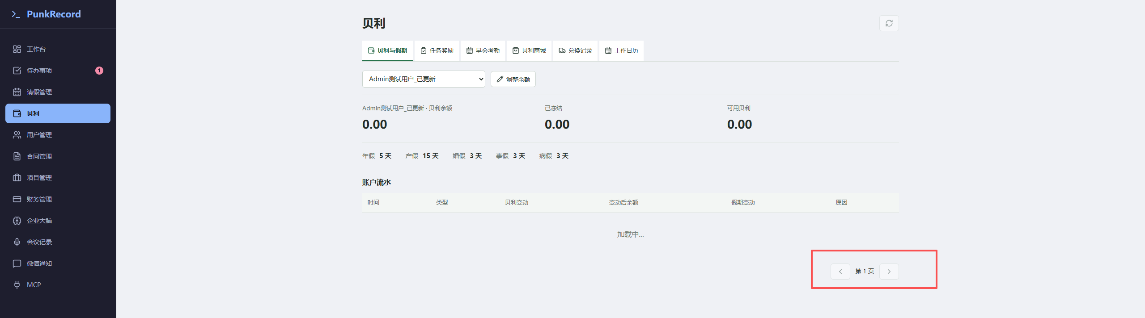

- 早会考勤，匹配员工时因该根据用户名匹配，用户名目前具有唯一性，姓名没有，存在两个相同姓名时，会出现匹配异常
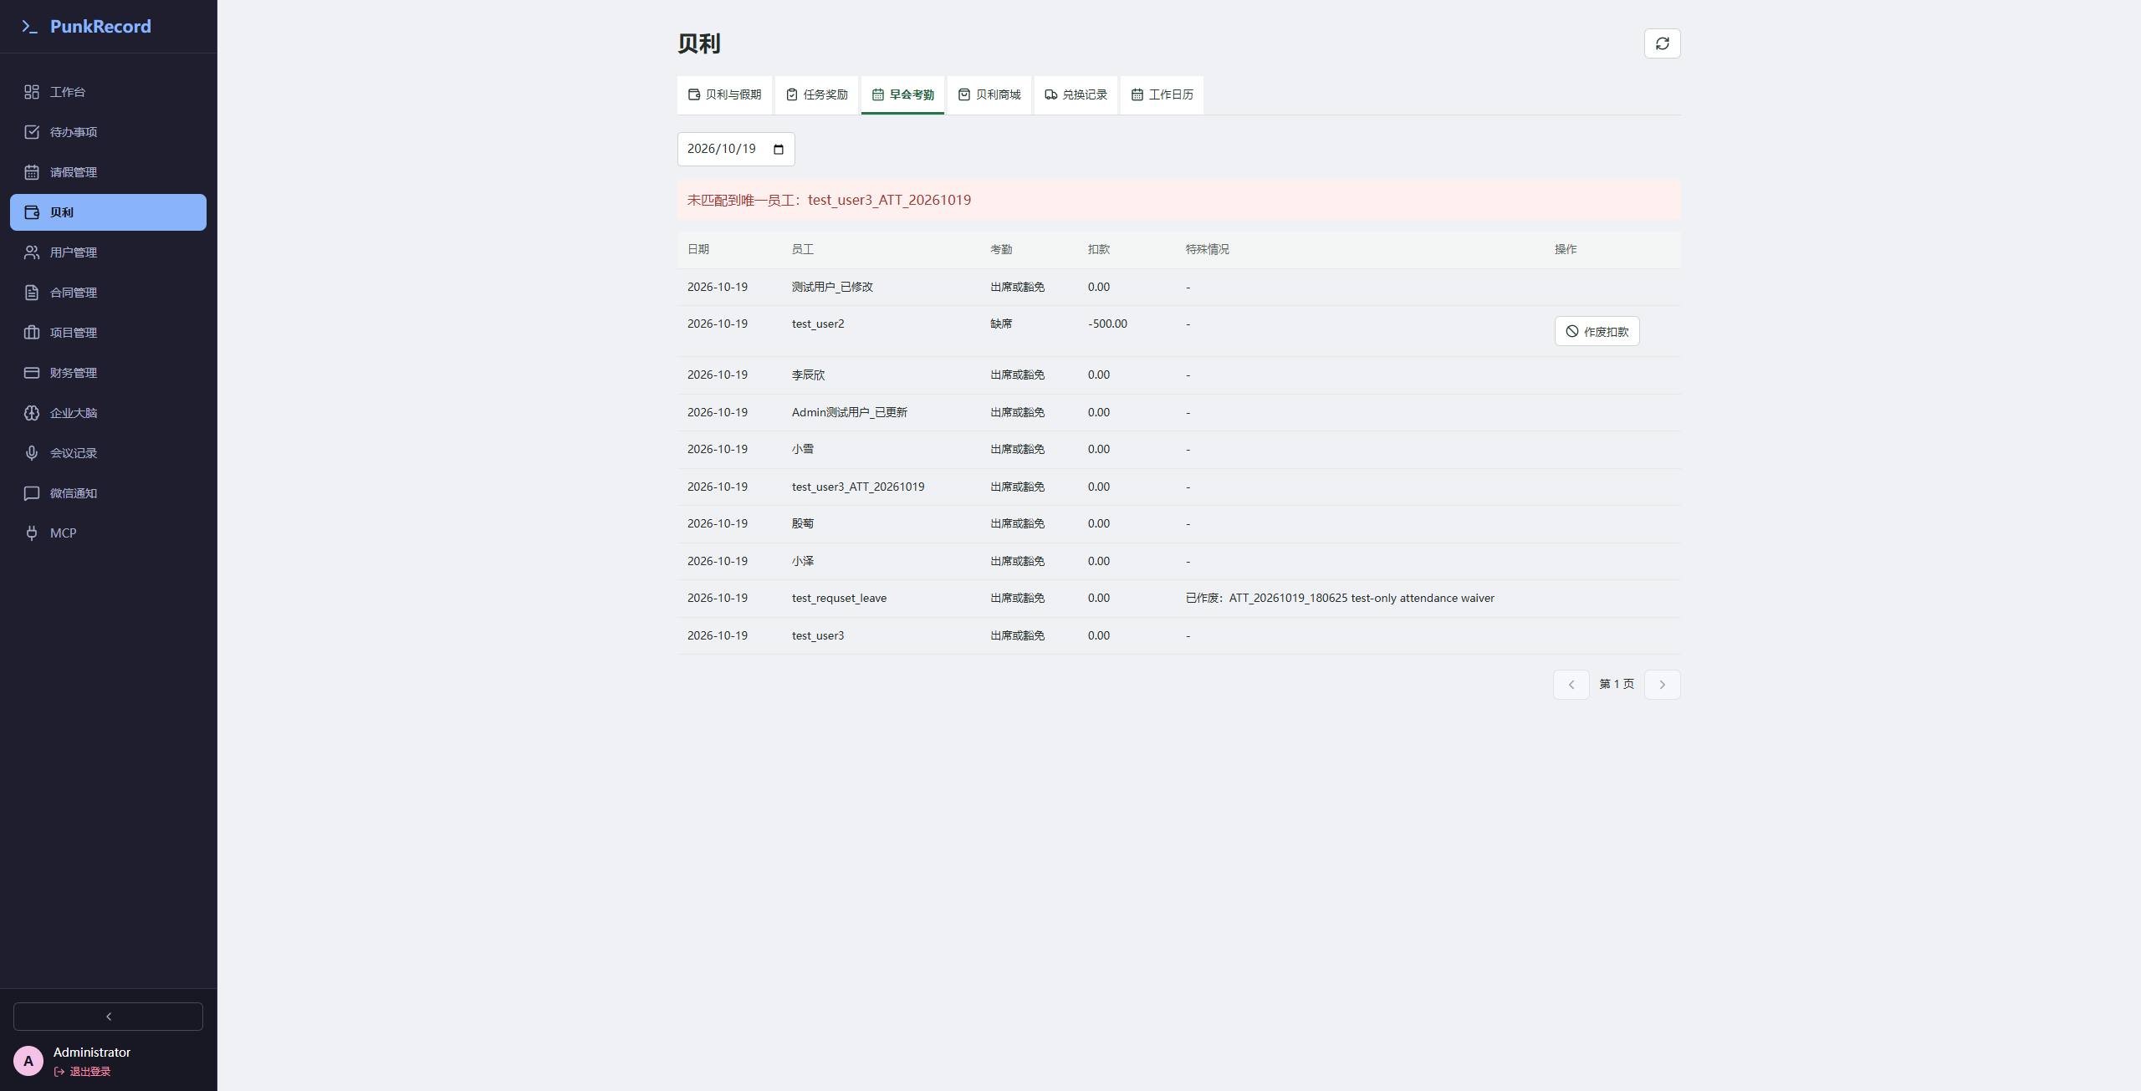

普通文本空格校验异常结果
纯空格输入为3个空格；首尾输入各含2个空格，应过滤两端空格，中间空格保留。特殊类型、枚举及自动生成字段不在范围内。
共26项功能，纯空格23项未通过、3项通过，首尾空格26项未通过。下表为原始断言JSON；更新日志content补充存储回读断言。
纯空格通过仅表示组合请求被拒绝，不代表每个字段均已独立校验。执行记录号可在autotest核对。

功能 | 字段 | 纯空格返回 |  | 首尾包含空格返回
功能 | 字段 | 返回结果 | 是否通过 | 返回结果 | 是否通过
项目 新增 | name  名称  description  描述或备注 | 执行记录 #20805  [  {  "type": "status_in",  "actual": 200,  "passed": false,  "expected": [  400,  422  ]  }  ] | 未通过 | 执行记录 #20806  [  {  "type": "status",  "actual": 200,  "passed": true,  "expected": 200  },  {  "type": "json_equals",  "actual": " STR3_1792469945169_347413 ",  "passed": false,  "expected": "STR3_1792469945169_347413"  },  {  "type": "json_equals",  "actual": " STR3_1792469945169_347413 ",  "passed": false,  "expected": "STR3_1792469945169_347413"  }  ] | 未通过
任务 新增 | title  标题  description  描述或备注  notes  备注 | 执行记录 #20799  [  {  "type": "status_in",  "actual": 200,  "passed": false,  "expected": [  400,  422  ]  }  ] | 未通过 | 执行记录 #20800  [  {  "type": "status",  "actual": 200,  "passed": true,  "expected": 200  },  {  "type": "json_equals",  "actual": " STR3_1792469931249_213936 ",  "passed": false,  "expected": "STR3_1792469931249_213936"  },  {  "type": "json_equals",  "actual": " STR3_1792469931249_213936 ",  "passed": false,  "expected": "STR3_1792469931249_213936"  },  {  "type": "json_equals",  "actual": " STR3_1792469931249_213936 ",  "passed": false,  "expected": "STR3_1792469931249_213936"  }  ] | 未通过
任务 编辑 | title  标题  description  描述或备注  notes  备注 | 执行记录 #20802  [  {  "type": "status_in",  "actual": 200,  "passed": false,  "expected": [  400,  422  ]  }  ] | 未通过 | 执行记录 #20803  [  {  "type": "status",  "actual": 200,  "passed": true,  "expected": 200  },  {  "type": "json_equals",  "actual": " STR3_1792469937241_886098 ",  "passed": false,  "expected": "STR3_1792469937241_886098"  },  {  "type": "json_equals",  "actual": " STR3_1792469937241_886098 ",  "passed": false,  "expected": "STR3_1792469937241_886098"  },  {  "type": "json_equals",  "actual": " STR3_1792469937241_886098 ",  "passed": false,  "expected": "STR3_1792469937241_886098"  }  ] | 未通过
项目 编辑 | name  名称  description  描述或备注 | 执行记录 #20808  [  {  "type": "status_in",  "actual": 200,  "passed": false,  "expected": [  400,  422  ]  }  ] | 未通过 | 执行记录 #20809  [  {  "type": "status",  "actual": 200,  "passed": true,  "expected": 200  },  {  "type": "json_equals",  "actual": " STR3_1792469951225_967394 ",  "passed": false,  "expected": "STR3_1792469951225_967394"  },  {  "type": "json_equals",  "actual": " STR3_1792469951225_967394 ",  "passed": false,  "expected": "STR3_1792469951225_967394"  }  ] | 未通过
非业务会议 新增 | title  标题 | 执行记录 #20823  [  {  "type": "status_in",  "actual": 200,  "passed": false,  "expected": [  400,  422  ]  }  ] | 未通过 | 执行记录 #20824  [  {  "type": "status",  "actual": 200,  "passed": true,  "expected": 200  },  {  "type": "json_equals",  "actual": " STR3_1792469986088_649231 ",  "passed": false,  "expected": "STR3_1792469986088_649231"  }  ] | 未通过
项目阶段 编辑 | deliverables  交付内容 | 执行记录 #20847  [  {  "type": "status_in",  "actual": 200,  "passed": false,  "expected": [  400,  422  ]  }  ] | 未通过 | 执行记录 #20848  [  {  "type": "status",  "actual": 200,  "passed": true,  "expected": 200  },  {  "type": "json_equals",  "actual": " STR3_1792470031036_333691 ",  "passed": false,  "expected": "STR3_1792470031036_333691"  }  ] | 未通过
项目任务计划 编辑 | title  标题  description  描述或备注 | 执行记录 #20853  [  {  "type": "status_in",  "actual": 400,  "passed": true,  "expected": [  400,  422  ]  }  ] | 通过 | 执行记录 #20854  [  {  "type": "status",  "actual": 200,  "passed": true,  "expected": 200  },  {  "type": "json_equals",  "actual": "STR3_1792470161000_214033",  "passed": true,  "expected": "STR3_1792470161000_214033"  },  {  "type": "json_equals",  "actual": " STR3_1792470161000_214033 ",  "passed": false,  "expected": "STR3_1792470161000_214033"  }  ] | 未通过
下架商品 新增 | name  名称  description  描述或备注 | 执行记录 #20811  [  {  "type": "status_in",  "actual": 200,  "passed": false,  "expected": [  400,  422  ]  }  ] | 未通过 | 执行记录 #20812  [  {  "type": "status",  "actual": 200,  "passed": true,  "expected": 200  },  {  "type": "json_equals",  "actual": " STR3_1792469960758_231860 ",  "passed": false,  "expected": "STR3_1792469960758_231860"  },  {  "type": "json_equals",  "actual": " STR3_1792469960758_231860 ",  "passed": false,  "expected": "STR3_1792469960758_231860"  }  ] | 未通过
下架商品 编辑 | name  名称  description  描述或备注 | 执行记录 #20814  [  {  "type": "status_in",  "actual": 200,  "passed": false,  "expected": [  400,  422  ]  }  ] | 未通过 | 执行记录 #20815  [  {  "type": "status",  "actual": 200,  "passed": true,  "expected": 200  },  {  "type": "json_equals",  "actual": " STR3_1792469967191_753675 ",  "passed": false,  "expected": "STR3_1792469967191_753675"  },  {  "type": "json_equals",  "actual": " STR3_1792469967191_753675 ",  "passed": false,  "expected": "STR3_1792469967191_753675"  }  ] | 未通过
待批请假（有效额度重测） 新增 | reason  原因 | 执行记录 #20844  [  {  "type": "status_in",  "actual": 200,  "passed": false,  "expected": [  400,  422  ]  }  ] | 未通过 | 执行记录 #20845  [  {  "type": "status",  "actual": 200,  "passed": true,  "expected": 200  },  {  "type": "json_equals",  "actual": " STR3_1792470024561_846979 ",  "passed": false,  "expected": "STR3_1792470024561_846979"  }  ] | 未通过
职位 新增 | name  名称  description  描述或备注 | 执行记录 #20775  [  {  "type": "status_in",  "actual": 200,  "passed": false,  "expected": [  400,  422  ]  }  ] | 未通过 | 执行记录 #20776  [  {  "type": "status",  "actual": 200,  "passed": true,  "expected": 200  },  {  "type": "json_equals",  "actual": " STR3_1792469885497_600443 ",  "passed": false,  "expected": "STR3_1792469885497_600443"  },  {  "type": "json_equals",  "actual": " STR3_1792469885497_600443 ",  "passed": false,  "expected": "STR3_1792469885497_600443"  }  ] | 未通过
职位 编辑 | name  名称  description  描述或备注 | 执行记录 #20778  [  {  "type": "status_in",  "actual": 200,  "passed": false,  "expected": [  400,  422  ]  }  ] | 未通过 | 执行记录 #20779  [  {  "type": "status",  "actual": 200,  "passed": true,  "expected": 200  },  {  "type": "json_equals",  "actual": " STR3_1792469890276_552783 ",  "passed": false,  "expected": "STR3_1792469890276_552783"  },  {  "type": "json_equals",  "actual": " STR3_1792469890276_552783 ",  "passed": false,  "expected": "STR3_1792469890276_552783"  }  ] | 未通过
部门 新增 | name  名称  description  描述或备注 | 执行记录 #20781  [  {  "type": "status_in",  "actual": 200,  "passed": false,  "expected": [  400,  422  ]  }  ] | 未通过 | 执行记录 #20782  [  {  "type": "status",  "actual": 200,  "passed": true,  "expected": 200  },  {  "type": "json_equals",  "actual": " STR3_1792469895506_451007 ",  "passed": false,  "expected": "STR3_1792469895506_451007"  },  {  "type": "json_equals",  "actual": " STR3_1792469895506_451007 ",  "passed": false,  "expected": "STR3_1792469895506_451007"  }  ] | 未通过
部门 编辑 | name  名称  description  描述或备注 | 执行记录 #20784  [  {  "type": "status_in",  "actual": 200,  "passed": false,  "expected": [  400,  422  ]  }  ] | 未通过 | 执行记录 #20785  [  {  "type": "status",  "actual": 200,  "passed": true,  "expected": 200  },  {  "type": "json_equals",  "actual": " STR3_1792469901893_546822 ",  "passed": false,  "expected": "STR3_1792469901893_546822"  },  {  "type": "json_equals",  "actual": " STR3_1792469901893_546822 ",  "passed": false,  "expected": "STR3_1792469901893_546822"  }  ] | 未通过
停用贝利规则 新增 | name  名称  note  备注 | 执行记录 #20787  [  {  "type": "status_in",  "actual": 400,  "passed": true,  "expected": [  400,  422  ]  }  ] | 通过 | 执行记录 #20788  [  {  "type": "status",  "actual": 200,  "passed": true,  "expected": 200  },  {  "type": "json_equals",  "actual": "STR3_1792469907297_123537",  "passed": true,  "expected": "STR3_1792469907297_123537"  },  {  "type": "json_equals",  "actual": " STR3_1792469907297_123537 ",  "passed": false,  "expected": "STR3_1792469907297_123537"  }  ] | 未通过
停用贝利规则 编辑 | name  名称  note  备注 | 执行记录 #20790  [  {  "type": "status_in",  "actual": 400,  "passed": true,  "expected": [  400,  422  ]  }  ] | 通过 | 执行记录 #20791  [  {  "type": "status",  "actual": 200,  "passed": true,  "expected": 200  },  {  "type": "json_equals",  "actual": "STR3_1792469912075_700775",  "passed": true,  "expected": "STR3_1792469912075_700775"  },  {  "type": "json_equals",  "actual": " STR3_1792469912075_700775 ",  "passed": false,  "expected": "STR3_1792469912075_700775"  }  ] | 未通过
交易方 新增 | name  名称  address  地址  bank_name  银行名称 | 执行记录 #20793  [  {  "type": "status_in",  "actual": 200,  "passed": false,  "expected": [  400,  422  ]  }  ] | 未通过 | 执行记录 #20794  [  {  "type": "status",  "actual": 200,  "passed": true,  "expected": 200  },  {  "type": "json_equals",  "actual": " STR3_1792469918204_684551 ",  "passed": false,  "expected": "STR3_1792469918204_684551"  },  {  "type": "json_equals",  "actual": " STR3_1792469918204_684551 ",  "passed": false,  "expected": "STR3_1792469918204_684551"  },  {  "type": "json_equals",  "actual": " STR3_1792469918204_684551 ",  "passed": false,  "expected": "STR3_1792469918204_684551"  }  ] | 未通过
交易方 编辑 | name  名称  address  地址  bank_name  银行名称 | 执行记录 #20796  [  {  "type": "status_in",  "actual": 200,  "passed": false,  "expected": [  400,  422  ]  }  ] | 未通过 | 执行记录 #20797  [  {  "type": "status",  "actual": 200,  "passed": true,  "expected": 200  },  {  "type": "json_equals",  "actual": " STR3_1792469924269_327150 ",  "passed": false,  "expected": "STR3_1792469924269_327150"  },  {  "type": "json_equals",  "actual": " STR3_1792469924269_327150 ",  "passed": false,  "expected": "STR3_1792469924269_327150"  },  {  "type": "json_equals",  "actual": " STR3_1792469924269_327150 ",  "passed": false,  "expected": "STR3_1792469924269_327150"  }  ] | 未通过
更新日志 新增 | version  版本  title  标题  content  内容 | 执行记录 #20817  [  {  "type": "status_in",  "actual": 200,  "passed": false,  "expected": [  400,  422  ]  }  ] | 未通过 | 执行记录 #20818  [  {  "type": "status",  "actual": 200,  "passed": true,  "expected": 200  },  {  "type": "json_equals",  "actual": " STR3_1792469974262_594374 ",  "passed": false,  "expected": "STR3_1792469974262_594374"  },  {  "type": "json_equals",  "actual": " STR3_1792469974262_594374 ",  "passed": false,  "expected": "STR3_1792469974262_594374"  }  ]  content 存储回读  [  {  "path": "content",  "type": "stored_field_equals",  "actual": " STR3_1792469974262_594374 ",  "passed": false,  "expected": "STR3_1792469974262_594374"  }  ] | 未通过
更新日志 编辑 | version  版本  title  标题  content  内容 | 执行记录 #20820  [  {  "type": "status_in",  "actual": 200,  "passed": false,  "expected": [  400,  422  ]  }  ] | 未通过 | 执行记录 #20821  [  {  "type": "status",  "actual": 200,  "passed": true,  "expected": 200  },  {  "type": "json_equals",  "actual": " STR3_1792469980137_879913 ",  "passed": false,  "expected": "STR3_1792469980137_879913"  },  {  "type": "json_equals",  "actual": " STR3_1792469980137_879913 ",  "passed": false,  "expected": "STR3_1792469980137_879913"  }  ]  content 存储回读  [  {  "path": "content",  "type": "stored_field_equals",  "actual": " STR3_1792469980137_879913 ",  "passed": false,  "expected": "STR3_1792469980137_879913"  }  ] | 未通过
草稿合同 新增 | name  名称 | 执行记录 #20838  [  {  "type": "status_in",  "actual": 200,  "passed": false,  "expected": [  400,  422  ]  }  ] | 未通过 | 执行记录 #20839  [  {  "type": "status",  "actual": 200,  "passed": true,  "expected": 200  },  {  "type": "json_equals",  "actual": " STR3_1792470013646_827504 ",  "passed": false,  "expected": "STR3_1792470013646_827504"  }  ] | 未通过
独立财务账户 新增 | account_name  账户名称  bank_name  银行名称  bank_branch  支行 | 执行记录 #20826  [  {  "type": "status_in",  "actual": 200,  "passed": false,  "expected": [  400,  422  ]  }  ] | 未通过 | 执行记录 #20827  [  {  "type": "status",  "actual": 200,  "passed": true,  "expected": 200  },  {  "type": "json_equals",  "actual": " STR3_1792469991412_205069 ",  "passed": false,  "expected": "STR3_1792469991412_205069"  },  {  "type": "json_equals",  "actual": " STR3_1792469991412_205069 ",  "passed": false,  "expected": "STR3_1792469991412_205069"  },  {  "type": "json_equals",  "actual": " STR3_1792469991412_205069 ",  "passed": false,  "expected": "STR3_1792469991412_205069"  }  ] | 未通过
独立财务账户 编辑 | account_name  账户名称  bank_name  银行名称  bank_branch  支行 | 执行记录 #20829  [  {  "type": "status_in",  "actual": 200,  "passed": false,  "expected": [  400,  422  ]  }  ] | 未通过 | 执行记录 #20830  [  {  "type": "status",  "actual": 200,  "passed": true,  "expected": 200  },  {  "type": "json_equals",  "actual": " STR3_1792469997430_800351 ",  "passed": false,  "expected": "STR3_1792469997430_800351"  },  {  "type": "json_equals",  "actual": " STR3_1792469997430_800351 ",  "passed": false,  "expected": "STR3_1792469997430_800351"  },  {  "type": "json_equals",  "actual": " STR3_1792469997430_800351 ",  "passed": false,  "expected": "STR3_1792469997430_800351"  }  ] | 未通过
未对账测试交易 新增 | purpose  用途 | 执行记录 #20832  [  {  "type": "status_in",  "actual": 200,  "passed": false,  "expected": [  400,  422  ]  }  ] | 未通过 | 执行记录 #20833  [  {  "type": "status",  "actual": 200,  "passed": true,  "expected": 200  },  {  "type": "json_equals",  "actual": " STR3_1792470002974_111608 ",  "passed": false,  "expected": "STR3_1792470002974_111608"  }  ] | 未通过
未对账测试交易 编辑 | purpose  用途 | 执行记录 #20835  [  {  "type": "status_in",  "actual": 200,  "passed": false,  "expected": [  400,  422  ]  }  ] | 未通过 | 执行记录 #20836  [  {  "type": "status",  "actual": 200,  "passed": true,  "expected": 200  },  {  "type": "json_equals",  "actual": " STR3_1792470008797_497577 ",  "passed": false,  "expected": "STR3_1792470008797_497577"  }  ] | 未通过
草稿合同 编辑 | name  名称 | 执行记录 #20841  [  {  "type": "status_in",  "actual": 200,  "passed": false,  "expected": [  400,  422  ]  }  ] | 未通过 | 执行记录 #20842  [  {  "type": "status",  "actual": 200,  "passed": true,  "expected": 200  },  {  "type": "json_equals",  "actual": " STR3_1792470019728_652056 ",  "passed": false,  "expected": "STR3_1792470019728_652056"  }  ] | 未通过

- 职位管理-删除异常、新增、编辑支持填写空字符串

