Xun Zhao 赵汛  ACADEMIC CURRICULUM VITAE  M.S. Student in Artificial Intelligence · Hubei University · EILab  zhaoxun@stu.hubu.edu.cn | zhaoxun.eu.cc | github.com/zx2002430 | 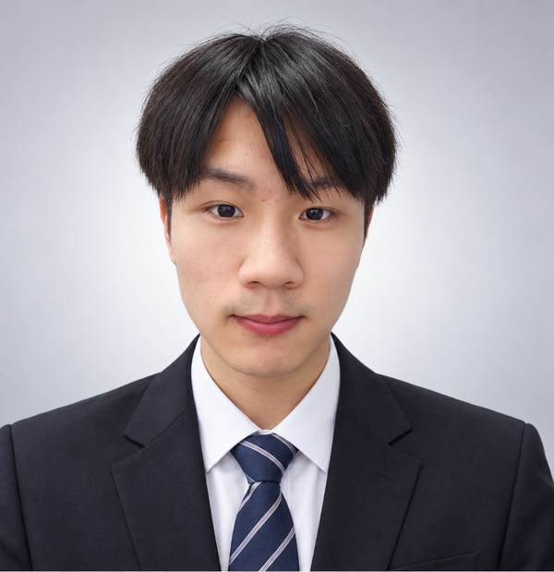

PROFILE
Master's student at Hubei University working on embodied AI and robot learning. Current research spans efficient vision-language-action adaptation, meta multi-agent reinforcement learning for dual-arm manipulation, and transfer from simulation to physical robots.
RESEARCH INTERESTS
Embodied AI · Vision-Language-Action Models · Multi-Agent Reinforcement Learning · Dual-Arm Manipulation · Sim-to-Real Transfer
EDUCATION
M.S. in Artificial Intelligence · Hubei University 2025–Present
School of Artificial Intelligence · EILab
B.S. in Computer Science and Technology · Wuhan Huaxia Institute of Technology 2023–2025
MANUSCRIPTS UNDER REVIEW
DM-NAV: Deployable Meta Multi-Agent Reinforcement Learning for Dual-Arm Dynamic Obstacle Avoidance
AAMAS 2027 · Under review
Empirical Investigation of Parameter-Efficient Fine-Tuning in Vision-Language-Action Models
AAMAS 2027 · Under review
SELECTED RESEARCH
DM-NAV · Dual-Arm Meta-MARL and Sim-to-Real Deployment
Research on a three-stage pipeline covering MuJoCo cross-task meta-training, budgeted target-task adaptation, and frozen-policy deployment to physical dual UR5 robots. Evaluation spans six simulated MARL baselines and 14 physical obstacle-motion conditions.
VLA Parameter-Efficient Fine-Tuning Study
Compared LoRA, DoRA, QLoRA, AdaLoRA, HiRA, and IA3 across LIBERO manipulation and R2R navigation, tracking task performance, memory use, and training time.
VLA-MoE · Action-Tail Specialization for Multi-Task Policies
Ongoing study of task-group action residuals in OpenVLA-OFT policies. Matched dense baselines and smaller alternatives remain under evaluation.
HONORS AND TEACHING
• Runner-up, Inaugural China (International) Robot Debate Competition
• Second Prize, Graduate Academic Scholarship · Hubei University
Teaching Assistant · Python and Fundamentals of Artificial Intelligence; supported lab instruction, homework feedback, exam preparation, invigilation, and marking.
TECHNICAL SKILLS
AI and Robotics: Python, PyTorch, MuJoCo, ROS 2, MoveIt, RGB-D perception, YOLO
Development Tools: Linux, Docker, CUDA, Git, LaTeX
Additional Software: Java, Spring MVC / Spring Boot, MySQL, HTML, CSS, JavaScript
CERTIFICATIONS AND ENGLISH
Huawei HCIA-Datacom · National Computer Rank Examination Level 3 (Network Technology) and Level 2 (C) · Putonghua Proficiency Test Level 2-B · CET-4

赵汛 Xun Zhao
学术简历 · ACADEMIC CV
湖北大学人工智能学院 · 人工智能专业硕士研究生 · EILab
zhaoxun@stu.hubu.edu.cn | zhaoxun.eu.cc | github.com/zx2002430

个人简介
湖北大学人工智能学院硕士研究生，研究聚焦具身智能与机器人学习，涉及视觉-语言-动作模型高效适配、双臂元多智能体强化学习和仿真到真机迁移。
研究兴趣
具身智能 · 视觉-语言-动作模型 · 多智能体强化学习 · 双臂操作 · 仿真到真机迁移
教育背景
湖北大学 · 人工智能专业硕士研究生 2025–至今
人工智能学院 · EILab
武汉华夏理工学院 · 计算机科学与技术专业本科 2023–2025
在投稿件
DM-NAV：面向双臂动态避障的可部署元多智能体强化学习
AAMAS 2027 · 在投
视觉-语言-动作模型参数高效微调的实证研究
AAMAS 2027 · 在投
代表性研究
DM-NAV · 双臂元多智能体学习与仿真到真机部署
围绕 MuJoCo 跨任务元训练、有限交互预算下的目标任务适应，以及冻结策略在真实双 UR5 上的部署开展研究。实验包括六种仿真 MARL 基线和 14 种真机障碍运动条件。
VLA 参数高效微调实证研究
在 LIBERO 操作和 R2R 导航任务中比较 LoRA、DoRA、QLoRA、AdaLoRA、HiRA、IA3，分别考察任务表现、显存占用和训练时间。
VLA-MoE · 多任务策略动作末端专门化
研究 OpenVLA-OFT 策略中的任务组动作残差；匹配 Dense 基线与更小替代方法仍在验证中。
荣誉与教学
• 首届中国（国际）机器人辩论大赛亚军
• 湖北大学硕士研究生学业奖学金二等奖
课程助教 ·《Python》《人工智能基础》；参与实验教学、作业反馈、考试准备、监考与阅卷。
技术能力
人工智能与机器人：Python、PyTorch、MuJoCo、ROS 2、MoveIt、RGB-D 感知、YOLO
开发工具：Linux、Docker、CUDA、Git、LaTeX
其他软件技术：Java、Spring MVC / Spring Boot、MySQL、HTML、CSS、JavaScript
专业证书与英语
华为 HCIA-Datacom 认证 · 全国计算机等级考试三级（网络技术）、二级（C 语言）· 普通话二级乙等 · 大学英语四级（CET-4）

