特点 Features

蓄电池及充电机 Batteries and chargers

标准配置垂直更换电池。可选左侧或右侧侧面更换电 |  | Vertical battery change as standard, optionally side battery
池 |  | change left or right
电池容量从180Ah to 620Ah 可选 |  | Wide range of batteries from 180Ah to 620 Ah
侧面更换电池选项的电池锁紧装置，可以将电池保护 |  | Battery locking system for side change option secures
在电池箱内，而且方便更换 |  | battery in compartment and eases the battery change

交流电机 AC motor

强劲平稳的3KW驱动电机 |  |  |  |  | Powerful, smooth-running motor, 3KW
满载爬坡能力13% |  |  |  |  | Gradeability 13% with coat
斜坡启动不下滑 |  |  |  |  | No rollback on uphill starting
满载与空载最大行驶速度10Km/h |  |  |  |  | Top speed 10 km/h, loaded as unloaded
有力的加速度，5秒钟内达到最高行驶速度 |  |  |  |  | Forceful acceleration takes truck to top speed within 5 metres
封闭的电机可以防止湿气与灰尘进入，完全免 |  |  |  |  | Moisture and dust-proof motor needs no maintenance
维护

标准配置 Standard Equipment

带护板的安全驾驶空间 |  |  | Safe operator's compartment with shielded cockpit
单手控制的易驾舵柄 |  |  | Drive control e-driver operated with only one hand
交流电机 |  |  | AC motor
橡胶驱动轮 |  |  | Rubber drive wheel
聚氨酯稳定轮 |  |  | Polyurethane castor wheels
聚氨酯双承载轮 |  |  | Polyurethane tandem load wheels
自动制动 |  |  | Automatic braking
喇叭 |  |  | Horn
标准电池规格: 24V/3PzS/330AH，充电机: E24/50P |  |  | Battery 24V/3PzS/330AH Charger E24/50P
货叉规格: 560mm(宽)x1150mm(长) |  |  | Fork width across 560mm, length 1150mm
启动钥匙开关 |  |  | Key switch
零下10°低温保护 |  |  | Protection -10°C
带比例控制的电子转向 |  |  | Proportional power assisted steering with positive steering
根据负载比例调节的电磁紧急制动 |  |  | feedback
电子控制主动式悬挂系统 |  |  | Electromagnetic emergency brake proportional to load
 |  |  | transported
 |  |  | Hydraulically suspended and electronically controlled
 |  |  | stabilisers

安全性 Safety
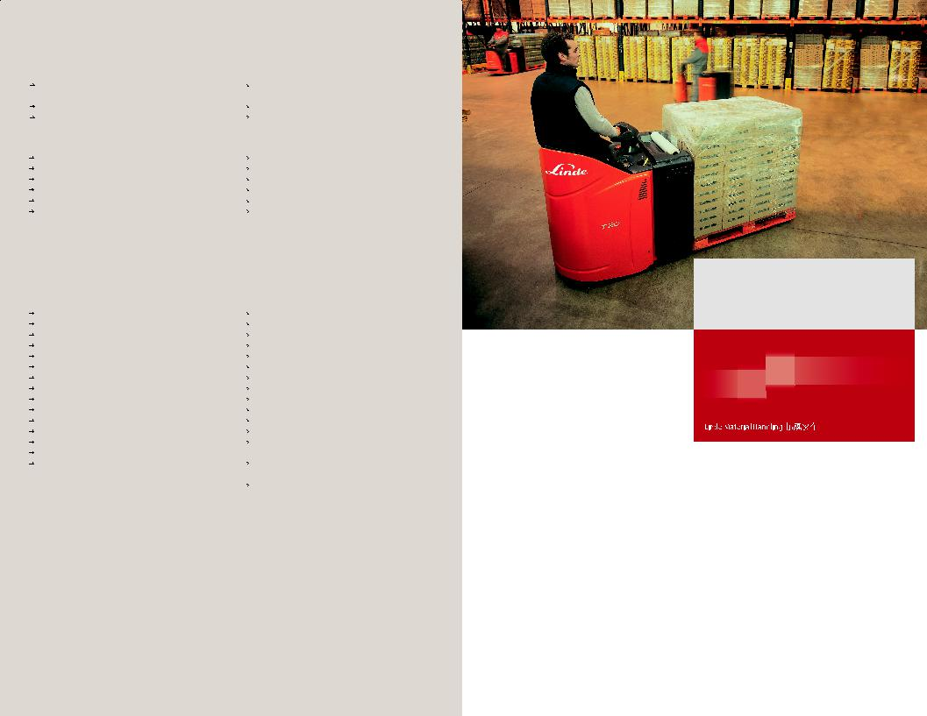
坚固的护板环绕在司机周围，有效的避免了碰撞可能造成的伤害，裙边保护保证叉车本身以及司机的腿部免受撞击。在任何时刻都能保证司机的身体处在叉车保护范围内。

The sturdy steel cockpit enclosure keeps the operator safe from shock and impact throughout the working day. The skirt surrounding the platform prevents damage to the truck or injury

站驾式电动托盘搬运叉车 T20SP

Stand-on Electric Pallet Truck
2000kg | 1158

可靠性 Reliability

特点 Features

舒适安全的电子转向
Power steering for comfort and safety

带比例控制的电子转向，可以自动

对中，容易操作 灵敏的转向反馈，使其在改变行驶

方向时也可以具有极佳的稳定性 转弯自动减速

Proportional power-assisted steering, self-centering and effortless to operate

Adjustable steering (drive wheel) feedback resulting in outstanding stability

Automatic speed reduction when cornering

驾驶系统
Total drive system

电子控制的主动悬挂系统保证了此

款叉车良好的稳定性 松开行驶按钮后实现自动制动

方便操控的反向电流制动 按下电源隔离开关实现电磁制动，作

用力的大小根据负载比例自动调整

Electronically controlled hydraulic-suspension active castor wheels provide superb stability and traction when transporting pallet loads

Automatic braking on releasing the travel switch
Well controllable countercurrent braking Electromagnetic braking initiated by the emergency stop button acts on the drive

CANBUS 数据总线
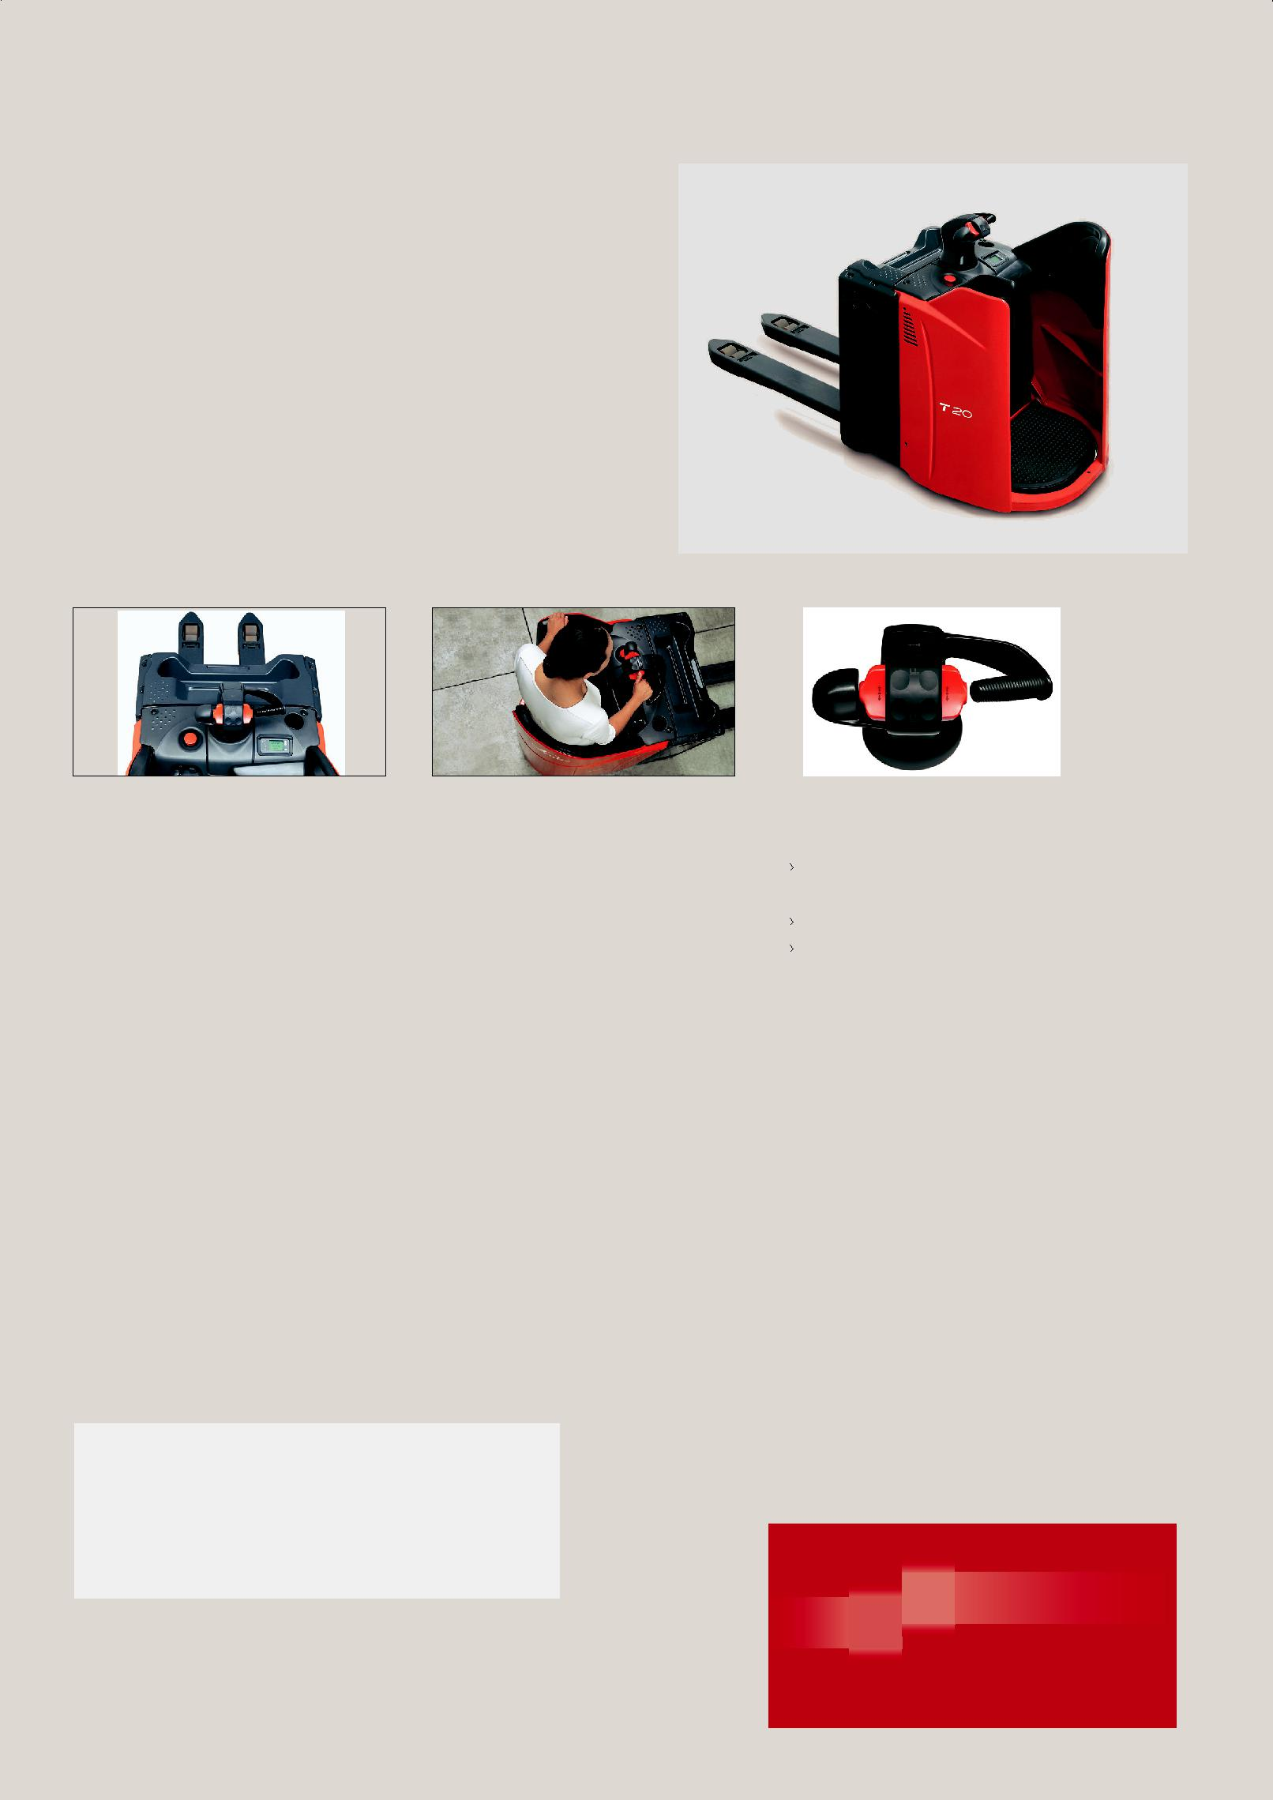
Linde operator compartment

用电脑对叉车进行快速诊断 所有的叉车参数都可由工程师设

定，以实现在各种工况下都有最完美的表现

E l e c t r o n i c m a n a g e m e n t o f components permitting quick and easy diagnosis

All truck parameters can be configured by the service technician to achieve best performance in every application

完美的45度角驾驶位置

Ideal 45° driving position

无论前进或后退都有极好的视野

任何情况下都具有最佳的安全性 超乎寻常的稳定性，特别体现在转弯的时候

Excellent view of environment driving in either forward or reverse direction

Utmost safety in every situation Exceptional stability, especially when cornering

 |  |  |  | 若有技术参数或配置的改进，恕不另行通知；所示图表可能含非标准配置。"Subjecttomodificationintheinterestsofprogress,Illustrationandtechnical | detailsnotbindingforactual constructions and may show the optional equipments."
林德"易驾"舵柄
Linde "E-Driver"
 |  | 符合人机工学的易驾舵柄可以实现
 |  | 司机的单手操作
 |  | 所有控制功能都集中于易驾手柄上
 |  | 与45° 角驾驶位置完美搭配

Ergonomic control handle allows one-hand operation
All main control functions integrated in one handle
Perfectly matched to 45° driving position

可选配置 Optional Equipment

可选货叉尺寸

驱动轮：聚氨酯、无痕橡胶或防滑轮胎

挡货架

可移动的/固定的电池架 (侧面更换电池) 低温保护至零下35°C

Alternative fork dimensions

Drive wheels: polyurethane, cushion non-marking or wet grip

Load backrest

Mobile and fixed battery stands (for side battery change) Cold store version -35°C

to legs and feet by intrusion of other forked vehicles. At no time is the operator’s body exposed beyond the contours of the truck.

高性能 Performance

T20SP配备了3KW的交流电机和主动的稳定轮。更强的加速度、更快的行驶速度和有效的制动使它在完成各种任务时都表现出色。

Its performance is based on a powerful 3 KW AC motor and active castor wheels. Forceful acceleration, high travel speed and efficient brakes add up to productivity in service at any duty level.

舒适性 Comfort

林德T20SP坚固的车体，使叉车运行更可靠。每根货叉均可负载2吨的货物而不变形。倾斜货叉尖、狭窄的货叉宽度使其可以平滑的进入闭式托盘。这些特点使其具有更长的工作寿命，且能更安全高效地进行搬运工作。

Rugged construction makes this truck reliable. Each fork tip supports a load of 2,000kg without bending. Smooth entry of the forks into closed pallets is assisted by the ramped tip shape, lead-in and narrow width.

Features that contribute to considerably longer truck lifetime as well as fast, easy and safe load handling.

易维护 Service

通过售后工程师把笔记本电脑接入数据口，CAN-Bus系统可以把叉车的数据全部读出。快速诊断、免维护的交流电机技术提高了叉车

motor, proportional to the load carried.

1158_T20SP_D-03_201204

可根据客户要求加装其他配置
Other Options Available on Request
与行驶方向成45°角的驾驶方式提供了叉车操作最理想的全景视野，无论是前进或者后退，司机都能保持良好的视野。

The ergonomic 45° angle driving position opens up entirely new perspectives by keeping the working environment in good view traveling either forwards or in reverse.

正常运行时间。

CAN-Bus connectivity enables all truck data to be read out on a laptop computer by the service technician. Swift access to all components and maintenance-free AC technology play anadditional part in keeping truck uptime up.
林德(中国)叉车有限公司 Linde (China) Forklift Truck Corp., Ltd.

地址：厦门市金尚路89号 Add.: No. 89, Jinshang Road, Xiamen 361009

电话/Tel: (0592)5533800 销售热线/Hot Line: (0592)5533888 800-858-2665(免费)

传真/Fax: (0592)5533242 服务热线/Service Hot Line: (0592)5533942

http: //www.linde-china.com

叉车技术参数 Technical Data |  |  |  |  |  |  |  |  | T20SP
 |  |  | 1.1 | 制造厂商 | Manufacturer |  | Linde
 |  | Characteristics | 1.2 | 型号 | Model designation |  | T20SP
 | 特 | Characteristics | 1.3 | 动力 | Power unit |  | 蓄电池 Battery
 |  |  | 1.4 | 驾驶方式 | Operation |  | 站驾式 Stand-on
 | 性 |  | 1.5 | 额定承载能力 | Load capacity | Q(kg) | 2000
 |  |  | 1.6 | 载荷中心距 | Load center | c(mm) | 600
 |  |  | 1.8 | 前悬距 (货叉提升/下降) | Axle centre to fork face (fork raised/lowered) | x(mm) | 895/962
 |  |  | 1.9 | 轴距 (货叉提升/下降) | Wheelbase (fork raised/lowered) | y(mm) | 1431/1497
 | 量Weights |  | 2.1 | 自重 | Service weight (with battery item 6.5) | kg | 897
 | 重
 |  |  | 2.2 | 满载时的桥负荷，驱动侧/承重侧 | Axle load with load, drive/load side | kg | 1164/1733
 |  |  | 2.3 | 空载时的桥负荷，驱动侧/承重侧 | Axle load without load drive/load side | kg | 740/157
 |  |  | 3.1 | 轮胎，驱动侧/承重侧：橡胶实心胎，聚胺酯胎 | Tyre,operator/load side: Rubber (R), polyurethane (PU) |  | R+P/P
 |  |  | 3.2 | 轮胎尺寸，驱动侧 | Tyre size, drive side | mm | 254 x 102
 | 轮 | Wheels | 3.3 | 轮胎尺寸，承重侧 | Tyre size, load side | mm | 85 x 105
 | 胎 | Wheels | 3.4 | 稳定轮尺寸 | Auxiliary wheel, size | mm | 125 x 60
 | 胎 |  | 3.5 | 车轮数量, 驱动侧/承重侧 (x=驱动轮) | Wheels number, drive/laod side (x=driven) |  | 1x+2/4
 |  |  | 3.6 | 轮距，驱动侧 | Track width, drive side | mm | 544
 |  |  | 3.7 | 轮距，承重侧 | Track width, load side | mm | 355/395/515
 |  |  | 4.4 | 提升高度 | Lift | h3(mm) | 125
 |  |  | 4.8 | 驾驶站板高度 (打开时) | Height of driving platform (low position) | h7(mm) | 160
 |  |  | 4.9 | 作业时手柄高度 | Height of tiller am in operation position | h14(mm) | 1160
 |  |  | 4.15 | 下降后货叉距地高度 | Fork height, lowered | h13(mm) | 85
 | 尺 |  | 4.19 | 总体长度 | Overall length | l1(mm) | 2346
 | 尺 | Dimensions | 4.22 | 货叉尺寸 | Fork dimensions | s/e/l(mm) | 55 x 165 x 1150
 |  |  | 4.20 | 车体长度 (不含货叉) | Length to fork face | l2(mm) | 1196
 |  |  | 4.21 | 车体宽度 | Overall width | b1(mm) | 790
 | 寸
 | 寸 |  | 4.25 | 过货叉距离 (最小/最大) | Fork spread | b5(mm) | 520/560/680
 |  |  | 4.32 | 轴距中心距地间隙 | Ground clearance, center of wheelbase min./max. | m2(mm) | 30/155
 |  |  | 4.33 | 直角堆垛通道宽度，托盘1000x1200 (1200 跨货叉放置) | Aisle width, 1000x1200mm pallet crosswise | Ast(mm) | 2395
 |  |  | 4.34 | 直角堆垛通道宽度，托盘800x1200 (1200 沿货叉放置) | Aisle width, 800x1200mm pallet lengthwise | Ast(mm) | 2595
 |  |  | 4.35 | 转弯半径 (货叉提升) | Turning radius (fork raised) | Wa(mm) | 2090
 |  | Performances | 5.1 | 行驶速度，满/空载 | Travel speed, with/without load | km/h | 10.0/10.0
 | 性 | Performances | 5.2 | 提升速度，满/空载 | Lift speed, with/without load | m/s | 0.036/0.043
 | 能 |  | 5.3 | 下降速度，满/空载 | Lower speed, with/without load | m/s | 0.064/0.060
 | 能 |  | 5.8 | 最大爬坡能力，满/空载 | Max. Climbing ability, with/without load | % | 13/20
 |  |  | 5.10 | 行车制动 | Service brake |  | 电磁 Electro-magnetic
 |  |  | 6.1 | 驱动电机功率 (60分钟) | Drive motor output (60 min.rating) | kw | 3.0
 | 驱 | Drive | 6.2 | 提升电机功率，15%功率 | Lift motor output (15% rating) | kw | 1.2
 |  | Drive | 6.3 | 蓄电池，根据DIN标准 | Battery according to DIN 43 531/35/36A,B,C,no |  | DIN 43535 B
 | 动 |  | 6.4 | 蓄电池电压/额定容量 (5小时放电量) | Battery voltage/rated capacity (5h) | V/Ah | 24/345
 |  |  | 6.5 | 电池重量 (+5%) | Battery weight | kg | 297
 | 其 | Others | 8.1 | 驱动控制方式 | Type of Drive control |  | LAC variator
 | 他 | Others
 | 他 | Others | 8.4 | 驾驶员耳边噪音水平 | Sound level at driver's ear | dB(A) | <70
 |  |  |  | 标准车型的数据，根据配置的不同会有所变化 | Figure for standard truck version may vary according to equipment

Ast=Wa-x+l6+a 安全距离 a=200mm
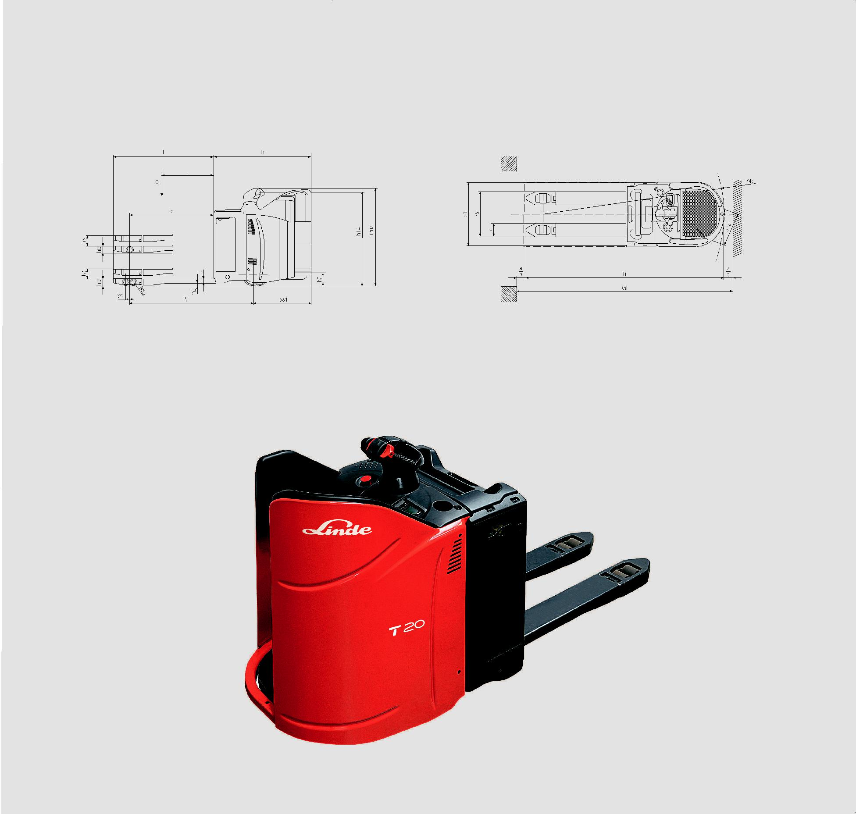
safety distance a=200mm

