特点 Features

特点 Features
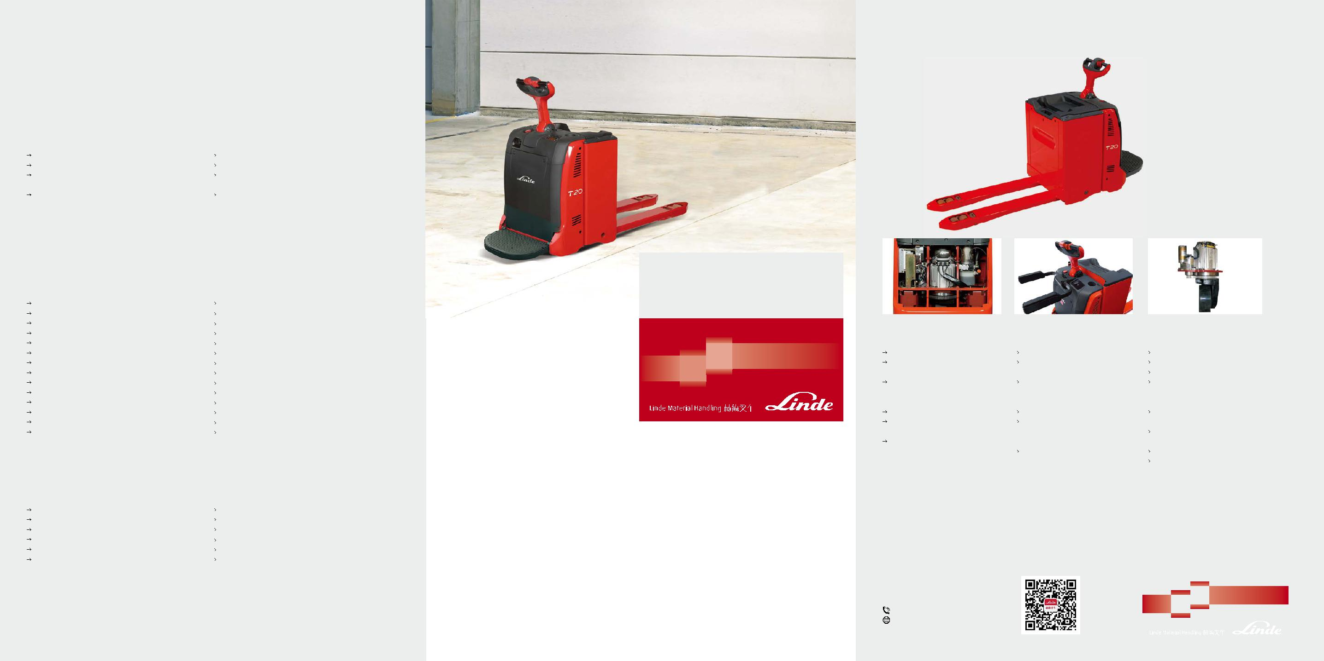

CAN-Bus总线系统 CAN-Bus connectivity

所有电子部件经由总线系统控制，叉车诊断方

便快捷 通过总线系统，服务工程师可根据用户实际情
况调节叉车运行参数

Electronic management of all components permitting quick and easy diagnosis

All performance parameters can be configured exactly by the service technician for every individual mission

林德独创控制舵柄
Linde control handlebars

人机工程设计及安装

充分保护双手 所有的控制按钮都集中在舵柄头部,单手即可操作

助力转向系统
Power steering

带比例控制功能的电子转向，操作

轻便 转弯自动减速
灵敏的转向反馈，使其在改变行驶方向时也可具有极佳的稳定性

驱动系统 Drive system

无论满载还是空载最高时速为 6km/h |  | Top speed 6km/h loaded and unloaded
松开加速开关自动制动 |  | Automatic braking on releasing the travel switch
按下电源隔离开关实现电磁制动，作用力的大小 |  | Electromagnetic braking initiated by the emergency stop button
根据负载自动调整 |  | acts on the drive motor, proportion to the load carried
反向行驶再生制动 |  | Well controllable regenerative braking on reversing direction of
 |  | travel

标准配置和选项 Standard and Optional Equipment

标准配置 Standard Equipment

电池放电指示器 |  | Battery discharge indicator
带防滑橡胶垫的悬浮式站板 |  | Suspension platform with skidproof mat
配备多种规格储物格的工作平台 |  | Workstation incorporating storage compartments
货叉560/1150 |  | Fork 560/1150
转向力可调的助力转向 |  | Power-assisted steering, adjustable steering resistance

安全性 Safety

蓄电池托盘搬运车 T20AP04

Pallet Truck

2000kg ₁₁₅₈

Ergonomic design and position

Optimum protection for both hands All main control functions integrated in the one handle for operation by either hand or both

电池和充电机 |  | 工作平台
Battary and charger |  | Workstation

Proportional power assisted steering, effortless to operate

Automatic speed reduction when cornering

Adjustable steering feedback resulting in outstanding stability

交流电机
AC motor

details not binding for actual constructions and may show the optional equipments." "Subject to modification in the interests of progress, Illustration and technical 若有技术参数或配置的改进，恕不另行通知；所示图表可能含非标准配置。

转弯自动减速系统 |  | Automatic speed reduction on cornering
交流驱动电机 |  | AC drive motor
松开加速按扭自动制动系统 |  | Automatic braking on releasing butterfly switch
两个固定式稳定轮 |  | Two fixed castor wheels
橡胶驱动轮 |  | Cushion drive wheel
双聚氨酯承载轮 |  | Tandem polyurethane load wheels
电喇叭 |  | Electric horn
低温保护至 -10°C |  | Low temperature protection to –10°C
负载自适应紧急制动系统 |  | Electromagnetic emergency brake acting proportionally to
 |  | the load weight

可选配置 Optional Equipment

电池侧面更换 |  | Side battery change
可折叠护臂 |  | Side guard
货叉680/1150 |  | Fork 680/1150
聚氨酯驱动轮 |  | Polyurethane drive wheel
冷库保护至-35°C |  | Cold store version to –35°C
多功能显示仪表盘 |  | Multifunctional display

其他满足客户要求的可选配置
Other Options Available on Request

三套制动系统：松开行驶开关自动制动；舵柄在垂直极限位置实现电磁机械制动；按下反向行驶开关实现反向电流制动。电源隔离开关切断所有电路，启动电磁机械制动。圆弧形车体轮廓，无锐边，所有车轮都布置在车体内，不露出车体轮廓，舵柄的弧形防护架对手提供充分的保护。

Three-way braking systems: automatic braking by LBC on releasing travel control switch; electromechanical braking when tiller is moved fully up; electronic braking by reversing travel control switch. Emergency stop button interrupts all electric circuits and actuates electromechanical brake. Round truck contours, no sharp edges, and all wheels contained within chassis, do not turn beyond truck contours. Hands protected within tiller head guard.

高性能 Performance

无论空载还是满载，1.5kW 的交流电机保证叉车在启动和高速行驶时都有足够的动力。整车的动力由林德数字控制器 LAC 精确控制，按需供能。

The 1.5kW AC motor guarantees reaction on start-up and a high top speed, almost identical whether unloaded or loaded. The developed power is operated by LAC and is perfectly controlled.

舒适性 Comfort

舒适的操作环境确保驾驶者高效精准的工作表现。站板表面配有柔软的减震垫以减少震动。与电子转向配合，新型的站板具有极优越的操作舒适性。

Precision working at the highest level of performance calls for a high level of operator comfort. The platform is fitted with a flexible anti-vibration carpet which dampens impacts. When combined with electric steering, this new platform provides incomparable operating and handling comfort.

可靠性 Reliability

T20AP-04 配备双承载轮，在不平地面上行驶时具有良好的可靠性。每根货叉尖端均可承重 2 吨的货物而不变形。倾斜的货叉尖端、狭窄的货叉宽度 (165mm) 使其可以平滑的进入闭式托盘。这些特点使其具有更长的工作寿命，且能更安全高效和方便地进行搬运作业。
Tandem load wheels provide excellent reliable especially on the uneven ground. Each fork tip endures a load of 2,000kg without bending. Smooth entry of the fork into closed pallets is assisted by the ramped tip shape, lead-in and narrow width (165mm). Features that contribute to considerably longer truck lifetime as well as fast, easy and safe load handing.

易维护 Service

故障诊断和预见性的保养快速、经济。通过售后工程师把笔记本电脑接入接口，CAN-Bus 系统可以把叉车数据全部读出。快速诊断、免维护的交流电机技术在提高叉车正常的运行时间上起到额外的作用。

Speed and economy continue over into truck diagnosis and preventive maintenance. CAN-Bus connectivity enables all truck data to be read out on laptop computer by the service technician. Swift access to all components and maintenance-free AC motors play an additional part in keeping truck uptime up.

电池垂直更换 |  | 电池放电指示器 |  | 1.5kW大功率电机动力强劲、运转平稳
多种电池容量可供选择，从270Ah 到 |  | 前部设置宽大的储物格，可用于存 |  | 防潮、防尘保护的电机完全不需维护
375Ah |  | 放如包装膜、手套、笔等工具 |  | 满载爬坡能力为13%
多种充电机可供选择，标准以及快 |  | 带安全开关的悬浮站板可以吸收震 |  | 斜坡启动不下滑
速充电机 |  | 动，站板橡胶垫使叉车操作舒适
Vertical battery change |  | Battery discharge indicator |  | Powerful, smooth-running 1.5kW (at
Wide range of batteries (low & high) |  | Wide and deep storage compartments |  | 100% performance) AC motor
from 270Ah to 375Ah |  | in front for wrapping paper, work |  | Moisture- and dust-proof motor, zero
Wide range of standard and rapid |  | gloves, writing utensils, etc. |  | maintenance requirement
chargers |  | Soft mat platform for high operator |  | Gradeability 13% fully loaded
 |  | comfort. Platform suspension with |  | No rollback on uphill starting
 |  | safety switch absorbs vibration and | 201504
 |  | shock |  | 1158 T20AP04 D-06

林德(中国)叉车有限公司
Linde (China) Forklift Truck Corp., Ltd. | 扫一扫 , 加入林德
800-858-2665 400-878-1999 | 官方微信公众平台
http://www.linde-china.com

叉车技术参数 Technical Data

 |  | 1.1 | 制造厂商 | Manufacturer |  | Linde
 |  | 1.2 | 型号 | Model designation |  | T20AP04
Characteristics
 |  | 1.3 | 动力 | Power unit |  | 蓄电池 Battery
特 |  | 1.3 | 动力 | Power unit
 |  | 1.4 | 驾驶方式 | Operation |  | 站驾式 Stand-on
性 |  | 1.5 | 额定承载能力 | Load capacity | Q(kg) | 2000
 |  | 1.6 | 载荷中心距 | Load center | c(mm) | 600
 |  | 1.8 | 前悬距 ( 货叉提升 / 下降 ) | Axle centre to fork face (fork raised/lowered) | x(mm) | 895/962
 |  | 1.9 | 轴距 ( 货叉提升 / 下降 ) | Wheelbase (fork raised/lowered) | y(mm) | 1431/1497
量Weights |  | 2.1 | 自重 | Service weight (with battery item 6.5) | kg | 867
重 |  | 2.2 | 满载时的桥负荷，驱动侧 / 承重侧 | Axle load with load, drive/load side | kg | 1133/1734
 |  | 2.3 | 空载时的桥负荷，驱动侧 / 承重侧 | Axle load without load drive/load side | kg | 706/161
 |  | 3.1 | 轮胎，驱动侧 / 承重侧：橡胶实心胎，聚胺酯胎 | Tyre, operator/load side: Rubber (R), polyurethane (PU) |  | R+P/P
 |  | 3.2 | 轮胎尺寸，驱动侧 | Tyre size, drive side | mm | Ø 254 x 102
轮 | Wheels | 3.3 | 轮胎尺寸，承重侧 | Tyre size, load side | mm | Ø 85 x 105
 | Wheels | 3.4 | 稳定轮尺寸 | Auxiliary wheel, size | mm | Ø 125 x 40
胎 |  | 3.5 | 车轮数量 , 驱动侧 / 承重侧 (x= 驱动轮 ) | Wheels number, drive/laod side (x=driven) |  | 1X+2/4
 |  | 3.6 | 轮距，驱动侧 | Track width, drive side | mm | 544
 |  | 3.7 | 轮距，承重侧 | Track width, load side | mm | 355/395/515
 |  | 4.4 | 提升高度 | Lift | h3(mm) | 125
 |  | 4.8 | 驾驶站板高度 ( 打开时 ) | Height of driving platform (low position) | h7(mm) | 160
 |  | 4.9 | 作业时手柄高度 | Height of tiller am in operation position | h14(mm) | 1103/1287
尺 |  | 4.15 | 下降后货叉距地高度 | Fork height, lowered | h13(mm) | 85
尺 |  | 4.19 | 总体长度 | Overall length | l1(mm) | 2288
 | Dimensions | 4.22 | 货叉尺寸 | Fork dimensions | s/e/l(mm) | 55x165x1150
 |  | 4.20 | 车体长度 ( 不含货叉 ) | Length to fork face | l2(mm) | 1138
 |  | 4.21 | 车体宽度 | Overall width | b1(mm) | 790
寸
寸 |  | 4.25 | 过货叉距离 ( 最小 / 最大 ) | Fork spread | b5(mm) | 560/680
 |  | 4.32 | 轴距中心距地间隙 | Ground clearance, center of wheelbase min./max. | m2(mm) | 30/155
 |  | 4.33 | 直角堆垛通道宽度，托盘 1000x1200(1200 跨货叉放置 ) | Aisle width, 1000x1200mm pallet crosswise | Ast(mm) | 1999¹⁾/2336 ²⁾
 |  | 4.34 | 直角堆垛通道宽度，托盘 800x1200(1200 沿货叉放置 ) | Aisle width, 800x1200mm pallet lengthwise | Ast(mm) | 2199¹⁾/2536 ²⁾
 |  | 4.35 | 转弯半径 ( 货叉提升 ) | Turning radius (fork raised) | Wa(mm) | 1694¹⁾/2031 ²⁾
 | Performances | 5.1 | 行驶速度，满 / 空载 | Travel speed, with/without load | km/h | 6.0/6.0 ³⁾
性 | Performances | 5.2 | 提升速度，满 / 空载 | Lift speed, with/without load | m/s | 0.036/0.043
能 |  | 5.3 | 下降速度，满 / 空载 | Lower speed, with/without load | m/s | 0.064/0.060
能 |  | 5.8 | 最大爬坡能力，满 / 空载 | Max. Climbing ability, with/without load | % | 13/20
 |  | 5.10 | 行车制动 | Service brake |  | 电磁机械 Electro-mechanical
 |  | 6.1 | 驱动电机功率 (60 分钟 ) | Drive motor output (60 min.rating) | kW | 1.5
驱 | Drive | 6.2 | 提升电机功率，15% 功率 | Lift motor output (15% rating) | kW | 1.2
 | Drive | 6.3 | 蓄电池，根据 DIN 标准 | Battery according to DIN 43 531/35/36A,B,C,no |  | DIN 43535 B
动 |  | 6.4 | 蓄电池电压 / 额定容量 (5 小时放电量 ) | Battery voltage/rated capacity (5h) | V/Ah | 24/345
 |  | 6.5 | 电池重量 (+5%) | Battery weight | kg | 297
其 |  | 8.1 | 驱动控制方式 | Type of Drive control |  | LAC variator
他Others
 |  | 8.4 | 驾驶员耳边噪音水平 | Sound level at driver's ear | dB(A) | <70
 |  |  | 标准叉车的参数根据实际装备会有所变化 | Figures for standard version may vary when optional equipment is fitted
 |  |  | 1) 驾驶站板折起状态 | 1) Folded platform
 |  |  | 2) 驾驶站板打开状态 | 2) Unfolded platform
 |  |  | 3) 当叉车加装护臂时，行驶速度为 7.5km/h | 3) Travel speed is 7.5km/h when T20AP04 equip with the side-guard
 |  |  |  | protection option

Ast=Wa-x+l6+a
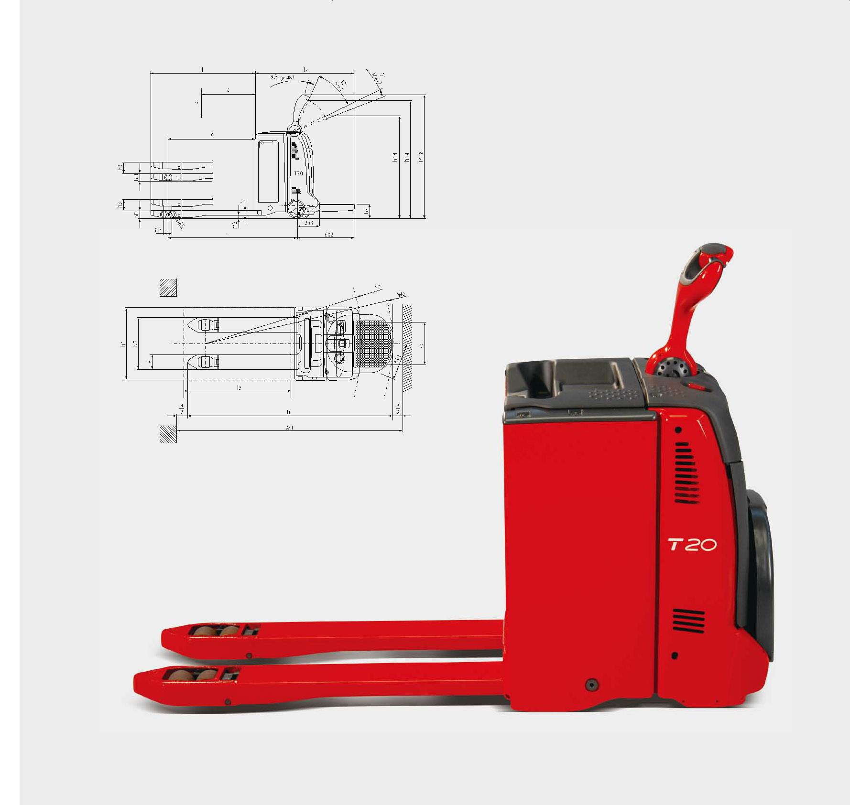
安全距离 a=200mm

Security distance a=200mm

