**漠影人系统**

**软件详细设计规格说明书**

**版本1.0**

**编写者:张栩**

**日期2017年12 月10日**

**版本历史**

表1.1版本历史表

|  |  |  |  |  |
| --- | --- | --- | --- | --- |
| 日期 | 版本 | 文件名 | 文档格式 | 状态 |
| 2017.12.10 | V1.0 | 详细设计规格说明书 | word | 创建 |

**更改列表.**

表1.2更改列表

|  |  |
| --- | --- |
| No | 描述 |
|  |  |

目录

**键入章标题(第 1 级)1**

键入章标题(第 2 级)2

键入章标题(第 3 级)3

**键入章标题(第 1 级)4**

键入章标题(第 2 级)5

键入章标题(第 3 级)6

# 前言

## 目的

本文档描述项目相关的标准和约束，介绍系统中简单类的实现方法，其目的是记录软件的详细设计过程。

本文档是后续开发的输入，主要读者是程序员。

## 范围

本文档包括项目的标准，约定和规程，以及系统中简单类的实现方法。

## 定义，首字母缩略词和简写

无。

## 参考文献

张栩，漠影人系统需求规格说明书，2017。

张栩，漠影人系统体系结构设计规格说明书，2017。

## 文档概要

项目标准，约定和规程:描述项目的一致标准，约定和规程信息。

构件设计规范:描述简单类的属性和方法信息。

# 项目标准，约定和规程

## 设计标准

采用面向对象设计方法设计，使用UML语言描述，支持面向对象语言编程开发，如:java。

## 文档标准

文档使用word编写，封面标题采用二号、加粗、宋体字体，章标题采用三号、加粗、宋体字体，节标题采用四号、加粗、宋体字体，正文内容采用小四、宋体字体，表格采用五号、宋体字体，图标编号采用五号、加粗、宋体字体，代码段采用五号、Times New Roman字体并按照java编程规范编写。

## 命名约定

|  |  |  |
| --- | --- | --- |
| 类型 | 命名约定 | 扩展名 |
| 文件 | 前缀为“漠影人”，即“漠影人XXX”。 | .docx |
| 类名 | 有意义的单词组合，无特殊字母，各个单词首字母大写。 | NA |
| 表名 | 有意义的单词组合，无特殊字母，各个单词首字母大写。 | NA |
| 对象名 | 有意义的单词组合，无特殊字符，与类名项对应。 | NA |
| 方法名 | 有意义的单词或单词组合，除收个单词首字母小写外其他单词首字母都为大写。 | NA |
| 属性名 | 有意义的单词或单词组合，采用驼峰命名法命名。 | NA |
| 参数名 | 有意义的单词或单词组合，采用驼峰命名法命名。 | NA |
| 返回值 | 有意义的单词或单词组合，采用驼峰命名法命名，与类型项对应。 | NA |
| 断行 | 程序中代码一行写不开时，会使用断行，断行不能断开一个有意义的单词或单词组合切断行后的内容应与断行前内容冲齐。 | NA |
| 缩进 | 程序中代码缩进原则应与编译器中代码缩进原则相同。 | NA |
| 注释 | 代码中注释可以使用单行注释或多行注释，注释内容要与注释项对应，注释内容写在要解释的代码前，注释前有代码的，应与前面代码段有一行或两行的间距。 | NA |

# 软解设计规范

## 用户交互层

### UserLogin

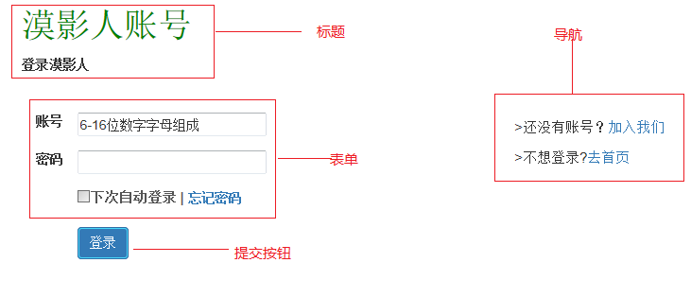

图3.1.1UserLogin界面

<!—用户登录界面标题-->

<div><h1 style="color: *green*">漠影人账号</h1></div>

<div>

<div>

<div><label>登录漠影人</label> <br> <br></div>

<!—用户登录界面导航-->

<div style="float: *right*;font-size: *15px*">

<div style="margin-bottom: *10px*"><br>

<p>>还没有账号？<a href=*"userregist.jsp"*>加入我们</a></p>

</div>

<div>

<p>>不想登录?<a href=*"index.jsp"*>去首页</a></p>

</div>

</div>

<!—用户登录界面表单-->

<form action=*" "* method=*"post"*>

<table style="border-collapse:*separate*;borderspacing:*15px*;">

<tr>

<td><label>账号</label></td>

<td> <input type=*"text"* style="width: *200px*;height: *25px*" placeholder=*"6-16位数字字母组成"*/>

</td>

<td>

<div id=*"hint"* style="color:*red*;font-size:*15px*"></div>

</td>

</tr>

<tr>

<td><label>密码</label> </td>

<td><input type=*"password"* maxlength=*"16"*name=*"userPassword"*

style="width: *200px*;height: *25px*"/>

</td>

</tr>

<tr>

<td></td>

<td>

<label><input type=*"checkbox"* id=*"rembe_psd"* />

<span style="color:*#545454*;font-size:*15px*">下次自动登录

<a href=*"#"*>忘记密码</a>

</label>

</td>

</tr>

<tr>

<td></td>

<td>

<!—用户登录界面提交按钮-->

<input class=*"btn btn-primary"* type=*"submit"*

value=*"登录"* name=*"login"*>

</td>

</tr>

</table>

</form>

</div>

UserLogin页面JavaScript脚本

<script type=*"text/javascript"*>

$(function(){

var page = "${param.score}";

$("#login").click(function(){

var name = $("#userName").val();

var psd = $("#userPsd").val();

if(name==""||psd==""){

alert("用户名密码不能为空")

}else{

$.ajax({

url:'login?userName='+name+'&userPassword='+psd,

type:'get',

success:function(date){

var res = date.res.trim();

var target = "index.jsp";

if(res=="success"){

switch(page){

case "movie":

target = "checkmovie?movieID=${cmovie['movieID']}";

break;

case "filmmaker":

target = "checkfilmmaker?filmmakerID =${gfilmmaker['filmmakerName']}";

break;

case "comment":

target = "ccomment?commentID=${comment['commentID']}"

}

window.location.href =target;

}else{

alert("您输入的账号名或密码不正确。");

}

}

})

}

})

})

</script>

### UserRegist

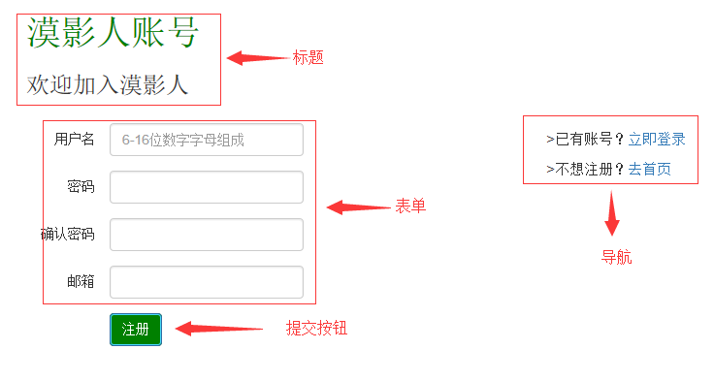

图3.1.2UserRegist界面

伪码:

<div><h1 style="color: *green*">漠影人账号</h1></div>

<div>

<div>

<h3>欢迎加入漠影人</h3>

</div>

<div style="float: *right*;font-size: *15px*">

<div style="margin-bottom: *10px*">

<br>>已有账号？<a href=*"userlogin.jsp"*>立即登录</a>

</div>

<div>

>不想注册？<a href=*"index.jsp"*>去首页</a>

</div>

</div>

<form action=*""* >

<table cellspacing=*"10"* style="border-collapse:*separate*;border-spacing:*15px*;">

<tr>

<td align=*"right"*>用户名</td>

<td><input class=*"form-control"* id=*"uname"* type=*"text"*

name=*"userName"* maxlength=*"16"*style="width: *200px*;"

placeholder=*"6-16位数字字母组成"* /></td>

<td><div id=*"un"*></div></td>

</tr>

<tr>

<td align=*"right"*>密码</td>

<td><input class=*"form-control"* id=*"psd1"* type=*"password"*

name=*"userPassword"*maxlength=*"16"* style="width: *200px*;" /></td>

<td><div id=*"psd_d1"*></div></td>

</tr>

<tr>

<td align=*"right"*>确认密码</td>

<td><input class=*"form-control"* id=*"psd2"* type=*"password"*

name=*"userPasswordSure"*maxlength=*"16"*

style="width: *200px*;"></td>

</tr>

<tr>

<td align=*"right"*>邮箱</td>

<td><input class=*"form-control"* type=*"text"* name=*"userEmail"*

maxlength=*"64"* style="width: *200px*;" /></td>

<td><div id=*"email"* style="color:*red*;font-size: *15px*"></div></td>

</tr>

<tr>

<td></td>

<td><input type=*"submit"* class=*"btn btn-primary"* value=*"注册"*

style="background-color: *green*"/></td>

</tr>

</table>

</form>

</div>

<div>

<div>

提交按钮CSS样式

.btn-primary{

color:#fff;

background-color:#337ab7;

border-color:#2e6da4

}

.btn-primary.focus,.btn-primary:focus{

color:#fff;

background-color:#286090;

border-color:#122b40

}

.btn-primary:hover{

color:#fff;

background-color:#286090;

border-color:#204d74

}

.btn-primary.active,.btn-primary:active,.open>.dropdown-toggle.btn-primary{

color:#fff;

background-color:#286090;

border-color:#204d74

}

.btn-primary.active.focus,.btn-primary.active:focus,.btn-primary.active:hover,

.btn-primary:active.focus,.btn-primary:active:focus,.btn

primary:active:hover,.open>

.dropdown-toggle.btn-primary.focus,.open>

.dropdown-toggle.btn-primary:focus,.open>

.dropdown-toggle.btn-primary:hover

{

color:#fff;background-color:#204d74;

border-color:#122b40

}

.btn-primary.active,.btn-primary:active,.open>

.dropdown-toggle.btn-primary

{

background-image:none

}

.btn-primary.disabled.focus,.btn-primary.disabled:focus,.btn-primary.disabled:hover,.btn-primary[disabled]

.focus,.btn-primary[disabled]:focus,.btn-primary[disabled]:hover,

fieldset[disabled]

.btn-primary.focus,fieldset[disabled]

.btn-primary:focus,fieldset[disabled]

.btn-primary:hover{

background-color:#337ab7;

border-color:#2e6da4

}

.btn-primary .badge{

color:#337ab7;

background-color:#fff

}

UserRegist页面JavaScript脚本

<script type=*"text/javascript"*>

//邮箱验证

**function** checkEmail(){

**var** uemail = $("#userEmail").val()

**var** email = document.getElementById("email");

**var** emcheck = **new** RegExp("[\\w!#$%&'*+/=?^_`{|}~-]+(?:\\.[\\w!#$%&'*+/=?^_`{|}~-]+)*@(?:[\\w](?:[\\w-]*[\\w])?\\.)+[\\w](?:[\\w-]*[\\w])?");

**var** emailcheckRes = **false**;

**if**(uemail==""){

email.innerHTML = "邮箱不能为空"

email.style.color="red";

}**else** **if**(!emcheck.test(uemail)){

email.innerHTML="邮箱格式不正确";

}**else**{

emailcheckRes = **true**;

email.innerHTML=""

}

**return** emailcheckRes;

}

**var** cutdown = 5;

//点击按钮时进入倒计时

**function** Verification(val){

**var** check = checkEmail();

**if**(check){

sign = check;

}

**if**(sign){

**if**(cutdown == 0){

val.removeAttribute("disabled");

val.value = "获取验证码"

email.innerHTML=""

sign = **false**;

cutdown = 5;

**return**;

}**else**{

val.setAttribute("disabled",**true**);

val.value = "重新获取 "+cutdown+"s";

email.innerHTML=""

cutdown--;

}

setTimeout(**function**(){

sign=**true**;

Verification(val);

},1000)

}

}

//向注册邮箱内发送验证码

$(**function**(){

$(".vfc").click(**function**(){

**var** check = checkEmail();

**if**(check){

**var** email = $("#userEmail").val();

$.ajax({

url:"registverf?userEmail="+email,

type:"get",

dateType:"json",

success:**function**(date){

}

})

}

})

})

//格式验证

**function** formatCheck(){

**var** uname = $("#uname").val();

**var** un = document.getElementById("un");

**var** uncheck = **new** RegExp("^\\w+$");

**var** unamecheckRes = **false**;

**if**(uname==""){

un.innerHTML = "用户名不能为空"

un.style.color = "red"

} **else** **if**(!uncheck.test(uname)){

un.innerHTML="用户格式不正确";

}**else** **if**(uname.length<6||uname.length>16){

un.innerHTML="用户名请在6-16数字或字母之间"

}**else**{

unamecheckRes = **true**;

un.innerHTML="";

}

**var** psd1 = $("#psd1").val();

**var** psd2 = $("#psd2").val();

**var** psdc = document.getElementById("psd_d1");

**var** psdcheckRes = **false**;

**if**(psd1==""||psd2==""){

psdc.innerHTML="密码与确认密码不能为空"

}**else** **if**(psd1.length>16||psd1.length<6){

psdc.innerHTML="密码请在6-16任意字符之间"

}**else** **if**(psd1!=psd2){

psdc.innerHTML="两次密码不一致"

}**else**{

psdcheckRes = **true**;

psdc.innerHTML="";

}

**var** verf = $("#verification").val();

**var** vercheckres = **false**;

**if**(verf==""){

$("#vercheck").html("验证码不能为空")

}**else** **if**(verf.length!=6){

$("#vercheck").html("验证码不正确")

}**else**{

vercheckres = **true**;

$("#vercheck").empty();

}

**if**(unamecheckRes&&psdcheckRes&vercheckres&&vercheckres){

**return** **true**;

}**else**{

**return** **false**;

}

}

//用户注册

$(**function**(){

$("#reg").click(**function**(){

**var** ce = checkEmail();

**var** fc = formatCheck();

**var** userName = $("#uname").val();

**var** userPsd = $("#psd1").val();

**var** userEmail = $("#userEmail").val();

**var** userVer = $("#verification").val();

//alert(userName+userPsd+userEmail+userVer)

**if**(ce&&fc){

$.ajax({

url:'regist',

type:'post',

data:{

'userName':userName,

'userPassword':userPsd,

'userVerification':userVer,

'userEmail':userEmail

},

dataType:'json',

success:**function**(data){

**var** res = date.res;

alert(res)

**if**(res=="codewrong"){

alert("输入的验证码不正确");

window.location.reload();

}**else** **if**(res=="emailused"){

$("#email").html("邮箱已被使用");

}**else** **if**(res=="userexist"){

$("#email").html("用户已存在");

}**else** **if**(res=="registfailed"){

alert("注册失败请稍后再试。");

window.location.reload();

}**else** **if**(res=="success"){

window.location.href="userlogin.jsp"

}

}

})

}

})

})

</script>

### Index

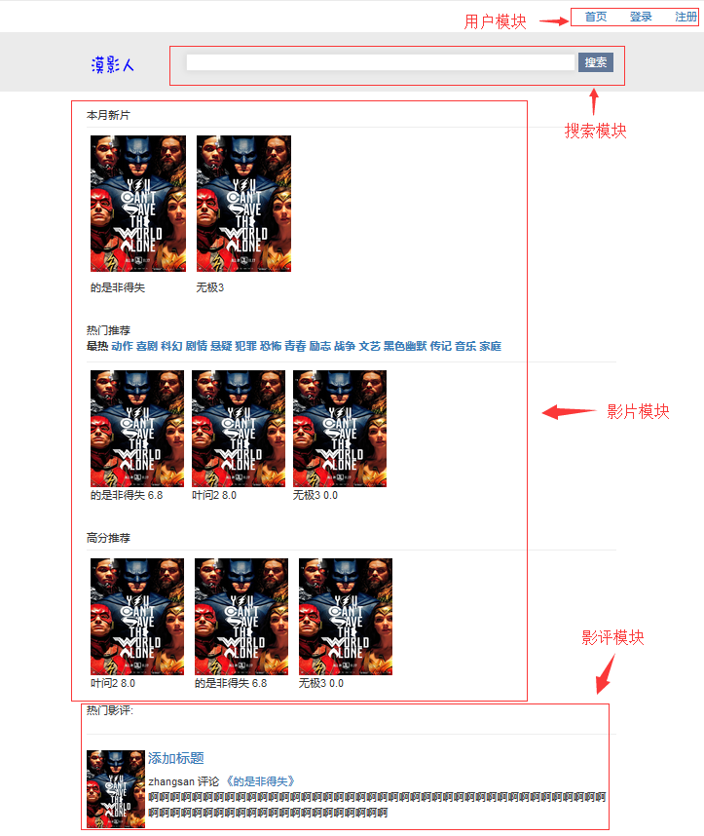

图3.1.3Index界面图

伪码:

<!—漠影人系统主界面用户模块-->

<div>

<nav class=*"navbar navbar"* role=*"navigation"*>

<div class=*"container-fluid"* style="background-color:*white*;" >

<div>

<ul class=*"nav navbar-nav pull-right"* >

<li class=*"active"*><a href=*"#"*>首页</a></li>

<li class=*"active"*><a href=*"userlogin.jsp"*>登录</a></li>

<li class=*"active"*><a href=*"userregist.jsp"*>注册</a></li>

<li class=*"dropdown"*>

<a href=*"#"* class=*"dropdown-toggle pull-right"*

data-toggle=*"dropdown"* >

用户的账号 ${sessionScope.user['userID'] }<b class=*"caret"*></b>

</a>

<ul class=*"dropdown-menu pull-right"* style="min-width:*5%*;">

<li><a href="userinformationcheck.jsp">个人信息</a></li>

<li><a href=*"#"*>注销</a></li>

</ul>

</li>

</ul>

</div>

<!-漠影人系统主界面搜索模块-->

<form action=*"search"* method=*"post"*>

<div id=*"search_div"* align=*"center"* style="height: *50px*;">

<img src=*"img/logo.png"* width=*"120px"* height=*"30px"*/>

<input id=*"search"* type=*"text"* name=*"keyword"* />

<input class=*"submit"* type=*"submit"* value=*"搜索"*/>

</div>

</form>

</nav>

<div>

<!—漠影人系统主界面影片模块-->

<span>

本月新片

</span>

<hr style="margin-bottom: *5px*;margin-top: *5px*">

<ul id=*"mv_ul"*>

<li>

<p><a id=*"pic_a"* href="*MovieCheck.jsp*" >

<img id=*"movie_img"*src = "影片封面" width=*"122px"* height=*"175px"* /> </a>

<p>

<p>影片名<p>

</li>

</ul>

</div>

<br>

<div >

<span>热门推荐</span>

<div>

<label id=*"lable_a"* ">最热</label>

<label id="lable_a" >喜剧</label>

<label id="lable_a" >科幻</label>

<label id="lable_a" >剧情</a></label》

<ul id="mo_list" >

<li ><a id="pic_a" href="moviecheck.jsp">

<img src="封面地址" width="120px" height="150px"/>

</a>

<p id="mo_na_p">影片2&nbsp

<span id="score_sp">8.0</span></p

</li>

<li ><a id="pic_a" href=" moviecheck.jsp ">

<img src="[files/mmb.jpg](view-source:http://localhost:8080/MovieShare/files/mmb.jpg) " width="120px" height="150px"/>

</a>

<p id="mo_na_p">影片2&nbsp

<span id="score_sp">8.0</span></p>

</li>

</ul>

</div>

</div>

<br>

<div >

高分推荐

<hr style="margin-bottom: *5px*;margin-top: *5px*">

<div>

<ul id=*"mo_list"* >

<li >

<a id="pic_a" href="MovieCheck.jsp ">

<img src="封面地址" width="120px" height="150px"/>

</a>

<p id="mo_na_p">影片1&nbsp;

<span id="score_sp">0.0</span></p>

</li>

<li >

<a id="pic_a" href="MovieCheck.jsp ">

<img src="封面地址" width="120px" height="150px"/>

</a>

<p id="mo_na_p">影片1&nbsp;

<span id="score_sp">0.0</span></p>

</li>

</ul>

</div>

</div>

</div>

</div>

</div>

<!--漠影人主界面影评模块-->

<span>热门影评:<span>

<hr>

<div style="clear:*both*;">

<div id=*"movie_cover"* style="float:*left*;">

<img src="封面地址" width=*"75px"* height=*"100px"*>&nbsp;</div>

<div ><h4><a href="*CommentCheck.jsp*">影评标题1</a></h4>

<span>评论用户&nbsp;评论&nbsp;<a href="*MovieCheck.jsp* ">《影片名》</a></span>

<div id= *"con_div"*style="height:*40px*;overflow:*hidden*;">影评内容</div>

</div>

<img src="封面地址" width=*"75px"* height=*"100px"*>&nbsp;</div>

<div ><h4><a href="*CommentCheck.jsp*">影评标题2</a></h4>

<span>评论用户&nbsp;评论&nbsp;<a href="*MovieCheck.jsp* ">《影片名》</a></span>

<div id= *"con_div"*style="height:*40px*;overflow:*hidden*;">影评内容</div>

</div>

</div>

</div>

影片模块ul与liCSS样式

//ul与li样式

*#movie_ul1***,***#movie_ul2***,***#mo_list*

{

display:*block*;

white-space:*nowrap*;margin:*0px*;

padding:*0px*;

}

*#movie_ul1* **li,***#movie_ul2* **li,***#mo_list* **li**{

margin:*5px*;

display:*inline-block*;

}

Index界面JavaScript脚本

//根据类型获取影片

<script type=*"text/javascript"*>

**function** getMovie(str){

$.ajax({

url:'recommendmovie',

type:'post',

data:{

'typeNo':str

},

dataType:'json',

success:**function**(movies){

**if**(movies==**null**){

$("#movie_ul1").html("<li><p>暂时还没有该类型的影片。</p></li>");

**return**;

}**else**{

**var** account = 0;

**var** li ="";

**var** li2="";

**for**(**var** movie **in** movies){

**if**(account<5){

li_c = "<a href='checkmovie?movieID="+movies[movie].movieID+

"'><li><div><img src = '"+movies[movie].movieCover+

"' width='110px' height='150px'/></div>"+

"<div align='center'><p>"+movies[movie].movieName+

"&nbsp;<span style='color:#D2691E'>"+movies[movie].movieEveryScore+

"</span></p></div></li></a>"

li+=li_c;

}**else**{

li_c2 = "<a href='checkmovie?movieID="+movies[movie].movieID+

"'><li><div><img src = '"+movies[movie].movieCover+

"' width='110px' height='150px'/></div>"+

"<div align='center'><p>"+movies[movie].movieName+

"&nbsp;<span style='color:#D2691E'>"+movies[movie].movieEveryScore+

"</span></p></div></li></a>";

li2+=li_c2;

}

account++;

}

$("#movie_ul1").empty();

$("#movie_ul2").empty();

$("#movie_ul1").html(li);

$("#movie_ul2").html(li2);

**return**;

}

}

})

}

//获取最近影评

**function** getLastMovie(page){

$.ajax({

url:'movieByDate?beginNum='+page,

type:'get',

dataType:'json',

success:**function**(movies){

**var** li='';

**for**(**var** movie **in** movies){

li_b ="<li><p>"

+"<a id='pic_a' href='checkmovie?movieID="

+movies[movie].movieID+"'>"

+"<img id='movie_img' src='"+movies[movie].movieCover+"' width='110px' height='150px'/></a>&nbsp;</p>"

+"<p align='center'>"+movies[movie].movieName+"</p></li>"

li+=li_b;

}

$("#mv_ul").slideDown("slow");

$("#mv_ul").html(li);

}

})

}

//获取评分最高的影片

$(**function**(){

**var** tp = ${pages};

**var** totalPage = parseInt(tp);

$("#next").click(**function**(){

**var** page = parseInt($("#beginPage").val());

**if**(page>=totalPage){

page=0;

getLastMovie(page)

$("#beginPage").val(1);

$("#nowPage").html(1);

}**else**{

getLastMovie(page)

$("#beginPage").val(page+1);

$("#nowPage").html(page+1);

}

})

$("#pre").click(**function**(){

**var** page = parseInt($("#beginPage").val());

**if**(page==1){

page=totalPage;

getLastMovie(page-1);

$("#beginPage").val(page);

$("#nowPage").html(page);

}**else**{

getLastMovie(page-2)

$("#beginPage").val(page-1);

$("#nowPage").html(page-1);

}

})

})

window.onload=**function**()

{

getMovie(0)

getLastMovie(-1)

$("#beginPage").val(1);

}

</script>

### MovieCheck

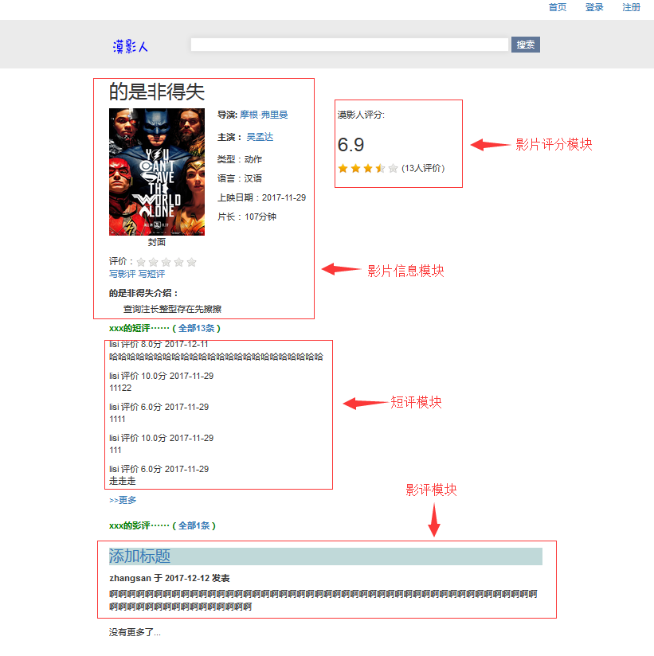

图3.1.4.1MovieCheck界面

<!—漠影人影片查看界面影片信息模块-->

<div id=*"cover"*>

<h2>影片名</h2>

<div style="float: *left*; margin-right: *20px*">

<img src="" width=*"150px"* height=*"200px"* />

<p align=*"center"*><span>封面</span></p>

</div>

<div style="float: *left*; margin-right: *50px*" id=*"info"*>

<p><label>导演:</label></p>导演

<p><label>主演:</label>主演1/主演2 </p>

<p>类型;类型1/类型2/类型3</p>

<p>语言:语言 </p>

<p>上映日期:yyyy-mm-dd</p>

<p>片长:90分钟</p>

</div>

<!—漠影人系统评分模块-->

<div style="float: *left*; display: *inline*" id=*"score"*>

<p>漠影人评分:</p>

<h2>得分</h2>

<table>

<tr>

<td><div id=*"eve_score"*></div></td>

<td>(11人评价)</td>

</tr>

</table>

</div>

<div style="clear: *both*;" id=*"opr"*>

<table>

<tr>

<td>评价:</td>

<td>

<a href=*"# "*style="text-decoration:*none*">

<div id=*"give_score"*></div>

</a>

</td>

</tr>

</table>

<p><a href="*CommentMovie.jsp* ">写影评</a>

<a href=*"# "* data-toggle=*"modal"* style="text-decoration: *none*">写影评</a>

</p>

</div>

<div id=*"des"*>

<label>介绍:</label>

<p>&nbsp;&nbsp; &nbsp; &nbsp;介绍内容 </p>

</div>

<!—漠影人影片查看界面短评模块-->

<div>

<div id=*"model_div"*>

<label>xxx的短评······（<a href=*"#"*>短评条数 </a>）</label>

</div>

<div>

<div>

<p>评价用户&nbsp;评价&nbsp;分数&nbsp;yyyy-mm-dd

<p>内容1 </p>

</div>

<div>

<p style="">评价用户&nbsp;评价&nbsp;分数&nbsp;yyyy-mm-dd

<p>内容3</p>

</div>

<div>

<p style="">评价用户&nbsp;评价&nbsp;分数&nbsp;yyyy-mm-dd

<p>内容4</p>

</div>

<div>

<p style="">评价用户&nbsp;评价&nbsp;分数&nbsp;yyyy-mm-dd

<p>内容5 </p>

</div>

<div>

<a href=*"#"*>>>更多</a>

</div>

<div>

<div>

<!—漠影人影片查看界面影评模块-->.

<div>

<div id=*"model_div"*>

<label>xxx的影评······（<a href=*"#"*>全部条数）</label>

</div>

<div>

<div style="background: *#C0D9D9*">

<h3><a href="*CommentCheck*">影评标题1</a></h3>

</div>

<label>发表用户&nbsp;于&nbsp;yyyy-mm-dd&nbsp;发表</label>

<div id=*"hint_div"*><p>>这篇影评可能有剧透</p></div>

<div>

<div>

<div style="background: *#C0D9D9*">

<h3><a href="*CommentCheck*">影评标题2</a></h3>

</div>

<label>发表用户&nbsp;于&nbsp;yyyy-mm-dd&nbsp;发表</label>

<div id=”comment_div”>影评内容</div>

<div>

<div style="background: *#C0D9D9*">

<h3><a href="*CommentCheck*">影评标题3</a></h3>

</div>

<label>发表用户&nbsp;于&nbsp;yyyy-mm-dd&nbsp;发表</label>

<div id=”comment_div”>影评内容</div>

<div>

<div>

<div style="background: *#C0D9D9*">

<h3><a href="*CommentCheck*">影评标题5</a></h3>

</div>

<label>发表用户&nbsp;于&nbsp;yyyy-mm-dd&nbsp;发表</label>

<div id=*"hint_div"*><p>>这篇影评可能有剧透</p></div>

<div>

<div>

<div style="background: *#C0D9D9*">

<h3><a href="*CommentCheck*">影评标题6</a></h3>

</div>

<label>发表用户&nbsp;于&nbsp;yyyy-mm-dd&nbsp;发表</label>

<div id=*"hint_div"*><p>>这篇影评可能有剧透</p></div>

<div>

<div>

<a href=*"#"*>>>更多</a>

</div>

<div>

<div>

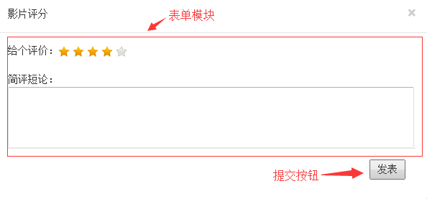

图3.1.4.2MovieCheck-MarkMovie界面

<div class=*"modal fade"* id=*"myModal"* tabindex=*"-1"* role=*"dialog"*aria-

labelledby=*"myModalLabel"* aria-hidden=*"true"*>

<div class=*"modal-dialog"*>

<div class=*"modal-content"*>

<!--漠影人系统影片打分表单模块-->

<form action=*"markmovie"* method=*"post"*>

<div class=*"modal-header"*>

<button type=*"button"* class=*"close"* data-dismiss=*"modal"*aria-

hidden=*"true"*>&times;</button>

影片评分

</div>

<div class=*"modal-body"*>

<div style="margin-bottom: *20px*">

<table>

<tr>

<td>给个评价:</td>

<td><div id=*"modle_score"*></div> </td>

</tr>

</table>

</div>

<div>

简评短论:

<textarea rows=*"5"* cols=*"88"* name=*"markContent"*

style="resize: *none*;"></textarea>

</div>

<!--漠影人系统影片打分提交按钮-->

<div class=*"modal-footer"*>

<input type=*"submit"* value=*"发表"*>

</div>

</div>

</form>

</div>

</div>

</div>

movieCheck界面JavaScript脚本

<script type=*"text/javascript"*>

//用户登录

$(**function**(){

$("#login").click(**function**(){

$("#flg").empty();

**var** name = $("#userName").val();

**var** psd = $("#userPsd").val();

**if**(name==""||psd==""){

$("#flg").append("用户名密码不能为空")

}**else**{

$.ajax({

url:'login?userName='+name+'&userPassword='+psd,

type:'get',

async:**false**,

success:**function**(date){

**if**(date.res=="success"){

$("#modle_log").hide();

window.location.reload();

}**else**{

$("#flg").append("用户名或密码不正确");

}

}

})

}

})

})

//短评发表

$(**function**(){

$("#mark_btn").click(**function**(){

$("#hint").empty();

**var** userID = " ${sessionScope.user['userID']}";

**var** movieID = "${cmovie['movieID']}"

**var** markScore =$("#mark_score").val();

**var** markContent = $("#mark_are").val();

**if**(markContent==""){

$("#hint").append("请输入短评的内容。");

}**else** **if**(markContent.length>500){

$("#hint").append("短评内容请不要超过140字")

}**else**{

$.ajax({

url:"markmovie?userID="+userID+"&movieID="+movieID+

"&markScore="+markScore+"&markContent="+markContent,

type:"get",

async:**false**,

success:**function**(date){

**if**(date.res=="success"){

alert("发表成功");

window.location.reload();

}**else** **if**(date.res=="failed"){

alert("发表失败，请稍后再试");

window.location.reload();

}

}

})

}

})

})

</script>

### CommentCheck

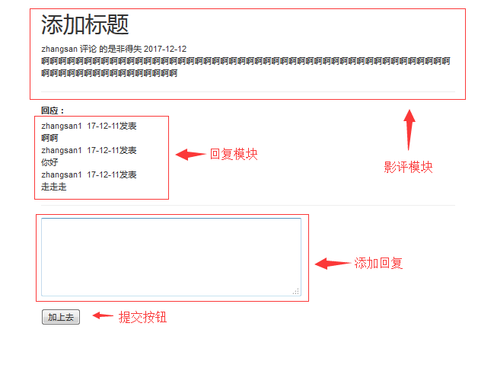

图3.1.5CommentCheck界面

伪码:

<div align=*"center"*>

<div style="width: *680px*">

<div align=*"left"*>

<!-漠影人系统影评查看影评模块-->

<div id=*"comment_con"*>

<h1>影评标题</h1>

<span>影评用户&nbsp;评论&nbsp;

评论影评&nbsp; 评论时间</span>

</div>

<div>影评内容</div>

<hr>

<label>回应:</label>

<div id=*"comment_reply"*>

<table>

<tr>

<td>回复用户1&nbsp;恢复时间 发表</td>

</tr>

<tr>

<td>回复内容1</td>

</tr>

<tr>

<td>回复用户2&nbsp;恢复时间 发表</td>

</tr>

<tr>

<td>回复内容2</td>

</tr>

<tr>

<td>回复用户3&nbsp;恢复时间 发表</td>

</tr>

<tr>

<td>回复内容3</td>

</tr>

<tr>

<td>回复用户4&nbsp;恢复时间 发表</td>

</tr>

<tr>

<td>回复内容4</td>

</tr>

…………

</table>

</div>

<hr>

<！--漠影人系统影评查看添加回复-->

<div id=*"user_reply"*>

<form action=*""* method=*"post"* >

<textarea cols=*"50"* rows=*"5"* name=*"replyContent"*></textarea>

<br>

<br>

<！--漠影人系统影评查看添加回复提交按钮-->

<input type=*"submit"* value=*"加上去"* />

</form>

</div>

</div>

</div>

</div>

CommentCheck界面JavaScript脚本

<script type=*"text/javascript"*>

//格式判断

**function** replyCheck() {

**var** replyContent = $("#reply_content").val();

**if** (replyContent == "") {

alert("回复不能为空");

} **else** **if** (repluContent.length < 140) {

alert("回复内容请在140字之内");

} **else** {

**return** **true**;

}

**return** **false**;

}

//发表回复

$(**function**(){

$("#btn_reply").click(**function**(){

**var** replyContent = $("#reply_content").val();

**if** (replyContent == ""||replyContent.length > 140) {

alert("回复内容请在1-140字之間")

}**else**{

$.ajax({

url:"reply?userID=${sessionScope.user.userID}"

+"&commentID=${comment['commentID']}"

+"&replyContent="+replyContent

+"&replyWho="+$("#replyWho").val(),

type:"get",

typeDate:"json",

success:**function**(date){

**if**(date.res=="success"){

$("#replyWho").val(0);

$("#reply_content").val("");

window.location.reload();

}**else**{

$("#replyWho").val(0);

alert("回復失敗");

}

}

})

}

})

//选择回复的回复

$("#beReplyContent").on("click","a",**function**(){

$("#beReplyContent").html("");

$("#replyWho").val(0);

$("#reply_content").focus();

})

})

//获取到要回复的回复的ID

**function** replyHe(obj){

$("#beReplyContent").html("&nbsp;@回复:"+$("#"+obj).text()+

"&nbsp;<a href='javascript:;' id='off'>取消</a>");

$("#replyWho").val(obj);

$("#reply_content").focus();

}

</script>

### InformationSearch

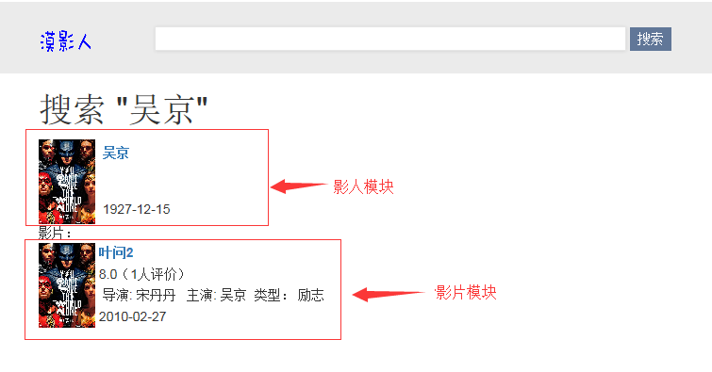

图3.1.6InformationSearch界面

伪码:

<div align=*"center"* >

<div style="width: *670px*">

<div align=*"left"*>

<h1>搜索&nbsp;" "</h1>

<!—漠影人系统信息搜索界面影人模块-->

<div id=*"filmmaker"*>

<table>

<tr>

<td rowspan=*"3"*>

<img src="照片" name=*"filmmakerPhoto"* />&nbsp;</td>

<th align=*"left"* >

<a href=*""*>&nbsp; 影人名</a

</th>

</tr>

<tr>

<td >

影人职业

</td>

</tr>

<tr>

<td >&nbsp影人生日</td>

</tr>

</table>

</div>

<!—漠影人系统信息搜索界面影片模块-->

<div id=*"movie"*>

<lable>影片:</lable>

<table>

<tr>

<td rowspan=*"4"*><img src="影片封面1" </td>

<th align=*"left"*><a href=*"#"*>&nbsp;影片名1</a></th>

</tr>

<tr>

<td>&nbsp;${movieEveryScore}（评价人数）</td>

</tr>

<tr>

<td>

&nbsp;导演:导演1

&nbsp;主演:主演1/主演2

&nbsp;类型:类型1/类型2

</td>

</tr>

<tr>

<td>&nbsp;上映日期</td>

</tr>

<tr>

<td rowspan=*"4"*><img src="影片封面2" </td>

<th align=*"left"*><a href=*"#"*>&nbsp;影片名2</a></th>

</tr>

<tr>

<td>&nbsp;${movieEveryScore}（评价人数）</td>

</tr>

<tr>

<td>

&nbsp;导演:导演1

&nbsp;主演:主演1/主演2

&nbsp;类型:类型1/类型2

</td>

</tr>

<tr>

<td>&nbsp;上映日期</td>

</tr>

<tr>

<td rowspan=*"4"*><img src="影片封面3" </td>

<th align=*"left"*><a href=*"#"*>&nbsp;影片名3</a></th>

</tr>

<tr>

<td>&nbsp;${movieEveryScore}（评价人数）</td>

</tr>

<tr>

<td>

&nbsp;导演:导演1

&nbsp;主演:主演1/主演2

&nbsp;类型:类型1/类型2

</td>

</tr>

<tr>

<td>&nbsp;上映日期</td>

</tr>

………

</table>

</div>

</div>

</div>

</div>

图片CSS样式

img{

width:60px

heigth:90px

}

### FilmmakerCheck

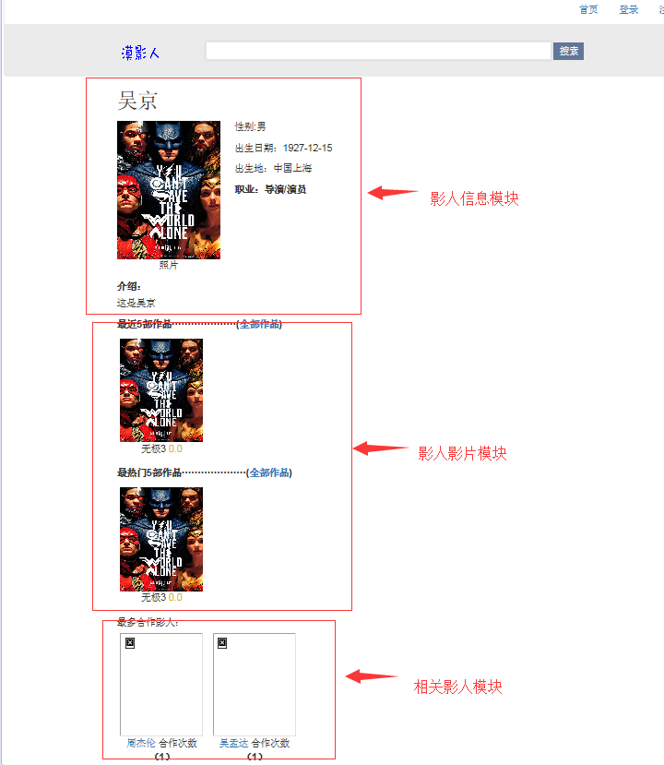

图3.1.7影片查看界面

伪码:

<div align=*"center"*>

<div style="width: *680px*">

<div align=*"left"*>

<div id=*"fim_info"*>

<h2>影人名</h2>

<div style="float: *left*; margin-right: *20px*">

<img src="影人照片" width=*"150px"* height=*"200px"* />

<p align=*"center"*><span>照片</span></p>

</div>

<div style="float: *left*; margin-right: *50px*" id=*"info"*>

<p>性别:男 </p>

<p>出生日期:xxxx-xx-xx </p>

<p>出生地:中国上海 </p>

<p><label>职业:导演/演员</label></p>

<label>介绍:</label>

</div>

<p>影人介绍</p>

</div>

<div id=*"last_movie"*>

<label>最近5部作品····················

(<a href=*"#"*>全部作品</a>)</label>

<ul id=*"mo_list"* >

<li >

<a id=*"photo_a"* href="*MovieCheck*">

<img src="影片封面1" id=”moviePhoto”/>

</a>

<p id=*"mo_na_p"*>影片名1&nbsp;

<span id="score_sp">评分</span></p>

</li>

<li >

<a id=*"photo_a"* href="*MovieCheck*">

<img src="影片封面2" id=”moviePhoto”/>

</a>

<p id=*"mo_na_p"*>影片名2&nbsp;

<span id="score_sp">评分</span></p>

</li>

<li >

<a id=*"photo_a"* href="*MovieCheck*">

<img src="影片封面3" id=”moviePhoto”/>

</a>

<p id=*"mo_na_p"*>影片名3&nbsp;

<span id="score_sp">评分</span></p>

</li>

<li >

<a id=*"photo_a"* href="*MovieCheck*">

<img src="影片封面4" id=”moviePhoto”/>

</a>

<p id=*"mo_na_p"*>影片名4&nbsp;

<span id="score_sp">评分</span></p>

</li>

<li >

<a id=*"photo_a"* href="*MovieCheck*">

<img src="影片封面5" id=”moviePhoto”/>

</a>

<p id=*"mo_na_p"*>影片名5&nbsp;

<span id="score_sp">评分</span></p>

</li>

</ul>

</div>

<div id=*"best_movie"*>

<label >最热门5部作品····················

(<a href=*"#"*>全部作品</a>)</label>

<ul id=*"mo_list"*>

<li >

<a id=*"photo_a"* href="MovieCheck">

<img src="影片封面1" >

</a>

<p id=*"mo_na_p"*>影片名1&nbsp;

<span id="score_sp">影片评分</span></p>

</li>

<li >

<a id=*"photo_a"* href="MovieCheck">

<img src="影片封面2" >

</a>

<p id=*"mo_na_p"*>影片名2&nbsp;

<span id="score_sp">影片评分</span></p>

</li>

<li >

<a id=*"photo_a"* href="MovieCheck">

<img src="影片封面3" >

</a>

<p id=*"mo_na_p"*>影片名3&nbsp;

<span id="score_sp">影片评分3</span></p>

</li>

<li >

<a id=*"photo_a"* href="MovieCheck">

<img src="影片封面4" >

</a>

<p id=*"mo_na_p"*>影片名4&nbsp;

<span id="score_sp">影片评分4</span></p>

</li>

</ul>

</div>

<div id=*"work_together"*>最多合作影人:

<ul id=*"mo_list"*>

<li >

<a id=*"photo_a"* href="*FIlmmakeCheck*">

<img src="影人照片1" id=”conFilmmaker”/>

</a>

<p id=*"mo_na_p"*><a href=*"#"* id=*"name_a"*>影人名1

</a>&nbsp;合作次数<label></label></p>

<p></p>

</li>

<li >

<a id=*"photo_a"* href="*FIlmmakeCheck*">

<img src="影人照片2" id=”conFilmmaker”/>

</a>

<p id=*"mo_na_p"*><a href=*"#"* id=*"name_a"*>影人名2

</a>&nbsp;合作次数<label></label></p>

<p></p>

</li>

<li >

<a id=*"photo_a"* href="*FIlmmakeCheck*">

<img src="影人照片3" id=”conFilmmaker”/>

</a>

<p id=*"mo_na_p"*><a href=*"#"* id=*"name_a"*>影人名3

</a>&nbsp;合作次数<label></label></p>

<p></p>

</li>

<li >

<a id=*"photo_a"* href="*FIlmmakeCheck*">

<img src="影人照片4" id=”conFilmmaker”/>

</a>

<p id=*"mo_na_p"*><a href=*"#"* id=*"name_a"*>影人名4

</a>&nbsp;合作次数<label></label></p>

<p></p>

</li>

<li >

<a id=*"photo_a"* href="*FIlmmakeCheck*">

<img src="影人照片5" id=”conFilmmaker”/>

</a>

<p id=*"mo_na_p"*><a href=*"#"* id=*"name_a"*>影人名5

</a>&nbsp;合作次数<label></label></p>

<p></p>

</li>

</ul>

</div>

</div>

</div>

</div>

### CommentMovie

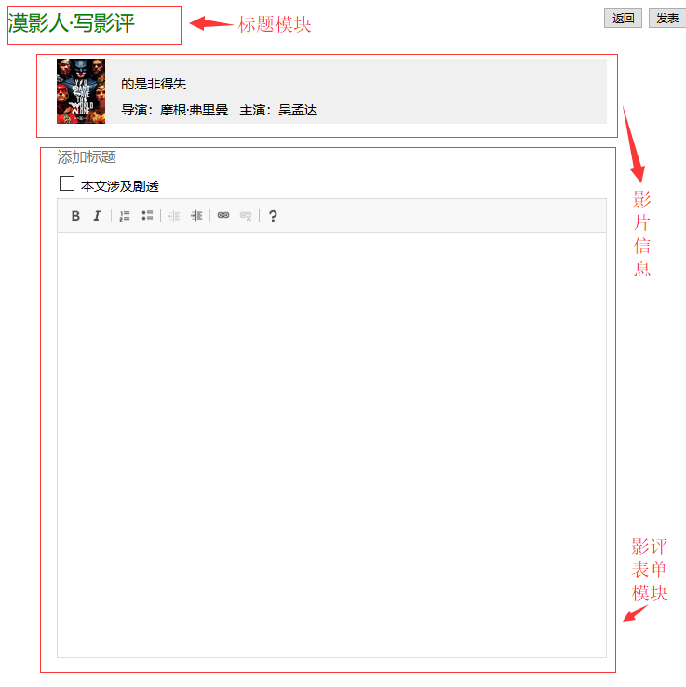

图3.1.8CommentMovie界面

伪码:

<div style="top:*0px*; width:*100%*; height:*40px*;left:*0px*;right:*0px*; position: *fixed*;"

align=*"center"*>

<div style="float:*right*;padding-top:*10px*">

<input type=*"button"* value=*"返回"* align=*"right"*/>

<input type=*"submit"* value=*"发表"* align=*"right"*/>

&nbsp;&nbsp;

</div>

<div style="width: *800px*">

<!—漠影人系统影评发表界面标题模块-->

<div align=*"left"* style="padding-top:*10px*">

<label style="color:*green*;font-size: *25px*">漠影人·写影评</label>

</div>

</div>

</div>

<br><br><br>

<div align=*"center"* style="clear: *both*">

<div style="width: *680px*">

<div align=*"left"*>

<div style="height: *80px*;background-color:*#F0F0F0* ">

<div style="background-color: *blue* ;height: *80px*;width:*60px*;float: *left*">

<img src="" width=*"60px"* height=*"80px"*/>

</div>

<!—漠影人系统影评发表界影片信息模块-->

<div style="height: *80px*;width:*600px*; float: *right*; margin-top: *20px*">

影片名

<div style="height: *10px*"></div>

导演:导演1&nbsp;主演:主演1/主演

</div>

</div>

<!—漠影人系统影评发表界面影评表单模块->

<div>

<input type=*"text"* name=*"commentTitle"* maxlength=*"50"*

style="width: *100%*; font-size: *18px*; height: *40px*; border: *none*"

placeholder=*"添加标题"*/>

<label id=*"ctitle"* style="color:*red*;font-size: *15px*"></label>

</div>

<div style="margin-bottom: *5px*">

<input type=*"checkbox"* value=*"yes"* name=*"ifSpoiler"* />

<label>本文涉及剧透</label>

</div>

<div>

<label id=*"cContent"* style="color:*red*;font-size: *15px*"></label>

<textarea id=*"content_tt"* name=*"commentContent"* ></textarea>

</div>

</div>

</div>

</div>

CommentMovie页面JavaScript脚本

<script type=*"text/javascript"*>

//格式判断

**function** commentCheck() {

**var** commentTitle = $("#title").val();

**var** ctitlehint = document.getElementById("ctitle");

**var** ctitleTrue = **false**;

**if** (commentTitle == "") {

ctitlehint.innerHTML = "请给影评添加一个标题";

} **else** **if** (commentTitle.length > 50 || commentTitle.length < 5) {

ctitlehint.innerHTML = "影片标题请在5到50个字之间"

} **else** {

ctitlehint.innerHTML = ""

ctitleTrue = **true**;

}

**var** commentContent = CKEDITOR && CKEDITOR.instances["content_tt"] ? CKEDITOR.instances["content_tt"]

.getData()

: document.getElementById("content_tt").value;

**var** cContenthint = document.getElementById("cContent");

**var** ccontentTrue = **false**;

**if** (commentContent == "" || commentContent.length < 140) {

cContenthint.innerHTML = "影评的内容请在140字以上";

} **else** {

cContenthint.innerHtml = "";

ccontentTrue = **true**;

}

**if** (ctitleTrue && ccontentTrue) {

**return** **true**;

} **else** {

**return** **false**;

}

}

//发表影评

$(**function**() {

$("#sub").click(**function**() {

**var** b = commentCheck();

**var** ctitle = $("#title").val();

**var** userID = "${sessionScope.user.userID}"

**var** movieID = "${cmovie['movieID']}"

**var** ifSpoiler = $("input[name=ifSpoiler]:checked").val();

**var** cContent = CKEDITOR&& CKEDITOR.instances["content_tt"] ? CKEDITOR.instances["content_tt"]

.getData()

: document.getElementById("content_tt").value;

**if** (b == **true**) {

$.ajax({

url : 'commentmovie',

type : 'post',

data:{

"commentTitle":ctitle,

"commentContent":cContent,

"userID":userID,

"movieID":movieID,

"ifSpoiler":ifSpoiler

},

dateType:'json',

success:**function**(date){

res = date[0].res;

**if**(res=="success"){

alert("评论成功。")

window.location.href ="checkmovie?movieID=${cmovie['movieID']}";

}**else**{

alert("发表失败，请稍后再试。")

}

}

})

}

})

})

</script>

### PasswordReset

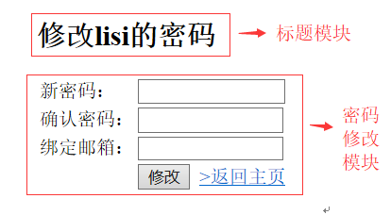

图3.1.9PasswordReset界面

伪码:

<div>

<div>

<div></div>

<!—漠影人系统密码修改界面标题模块-->

<div>

<h2>修改lisi的密码</h2>

</div>

<!—漠影人系统密码修改界面密码修改模块-->

<form action=" " method=*"post"*>

<table>

<tr>

<td>新密码:</td>

<td><input type=*"password"* name=*"userPassword"* style="width:*152px*"/>

</td>

</tr>

<tr>

<td>确认密码:</td>

<td><input type=*"password"* name=*"surePassword"* style="width: *150px*"> </td>

</tr>

<tr>

<td>绑定邮箱:</td>

<td><input type=*"text"* name=*"userEmail"* style="width: *150px*"/></td>

</tr>

<tr>

<td></td>

<td><input type=*"submit"* value=*"修改"* />&nbsp;&nbsp;

<a href=*"#"*>>返回主页</a></td>

</tr>

</table>

</form>

</div>

</div>

### AdministratorLogin

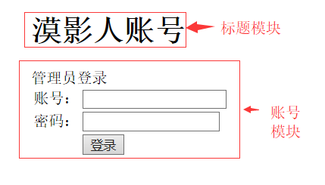

图3.1.10AdministratorLogin界面

伪码:

<div align=*"center"*>

<div style="width: *600px*">

<div align=*"left"*>

<!—漠影人系统管理员登录界面标题模块-->

<div>

<h1>漠影人账号</h1>

</div>

<div>管理员登录</div>

<div>

<!—漠影人系统管理员登录界面账号模块-->

<form action=*"admlog"* method=*"post"*>

<table>

<tr>

<td>账号:</td>

<td><input type=*"text"* name=*"admAccount"* /></td>

</tr>

<tr>

<td>密码:</td>

<td><input type=*"password"* name=*"admPassword"* /></td>

</tr>

<tr>

<td></td>

<td><input type=*"submit"* value=*"登录"* /></td>

</tr>

</table>

</form>

</div>

</div>

</div>

</div>

### AdministratorIndex

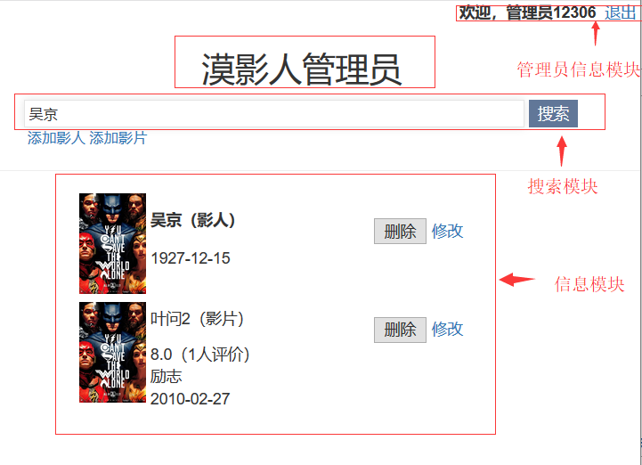

图3.1.11AdministratorIndex界面

伪码:

<div>

<div align=*"right"*>

<label>欢迎，管理员12306$（账号）&nbsp;</label>

<a href=*"#"*>退出&nbsp;</a>

</div>

<div align=*"center"*>

<div><h2>漠影人管理员</h2></div>

<div style="width: *500px*" >

<form action=*"admsearch"* method=*"post"*>

<div align=*"left"*>

<input id=*"search"* type=*"text"* name=*"keyword"*

style="width:*450px*;height: *25px*" "/>

<input class=*"submit"* type=*"submit"* value=*"搜索"* />

</div>

<div align=*"left"* style="font-size:*small*;">&nbsp;

<a href=*"insertfilmmaker"*>添加影人</a>

<a href=*"addmovie.jsp"*> 添加影片</a></div>

</form>

</div>

<hr>

</div>

<div align=*"center"*>

<div style="width:*400px*;height: *500px*; overflow:*auto*">

<div align=*"left"*>

<table>

<tr>

<td rowspan=*"4"*><img src=""width=*"60"* height=*"90"*

name=*"filmmakerPhoto"* />&nbsp;</td>

<th align=*"left"* style="width: *200px*">影人名（影人）</th>

<td>&nbsp;

<input type=*"button"* value=*"删除"*/>

<a href="*updatefilmmaker*">修改</a>

</td>

</tr>

<tr>

<td>职业</td>

</tr>

<tr>

<td >出生日期</td>

</tr>

</table>

</div>

<div>

<table>

<tr>

<td rowspan=*"4"*><img src="movieCover "

width=*"60"*height=*"90"* />&nbsp;</td>

<td align=*"left"* style="width: *200px*">影片名（影片）</td>

<td>&nbsp;

<input type=*"submit"*value=*"删除"*/>

<a href="*updatemovie*">修改</a>

</td>

</tr>

<tr>

<td>评分（评价人数）</td>

</tr>

<tr>

<td>类型</td>

</tr>

<tr>

<td>上映日期</td>

</tr>

</table>

</div>

</div>

</div>

</div>

### AddMovie

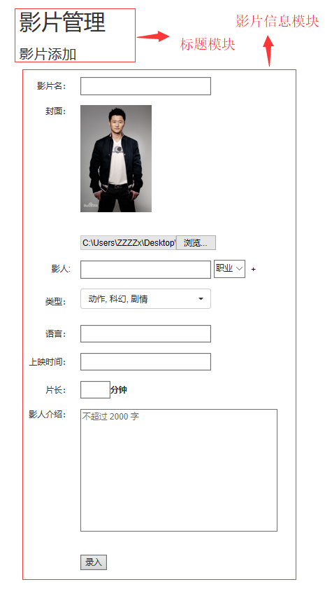

图3.1.12AddMovie界面

伪码:

<div align=*"center"*>

<div style="width: *650px*">

<div align=*"left"*>

<!—漠影人系统影片添加界面标题模块-->

<div><h1>影片管理</h1></div>

<div><h3>影片添加</h3></div>

<div>

<!—漠影人系统影片添加界面影片信息模块-->

<form name = *"movieform"* action=*"addmovie"* method=*"post"* >

<table id=*"addmovie"* >

<tr>

<td align=*"right"*>影片名:</td>

<td><input id=*"input"* type=*"text"* maxlength=*"50"*

name=*"movieName"* />

<label id=*"mname"*></label></td>

</tr>

<tr>

<td align=*"right"* valign=*"top"*>封面:</td>

<td><img src=*""* id=*"showCover"* height=*"180px"*

width=*"120px"*></td>

</tr>

<tr>

<td></td>

<td><s:file id="movieCover" name="movieCover">

<label id=*"mcover"*></label></s:file></td>

</tr>

<tr>

<td align=*"right"*>影人:</td>

<td><input id=*"input"* type=*"text"* name=*"filmmakerName"* />

<select name="filmmakerJob" style="">

<option selected=*"selected"*>职业</option>

<option selected=*"selected"*>导演</option>

<option selected=*"selected"*>演员</option>

</select>

<input type=*"button"* id=*"plus"* value=*"+"* />

<label id=*"finfo"*></label>

</td>

</tr>

<tr>

<td align=*"right"*>类型:</td>

<td><select name="filmmakerJob" style="">

<option selected=*"selected"*>喜剧</option>

<option selected=*"selected"*>动作</option>

<option selected=*"selected"*>爱情</option>

……

</select>

<label id=*"mtype"*></label>

</td>

</tr>

<tr>

<td align=*"right"*>语言:</td>

<td>

<input id=*"input"* type=*"text"* maxlength=*"10"*

name=*"movieLanguage"* />

<label id=*"mlanguage"*></label>

<td>

</tr>

<tr>

<td align=*"right"*>上映时间:</td>

<td><input id=*"input"* type=*"text"* name=*"movieDate"*

class=*"movieDate"* />

<label id=*"mdate"*></label><td>

</tr>

<tr>

<td align=*"right"*>片长:</td>

<td><input id=*"input"* type=*"text"* name=*"movieLong"*

maxlength=*"3"*style="width: *50px*" />

<label>分钟</label><label id=*"mlong"*></label></td>

</tr>

<tr>

<td align=*"right"* valign=*"top"*>影人介绍:</td>

<td><textarea name=*"movieDescribe"*

rows=*"10"* cols=*"50"* placeholder=*"*不超过 2000 字*"*>

</textarea></td>

</tr>

<tr>

<td></td><td><label id=*"mdescribe"*></label></td>

</tr>

<tr>

<td></td>

<td><input type=*"submit"* value=*"录入"* /></td>

</tr>

</table>

</form>

</div>

</div>

</div>

</div>

### AddFilmmaker

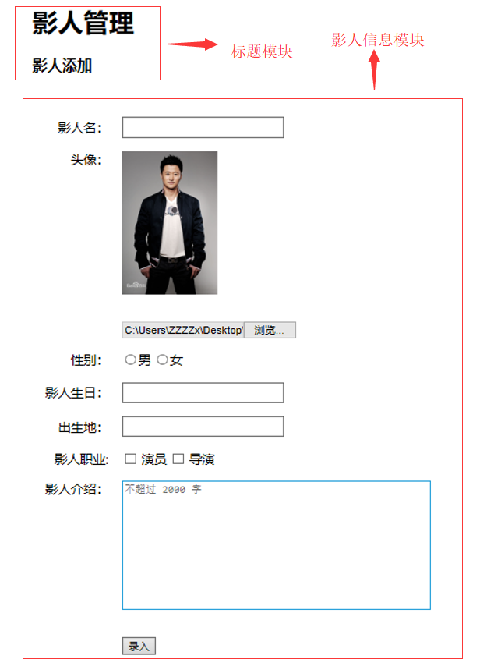

AddFilmmaker界面

伪码:

<div style="width: *680px*">

<div align=*"left"*>

<!—漠影人系统影人添加界面标题模块-->

<div><h1>影人管理</h1></div>

<div>

<div><h3>影人添加</h3></div>

<div>

<s:form name="filmmakerform" action="addfilmmaker" >

<table>

<tr>

<td align=*"right"*>影人名:</td>

<td><input type=*"text"* name=*"filmmakerName"*

style="width: *200px*;height: *20px*"/>&nbsp;

<label id=*"fname"* style="color:*red*;font-size: *15px*">

<label>

</td>

</tr>

<tr>

<td align=*"right"* valign=*"top"*>头像:</td>

<td><img src=*""* id=*"showPhoto"* height=*"180px"*

width=*"120px;"* /></td>

</tr>

<tr>

<td><s:file name="filmmakerPhoto">

<label id=*"fphoto"* style="color:*red*;font-size: *15px*">

</label></s:file>&nbsp;</td>

</tr>

<tr>

<td align=*"right"*>性别:</td>

<td>

<input id=*"fSex"* type=*"radio"* name=*"filmmakerSex"*

value=*"男"* />男

<input id=*"fSex"* type=*"radio"* name=*"filmmakerSex"*

value=*"女"* />女

<label id=*"fsex"* style="color:*red*;font-

size:*15px*"></label>

</td>

</tr>

<tr>

<td align=*"right"*>影人生日:</td>

<td><input type=*"text"* name=*"filmmakerBirth"*

id=*"filmmakerBirth"* style="width: *200px*;height: *20px*"/>

<label id=*"fbirth"* style="color:*red*;font-size: *15px*">

</label></td>

</tr>

<tr>

<td align=*"right"*>出生地:</td>

<td><input type=*"text"* name=*"filmmakerBirthPlace"*

maxlength=*"20"* style="width: *200px*;height: *20px*"/>

<label id=*"fbirthplace>*

</label></td>

</tr>

<tr>

<td align=*"right"*>影人职业:</td>

<td>

<input type=*"checkbox*name=*"filmmakerJob"*value="

演员" />演员

<input type=*"checkbox*name=*"filmmakerJob"*value="

导演" />导演

<label id=*"fjob"* style="color:*red*;font-size: *15px*">

</label>

</td>

</tr>

<tr>

<td align=*"right"* valign=*"top"*>影人介绍:</td>

<td><textarea maxlength=*"2000"*

name=*"filmmakerDescribe"*rows=*"10"* cols=*"50"*

placeholder=*"不超过 2000 字"* ></textarea></td>

</tr>

<tr>

<td>

<label id=*"fdescribe"* style="color:*red*;font-size: *15px*">

</label></td>

</tr>

<tr>

<td><input type=*"submit"* value=*"录入"* name=*"add"* />

</td>

</tr>

</table>

</s:form>

</div>

</div>

</div>

</div>

</div>

## 领域模型层

### UserInformation



图3.2.1UserInformation类图

|  |  |  |  |  |  |
| --- | --- | --- | --- | --- | --- |
| 名称 | 类型 | 长度限制 | 缺省值 | 可否缺省 | 是否为空 |
| userID | int | 8 | 无 | 否 | 是 |
| userName | String | 6-16字符 | 无 | 否 | 否 |
| userPassword | String | 6-16字符 | 无 | 否 | 否 |
| userEmail | String | 16-64字符 | 无 | 否 | 否 |

方法介绍及伪码

1.UserInformation:User(String userName, String userPassword, String userEmail):void

作用:类的有参构造方法。

伪码:

UserInformation:UserInformation (String userName, String userPassword, String userEmail):void

{

super();

this.userName = userName;

this.userPassword = userPassword;

this.userEmail = userEmail;

}

2.UserInformation:UserInformation ():void

作用:类的无参构造方法。

伪码:

UserInformation:UserInformation():void

{

super();

}

3.UserInformation:getUserID():Integer

作用:获取userID的值。

伪码:

UserInformation:getUserID():Integer

{

return userID;

}

4.UserInformation:setUserID(Integer userID):void

作用:给userID赋值。

伪码:

UserInformation:setUserID(Integer userID):void

{

this.userID = userID;

}

5.UserInformation:getUserName() :String

作用:获取userName的值。

伪码:

UserInformation:getUserName() :String

{

return userName;

}

6.UserInformation:setUserName(String userName):void

作用:给userName赋值。

伪码:

UserInformation:setUserName(String userName):void

{

this.userName = userName;

}

7.UserInformation:getUserPassword():String

作用:获取到UserPassword的值

伪码:

UserInformation:getUserPassword():String

{

return userPassword;

}

8.UserInformation:setUserPassword(String userPassword):void

作用:给userPassword赋值。

伪码:

UserInformation:setUserPassword(String userPassword):void

{

this.userPassword = userPassword;

}

9.UserInformation:getUserEmail():String

作用:获取userEmail的值。

伪码:

UserInformation:getUserEmail():String

{

return userEmail;

}

10.UserInformation:setUserEmail(String userEmail):void

作用:获取userEmail的值。

UserInformation:setUserEmail(String userEmail):void

{

this.userEmail = userEmail;

}

### MovieInformaiton



图3.2.2MovieInformation类图

方法介绍及伪码:

1.MovieInformation:MovieInformation(String movieName, String movieCover, String movieDescribe, Integer movieLong, String movieDate, String movieLanguage,) :void

作用:类的有参构造方法。

伪码:

MovieInformation:Movie(String movieName, String movieCover, String movieDescribe, Integer movieLong,

String movieDate, String movieLanguage,) :void

{

**super**();

**this**.movieName = movieName;

**this**.movieCover = movieCover;

**this**.movieDescribe = movieDescribe;

**this**.movieLong = movieLong;

**this**.movieDate = movieDate;

**this**.movieLanguage = movieLanguage;

**this**.filmmakerList = filmmakerList;

**this**.typeList = typeList;

}

2.MovieInformation:MovieInformation():void

作用:类的无参构造方法

伪码:

MovieInformation:MovieInformation():void

{

super();

}

3.MovieInformation:getMovieID():Integer

作用:获取movieID得值。

伪码:

MovieInformation:getMovieID():Integer{

return movieID;

}

4.MovieInformation:setMovieID(Integer movieID):void

作用:给MovieID赋值。

伪码:

MovieInformation:setMovieID(Integer movieID):void{

this.movieID = movieID

}

5.MovieInformation:getMovieName():String

作用:获取movieName的值

伪码:

MovieInformation:getMovieName():String{

return movieName;

}

6.MovieInformation:setMovieName(String movieName):void

作用:给movieName 赋值。

伪码:MovieInformation:setMovieName(String movieName):void

{

this.movieName = movieName;

}

7.MovieInformation:getMovieCover():String

作用:获取movieCover的值。

伪码:

MovieInformation:getMovieCover():String{

return movieCover;

}

8.MovieInformation:setMovieCover(String movieCover) :void

作用:给MovieCover赋值。

伪码:

MovieInformation:setMovieCover(String movieCover) :void{

this.movieCover = movieCover;

}

9.MovieInformation:getMovieDescribe():String

作用:获取movieDescribe的值

伪码:

MovieInformation:getMovieDescribe():String{

return movieDescribe;

}

10.MovieInformation:setMovieDescribe(String movieDescribe):void

作用:给movieDescribe赋值。

伪码:

MovieInformation:setMovieDescribe(String movieDescribe):void{

this.movieDescribe = movieDescribe;

}

11.MovieInformation:getMovieLong():Integer

作用:获取movieLong的值。

伪码:

MovieInformation:getMovieLong():Integer{

return movieLong;

}

12.MovieInformation:setMovieLong(Integer movieLong) :void

作用:给movieLong赋值。

伪码:

MovieInformation:setMovieLong(Integer movieLong) :void{

this.movieLong = movieLong;

}

13.MovieInformation:getMovieDate() :String

作用:获取movieDate的值。

伪码:

MovieInformation:getMovieDate() :String{

return movieDate;

}

14.MovieInformation:setMovieDate(String movieDate):void

作用:给movieDate赋值。

伪码:

MovieInformation:setMovieDate(String movieDate):void {

This.movieDate = movieDate;

}

15.MovieInformation:getMovieLanguage():String

作用:获取movieLanguage的值。

伪码:

MovieInformation:getMovieLanguage():String{

return movieLanguage;

}

16.MovieInformation:setMovieLanguage(String movieLanguage) :void

作用:给movieLanguage赋值。

伪码:

MovieInformation:setMovieLanguage(String movieLanguage) :void{

this.movieLanguage = movieLanguage;

}

### FilmmakerInformaiton



图3.2.3FilmmakerInformation类图

方法介绍及伪码:

1.FilmmakerInformation:Filmmaker():void

作用:类的无参构造方法。

伪码:

FilmmakerInformation:Filmmaker():void{

super();

}

2.FilmmakerInformation:Filmmaker(String filmmakerName, String filmmakerSex, String filmmakerPhoto, String filmmakerDescribe,String filmmakerBirth, String filmmakerBirthPlace):void

作用:类的有参构造方法。

伪码:

FilmmakerInformation:Filmmaker(String filmmakerName, String filmmakerSex, String filmmakerPhoto, String filmmakerDescribe,String filmmakerBirth, String filmmakerBirthPlace):void

{

**super**();

**this**.filmmakerName = filmmakerName;

**this**.filmmakerSex = filmmakerSex;

**this**.filmmakerPhoto = filmmakerPhoto;

**this**.filmmakerDescribe = filmmakerDescribe;

**this**.filmmakerBirth = filmmakerBirth;

**this**.filmmakerBirthPlace = filmmakerBirthPlace;

}

3.FilmmakerInformation:getFilmmakerID():Integer

作用:获取filmmakerID的值。

伪码:

FilmmakerInformation:getFilmmakerID():Integer{

Return filmmakerID;

}

4. FilmmakerInformation:setFilmmakerID(Integer filmmakerID):void

作用:给filmmakerID赋值。

伪码:

FilmmakerInformation:setFilmmakerID(Integer filmmakerID):void{

this.filmmakerID = filmmakerID;

}

5.FilmmakerInformation:getFilmmakerName():String

作用:获取filmmakerName的值。

伪码:

FilmmakerInformation:getFilmmakerName():String

{

return filmmakerName;

}

6.FilmmakerInformation:setFilmmakerName(String filmmakerName):void

作用:给filmmakerName赋值。

伪码:

FilmmakerInformation:setFilmmakerName(String filmmakerName):void{

this.filmmakerName = filmmakerName;

}

7.FilmmakerInformation:getFilmmakerSex():String

作用:获取filmmakerSex的值。

伪码:

FilmmakerInformation:getFilmmakerSex():String{

return filmmakerSex;

}

8.FilmmakerInformation:setFilmmakerSex(String filmmakerSex):void

作用:给filmmakerSex赋值。

伪码:

FilmmakerInformation:setFilmmakerSex(String filmmakerSex):void{

this.filmmakerSex = filmmakerSex;

}

9.FilmmakerInformation:getFilmmakerPhoto():String

作用:获取filmmakerPhoto的值。

伪码:

FilmmakerInformation:getFilmmakerPhoto():String{

return filmmakerPhoto;

}

10.FilmmakerInformation:setFilmmakerPhoto(String filmmakerPhoto):void

作用:给filmmakerPhoto赋值。

伪码:

FilmmakerInformation:setFilmmakerPhoto(String filmmakerPhoto):void{

this.filmmakerPhoto = filmmakerPhoto;

}

11.FilmmakerInformation:getFilmmakerBirth():String

作用:获取filmmakerBirth的值。

伪码:

FilmmakerInformation:getFilmmakerBirth():String{

return filmmakerBirth;

}

12.FilmmakerInformation:setFilmmakerBirth(String filmmakerBirth):void

作用:给filmmakerBirth赋值。

伪码:

FilmmakerInformation:setFilmmakerBirth(String filmmakerBirth):void{

this.filmmakerBirth = filmmakerBirth;

}

13.FilmmakerInformation:getFilmmakerDescribe():String

作用:获取filmmakerDescribe的值。

伪码:

FilmmakerInformation:getFilmmakerDescribe():String{

return filmmakerDescribe;

}

14.FilmmakerInformation:setFilmmakerDescribe(String filmmakerDescribe):void

作用:给filmmakerDescribe赋值。

伪码:

FilmmakerInformation:setFilmmakerDescribe(String filmmakerDescribe):void{

this.filmmakerDescribe = filmmakerDescribe;

}

15.FilmmakerInformation:getFilmmakerBirthPlace():String

作用:获取filmmakerBirthPlace的值。

伪码:

FilmmakerInformation:getFilmmakerBirthPlace():String{

return filmmakerBirthPlace;

}

16.FilmmakerInformation:setFilmmakerBirthPlace(String filmmakerBirthPlace):void

作用:给filmmakerBirthPlace赋值。

伪码:

FilmmakerInformation:setFilmmakerBirthPlace(String filmmakerBirthPlace):void{

This.filmmakerBirthPlace = filmmakerBirthPalce;

}

### JobInformation



图3.2.4JobInformation类图

方法介绍及伪码:

1.JobInformation:JobInformation()

作用:类的无参构造方法。

伪码:

JobInformation:JobInformation (){

super();

}

2.JobInformation:Job(Integer jobID)

作用:类的有参构造方法。

伪码:

JobInformation:Job(Integer jobID):void{

**super**();

**this**.jobID = jobID;

}

3.JobInformation:getJobID():Integer

作用:获取jobID的值。

伪码:

JobInformation:getJobID():Integer{

return jobID;

}

4.JobInformation:setJobID(Integer jobID):void

作用:给jobID赋值。

伪码:

JobInformation:setJobID(Integer jobID):void{

this.jobID = jobID;

}

5.JobInformation:getJobName():String

作用:获取jobName 的值。

伪码:

JobInformation:getJobName():String{

return jobName;

}

6.JobInformation:setJobName(String jobName):void

作用:给jobName赋值。

伪码:

JobInformation:setJobName(String jobName):void{

this.jobName = jobName;

}

### MarkInformation



图3.2.4MarkInformation类图

方法介绍及伪码:

1.MarkInformation:MarkInformation()

作用:类的无参构造方法。

伪码:

MarkInformation:MarkInformation(){

super();

}

2.MarkInformation:MarkInformation(Integer markID,float markScore, String markContent, Date markDate, Integer userID, Integer movieID):void

作用:类的有参构造方法。

伪码:

MarkInformation:MarkInformation(Integer markID,float markScore, String markContent, Date markDate, Integer userID, Integer movieID):void

{

super();

this.markScore = markScore;

this.markContent = markContent;

this.markDate = markDate;

this.user = user;

this.movie = movie;

}

3.MarkInformation:getMarkID():Integer

作用:获取markID的值。

伪码:

MarkInformation:getMarkID():Integer{

return markID;

}

4.MarkInformation:setMarkID(Integer markID):void

作用:给markID赋值。

伪码:

MarkInformation:setMarkID(Integer markID):void{

this.markID = markID;

}

5.MarkInformation:getMarkScore():Float

作用:获取markScore的值。

伪码:

MarkInformation:getMarkScore():Float {

return.markScore = markScore;

}

6.MarkInformation:setMarkScore(float markScore):void

作用:给markScore赋值。

伪码:

MarkInformation:setMarkScore(float markScore):void{

this.markSocre = markScore;

}

7.MarkInformation:getMarkContent():String

作用:获取markCount的值。

伪码:

MarkInformation:getMarkContent():String{

return markCount;

}

8.MarkInformation:setMarkContent(String markContent):void

作用；给markCount赋值。

伪码:

MarkInformation:setMarkContent(String markContent):void{

this.markCount = markCount;

}

9.MarkInformation:getMarkDate():String

作用:获取markDate的值。

伪码:

MarkInformation:getMarkDate():String{

return markDate;

}

10.MarkInformation:setMarkDate(String markDate):void

作用:给markDate赋值。

伪码:

MarkInformation:setMarkDate(String markDate):void{

this.markDate = markDate;

}

11.MarkInformation:getUserID():Integer

作用:获取userID的值。

伪码:

MarkInformation:getUserID():Integer{

return userID;

}

12.MarkInformation:setUserID(Integer userID):void

作用:给userID赋值。

伪码:

MarkInformation:setUserID(Integer userID):void{

this.userID = userID;

}

13.MarkInformation:getMovieID():Integer

作用:获取movieID的值。

伪码:

MarkInformation:getMovieID():Integer{

this.movieID = movieID;

}

14.MarkInformation:setMovieID(Integer movieID):void

作用:给movieID赋值。

伪码:

MarkInformation:setMovieID(Integer movieID):void{

this.movieID = movieID;

}

### CommentInformation



图3.2.6CommentInformation类图

1.CommentInformation:CommentInformation()

方法:类的无参构造方法。

伪码:

CommentInformation:CommentInformation(){

super();

}

2.CommentInformation:CommentInformation(Integer commentID, String commentTitle, String commentContent, String commentDate,Integer userID, Integer movieID)

方法:类的有参构造方法。

伪码:

CommentInformation:CommentInformation(Integer commentID, String commentTitle, String commentContent, String commentDate,Integer userID, Integer movieID){

super();

this.commentID = commentID;

this.commentTitle = commentTitle;

this.commentContent = commentContent;

this.commentDate = commentDate;

this.user = user;

this.movie = movie;

}

3.getCommentID():Integer

作用:获取到commentID的值。

伪码:

getCommentID():Integer{

return commentID;

}

4.setCommentID(Integer commentID):void

作用:给commentID赋值。

伪码:

setCommentID(Integer commentID):void{

this.commentID = commentID

}

5.String getCommentTitle():String

作用:获取commentTitle的值。

伪码:

String getCommentTitle():String{

return commentTitle;

}

6.setCommentTitle(String commentTitle):void

作用:给commentTitle赋值。

伪码:

setCommentTitle(String commentTitle):void{

this.commentTitle = commentTitle;

}

7.getCommentContent():String

作用:获取commentContent的值。

伪码:

getCommentContent():String{

return commentContent;

}

8.setCommentContent(String commentContent):void

作用:给commentContent赋值。

伪码:

setCommentContent(String commentContent):void{

this.commentContent = commentContent;

}

9.getCommentDate():String

作用:获取到commentDate的值。

伪码:

getCommentDate():String{

return commentDate;

}

10.setCommentDate(String commentDate):void

作用:给commentDate赋值。

伪码:

setCommentDate(String commentDate):void{

this.commentDate = commentDate;

}

11.getUserID():Integer

作用:获取userID的值。

伪码:

getUserID():Integer{

return userID;

}

12.setUser(Integer userID):void

作用:给userID赋值。

伪码:

setUser(Integer userID):void{

this.userID = userID;

}

13.getMovieID():Integer

作用:获取movieID的值。

伪码:

getMovieID():Integer{

return movieID;

}

14.setMovieID(Integer movieID):void

作用:给movieID赋值。

伪码:

setMovieID(Integer movieID):void{

this.movieID = movieID;

}

### ReplyInformation



图3.2.7ReplyInformation类图

1.ReplyInformation:ReplyInformation()

作用:类的无参构造方法

伪码:

ReplyInformation(){

super();

}

2.ReplyInformation:ReplyInformation (String replyContent,

Integer userID,Integer commentID,Integer replyWhich)

作用:类的有参构造方法。

伪码:

ReplyInformation:ReplyInformation (String replyContent,

Integer userID,Integer commentID,Integer replyWhich)

{

super();

this.replyContent = replyContent;

this.userID = userID;

this.commentID = commentID;

this.replyWhich = replyWhich;

}

3.ReplyInformation:getReplyID():Integer

作用:获取replyID的值。

伪码

ReplyInformation:getReplyID():Integer{

return replyID;

}

4.ReplyInformation:setReplyID(Integer replyID):void

作用:给replyID赋值。

伪码:

ReplyInformation:setReplyID(Integer replyID):void{

this.replyID = replyID;

}

5.ReplyInformation:getReplyContent():String

作用:获取replyContent的值。

伪码:

ReplyInformation:getReplyContent():String{

return replyContent;

}

6.ReplyInformation:setReplyContent(String replyContent):void

作用:给replyContent赋值。

伪码:

ReplyInformation:setReplyContent(String replyContent):void{

this.replyContent = replyContent;

}

7.ReplyInformation:getUserID():Integer

作用:获取userID的值。

伪码:

ReplyInformation:getUserID():Integer {

return userID;

}

8.ReplyInformation:setUserID(Integer userID):void

作用:给userID赋值。

伪码:

ReplyInformation:setUserID(Integer userID):void {

this.userID = userID;

}

9.ReplyInformation:getCommentID():Integer

作用:获取commentID的值。

伪码:

ReplyInformation:getCommentID():Integer {

return commentID;

}

10.ReplyInformation:setCommentID(Integer commentID):void

作用:给commentID赋值。

伪码:

ReplyInformation:getCommentID():Integer {

this.commentID = commentID;

}

11.ReplyInformation:getReplyWhich():Integer

作用:获取replyWhich的值。

伪码:

ReplyInformation:getReplyWhich():Integer {

return replyWhich;

}

12.ReplyInformation:setReplyWhich(Integer replyWhich):void

作用:给replyWhich赋值。

伪码:

ReplyInformation:setReplyWhich(Integer replyWhich):void {

this.replyWhich = replyWhich;

}

13.ReplyInformation:getUserName():String

作用:获取到userName的值。

伪码:

ReplyInformation:getUserName():String {

return userName;

}

14.ReplyInformation:setUserName(String userName):void

作用:给userName赋值。

伪码:

ReplyInformation:setUserName(String userName):void {

this.userName = userName;

}

15.ReplyInformation:getReplyDate():String

作用:获取到replyDate的值。

伪码:

ReplyInformation:getReplyDate():String

{

return replyDate;

}

16.ReplyInformation:setReplyDate(String replyDate):void

作用:给replyDate赋值。

伪码:

ReplyInformation:setReplyDate(String replyDate):void{

this.replyDate = replyDate;

}

## 应用服务器配置

### c3p0-config.xml

<?xml version=*"1.0"* encoding=*"UTF-8"*

<c3p0-config>

<named-config name=*"movieshare"*>

<property name=*"driverClass"*>com.mysql.jdbc.Driver</property>

<property name=*"jdbcUrl"*>jdbc:mysql://localhost:3306/movieshare?useSSL=false</property>

<property name=*"user"*>root</property>

<property name=*"password"*>123123</property>

<property name=*"acquireIncrement"*>5</property>

<property name=*"initialPoolSize"*>20</property>

<property name=*"minPoolSize"*>10</property>

<property name=*"maxPoolSize"*>40</property>

<property name=*"maxStatements"*>20</property>

<property name=*"maxStatementsPerConnection"*>5</property>

</named-config>

</c3p0-config>

### struts.xml

<?xml version=*"1.0"* encoding=*"UTF-8"* ?>

<!DOCTYPE struts PUBLIC

"-//Apache Software Foundation//DTD Struts Configuration 2.3//EN"

"http://struts.apache.org/dtds/struts-2.3.dtd">

<struts>

<constant name=*"struts.enable.DynamicMethodInvocation"* value=*"true"* />

<constant name=*"struts.i18n.encoding"* value=*"UTF-8"*></constant>

<package name=*"User"* namespace=*"/"* extends=*"struts-default"*>

<action name=*"regist"* class=*"com.zx.action.UserAction"* method=*"userRegist"*>

<result name=*"exist"*>/userregist.jsp</result>

<result name=*"used"*>/userregist.jsp</result>

<result name=*"erro"*>/WEB-INF/pages/erro.jsp</result>

<result name=*"success"*>/index.jsp</result>

</action>

<action name=*"login"* class=*"com.zx.action.UserAction"* method=*"userLogin"*>

<result name=*"success"*>/index.jsp</result>

<result name=*"input"*>/userlogin.jsp</result>

</action>

<action name=*"usercheck"* class=*"com.zx.action.UserAction"* method=*"userInformationCheck"*>

<result name=*"success"*>/userinformation.jsp</result>

<result name=*"erro"*>/WEB-INF/pages/erro.jsp</result>

</action>

<action name =*"editpsd"* >

<result >/passwordreset.jsp</result>

</action>

<action name=*"resetpsd"* class=*"com.zx.action.UserAction"* method=*"userPasswordReset"*>

<result name=*"success"*>/WEB-INF/pages/resetpsdmsg.jsp</result>

<result name=*"failed"*>/WEB-INF/pages/resetpsdmsg.jsp</result>

</action>

<action name=*"admlog"* class=*"com.zx.action.UserAction"* method=*"administratorLogin"*>

<result name=*"success"* type=*"redirect"*>/administratorindex.jsp</result>

<result name=*"input"*>/administratorlogin.jsp</result>

<result name=*"erro"*>/administratorlogin.jsp</result>

</action>

</package>

<package name=*"Movie"* namespace=*"/"* extends=*"struts-default"*>

<action name=*"type"* class=*"com.zx.action.MovieAction"* method=*"getType"*>

<result name=*"success"*>/addmovie.jsp</result>

</action>

<action name=*"addmovie"* class=*"com.zx.action.MovieAction"* method=*"addMovie"*>

<result name=*"success"*>/addmovie.jsp</result>

</action>

<action name=*"movieByDate"* class=*"com.zx.action.MovieAction"* method=*"getMovieByDate"*>

<result name=*"success"*>/NewFile.jsp</result>

</action>

<action name=*"checkmovie"* class=*"com.zx.action.MovieAction"* method=*"checkMovie"*>

<result name=*"success"* >/moviecheck.jsp</result>

<result name=*"erro"*>/WEB-INF/pages/erro.jsp</result>

</action>

<action name=*"lastmovie"* class =*"com.zx.action.MovieAction"* method = *"lastMovie"*>

<result name=*"success"*>/filmmakercheck.jsp</result>

</action>

<action name = *"bestmovie"* class=*"com.zx.action.MovieAction"* method=*"bestMovie"*>

<result name = *"success"*>/filmmakercheck.jsp</result>

</action>

<action name=*"mvpmovie"* class=*"com.zx.action.MovieAction"* method=*"mvpMovie"*>

<result name=*"success"*>/index.jsp</result>

</action>

<action name=*"updatemovie"* class=*"com.zx.action.MovieAction"* method=*"getMovie"*>

<result name=*"success"* type=*"redirect"*>/resetmovie.jsp</result>

<result name=*"erro"*>/WEB-INF/pages/admerro.jsp</result>

</action>

<action name=*"resetmovie"* class=*"com.zx.action.MovieAction"* method=*"resetMovie"*>

<result name=*"success"* >/WEB-INF/pages/success.jsp</result>

<result name=*"erro"*>/WEB-INF/pages/admerro.jsp</result>

</action>

<action name=*"deletemovie"* class=*"com.zx.action.MovieAction"* method=*"deleteMovie"*>

<result name=*"success"* type=*"redirect"*>/administratorindex.jsp</result>

<result name=*"erro"*>/WEB-INF/pages/admerro.jsp</result>

</action>

<!-- <action name="recommendmovie" class="com.zx.action.MovieAction" method="recommendMovie">

<result name="success" type="json">/index.jsp

<param name="root">result</param>

</result>

<result name="erro" >/WEB-INF/pages/erro.jsp</result>

</action> -->

</package>

<package name=*"jsonmovie"* namespace=*"/"* extends=*"json-default"*>

<action name=*"recommendmovie"* class=*"com.zx.action.MovieAction"* method=*"recommendMovie"*>

<result name=*"success"* type=*"json"*>/index.jsp

<param name=*"root"*>result</param>

</result>

<result name=*"erro"* >/WEB-INF/pages/erro.jsp</result>

</action>

</package>

<package name=*"Filmmaker"* namespace=*"/"* extends=*"struts-default"*>

<action name=*"job"* class=*"com.zx.action.FilmmakerAction"* method=*"getJob"*>

<result name=*"success"*>/addfilmmaker.jsp</result>

</action>

<action name=*"addfilmmaker"* class=*"com.zx.action.FilmmakerAction"* method=*"addFilmmaker"*>

<result name=*"success"*>/addfilmmaker.jsp</result>

</action>

<action name=*"insertfilmmaker"* class=*"com.zx.action.FilmmakerAction"* >

<result name=*"success"* type=*"redirect"*>/addfilmmaker.jsp</result>

</action>

<action name=*"worktogether"* class=*"com.zx.action.FilmmakerAction"* method=*"workTogetherFilmmaker"*>

<result name=*"success"*>/filmmakercheck.jsp</result>

</action>

<action name=*"checkfilmmaker"* class=*"com.zx.action.FilmmakerAction"* method=*"checkFilmmaker"*>

<result name=*"success"*>/filmmakercheck.jsp</result>

<result name=*"erro"*>/WEB-INF/pages/erro.jsp</result>

</action>

<action name = *"resetfilmmaker"* class=*"com.zx.action.FilmmakerAction"* method=*"resetFilmmaker"*>

<result name=*"success"*>/WEB-INF/pages/success.jsp</result>

<result name = *"erro"*>/WEB-INF/pages/admerro.jsp</result>

<result name = *"input"*>/resetfilmmaker.jsp</result>

</action>

<action name = *"updatefilmmaker"* class=*"com.zx.action.FilmmakerAction"* method=*"getFilmmaker"*>

<result name=*"success"* type=*"redirect"*>/resetfilmmaker.jsp</result>

<result name=*"erro"*>/WEB-INF/pages/admerro.jsp</result>

</action>

<action name=*"deletefilmmaker"* class=*"com.zx.action.FilmmakerAction"* method=*"deleteFilmmaker"*>

<result name=*"success"* type=*"redirect"*>/administratorindex.jsp</result>

<result name=*"erro"*>/WEB-INF/pages/admerro.jsp</result>

</action>

</package>

<package name=*"Search"* namespace=*"/"* extends=*"struts-default"*>

<action name=*"search"* class=*"com.zx.action.SearchAction"* method=*"searchInformation"*>

<result name=*"success"*>/informationsearch.jsp</result>

<result name=*"erro"*>/WEB-INF/pages/erro.jsp</result>

</action>

<action name=*"admsearch"* class=*"com.zx.action.SearchAction"* method=*"admSearchInformation"*>

<result name=*"success"* type=*"redirect"*>/administratorindex.jsp</result>

<result name=*"erro"*>/WEB-INF/pages/admerro.jsp</result>

</action>

</package>

<package name=*"Mark"* namespace=*"/"* extends=*"struts-default"*>

<action name=*"markmovie"* class=*"com.zx.action.MarkAction"* method=*"markMovie"*>

<result name=*"success"*>/moviecheck.jsp</result>

<result name=*"erro"*>/WEB-INF/pages/erro.jsp</result>

</action>

</package>

<package name=*"Comment"* namespace=*"/"* extends=*"struts-default"*>

<action name=*"writecomment"* class=*"com.zx.action.CommentAction"* >

<result name=*"success"*>/WEB-INF/pages/commentmovie.jsp</result>

</action>

<action name=*"commentmovie"* class=*"com.zx.action.CommentAction"* method=*"commentMovie"*>

<result name=*"success"*>/WEB-INF/pages/commentmsg.jsp</result>

<result name=*"erro"* >/WEB-INF/pages/erro.jsp</result>

</action>

<action name=*"commentcheck"* class=*"com.zx.action.CommentAction"* method=*"checkComment"*>

<result name=*"success"*>/commentcheck.jsp</result>

<result name=*"erro"*>/WEB-INF/pages/erro.jsp</result>

</action>

<action name=*"allcomment"* class=*"com.zx.action.CommentAction"* method = *"bestComment"*>

<result name=*"success"*>/index.jsp</result>

</action>

<action name=*"deletecomment"* class=*"com.zx.action.CommentAction"* method=*"deleteMovieComment"*>

<result name=*"success"* type=*"redirect"*>/userinformation.jsp</result>

<result name=*"erro"*>/WEB-INF/pages/erro.jsp</result>

</action>

</package>

<package name=*"Reply"* namespace=*"/"* extends=*"struts-default"*>

<action name=*"reply"* class=*"com.zx.action.ReplyAction"* method=*"replyComment"*>

<result name=*"success"*>WEB-INF/pages/commentcheckmsg.jsp</result>

<result name=*"erro"*>/WEB-INF/pages/erro.jsp</result>

</action>

</package>

<include file=*"example.xml"*/>

<!-- Add packages here -->

</struts>

### web.xml

<?xml version=*"1.0"* encoding=*"UTF-8"*?>

<web-app xmlns:xsi=*"http://www.w3.org/2001/XMLSchema-instance"* xmlns=*"http://xmlns.jcp.org/xml/ns/javaee"* xsi:schemaLocation=*"http://xmlns.jcp.org/xml/ns/javaee http://xmlns.jcp.org/xml/ns/javaee/web-app_3_1.xsd"* id=*"WebApp_ID"* version=*"3.1"*>

<filter>

<filter-name>struts2</filter-name>

<filter-class>org.apache.struts2.dispatcher.ng.filter.StrutsPrepareAndExecuteFilter</filter-class>

</filter>

<filter-mapping>

<filter-name>struts2</filter-name>

<url-pattern>/*</url-pattern>

</filter-mapping>

</web-app>