Green Team Documentation

Cyber Defense Competition 2017

Wright State University

Scripts:

**1. Log in**

To login the user should first find their username and password file in Table 1 in appendix A below.

Next proceed to the main webpage located at <http://10.0.150.70> and enter the username and password in the corresponding boxes.

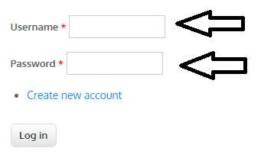

Last click log in.

Now you should be logged in.

Note: if you do not have a username and password you cannot login.

**2. Upload and download files**

//todo, need ldap up to demonstrate this

**3. Add Comment to Posts**

To comment on a post first locate the post you wish to comment on.

Next click the “Add New Comment” button.

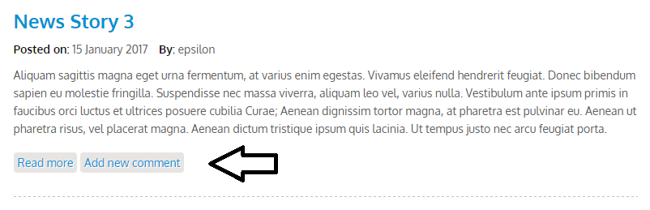

Next fill out the comment form, with your name, if not logged in, subject and comment.

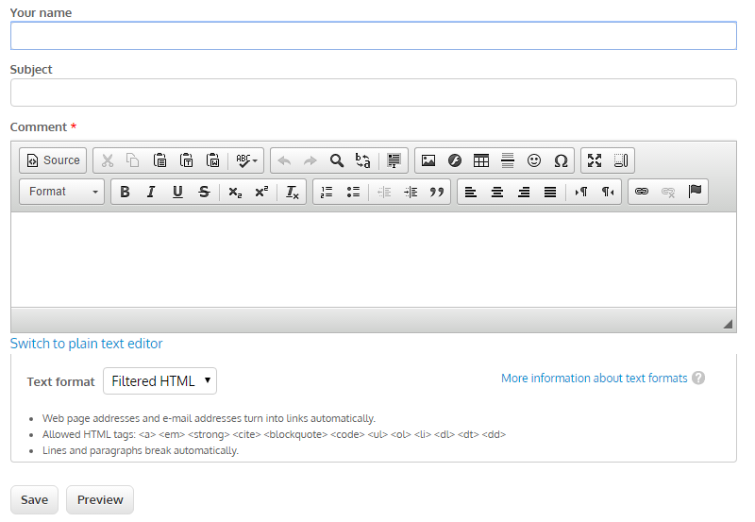

Last click save to post your comment.

**4. How to access ICS HMI**

First log in, refer to the login instructions above, if you do not have a username and password, you cannot login.

Next click the HMI tab at the top



Now you should have a page that displays access the the HMI

//to do, not sure what happens if you successfully connect to hmi

**5. How to request support through help desk**

// need ldap

**6. How to answer a request from help desk**

//need ldap

Appendix A

Table 1

|  |  |  |  |  |  |  |
| --- | --- | --- | --- | --- | --- | --- |
| NAME | ROLE | BADGE ID | EMAIL | PHONE | USERNAME | PASSWORD |
| Frank Castle | CEO | x4421 | f.castle@cdc.pan | 555-122-4121 | f.castle | Pangea11 |
| Lisa Delrose | Prime Minister | x8723 | l.delrose@cdc.pan | 555-122-8723 | l.delrose | Pangea12 |
| Chuck Wheeler | CIO | x3637 | c.wheeler@cdc.pan | 555-122-3637 | c.wheeler | Pangea13 |
| James Hoyt | Secretary | x5345 | j.hoyt@cdc.pan | 555-122-5345 | j.hoyt | Pangea14 |
| Sandra Wilhelm | Maintenance | x6365 | s.wilhelm@cdc.pan | 555-122-6365 | s.wilhelm | Pangea15 |
| Patricia Emerson | CSO | x8373 | p.emerson@cdc.pan | 555-122-8373 | p.emerson | Pangea16 |
| Piotre Luther | Grounds Keeper | x2383 | p.luther@cdc.pan | 555-122-2383 | p.luther | Pangea17 |
| Karen Holmes | Security Officer | x1122 | k.holmes@cdc.pan | 555-122-1122 | k.holmes | Pangea18 |
| Simon Smith | Intern | x9923 | s.smith@cdc.pan | 555-122-9923 | s.smith | Pangea19 |
| Jane Wright | Pump Technician | x3342 | j.wright@cdc.pan | 555-122-3342 | j.wright | Pangea21 |
| Ted Fritz | Pump Technician | x9121 | t.fritz@cdc.pan | 555-122-9121 | t.fritz | Pangea22 |
| Crystal Licht | Electrical Engineer | x2287 | c.licht@cdc.pan | 555-122-2287 | c.licht | Pangea23 |
| Holly Peterson | Software Engineer | x2342 | h.peterson@cdc.pan | 555-122-2342 | h.peterson | Pangea24 |
| Brad Wells | Web Design | x1022 | b.wells@cdc.pan | 555-122-1022 | b.wells | Pangea25 |
| Susan Taylor | Database Admin | x3234 | s.taylor@cdc.pan | 555-122-3234 | s.taylor | Pangea26 |
| Andrea Thompson | ICS Line Manager | X2589 | a.thompson@cdc.pan | 555-122-2589 | a.thompson | Pangea27 |