文章编号、中图分类号、文献标志码及学科分类号：中间标点为全角，字号小五号，中文黑体，数字及英文Times New Roman
促消保供场景下常规跨区直流日内柔性市场化调度：概念、判据及模型
文旭¹,周全¹,重大,杨洋¹,重大,重大,吴育全¹
(1. 国家电网有限公司西南分部，四川省 成都市 610041；
2. 输配电装备及系统安全与新技术国家重点实验室(重庆大学)，重庆市 沙坪坝区 400044；)

LCC-HVDC Intraday Flexible Marketization Dispatch Under the scenario of promoting consumption and ensuring supply: Concepts, Criteria, and Models
WEN Xu¹, ZHOU Quan¹, ***, YANG Yang¹, ***, ***, WU Yuquan¹
(1. Southwest Branch of State Grid Corporation of China, Chengdu 610041, Sichuan Province, China;
2. State Key Laboratory of Power Transmission Equipment & System Security and New Technology (Chongqing University), Shapingba District, Chongqing, 400044, China;)
ABSTRACT: Currently, with the increasing penetration of high-proportion renewable energy and the frequent occurrence of extreme weather events, the pressure of short-term promoting consumption and ensuring supply among regional power grids in China has become increasingly prominent, leading to the inter-regional power transformation mutual assistance demand from “seasonal” to “short-term”. Based on the engineering practical of the Debao high-voltage direct current (HVDC) intraday flexible dispatch, this paper proposed the line-commutated converter based high voltage direct current (LCC-HVDC) intraday flexible marketization dispatch under the scenario of promoting consumption and ensuring supply. First, this paper defines the basic concepts of the LCC-HVDC intraday flexible dispatch and intraday flexible marketization dispatch respectively, and expounds the core connotation from three dimensions. Combining the current market operation and system dispatch operation in China to design implementation process. Second, before organizing the intraday flexible marketization dispatch of LCC-HVDC, it is necessary to judge whether the start-up trigger. To reduce misjudgment of “required start-up”, this paper proposes a data-driven start-up trigger judgment method with high recall rate as the target. Then, multiple integer variables are introduced to represent the operating characteristics of LCC-HVDC, and the cross-regional market clearing model with embedded LCC-HVDC intraday flexible marketization dispatch is constructed, which realizes the normalization and marketization transaction. Finally, simulation-based calculation of the interconnected system for the Southwest-Northwest region grid, Verified the feasibility and efficacy of the proposes research.
KEY WORDS: LCC-HVDC; Regional Interconnection; Intraday Flexible Marketization Dispatch; Electricity Trading
摘要：当前，随着高比例新能源并网与极端天气事件频发，我国区域电网间短时促消保供压力日益凸显，导致我国跨区电力互济需求由“季节性”转变为“短期性”。为此，本文以德宝直流日内柔性调度工程实践为基础，提出促消保供场景下常规跨区直流日内柔性市场化调度方法。首先，本文分别对常规跨区直流日内柔性调度与日内柔性市场化调度的基本概念进行定义，并从三个维度阐述核心内涵，结合我国现行市场运营和调度运行体系设计实施流程。其次，在组织常规跨区直流柔性市场化调度交易前需提前对其启动触发进行研判，为降低“需要启动”被误判为“不需启动”的情况，本文提出以高召回率为目标构建数据驱动启动触发研判方法。然后，引入多个整数变量表征常规跨区直流运行特性，构建内嵌常规跨区直流日内柔性市场化调度出清模型，实现了常规跨区直流柔性调度常态化、市场化交易。最后，基于模拟西南西北区域互联的算例系统进行仿真测算，验证了所做研究的可行性和有效性。
关键词：常规跨区直流；跨区互济；日内柔性调度；电力交易

附录A
A1 算例参数
表A1 区域互联系统售电主体固定参数
Table.A1 Fix parameters of electricity sales entities for regional interconnection system
区域 | 市场主体 | 装机容量/MW | 上下爬坡率/MW·h | 最小出力/MW
区域A | 火电发电主体 | 220 | 110 | 44
区域A | 水电发电主体1 | 400 | / | 0
区域A | 水电发电主体2 | 200 | / | 0
区域 | 火电发电主体 | 320 | 160 | 64
区域 | 风电发电主体 | 400 | / | 0
区域 | 光伏发电主体 | 600 | / | 0

表A2 区域互联系统购售电主体电价申报参数
Table.A2 Electricity price quotation parameters of electricity purchase and sales entities for regional interconnection system
区域 | 市场主体 | 1段/元(MW·h)⁻¹ | 2段/元(MW·h)⁻¹ | 3段/元(MW·h)⁻¹ | 4段/元(MW·h)⁻¹ | 5段/元(MW·h)⁻¹
区域A | 火电发电主体 | 320 | 368 | 428 | 481 | 545
区域A | 水电发电主体1 | 30 | 130 | 280 | 350 | 430
区域A | 水电发电主体2 | 50 | 150 | 260 | 360 | 450
区域A | 区域购电主体 | 400 | 430 | 450 | 470 | 500
区域B | 火电发电主体 | 320 | 368 | 428 | 481 | 545
区域B | 风电发电主体 | 40 | 130 | 245 | 355 | 435
区域B | 光伏发电主体 | 30 | 120 | 240 | 350 | 430
区域B | 区域购电主体 | 400 | 430 | 450 | 470 | 500

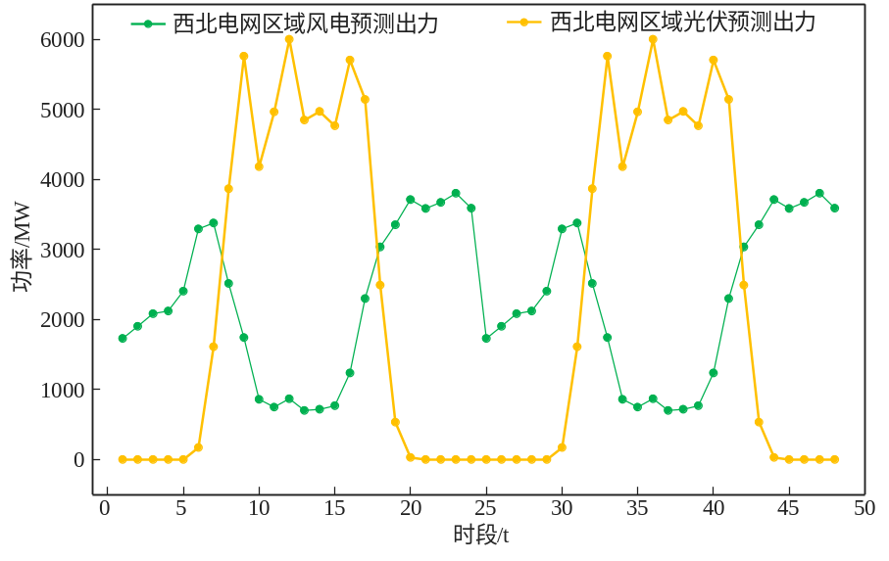
图A1 区域B区域新能源预测出力
Fig.A1 New energy forecast output in region B
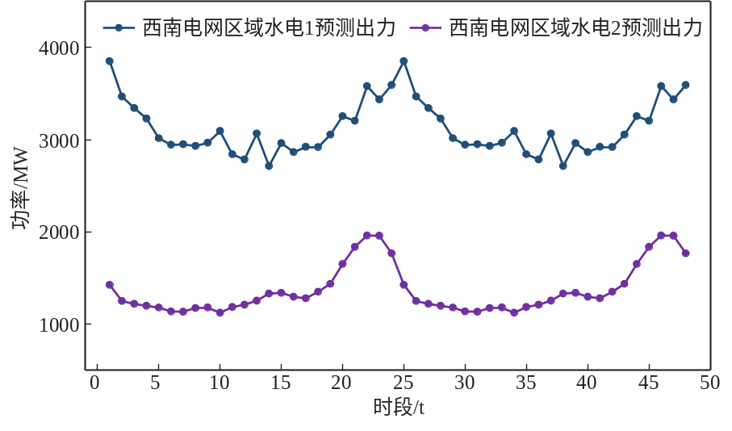
图A2 区域A区域水电预测出力
Fig.A2 Hydropower forecast output in region A
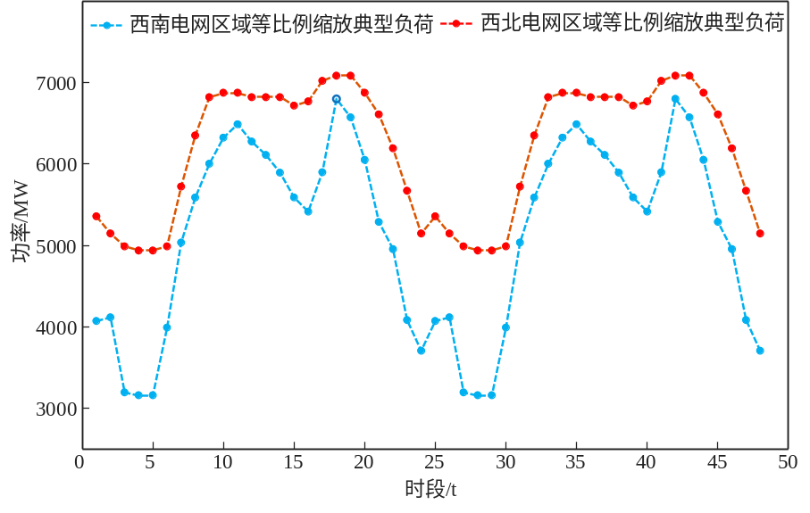
图A3 区域典型负荷
Fig.A3 Regional typical load

