**Redis Exercises**

1. **Connect to Redis**: Connect to a Redis server and verify the connection with PING.

redis-cli

PING

1. **Basic Key-Value Operations**: Store, retrieve, and delete a value using SET, GET, and DEL.

SET mykey "Test Redis"

GET mykey

DEL mykey

1. **Key Expiration**: Set a 10-second expiration for a key using EXPIRE.

SET temp_key "This will expire"

EXPIRE temp_key 10

TTL temp_key

1. **Lists**: Add elements to a list with LPUSH, retrieve them with LRANGE, and remove the first element with LPOP.

LPUSH mylist "element1"

LPUSH mylist "element2"

LPUSH mylist "element3"

LRANGE mylist 0 -1

LPOP mylist

1. **Sets**: Add elements to a set with SADD, retrieve them with SMEMBERS, and check membership with SISMEMBER.

SADD myset "element1"

SADD myset "element2"

SADD myset "element3"

SMEMBERS myset

SISMEMBER myset "element1"

1. **Hashes**: Add fields and values to a hash with HSET, retrieve them with HGETALL, and get a specific field with HGET.

HSET myhash field1 "value1"

HSET myhash field2 "value2"

HSET myhash field3 "value3"

HGETALL myhash

HGET myhash field1

1. **Sorted Sets (ZSET)**: Add elements with scores to a sorted set with ZADD and retrieve them with ZRANGE.

ZADD myzset 1 "element1"

ZADD myzset 2 "element2"

ZADD myzset 3 "element3"

ZRANGE myzset 0 -1 WITHSCORES

1. **Publish and Subscribe (Pub/Sub)**: Subscribe to a channel with SUBSCRIBE and publish a message with PUBLISH.

In first terminal

SUBSCRIBE mychannel

In second terminal

PUBLISH mychannel "Test Sub"

1. **Basic Transactions**: Start a transaction with MULTI, add commands, and execute with EXEC.

MULTI

SET key1 "value1"

SET key2 "value2"

EXEC

1. **Transactions with Discard**: Start a transaction with MULTI, add commands, and discard with DISCARD.

MULTI

SET key1 "temporary_value1"

SET key2 "temporary_value2"

DISCARD

1. **Transactions with WATCH**: Use WATCH to monitor keys, start a transaction with MULTI, and execute with EXEC.

WATCH key1

MULTI

SET key1 "new_value"

EXEC

1. **Transactions with Unwatch**: Use WATCH to monitor keys, disable monitoring with UNWATCH, and execute with EXEC.

WATCH key1

UNWATCH

MULTI

SET key1 "final_value"

EXEC

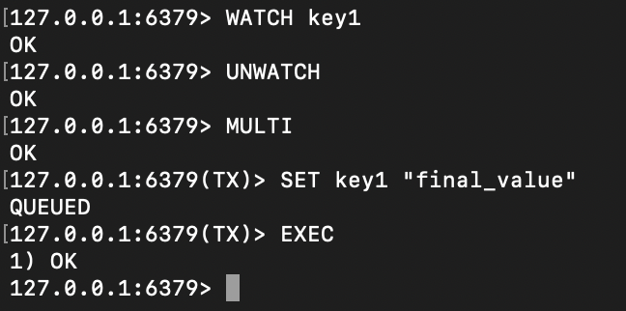

1. **Sorted Sets (ZSET) - Range and Removal**: Retrieve elements within a score range with ZRANGEBYSCORE and remove elements with ZREM.

ZRANGEBYSCORE myzset 2 3

ZREM myzset "element2"

1. **Sorted Sets (ZSET) - Count and Rank**: Count elements within a score range with ZCOUNT and get the rank of an element with ZRANK.

ZADD myzset 1 "element1" 2 "element2" 3 "element3" 4 "element4"

ZCOUNT myzset 2 3

ZRANK myzset "element3"

ZRANK myzset "element1"

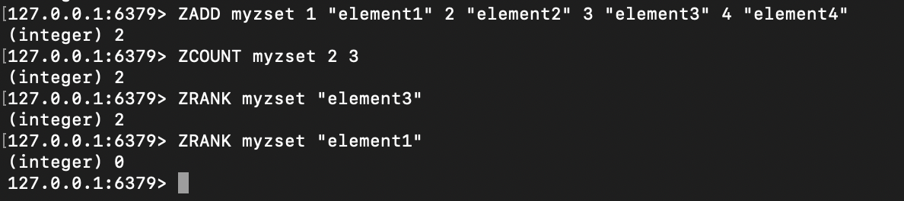

1. **Sorted Sets (ZSET) - Increment Score**: Increment the score of an element with ZINCRBY and verify the new score with ZSCORE.

ZSCORE myzset "element3"

ZINCRBY myzset 2 "element3"

ZSCORE myzset "element3"

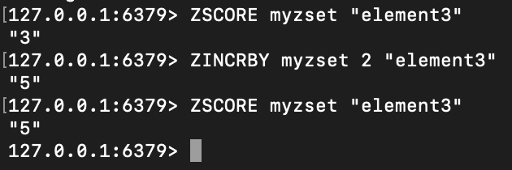

1. **Cache Configuration - List Cache**: Add values to a list with LPUSH, retrieve them with LRANGE, and set an expiration with EXPIRE.

LPUSH cache_list "value1"

LPUSH cache_list "value2"

LPUSH cache_list "value3"

LRANGE cache_list 0 -1

EXPIRE cache_list 60

TTL cache_list

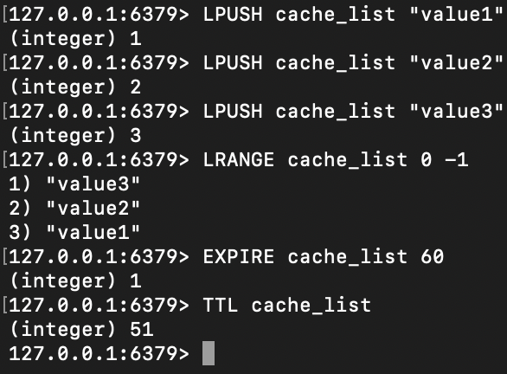

1. **Cache Configuration - Hash Cache**: Store fields and values in a hash with HSET, retrieve them with HGETALL, and set an expiration with EXPIRE.

HSET cache_hash field1 "value1"

HSET cache_hash field2 "value2"

HSET cache_hash field3 "value3"

HGETALL cache_hash

EXPIRE cache_hash 60

TTL cache_hash

1. **Cache Configuration - Set Cache**: Add values to a set with SADD, retrieve them with SMEMBERS, and set an expiration with EXPIRE.

SADD cache_set "value1"

SADD cache_set "value2"

SADD cache_set "value3"

SMEMBERS cache_set

EXPIRE cache_set 60

TTL cache_set

1. **Cache Configuration - Sorted Set Cache**: Add values with scores to a sorted set with ZADD, retrieve them with ZRANGE, and set an expiration with EXPIRE.

ZADD cache_zset 1 "value1"

ZADD cache_zset 2 "value2"

ZADD cache_zset 3 "value3"

ZRANGE cache_zset 0 -1 WITHSCORES

EXPIRE cache_zset 60

TTL cache_zset

1. **Increment Operations**: Store a numeric value with SET, increment with INCR, and decrement with DECR.

SET numeric_key 10

INCR numeric_key

DECR numeric_key

