Computer Vision HW2 Report
Student ID: R13945041
Name: 王獻霆

Part 1. (10%)
• Plot confusion matrix of two settings. (i.e. Bag of sift and tiny image) (5%)
Ans:

Tiny Image + KNN | Bag of SIFT + KNN
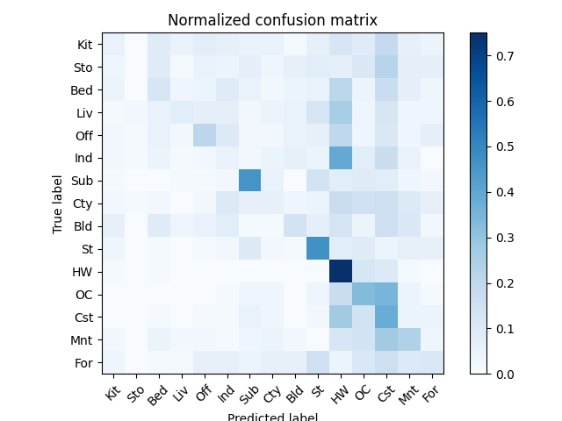 | 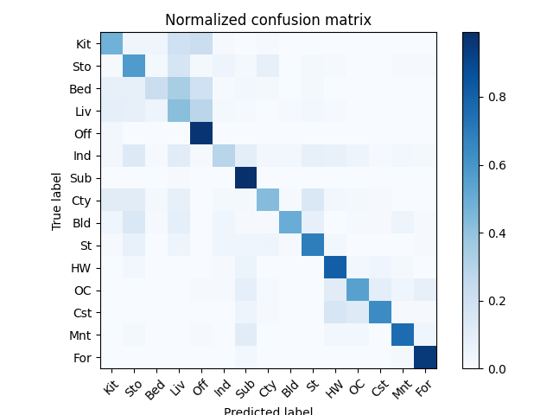

• Compare the results/accuracy of both settings and explain the result. (5%)
Ans:
Tiny Image + KNN | Bag of SIFT + KNN
Accuracy = 0.23 | Accuracy = 0.6186666666666667

From the confusion matrix, observe that the matrix generated by Tiny Image is scattered, indicating a high number of misclassifications between different categories. In contrast, Bag of SIFT exhibits a distinct diagonal pattern, suggesting that the majority of images are correctly classified.After downsampling, Tiny Image can only capture global brightness information, whilst losing important spatial structure and local details. Consequently, it is unable to effectively distinguish between different scene categories. On the other hand, Bag of SIFT characterises images using local invariant features such as edges and textures.
By clustering these features into a visual vocabulary, it forms a more discriminative representation, thereby significantly improving classification performance.Consequently, Bag of SIFT performs far better than Tiny Image.

Part 2. (25%)
• Report accuracy of both models on the validation set. (2%)
Ans:
 | A = MyNet | B = ResNet18
accuracy | 0.84140(84.14%) | 0.91660 (91.66%)

• Print the network architecture & number of parameters of both models. What is the main difference between ResNet and other CNN architectures? (5%)
Ans:
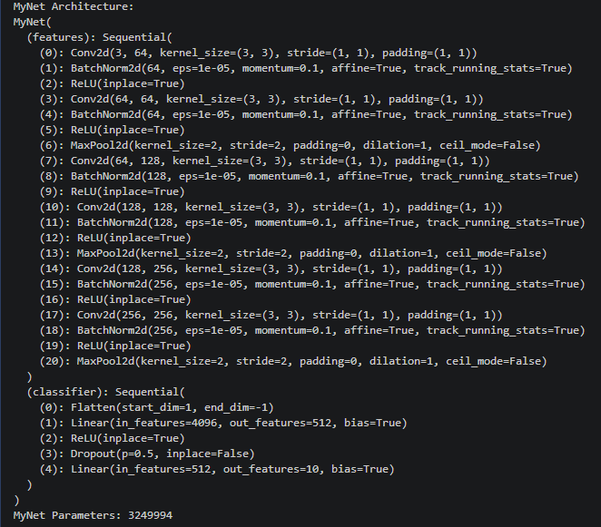
Model A: MyNet
The architecture of MyNet is shown in the figure above.
MyNet consists of multiple convolutional blocks, each containing a convolutional layer, a batch normalisation layer, a ReLU activation layer and a max-pooling layer, followed by a fully connected layer for classification.
Number of parameters: 3,249,994
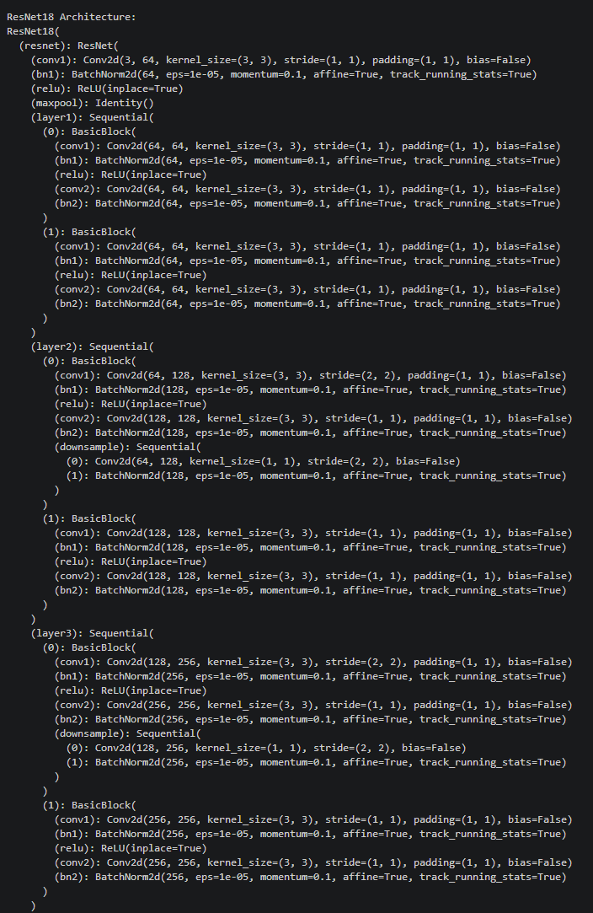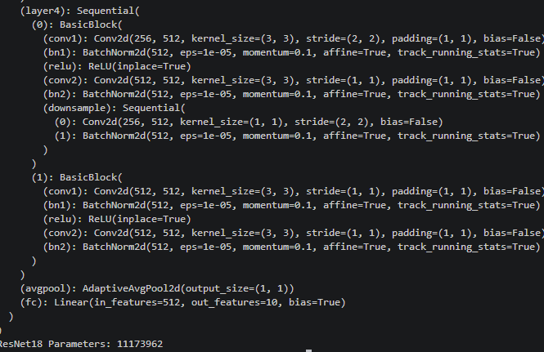
Model B: ResNet18
The architecture of ResNet18 is shown in the figure above.
ResNet18 consists of multiple BasicBlocks, which contain residual connections (skip connections). The network also includes adaptive average pooling layers and fully connected layers for classification.
Number of parameters: 11,173,962

Differences between ResNet and other CNN architectures:
The main difference between ResNet and traditional CNN architectures lies in the use of residual connections (jump connections).
In traditional CNNs, information flows sequentially from one layer to the next. As the number of layers in the network increases, training becomes more difficult due to issues such as vanishing gradients. In contrast, ResNet introduces jump connections, allowing the input of a given layer to be directly added to its output. This helps preserve information across layers and makes it easier to train deeper networks. Consequently, ResNet achieves better performance compared to standard CNN architectures. Furthermore, ResNet18 has far more parameters than MyNet, which also gives it stronger representational capabilities. Residual connections (jump connections) allow the network to learn identity mappings, which makes it easier to train very deep networks.

• Plot four learning curves (loss & accuracy) of the training process (train/validation) for both models. Total 8 plots. (8%)
Ans:
 | Model A：MyNet | Model B：ResNet18
Training Accuracy | 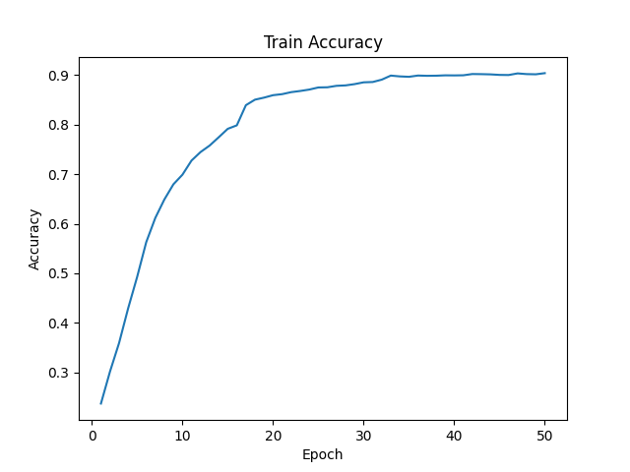 | 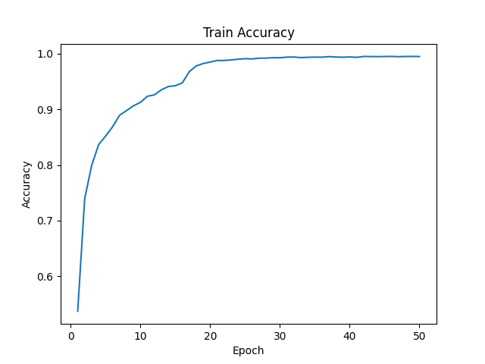
Training Loss | 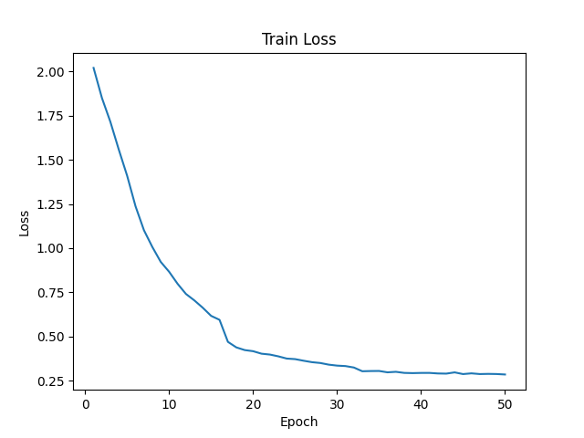 | 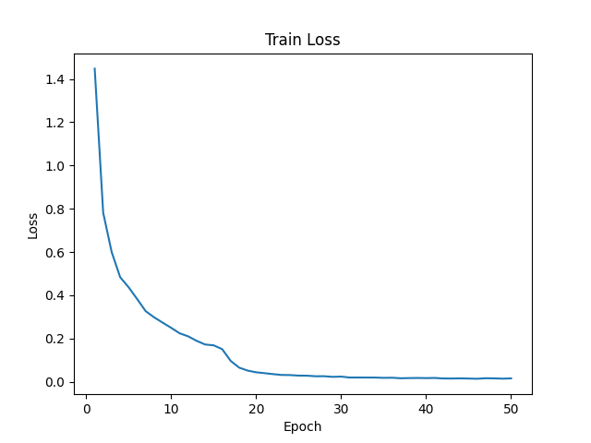
Validation Accuracy | 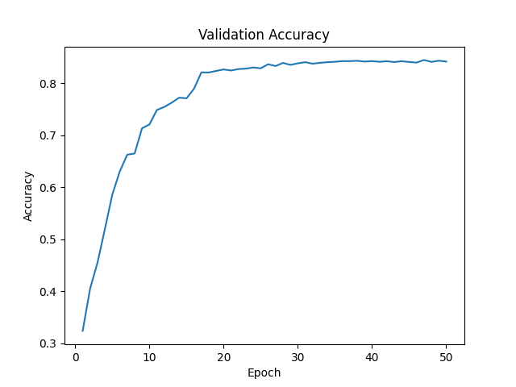 | 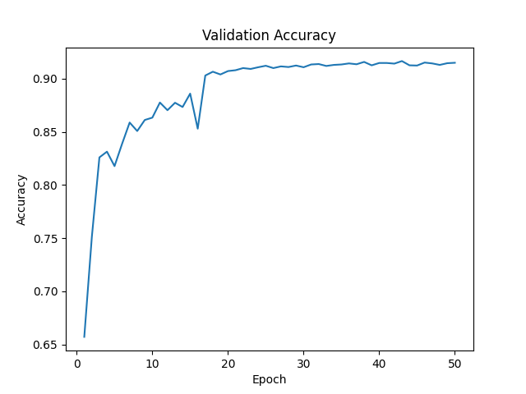
Validation Loss | 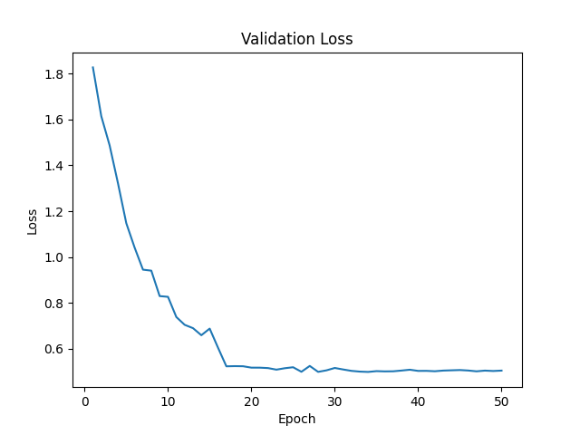 | 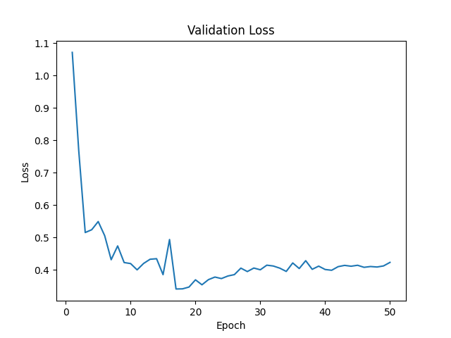

From the learning curves, both models converge during training.
ResNet18 achieves higher validation accuracy and better generalization ability than MyNet.

• Briefly describe what method do you apply on your best model? (e.g. data augmentation, model architecture, loss function, etc) (10%)
Ans:
To improve the performance of my best model (ResNet18), I applied the following methods:
- Using a pre-trained ResNet18：The pretrained weights provide better feature representations and help the model converge faster.
- Modify the architecture for 32×32 images
(1) Change the first convolution layer to 3×3 with stride=1
(2) Remove the original max-pooling layer
- Data augmentation
(1) RandomCrop(32, padding=4)
(2) RandomHorizontalFlip
(3) ColorJitter
This increases data diversity and improves generalization.
4. Normalise the input image
5. CrossEntropyLoss：Use CrossEntropyLoss for multi-class classification
6. Use SGD optimisation：stable training.
7. Learning rate scheduler ：Apply a multi-step learning rate scheduler with initial learning rate = 0.01.
The learning rate is reduced at epochs 16, 32, and 45 (milestones), which helps the model converge more stably during later training stages.8. Best model selection：Save the model with the highest validation accuracy.

Overall, the combination of a pre-trained ResNet18, architectural modifications tailored for small-sized images, and data augmentation techniques significantly improved the model’s performance, achieving an accuracy of 91.66% on the validation set.

