Computer Vision HW1 Report
Student ID: R13945041
Name: 王獻霆
Part 1.
- Visualize the DoG images of 1.png.
 | DoG Image (threshold = 5) |  | DoG Image (threshold = 5)
DoG1-1.png | 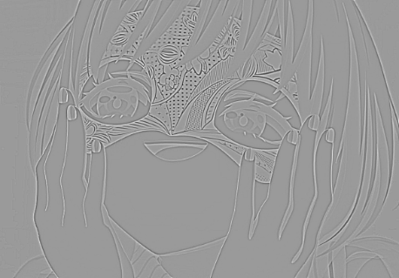 | DoG2-1.png | 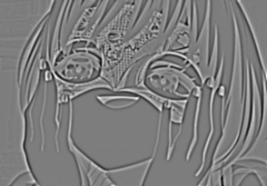
DoG1-2.png | 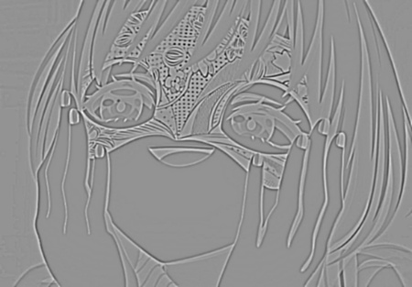 | DoG2-2.png | 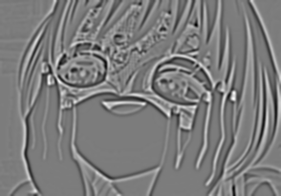
DoG1-3.png | 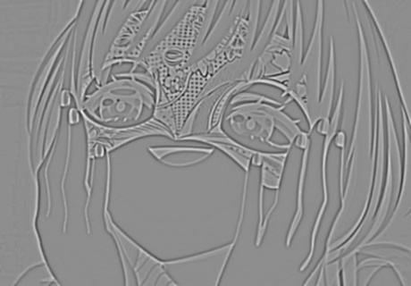 | DoG2-3.png | 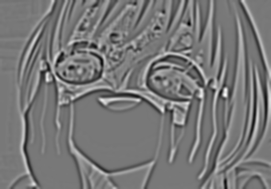
DoG1-4.png | 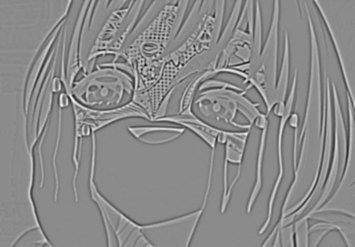 | DoG2-4.png | 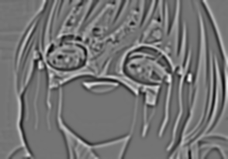

- Use three thresholds (1,2,3) on 2.png and describe the difference.
Threshold | Image with detected keypoints on 2.png
0.5 | 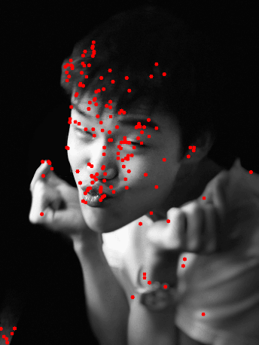
1.0 | 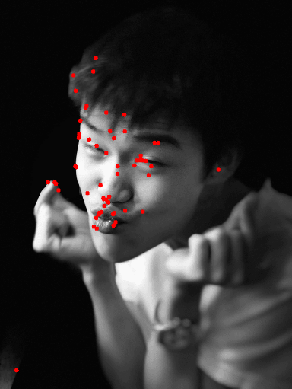
5.0 | 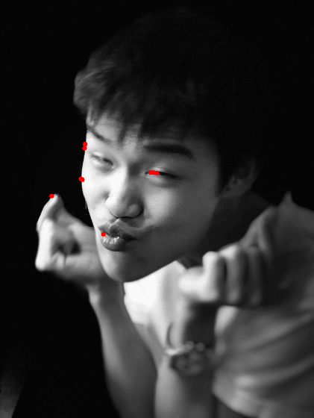
(describe the difference)

Part 2.
- Report the cost for each filtered image.
Gray Scale Setting | Cost (1.png)
cv2.COLOR_BGR2GRAY | 1207799
R*0.0+G*0.0+B*1.0 | 1439568
R*0.0+G*1.0+B*0.0 | 1305961
R*0.1+G*0.0+B*0.9 | 1393620
R*0.1+G*0.4+B*0.5 | 1279697
R*0.8+G*0.2+B*0.0 | 1127913
Gray Scale Setting | Cost (2.png)
cv2.COLOR_BGR2GRAY | 183851
R*0.1+G*0.0+B*0.9 | 77883
R*0.2+G*0.0+B*0.8 | 86023
R*0.2+G*0.8+B*0.0 | 188019
R*0.4+G*0.0+B*0.6 | 128341
R*1.0+G*0.0+B*0.0 | 110862

- Show original RGB image / two filtered RGB images and two grayscale images with highest and lowest cost.
Original RGB image (1.png) | Filtered RGB image and Grayscale image of  Highest cost | Filtered RGB image and Grayscale image of  Lowest cost
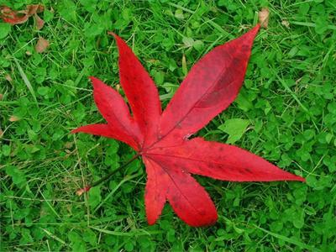 | 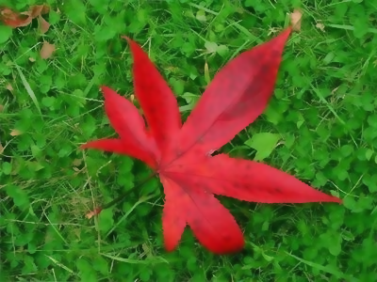 | 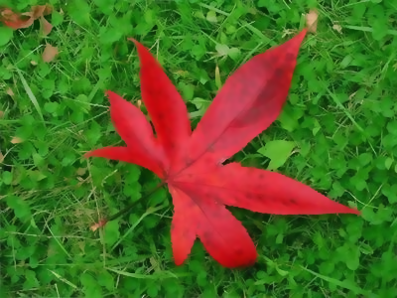
 | 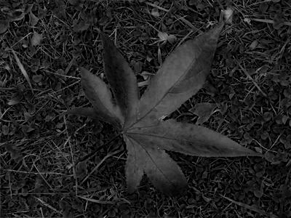 | 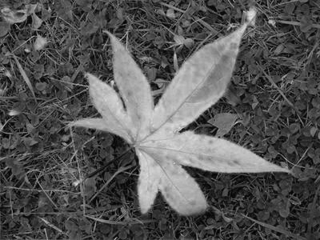
(Describe the difference between those two grayscale images)

Original RGB image (2.png) | Filtered RGB image and Grayscale image of  Highest cost | Filtered RGB image and Grayscale image of  Lowest cost
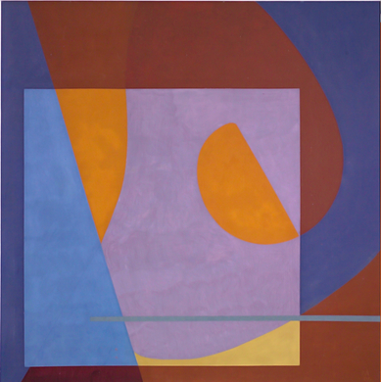 | 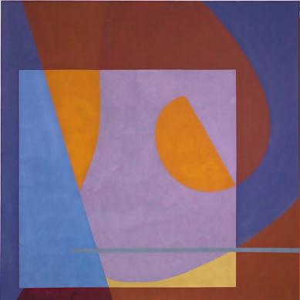 | 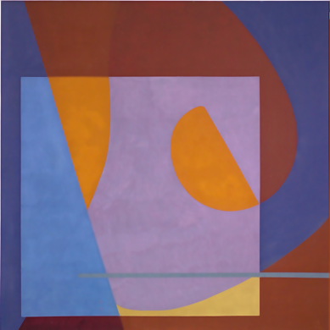
 | 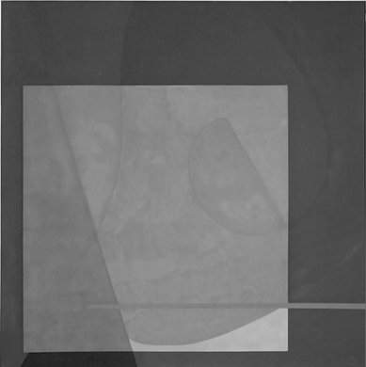 | 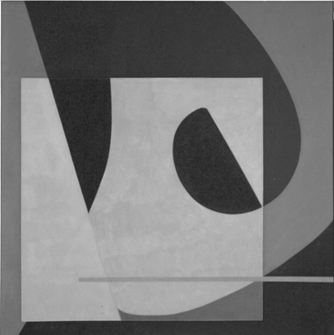
(Describe the difference between those two grayscale images)

- Describe how to speed up the implementation of bilateral filter.

