電通二乙微處理器實驗 實驗結報

實驗名稱 | Lab06
組別 |  | 組員 | 胡志鴻

- 實驗目的
如何使 Arduino 發出特定旋律的聲音?
Arduino 接喇叭如何接線?
如何使用 tone library?
如何演奏一段音樂?
如何使用 4x4 鍵盤演奏音樂?
如何發報摩斯電碼?

- 實驗步驟
Arduino 演奏一段特定的音樂, 旋律不得是小蜜蜂
使用 4x4 鍵盤演奏音樂
發報摩斯電碼

- 程式碼
Check1
#define NOTE_C3 131
#define NOTE_CS3 139
#define NOTE_D3 147
#define NOTE_DS3 156
#define NOTE_E3 165
#define NOTE_F3 175
#define NOTE_FS3 185
#define NOTE_G3 196
#define NOTE_GS3 208
#define NOTE_A3 220
#define NOTE_AS3 233
#define NOTE_B3 247
#define NOTE_C4 262
#define NOTE_CS4 277
#define NOTE_D4 294
#define NOTE_DS4 311
#define NOTE_E4 330
#define NOTE_F4 349
#define NOTE_FS4 370
#define NOTE_G4 392
#define NOTE_GS4 415
#define NOTE_A4 440
#define NOTE_AS4 466
#define NOTE_B4 494
#define NOTE_AA2 587

#define WHOLE 1
#define HALF 0.5
#define QUARTER 0.25
#define EIGHTH 0.25
#define SIXTEENTH 0.625

int tune[] =
{
NOTE_B4,NOTE_G4,NOTE_D4,NOTE_G4,NOTE_A4,NOTE_AA2,NOTE_A4,NOTE_B4,NOTE_A4,NOTE_D4,NOTE_G4
};

float duration[]=

{
1,1,1,1,1,1+1,1,1,1,1,1
};

int length;

int tonePin=8;
void setup()
{
pinMode(tonePin,OUTPUT);
length = sizeof(tune)/sizeof(tune[0]);
}
void loop()
{

for(int x=0;x<length;x++)
{
tone(tonePin,tune[x]);

delay(400*duration[x]);

noTone(tonePin);

}
delay(2000);
}

Check2
#include <Keypad.h>
#define PIN 11
#define C3 131
#define D3 147
#define E3 165
#define F3 175
#define G3 196
#define A3 220
#define B3 247

#define C4 262
#define D4 294
#define E4 330
#define F4 349
#define G4 392
#define A4 440
#define B4 494

#define C5 523
#define D5 587
const byte ROWS = 4; // 4 Rows
const byte COLS = 4; // 4 Columns
char keys[ROWS][COLS] = {
{'7', '4', '1', '0'}, {'8', '5', '2', 'A'},
{'9', '6', '3', 'B'}, {'C', 'D', 'E', 'F'}
};
byte rowPins[ROWS] = {5, 4, 3, 2};
byte colPins[COLS] = {10, 9, 8, 7};
Keypad keypad =
Keypad( makeKeymap(keys), rowPins,
colPins, ROWS, COLS );
void setup() {
pinMode(PIN, OUTPUT);
Serial.begin(9600);
}
void loop() {
char key = keypad.getKey();
if (key != NO_KEY) {
if (key == '0')
{
tone(PIN, C3);
delay(1000);
noTone(PIN);
}
else if (key == '1')
{
tone(PIN, D3);
delay(1000);
noTone(PIN);
}
else if (key == '4')
{
tone(PIN, E3);
delay(1000);
noTone(PIN);
}
else if (key == '7')
{
tone(PIN, F3);
delay(1000);
noTone(PIN);
}
else if (key == 'A')
{
tone(PIN, G3);
delay(1000);
noTone(PIN);
}
else if (key == '2')
{
tone(PIN, A3);
delay(1000);
noTone(PIN);
}
else if (key == '5')
{
tone(PIN, B3);
delay(1000);
noTone(PIN);
}
else if (key == '8')
{ tone(PIN, C4);
delay(1000);
noTone(PIN);
}
else if (key == 'B')
{ tone(PIN, D4);
delay(1000);
noTone(PIN);
}
else if (key == '3')
{ tone(PIN, E4);
delay(1000);
noTone(PIN);
}
else if (key == '6')
{ tone(PIN, F4);
delay(1000);
noTone(PIN);
}
else if (key == '9')
{ tone(PIN, G4);
delay(1000);
noTone(PIN);
}
else if (key == 'F')
{ tone(PIN, A4);
delay(1000);
noTone(PIN);
}
else if (key == 'E')
{ tone(PIN, B4);
delay(1000);
noTone(PIN);
}
else if (key == 'D')
{ tone(PIN, C5);
delay(1000);
noTone(PIN);
}
else if (key == 'C')
{ tone(PIN, D5);
delay(1000);
noTone(PIN);
}
Serial.println(key);
}
}

Check3
char *morse[] = {"01", "1000", "1010", "100",
"0", "0010", "110", "0000",
"00", "0111", "101", "0100",
"11", "10", "111", "0110",
"1101", "010", "000", "1",
"001", "0001", "011", "1001", "1011", "1100"
};
#define PIN 11
char k, con;
char *ptr;

void setup() {
pinMode(PIN, OUTPUT);
Serial.begin(9600);
}

void loop() {
if (Serial.available())
{
k = Serial.read();
Serial.println(k);
if ((k - 'A') >= 0 && (k - 'Z') <= 0)
{ con = k - 'A';
ptr = morse[con];

while (*ptr != '\0')
{
if (*ptr == '0')
{
tone(PIN, 440, 100);
delay(100);

}
else
{
tone(PIN, 440, 300);
delay(300);

}
ptr++;

delay(100);

}
}
}
}
- 實驗結果及分析
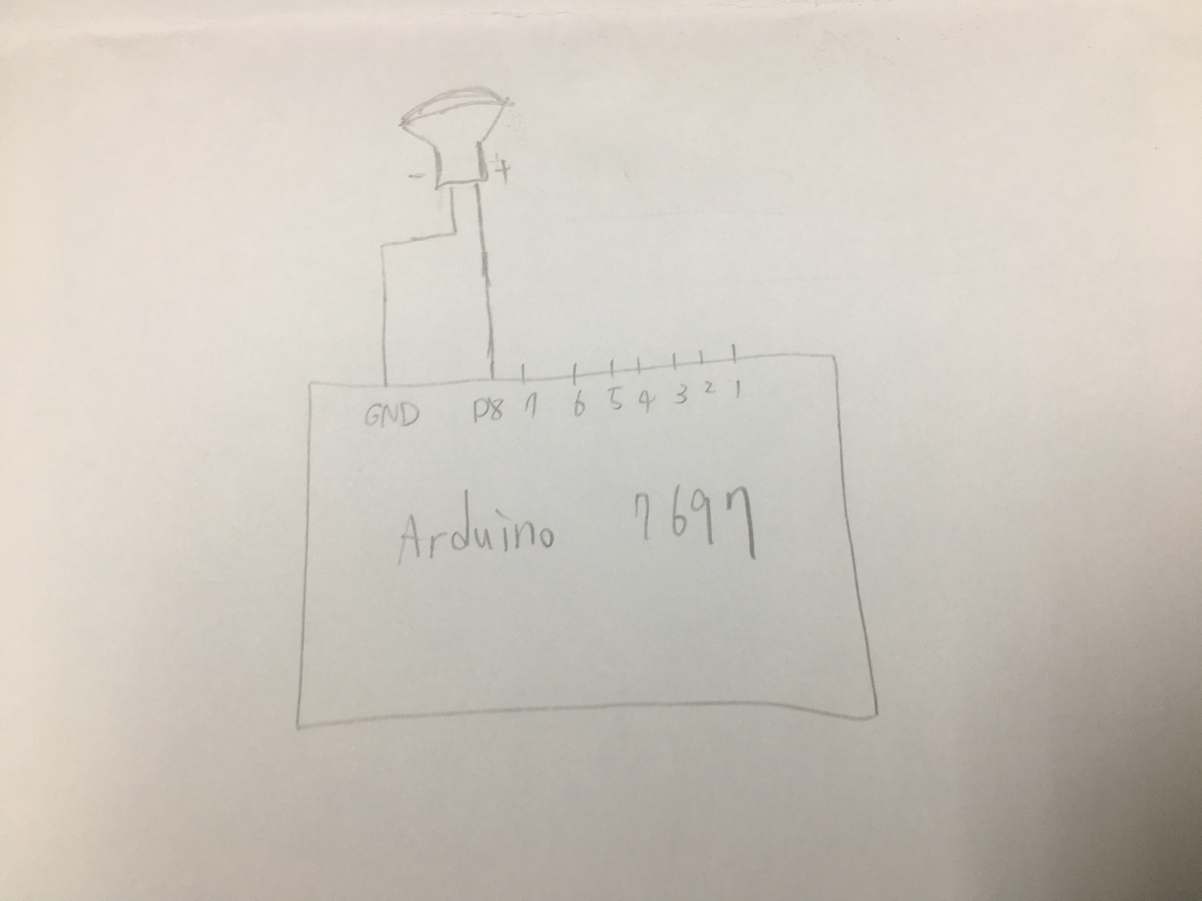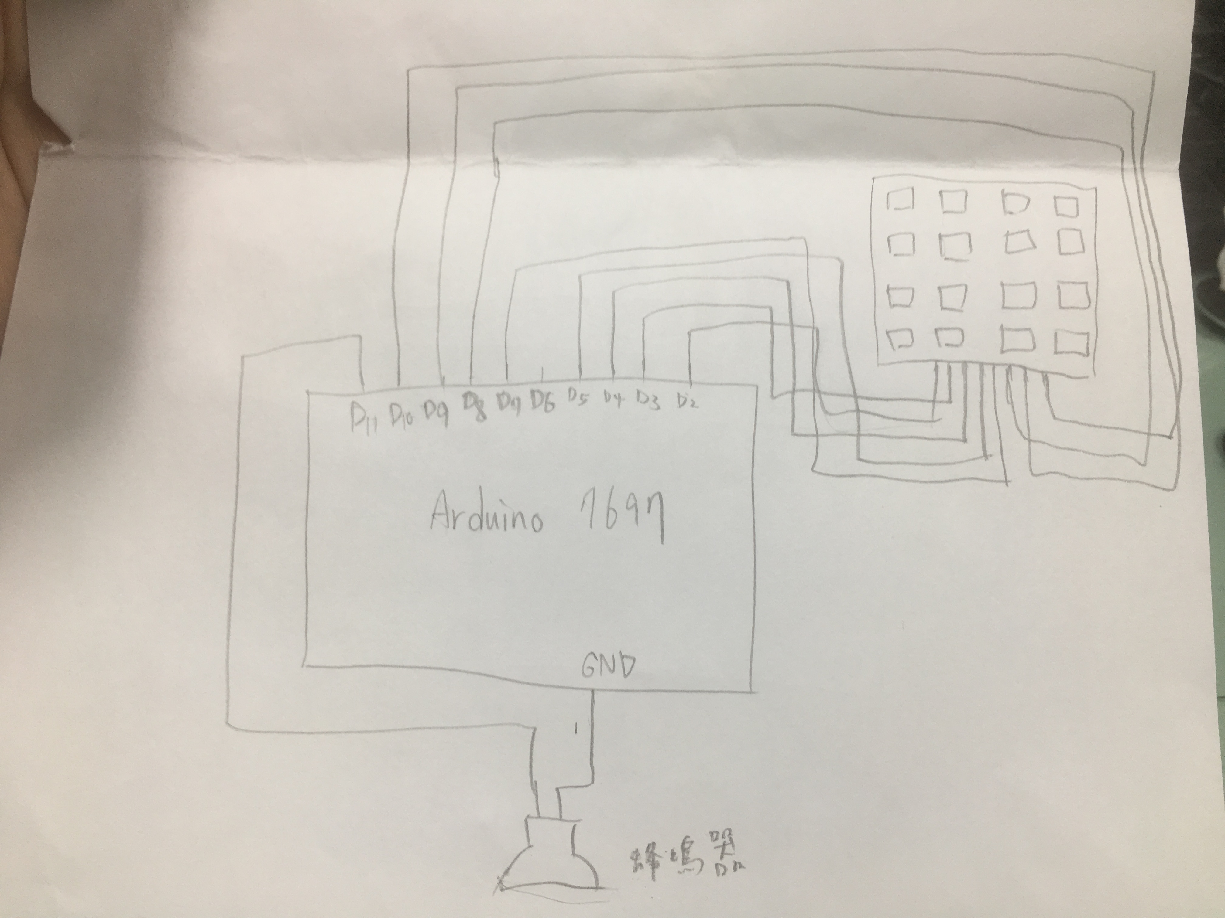
- 心得討論
上次沒上到課，這次上課才把他做完，這次的蜂鳴器還蠻好玩的，希望之後也不會太無趣。

