2. Traffic Analysis

Q1: The full TCP stream statistic and total data in bytes for the access session

A1: 13 kB

First we need to know the ip address of ccu.edu.tw

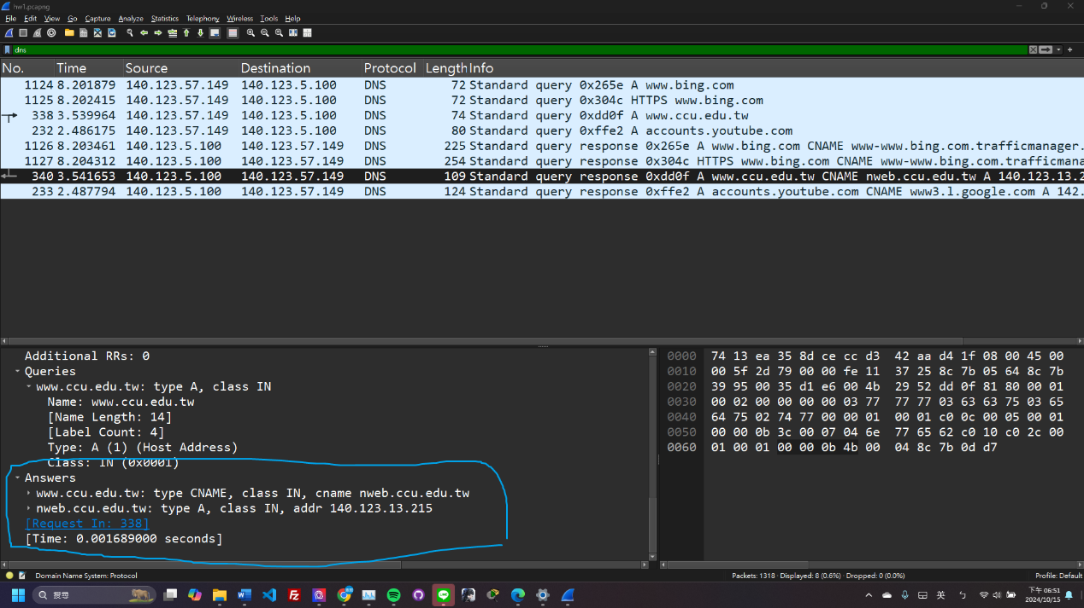

and our ip address(140.123.57.149)

Then we filter 140.123.13.215 and 140.123.57.149, find out the earliest tcp conversation. This is what we want.

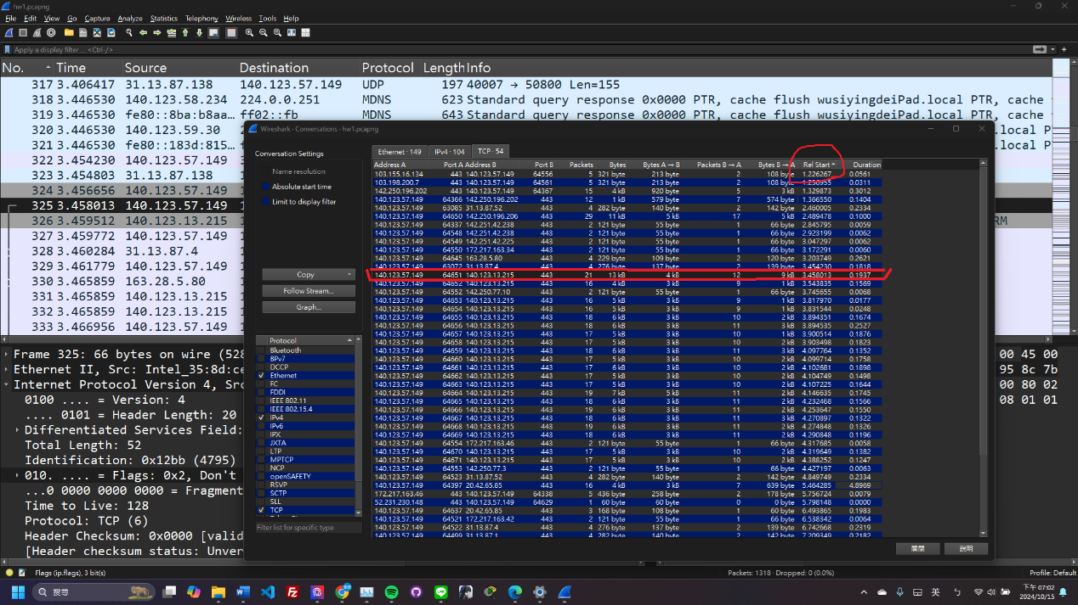

Q2: The IP address of the website (DNS resolution)

A2: 140.123.13.215



3. Fix the network problem

Q1: What are the reasons of when PC1 pings PC2 in the provided pkt, it shows “Request time out”?

A1:

1. At 11:27 in this [video](https://www.youtube.com/watch?v=IYusDFMPZWU),teacher was dealing with pinging to “My PC”. But he failed. He modified the RIP settings on two routers. So we checked the RIP settings of NTU Router and CCU Router, we found they were incorrect (Fig. 5). The RIP setting of NTU Router needs to add the section circled in blue, while the RIP setting of CCU Router should include the section circled in orange, as shown in Fig. 6.

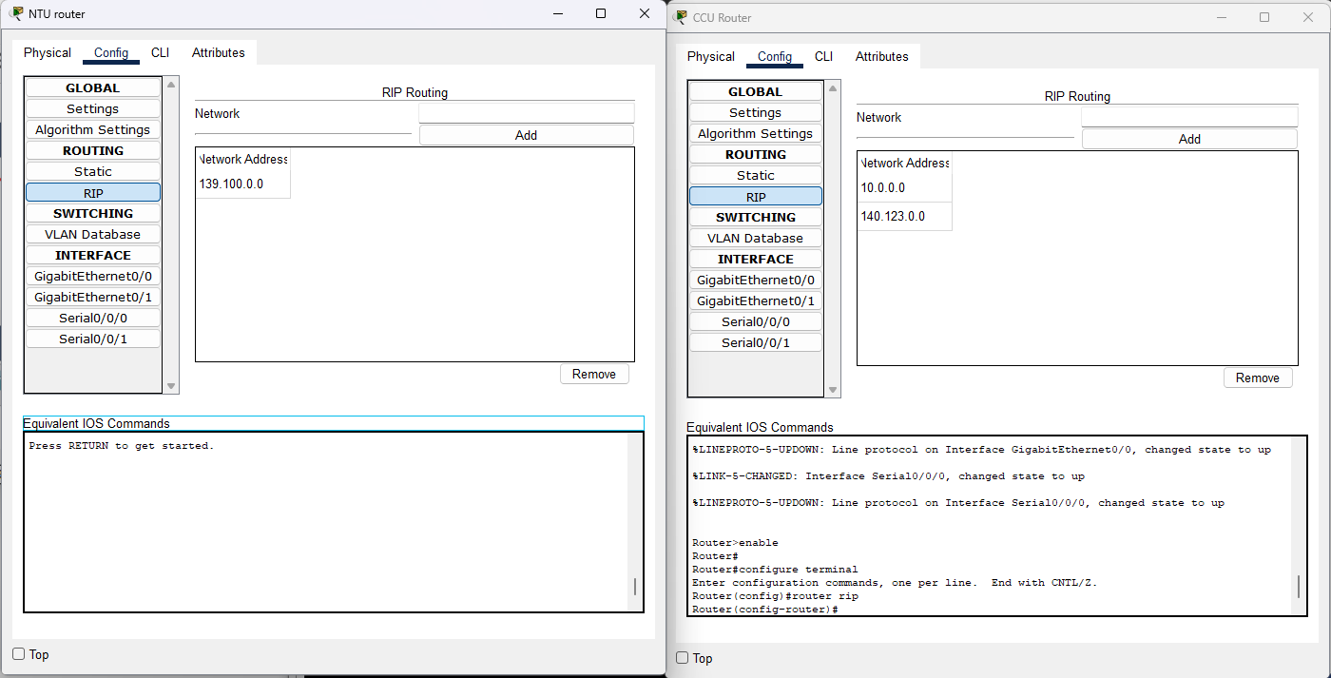

Fig. 5

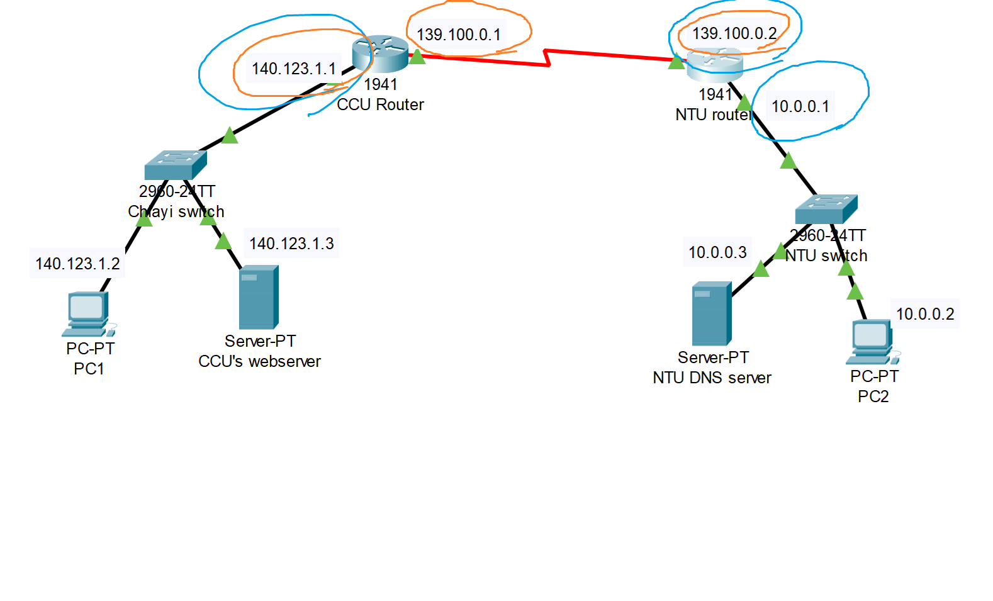

Fig. 6

1. The IP Configuration of CCU Router is wrong(Fig. 7)

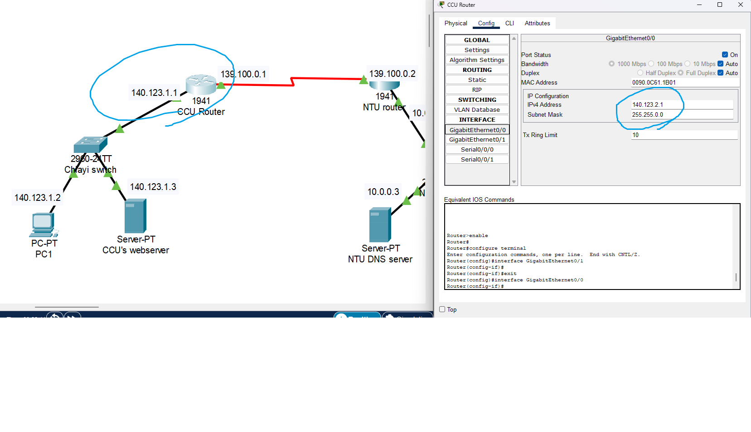

(Fig. 7)

Q2: How to fix the above problem? Show screenshots to proof how you fix to let PC1 ping PC2 successfully.

A2: We need to modified two routers. In Figures 8, 9, and 10, the left side shows the configuration before modification, and the right side shows the configuration after modification.

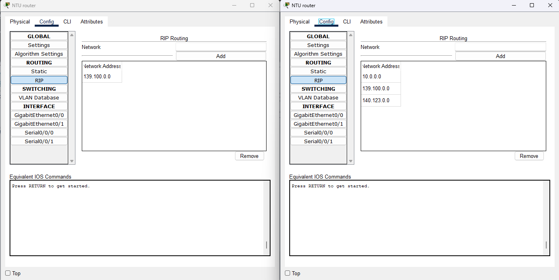

Fig. 8

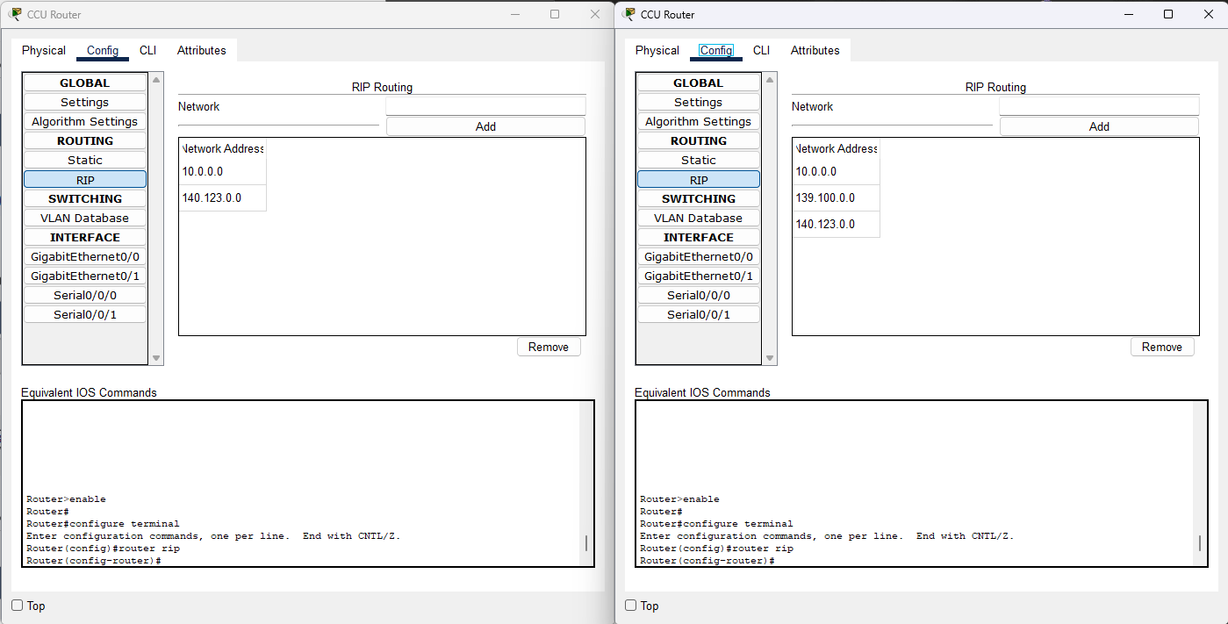

Fig. 9

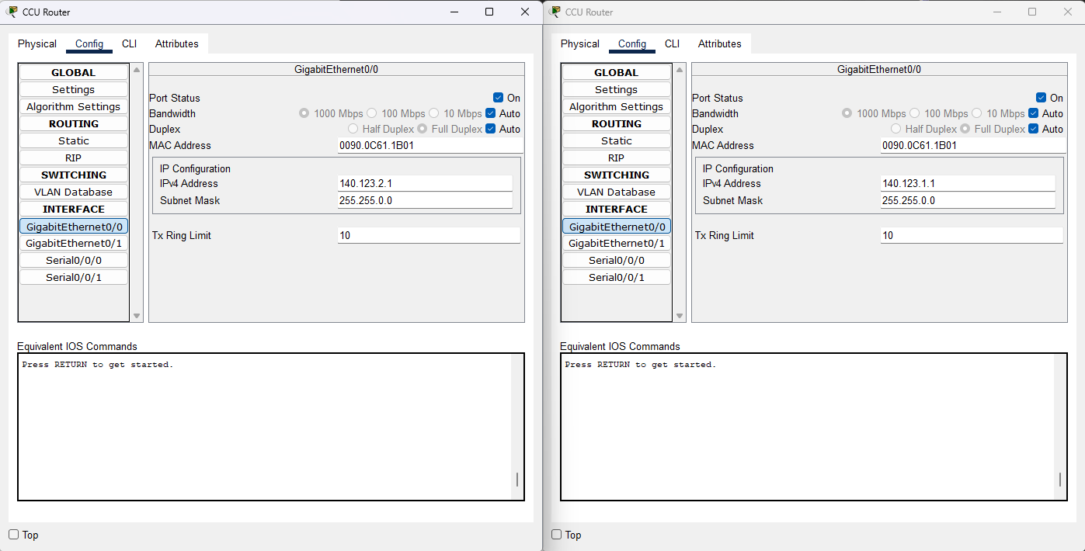

Fig. 10

Now we can use PC1 to ping PC2!

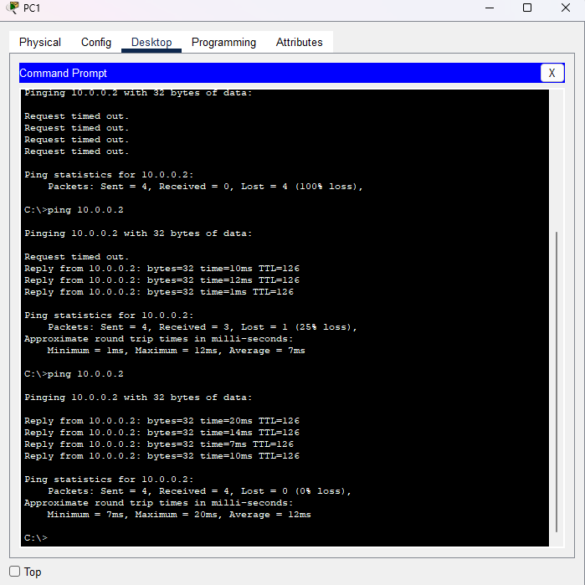

Reference：

<https://www.youtube.com/watch?v=9-sXlykDSs4>

<https://www.youtube.com/watch?v=3f9z-upxqW4&t=12s>

<https://www.youtube.com/watch?v=Bl6dZJq_Wc0&t=274s>

<https://www.computernetworkingnotes.com/ccna-study-guide/extended-acl-configuration-commands-explained.html>

<https://www.cisco.com/c/zh_tw/support/docs/security/ios-firewall/23602-confaccesslists.html>

<https://support.hpe.com/techhub/eginfolib/networking/docs/switches/RA/15-18/5998-8151_ra_2620_asg/content/ch10s09.html>

<https://lobotsai.blogspot.com/2012/03/ccna_10.html>