Here will have more information in the future 0.0  
But now only file name :D

Therefore, this document is not the final version, and its contents may change :-P

Cockpit:  
(Format:Titan_Cockpit_col.dds)

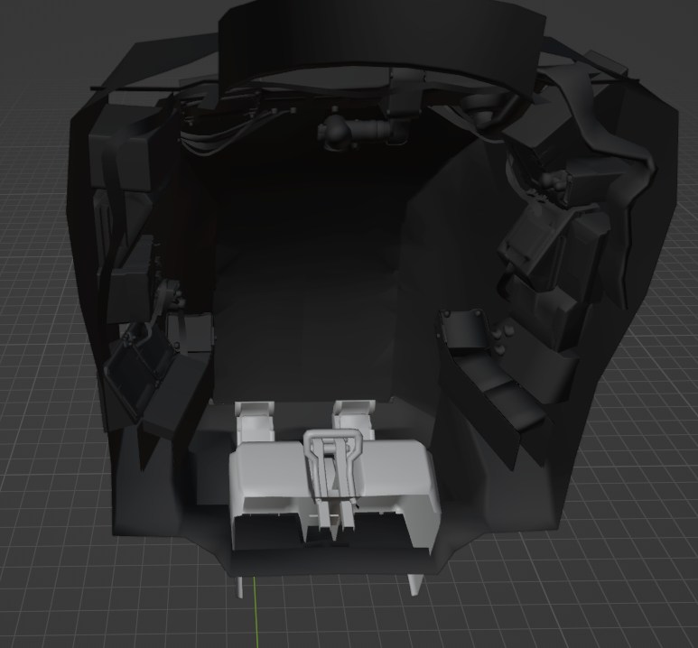

Console:  
(Format:Titan_Console_col.dds)

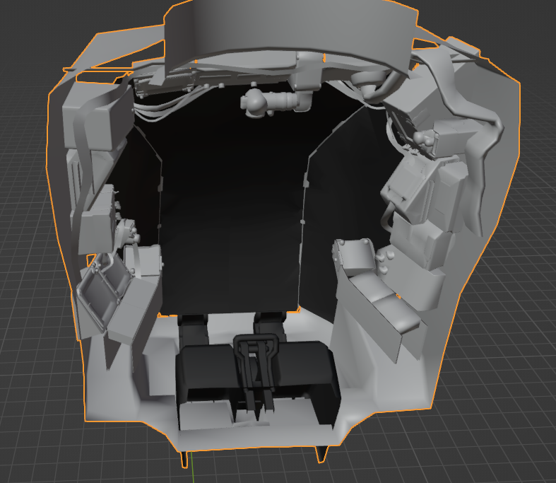

|  |  |
| --- | --- |
| Titan Skin | |
| Ion | ION |
| Legion | Legion |
| Northstar | Northstar |
| Ronin | Ronin |
| Scorch | Scorch |
| Tone | Tone |
| Monarch(May have bug) | Monarch |
| Prime Titan Skin | |
| Prime Ion | PrimeION |
| Prime Legion | PrimeLegion |
| Prime Northstar | PrimeNorthstar |
| Prime Ronin | PrimeRonin |
| Prime Scorch | PrimeScorch |
| Prime Tone | PrimeTone |