Vyazhev Mikhail, Data Science
https://github.com/zxcTerrorize/CSE_205_Final_Project_VyazhevMikhail
“Lost and Found System” Report
Code & Explanation
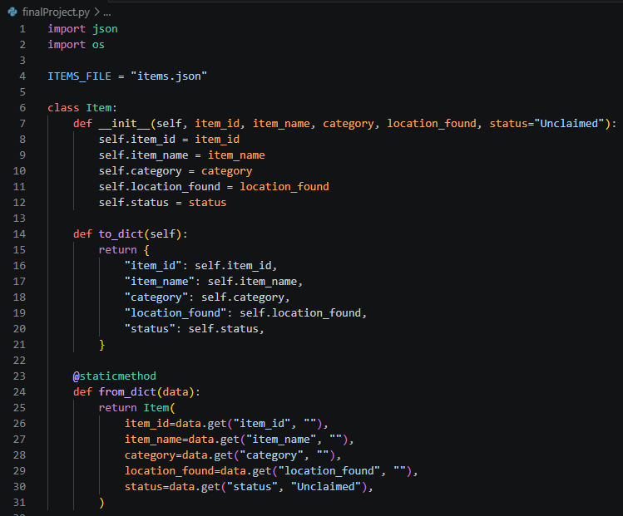
__init__ method & other useful methods to return data in convenient format
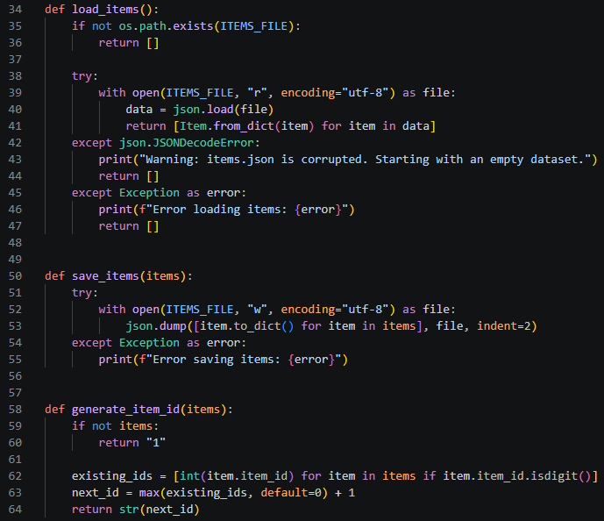
Load, saving and generating items methods logic, including errors handling in case json is corrupted or other json exceptions.
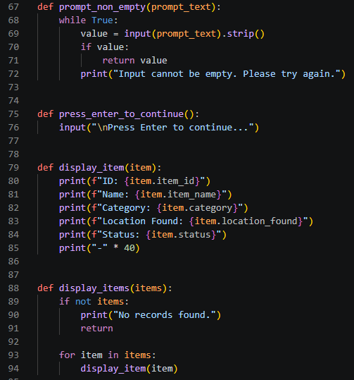
Method for empty input handling, separate method to output “press enter to continue”, method to display items from system.
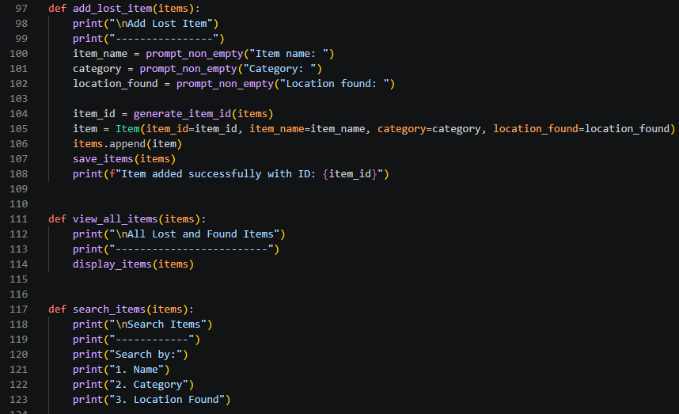
Methods for menu parts: adding & viewing methods, search
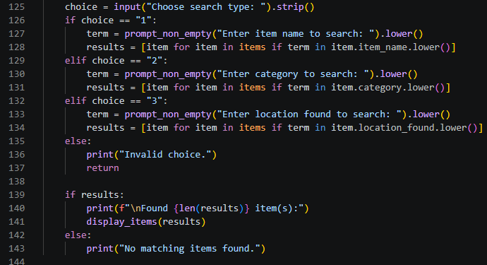
Search method if else logic
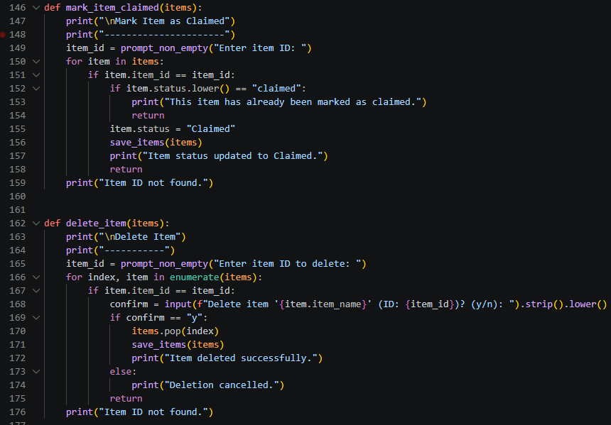
Method to change status of item when it is claimed, method for deleting (using loops and if/else logic)
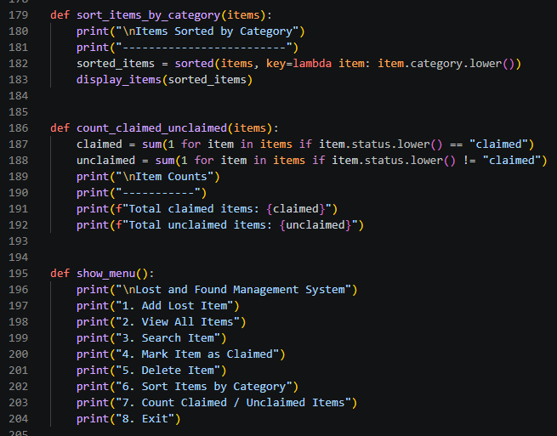
Method for sorting based on lambda method, method for calculating claimed and unclaimed items, and finaly menu printing method.
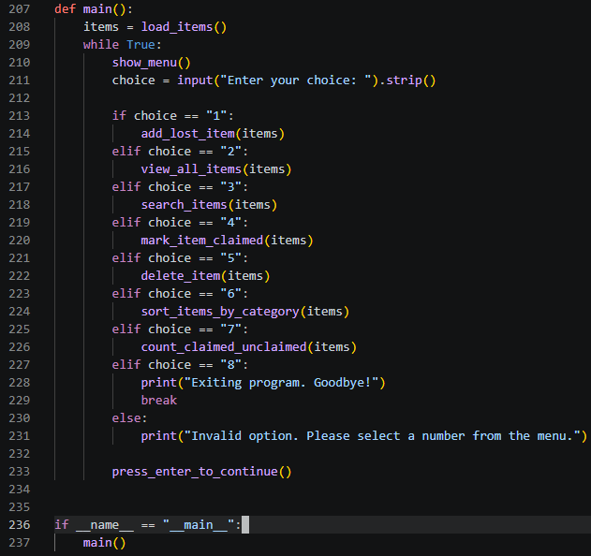
Finaly main method with infinite loop that implements menu function using if else logic.
Input and Output
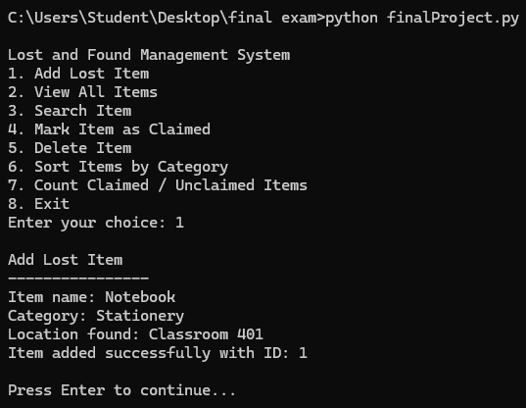
This is how adding item looks like.
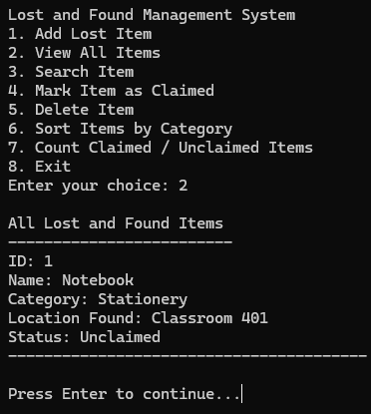
Checking all lost items list
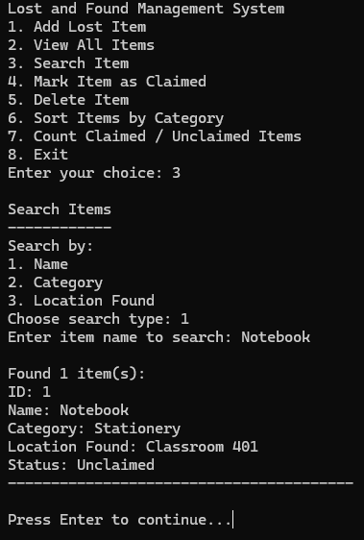
Searching items by name (by category and location found – also possible)
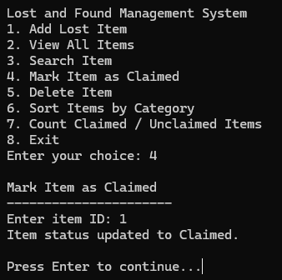
Changing status to claimed
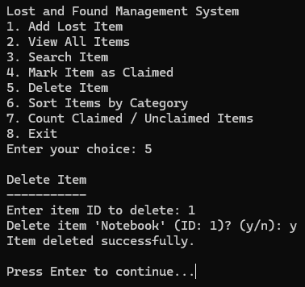
Deleting item
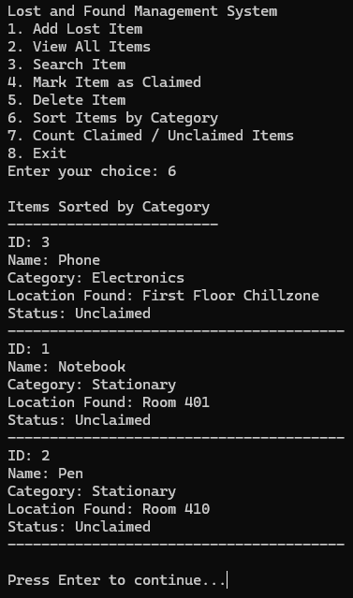
Sorting items by category
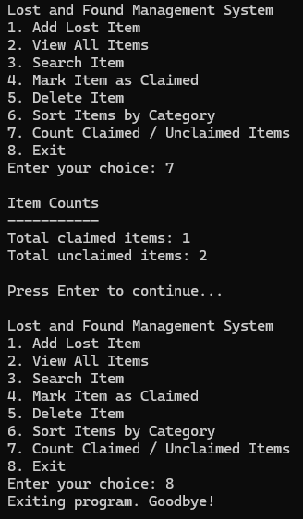
Count claimed \ unclaimed items, exiting program
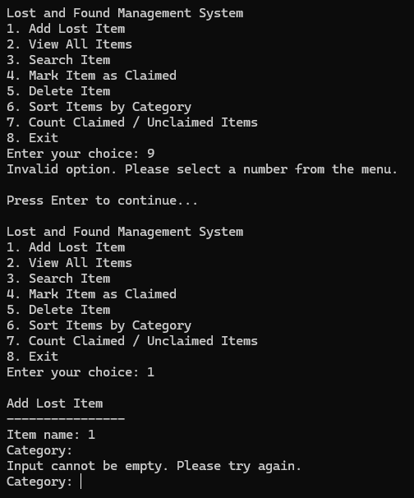
Simple error handling

