Lab 2.1 Solution

1. Program Flow Diagram:
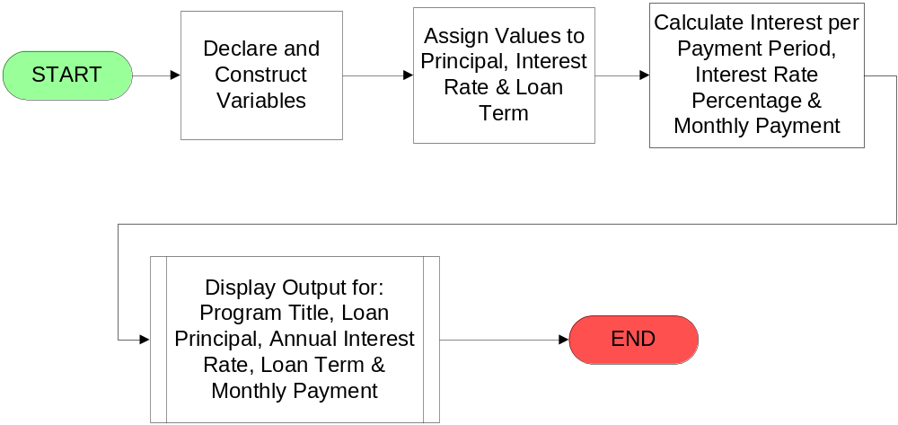

2. Java Source Code (MorgageCalculator.java):

/**
---------------------------------------------------------------------------------------
Filename: MortgagePayment.java
Purpose: Calculate and display the montly payment amount
to fully amortize a $200,000.00 loan over a 30
year term at 5.75% interest
---------------------------------------------------------------------------------------
*/
package com.avtech.j2ee.lab1;

// Import statements
// ------------------
import java.io.*; //for system input and output
import java.text.*; //for handling text, dates and formatting numbers and messages

public class MortgagePayment
{
public static void main (String[] args) throws IOException
{
//declare variables
//------------------
double principal, rate, years, months, monthlyInterest, monthlyPayment;
BufferedReader lineIn= new BufferedReader(new InputStreamReader(System.in));

//Setup up formatting for the monthly payment (round to two decimal places)
//-------------------------------------------------------------------------
DecimalFormat twoDigits = new DecimalFormat("$#,000.00");

//Set variables for calculation, this will later be
//provided by the user input
//--------------------------------------------------
principal = 200000.00;
rate = 5.75;
years = 30;
months = 30 * 12.0;
monthlyInterest = rate / (12 * 100);

//Calculate the monthly payment
//---------------------------------------------------
monthlyPayment = principal * (monthlyInterest / (1 - Math.pow((1 + monthlyInterest),(months * -1))));

//screen display and prompts
//---------------------------
System.out.println();
System.out.println("\tMortgage Calculator");
System.out.println("\t=====================================");
System.out.println();
System.out.println("\tPrincipal:\t\t" + twoDigits.format(principal));
System.out.println("\tInterest Rate:\t\t" + rate + "%");
System.out.println("\t# of Years:\t\t" + years);
System.out.println();
System.out.println("\t=====================================");
System.out.println();
System.out.println("\tMonthly Payment:\t" + twoDigits.format(monthlyPayment));
System.out.println();

} //end of main

} //end of class

3. Batch file to compile Java source code (compile.bat or compile.cmd):

set JAVA_HOME=C:\Program Files\Java\jdk1.5.0_06
set PATH=%JAVA_HOME%\bin;%PATH%
set LIB=classes
javac -d classes -classpath %LIB% src\*.java

3. Batch file to execute Java class (run.bat or run.cmd):

set JAVA_HOME=C:\Program Files\Java\jdk1.5.0_06
set PATH=%JAVA_HOME%\bin;%PATH%
set LIB=classes
java -classpath %LIB% com.avtech.j2ee.lab1. MortgagePayment

