## 分区表自动安装配置程序

1. 新建临时表，

create table "informix".mcn_contralogtmp

(

streamnumber serial not null ,

servicekey integer,

calltype char(1),

chargetype char(1),

roamflag char(1),

callingpartynumber char(16),

calledpartynumber char(24),

mcnnumber char(16),

roamareanumber char(6),

mscaddress char(16),

callreferencenum char(16),

msinfovlrnumber char(20),

msinfolai char(10),

msinfocellid char(14),

msinfoimsi char(16),

callbegintime char(14),

callendtime char(14),

callduration integer,

chargepartyindicat char(1),

extbearercapabilit char(27),

teleservicecode char(10),

bearerservicecode char(10),

scfid char(10),

callingvareanumber char(6),

calledvareanumber char(6),

callinghlrnumber char(6),

calledhlrnumber char(6),

callingpartyscateg smallint,

redirectingpartyid char(16),

redirectioninfor char(4),

subscriberstate smallint,

cause char(5),

reason char(2),

internumflag char(1)

default '0' not null

)

fragment by expression

partition p2017112000 ((callbegintime >= '20171120000000'

) AND (callbegintime < '20171127000000' ) ) in userdbs,

partition rmd remainder in userdbs

extent size 64000 next size 64000 lock mode row;

create index "informix".idx1204_contralog_streamnumberft on "informix"

.mcn_contralogtmp (streamnumber) using btree ;

create index "informix".idx1204_mcnnumberft on "informix".mcn_contralogtmp

(mcnnumber) using btree ;

create index "informix".idx1204_contralog_callingpartynumberft on

"informix".mcn_contralogtmp (callingpartynumber) using btree

;

create table "informix".mcn_smslogtmp

(

streamnumber serial not null ,

smsseqno char(20),

msgid varchar(50),

chargetype smallint,

phonenumber char(16),

mcnnumber char(16),

sendorrecenum char(24),

orginalnum char(24),

optime char(14),

msgresult char(2),

failreason char(10)

)

fragment by expression

partition p2017112000 ((optime >= '20171120000000' ) AND

(optime < '20171127000000' ) ) in userdbs,

partition rmd remainder in userdbs

extent size 64000 next size 64000 lock mode page;

create index "informix".idx1204_smslog_mcnnumber1_rebuildft on "informix"

.mcn_smslogtmp (mcnnumber) using btree ;

create index "informix".idx1204_smslog_phonenumber1_rebuildft on

"informix".mcn_smslogtmp (phonenumber) using btree ;

create index "informix".idx1204_smslog_sendorrecenumft on "informix"

.mcn_smslogtmp (sendorrecenum) using btree ;

create index "informix".idx1204_smslog_streamnumberft on "informix"

.mcn_smslogtmp (streamnumber) using btree ;

create table "informix".mcn_mid_voicelogtmp

(

streamnumber serial not null ,

servicekey integer,

midgroupid char(20),

calltype integer,

oroamareanum integer,

callingmsisdn char(20),

callingnumtype char(1),

mcnnumber char(16),

calledmsisdn char(20),

callednumtype char(1),

maxallowtime char(5),

mscaddress char(16),

callreferencenum char(16),

startdatetime char(14),

enddatetime char(14),

callduration integer,

chargepartyindicat integer,

scfid char(10),

redirectingpartyid char(16),

rccause char(5),

callresult char(2),

bindid char(32),

midcallid char(40),

cityid integer,

realcallduration integer,

record char(1),

gxbgroupid char(22),

mcnnumbery char(16)

)

fragment by expression

partition p2017112000 ((startdatetime >= '20171120000000'

) AND (startdatetime < '20171127000000' ) ) in userdbs,

partition rmd remainder in userdbs

extent size 64000 next size 64000 lock mode row;

create index "informix".idx1204_midvlog_grpidft on "informix".mcn_mid_voicelogtmp

(midgroupid) using btree ;

create index "informix".idx1204_midvlog_mcnnumft on "informix".mcn_mid_voicelogtmp

(mcnnumber) using btree ;

create index "informix".idx1204_midvlog_streamnumberft on "informix"

.mcn_mid_voicelogtmp (streamnumber) using btree ;

1. 确认存在：

select * from TLM_table

select * from tlm_errlog

select * from fragtabinfo

add_par_for_date

add_par_for_date

上述表和存储过程，如果确认现网肯定不使用，可以drop。

drop table TLM_table;

drop table tlm_errlog;

drop table fragtabinfo;

drop procedure add_par_for_date;

drop procedure del_par_for_date;

1. 一键安装：

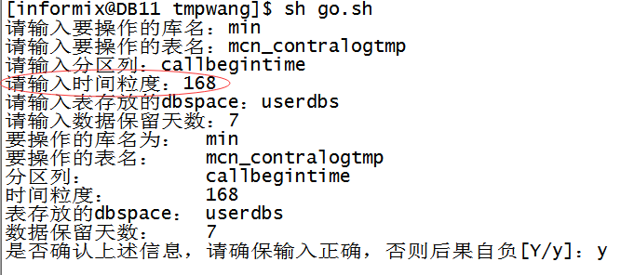

1. 随后确认新表结构：

oncheck -pt min:mcn_contralogtmp |grep -E 'rows|partition'

oncheck -pt min:mcn_smslogtmp |grep -E 'rows|partition'

oncheck -pt min:mcn_mid_voicelogtmp |grep -E 'rows|partition'

1. rename互换现网表；
2. 导数据
3. 更新TLM_table和fragtabinfo表信息：

TLM_table表的table_name更改成现网表名；

Fragtabinfo表的tabname更改成现网表名。

1. 配置cron

添加两个cron，因为程序会自己判断如何增删，所以找个闲时每天定时执行即可

50 2 * * * . ./.bash_profile;sh /home/informix/frag/add_par_for_date.sh ismpdb（数据库名）

55 2 * * * . ./.bash_profile;sh /home/informix/frag/del_par_for_date.sh ismpdb（数据库名）

1. 给现网已经存在的mcn_oplog表，配置TLM_table和fragtabinfo表信息