Homework 2

Bo Peng

Direct Observation:

|  |  |
| --- | --- |
| Observation 1 | Sometimes, some students who are not major in engineering field would hardly learn courses related to logic. Even though they might be able to solve simple questions that are based on logic knowledge, they lack systematic learning of logic. Some of them would like to have such knowledge because they could be pretty helpful to their career. Since most college students are busy finishing their course related work, it is usually hard for them to have additional course that is related to logic. For most of them, they would rather to choose to learn logic by reading relevant books. Besides, there are some applications could train people and make them think faster like: Lumosity. Some students would like to use application like that to train their brain during free time. Some students like to play such game while waiting in the food line or using the toilet. Some of them comment that they prefer to use such application on their laptop because playing games on their phone could be harmful to their eyes. |
| Observation 2 | Some parents want their children could get familiar with logic thinking and related skill earlier, especially some Chinese parents. They prefer to let their kids enroll in different kinds of courses and make them learn mathematics and logic when their kids are still young to make them have a better grade during their academic learning. Some parents complain that those courses are expensive which usually takes from hundreds of dollars to thousands of dollars. A great amount of them feel that would be a burden to them. What’s more, their kids usually get annoyed by those tedious, boring courses. They prefer to learn those knowledge in a more interesting way. Some of they complain that it could be much better if there are games that teach them logic. That means there are potential market for logic games. |

Persona:

|  |  |
| --- | --- |
| Persona | ME student study in Rose-Hulman |
| Fictional Name | Martin Van Wilkins |
| Job Title | Junior student, major in Mechanical Engineering, Rose-Hulman Institute of Technology |
| Demographics | 21 years old  Single  Have previous experience playing logic games on phone |
| Goals and tasks | He is focused on his study while training himself to use logic in real life situation. One of his concern is having a systematic training to think more accurately.   1. Want to spend less than 30 minutes every day on training logic 2. Want to have a systematic learning and more general learning of logic knowledge |
| Environment | He is comfortable using both mobile devices and personal computers. He is busy finishing his school work this quarter and has almost no free time spending large chunk of time playing games. He uses computer about 5 hours per day. |
| Quote | “I hope there could be an application which won’t take me so much time training my logic.” |

Epic User Story:

|  |
| --- |
| Logic Training Epic |
| As a user, I want to train my logic so |
| that I can behave more reasonable and |
| use my logic thinking in my work and |
| life. |

Discover Ideas:

|  |  |  |
| --- | --- | --- |
| Feature | Owner | Vote |
| Web application | PK | 6 dots |
| One general game | CS | 0 dot |
| Different small games | PK | 5 dots |
| Browser based | CS | 1 dot |
| Mobile vs. Desktop | JH | 1 dot |
| Use graphical shapes to replace logical symbols | XX | 3 dots |
| Using sound/music to convey/teach logic | PB | 2 dots |
| Using abstract algebra/modeling context free grammar | JH | 1 dot |
| Have different level of difficulties | XX | 3 dots |
| User difficulty selection | PB | 3 dots |

Decide Ideas:

PB 🡪Web application …… 6

JH 🡪Different small games ….. 5

XX 🡪Use graphical shapes to replace logical symbols … 3

CS 🡪Have different level of difficulties … 3

PK 🡪User difficulty selection … 3

Story Board:

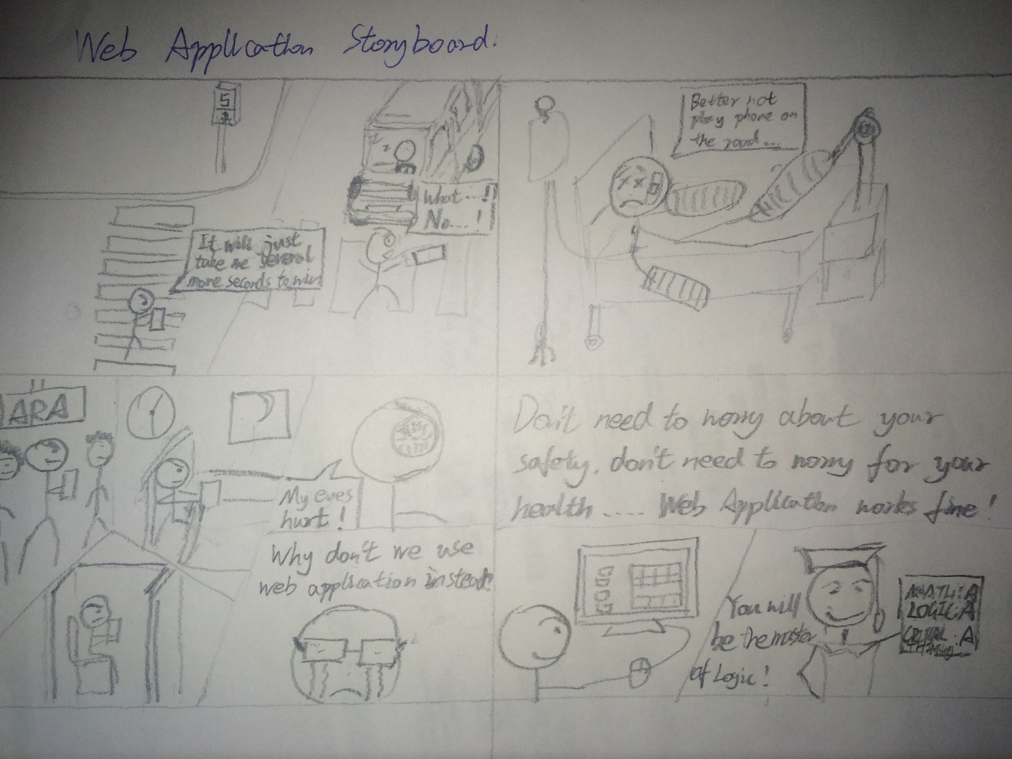

Response to Story Board:

“So if you play games on your cell phone it could lead to accidents and pain.  So, instead make a web application to be used on a computer, people can focus on what they're doing and aren't trying to do this while walking.  Also, the game will make them good at logic and problem solving.”

The response shows that user could understand this storyboard tries to tell them why use web application. There is no misunderstanding or unclear about the meaning of the storyboard.