Cleanliness Analysis according to ISO 16232
清洁度分析根据 ISO 16232

Description of sample样品描述
Component:  零件 | 主轮 | Date of Extraction:  清洗日期
Comp. No.:  零件号 | L7B09PP1A0835 | Examiner:  检测员
Sample No.:  制样编号 | H36 | Date of Analysis:  分析日期 | 2021/11/11
Customer:
客户

Extraction制样
Method:  方法 |  | Components on filter:  滤膜上零件数量 | 3
Liquid:  溶剂 |  | Comp. Surface [cm²]:  零件表面积
Amount [L]:  溶剂量 |  | Filter Type:  滤膜类型
Weight [mg] :  重量 | 0.48

Microscopic Analysis显微镜分析
Scale比例尺: | 6.1 µm/Pxl | Eval. Diameter分析直径[mm]: | 44

Largest metallic particle最大金属 | Length长 [µm]: | 160 | Width宽 [µm]: | 104
Largest nonmetallic particle¹最大非金属 | Length长 [µm]: | 106 | Width宽 [µm]: | 44

Length of largest fiber² [µm] 最长纤维: | 1211 | Total length of fibers² [mm]: 纤维总长度 | 15.9

 |  | Particle count¹  on membrane每滤膜 |  | Particle count¹  per sample每零件 |  | Particle count¹  per 1000 cm²每1000 cm²
Particle size  等级[µm] | Code  代码 | Total¹  总数 | Metallic  金属 | Total¹  总数 | Metallic  金属 | Total¹  总数 | Metallic  金属

Summarized results汇总:
> 600 | J1-K | 0 | 0 | 0.0 | 0.0
> 400 | I-K | 0 | 0 | 0.0 | 0.0
> 100 | F-K | 7 | 5 | 7.0 | 5.0
100-400 | F-H | 7 | 5 | 7 | 5
5-100 | B-E | 992 | 86 | 992 | 86

Detailed results明细:
> 1000 | K | 0 | 0 | 0.0 | 0.0
800 - 1000 | J2 | 0 | 0 | 0.0 | 0.0
600 - 800 | J1 | 0 | 0 | 0.0 | 0.0
400 - 600 | I | 0 | 0 | 0.0 | 0.0
200 - 400 | H | 0 | 0 | 0.0 | 0.0
150 - 200 | G | 2 | 2 | 2.0 | 2.0
100 - 150 | F | 5 | 3 | 5.0 | 3.0
50 - 100 | E | 98 | 23 | 98.0 | 23.0
25 - 50 | D | 249 | 54 | 249.0 | 54.0
15 - 25 | C | 182 | 7 | 182.0 | 7.0
5 - 15 | B | 463 | 2 | 463.0 | 2.0

CCC¹ (Component Cleanliness Code) 清洁度代码:

¹: Particles without fibers不含纤维
²: Definition fiber: Nonmetallic, Compactness < 30% or Length/Width > 10.
定义纤维与非金属，以面积比<30%或者长/宽>10
Remarks备注:
Images图像:

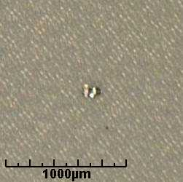 | 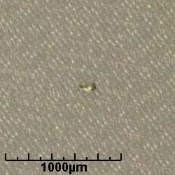
Largest metallic particle最大金属颗粒  160 µm x 104 µm | Second largest metallic particle第二大金属颗粒  152 µm x 61 µm

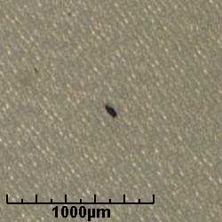
Largest nonmetallic particle最大非金属颗粒  106 µm x 44 µm | Membrane overview滤膜概况

