MetroWeb Simple Guide

# Project GIT page:

https://github.com/zxd882002/MetroWeb.git

# Structure

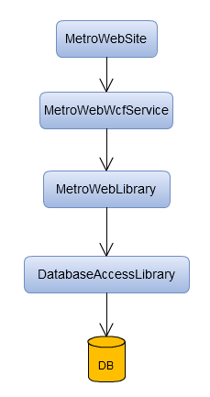

## DB

DB layer contains all the metro information including station, line, interchange, etc. Script is under: MetroWeb\Scripts folder.

## DatabaseAccessLibrary

This layer’s purpose is to CRUD the database and make it into proper object. TableBase contains the main logic for CURD.

## MetroWebLibrary

This layer is designed for the following business purpose:

1. Make Entity for DatabaseAccessLibrary model: each DatabaseAccessLibrary model contains 2 entities. For example, Station contains StationEntity and StationCollectionEntity. XXXEntity contains the information about station not only including the information from database, it also contains some information which is linked from other table like StationList. XXXCollectionEntity contains the table of XXX, and some index method to get XXXEntity.
2. Use RouteFinder and StationLineentityExtender to get the nearest route. RouteFinder only contains one method GetTheNearestRouteBetween() which will call StationLineentityExtender to get the route. StationLineentityExtender contains the major logic to get the route.

## MetroWebWcfService

This layer has two purpose:

1. Decorate the return member according to the requirement from MetroWebSite. The return object will be converted to JSON and the MetroWebSite could use it.
2. Create a cross-domain WCF so that it could be handle the request (design the POST request + JSON body) and return the result as response (JSON format).

## MetroWebSite

A website will complete the following requirements:

1. Draw the metro lines
2. Get the station information
3. Get the latest route between from station and to station

The website is written by html + Jquery.