What are dinosaurs?

- Millions of years ago, long before people even existed, dinosaurs roamed the Earth. The dinosaurs were a group of land-dwelling creatures that lived during the Mesozoic Era, about 230-65 million years ago. They ranged from very large to very small animals, each unique in its own way. Dinosaurs were made up of meat-eaters, plant-eaters, and scavengers.
- Dinosaurs have been classified into two major groups, carnivores and herbivores.

Carnivorous Dinosaurs: meat eaters; diet consisted of other dinosaurs and animals
Herbivorous Dinosaurs: plant eaters; diet consisted of plants, grass, and trees

Examples of Carnivores:
Tyrannosaurus Rex:

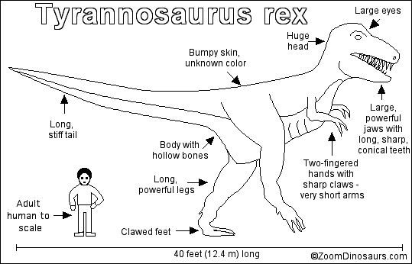
- More commonly known as “T-Rex”
- Its name means “King Tyrant Lizard”
- Ranged from 40 to 50 feet in height
- Had a four foot long head
- Weighed about six tons, and had very small forearms compared to the rest of its body
- Its razor sharp teeth grew anywhere from 6 to 13 inches long.
- Liked to snack on smaller dinosaurs
- There is evidence of cannibalism among the T-Rexes. One fossil specimen of a T-Rex named "Sue" revealed that she had died from a broken rib. Embedded in the rib were remains of a T-Rex tooth. There were also puncture marks on the left side of Sue’s skull

Deinonychus

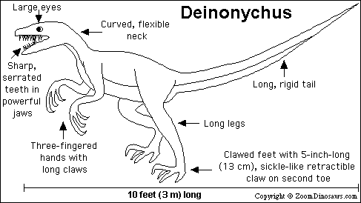
- Especially fearsome dinosaur
- Its name means “Terrible Claw” because of its sickle shaped claw
- 3 to 6 feet tall, 9 to 15 feet long, 150 pounds to a ton in weight
- Built for swift movement and savage attacks
- Hunted in packs
- Technique included closing in on prey and using their claws for the kill
Eoraptor
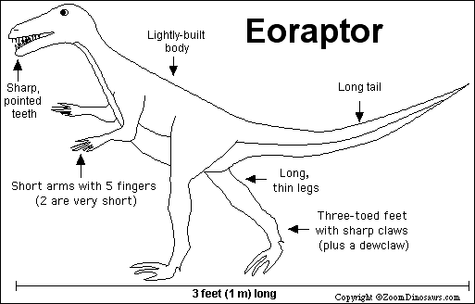
- One of the earliest known dinosaurs
- Its name means “Dawn Thief”
- It was a very small carnivore and scavenger
- Lightly built and walked on two legs
- Its bones were light and hollow
- 3 feet long, with a long head and very sharp teeth
- Each hand contained 5 fingers
Pterodactyl
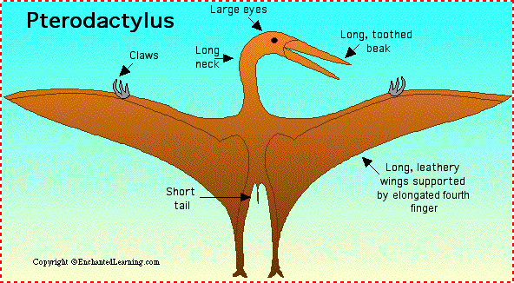
- Group of flying reptiles
- Wingspan ranged from a few inches to 40 feet
- Lightly built with hollow bones, long curved necks, long skulls, and small bodies
- Large brains and good eyesight
- Most could flap their wings and fly with power, others had to use updrafts and breezes
- Some other types of Pterodactyls included the Pterodactlus, Dsungaripterus, and the Quetzalcoatlus
Examples of Herbivores:
Triceratops
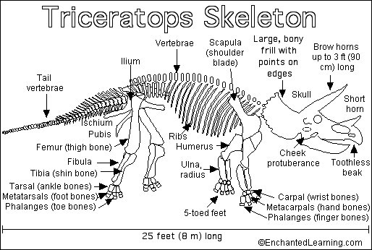
- Rhinoceros like dinosaur
- One of the biggest and most dangerous that lived
- Very slow moving
- Had three large horns on top of its head that were used for mating, ritual, and protection
- Had leathery skin and a large frill (large bony plate) at the back of its head
- They had rows of cutting and grinding teeth along its jaws
- Size could reach 75 meters long and 3 meters high
- Weight ranged from 5 to 6 tons
- Diet included ever green trees and fern like flowering plant.
- Its main enemy was the T-Rex
Brachiosaurus
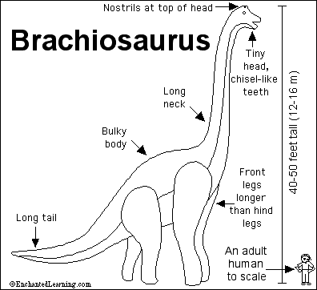

- One of the tallest and largest dinosaurs ever
- Its height reached about 40 to 50 feet high
- Its length could reach up to 85 feet long
- Its weight ranged from 33 to 88 tons
- It had a long neck, small head, and a short, thick tail
- Walked on four legs and, with its front legs longer than its hind legs
- Had a giraffe-like stance
- Had a good sense of smell
- Diet mainly consisted of the tops of tall trees

Euoplocephalus
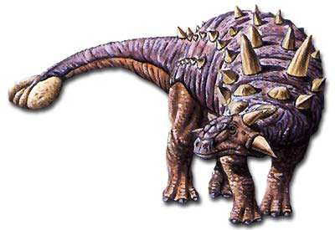
- Large armored dinosaur
- Measured about 20 feet long and weighed about 2 tons
- Had a wide head with a horny, toothless beak, bony horns, and a small brain
- Top side was protected from predators with thick, oval plates that covered leathery skin, rows of large spikes along its body, large horns on its head, and a raised, club-like tail
- Only way to harm this herbivore would be to flip it over onto its back
- Had four short and a short neck
- Diet included a huge amount of low lying plant material
- Its intelligence was among the lowest of the dinosaurs
Stegosaurus
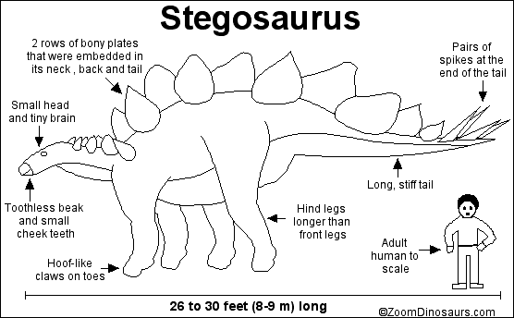
- Had a very small head with a tiny brain that was about the size of a walnut
- Had large, bony, triangular plates along its back and a heavy spiked tail that was used for its protection
- Walked on four legs, back legs were twice as long as the front ones
- 30 feet in length and 9 feet in height, 6,800 pounds

