Пензенский Государственный университет

Кафедра «Вычислительная техника»

**Отчёт**

По лабораторной работе №2

по дисциплине: «Программирование на языке Java»

на тему: «Работа с коллекциями объектов»

Вариант №6

Выполнили студенты группы 20ВВП2:

Китаев А.А.

Новиков И.М.

Приняли:

Юрова О.В.

Карамышева Н.С.

Пенза 2023

**Цель работы:** изучить библиотеку стандартных коллекций Java Collections Framework, позволяющую хранить различные структуры данных.

**Задание на лабораторную работу:** модифицировать приложение из предыдущей лабораторной работы, реализовав хранение данных таблицы с использованием библиотеки коллекций. Для этого реализовать класс RecIntegral, способный хранить одну запись таблицы. Для нечетных вариантов в качестве класса-коллекции выбрать ArrayList, для четных - LinkedList. Кроме того, добавить пару кнопок: очистить / заполнить, которые будут очищать таблицу и заполнять ее данными из коллекции соответственно.

**Решение:**

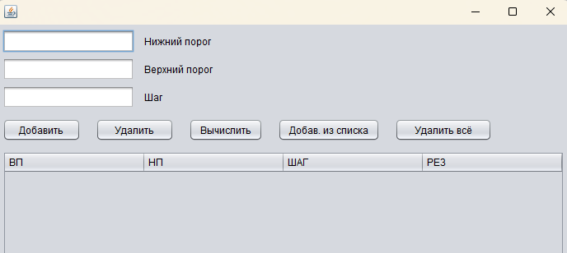

*Рисунок 1.*

Добавили кнопки «Добавить из списка», «Удалить всё».

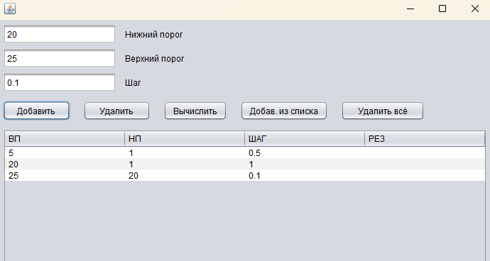

*Рисунок 2.*

Заполнили таблицу данными.

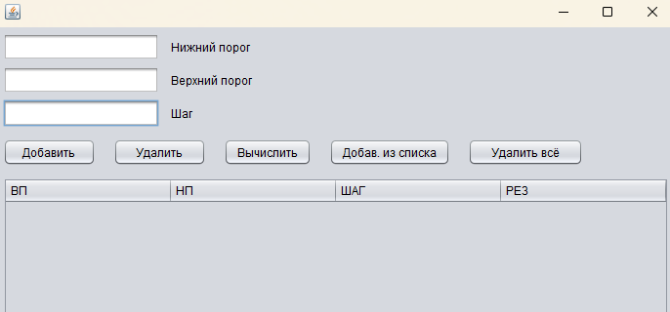

*Рисунок 3.*

Очистили таблицу с помощью кнопки «Удалить всё»

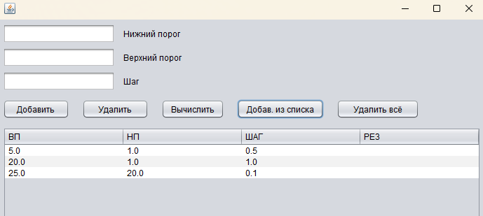

*Рисунок 4.*

Заполнили таблицу данными из списка с помощью кнопки «Добавить из списка».

**Вывод:** изучили библиотеку стандартных коллекций Java Collections Framework, позволяющую хранить различные структуры данных.

**Листинг:**

RecIntegral.java

public class RecIntegral {

public double start;

public double end;

public double step;

public double result ;

public RecIntegral(){

}

public RecIntegral(double _start, double _end, double _step){

start = _start;

end = _end;

step = _step;

}

}

Frame1.java

import java.util.Set;

import javax.swing.table.DefaultTableModel;

import java.util.LinkedList;

/*

* To change this license header, choose License Headers in Project Properties.

* To change this template file, choose Tools | Templates

* and open the template in the editor.

*/

/**

*

* @author Vanya

*/

public class frame1 extends javax.swing.JFrame {

/**

* Creates new form frame1

*/

public frame1() {

initComponents();

}

/**

* This method is called from within the constructor to initialize the form.

* WARNING: Do NOT modify this code. The content of this method is always

* regenerated by the Form Editor.

*/

@SuppressWarnings("unchecked")

// <editor-fold defaultstate="collapsed" desc="Generated Code">

private void initComponents() {

addButton = new javax.swing.JButton();

deleteButton = new javax.swing.JButton();

jButton3 = new javax.swing.JButton();

jTextField1 = new javax.swing.JTextField();

jTextField2 = new javax.swing.JTextField();

jTextField3 = new javax.swing.JTextField();

jScrollPane2 = new javax.swing.JScrollPane();

jTable2 = new javax.swing.JTable();

addToList = new javax.swing.JButton();

addToTableFromList = new javax.swing.JButton();

deleteALLButton = new javax.swing.JButton();

jLabel1 = new javax.swing.JLabel();

jLabel2 = new javax.swing.JLabel();

jLabel3 = new javax.swing.JLabel();

setDefaultCloseOperation(javax.swing.WindowConstants.EXIT_ON_CLOSE);

setPreferredSize(new java.awt.Dimension(710, 465));

addButton.setText("Добавить");

addButton.addActionListener(new java.awt.event.ActionListener() {

public void actionPerformed(java.awt.event.ActionEvent evt) {

addButtonActionPerformed(evt);

}

});

deleteButton.setText("Удалить");

deleteButton.addActionListener(new java.awt.event.ActionListener() {

public void actionPerformed(java.awt.event.ActionEvent evt) {

deleteButtonActionPerformed(evt);

}

});

jButton3.setText("Вычислить");

jButton3.addActionListener(new java.awt.event.ActionListener() {

public void actionPerformed(java.awt.event.ActionEvent evt) {

jButton3ActionPerformed(evt);

}

});

jTextField1.addActionListener(new java.awt.event.ActionListener() {

public void actionPerformed(java.awt.event.ActionEvent evt) {

jTextField1ActionPerformed(evt);

}

});

jTable2.setModel(new javax.swing.table.DefaultTableModel(

new Object [][] {

},

new String [] {

"ВП", "НП", "ШАГ", "РЕЗ"

}

));

jTable2.getTableHeader().setReorderingAllowed(false);

jTable2.addMouseListener(new java.awt.event.MouseAdapter() {

public void mouseClicked(java.awt.event.MouseEvent evt) {

jTable2MouseClicked(evt);

}

});

jScrollPane2.setViewportView(jTable2);

addToList.setText("Добав. в список");

addToList.addActionListener(new java.awt.event.ActionListener() {

public void actionPerformed(java.awt.event.ActionEvent evt) {

addToListActionPerformed(evt);

}

});

addToTableFromList.setText("Добав. из списка");

addToTableFromList.addActionListener(new java.awt.event.ActionListener() {

public void actionPerformed(java.awt.event.ActionEvent evt) {

addToTableFromListActionPerformed(evt);

}

});

deleteALLButton.setText("Удалить всё");

deleteALLButton.addActionListener(new java.awt.event.ActionListener() {

public void actionPerformed(java.awt.event.ActionEvent evt) {

deleteALLButtonActionPerformed(evt);

}

});

jLabel1.setText("Нижний порог");

jLabel2.setText("Верхний порог");

jLabel3.setText("Шаг");

javax.swing.GroupLayout layout = new javax.swing.GroupLayout(getContentPane());

getContentPane().setLayout(layout);

layout.setHorizontalGroup(

layout.createParallelGroup(javax.swing.GroupLayout.Alignment.LEADING)

.addGroup(layout.createSequentialGroup()

.addContainerGap()

.addGroup(layout.createParallelGroup(javax.swing.GroupLayout.Alignment.LEADING)

.addComponent(jScrollPane2)

.addGroup(layout.createSequentialGroup()

.addGroup(layout.createParallelGroup(javax.swing.GroupLayout.Alignment.LEADING)

.addGroup(layout.createSequentialGroup()

.addComponent(addButton, javax.swing.GroupLayout.PREFERRED_SIZE, 95, javax.swing.GroupLayout.PREFERRED_SIZE)

.addPreferredGap(javax.swing.LayoutStyle.ComponentPlacement.RELATED)

.addComponent(deleteButton, javax.swing.GroupLayout.PREFERRED_SIZE, 95, javax.swing.GroupLayout.PREFERRED_SIZE)

.addPreferredGap(javax.swing.LayoutStyle.ComponentPlacement.RELATED)

.addComponent(jButton3)

.addPreferredGap(javax.swing.LayoutStyle.ComponentPlacement.UNRELATED)

.addComponent(addToList)

.addPreferredGap(javax.swing.LayoutStyle.ComponentPlacement.UNRELATED)

.addComponent(addToTableFromList)

.addPreferredGap(javax.swing.LayoutStyle.ComponentPlacement.RELATED)

.addComponent(deleteALLButton, javax.swing.GroupLayout.PREFERRED_SIZE, 118, javax.swing.GroupLayout.PREFERRED_SIZE))

.addGroup(layout.createSequentialGroup()

.addComponent(jTextField2, javax.swing.GroupLayout.PREFERRED_SIZE, 160, javax.swing.GroupLayout.PREFERRED_SIZE)

.addPreferredGap(javax.swing.LayoutStyle.ComponentPlacement.UNRELATED)

.addComponent(jLabel1, javax.swing.GroupLayout.PREFERRED_SIZE, 97, javax.swing.GroupLayout.PREFERRED_SIZE))

.addGroup(layout.createSequentialGroup()

.addComponent(jTextField1, javax.swing.GroupLayout.PREFERRED_SIZE, 160, javax.swing.GroupLayout.PREFERRED_SIZE)

.addPreferredGap(javax.swing.LayoutStyle.ComponentPlacement.UNRELATED)

.addComponent(jLabel2, javax.swing.GroupLayout.PREFERRED_SIZE, 97, javax.swing.GroupLayout.PREFERRED_SIZE))

.addGroup(layout.createSequentialGroup()

.addComponent(jTextField3, javax.swing.GroupLayout.PREFERRED_SIZE, 160, javax.swing.GroupLayout.PREFERRED_SIZE)

.addPreferredGap(javax.swing.LayoutStyle.ComponentPlacement.UNRELATED)

.addComponent(jLabel3, javax.swing.GroupLayout.PREFERRED_SIZE, 97, javax.swing.GroupLayout.PREFERRED_SIZE)))

.addGap(0, 23, Short.MAX_VALUE)))

.addContainerGap())

);

layout.setVerticalGroup(

layout.createParallelGroup(javax.swing.GroupLayout.Alignment.LEADING)

.addGroup(layout.createSequentialGroup()

.addContainerGap()

.addGroup(layout.createParallelGroup(javax.swing.GroupLayout.Alignment.LEADING, false)

.addComponent(jLabel1, javax.swing.GroupLayout.DEFAULT_SIZE, javax.swing.GroupLayout.DEFAULT_SIZE, Short.MAX_VALUE)

.addComponent(jTextField2))

.addPreferredGap(javax.swing.LayoutStyle.ComponentPlacement.RELATED)

.addGroup(layout.createParallelGroup(javax.swing.GroupLayout.Alignment.BASELINE)

.addComponent(jTextField1, javax.swing.GroupLayout.PREFERRED_SIZE, javax.swing.GroupLayout.DEFAULT_SIZE, javax.swing.GroupLayout.PREFERRED_SIZE)

.addComponent(jLabel2, javax.swing.GroupLayout.DEFAULT_SIZE, javax.swing.GroupLayout.DEFAULT_SIZE, Short.MAX_VALUE))

.addPreferredGap(javax.swing.LayoutStyle.ComponentPlacement.RELATED)

.addGroup(layout.createParallelGroup(javax.swing.GroupLayout.Alignment.BASELINE)

.addComponent(jTextField3, javax.swing.GroupLayout.PREFERRED_SIZE, javax.swing.GroupLayout.DEFAULT_SIZE, javax.swing.GroupLayout.PREFERRED_SIZE)

.addComponent(jLabel3, javax.swing.GroupLayout.DEFAULT_SIZE, javax.swing.GroupLayout.DEFAULT_SIZE, Short.MAX_VALUE))

.addPreferredGap(javax.swing.LayoutStyle.ComponentPlacement.UNRELATED)

.addGroup(layout.createParallelGroup(javax.swing.GroupLayout.Alignment.LEADING)

.addComponent(addToTableFromList, javax.swing.GroupLayout.DEFAULT_SIZE, javax.swing.GroupLayout.DEFAULT_SIZE, Short.MAX_VALUE)

.addGroup(layout.createParallelGroup(javax.swing.GroupLayout.Alignment.BASELINE)

.addComponent(addButton)

.addComponent(deleteButton)

.addComponent(jButton3)

.addComponent(addToList)

.addComponent(deleteALLButton)))

.addPreferredGap(javax.swing.LayoutStyle.ComponentPlacement.UNRELATED)

.addComponent(jScrollPane2, javax.swing.GroupLayout.PREFERRED_SIZE, javax.swing.GroupLayout.DEFAULT_SIZE, javax.swing.GroupLayout.PREFERRED_SIZE)

.addGap(215, 215, 215))

);

pack();

}// </editor-fold>

double vp,np,interval,result;

private LinkedList<RecIntegral> list = new LinkedList<>();

private void addButtonActionPerformed(java.awt.event.ActionEvent evt) {

DefaultTableModel model = (DefaultTableModel)jTable2.getModel();

model.addRow(new Object[]{jTextField1.getText(),jTextField2.getText(),jTextField3.getText()});

list.add(new RecIntegral(Double.valueOf((String)jTextField1.getText()),

Double.valueOf((String)jTextField2.getText()),

Double.valueOf((String)jTextField3.getText()))

);

}

private void jTextField1ActionPerformed(java.awt.event.ActionEvent evt) {

}

private void deleteButtonActionPerformed(java.awt.event.ActionEvent evt) {

DefaultTableModel model = (DefaultTableModel)jTable2.getModel();

list.remove(jTable2.getSelectedRow());

model.removeRow(jTable2.getSelectedRow());

}

private void jTable2MouseClicked(java.awt.event.MouseEvent evt) {

DefaultTableModel model = (DefaultTableModel)jTable2.getModel();

vp = Double.valueOf((String)model.getValueAt(jTable2.getSelectedRow(), 0));

np = Double.valueOf((String)model.getValueAt(jTable2.getSelectedRow(), 1));

interval = Double.valueOf((String)model.getValueAt(jTable2.getSelectedRow(), 2));

//System.out.print(vp+":"+np+":"+interval+"\n");

}

private void jButton3ActionPerformed(java.awt.event.ActionEvent evt) {

result = 0;

double start = np;

double end = vp;

double step = interval;

if((start != 0) && (end != 0)){

while(start < end){

if(start + step > end){

step = end - start;

}

result += ( (Math.sqrt(start) + Math.sqrt(start + step)) /2)*step; //sqrt(x)

start += step;

}

DefaultTableModel model = (DefaultTableModel)jTable2.getModel();

model.setValueAt(result, jTable2.getSelectedRow(), 3);

};

}

private void addToListActionPerformed(java.awt.event.ActionEvent evt) {

DefaultTableModel model = (DefaultTableModel)jTable2.getModel();

for(int row = 0; row<model.getRowCount(); row++){

list.add(new RecIntegral(Double.valueOf((String)model.getValueAt(row,0)),

Double.valueOf((String)model.getValueAt(row,1)),

Double.valueOf((String)model.getValueAt(row,2)))

);

};

System.out.println(model.getRowCount());

//RecIntegral spisok = new RecIntegral(np,vp,interval);

//list.add(spisok);

//System.out.println(spisok.start);

}

private void addToTableFromListActionPerformed(java.awt.event.ActionEvent evt) {

DefaultTableModel model = (DefaultTableModel)jTable2.getModel();

for(int row = 0; row<list.size(); row++){

model.addRow(new Object[]{list.get(row).start,list.get(row).end,list.get(row).step});

};

}

private void deleteALLButtonActionPerformed(java.awt.event.ActionEvent evt) {

DefaultTableModel model = (DefaultTableModel)jTable2.getModel();

model.setRowCount(0);

}

/**

* @param args the command line arguments

*/

public static void main(String args[]) {

/* Set the Nimbus look and feel */

//<editor-fold defaultstate="collapsed" desc=" Look and feel setting code (optional) ">

/* If Nimbus (introduced in Java SE 6) is not available, stay with the default look and feel.

* For details see http://download.oracle.com/javase/tutorial/uiswing/lookandfeel/plaf.html

*/

try {

for (javax.swing.UIManager.LookAndFeelInfo info : javax.swing.UIManager.getInstalledLookAndFeels()) {

if ("Nimbus".equals(info.getName())) {

javax.swing.UIManager.setLookAndFeel(info.getClassName());

break;

}

}

} catch (ClassNotFoundException ex) {

java.util.logging.Logger.getLogger(frame1.class.getName()).log(java.util.logging.Level.SEVERE, null, ex);

} catch (InstantiationException ex) {

java.util.logging.Logger.getLogger(frame1.class.getName()).log(java.util.logging.Level.SEVERE, null, ex);

} catch (IllegalAccessException ex) {

java.util.logging.Logger.getLogger(frame1.class.getName()).log(java.util.logging.Level.SEVERE, null, ex);

} catch (javax.swing.UnsupportedLookAndFeelException ex) {

java.util.logging.Logger.getLogger(frame1.class.getName()).log(java.util.logging.Level.SEVERE, null, ex);

}

//</editor-fold>

/* Create and display the form */

java.awt.EventQueue.invokeLater(new Runnable() {

public void run() {

new frame1().setVisible(true);

}

});

}

// Variables declaration - do not modify

private javax.swing.JButton addButton;

private javax.swing.JButton addToList;

private javax.swing.JButton addToTableFromList;

private javax.swing.JButton deleteALLButton;

private javax.swing.JButton deleteButton;

private javax.swing.JButton jButton3;

private javax.swing.JLabel jLabel1;

private javax.swing.JLabel jLabel2;

private javax.swing.JLabel jLabel3;

private javax.swing.JScrollPane jScrollPane2;

private javax.swing.JTable jTable2;

private javax.swing.JTextField jTextField1;

private javax.swing.JTextField jTextField2;

private javax.swing.JTextField jTextField3;

// End of variables declaration

}