Пензенский Государственный университет

Кафедра «Вычислительная техника»

**Отчёт**

По лабораторной работе №4

по дисциплине: «Программирование на языке Java»

на тему: «Работа с файлами»

Вариант №6

Выполнили студенты группы 20ВВП2:

Китаев А.А.

Новиков И.М.

Приняли:

Юрова О.В.

Карамышева Н.С.

Пенза 2023

**Цель работы:** изучить работу с файлами и механизмы сериализации данных.

**Задание на лабораторную работу:** Модифицировать приложение из предыдущей лабораторной работы, реализовав сохранение в файл и загрузку данных из файла. Предусмотреть сохранение данных, как в текстовом виде, так и в двоичном (с использованием механизма сериализации). Для этого нужно добавить 4 кнопки для сохранения и загрузки в текстовом и двоичном виде соответственно. Кроме того, в программе нужно предусмотреть использование стандартного диалога открытия файла (JFileChooser).

**Решение:**

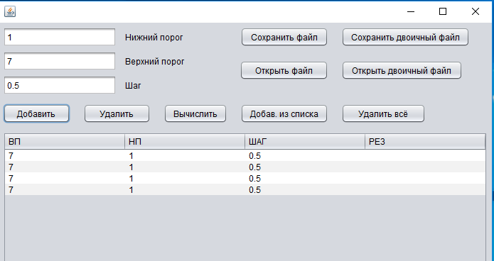

*Рисунок 1.*

Заполнили таблицу данными

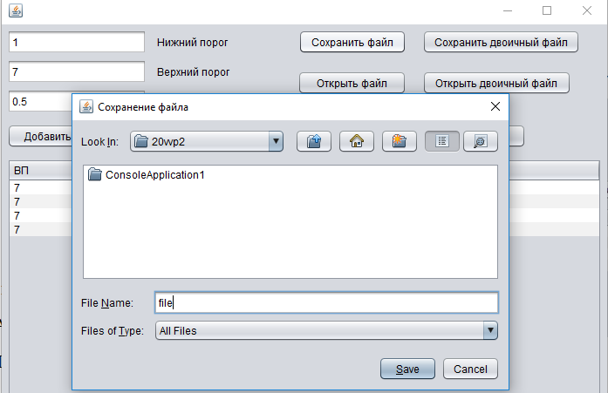

*Рисунок 2.*

Сохранили файл с помощью FileChooser.

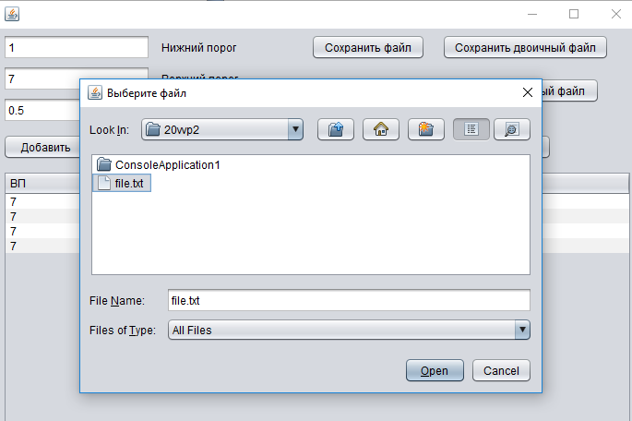

*Рисунок 3.*

Открыли файл.

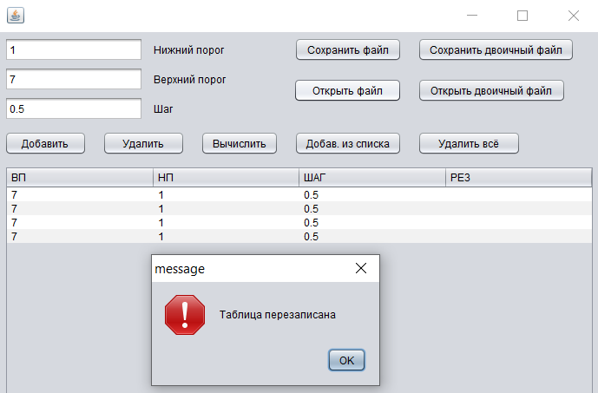

*Рисунок 4.*

Таблица перезаписала данные из файла.

Аналогично работает с двоичными файлами.

**Вывод:** в ходе выполнения данной лабораторной работы были изучены работа с файлами и механизмы сериализации данных.

**Листинг:**

**valueException.java**

import javax.swing.JOptionPane;

public class valueException extends Exception{

public valueException() {

}

public valueException(String message) {

super(message);

}

public valueException(String message, Throwable cause) {

super(message, cause);

}

public valueException(Throwable cause) {

super(cause);

}

public valueException(String message, Throwable cause, booleanenableSuppression, booleanwritableStackTrace) {

super(message, cause, enableSuppression, writableStackTrace);

}

}

**RecIntegral.java**

public class RecIntegral implements Serializable{

public double start;

public double end;

public double step;

public double result ;

public RecIntegral(){

}

public RecIntegral(double _start, double _end, double _step) throws valueException{

if(CheckMaxMin(_start, 0.000001, 1000000)==false ||

CheckMaxMin(_end, 0.000001, 1000000)==false ||

CheckMaxMin(_step, 0.000001, 1000000)==false)

{

JOptionPane.showMessageDialog(null, "missing range", "Error", JOptionPane.ERROR_MESSAGE);

throw new valueException("missing range");

}

else if((_step > _start - _end)){

JOptionPane.showMessageDialog(null, "step can't be higher than interval", "Error", JOptionPane.ERROR_MESSAGE);

throw new valueException("step can't be higher than interval");

}

else if (_start < _end){

JOptionPane.showMessageDialog(null, "end can't be higher than start", "Error", JOptionPane.ERROR_MESSAGE);

throw new valueException("end can't be higher than start");

}

else{

start = _start;

end = _end;

step = _step;

}

}

private booleanCheckMaxMin(double number, double min, double max){

if(number > min && number < max){

return true;

}

return false;

}

}

**Frame1.java**

import java.util.Set;

import javax.swing.table.DefaultTableModel;

import java.util.LinkedList;

import java.util.logging.Level;

import java.util.logging.Logger;

import javax.swing.JOptionPane;

import java.lang.Math;

import javax.swing.filechooser.FileNameExtensionFilter;

import java.io.*;

import java.awt.*;

import java.util.Vector;

import java.awt.event.ActionEvent;

import java.awt.event.ActionListener;

import java.nio.file.Files;

/*

* To change this license header, choose License Headers in Project Properties.

* To change this template file, choose Tools | Templates

* and open the template in the editor.

*/

/**

*

* @author Vanya

*/

public class frame1 extends javax.swing.JFrame {

/**

* Creates new form frame1

*/

public frame1() {

initComponents();

}

/**

* This method is called from within the constructor to initialize the form.

* WARNING: Do NOT modify this code. The content of this method is always

* regenerated by the Form Editor.

*/

@SuppressWarnings("unchecked")

// <editor-fold defaultstate="collapsed" desc="Generated Code">

private void initComponents() {

jFileChooser1 = new javax.swing.JFileChooser();

addButton = new javax.swing.JButton();

deleteButton = new javax.swing.JButton();

jButton3 = new javax.swing.JButton();

jTextField1 = new javax.swing.JTextField();

jTextField2 = new javax.swing.JTextField();

jTextField3 = new javax.swing.JTextField();

jScrollPane2 = new javax.swing.JScrollPane();

jTable2 = new javax.swing.JTable();

addToTableFromList = new javax.swing.JButton();

deleteALLButton = new javax.swing.JButton();

jLabel1 = new javax.swing.JLabel();

jLabel2 = new javax.swing.JLabel();

jLabel3 = new javax.swing.JLabel();

saveFile = new javax.swing.JButton();

saveBinFile = new javax.swing.JButton();

openBinFile = new javax.swing.JButton();

openFile = new javax.swing.JButton();

setDefaultCloseOperation(javax.swing.WindowConstants.EXIT_ON_CLOSE);

setPreferredSize(new java.awt.Dimension(710, 465));

addButton.setText("Добавить");

addButton.addActionListener(new java.awt.event.ActionListener() {

public void actionPerformed(java.awt.event.ActionEvent evt) {

addButtonActionPerformed(evt);

}

});

deleteButton.setText("Удалить");

deleteButton.addActionListener(new java.awt.event.ActionListener() {

public void actionPerformed(java.awt.event.ActionEvent evt) {

deleteButtonActionPerformed(evt);

}

});

jButton3.setText("Вычислить");

jButton3.addActionListener(new java.awt.event.ActionListener() {

public void actionPerformed(java.awt.event.ActionEvent evt) {

jButton3ActionPerformed(evt);

}

});

jTextField1.addActionListener(new java.awt.event.ActionListener() {

public void actionPerformed(java.awt.event.ActionEvent evt) {

jTextField1ActionPerformed(evt);

}

});

jTable2.setModel(new javax.swing.table.DefaultTableModel(

new Object [][] {

},

new String [] {

"ВП", "НП", "ШАГ", "РЕЗ"

}

));

jTable2.getTableHeader().setReorderingAllowed(false);

jTable2.addMouseListener(new java.awt.event.MouseAdapter() {

public void mouseClicked(java.awt.event.MouseEvent evt) {

jTable2MouseClicked(evt);

}

});

jScrollPane2.setViewportView(jTable2);

addToTableFromList.setText("Добав. из списка");

addToTableFromList.addActionListener(new java.awt.event.ActionListener() {

public void actionPerformed(java.awt.event.ActionEvent evt) {

addToTableFromListActionPerformed(evt);

}

});

deleteALLButton.setText("Удалить всё");

deleteALLButton.addActionListener(new java.awt.event.ActionListener() {

public void actionPerformed(java.awt.event.ActionEvent evt) {

deleteALLButtonActionPerformed(evt);

}

});

jLabel1.setText("Нижний порог");

jLabel2.setText("Верхний порог");

jLabel3.setText("Шаг");

saveFile.setText("Сохранить файл");

saveFile.addActionListener(new java.awt.event.ActionListener() {

public void actionPerformed(java.awt.event.ActionEvent evt) {

saveFileActionPerformed(evt);

}

});

saveBinFile.setText("Сохранить двоичный файл");

saveBinFile.addActionListener(new java.awt.event.ActionListener() {

public void actionPerformed(java.awt.event.ActionEvent evt) {

saveBinFileActionPerformed(evt);

}

});

openBinFile.setText("Открыть двоичный файл");

openBinFile.addActionListener(new java.awt.event.ActionListener() {

public void actionPerformed(java.awt.event.ActionEvent evt) {

openBinFileActionPerformed(evt);

}

});

openFile.setText("Открыть файл");

openFile.addActionListener(new java.awt.event.ActionListener() {

public void actionPerformed(java.awt.event.ActionEvent evt) {

openFileActionPerformed(evt);

}

});

javax.swing.GroupLayout layout = new javax.swing.GroupLayout(getContentPane());

getContentPane().setLayout(layout);

layout.setHorizontalGroup(

layout.createParallelGroup(javax.swing.GroupLayout.Alignment.LEADING)

.addGroup(layout.createSequentialGroup()

.addContainerGap()

.addGroup(layout.createParallelGroup(javax.swing.GroupLayout.Alignment.LEADING)

.addComponent(jScrollPane2)

.addGroup(layout.createSequentialGroup()

.addGroup(layout.createParallelGroup(javax.swing.GroupLayout.Alignment.LEADING, false)

.addGroup(layout.createSequentialGroup()

.addGroup(layout.createParallelGroup(javax.swing.GroupLayout.Alignment.LEADING)

.addGroup(layout.createSequentialGroup()

.addComponent(addButton, javax.swing.GroupLayout.PREFERRED_SIZE, 95, javax.swing.GroupLayout.PREFERRED_SIZE)

.addGap(18, 18, 18)

.addComponent(deleteButton, javax.swing.GroupLayout.PREFERRED_SIZE, 95, javax.swing.GroupLayout.PREFERRED_SIZE)

.addGap(18, 18, 18)

.addComponent(jButton3))

.addGroup(layout.createSequentialGroup()

.addComponent(jTextField2, javax.swing.GroupLayout.PREFERRED_SIZE, 160, javax.swing.GroupLayout.PREFERRED_SIZE)

.addPreferredGap(javax.swing.LayoutStyle.ComponentPlacement.UNRELATED)

.addComponent(jLabel1, javax.swing.GroupLayout.PREFERRED_SIZE, 97, javax.swing.GroupLayout.PREFERRED_SIZE)))

.addGap(18, 18, 18)

.addGroup(layout.createParallelGroup(javax.swing.GroupLayout.Alignment.LEADING, false)

.addComponent(saveFile, javax.swing.GroupLayout.DEFAULT_SIZE, javax.swing.GroupLayout.DEFAULT_SIZE, Short.MAX_VALUE)

.addComponent(addToTableFromList, javax.swing.GroupLayout.DEFAULT_SIZE, javax.swing.GroupLayout.DEFAULT_SIZE, Short.MAX_VALUE)))

.addGroup(layout.createSequentialGroup()

.addGroup(layout.createParallelGroup(javax.swing.GroupLayout.Alignment.LEADING)

.addGroup(layout.createSequentialGroup()

.addComponent(jTextField1, javax.swing.GroupLayout.PREFERRED_SIZE, 160, javax.swing.GroupLayout.PREFERRED_SIZE)

.addPreferredGap(javax.swing.LayoutStyle.ComponentPlacement.UNRELATED)

.addComponent(jLabel2, javax.swing.GroupLayout.PREFERRED_SIZE, 97, javax.swing.GroupLayout.PREFERRED_SIZE))

.addGroup(layout.createSequentialGroup()

.addComponent(jTextField3, javax.swing.GroupLayout.PREFERRED_SIZE, 160, javax.swing.GroupLayout.PREFERRED_SIZE)

.addPreferredGap(javax.swing.LayoutStyle.ComponentPlacement.UNRELATED)

.addComponent(jLabel3, javax.swing.GroupLayout.PREFERRED_SIZE, 97, javax.swing.GroupLayout.PREFERRED_SIZE)))

.addGap(64, 64, 64)

.addComponent(openFile, javax.swing.GroupLayout.DEFAULT_SIZE, javax.swing.GroupLayout.DEFAULT_SIZE, Short.MAX_VALUE)))

.addGap(18, 18, 18)

.addGroup(layout.createParallelGroup(javax.swing.GroupLayout.Alignment.LEADING)

.addComponent(deleteALLButton, javax.swing.GroupLayout.PREFERRED_SIZE, 119, javax.swing.GroupLayout.PREFERRED_SIZE)

.addComponent(openBinFile, javax.swing.GroupLayout.PREFERRED_SIZE, 171, javax.swing.GroupLayout.PREFERRED_SIZE)

.addComponent(saveBinFile))

.addGap(0, 0, Short.MAX_VALUE)))

.addContainerGap())

);

layout.setVerticalGroup(

layout.createParallelGroup(javax.swing.GroupLayout.Alignment.LEADING)

.addGroup(layout.createSequentialGroup()

.addContainerGap()

.addGroup(layout.createParallelGroup(javax.swing.GroupLayout.Alignment.LEADING)

.addComponent(jTextField2, javax.swing.GroupLayout.Alignment.TRAILING, javax.swing.GroupLayout.PREFERRED_SIZE, javax.swing.GroupLayout.DEFAULT_SIZE, javax.swing.GroupLayout.PREFERRED_SIZE)

.addGroup(layout.createParallelGroup(javax.swing.GroupLayout.Alignment.BASELINE)

.addComponent(jLabel1)

.addComponent(saveFile)

.addComponent(saveBinFile)))

.addGroup(layout.createParallelGroup(javax.swing.GroupLayout.Alignment.LEADING)

.addGroup(layout.createSequentialGroup()

.addPreferredGap(javax.swing.LayoutStyle.ComponentPlacement.RELATED)

.addGroup(layout.createParallelGroup(javax.swing.GroupLayout.Alignment.BASELINE)

.addComponent(jTextField1, javax.swing.GroupLayout.PREFERRED_SIZE, javax.swing.GroupLayout.DEFAULT_SIZE, javax.swing.GroupLayout.PREFERRED_SIZE)

.addComponent(jLabel2, javax.swing.GroupLayout.DEFAULT_SIZE, javax.swing.GroupLayout.DEFAULT_SIZE, Short.MAX_VALUE))

.addPreferredGap(javax.swing.LayoutStyle.ComponentPlacement.RELATED)

.addGroup(layout.createParallelGroup(javax.swing.GroupLayout.Alignment.BASELINE)

.addComponent(jTextField3, javax.swing.GroupLayout.PREFERRED_SIZE, javax.swing.GroupLayout.DEFAULT_SIZE, javax.swing.GroupLayout.PREFERRED_SIZE)

.addComponent(jLabel3, javax.swing.GroupLayout.DEFAULT_SIZE, javax.swing.GroupLayout.DEFAULT_SIZE, Short.MAX_VALUE))

.addPreferredGap(javax.swing.LayoutStyle.ComponentPlacement.UNRELATED))

.addGroup(layout.createSequentialGroup()

.addGap(19, 19, 19)

.addGroup(layout.createParallelGroup(javax.swing.GroupLayout.Alignment.BASELINE)

.addComponent(openBinFile)

.addComponent(openFile))

.addPreferredGap(javax.swing.LayoutStyle.ComponentPlacement.RELATED, javax.swing.GroupLayout.DEFAULT_SIZE, Short.MAX_VALUE)))

.addGroup(layout.createParallelGroup(javax.swing.GroupLayout.Alignment.BASELINE)

.addComponent(addButton)

.addComponent(deleteButton)

.addComponent(jButton3)

.addComponent(deleteALLButton)

.addComponent(addToTableFromList, javax.swing.GroupLayout.DEFAULT_SIZE, javax.swing.GroupLayout.DEFAULT_SIZE, Short.MAX_VALUE))

.addPreferredGap(javax.swing.LayoutStyle.ComponentPlacement.UNRELATED)

.addComponent(jScrollPane2, javax.swing.GroupLayout.PREFERRED_SIZE, javax.swing.GroupLayout.DEFAULT_SIZE, javax.swing.GroupLayout.PREFERRED_SIZE)

.addGap(215, 215, 215))

);

pack();

}// </editor-fold>

double vp,np,interval,result;

private LinkedList<RecIntegral> list = new LinkedList<>();

private void addButtonActionPerformed(java.awt.event.ActionEvent evt) {

try {

DefaultTableModel model = (DefaultTableModel)jTable2.getModel();

list.add(new RecIntegral(Double.valueOf((String)jTextField1.getText()),

Double.valueOf((String)jTextField2.getText()),

Double.valueOf((String)jTextField3.getText()))

);

model.addRow(new Object[]{jTextField1.getText(),jTextField2.getText(),jTextField3.getText()});

} catch (valueException ex) {

Logger.getLogger(frame1.class.getName()).log(Level.SEVERE, null, ex);

//ex.printStackTrace();

return;

}

}

private void jTextField1ActionPerformed(java.awt.event.ActionEvent evt) {

}

private void deleteButtonActionPerformed(java.awt.event.ActionEvent evt) {

DefaultTableModel model = (DefaultTableModel)jTable2.getModel();

list.remove(jTable2.getSelectedRow());

model.removeRow(jTable2.getSelectedRow());

}

private void jTable2MouseClicked(java.awt.event.MouseEvent evt) {

DefaultTableModel model = (DefaultTableModel)jTable2.getModel();

vp = Double.valueOf((String)model.getValueAt(jTable2.getSelectedRow(), 0));

np = Double.valueOf((String)model.getValueAt(jTable2.getSelectedRow(), 1));

interval = Double.valueOf((String)model.getValueAt(jTable2.getSelectedRow(), 2));

//System.out.print(vp+":"+np+":"+interval+"\n");

}

private void jButton3ActionPerformed(java.awt.event.ActionEvent evt) {

result = 0;

double start = np;

double end = vp;

double step = interval;

if((start != 0) && (end != 0)){

while(start < end){

if(start + step > end){

step = end - start;

}

result += ( (Math.sqrt(start) + Math.sqrt(start + step)) /2)*step; //sqrt(x)

start += step;

}

DefaultTableModel model = (DefaultTableModel)jTable2.getModel();

model.setValueAt(result, jTable2.getSelectedRow(), 3);

};

}

private void addToTableFromListActionPerformed(java.awt.event.ActionEvent evt) {

DefaultTableModel model = (DefaultTableModel)jTable2.getModel();

for(int row = 0; row<list.size(); row++){

model.addRow(new Object[]{list.get(row).start,list.get(row).end,list.get(row).step});

};

}

private void deleteALLButtonActionPerformed(java.awt.event.ActionEvent evt) {

DefaultTableModel model = (DefaultTableModel)jTable2.getModel();

list.clear();

model.setRowCount(0);

}

private void saveFileActionPerformed(java.awt.event.ActionEvent evt) {

DefaultTableModel model = (DefaultTableModel)jTable2.getModel();

jFileChooser1.setDialogTitle("Сохранение файла");

if(jFileChooser1.showSaveDialog(null) == jFileChooser1.APPROVE_OPTION){

File file = new File(jFileChooser1.getSelectedFile() + ".txt");

try{

if(!file.exists()){

file.createNewFile();

}

PrintWriter out = new PrintWriter(file);

try {

for(int i = 0; i < model.getRowCount(); i++){

for(int j = 0; j < 3; j++){

out.println(model.getValueAt(i, j));

}

}

}finally {

out.close();

}

}catch (IOException ex){

throw new RuntimeException(ex);

}

}

}

private void saveBinFileActionPerformed(java.awt.event.ActionEvent evt) {

try{

int ret = jFileChooser1.showSaveDialog(null);

File file = null;

if(ret == jFileChooser1.APPROVE_OPTION){

file = jFileChooser1.getSelectedFile();

} else{

file = new File(jFileChooser1.getSelectedFile() + ".ser");

}

FileOutputStream fileStream = new FileOutputStream(file);

ObjectOutputStream os = new ObjectOutputStream(fileStream);

for(int row = 0; row<list.size(); row++){

os.writeObject(list);

}

}catch (Exception ex){

ex.printStackTrace();

}

}

private void openBinFileActionPerformed(java.awt.event.ActionEvent evt) {

DefaultTableModel model = (DefaultTableModel)jTable2.getModel();

jFileChooser1.setDialogTitle("Выберите файл");

int result = jFileChooser1.showOpenDialog(frame1.this);

if(result == jFileChooser1.APPROVE_OPTION){

if(model.getRowCount() > 0){

JOptionPane.showMessageDialog(null, "Таблица перезаписана", "message",0);

list.clear();

model.setRowCount(0);

}

File fileReader = jFileChooser1.getSelectedFile();

ObjectInputStream obj_in = null;

try{

obj_in = new ObjectInputStream(new BufferedInputStream(new FileInputStream( fileReader.getAbsolutePath())));

list = (LinkedList<RecIntegral>) obj_in.readObject();

}catch (IOException ex){

ex.printStackTrace();

}catch (ClassNotFoundException exception){

}

// clear.doClick();

// fill.doClick();

}

for(int row = 0; row<list.size(); row++){

model.addRow(new Object[]{list.get(row).start,list.get(row).end,list.get(row).step});

};

}

private void openFileActionPerformed(java.awt.event.ActionEvent evt) {

DefaultTableModel model = (DefaultTableModel)jTable2.getModel();

jFileChooser1.setDialogTitle("Выберите файл");

if(jFileChooser1.showOpenDialog(null) == jFileChooser1.APPROVE_OPTION){

if(model.getRowCount() > 0){

JOptionPane.showMessageDialog(null, "Таблица перезаписана", "message",0);

list.clear();

model.setRowCount(0);

}

String file = jFileChooser1.getSelectedFile().toString();

long lines = 0;

try {

lines = Files.lines(jFileChooser1.getSelectedFile().toPath()).count();

System.out.println(lines);

} catch (IOException e) {

e.printStackTrace();

}

try{

BufferedReader in = new BufferedReader(new FileReader(file));

String[] s = new String[3];

try {

for(int i = 0; i < lines/3; i++){

for(int j = 0; j < 3; j++){

s[j] = in.readLine();

}

model.insertRow(model.getRowCount(), s);

}

}finally {

in.close();

}

}catch (IOException ex){

throw new RuntimeException(ex);

}

}

}

/**

* @param args the command line arguments

*/

public static void main(String args[]) {

/* Set the Nimbus look and feel */

//<editor-fold defaultstate="collapsed" desc=" Look and feel setting code (optional) ">

/* If Nimbus (introduced in Java SE 6) is not available, stay with the default look and feel.

* For details see http://download.oracle.com/javase/tutorial/uiswing/lookandfeel/plaf.html

*/

try {

for (javax.swing.UIManager.LookAndFeelInfo info : javax.swing.UIManager.getInstalledLookAndFeels()) {

if ("Nimbus".equals(info.getName())) {

javax.swing.UIManager.setLookAndFeel(info.getClassName());

break;

}

}

} catch (ClassNotFoundException ex) {

java.util.logging.Logger.getLogger(frame1.class.getName()).log(java.util.logging.Level.SEVERE, null, ex);

} catch (InstantiationException ex) {

java.util.logging.Logger.getLogger(frame1.class.getName()).log(java.util.logging.Level.SEVERE, null, ex);

} catch (IllegalAccessException ex) {

java.util.logging.Logger.getLogger(frame1.class.getName()).log(java.util.logging.Level.SEVERE, null, ex);

} catch (javax.swing.UnsupportedLookAndFeelException ex) {

java.util.logging.Logger.getLogger(frame1.class.getName()).log(java.util.logging.Level.SEVERE, null, ex);

}

//</editor-fold>

/* Create and display the form */

java.awt.EventQueue.invokeLater(new Runnable() {

public void run() {

new frame1().setVisible(true);

}

});

}

// Variables declaration - do not modify

private javax.swing.JButton addButton;

private javax.swing.JButton addToTableFromList;

private javax.swing.JButton deleteALLButton;

private javax.swing.JButton deleteButton;

private javax.swing.JButton jButton3;

private javax.swing.JFileChooser jFileChooser1;

private javax.swing.JLabel jLabel1;

private javax.swing.JLabel jLabel2;

private javax.swing.JLabel jLabel3;

private javax.swing.JScrollPane jScrollPane2;

private javax.swing.JTable jTable2;

private javax.swing.JTextField jTextField1;

private javax.swing.JTextField jTextField2;

private javax.swing.JTextField jTextField3;

private javax.swing.JButton openBinFile;

private javax.swing.JButton openFile;

private javax.swing.JButton saveBinFile;

private javax.swing.JButton saveFile;

// End of variables declaration

}