1.Setting up AWS IoT Core
A. Visit AWS IoT Core Console and select Manage - Things from the left menu, then click Register a thing button.
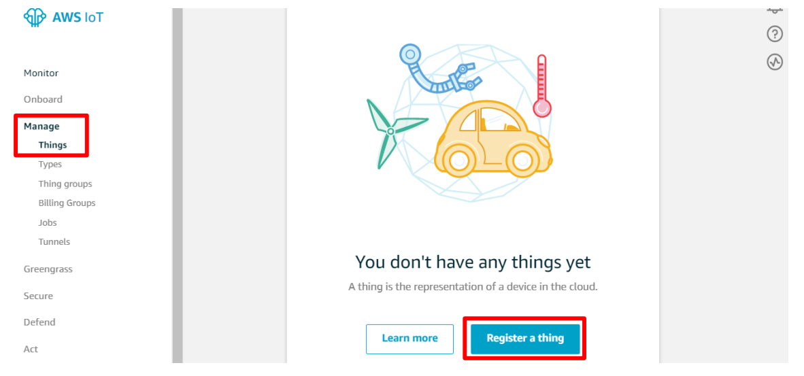
B. Click Create a single thing button.
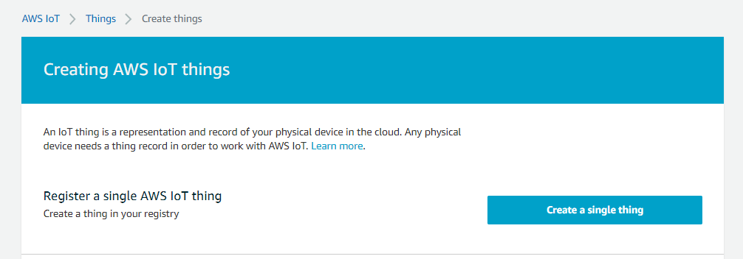
C. Type “testThing” in the Name filed, then scroll down and click Next button.
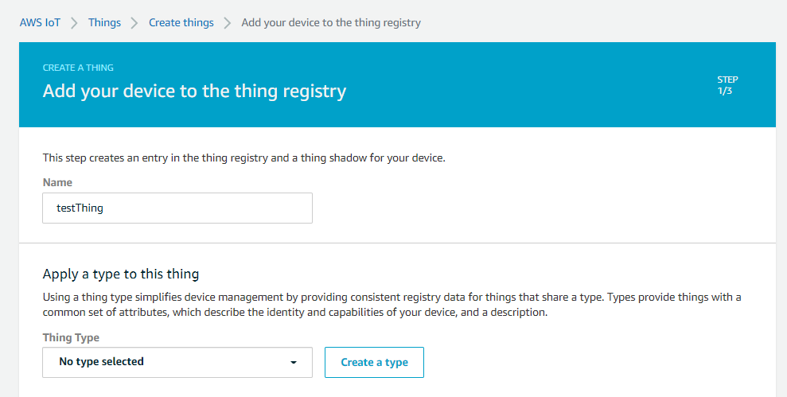
D. Click Create certificate button
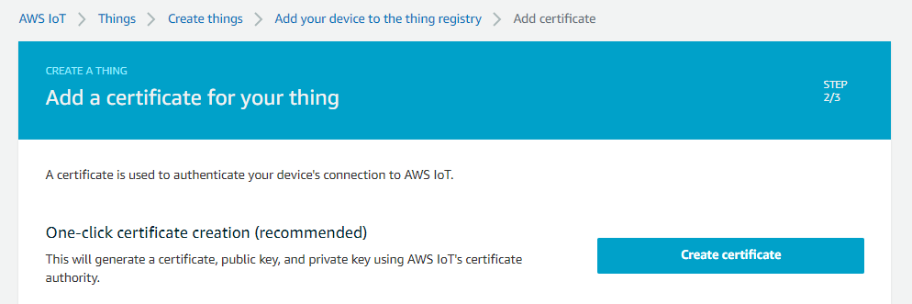
E. Download all of files and save them in a safe place. Make sure that you download private key and public key as they cannot be retrieved after you close this page.
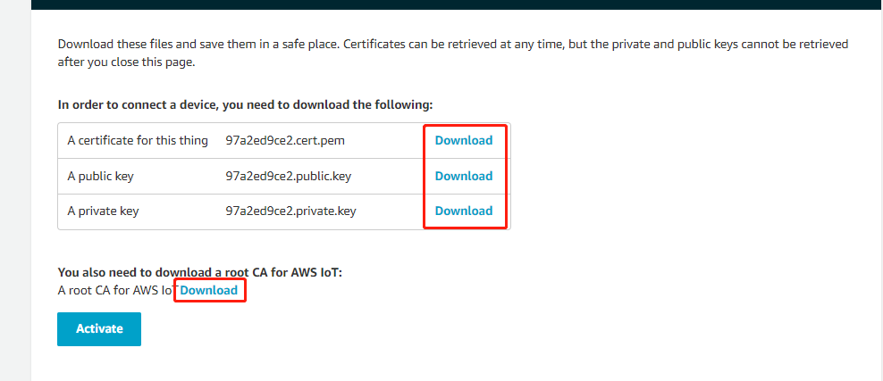
F. Regarding root CA for AWS IoT, download RSA 2048 bit key: Amazon Root CA 1.
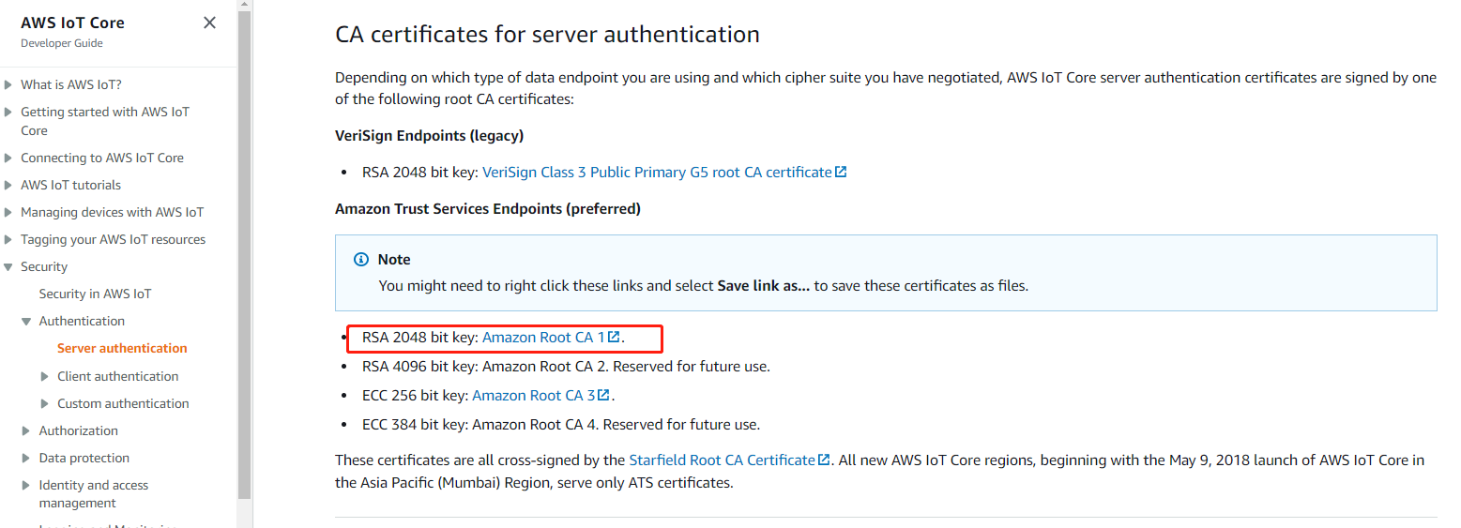
G. After making sure you have downloaded private key and public key (and certificate and Amazon root CA), scroll down and click Activate button, then click Done button.
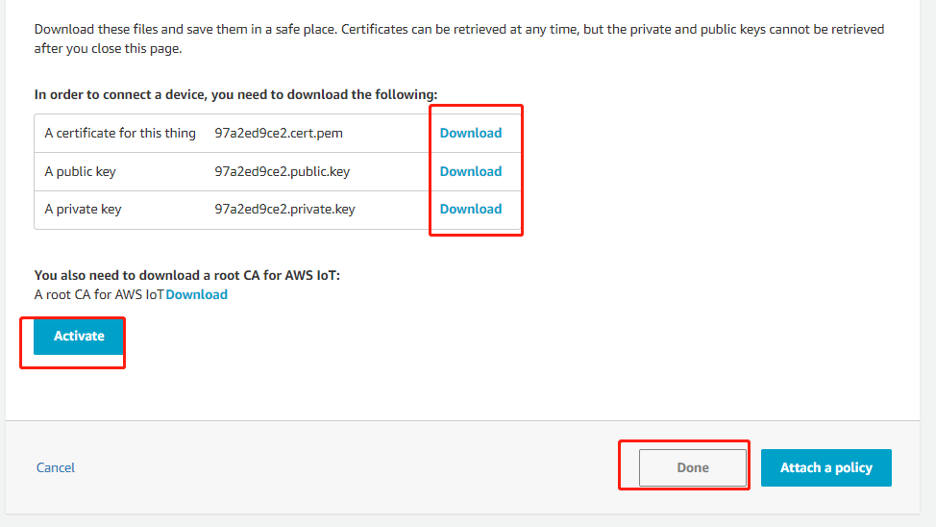
H. Select Secure - Policies from left menu and click Create policy button.
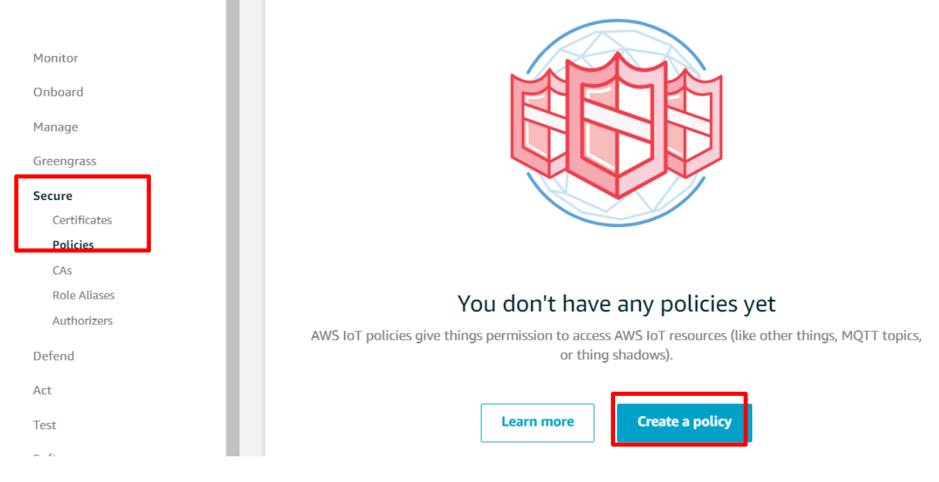
I. Type “iot:*” in the Action filed, “*” in the Resource ARN field, check Allow and click Create button.
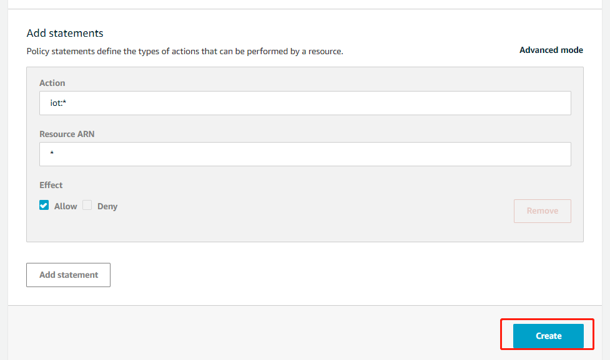
J. Click Secure - Certificates from left menu then click three dots menu on your certificate, and then click Attach policy.
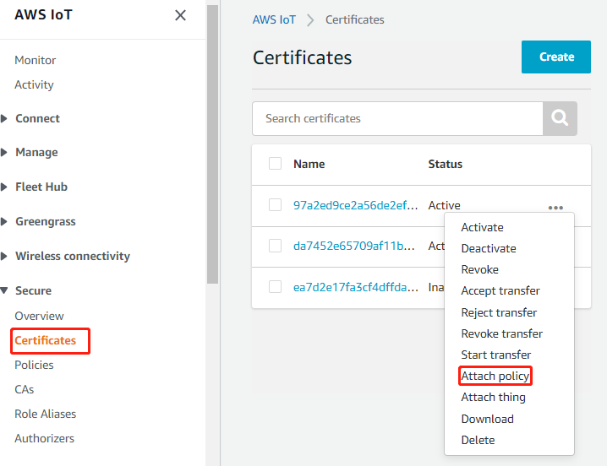
K. Check testPolicy you just created and click Attach button.
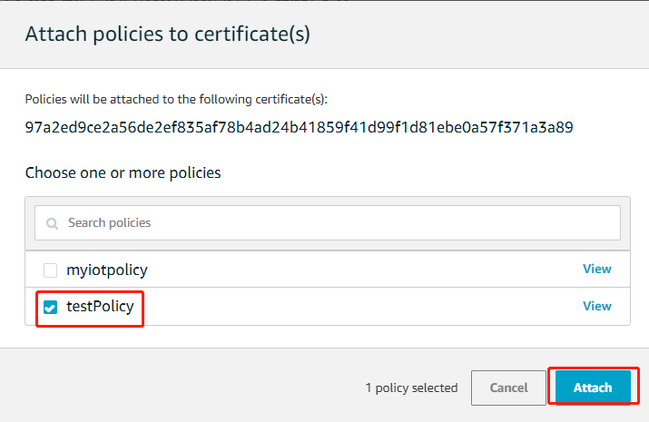
L. Checking Your AWS Endpoint
Visit AWS IoT Core Console and select Settings from the left menu, then copy the Endpoint. You need this in later sections.
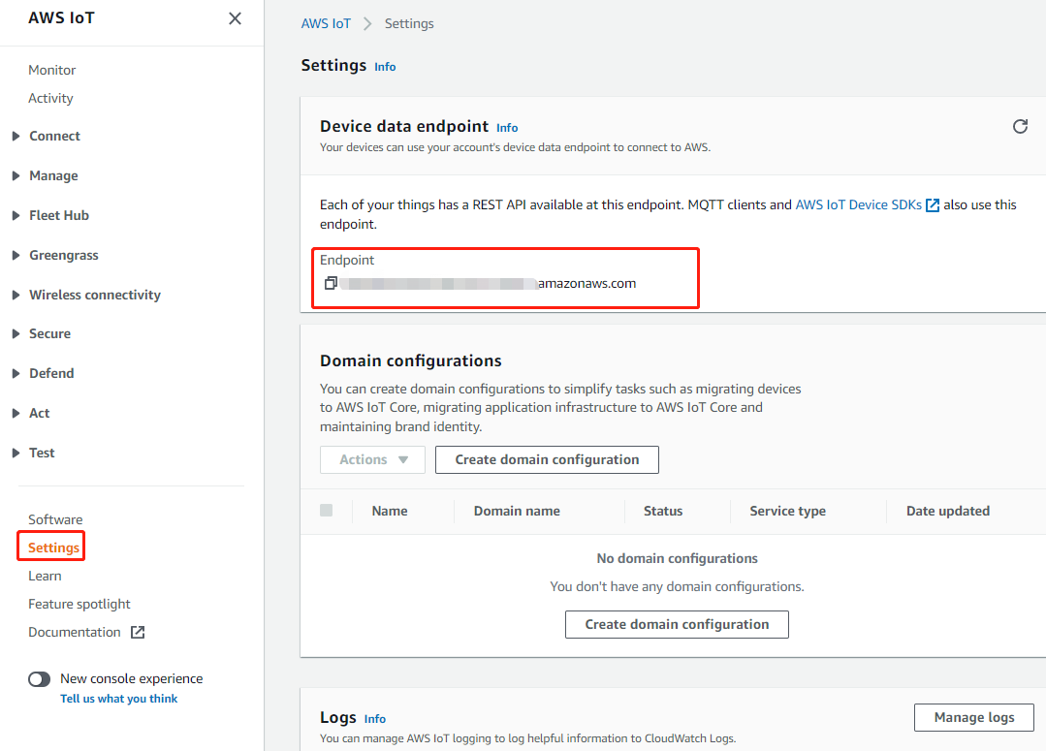

2.运行应用程序
A.配置证书和Endpoint。添加AmazonRootCA1.pem, XXXXXX-certificate.pem.crt, XXXXX-private.pem.key和Endpoint到 customer_app/cloud/aws_iot_core/aws_iot_core/aws_test_cert.h
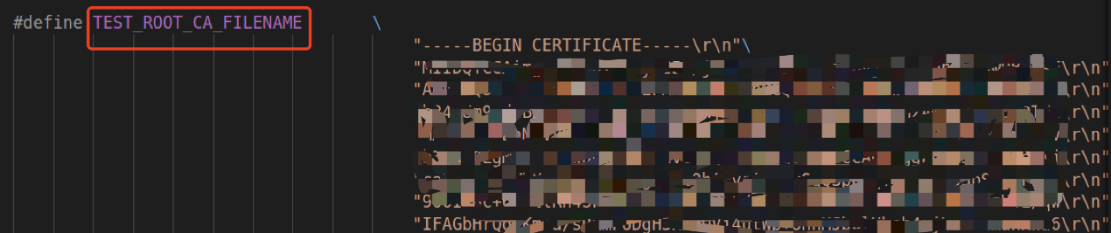
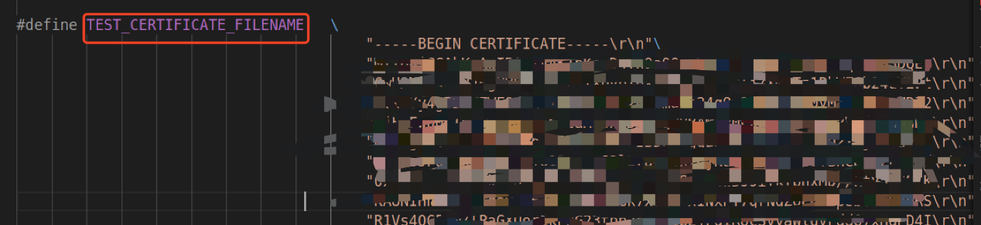
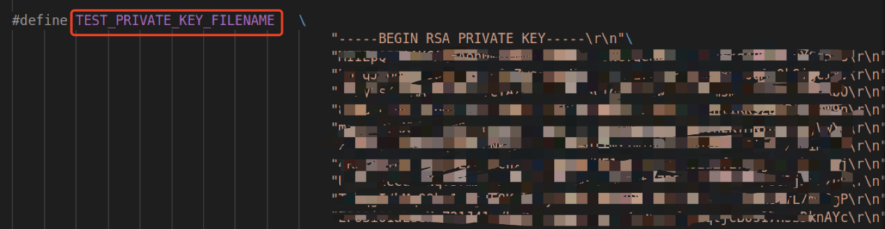
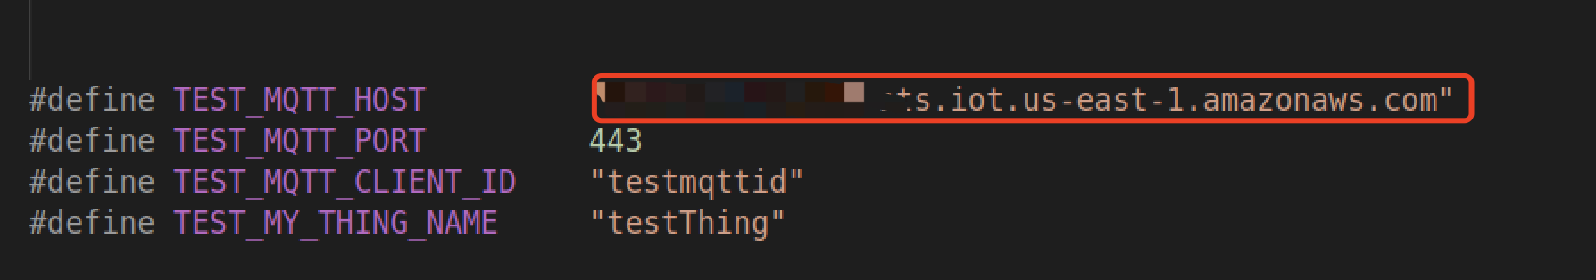
B.编译aws_iot_core。进入customer_app/cloud/aws_iot_core/目录下，执行./ genromap
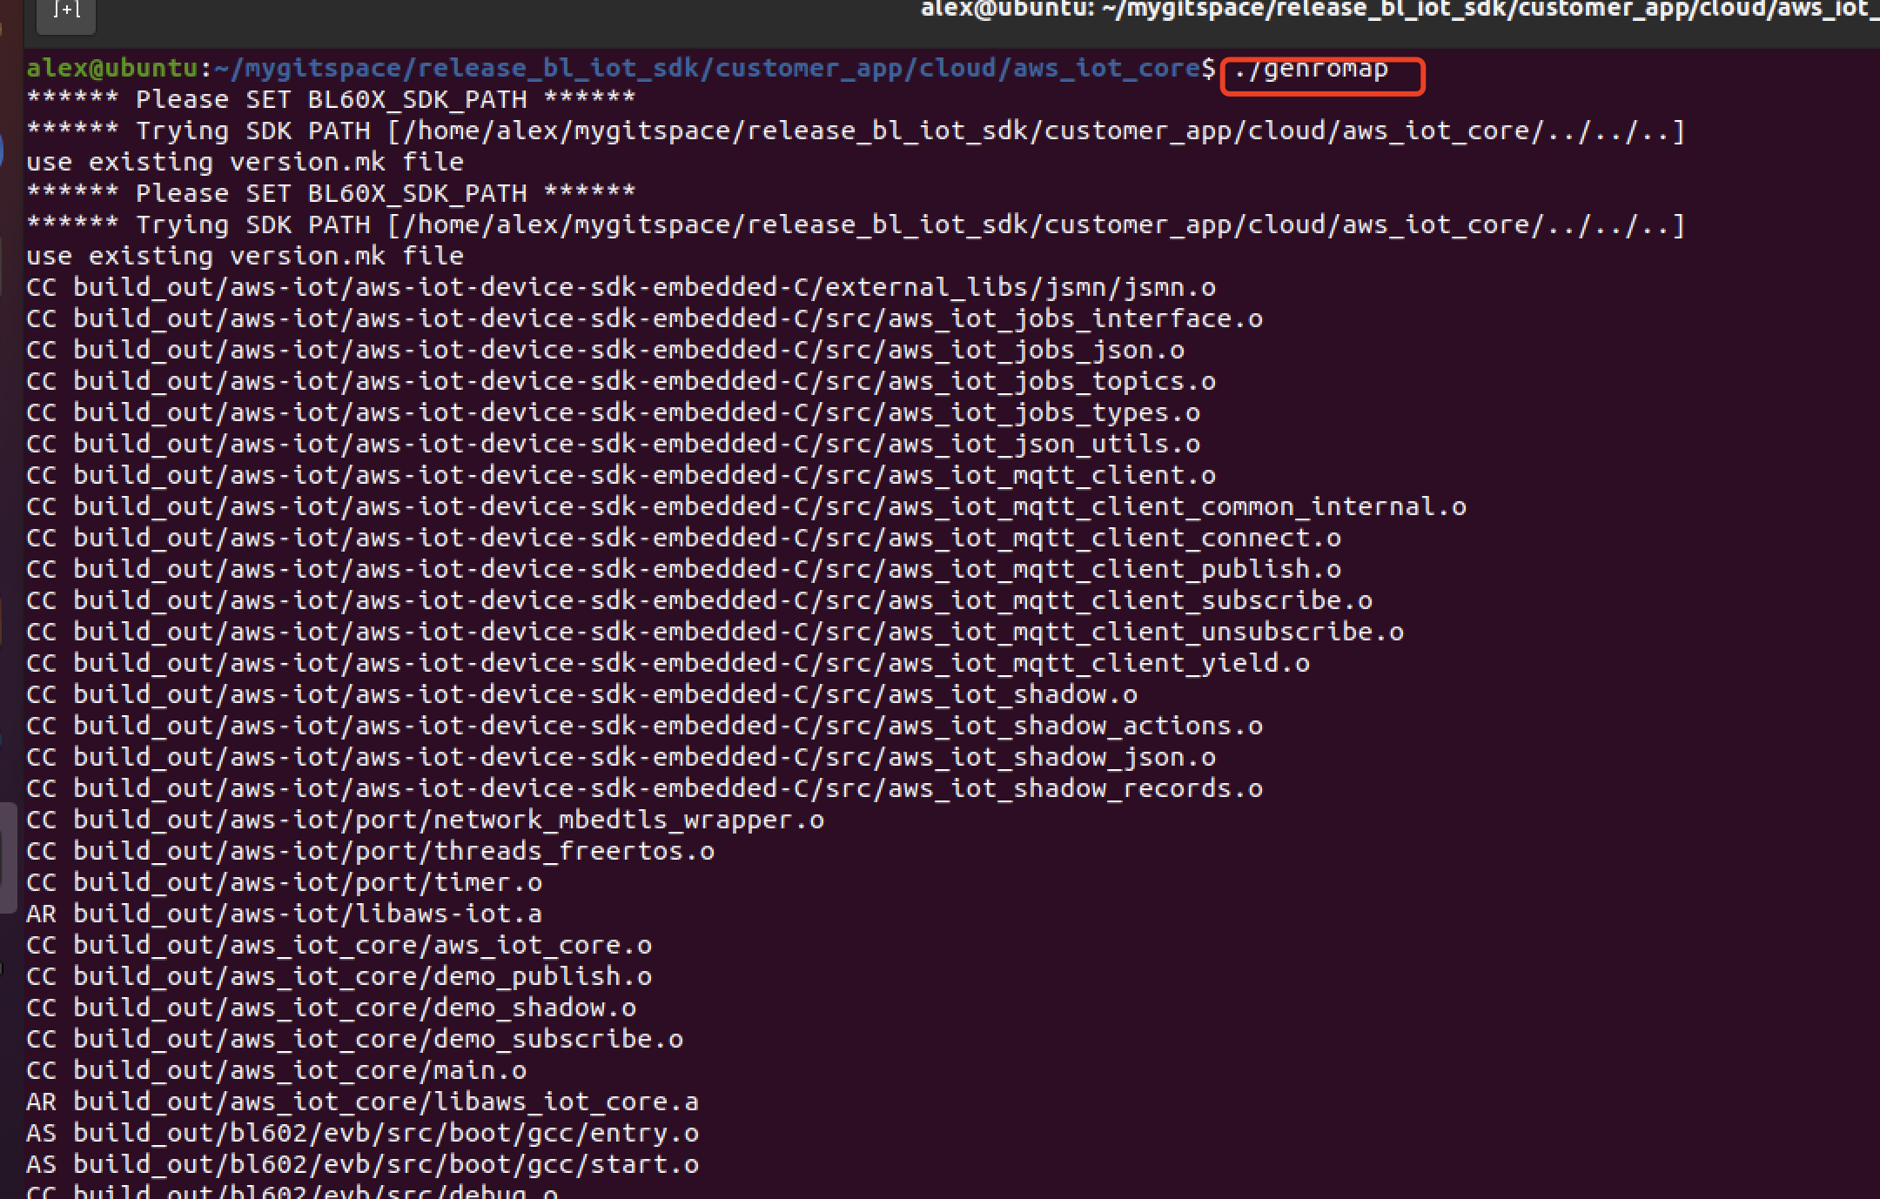
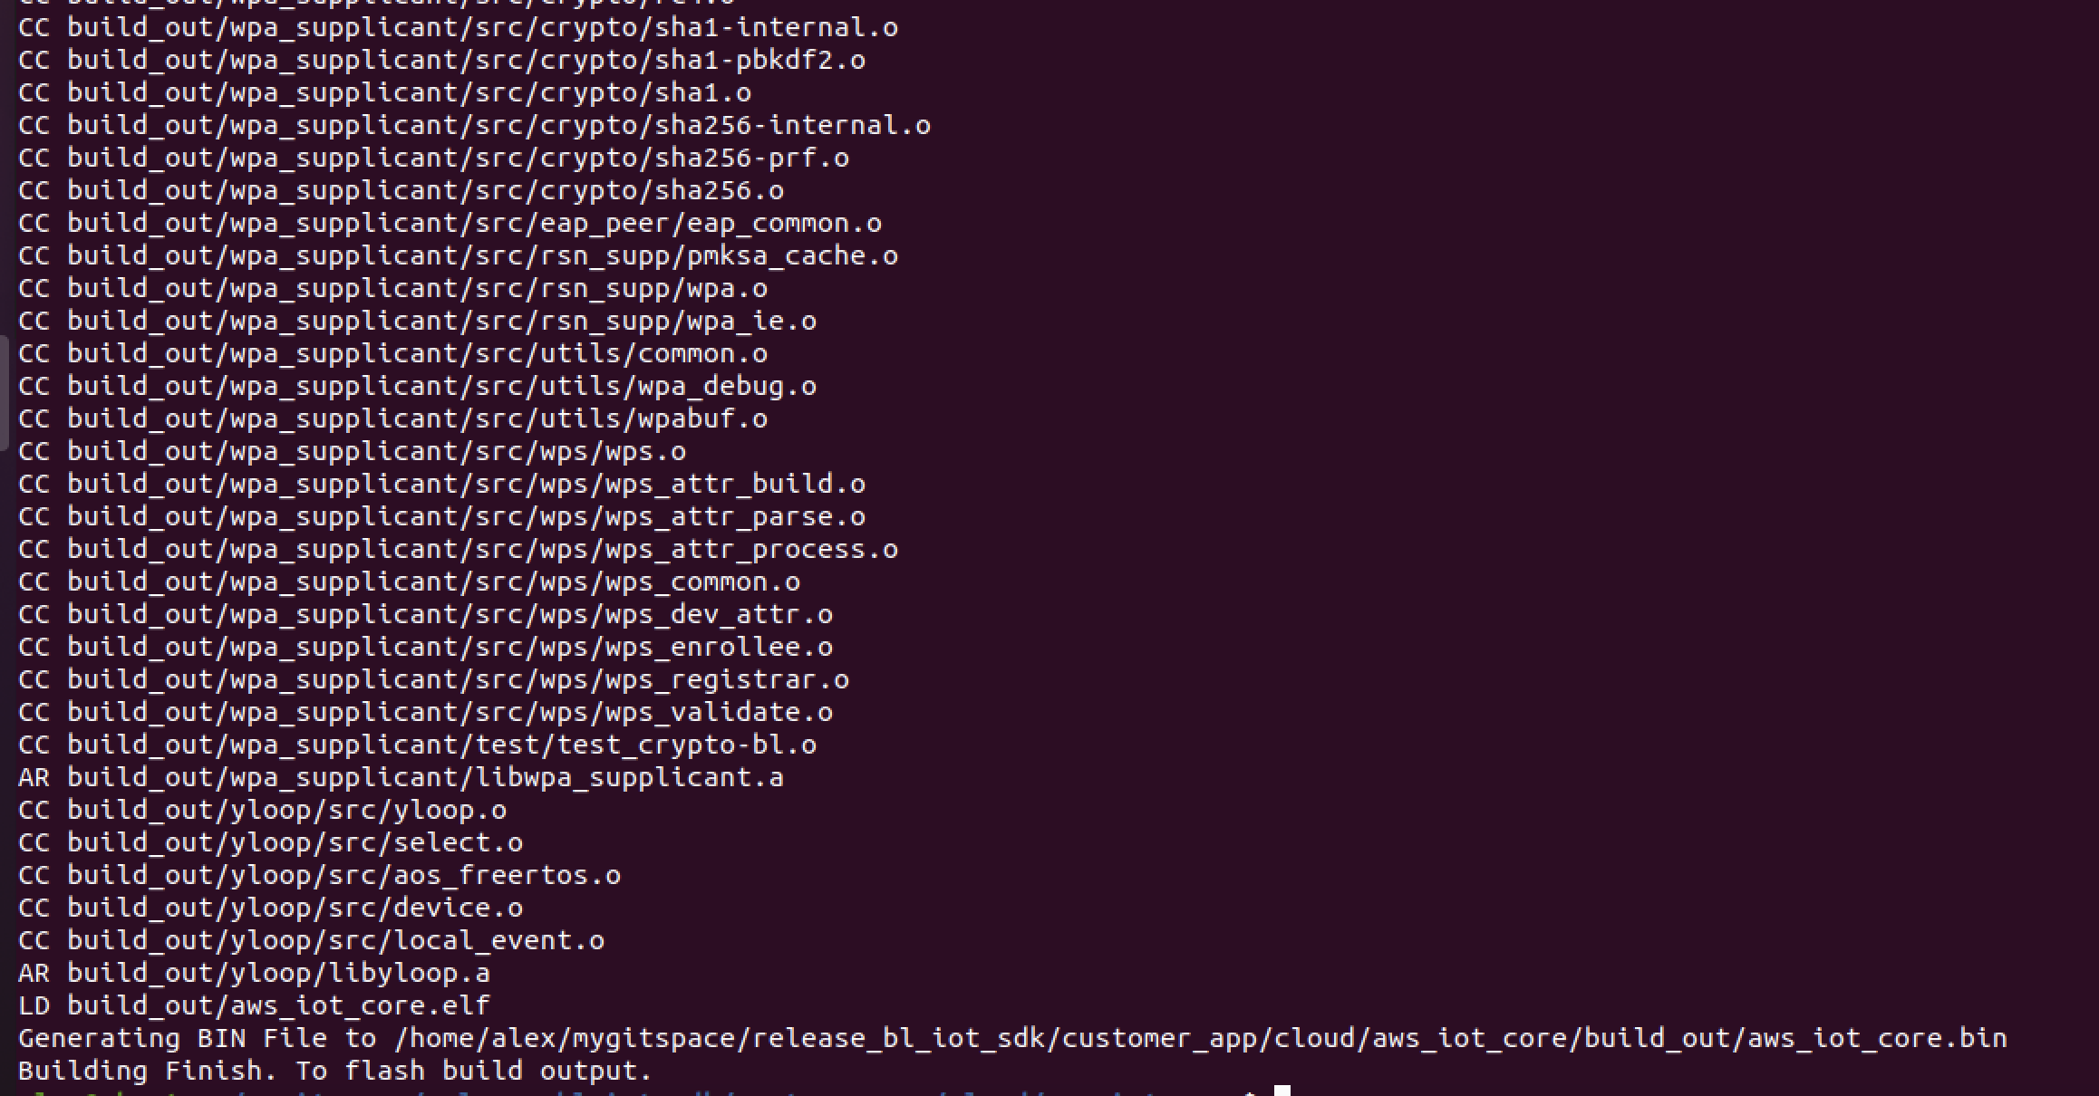
C.烧录测试固件。串口选择开发板识别的COM口，先按下boot键同时按下rst键后放开进入烧录模式，点击download
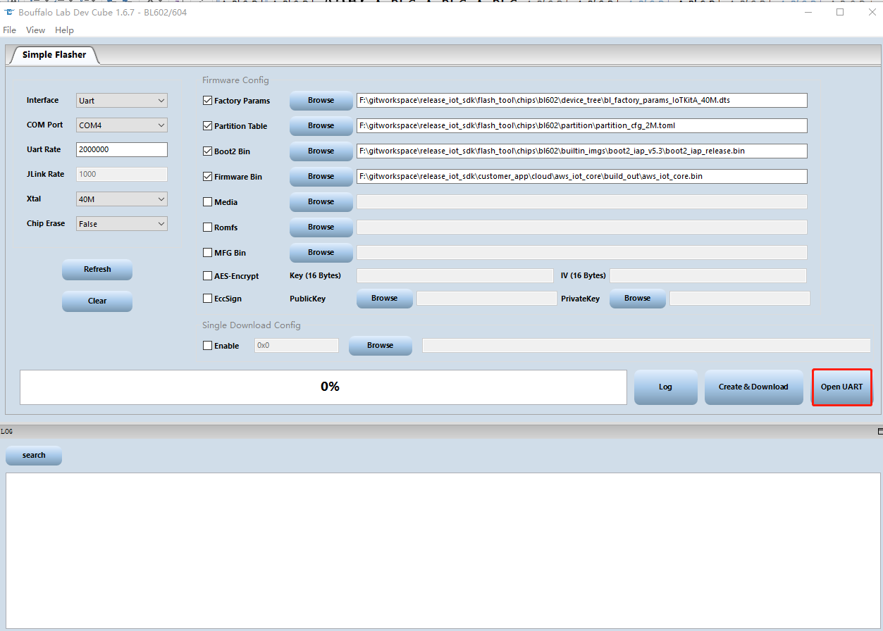
D. 配置串口.
配置串口波特率：2000000
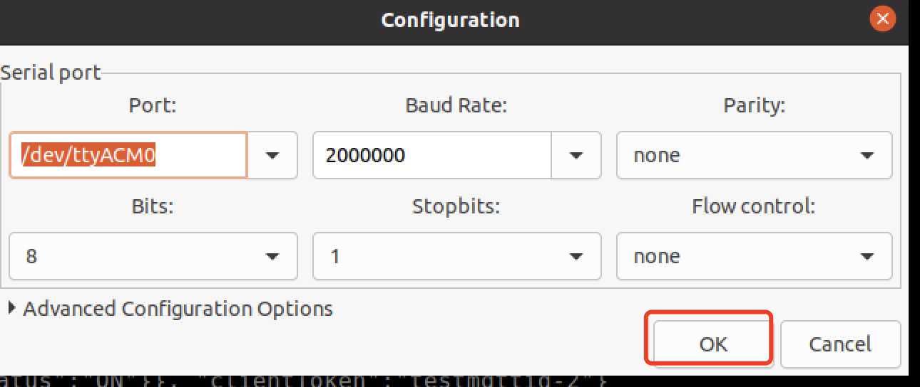
E. Running Publisher Application.
step1:RESET 开发板
Step2: 在AWS IoT控制台订阅myTopic/pub主题
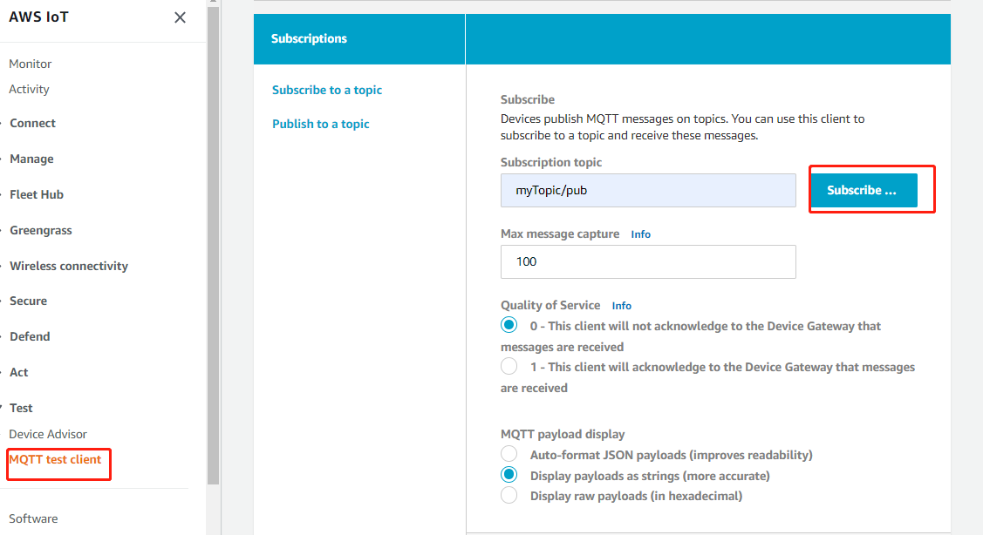
step3:在串口终端输入连接路由器命令 wifi_sta_connect ssid password
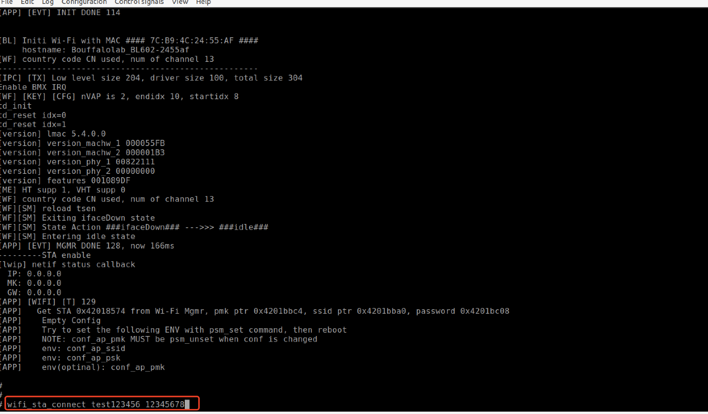
step4:连接路由器成功后，输入aws_test_publish命令
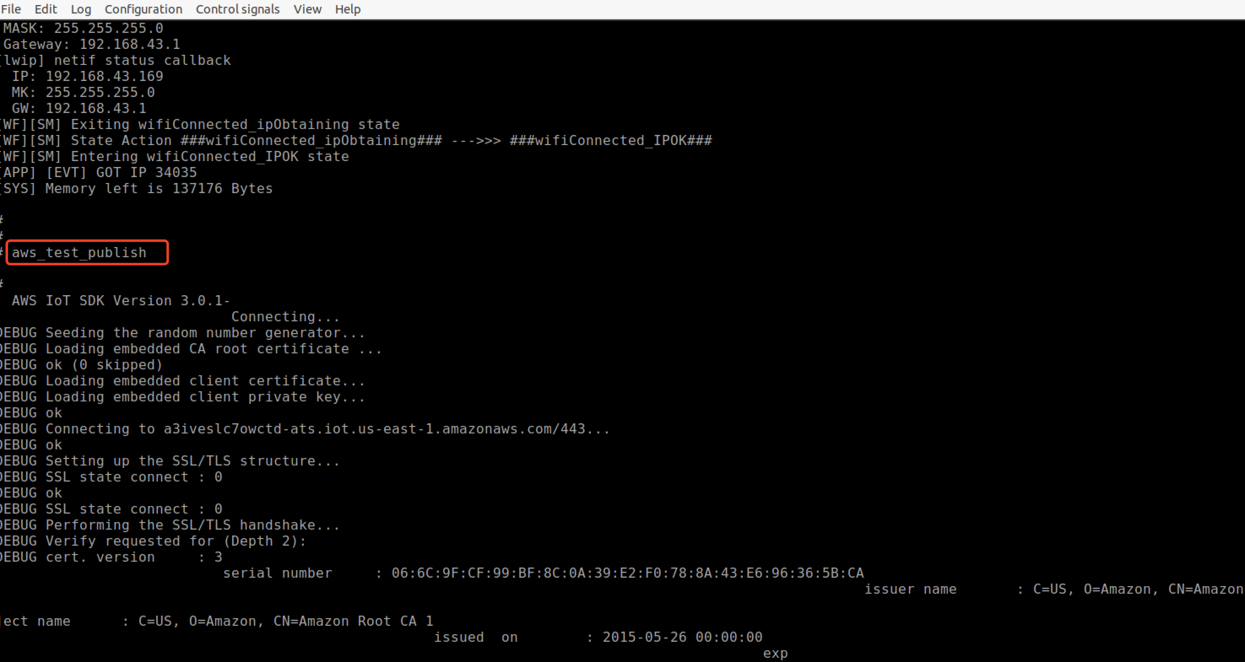
step5: 在AWS IoT控制台查看订阅的数据。收到Light ON/Light OFF消息。
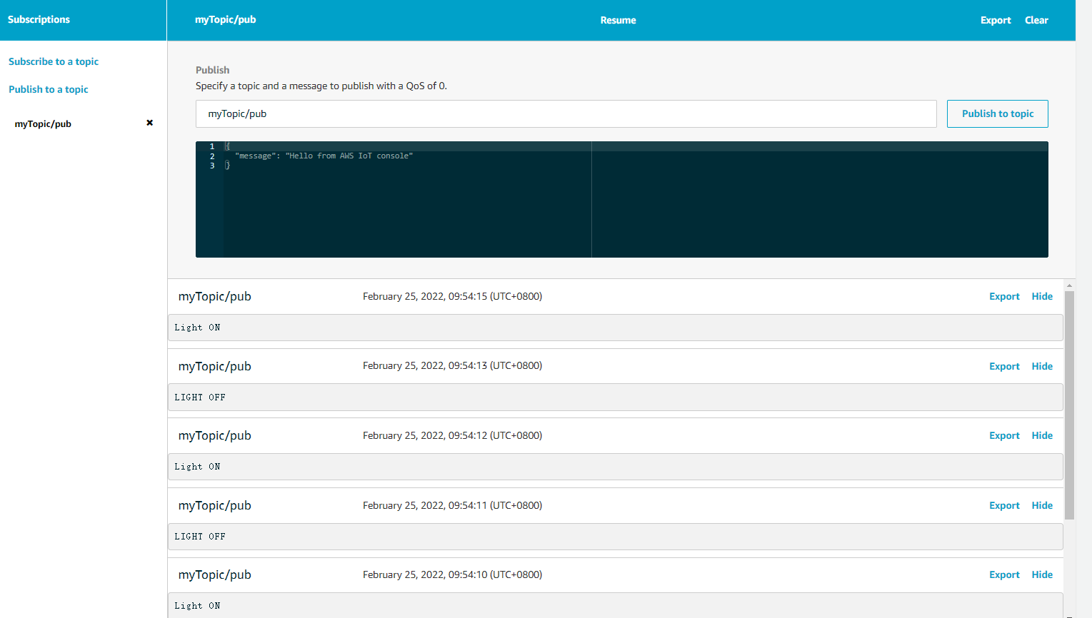
F. Running Subscriber Application
step1:RESET 开发板
step2:在串口终端输入连接路由器命令 wifi_sta_connect ssid password

step3: 连接路由器成功后，输入aws_test_subscribe
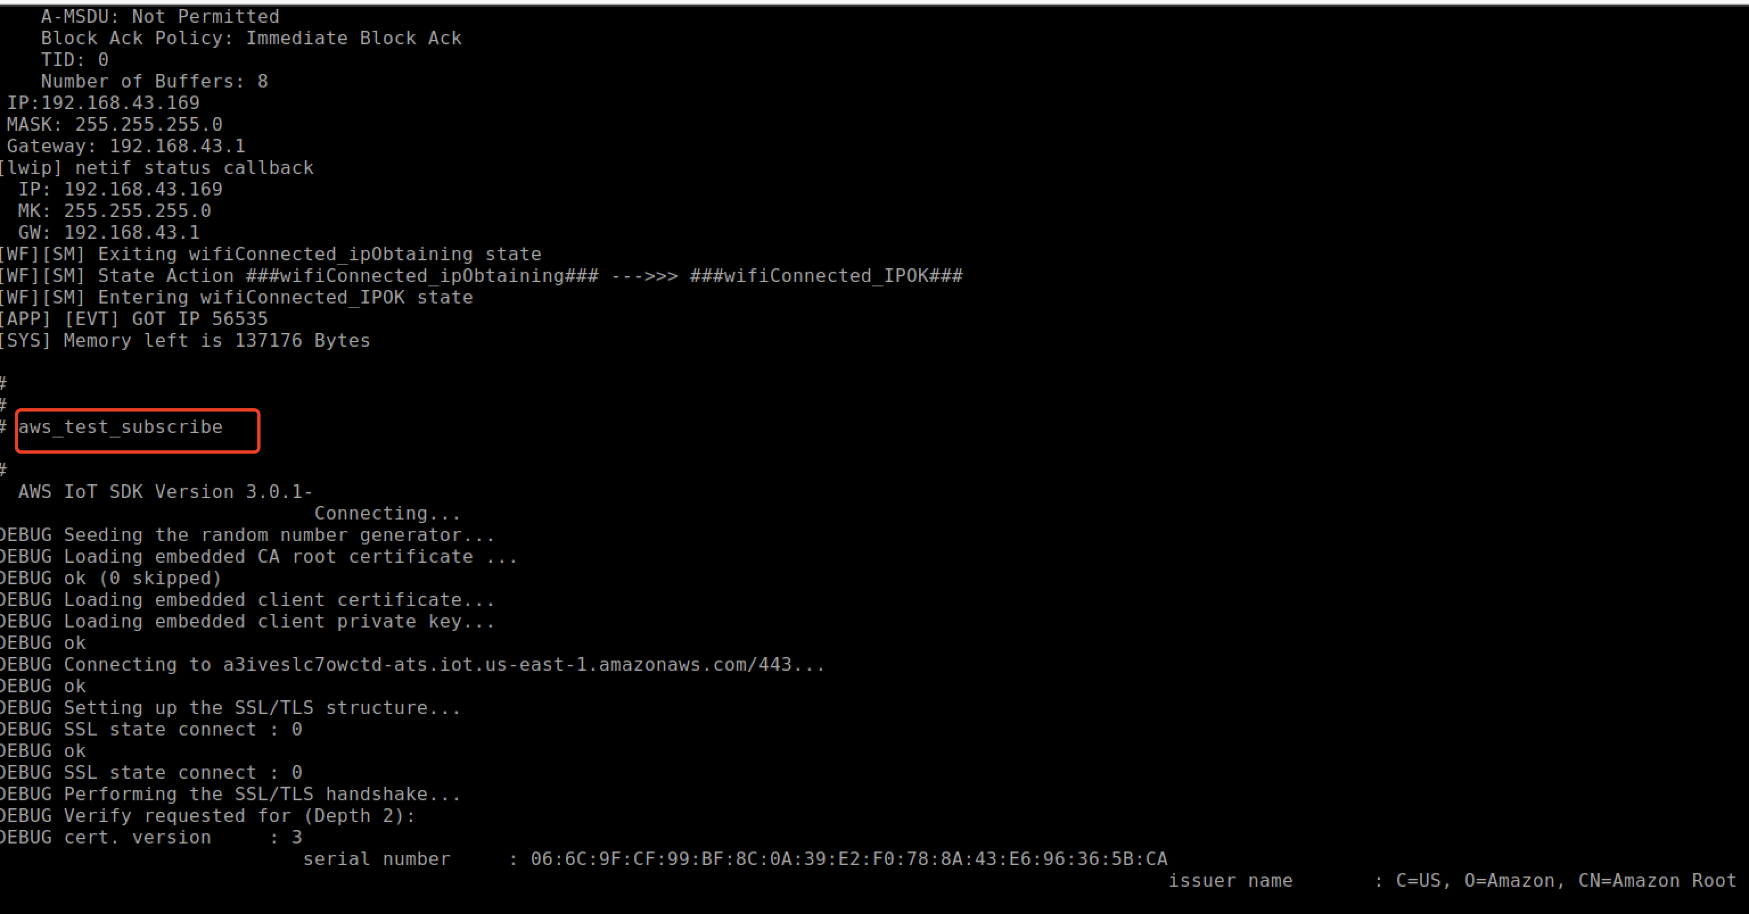
step4: 在AWS IoT控制台发布myTopic/sub主题。
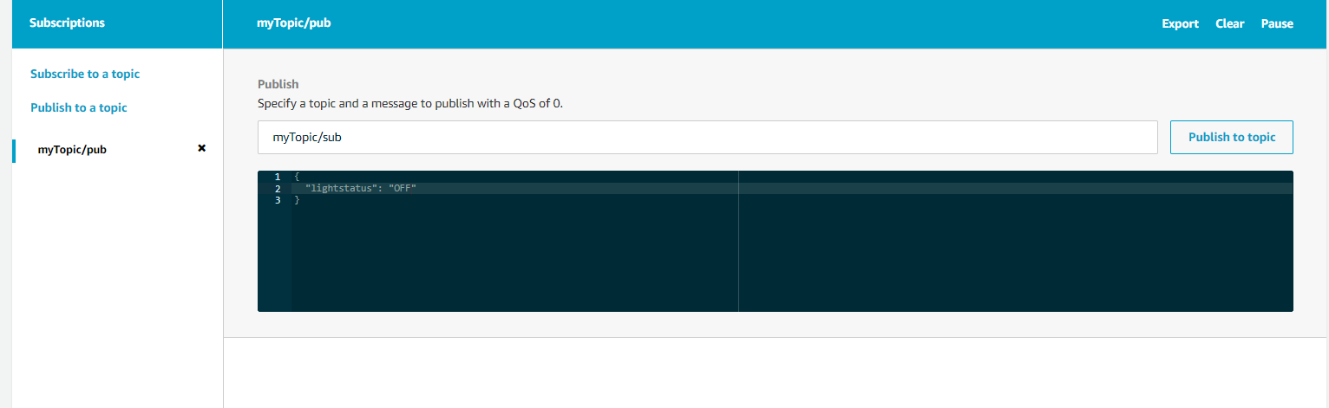
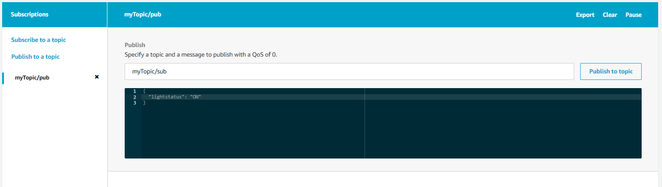
step5: 在串口终端查看接收数据
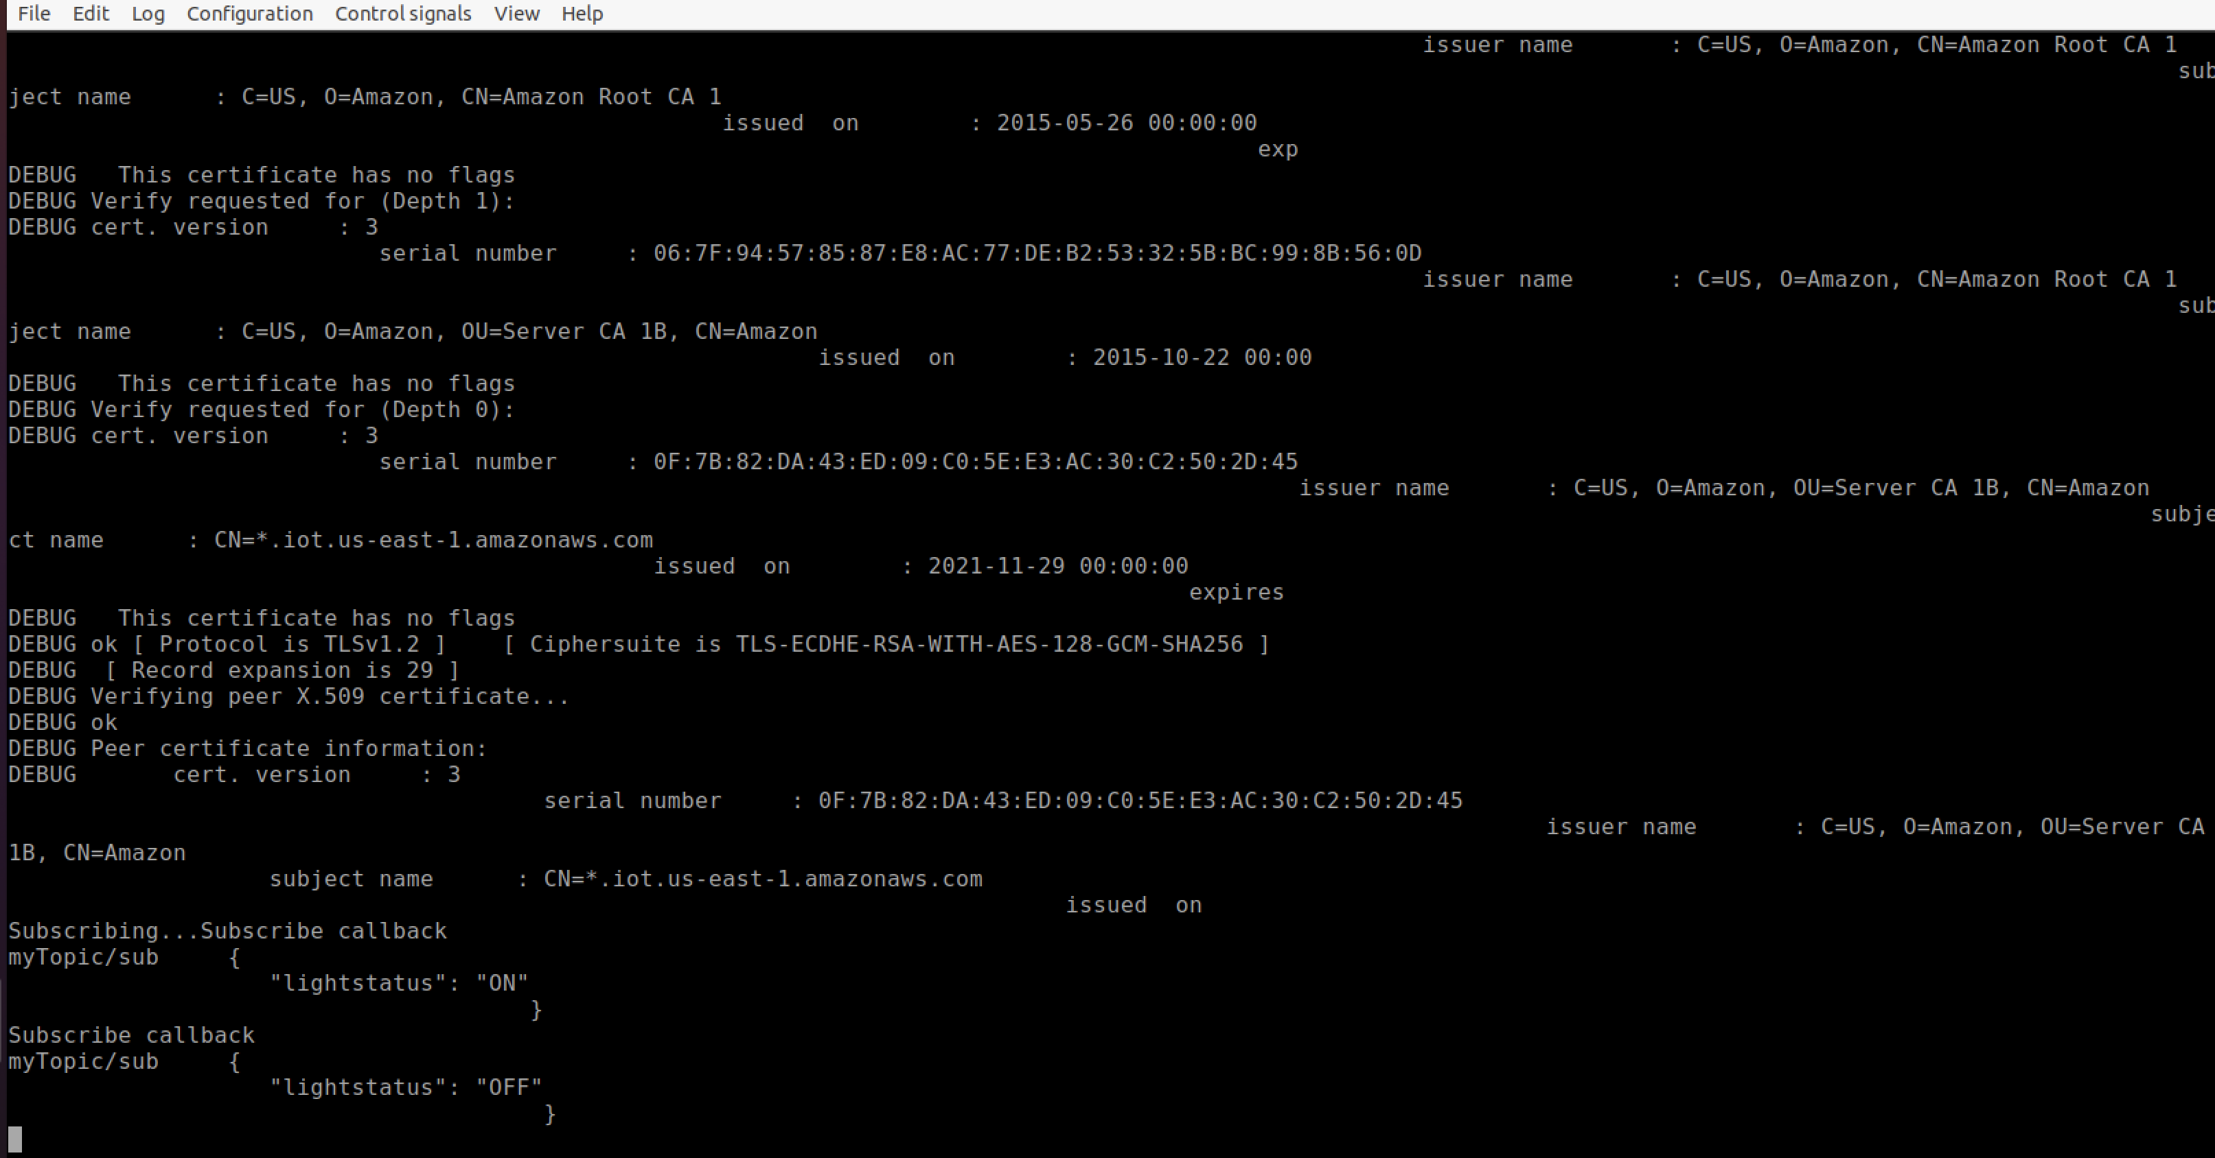
G. Running AWS Shadow Application
step1:RESET 开发板
step2: 在AWS IoT控制台编辑shadow state
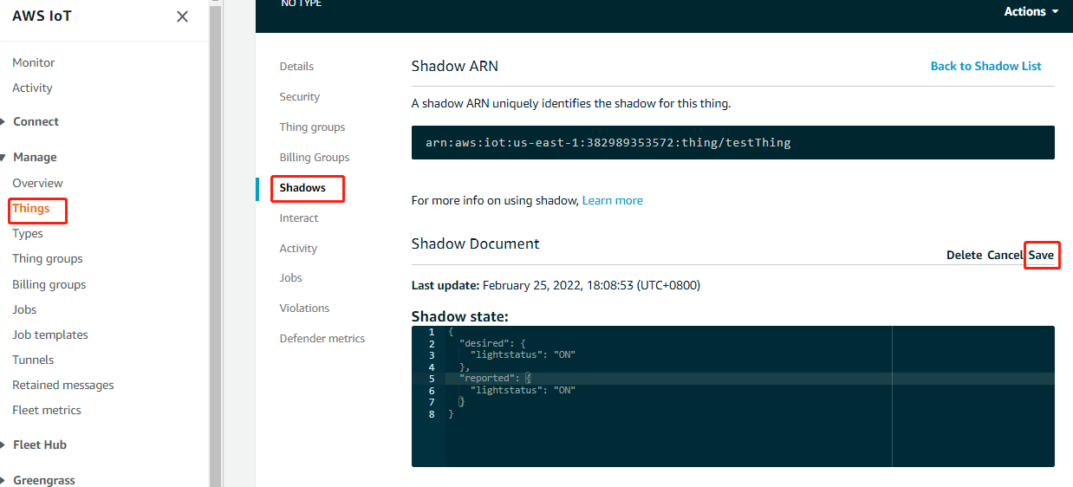
step3:在串口终端输入连接路由器命令 wifi_sta_connect ssid password

Step4: 连接路由器成功后，输入aws_test_shadow
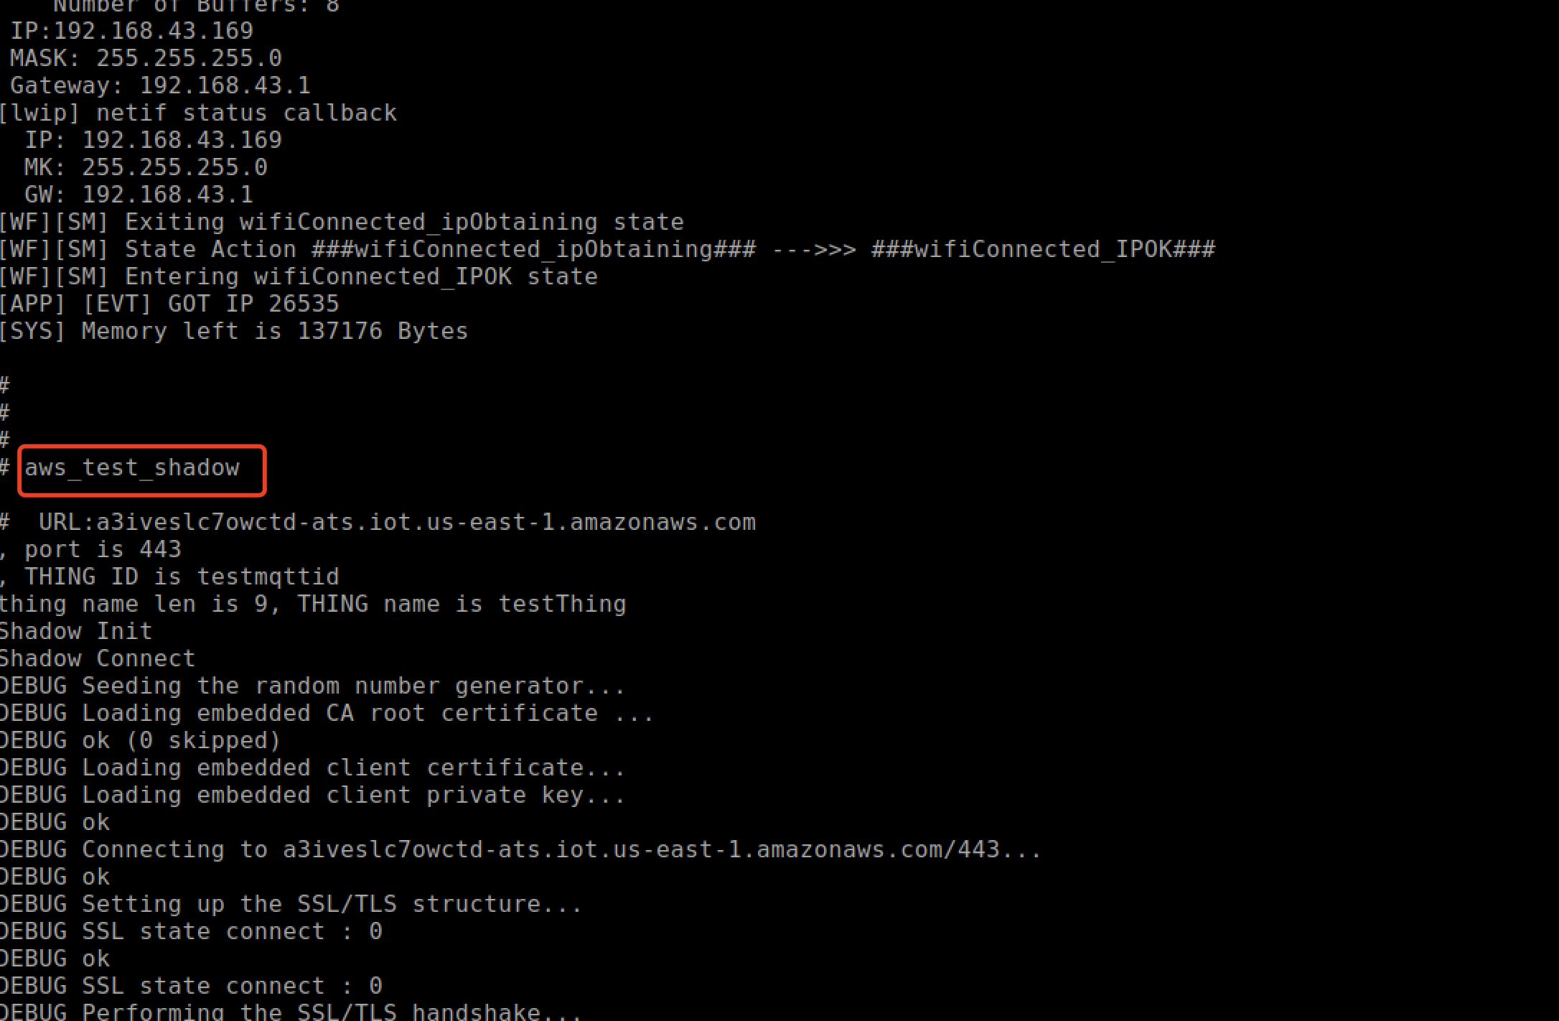
Step5: 在串口终端查看更新shadow data
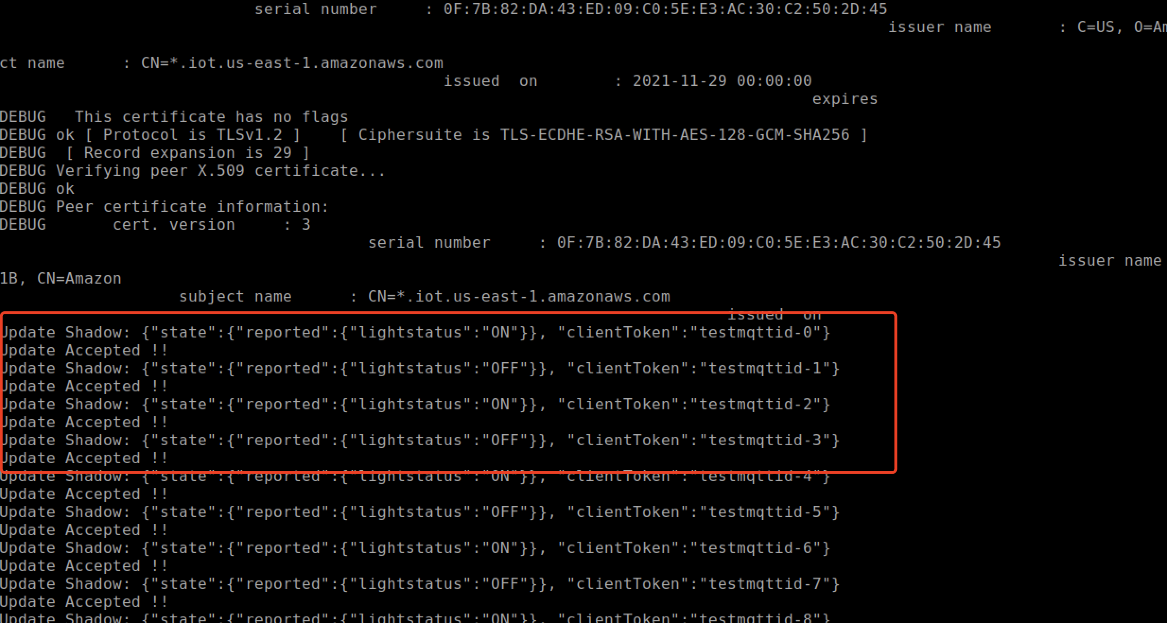
Step6: 在AWS IoT控制台查看更新shadow data
