编程接口
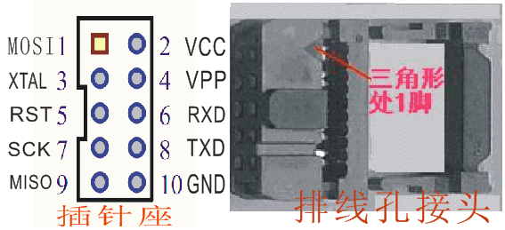
智峰系列下载器标准接口
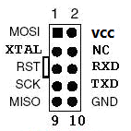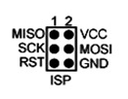
ISP标准10pin接口 ISP标准6pin接口
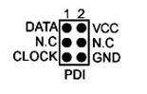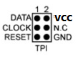
PDI标准接口 TPI标准接口
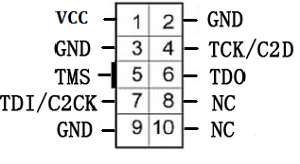
C8051F标准的JTAG/C2接口

智峰下载器接口转接一览表
下载器接口 |  | SWD | RS232 | PDI | TPI | SWIM | C2 | JTAG | nRF24
MOSI | 1 |  |  |  |  |  | C2CK | TDI | MOSI
VCC | 2 | VCC | VCC | VCC | VCC | VCC | VCC | VCC | VCC
XTAL | 3 | RST |  | CLOCK | CLOCK |  |  |  | RESET
NC(VPP) | 4
RST | 5 | SWDIO | RST |  | RST |  |  | TMS | CSN
RXD | 6 |  | RXD |  |  |  |  |  | PROG
SCK | 7 | SWDCLK | BOOT |  |  | RST | C2D | TCK | SCK
TXD | 8 |  | TXD
MISO | 9 |  |  | DATA | DATA | SWIM |  | TDO | MISO
GND | 10 | GND | GND | GND | GND | GND | GND | GND | GND
注：不同的下载器支持的芯片不同，具体要根据下载器型号确定支持的接口

转换板连接示意图
