Cordova 3.x 实用插件（2） -- 二维码Barcode
插件地址：https://github.com/wildabeast/BarcodeScanner （1）创建工程
引用
cordova create HelloBarcode com.rensanning.cordova HelloBarcode cd HelloBarcode cordova platform add android
（2）安装plugin
引用
cordova plugin add https://github.com/wildabeast/BarcodeScanner.git
（3）修改index.html后编译执行 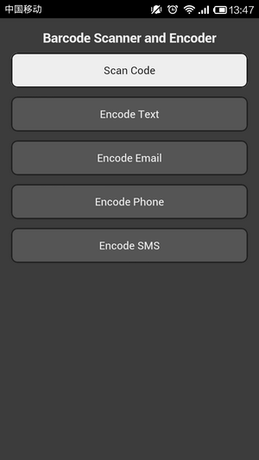
<a href="#"class="btn"onclick="scanCode();">Scan Code</a>
<script type="text/javascript">
function scanCode() {
cordova.plugins.barcodeScanner.scan(
function (result) {
alert("We got a barcoden"+
"Result:"+ result.text +"n"+
"Format:"+ result.format +"n"+
"Cancelled:"+ result.cancelled);
},
function (error) {
alert("Scanning failed:"+ error);
}
);
}
</script>
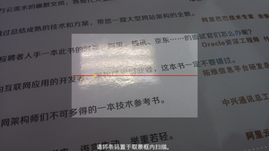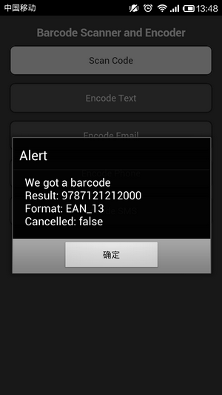Android版本的Zxing插件默认是横向扫描的，竖向扫码需要修改插件的代码。这里有改好的，可以试试。com.phonegap.plugins.barcodescanner.rar
<a href="#"class="btn enc"onclick="encodeText();">Encode Text</a>
<script type="text/javascript">
function encodeText() {
cordova.plugins.barcodeScanner.encode(
"TEXT_TYPE",
"http://www.baidu.com",
function(success) {
alert("encode success:"+ success);
}, function(fail) {
alert("encoding failed:"+ fail);
}
);
}
</script>
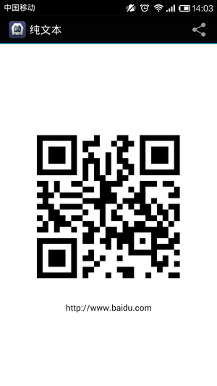
<a href="#"class="btn enc"onclick="encodeEmail();">Encode Email</a>
<script type="text/javascript">
function encodeEmail() {
cordova.plugins.barcodeScanner.encode(
"EMAIL_TYPE",
"rensanning@gmail.com",
function(success) {
alert("encode success:"+ success);
}, function(fail) {
alert("encoding failed:"+ fail);
}
);
}
</script>
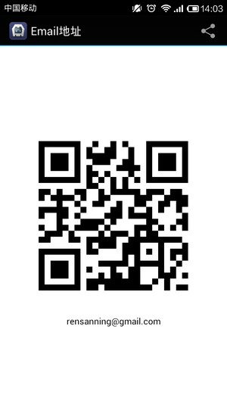
<a href="#"class="btn enc"onclick="encodePhone();">Encode Phone</a>
<script type="text/javascript">
function encodePhone() {
cordova.plugins.barcodeScanner.encode(
"PHONE_TYPE",
"135-1234-5678",
function(success) {
alert("encode success:"+ success);
}, function(fail) {
alert("encoding failed:"+ fail);
}
);
}
</script>
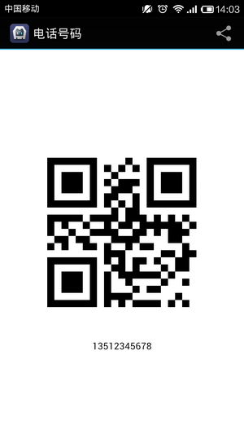
<a href="#"class="btn enc"onclick="encodeSMS();">Encode SMS</a>
<script type="text/javascript">
function encodeSMS() {
cordova.plugins.barcodeScanner.encode(
"SMS_TYPE",
"An important message for someone.",
function(success) {
alert("encode success:"+ success);
}, function(fail) {
alert("encoding failed:"+ fail);
}
);
}
</script>
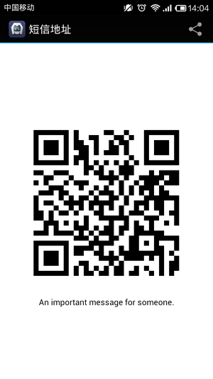注意： a) 没有实现CONTACT_TYPE 和 LOCATION_TYPE的encode。 b) 如果encode出错：
java.lang.NullPointerException
at com.google.zxing.client.android.encode.EncodeActivity.onCreateOptionsMenu(EncodeActivity.java:89)
下载最新的encode.xml文件，覆盖 platformsandroidresmenuencode.xml
<menu xmlns:android="http://schemas.android.com/apk/res/android">
<item android:id="@+id/menu_share"
android:title="@string/menu_share"
android:icon="@android:drawable/ic_menu_share"
android:orderInCategory="1"
android:showAsAction="withText|ifRoom"/>
<item android:id="@+id/menu_encode"
android:title="@string/menu_encode_vcard"
android:icon="@android:drawable/ic_menu_sort_alphabetically"
android:orderInCategory="2"
android:showAsAction="withText|ifRoom"/>
</menu>
- HelloBarcode-debug-unaligned.rar (538.8 KB)
- 下载次数: 56
- www.rar (1.3 KB)
- 下载次数: 52
- com.phonegap.plugins.barcodescanner.rar (1.4 MB)
- 下载次数: 30
- 查看图片附件

