photoPicke
大小 136k 本版本为Androidx
不用管权限，已经处理权限

1 项目生成aar
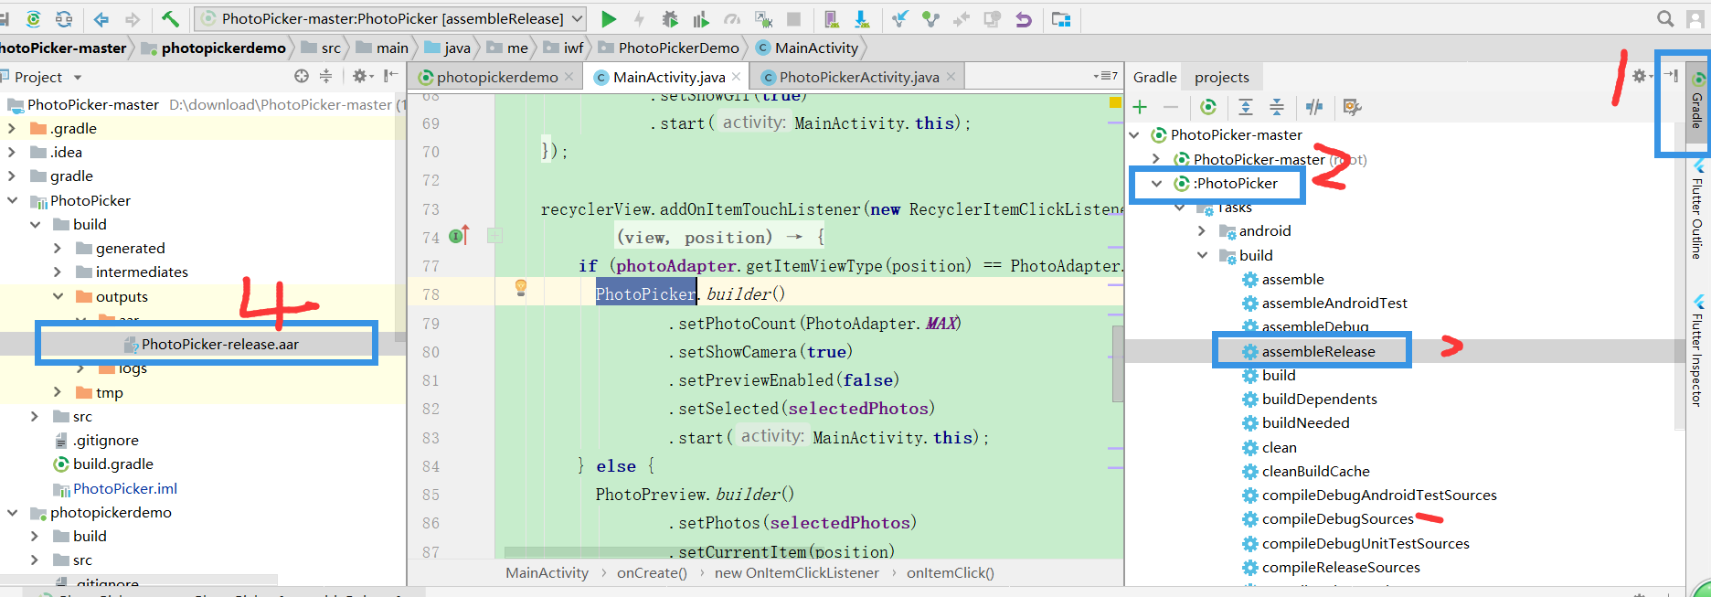

2 GitHub下载需要将demo中 bug统计删除
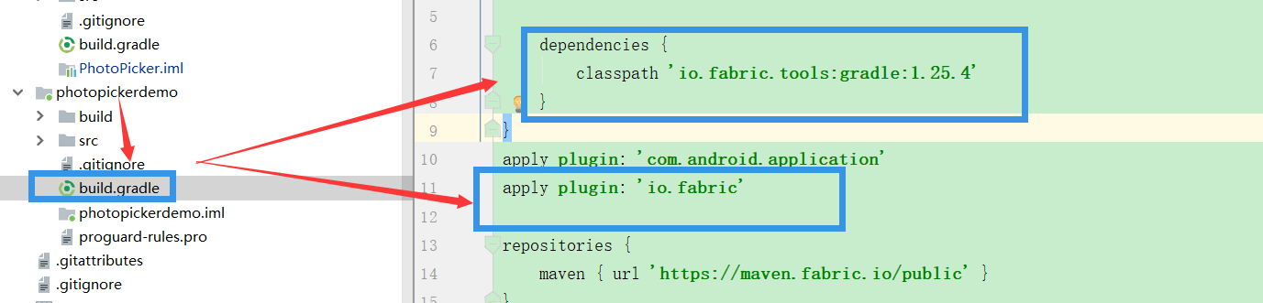

3 具体配置 权限+Activity
参照 https://github.com/zxiaolongo/PhotoPicker-master
Gradle 下添加即可使用
implementation fileTree(dir: 'libs', include: ['*.jar'])
// 要引用的aar文件
implementation files('libs/PhotoPicker.aar')

4 额外添加直接打开相机代码
public class CollectPersonActivity extends BaseActivity implements EasyPermissions.PermissionCallbacks {
// 申请相机权限的requestCode
private static final int PERMISSION_CAMERA_REQUEST_CODE = 0x00000012;
private ActivityCollectPersonBinding personBinding;
//用于保存拍照图片的uri
private Uri mCameraUri;
// 用于保存图片的文件路径，Android 10以下使用图片路径访问图片
private String mCameraImagePath;
private int CAMERA_REQUEST_CODE = 2;
// 是否是Android 10以上手机
private boolean isAndroidQ = Build.VERSION.SDK_INT >= android.os.Build.VERSION_CODES.Q;
private PicAdapter adapter;
@Override
protected void onCreate(Bundle savedInstanceState) {
super.onCreate(savedInstanceState);
personBinding = DataBindingUtil.setContentView(this, R.layout.activity_collect_person);
personBinding.setHandle(this);
personBinding.top.setHandle(this);
personBinding.top.setTitle("重点人员信息采集");
personBinding.rvPic.setLayoutManager(new GridLayoutManager(this, 4));
adapter = new PicAdapter(this);
adapter.setOnCameraClickCallBack(new PicAdapter.OnClickCallBack() {
@Override
public void onCameraClick() {
checkPermissionAndCamera();
}
@Override
public void onPicClick(int position) {
}
});
personBinding.rvPic.setAdapter(adapter);
}
/**
* 检查权限并拍照。
* 调用相机前先检查权限。
*/
private void checkPermissionAndCamera() {
String[] perms = {Manifest.permission.CAMERA};
if (EasyPermissions.hasPermissions(this, perms)) {
//有调起相机拍照。
openCamera();
} else {
EasyPermissions.requestPermissions(this, "请求打开相机",
PERMISSION_CAMERA_REQUEST_CODE, perms);
}
}
@Override
public void onRequestPermissionsResult(int requestCode, String[] permissions, int[] grantResults) {
super.onRequestPermissionsResult(requestCode, permissions, grantResults);
EasyPermissions.onRequestPermissionsResult(requestCode, permissions, grantResults, this);
}
@Override
public void onPermissionsGranted(int requestCode, List<String> list) {
//允许权限，有调起相机拍照。
openCamera();
}
@Override
public void onPermissionsDenied(int requestCode, List<String> list) {
ToastUtils.show("拍照权限被拒绝");
}
/**
* 调起相机拍照
*/
private void openCamera() {
Intent captureIntent = new Intent(MediaStore.ACTION_IMAGE_CAPTURE);
// 判断是否有相机
if (captureIntent.resolveActivity(getPackageManager()) != null) {
File photoFile = null;
Uri photoUri = null;
if (isAndroidQ) {
// 适配android 10
photoUri = createImageUri();
} else {
try {
photoFile = createImageFile();
} catch (IOException e) {
e.printStackTrace();
}
if (photoFile != null) {
mCameraImagePath = photoFile.getAbsolutePath();
if (Build.VERSION.SDK_INT >= Build.VERSION_CODES.N) {
//适配Android 7.0文件权限，通过FileProvider创建一个content类型的Uri
photoUri = FileProvider.getUriForFile(this, getPackageName() + ".fileprovider", photoFile);
} else {
photoUri = Uri.fromFile(photoFile);
}
}
}
mCameraUri = photoUri;
if (photoUri != null) {
captureIntent.putExtra(MediaStore.EXTRA_OUTPUT, photoUri);
captureIntent.addFlags(Intent.FLAG_GRANT_WRITE_URI_PERMISSION);
startActivityForResult(captureIntent, CAMERA_REQUEST_CODE);
}
}
}
/**
* 创建图片地址uri,用于保存拍照后的照片 Android 10以后使用这种方法
*/
private Uri createImageUri() {
String status = Environment.getExternalStorageState();
// 判断是否有SD卡,优先使用SD卡存储,当没有SD卡时使用手机存储
if (status.equals(Environment.MEDIA_MOUNTED)) {
return getContentResolver().insert(MediaStore.Images.Media.EXTERNAL_CONTENT_URI, new ContentValues());
} else {
return getContentResolver().insert(MediaStore.Images.Media.INTERNAL_CONTENT_URI, new ContentValues());
}
}
/**
* 创建保存图片的文件
*/
private File createImageFile() throws IOException {
String imageName = new SimpleDateFormat("yyyyMMdd_HHmmss", Locale.getDefault()).format(new Date());
File storageDir = getExternalFilesDir(Environment.DIRECTORY_PICTURES);
if (!storageDir.exists()) {
storageDir.mkdir();
}
File tempFile = new File(storageDir, imageName);
if (!Environment.MEDIA_MOUNTED.equals(EnvironmentCompat.getStorageState(tempFile))) {
return null;
}
return tempFile;
}
public void commit(View view) {
startActivity(new Intent(this,Main2Activity.class));
}
@Override
protected void onActivityResult(int requestCode, int resultCode, @Nullable Intent data) {
super.onActivityResult(requestCode, resultCode, data);
if (requestCode == CAMERA_REQUEST_CODE) {
if (resultCode == RESULT_OK) {
List<String> list = new ArrayList<>();
if (isAndroidQ) {
// Android 10 使用图片uri加载
list.add(mCameraUri.getPath());
adapter.loadMoreData(list);
} else {
// 使用图片路径加载
list.add(mCameraImagePath);
}
adapter.loadMoreData(list);
} else {
ToastUtils.show("取消");
}
}
}
}

