**Capstone-The-Battle-of-Neighborhood**

Quality of the Thai Restaurant in New York City

**Introduction**

It is well known that New York City is the center of east coast and food there is really good. As a Asian student nearby, I really like to take bus to the city for a good meal on the weekend. But at the same time, one question comes to my mind: How do I know the overall quality of Asian food, or specifically, Thai food, in Asian restaurants. At this time, I want to use the knowledge I learned here to solve the following questions:

1. What is the best location to enjoy Thai food in NYC?
2. Is it a good idea to open a Thai restaurant in NYC now?

**Methodology**

• Data will be collected from  <https://cocl.us/new_york_dataset> , which has been used as an example before, and cleaned and processed into a data frame. This dataset is quite easy to be accessed for me.

• FourSquare be used to locate all venues and then filtered by Asian restaurants. Ratings, tips, and likes by users will be counted and added to the data frame.

• Data will be sorted based on rankings and be visually assessed by using graphing from Python libraries.

**Results**

At the beginning, I obtained the number of Thai restaurants in the New York city among different boroughs and different neighborhoods. It is quite obvious that the Thai restaurants are mainly popular in Brooklyn, Manhattan and Queens. The folium map also shows the similar result.

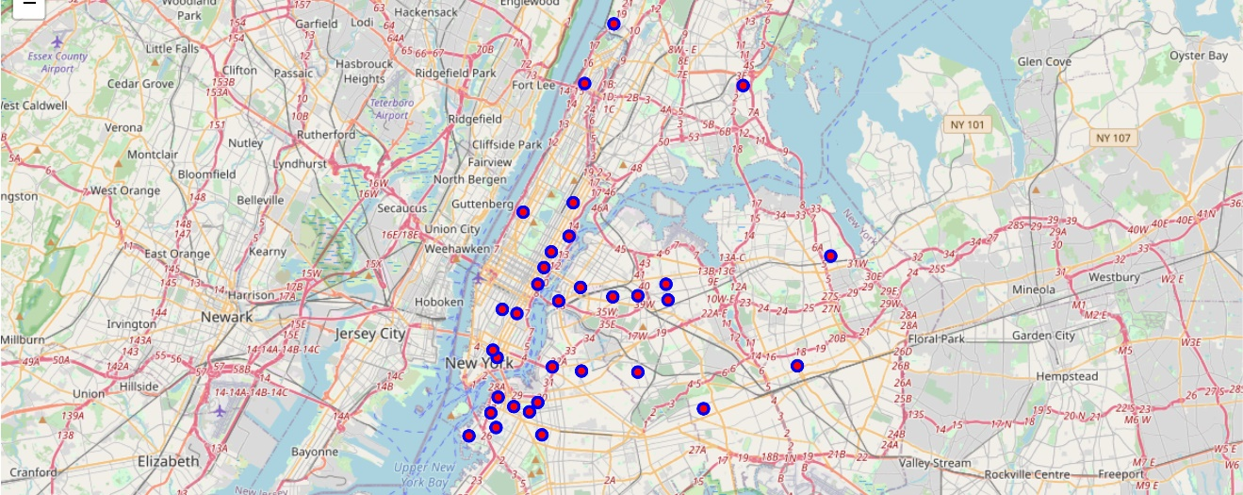

Then, we are looking for the restaurant which get the best rating one the Foursquare.com and finally we find this one: SriPraPhai. However, at the same time, we consider the tips and the neighborhood the restaurant is located, we are questioning if this restaurant is actually affordable to the normal students in fact.

At the same time, when we look at the descriptive statistics of all 57 Thai restaurants from Foursquare.com, we find that the overall rating for the Thai restaurant is still good and there are many affordable Thai restaurants for us.

Then we look at the locations for those 57 Thai restaurants to see if location can be a factor to the average ratings of Thai restaurant:

To our surprise, rather than Queens borough, Manhattan borough has the best overall rating of Thai restaurants. The number of Thai restaurants is not as large as Brooklyn and Queens but the average rating is surprisingly much higher than other boroughs.

But generally, the overall rating of Thai restaurants is pretty good among New York City

**Discussion**

This project is generally retrieving data from Foursquare.com to find which location is the best place to have Thai food. Our finding shows that Manhattan may be the best place to enjoy Thai food but the best Thai food restaurant is located in Queens. Not surprisingly, the overall rating of Thai food in New York City is above the average.

At the same time, there are many questions remaining for us. For instance, Brooklyn has the largest number of Thai restaurants in New York City but the overall rating is lower than Manhattan. Why is it? It is possible that the some restaurants in Manhattan have really great rating and make the average rating in Manhattan higher, which may be perceived as outlier effect. But if so, why Queens does not get the champion of the best borough to enjoy Thai food?

Another topic which we missed is that we did not evaluate the price of restaurant and if it is affordable to a normal student. We may need some other tools and data resource for this consideration.

**Conclusion**

On average, Manhattan may be the best borough to enjoy Thai food. Overall, New York City has 57 Thai restaurants and overall rating is good. It may not be a good choice to open a Thai restaurant now due to high competition.