Multi-Agent Modeling of Risk-Aware and Privacy-Preserving Recommender

Systems

By

Vishnu Srivastava

A thesis

Presented to the University of Waterloo

in fulfillment of the

thesis requirement for the degree of

Master of Mathematics

in

Computer Science

Waterloo, Ontario, Canada, 2017

© (Vishnu Srivastava) 2017

AUTHOR'S DECLARATION

I hereby declare that I am the sole author of this thesis. This is a true copy of the thesis, including any required final revisions, as accepted by my examiners. I understand that my thesis may be made electronically available to the public.

Abstract

Recent progress in the field of recommender systems has led to increases in the accuracy and improvements in the personalization of the supported recommendations [18]. These results are being achieved in general by gathering more user data and generating relevant insights from it. However, user privacy concerns are often underestimated and recommendation risks are not usually addressed. In fact, many users are not sufficiently aware of what data is collected about them and how the data is collected (e.g., whether third parties are collecting and selling their personal information)..

Research in the area of recommender systems should strive towards not only achieving high accuracy of the generated recommendations but also protecting user privacy [2,4,5,6,11,12,14] and making recommender systems aware of the user’s context [128], which involves user intentions and user current situation. Through research it has been established that a tradeoff is required between the accuracy, the privacy [130] and the risks [7] in a recommender system and that it is highly unlikely to have recommender systems completetely satisfying all the context-aware and privacy-preserving requirements. Nonetheless, a significant attempt can be made to describe a novel modeling approach that supports designing a recommender system encompassing some of these previously mentioned requirements.

This thesis focuses on designing a multi-agent model of a recommender system by breaking the system down into three different subsystems, i.e. the data subsystem, the risk subsystem and the privacy subsystem. Within each subsystem, the operations are carried out by at least one agent. Each agent has a specific role in order to achieve a prescribed goal by performing specific activities. Such a description of a system will be able to represent a subset of recommender systems which can be classified as both risk-aware and privacy-preserving.

Acknowledgements

I would like to thank Professor Paulo Alencar, for his patience, understanding, kindness and guidance. I learned a lot while working with him and I am proud to be his student. I am thankful to Professor Daniel Berry for serving as my co-supervisor. I also thank Professor Donald Cowan and Professor Gladimir Baranoski for agreeing to read my thesis and providing me valuable feedback.

Table of Contents

AUTHOR'S DECLARATION ii

Abstract iii

Acknowledgements iv

Table of Contents v

List of Figures viii

List of Tables x

Chapter 1 Introduction 11

1.1 Research Issue 12

1.2 Thesis Statement 13

1.3 Major Contributions 13

1.4 Thesis Organization 14

Chapter 2 Recommender Systems **Error! Bookmark not defined.**

2.1 Context-Aware Recommender Systems 16

2.2 Privacy in Recommender Systems 17

2.3 Privacy Protection 17

2.3.1 User control 17

2.4 Risk-Aware Recommender Systems 18

Chapter 3 Related Work 19

3.1 Modelling Recommender Systems 19

3.2 Risk-Aware Recommender Systems 19

3.3 Privacy-Preserving Recommender Systems 19

3.4 Privacy-Preserving Methodologies for Recommender Systems 21

Chapter 4 Proposed Approach 22

4.1 UML Diagrams 25

4.1.1 Activity Diagram 25

4.1.2 Sequence Diagrams 25

4.2 Goal Model 26

4.3 Multi-agent System Model and System Description 26

4.4 Goal Models for the Subsystems 29

4.4.1 Goal Model: Data Subsystem 29

4.4.2 Goal Model: Privacy Subsystem 30

4.4.3 Goal Model: Risk Subsystem 31

4.4.4 Combined Goal Model of the System 32

4.5 Activity Models for the Subsystems 34

4.5.1 Activity Model: Data Subsystem 34

4.5.2 Activity Model: Privacy Subsystem 35

4.5.3 Activity Model: Risk Subsystem 35

4.5.4 Combined Activity Model for the system 36

4.6 Sequence Diagrams for the Subsystems 38

4.6.1 Sequence Diagrams: Data Subsystem 38

4.6.2 Sequence Diagram: Privacy Subsystem 39

4.6.3 Sequence Diagram: Risk Subsystem 41

4.6.4 Combined Sequence Diagram 41

Chapter 5 Case Study: A Job Recommender System 43

5.1 Problem Description 43

5.2 Approach 47

5.3 Goal Models of the subsystems 47

5.3.1 Goal Model: Data Subsystem 48

5.3.2 Goal Model: Privacy Subsystem 48

5.3.3 Goal Model: Risk Subsystem 49

5.3.4 Combined Goal Model of the System 50

5.4 Activity Models of the subsystems 52

5.4.1 Activity Model: Data Subsystem 52

5.4.2 Activity Model: Risk Subsystem 53

5.4.3 Activity Model: Privacy Subsystem 54

5.4.4 Combined Activity Model of the System 55

5.5 Sequence Diagram for the Subsystems 57

5.5.1 Sequence Diagram: Data Subsystem 57

5.5.2 Sequence Diagram: Risk Subsystem 58

5.5.3 Sequence Diagram: Privacy Subsystem 58

5.5.4 Combined Sequence Diagram of the System 59

Chapter 6 Conclusion & Future Work 61

6.1 Conclusion 61

6.2 Future Work 61

Appendix 62

Privacy scope of a system 62

Contextual risk scope 63

Explanation of a multidimensional system diagram 64

Extension of the evaluation method to the case study 66

Bibliography 68

List of Figures

Figure 1 Conceptualization of a Recommender System **Error! Bookmark not defined.**

Figure 2 Proposed Approach 23

Figure 3 Proposed Approach 27

Figure 4 Relationship Model for Subsystems 28

Figure 5 Goal Model for the Data Agent and the Aggregator Agent 29

Figure 6 Goal Model for the User Privacy Agent 30

Figure 7 Goal Model for the User Risk and Context Analyzer Agent 31

Figure 8 System Goal Model 33

Figure 9 Activity Diagram of Data Subsystem 34

Figure 10 Activity diagram for the Privacy Agent 35

Figure 11 Activity Diagram for the Risk Subsystem 36

Figure 12 Complete Activity Model of the System 37

Figure 13 Data Subsystem Sequence Diagram 38

Figure 14 Privacy Subsystem Sequence Diagram 39

Figure 15 Contextual Risk Subsystem Sequence Diagram 41

Figure 16 Combined Sequence Diagram 42

Figure 17 Graph Framework described in [9] 45

Figure 18 Resume Matcher System described in [10] 45

Figure 19 Information Processing Pipeline described in [10] 46

Figure 20 Goal Model: Data Subsystem 48

Figure 21 Goal Model: Privacy Subsystem 49

Figure 22 Goal Model: Risk Subsystem 50

Figure 23 Combined Goal Model of the Job Recommender System 51

Figure 24 Job Data Agent 52

Figure 25 Risk Agent for the Job Recommender 53

Figure 26 Privacy Agent for the Job Recommender 54

Figure 27 Job Recommender System Model 56

Figure 28 Sequence Diagram: Data Subsystem 57

Figure 29 Sequence Diagram: Risk Subsystem 58

Figure 30 Sequence Diagram: Privacy Subsystem 59

Figure 31 Combined Sequence diagram of the Job Recommender System 60

Figure 32 Privacy Scope 63

Figure 33 Contextual Risk Scope 64

Figure 34 Dimensional Plot of a Recommender System 65

Figure 35 Multidimensional Description of the Job Recommender System 66

List of Tables

Table 1 Interaction Entities proposed in [9] 44

Table 2 General Dimensional Analysis of Various Approaches 65

# Introduction

In recent times, recommender systems (RSs) can take advantage of the semantic reasoning capabilities [128] to overcome common limitations and improve the recommendation quality. These systems uses domain properties, types and relationships to enhance user personalization. Current research in the area of RSs hasfocussed on context-aware RSs [18]. A context-independent representation may lose predictive power because potentially useful information from multiple contexts is not taken into account [128]. The ideal context-aware RS would, therefore, be able to reliably associate each user action with an appropriate context and effectively modify the system output for the user in that given context. The majority of existing approaches to RSs focus on recommending the most relevant content to users using contextual information and do not take into account the risk of upsetting the user by not providing accurate recommendations. However, in many applications, such as recommending personalized content, it is also important to consider the risk of upsetting the user by not being aware of the user’s situation and intentions [7]. Therefore, the performance of a RS depends in part on the degree to which it has incorporated the risk into the recommendation process. Risks in RSs can involve, for example, the possibility of disturbing or to upsetting the user, which can lead to a negative feedback from the user. With the advent of enormous amounts of personal data collection for the sake of personalization and improving recommendation quality, the focus of the current research on RSs has been shifting to privacy protection [129]. Personalization provides convenience in the user experience, and it can have a direct impact on marketing, sales, and profit. On the other hand, privacy, which is a serious concern for many users, is the price users have to pay for the convenience of RSs can provide in a world with booming information. Users normally have no choice but to trust the service provider to keep their sensitive personal profile and information safe.

## Research Issue

Since a major focus in the area of RSs has been the improvement of the accuracy of the recommendations generated by the Recommender System, there is a lack of a modelling approach for the RSs that takes into account both sufficient knowledge of the user’s context and the privacy of the users. A novel model of RSs involving both contextual risk and privacy would make things much easier for domain experts to study and advance research in the area of risk- aware and privacy-preserving RSs, thereby contributing with methods that can produce more detailed designs of such systems.

In the past few decades, collaboration of multiple teams in a large software project has become a usual path for developing large-scale software [15]. In spite of increasing adoption of collaborative software development, there is scope for a lot of improvements to fill the gap between what is needed and what has been provided today as the software development landscape changes rapidly. Multi-agent software development has emerged as a way to develop software by considering the different aspects of a software system as separate agents that working in coherence to achieve the overall goal of the system. However, although the area of multi-agent systems has experienced much growth in the last decade, there is still a need for multi-agent approaches that supports both context-aware and privacy-preserving mechanism [18].

## Thesis Statement

The aim of this research is to provide a multi-agent based system model of RSs by introducing both privacy and risk-related abstractions into traditional recommender systems. The model can support designing these systems when privacy and contextual risk related to user data and information needs to be taken into account. The applicability of the approach is illustrated by a case study involving a job recommender system in which the general design model is instantiated to represent the required domain-specific abstractions.

## Major Contributions

This research focuses on the importance of the privacy and the risk aspects of the Recommender Systems, that is, on how much a RS safeguards users’ privacy and also on how a RS addresses contextual risks.

The approach utilizes a multi-agent system model that divides the system into individual units. This breakdown of the Recommender System into small individual units enables the designers of the RS to focus on each of the small objectives that must be accomplished by the individual units in order to fulfil the overall objective of the entire system.

This approach combines two existing research areas within RSs, i.e. risk and privacy, into a unified system model. As part of this thesis, a sample case study that illustrates the applicability of the proposed in the filed of job recommender systems approach is also provided.

## Thesis Organization

The thesis is divided into three parts. The first part introduces the problem addressed in the thesis, along with a survey of the RSs field that covers both risk and privacy issues, two fundamental concepts upon which this thesis is framed. The second part describes related work in the RSs literature and provides an analysis of the related design alternatives and statistical biases. It also provides a detailed discussion of the proposed approach to solve the identified issues related to existing multi-agent models Towards the end of this part, a brief case study is provided, in which the proposed multi-agent model is used to model a job recommender system. The final part of the thesis describes conclusions and future work that can be done to extend the proposed system model. In the Appendix, a preliminary evaluation method for RSs based both the privacy and risk dimensions is discussed.

In more detail, the content of this thesis is organized as follows:

**Part I. Introduction**

**Chapter 1** In this chapter, a brief description of the current focus in the area of RS is provided, followed by the description of the issues currently faced by researchers and domain experts in the area of RSs. A thesis statement is then provided to give an idea of what this thesis is trying to achieve. This is followed by the description of the major contributions of the thesis.

**Chapter 2** provides an overview of the state of the art in the area of RSs, which includes a classification of the main types of recommendation approaches. We also describe the weaknesses of the different recommendation techniques and present a broader class of hybrid recommenders that aim to overcome these limitations. We also discuss risk and privacy issues in the RSs, and how these issues arise in these systems in the first place. The discussion is carried forward with the description of the some of the mitigating techniques that can be used to address some of the identified issues.

**Part II. The System Model**

**Chapter 3** describes some of the related research work in the field of RSs that has contributed toward the conceptualization of the proposed approach discussed in this thesis.

**Chapter 4** presents the proposed approach. In this section, a detailed description of the multi-agent system model is provided along with an explanation of different aspects of this model.

**Chapter 5** presents a case study to illustrate the applicability of the proposed approach, in which the multi-agent model is applied to a job RS. In this chapter a discussion about two previous job RSs is provided, and enhancements to these systems is provided in the form of a new multi-agent model for risk-aware and privacy-preserving job RSs.

**Part III. Future work**

**Chapter 6** discusses future work that can be carried out to improve or extend the proposed approach, including the instantiation of the multi-agent model for the RSs across different application areas.

**Appendix** This section discusses a preliminary method for the evaluation of RSs using privacy-preserving and risk-aware concepts.

# Recommender Systems

Recommender systems are software systems that produce a list of recommendations for its users by deploying in general two algorithms (i.e. collaborative filtering or content-based filtering) or a mix of these algorithms as a hybrid approach. The approach used in collaborative filtering utilizes the user’s historic data (i.e. items purchased by the user, browsing/navigation history on the website or the feedback provided for the purchased item). The result of this approach is a list produced by the system of recommendations of interest to the user [22]. On the other hand, content-based filtering approaches employ a set of attributes of an item in order to come up with a list of recommendations having items with similar attributes [23]. A hybrid approach can be used as a combination of the previously discussed approaches in order to find a solution with the best recommendation accuracy.

## Context-Aware Recommender Systems

Bouneffouf has briefly discussed the concept of context-aware RSs [7]. In order to make recommendations more accurate, the context at the time of generating recommendations is also an important factor. The contextual data can be added as a source of information for generating better recommendations or can help in filtering out non-relevant recommendations from the list of resultant recommendations generated by the system. Therefore, the introduction of context information into RSs leads to context-aware RSs [21].

## Privacy in Recommender Systems

A wide variety of information needs to be processed by RSs. Some authors discuss these diverse information types in detail [19]. Some of this information can be confidential and should not be revealed to any other person or organization, except the information owner. On the user’s end, there is always a trade-off between the amount of information to be provided to a RS and the accuracy of the resulting recommendations. This aspect is represented in their paper [19] with the help of a three-dimensional representation that has the duration of information storage, the size of the audience and the extent of usage as its three axes.

## Privacy Protection

In order to alleviate the privacy concerns of the user to make the user provide more information to the system for better recommendations, some privacy-protection techniques can be employed. One of the methods is anonymization, which involves removing any link in the data to a specific user while preserving the structure in the data. Some authors use thi approach by introducing trust agents [34]. Other methods to deal with privacy concerns are based on randomization techniques or differential privacy servers.

### User control

Zhang, Na and Hogxia discuss two techniques to mitigate concerns over privacy risk breaches in the RSs that give users the option to manage the release of information to the RSs [14, 41] or provide appropriate reasons for the requirements of information release to users [42]. These two methods help in reducing breachers of user privacy.

## Risk Aware Recommender Systems

Bouneffouf discusses risk-aware RSs [7]. In this variation of RSs an approach is used to calculate the trade-off between discovering contextual information and upsetting users by providing them non-relevant recommendations. This trade-off factor is termed as risk and is calculated by using the multi-arm bandit optimization method. The techniques that are discussed in this paper are derived from the “variance of the cost” approach [44, 43], “the expected environment cost” approach [45, 46, 47] and the hybrid approach [48].

# Related Work

## Modelling Recommender Systems

Girardi and Marinho provide a description of an ontology-driven model for usage mining in the context of agent-based Recommender Systems is provided [1]. It first starts with a description of MADEM (Multi-Agent Domain Engineering Methodology) as a software development methodology for multi-agent domain engineering, followed by the description of the modeling concepts, tasks and products for the development of a family of multi-agent systems in a problem domain.

## Risk-Aware Recommender Systems

After introducing the concept of multi-agent system in context of RSs, we now introduce the dynamic risk-aware RS, as described in [7]. A dynamic risk-aware recommender system (DRARS) is essentially a context-aware RS which takes into account the exploration-exploitation trade-off using a multi-arm bandit optimization solution.

## Privacy Preserving Recommender Systems

Elmiseri, Rho and Botvich present a collaborative privacy framework for preserving user profile privacy in social recommender services [5]. It is a description of a novel two stage concealment process that offers to the users privacy control over their ratings profiles. The concealment process utilizes a hierarchical topology, where users are organized in peer-groups. This paper also provides a performance test of the proposed framework on a real dataset and the evaluation of how the overall accuracy of the recommendations depends on the number of users and requests. The experimental and analysis results showed that privacy increases under the proposed middleware without hampering the accuracy of recommendations. Moreover, the approach used in the paper has been shown to reduce privacy breaches on the concealed data without severely affecting the accuracy of recommendations based on collaborative filtering techniques by realizing that there are many challenges in building a collaborative privacy framework for preserving privacy in social recommender services. Ma et al. provide an evidence that the disclosure of user preferences in a RS seriously threatens the users’ personal privacy, especially when service providers move the user data to an untrusted cloud [6]. In this paper, a novel solution, called APPLET is presented, to address the significant challenges in privacy-preserving location-aware RSs. In APPLET, multiple cryptography methodologies were introduced in order to highlight the aspect of protecting the privacy of the RS users without affecting the quality of the recommendations. Moreover, an evaluation has been provided which shows that the effectiveness and performance of APPLET turns out to be well-suited. Shokri et al. proposed a novel method for privacy preservation in collaborative filtering RSs [12]. The authors addressed the problem of protecting user privacy in the presence of an untrusted central server, where the server has access to the user profiles. To avoid privacy violation, a mechanism is proposed where users store locally an offline profile on their client side, hidden from the server, and an online profile on the server from which the server generates the recommendations. The online profiles of different users are frequently synchronized with their offline versions in an independent and distributed way. Using a graph theoretic approach, the authors developed a model where each user arbitrarily contacts other users over time, and modifies his own offline profile through a process known as aggregation. Through experiments discussed in the paper, it is concluded in the paper that such a mechanism can lead to a high level of privacy through a proper choice of aggregation functions, while having a very little effect on the accuracy of the recommendation system. The results illustrated that similarity-based aggregation functions, where users receive items from other users proportional to the similarity between them, yield a considerable privacy level at a very low accuracy loss. Other findings suggest that the users’ online information is multi-dimensional regarding privacy concerns, especially in a recommender context [14].

## Privacy-Preserving Methodologies for Recommender Systems

Traditional location-aware RSs are facing a significant challenge, namely, how to protect the location privacy of users while preserving the quality of the recommendations. There are several studies that have achieved location privacy, which are based on anonymity, differential privacy, and encryption schemes. Some authors proposed location-oriented privacy-preserving mechanisms based on anonymity to protect user location privacy [49-51]. To solve the shortcomings of these solutions, other authors introduced differential privacy mechanisms to protect the user’s exact location independently from any side information [52-54].

# Proposed Approach

In this chapter we will discuss the proposed approach to tackle the challenges described in the previous sections. Let us start with a conceptual model depicted in Figure 1of a RS as a system where the resultant recommendations are affected by the privacy factors (e.g. user controls, privacy settings etc.) and the contextual risk factors (e.g. location, social connections etc.). The privacy risk factors can be understood as the parameters which are formulated by taking privacy instructions from the user and then filtering out the data to be considered for generating recommendations based on those privacy parameters set by the users. On the other hand, the contextual risk factors are the parameters that are obtained from the continuous or periodical streams of user data followed by filtering by the privacy parameters, which are used as one of the data sources for generating the recommendations. Thus, in order to propose a model for the Risk-Aware Privacy-Preserving Recommender System (RPRS), we need to have model that takes into account these two factors affecting the system, namely privacy and contextual risk.

The proposed approach to model the RPRS follows a sequence of steps in order to produce a model of the system (Figure 2). In the first step the system is conceptually broken down into three subsystems (i.e. the Data Subsystem, the Contextual Risk Subsystem and the Privacy Subsystem) to consider the impact of the privacy and the risk factor on the overall objective of the system, which is to produce recommendations. This step also involves the introduction of an agent-based approach where each subsystem is assumed to be modeled by one or more agents in order to accomplish the objective of that subsystem.

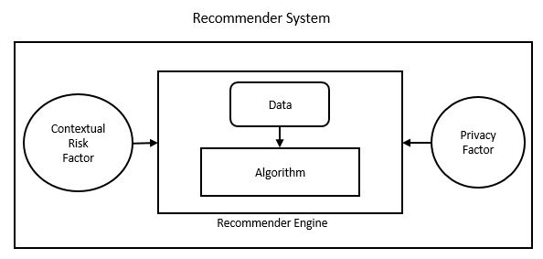

Figure 1 Conceptual Diagram of the Risk-Aware Privacy-Preserving Recommender System

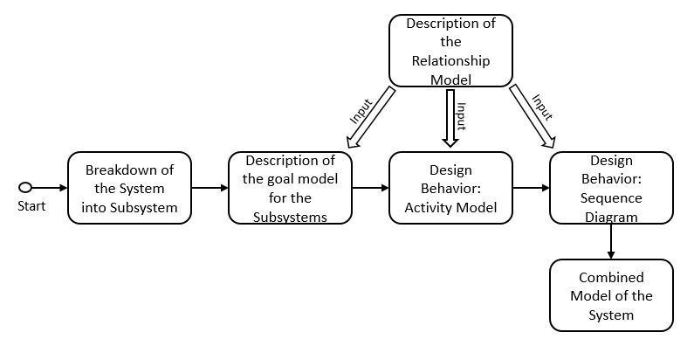

Figure 2 Proposed Steps of the Modeling Approach

In the next step, we provide a goal model for each subsystem within the entire system in order to specify the goal of these subsystems. The agents within these subsystems are described in terms of the roles they perform, the responsibilities they fulfill and the activities performed by these agents in order to achieve the objective of the subsystem. This is achieved partially by the introduction of the relationship model which provides a set of attributes displayed by each agent and their associated relationships in order to accomplish its responsibilities within the subsystem.

We introduce two design behaviors for the next two subsequent steps. These design behaviors help in understanding the system by providing the internal behavior of each subsystem. The first behavior design we discuss is the activity model of the subsystems. It describes the behavior of the subsystem in context of the relationship model discussed previously. The activity models for each subsystem are then combined to form an activity model of the entire RPRS.

The second behavior design which is discussed is the sequence diagrams of the subsystems. The sequence diagrams describe the sequence of events that occur within the subsystems. These sequence diagrams are then combined to form the sequence diagram of the whole RPRS. The behaviors defined by the sequence diagrams are based on the contextual information from a relationship model.

Before going further in the description of the system model, it is indispensable to describe the notations used in this approach, which involve UML modeling techniques. Various types of UML diagrams are used (e.g. activity diagram and sequence models) to provide the system models and to gain understanding of the behavior of the subsystems and the recommender systems as a whole. These diagrams are explained in the following section.

## UML Diagrams

UML stands for Unified Modeling Language and is used in object-oriented software engineering. Although typically used in software engineering, it is a rich language that can be used to model application structures, behavior and even business processes. There are 14 UML diagram types but for the purpose of this thesis, we will be focusing only on activity diagram and the sequence diagrams.

### Activity Diagrams

The basic purposes of activity diagrams is to capture the dynamic behavior of the system by showing the message flow from one activity to another. Activity is a particular operation of the system. Activity diagrams are not only used for visualizing dynamic nature of a system but they are also used to construct the executable system within forward and reverse engineering techniques. A missing element in activity diagrams is the message part: it does not show any message flow from one activity to another. Although activity diagrams bear some similarities to flow charts, they different in that they depict flow such as parallel, concurrent, single and branched flows.

### Sequence Diagrams

UML sequence diagrams are used to represent or model the flow of messages, events and actions between the objects or components of a system. Time is represented in the vertical direction showing the sequence of interactions of the header elements, which are displayed horizontally at the top of the diagram. Sequence Diagrams are used primarily to design, document and validate the architecture, interfaces and logic of the system by describing the sequence of actions that need to be performed to complete a task or scenario. UML sequence diagrams are useful design tools because they provide a dynamic view of the system behavior which can be difficult to extract from static diagrams or specifications. Although UML sequence diagrams are typically used to describe object-oriented software systems, they are also extremely useful as system engineering tools to design system architectures, in business process engineering as process flow diagrams and as message sequence charts for protocol stack design and analysis.

## Goal Model

Goal models for the RSs were introduced in [1]. In this thesis, goal models are used to model subsystems of the RPRS in order to describe the objectives of the subsystems. This is an agent-based model in which the goals of each subsystem is represented diagrammatically and that relies on information provided by a relationship model.

## Multi-agent System Model and System Description

In the proposed approach, we will start by breaking-down the system into subsystems. Each subsystem will be responsible for accomplishing a pre-defined task and will be modeled using agents. We will focus on modeling the goals of the subsystems, the roles of the agents, the activities performed by the agents, and finally the interactions of the agents. Agents possess knowledge that is used to help reach their goals. A subsystem is composed of agents having specific goals that establish what the subsystem intends to accomplish. The achievement of specific goals by the agents within a subsystem allows the entire system to reach its goal when the subsystems are put together.

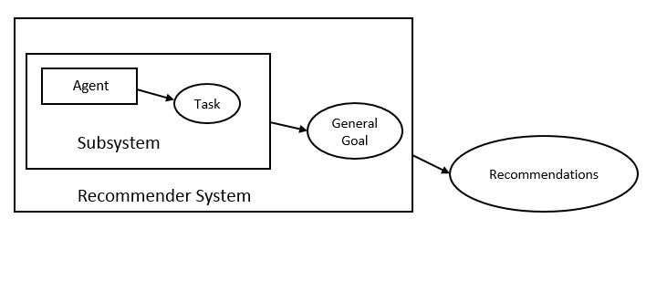

Figure 3 Combining Subsystem Goals to Achieve the System Goal

Specific goals of an agent within a subsystem are reached through the performance of responsibilities that agents have, in which the agent plays roles with a certain degree of autonomy. Responsibilities are exercised through the execution of activities by each individual agent within the subsystem. The set of activities associated with a responsibility are a functional decomposition of it. Roles have skills on one or a set of techniques that support the execution of responsibilities and activities in an effective way within the subsystem. Pre-conditions and post-conditions may need to be satisfied before or after the execution of an activity by each agent within the subsystem. Knowledge can be consumed and produced through the execution of an activity. Skills can be, for instance, the rules of the subsystem that agents know in order to access and structure its information sources. Sometimes, agents have to communicate with other agents to cooperate in the execution of an activity. This approach allows for such communication to take place between the agents within the subsystems.

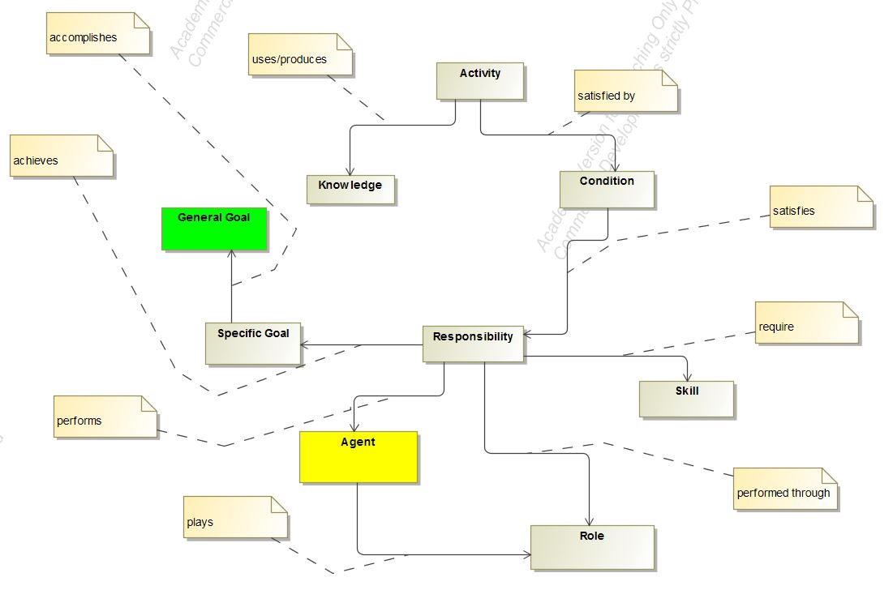

Figure 4 Relationship model for subsystems

## Goal Models for the Subsystems

We will now discuss the goal models of the subsystems which make up a RPRS and also explain the contribution of each subsystem and the agents involved in these subsystems.

### Goal Model: Data Subsystem

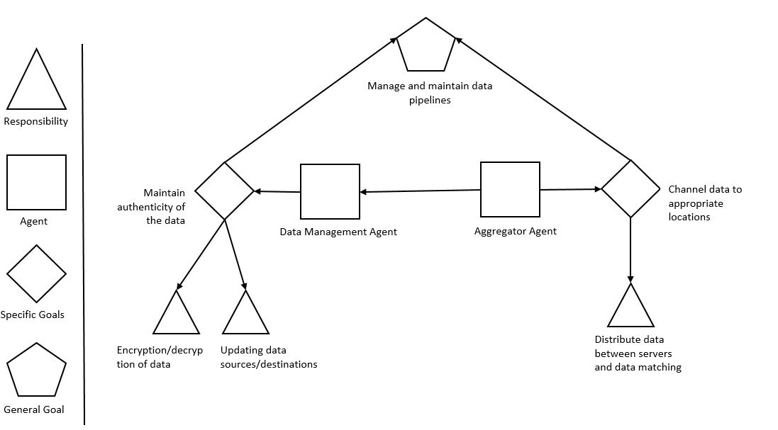

Figure 5 Goal Model for the Data Agent and the Aggregator Agent

Let us start with the data management subsystem. This subsystem is responsible for managing the data inflow and outflow from the RPRS. The subsystem consists of two agents, the Data Manager Agent and the Aggregator Agent. The goal of the Data Manager Agent is to maintain the authenticity of the data by preventing it from getting corrupted and also to manage the piping of data from data sources to the desired destinations. This goal of the data agent is achieved by fulfilling two responsibilities: the responsibility of properly encrypting and decrypting the data from the source and the destination, respectively, and of updating the proper locations of source and destination of the data to be used by the system. The main task of the Aggregator Agent is to channel between the user interface and the various servers to support computation, storage and generating recommendations. This specific goal is achieved by the proper distribution and redistribution of data within the system.

### Goal Model: Privacy Subsystem

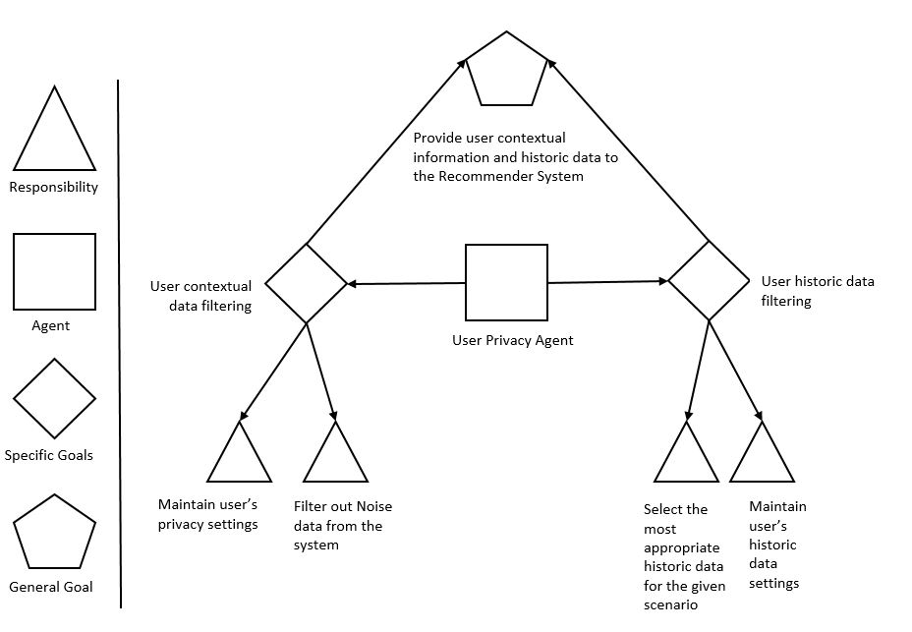

Figure 6 Goal model for the User Privacy Agent

The privacy subsystem manages the privacy aspect of the RPRS. This subsystem relies on the User Privacy Agent to carry out its operations. The main role of this subsystem is to provide user contextual data and the historic data to the computation server in order to generate recommendations for the users. The contextual information about the users can involve user location and social user information, combined with the timing of the information. The user history data refers to the user behavior that is recorded at runtime for analysis purposes.

To understand the role of the privacy subsystem within the RPRS, we need to look at the goals of the User Privacy Agent. The User Privacy Agent performs the task of maintaining user privacy settings for the contextual data and is responsible for filtering out the noise from the contextual data that is obtained from the users. These two responsibilities form the specific goal of filtering and maintaining the users’ contextual privacy information. On the other hand, the User Privacy Agent also fulfills the responsibility of maintaining the access to the users’ historic data based on the settings provided by the users and of selecting the most appropriate data for generating the recommendations after filtering out the noise from of historic data.

### Goal Model: Risk Subsystem

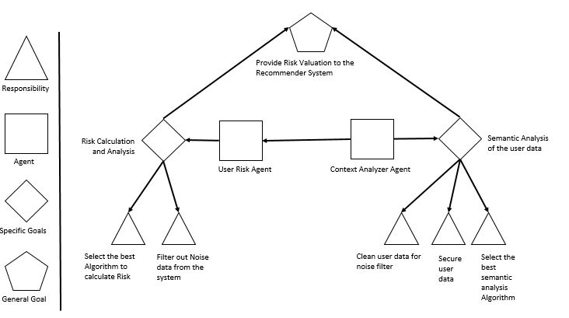

Figure 7 Goal Model for the User Risk Agent and the Context Analyzer Agent

This subsystem handles the contextual risk by getting the contextual information (i.e. time, location and social information) from the user and then feeding this information to the RPRS. It consists of two agents: the Context Analyzer Agent and the User Risk Agent.

The information processed in this step is utilized by the RPRS to produce a more context-aware system not only by providing more relevant information to its users but also by keeping itself aware of the risks associated with disturbing or negatively affecting the user with inconvenient recommendations. This tradeoff between providing relevant recommendations and the associated risks of doing so is the part of the risk calculation through the exploration and exploitation approach [7].

The two agents involved in this subsystem have some specific goals and responsibilities. The responsibility of the User Risk Agent is to ensure that no noise remains in the data and to calculate the risk tradeoff for generating the recommendations and the relevance of these recommendations to the user from the user feedback related to the previously generated recommendations. These two responsibilities help in achieving the goal of carrying out the risk calculation and the analysis of the user data. The Context Analyzer Agent is responsible for cleaning the data obtained from the risk calculation stage, selecting the best possible algorithm for the analysis and securing the generated data to be forwarded as recommendations to the users. This helps in achieving the task of semantic analysis of the user data and, finally, in providing the analysis results as recommendations to the users of the system.

### Combined Goal Model of the System

The combined goal model of the RPRS consists of the aggregation of the individual subsystems and the combination of the goals of the agents within each subsystem in order to achieve the goal of the entire system.

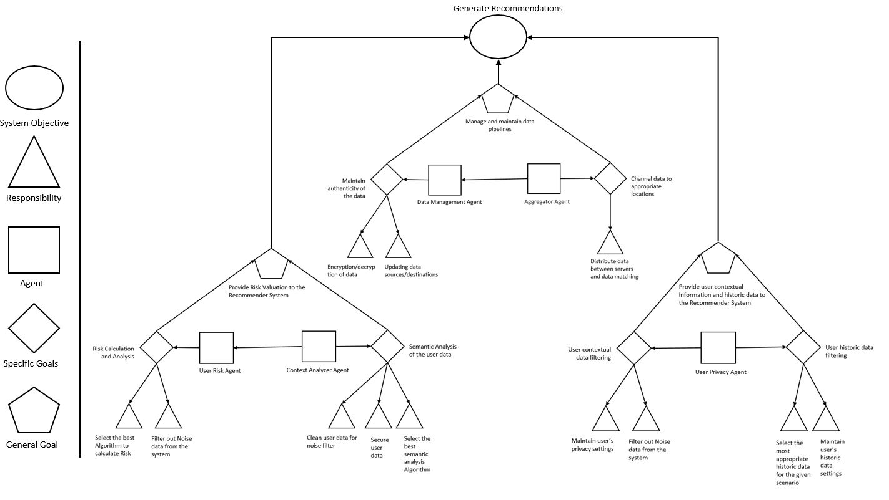

Figure 8 System Goal Model

## Activity Models for the Subsystems

We will now discuss the activity models of the subsystems which make up a RPRS and also in terms of these models the contribution of each subsystem and the agents involved in the respective subsystems.

### Activity Model: Data Subsystem

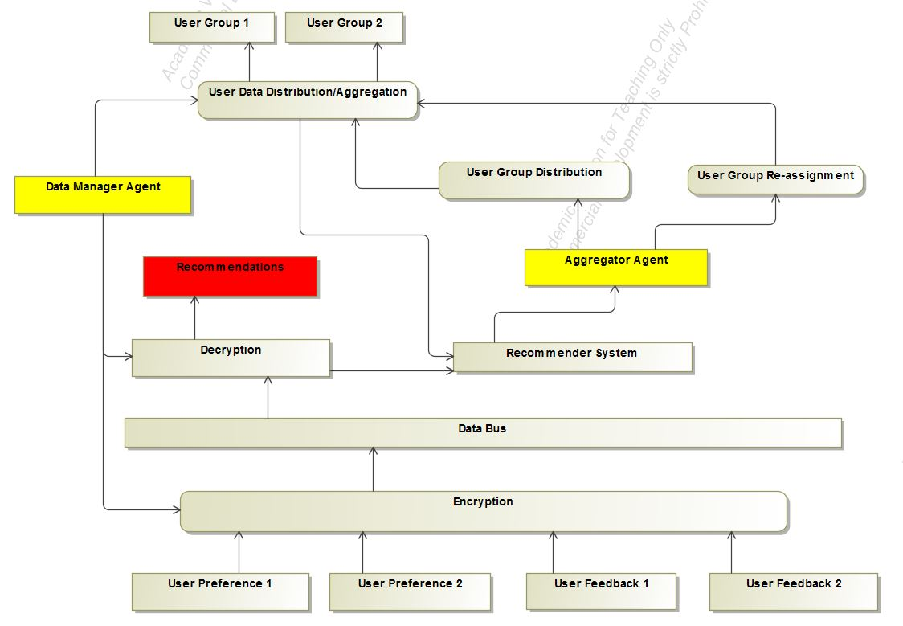

Figure 9 Activity Diagram of Data Subsystem

This subsystem receives data in form of User Preferences and User Feedback. Its multiple elements perform the tasks that brings out the functioning of the data subsystem. The Data Manager Agent uses hashing, SHA, and MD5 checking to ensure data authenticity. An example of an Aggregator Agent is the typical messaging broker used in modern applications. Apache Kafa and RabbitMQ are two types of such message brokers. Together, these two agents fulfill the objective of the Data Subsystem, i.e. the management and maintenance of the data pipelines within the system.

### Activity Model: Privacy Subsystem

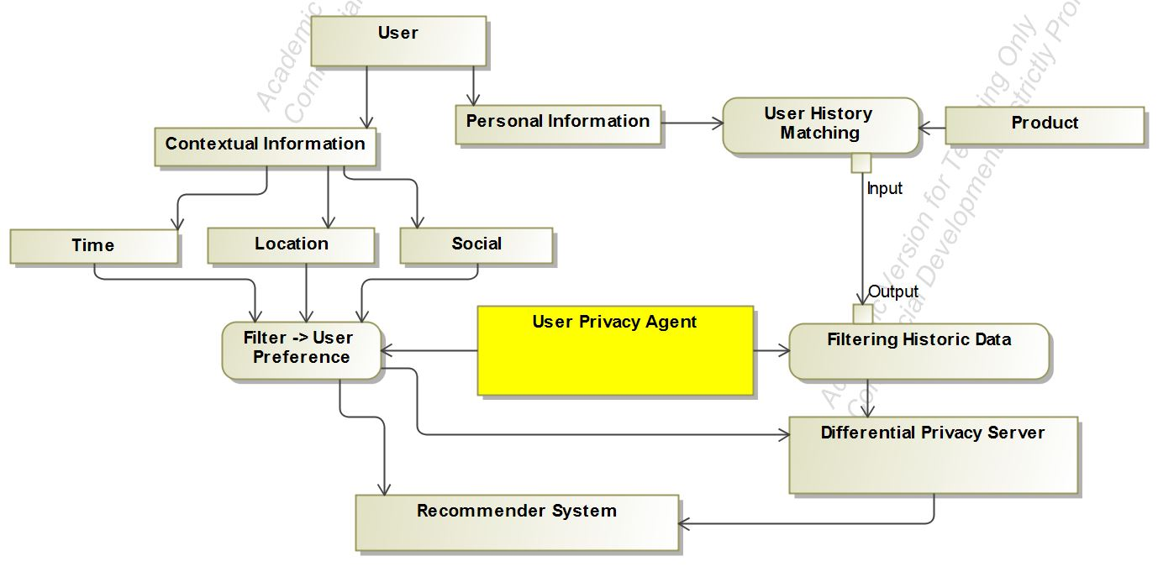

Figure 10 Activity diagram for the User Privacy Subsystem

Within this subsystem the contextual and personal information is extracted from the user and fed into the RPRS. An addition differential privacy server is used to handle the differential privacy aspect of the subsystem. The contextual data from the user along with the historic data of the user provides valuable insights that help to provide quality recommendations to the user.

### Activity Model: Risk Subsystem

The information processed in this step is utilized by the RPRS to generate a more context-aware system by not only providing more relevant information to its users but also keeping itself aware of the risks associated with disturbing or negatively affecting the user with inconvenient recommendations. This tradeoff between providing relevant recommendations and the associated risks is captured in the risk calculation using the exploration and exploitation approach [7].

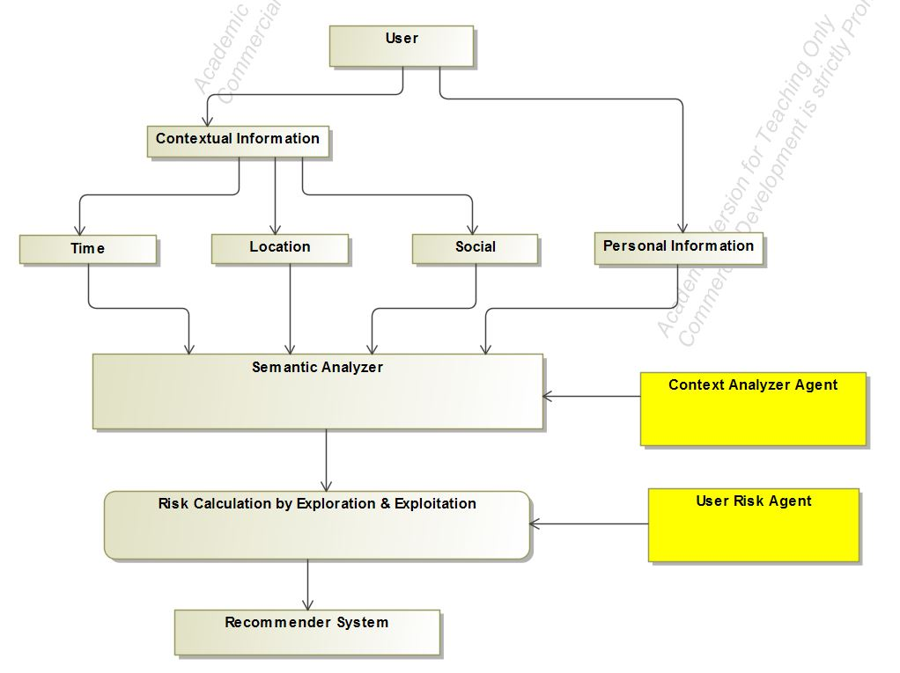

Figure 11 Activity Diagram for the Risk Subsystem

### Combined Activity Model for the System

The combined Activity model of the RPRS consists of the aggregation of the individual subsystems and the combination of the activity diagrams of the individual agents within each subsystem to achieve the goals of the entire system.

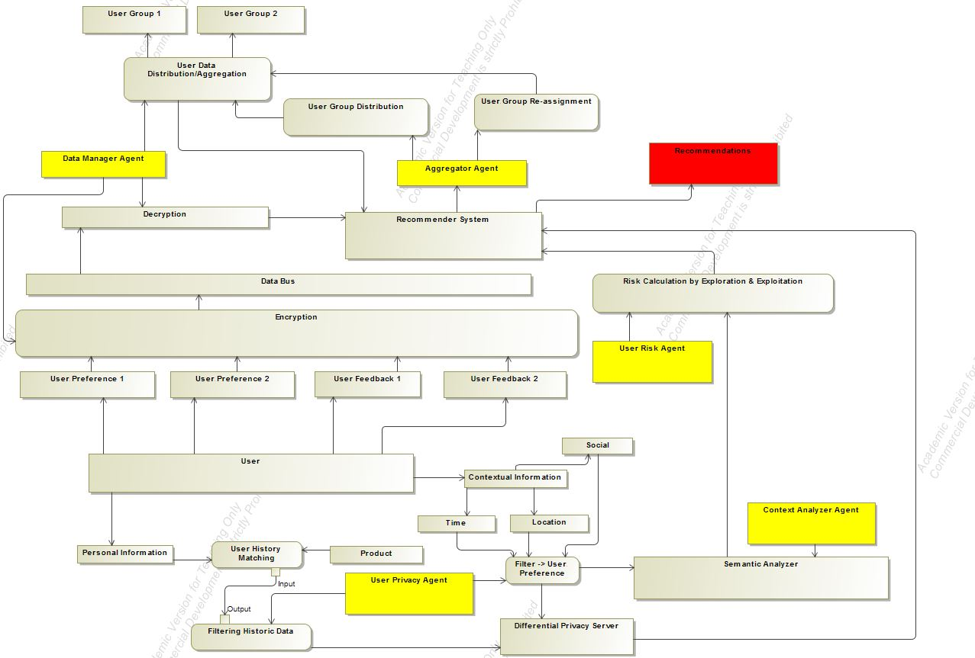

Figure 12 Complete Activity Model of the System

## Sequence Diagrams for the Subsystems

We will now discuss the sequence diagrams of the subsystems involved in the RPRS and also explain the sequence of actions that takes place within each subsystem.

### Sequence Diagrams: Data Subsystem

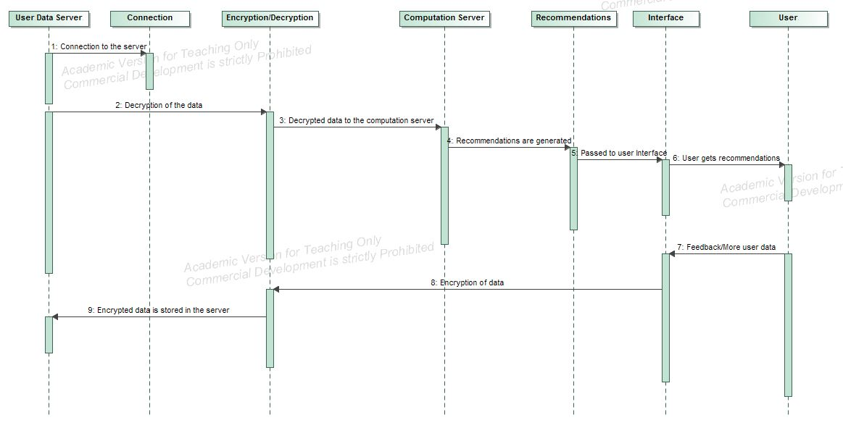

Figure 13 Data Subsystem sequence diagram

The sequence diagram of the data subsystem is provided in Figure 13. In this diagram, a recommendation generation process starts when a connection is established between the user-data database and the computation server where the data to be used is decrypted. This data is then piped to the computation server. After the processing at the communication server, the recommendations are generated and are then forwarded to the user through an interface. Based on the quality of recommendation, the user provides a feedback which is stored in the user-data database. The transfer of data between the servers, including the encryption and the decryption process, is carried out within the data subsystem. These tasks are carried out by the Data Agent and the Aggregator Agent within the data subsystem, and a summarized description of their behavior has been provided in the previous section.

### Sequence Diagram: Privacy Subsystem

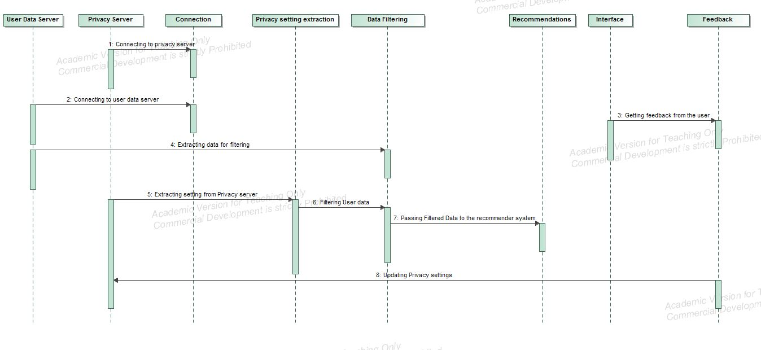

Figure 14 Privacy Subsystem Sequence Diagram

In order to understand the privacy subsystem it is necessary to know the flow of control within this subsystem. The first step involves establishing a connection with the user data server and with the privacy server. This is followed by extracting the user data and the user privacy settings from the server. Once this data has been extracted from the server, it is filtered against the user settings. The user data includes the contextual data (i.e. location, time and social) data as well as the user’s previous behavior patterns obtained while the user interacted with the system. The user is made aware of the data through user controls and is asked permission to utilize his or her data for generating recommendations.

Once the data has been filtered of the noise and against the user settings, it is piped through the computation server to generate the recommendations to the user. After the recommendations have been generated, they are forwarded to the user via a specific interface.

Based on the quality of the recommendations, the user provides a feedback or exhibits certain behavior patterns (e.g. clicks, navigation, dismiss) which indicate the user’s opinion about the quality of the generated recommendations. This feedback data is then encrypted and stored in the user-data database to serve as an input for future computations for recommendation generation.

### Sequence Diagram: Risk Subsystem

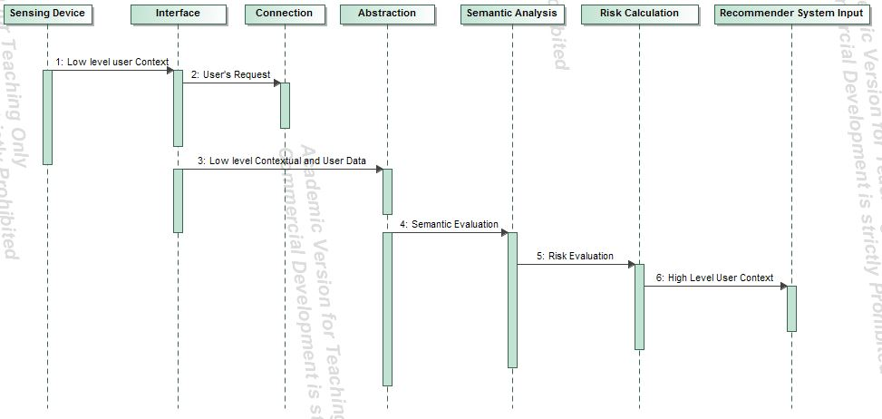

Figure 15 Contextual Risk Subsystem Sequence Diagram

The sequence diagram helps in understanding the steps that take place within the contextual risk subsystem. First, a connection is established with a sensing device at the user’s end, through an interface. After this step, the low-level abstraction of the user’s data is sent to the servers running the semantic analysis. As a result the risk is calculated and based on the value of this parameter the recommendations are forwarded to the user.

### Combined Sequence Diagram

The sequence diagram of the RPRS consists of the combination of the actions taking place within the system to achieve the goals of the entire system.

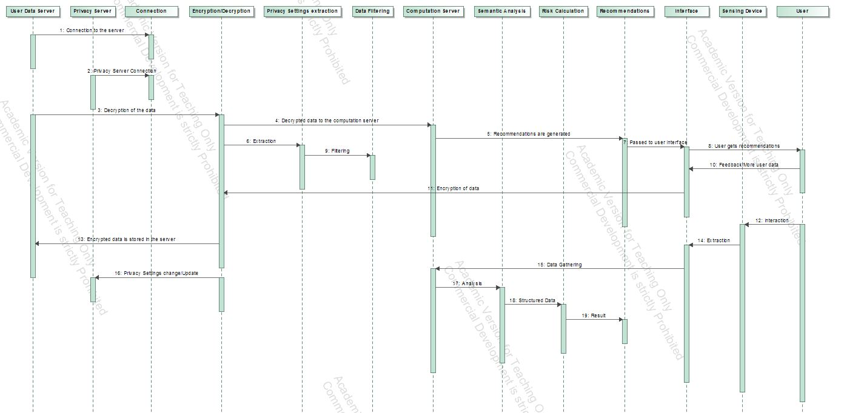

Figure 16 Combined Sequence Diagram

# Case Study: A Job Recommender System

In general, a recommendation system suggests personalized choices from a large set of possible options with the objective of reducing complex decision making. The last decade has witnessed the emergence of a wide variety of job portals offering recommendation services to help their users find employment. Such recommendation systems work based on information filtering techniques and provide information of interest to concerned users. Typically, a recommendation engine, which employs a set of similarity and ranking algorithms, compares the user’s profile to some reference characteristics collected from the job description across multiple jobs posted on the job portal or the user’s social environment, and seeks to predict a set of suitable jobs for the user.

## Problem Description

The main problem is that these recommendation systems do not support privacy-preserving and risk-aware mechanisms. Therefore, in this chapter, a multi-agent model based on the RPRS model is provide to address this gap.

In order to provide a specific RPRS model to support job recommendations, information about how job recommendations work conceptually and from a processing viewpoint are needed so that goal diagrams, activity diagrams and sequence diagrams are produce as part of the specific RPRS design model. After reviewing the literature on job recommendation systems, two of them were found that provide to some extent the required information. A first paper describes the system conceptually and includes information such as the types of data used, and the user’s actions, objectives and interactions [9]. A second paper focuses more on the data processing mechanisms and provide more information on how the data is processed and on how the filtering process works [10]. In summary, the first paper provides the information needed for the generation of the RPRS goal models, and the second paper, provides the information required to produce the RPRS activity and sequence diagrams.

We will now describe the job recommendation systems proposed in [9] (in 2013) and in [10] (in 2016). In [9], Guo and Alamudun describe a hybrid RS for job seeking and recruiting websites. This hybrid RS exploits the job and user profiles and the actions undertaken by users in order to generate personalized recommendations of candidates and jobs. The data collected from the website is modeled using a directed, weighted, and multi-relational graph, and the 3A ranking algorithm [16] is exploited to rank items according to their relevance to the target user. The authors also provide a preliminary evaluation based on simulated data and production data from a job hunting website in Switzerland. The approach presented in the paper involves modelling the entity and interaction-based relations by building a graph consisting of these entities and computing a ranking from this graph.

Table 1 Interaction Entities proposed in [9]

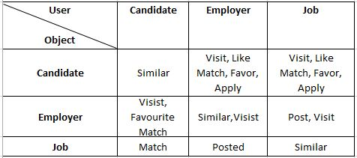

The technique proposed by the authors involves interaction-based relations. The first of these relations is the ‘POST’ relation, described as a bidirectional relation between the employer and its jobs which comes into play while comparing two similar jobs posted by different employers. The second relationship that is described in the paper is ‘APPLY’, which signals that a candidate is interested in the job. This signal leads the candidate to other jobs similar to the ones he or she applied for. The third relationship that is described in the paper is ‘FAVOURITE’, through which a user can add an entity into her or his ‘favorite list’. This is also a strong and explicit signal of interest. The fourth relationship, the ‘LIKE’ relationship, is similar to the previous one, but differs in this case in that users may not revisit the items they liked. In the paper, the ‘LIKE’ relationship is considered as an explicit feedback, but is weaker than ‘APPLY’ or ‘FAVOURITE’. The final relationship signal that is discussed in the paper is ‘VISIT’, which is animplicit feedback about the user’s interest.

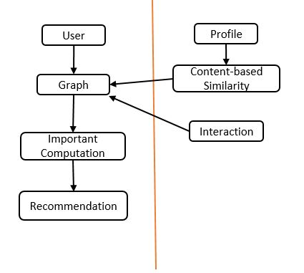

Figure 17 Graph Framework described in [9]

A pipelined hybrid recommendation approach is described and implemented in [9], which provides the results of content-based similarity as an input into a relation-based algorithm after normalization. Figure 12 shows a conceptual view of the recommendation graph framework described in the paper for generating personalized job recommendations.

In contrast, in [10], Yao, Helou and Gillet describe a resume matching system which intelligently extracts the qualifications and experience of a job seeker directly from his or her résume, as well as relevant information about the qualifications and experience requirements of the job postings. Using a novel statistical similarity index, the resume matching system returns results that are more relevant to the job seekers’ experience, and academic and technical qualifications, with minimal active user input.

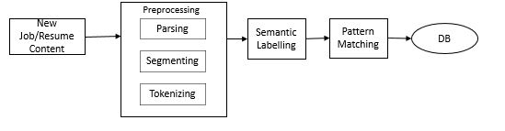

Figure 18 Resume Matching System described in [10]

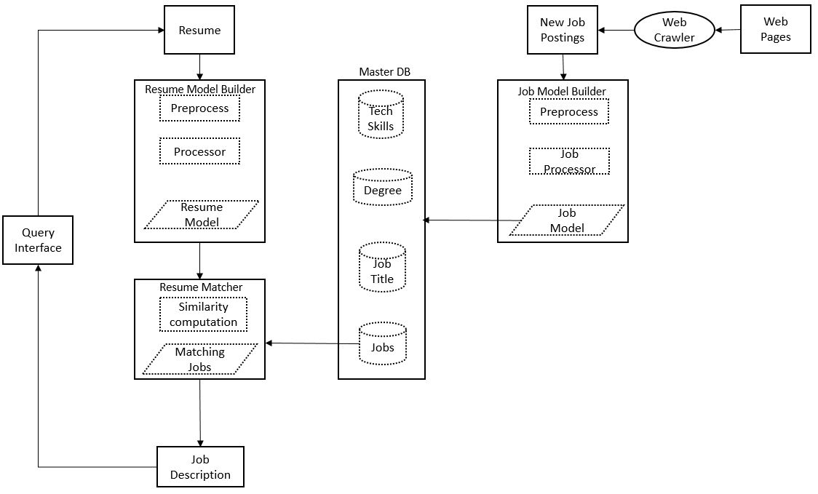

Figure 19 Information Processing Pipeline described in [10]

## Approach

In this section, the RPRS modeling approach provided in the previous section is applied to the domain of job recommender systems. As a result, job recommender systems that support both privacy-preserving and risk-aware mechanisms are modeled using the RPRS approach. The construction of the design models are based on both the conceptual and processing-related information described in papers [9] and [10].

The first step towards producing the design models is to determine the conceptual and processing features of the described job recommender systems, and then laying out these features in terms of the discussed approach. This involves focusing on the multi-agent aspects of the system,breaking the system down into the three RPRS subsystems, providing the goal, activity and sequence diagrams related to each subsystem, and, finally, combining the individual subsystem models to obtain the entire job-oriented RPRS system models.

## Goal Models of the Subsystems

This subsystem has two responsibilities. The first responsibility is to encrypt the data obtained from the employers and the candidates and store this data in a database,making it available for use by fetching it from the system and decrypting it. The second responsibility is not only to maintain the the pipelines of candidate’s data and the employer’s data within the system but also to help in anonymizing the data by piping it through the differential privacy servers. These responsibilities gives rise to two goals of the system, i.e. to maintain the authenticity of the data and to channel the data through the system while protecting it as well. These tasks are performed by the Data Management Agent and the Aggregator Agent. The end goal of this subsystem is to manage and maintain the subsystem data pipelines. There are multiple supporting software systems used within this subsystem. Some examples of such systems are messaging brokers such as Apache KAFKA and RabbitMQ, which work within a distributed system framework (e.g. the Hadoop Distributed File Fystem).

### Goal Model: Data Subsystem

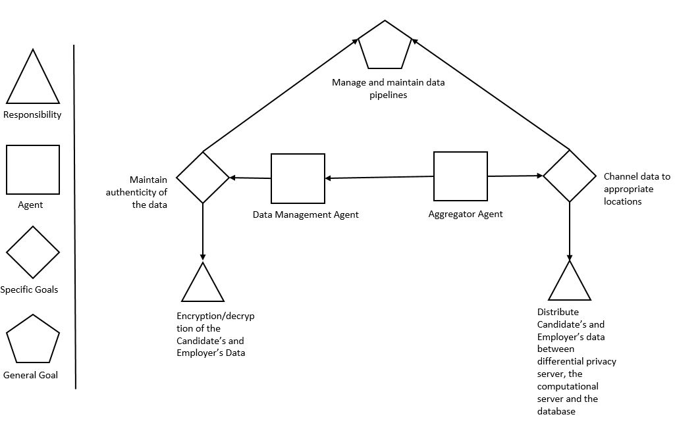

Figure 20 Goal Model: Data Subsystem

### Goal Model: Privacy Subsystem

The privacy subsystem has a User Privacy Agent. The goals of the User Privacy Agent involve contextual and historic data filtering and selectionn, which are carried out by fulfilling some responsibilities. The first responsibility is to maintain the privacy settings of the employers and the candidate’s data in the system. This isfollowed by the responsibility of filtering out contextual data based on the privacy settings. The third responsibility is to maintain the historic data setting for both types of the users and then, as a fourth responsibility, to filter out the historic data based on these settings. These goals and responsibilities help in achieving the goal of the privacy subsystem, i.e. to provide user contextual and historic data filtering to the RPRS.

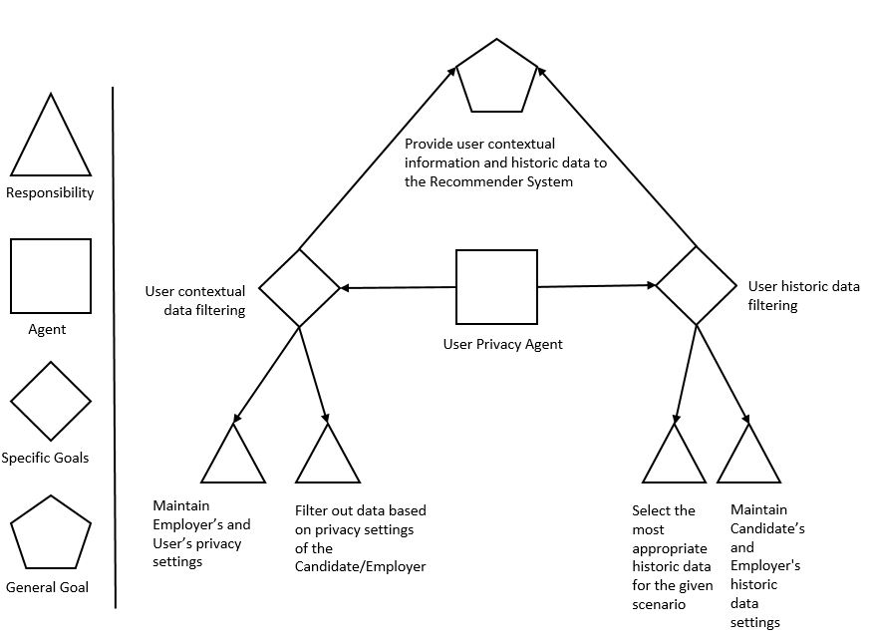

Figure 21 Goal Model: Privacy Subsystem

### Goal Model: Risk Subsystem

The risk subsystem has two agents, the User Risk Agent and the Context Analyzer Agent. The goal of the User Risk Agent is to calculate the risk factor for contextual data. The goal of the Context Analyzer is to carry out the semantic analysis of the user data. These goals help in fulfilling the responsibilities associated with these agents. These responsibilities are calculating the risk using a candidate’s profile information and an employer’s job description, extracting relevant information from the candidate’s profile and the job description, and then using an anlysis /matching algorithm to deal with the current scenario. The overall objective of the subsystem is to provide risk evaluation to the RPRS.

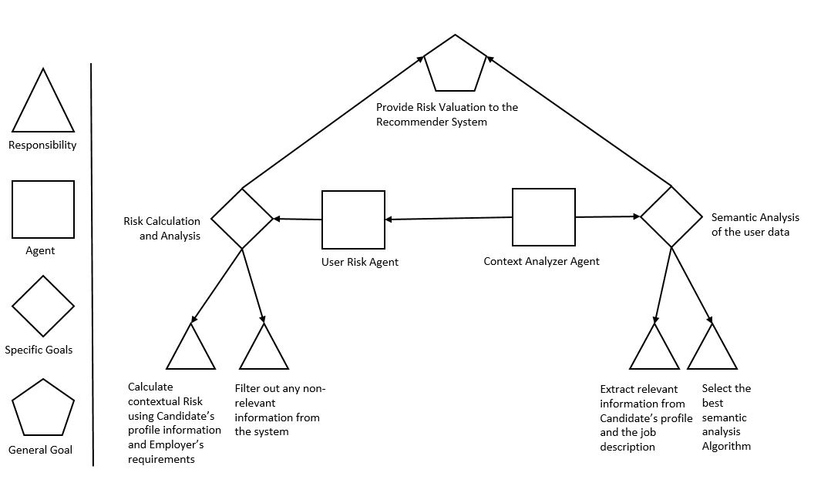

Figure 22 Goal Model: Risk Subsystem

### Combined Goal Model of the System

The combined goal model of the job-oriented RPRS consists of the composition of the individual subsystems and the combination of the goals of the agents working within each subsystem to achieve the goal of the entire system. The combined goals of the risk subsystem, the data subsystem and the privacy subsystem in the recommender system accomplishes the goal of the entire system by generating recommendations.

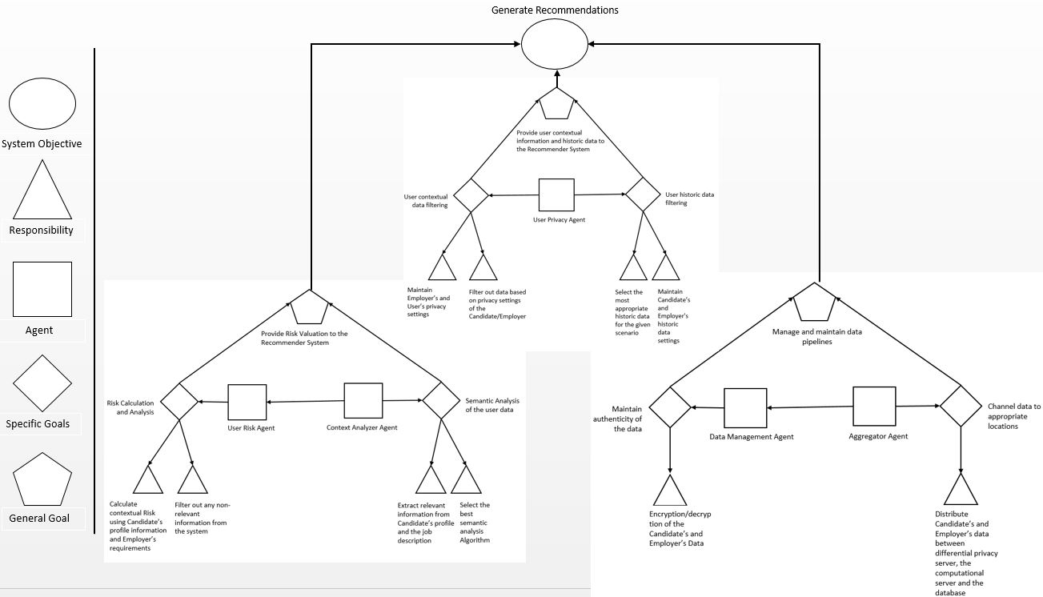

Figure 23 Combined Goal Model of the Job Recommender System

## Activity Models of the Subsystems

### Activity Model: Data Subsystem

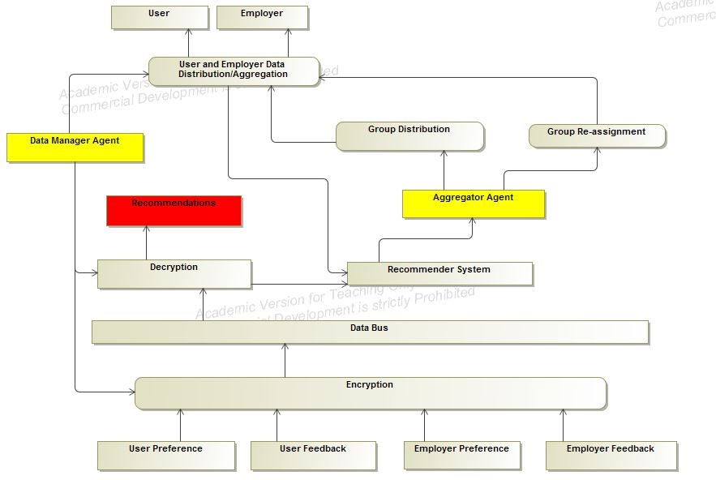

Figure 24 Data Agents for Job Recommendations

The data subsystem manages the data flow within the RPRS. It manages the data from the candidate and the employer as well as the subsequent distribution of this data between different channels. It also filters the noise of the data before encryption/decryption. This is one of the most important subsystems and probably serves as the backbone of the entire system.

### Activity Model: Risk Subsystem

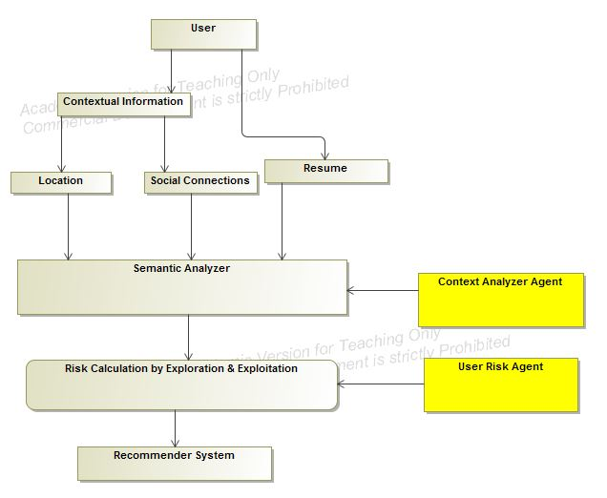

Figure 25 Risk Agent for job recommender

The contextual risk subsystem, as described previously, provides the risk calculation so that the RPRS can generate suitable recommendations. The contextual information in the job recommender system is the location of the candidate and the employer and his or her the social connections. As described in previous sections, this subsystem consists of two agents: the Context Analyzer Agent and the User Risk Agent. The information processed in this step is utilized by the RPRS to generate a more context-aware system by not only providing more relevant information to its users but also by keeping itself aware of the risks associated with disturbing or negatively affecting the user with inconvenient recommendations. This tradeoff between providing relevant recommendations and the incurring risks is the part of the risk calculation using the exploration and exploitation approach [7].

### Activity Model: Privacy Subsystem

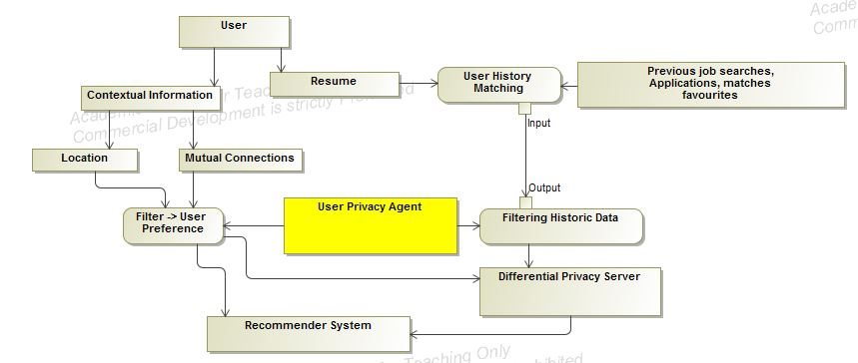

Figure 26 User Privacy Agent for Job recommendations

Figure 26 present the activity model diagram of the RPRS privacy subsystem. Within this subsystem the contextual and resume information is extracted from the user and fed into the RPRS. A differential privacy server manages the data anonymization within this subsystem by implementing privacy differential algorithms. The main role of this subsystem is to provide thes contextual data, personal information and the historic data ( i.e. favorites, visits and applications) of the user to the computation server in order to generate the user recommendations. The user history data refers to the user’s behavior that is recorded for analysis at runtime. The contextual data along with the historic data of the user presents valuable insights in order to provide quality recommendations.

### Combined Activity Model of the system

The combined activity model of the job-oriented RPRS consists of the combination of the activity diagrams related to the agents working within each subsystem to achieve the goal of the entire system.

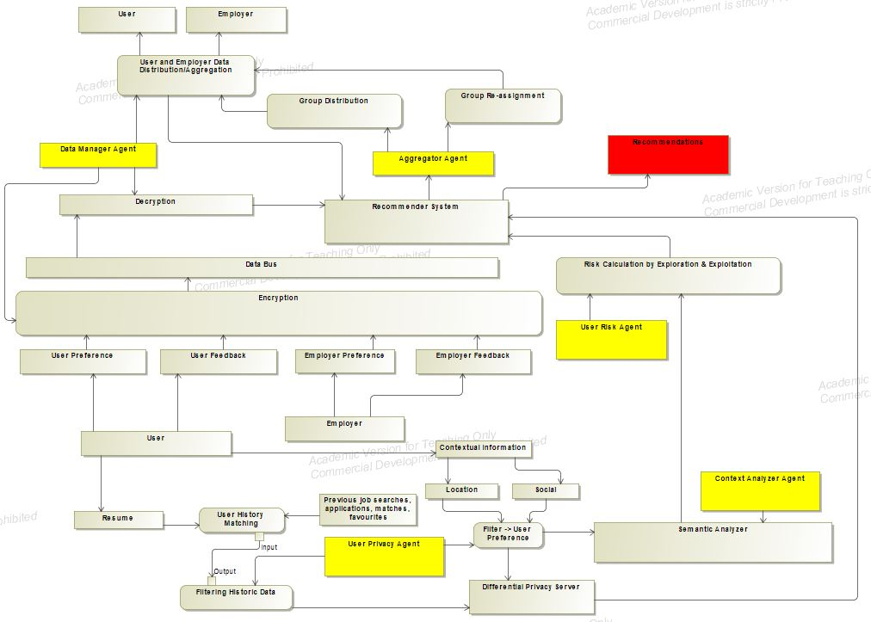

Figure 27 Job Recommender System Model

## Sequence Diagram for the Subsystems

### Sequence Diagram: Data Subsystem

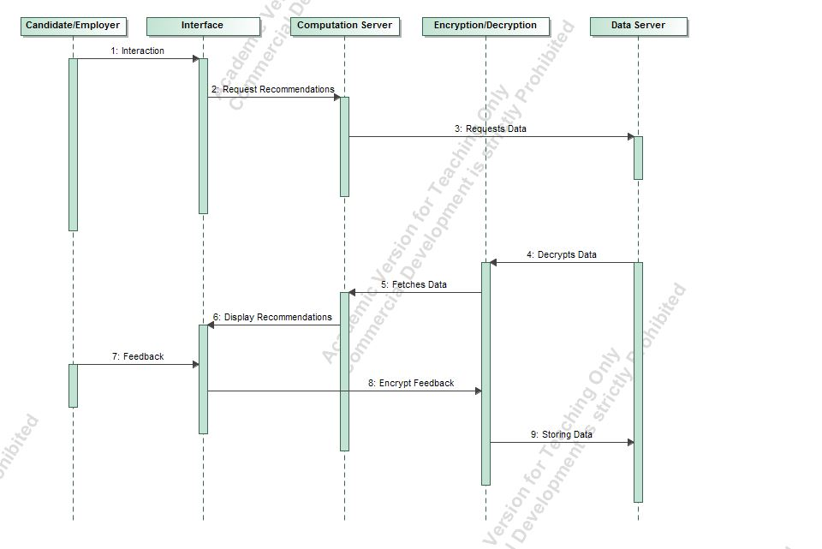

Figure 28 Sequence Diagram: Data Subsystem

The sequence diagram of the data subsystem is provided in Figure 28. The process within the data subsystem is initiated when the candidate interacts with the system interface. This interface can be a website or a mobile device. The data from the interface is sent to the computation server from where the recommendations are generated. The data is then encrypted and stored in the data server. The recommendations are forwarded to the interface and the feedback is obtained in order to enhance the recommendations. This data is again stored in the database.

### Sequence Diagram: Risk Subsystem

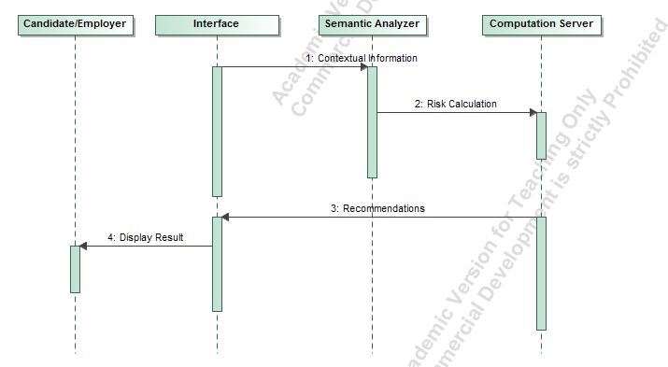

Figure 29 Sequence Diagram: Risk Subsystem

The sequence diagram of the risk subsystem is shown in Figure 29. The contextual information is fed into the computation server through the interface after being processed by the semantic analyzer. Based on the algorithms on the computation server, the recommendations are generated and forwarded to the interface to be displayed to the users.

### Sequence Diagram: Privacy Subsystem

The sequence diagram of the privacy subsystem, which represents the sequence of interactions within the system that deal with filtering, is presented in Figure 30. The contextual data is first passed through a privacy filter before travelling to the database or the server. The filtered data is recovered from the database for the purpose of generating the recommendations. This data passes through a differential privacy server to enforce anonymity. Then, the data is processed by the recommendation server to generate recommendations to be provided to the users through a system interface.

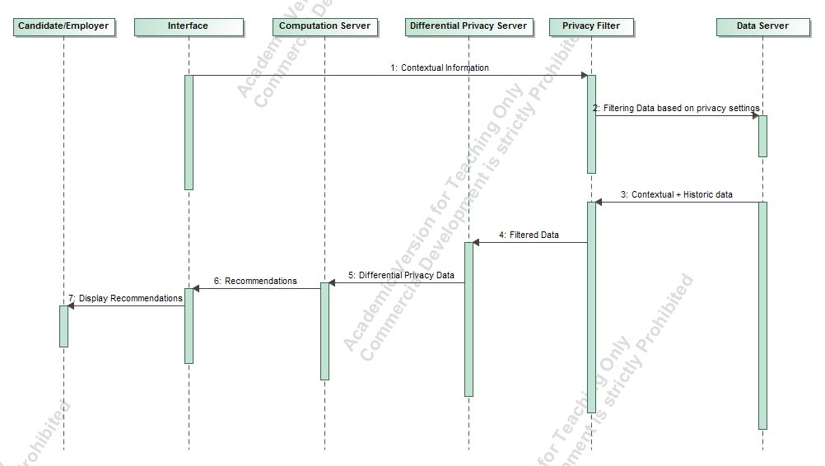

Figure 30 Sequence Diagram: Privacy Subsystem

### Combined Sequence Diagram of the System

The sequence diagram of the job-oreinted RPRS consists of the combination of the actions taking place within each subsystem to achieve the goals of the entire system is provided in Figure 21.

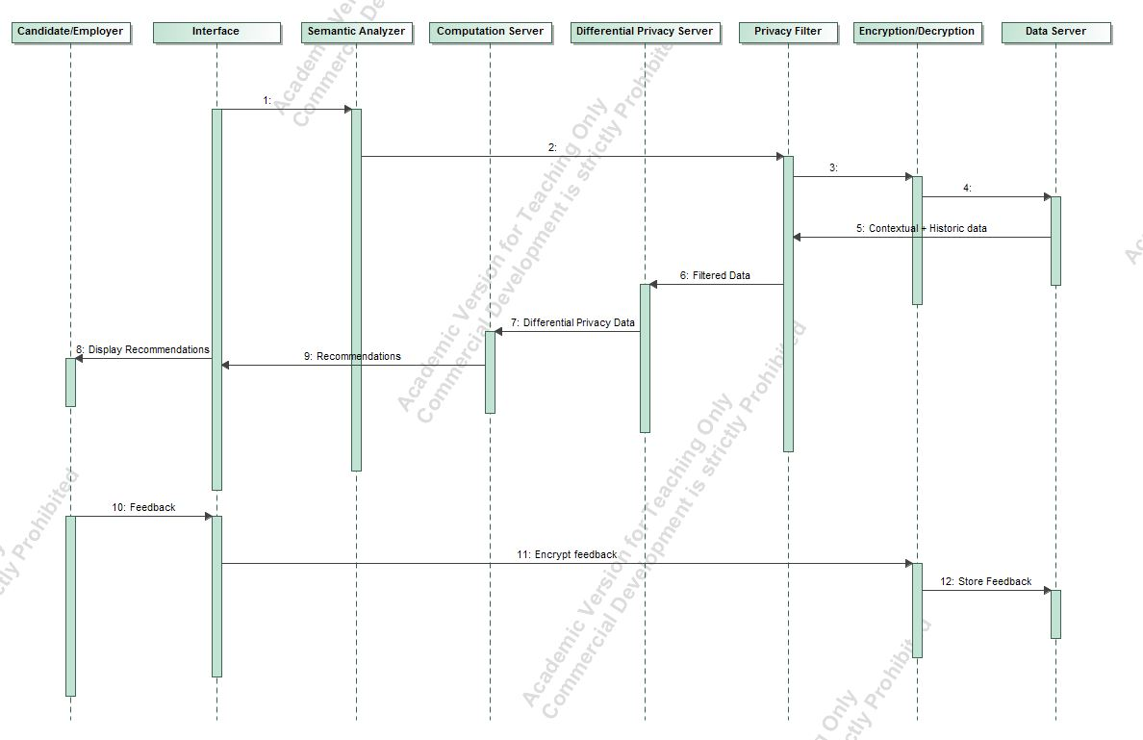

Figure 31 Combined Sequence Diagram of the Job Recommender System

# Conclusions and Future Work

## Conclusions

We have now show how the proposed approach provides a broader aspect to the system description and a prospect for evaluation of a Recommender System across multiple application areas. We have also shown that this approach utilizes multi-agent system description in a sense that the designers of the Recommender Systems can focus on individual units by breaking the Recommender System into small individual units enables fast and fault tolerant development of the system. It also enables the designers of the Recommender System to be aware of the each of the small objectives that must be accomplished by the each individual units in order to fulfil the objective of the entire system. This high level approach to describe the system is helpful for domain experts to gain valuable knowledge of a Recommender System, operational in a particular application area in a short period of time.

## Future Work

The multi-agent approach can be extended in the future to include other domains of Recommender System such as news recommender or restraint Recommender System. The system can be represented with other UML models like a state model or class diagram. Frameworks can be implemented to use domain specific language to generate class structure for the Recommender System or can be used to generate code. But most importantly, a model verification method, possibly through experimentation can be used to enhance the model.

# Appendix

This section discusses a preliminary approach for evaluating recommender systems based on dimensions involving two scopes, namely the privacy scope and the contextual risk scope. Traditionally, recommender systems are evaluated based on the accuracy of the results produced by the system but, using this approach, recommender systems could, in principle, be evaluated based on features related to privacy and risk.

### Privacy scope of a system

We introduce a coordinate system to describe the state of a Recommender System in terms of the privacy it offers to the user. It is a 3 dimensional representation with each of the mutually independent axis representing the state of the Recommender System. On one of the axis we have a feature which states the size of the audience to which recommendations will be disclosed using data of a participant in the system i.e. if a user allows the system to use his/her data, then how many people other than the user, will be able to receive the recommendation based on that user’s data in a collaborative environment. The extent of usage axis refers to the amount of information that is extracted from each participant in the system. The third and the final axis represents the duration for which the data remains in the system.

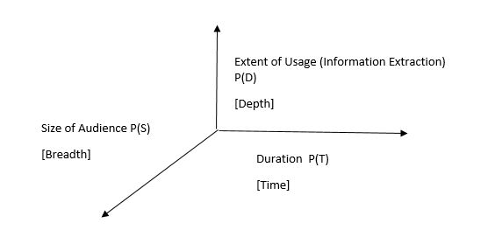

Figure 32 Privacy Scope

### Contextual risk scope

This section describe the contextual risk scope of a Recommender System. Similar to the description of the privacy scope, the contextual scope is also a three dimensional representation for the purpose of characterizing Recommender Systems. The three axis of the contextual risk scope are mutually independent. The first axis is the similarity axis denoted of the R(s) notation. It is defined as the extent of similarity between the user and the user group into which the user is placed. The second axis denoted by R(C) is the axis of intention and is described as the extent of awareness of the user’s intention by the system. This axis is conceptual i.e. the valuation provided by the Recommender System based on this metric is highly based on experimentation results. The third and the last axis is the axis of duration and is the measure of how long the contextual data will be stored by the system.

This axis is represented by the notation R(T) and may also represent the period of data used by the Recommender System for the purpose of generating recommendations.

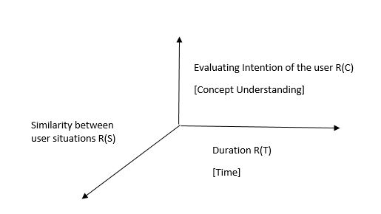

Figure 33 Contextual Risk Scope

### Explanation of a multidimensional system diagram

We are now in position to describe a Recommender System in a five dimensional representation. Parallel coordinates is a visualization technique used to plot individual data elements across many dimensions. Each of the dimensions corresponds to a vertical axis and each data element is displayed as a series of connected points along the dimensions/axes. Thus, a Recommender System can be described as a series of connected points along the diagram, intersecting at these axis/dimensions.

Since it is a start of a research for visualizing a Recommender System by these axis, there is the dearth of data for exactly calculating the exact value of a particular recommendation. Hence, through this thesis, an approximate representation is used for visualizing a Recommender System by using this method.

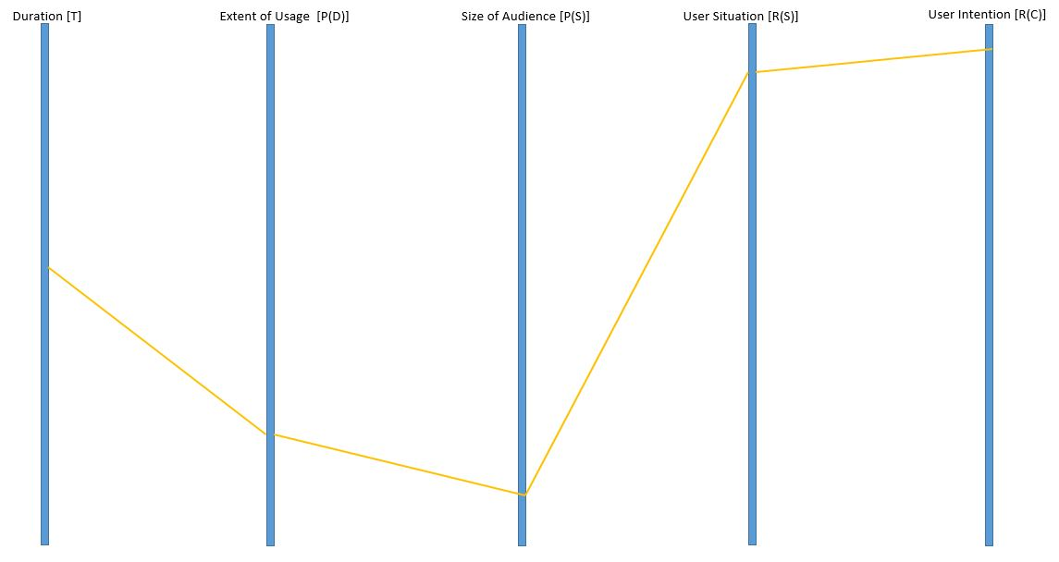

Figure 34 Dimensional Plot of a Recommender System

Table 2 General Dimensional Analysis of various Algorithms

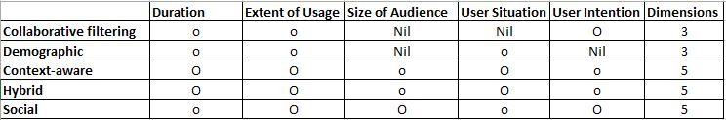

In the above table an approximate idea has been provided about the possible dimensions that can be used by the Recommender System using different methodologies, architecture and algorithms. The conclusion listed above is a result of review of current text in the area of Recommender Systems.

The extent of utilization/valuation of different metrics on the five dimensional recommendations is being distinguished in the table by using two different notations. The ‘O’ symbol is used where the utilization/valuation on a particular dimension is conceptually high and the ‘o’ notation is used for those system whose utilization/valuation on a particular dimension is relatively low.

### Extension of the evaluation method to the case study

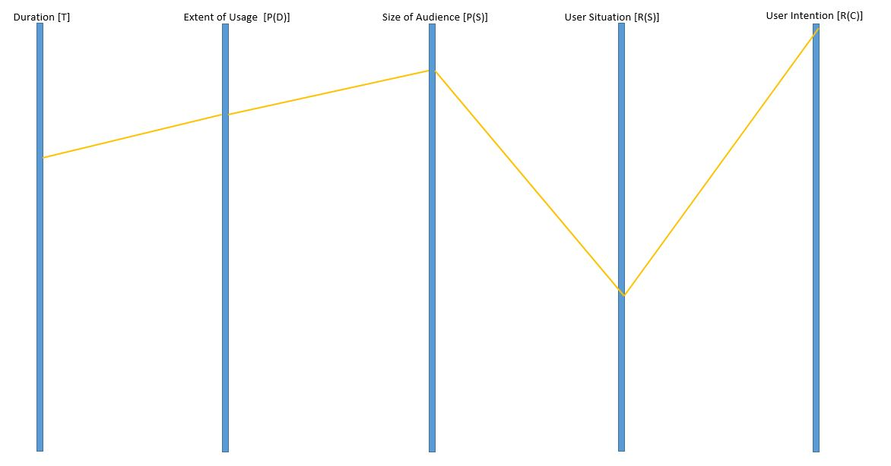

Figure 35 Multidimensional description of the Job Recommender System

The five dimensional representation of the Recommender System, described in the previous section is now provided. The duration dimension is described as the period of time for which the job data and the resume were kept in the system and duration of chunk of historic data being used for generating recommendation. It is evident from the papers that this factor is on the higher side.

The next factor to consider is the extent of usage of user data by the Recommender System. Since, large extent of user’s personal data is available to the system in form of resume and user’s actions (like, favorite, apply etc.) were being recorded by the system, the extent of data usage is supposed to be at high levels.

The size of audience in this scenario is also a big factor on the higher side. It can be considered to be higher than the valuation/utilization of the two previously discussed dimension because the data is available to many organizations and users that are accessing the system for their job search and getting recommendations from the system.

Since, most of the user data that is obtained, stored and utilized by the system is in static form involving personal information of both the job applicant and the employers, the value of user situation awareness by the Recommender System is on the lower side.

Finally, the user intention factor of the system is at a high level in the graph because of the fact that the main objective of the system is to obtain meaningful job recommendation to the user and being aware of the user’s intention to display better results.

The future work can be focused on either reducing the number of dimensions from five, in order to better represent the system by finding relationship or equations between the existing dimensions. More dimensions can be added into the system by figuring out more parameter for the evaluation of the Recommender System across multiple platforms.

Quantitative analysis can be performed over the Recommender Systems across multiple dimension in order to find the optimal values for each of the existing dimension that the Recommender System must satisfy. These optimal value can be served as the threshold values for these dimensions and the Recommender Systems can be characterized based on these threshold values. The characterization of the Recommender System could lead to a standard for evaluation for these systems contrary to the existent metric i.e. the accuracy and predictability.

This metric of Recommender System evaluation will be more efficient and fair because sample used for predicting the accuracy can be colluded or the testing and validation set for determine the accuracy of the Recommender System might not be applicable in the real world applications.

Bibliography

[1] Girardi, Rosario, and Leandro Balby Marinho. "A model of Recommender Systems based on usage mining and collaborative filtering." *Requirements Engineering* 12.1 (2007): 23-40.

[2] Rasmussen, Curtis, and Rozita Dara. "Recommender Systems for Privacy Management: A Framework." *High-Assurance Systems Engineering (HASE), 2014 IEEE 15th International Symposium on*. IEEE, 2014.

[3] Sankar, C. Prem, R. Vidyaraj, and K. Satheesh Kumar. "Trust Based Stock Recommendation System–A Social Network Analysis Approach." *Procedia Computer Science* 46 (2015): 299-305.

[4] Zhao, Vicky Na, Melody Moh, and Teng-Sheng Moh. "Contextual-Aware Hybrid Recommender System for Mixed Cold-Start Problems in Privacy Protection." *Big Data Security on Cloud (BigDataSecurity), IEEE International Conference on High Performance and Smart Computing (HPSC), and IEEE International Conference on Intelligent Data and Security (IDS), 2016 IEEE 2nd International Conference on*. IEEE, 2016.

[5] Elmisery, Ahmed M., Seungmin Rho, and Dmitri Botvich. "Collaborative privacy framework for minimizing privacy risks in an IPTV social recommender service." *Multimedia Tools and Applications* 75.22 (2016): 14927-14957.

[6] Ma, Xindi, et al. "APPLET: a privacy-preserving framework for location-aware Recommender System." *Science China Information Sciences* 60.9 (2017): 092101.

[7] Bouneffouf, Djallel. *DRARS, A Dynamic Risk-Aware Recommender System*. Diss. Institut National des Télécommunications, 2013.

[8] Wang, Zhibo, et al. "Friendbook: a semantic-based friend recommendation system for social networks." *IEEE Transactions on Mobile Computing* 14.3 (2015): 538-551.

[9] Guo, Shiqiang, Folami Alamudun, and Tracy Hammond. "RésuMatcher: A personalized résumé-job matching system." *Expert Systems with Applications* 60 (2016): 169-182.

[10] Lu, Yao, Sandy El Helou, and Denis Gillet. "A Recommender System for job seeking and recruiting website." *Proceedings of the 22nd International Conference on World Wide Web*. ACM, 2013.

[11] McSherry, Frank, and Ilya Mironov. "Differentially private Recommender Systems: building privacy into the net." *Proceedings of the 15th ACM SIGKDD international conference on Knowledge discovery and data mining*. ACM, 2009.

[12] Shokri, Reza, et al. "Preserving privacy in collaborative filtering through distributed aggregation of offline profiles." *Proceedings of the third ACM conference on Recommender Systems*. ACM, 2009.

[13] Shang, Shang, et al. "Beyond personalization and anonymity: Towards a group-based Recommender System." *Proceedings of the 29th Annual ACM Symposium on Applied Computing*. ACM, 2014.

[14] Zhang, Bo, Na Wang, and Hongxia Jin. "Privacy concerns in online Recommender Systems: influences of control and user data input." *Symposium on Usable Privacy and Security (SOUPS)*. 2014.

[15] Zimmermann, Thomas, and Christian Bird. "Collaborative software development in ten years: Diversity, tools, and remix culture." *Proceedings of the Workshop on The Future of Collaborative Software Development*. 2012.

[16] El Helou, Sandy, et al. "The 3A contextual ranking system: simultaneously recommending actors, assets, and group activities." *Proceedings of the third ACM conference on Recommender Systems*. ACM, 2009.

[17] Adomavicius, Gediminas, and Alexander Tuzhilin. "Toward the next generation of Recommender Systems: A survey of the state-of-the-art and possible extensions." *IEEE transactions on knowledge and data engineering* 17.6 (2005): 734-749.

[18] Beel, Joeran, et al. "Research-paper Recommender Systems: a literature survey." *International Journal on Digital Libraries* 17.4 (2016): 305-338.

[19] Jeckmans, Arjan JP, et al. "Privacy in Recommender Systems." *Social media retrieval*. Springer London, 2013. 263-281.

[20] Jafarkarimi, Hosein, Alex Tze Hiang Sim, and Robab Saadatdoost. "A naive recommendation model for large databases." *International Journal of Information and Education Technology* 2.3 (2012): 216.

[21] Dey, Anind K. "Understanding and using context." *Personal and ubiquitous computing* 5.1 (2001): 4-7.

[22] Melville, Prem, and Vikas Sindhwani. "Recommender Systems." *Encyclopedia of machine learning*. Springer US, 2011. 829-838.

[23] Mooney, Raymond J., and Loriene Roy. "Content-based book recommending using learning for text categorization." *Proceedings of the fifth ACM conference on Digital libraries*. ACM, 2000.

[24] Grudin, Jonathan. "Partitioning digital worlds: focal and peripheral awareness in multiple monitor use." *Proceedings of the SIGCHI conference on Human factors in computing systems*. ACM, 2001.

[25] Kang, Jerry. "Information privacy in cyberspace transactions." *Stanford Law Review* (1998): 1193-1294.

[26] Palen, Leysia, and Paul Dourish. "Unpacking privacy for a networked world." *Proceedings of the SIGCHI conference on Human factors in computing systems*. ACM, 2003.

[27] Palen, Leysia, and Paul Dourish. "Unpacking privacy for a networked world." *Proceedings of the SIGCHI conference on Human factors in computing systems*. ACM, 2003.

[28] Gross, Ralph, and Alessandro Acquisti. "Information revelation and privacy in online social networks." *Proceedings of the 2005 ACM workshop on Privacy in the electronic society*. ACM, 2005.

[29] Tufekci, Zeynep. "Can you see me now? Audience and disclosure regulation in online social network sites." *Bulletin of Science, Technology & Society* 28.1 (2008): 20-36.

[30] Shyong, K., Dan Frankowski, and John Riedl. "Do you trust your recommendations? An exploration of security and privacy issues in Recommender Systems." *Emerging Trends in Information and Communication Security*. Springer Berlin Heidelberg, 2006. 14-29.

[31] Konstas, Ioannis, Vassilios Stathopoulos, and Joemon M. Jose. "On social networks and collaborative recommendation." *Proceedings of the 32nd international ACM SIGIR conference on Research and development in information retrieval*. ACM, 2009.

[32] Ramakrishnan, Naren, et al. "Privacy risks in Recommender Systems." *IEEE Internet Computing* 5.6 (2001): 54.

[33] Rosenblum, David. "What anyone can know: The privacy risks of social networking sites." *IEEE Security & Privacy* 5.3 (2007).

[34] Cissée, Richard, and Sahin Albayrak. "An agent-based approach for privacy-preserving Recommender Systems." *Proceedings of the 6th international joint conference on Autonomous agents and multiagent systems*. ACM, 2007.

[35] Polat, Huseyin, and Wenliang Du. "SVD-based collaborative filtering with privacy." *Proceedings of the 2005 ACM symposium on Applied computing*. ACM, 2005.

[36] Polat, Huseyin, and Wenliang Du. "Privacy‐preserving top‐N recommendation on distributed data." *Journal of the American Society for Information Science and Technology* 59.7 (2008): 1093-1108.

[37] Berkovsky, Shlomo, et al. "Enhancing privacy and preserving accuracy of a distributed collaborative filtering." *Proceedings of the 2007 ACM conference on Recommender Systems*. ACM, 2007.

[38] Shokri, Reza, et al. "Preserving privacy in collaborative filtering through distributed aggregation of offline profiles." *Proceedings of the third ACM conference on Recommender Systems*. ACM, 2009.

[39] Bugliesi, Michele, et al., eds. *Automata, Languages and Programming: 33rd International Colloquium, ICALP 2006, Venice, Italy, July 10-14, 2006, Proceedings*. Vol. 4051. Springer, 2006.

[40] McSherry, Frank, and Ilya Mironov. "Differentially private Recommender Systems: building privacy into the net." *Proceedings of the 15th ACM SIGKDD international conference on Knowledge discovery and data mining*. ACM, 2009.

[41] Lampe, Cliff, Nicole B. Ellison, and Charles Steinfield. "Changes in use and perception of Facebook." *Proceedings of the 2008 ACM conference on Computer supported cooperative work*. ACM, 2008.

[42] Knijnenburg, Bart P., and Alfred Kobsa. "Making decisions about privacy: information disclosure in context-aware Recommender Systems." *ACM Transactions on Interactive Intelligent Systems (TiiS)* 3.3 (2013): 20.

[43] Filar, Jerzy A., Dmitry Krass, and Kirsten W. Ross. "Percentile performance criteria for limiting average Markov decision processes." *IEEE Transactions on Automatic Control* 40.1 (1995): 2-10.

[44] Marcus, Steven I., et al. "Risk sensitive Markov decision processes." *Systems and control in the twenty-first century*. Birkhäuser Boston, 1997. 263-279.

[45] Geibel, Peter, and Fritz Wysotzki. "Risk-sensitive reinforcement learning applied to control under constraints." *J. Artif. Intell. Res.(JAIR)* 24 (2005): 81-108.

[46] Yu, Xiang, et al. "An autonomous robust fault tolerant control system." *Information Acquisition, 2006 IEEE International Conference on*. IEEE, 2006.

[47] Hans, Alexander, et al. "Safe exploration for reinforcement learning." *ESANN*. 2008.

[48] Castro, Dotan D., Aviv Tamar, and Shie Mannor. "Policy gradients with variance related risk criteria." *Proceedings of the 29th International Conference on Machine Learning (ICML-12)*. 2012.

[49] Gao, Sheng, et al. "TrPF: A trajectory privacy-preserving framework for participatory sensing." *IEEE Transactions on Information Forensics and Security* 8.6 (2013): 874-887.

[50] Niu, Ben, et al. "Enhancing privacy through caching in location-based services." *Computer Communications (INFOCOM), 2015 IEEE Conference on*. IEEE, 2015.

[51] Cicek, A. Ercument, Mehmet Ercan Nergiz, and Yucel Saygin. "Ensuring location diversity in privacy-preserving spatio-temporal data publishing." *The VLDB Journal* 23.4 (2014): 609-625.

[52] Andrés, Miguel E., et al. "Geo-indistinguishability: Differential privacy for location-based systems." *Proceedings of the 2013 ACM SIGSAC conference on Computer & communications security*. ACM, 2013.

[53] Xiao, Yonghui, and Li Xiong. "Protecting locations with differential privacy under temporal correlations." *Proceedings of the 22nd ACM SIGSAC Conference on Computer and Communications Security*. ACM, 2015.

[54] To, Hien, Gabriel Ghinita, and Cyrus Shahabi. "A framework for protecting worker location privacy in spatial crowdsourcing." *Proceedings of the VLDB Endowment* 7.10 (2014): 919-930.

[55] Shao, Jun, Rongxing Lu, and Xiaodong Lin. "Fine: A fine-grained privacy-preserving location-based service framework for mobile devices." *INFOCOM, 2014 Proceedings IEEE*. IEEE, 2014.

[56] Popa, Raluca Ada, et al. "CryptDB: processing queries on an encrypted database." *Communications of the ACM* 55.9 (2012): 103-111.

[57] Calandrino, Joseph A., et al. "" You Might Also Like:" Privacy Risks of Collaborative Filtering." *Security and Privacy (SP), 2011 IEEE Symposium on*. IEEE, 2011.

[58] Bhagat, Smriti, et al. "Recommending with an agenda: Active learning of private attributes using matrix factorization." *Proceedings of the 8th ACM Conference on Recommender Systems*. ACM, 2014.

[59] Staff, C. A. C. M. "Recommendation algorithms, online privacy, and more." *Communications of the ACM* 52.5 (2009): 10-11.

[60] Celdrán, Alberto Huertas, et al. "PRECISE: Privacy-aware recommender based on context information for cloud service environments." *IEEE Communications Magazine* 52.8 (2014): 90-96.

[61] Zhu, Jieming, et al. "A privacy-preserving qos prediction framework for web service recommendation." *Web Services (ICWS), 2015 IEEE International Conference on*. IEEE, 2015.

[62] Jorgensen, Zach, and Ting Yu. "A Privacy-Preserving Framework for Personalized, Social Recommendations." *EDBT*. 2014.

[63] Guerraoui, Rachid, et al. "D 2 P: distance-based differential privacy in recommenders." *Proceedings of the VLDB Endowment* 8.8 (2015): 862-873.

[64] Shen, Yilin, and Hongxia Jin. "Privacy-preserving personalized recommendation: An instance-based approach via differential privacy." *Data Mining (ICDM), 2014 IEEE International Conference on*. IEEE, 2014.

[65] Liu, Bisheng, and Urs Hengartner. "pTwitterRec: a privacy-preserving personalized tweet recommendation framework." *Proceedings of the 9th ACM symposium on Information, computer and communications security*. ACM, 2014.

[66] Samanthula, Bharath K., et al. "Privacy-Preserving and Efficient Friend Recommendation in Online Social Networks." *Trans. Data Privacy* 8.2 (2015): 141-171.

[67] Gong, Yanmin, Yuanxiong Guo, and Yuguang Fang. "A privacy-preserving task recommendation framework for mobile crowdsourcing." *Global Communications Conference (GLOBECOM), 2014 IEEE*. IEEE, 2014.

[68] Hoens, T. Ryan, et al. "Reliable medical recommendation systems with patient privacy." *ACM Transactions on Intelligent Systems and Technology (TIST)* 4.4 (2013): 67.

[69] Guo, Linke, Chi Zhang, and Yuguang Fang. "A trust-based privacy-preserving friend recommendation scheme for online social networks." *IEEE Transactions on Dependable and Secure Computing* 12.4 (2015): 413-427.

[70] Xin, Yu, and Tommi Jaakkola. "Controlling privacy in Recommender Systems." *Advances in Neural Information Processing Systems*. 2014.

[71] Tinghuai, M. A., et al. "Social network and tag sources based augmenting collaborative Recommender System." *IEICE transactions on Information and Systems* 98.4 (2015): 902-910.

[72] Aïmeur, Esma, et al. "Alambic: a privacy-preserving Recommender System for electronic commerce." *International Journal of Information Security* 7.5 (2008): 307-334.

[73] Zhu, Hengshu, et al. "Mobile app recommendations with security and privacy awareness." *Proceedings of the 20th ACM SIGKDD international conference on Knowledge discovery and data mining*. ACM, 2014.

[74] N. Lao, “Efficient Random Walk Inference with Knowledge Bases,” PhD Thesis. The Carnegie Mellon University, 2012.

[75] N. Lao and W. W. Cohen, “Personalized Reading Recommendations for Saccharomyces Genome Database,” *Unpublished Paper, http://www.cs.cmu.edu/ nlao/publication/2012/2012.dils.pdf*, pp. 1–15, 2012.

[76] N. Lao and W. W. Cohen, “Personalized Reading Recommendations for Saccharomyces Genome Database,” *Unpublished Poster, http://www.cs.cmu.edu/ nlao/publication/2012/2012.dils.poster.portrat.pdf*, 2012.

[77] N. Lao and W. W. Cohen, “Contextual Recommendation with Path Constrained Random Walks,” *Unpublished, http://www.cs.cmu.edu/ nlao/doc/2011.cikm.pdf*, pp. 1–9, 2011.

[78] P. Lakkaraju, S. Gauch, and M. Speretta, “Document similarity based on concept tree distance,” in *Proceedings of the nineteenth ACM conference on Hypertext and hypermedia*, 2008, pp. 127–132.

[79] N. Lao and W. W. Cohen, “Relational retrieval using a combination of path-constrained random walks,” *Machine learning*, vol. 81, no. 1, pp. 53–67, 2010.

[80] K. D. B. S. Lawrence, “A System For Automatic Personalized Tracking of Scientific Literature on the Web,” in *Proceedings of the fourth ACM conference on Digital libraries*, 1999, pp. 105–113.

[81] S. R. Lawrence, K. D. Bollacker, and C. L. Giles, “Autonomous citation indexing and literature browsing using citation context,” U.S. Patent US 6,738,780 B2Summer-2004.

[82] S. R. Lawrence, C. L. Giles, and K. D. Bollacker, “Autonomous citation indexing and literature browsing using citation context,” U.S. Patent US 6,289,342 B1Nov-2001.

[83] H. Li, I. Councill, W.-C. Lee, and C. L. Giles, “CiteSeerx: an architecture and web service design for an academic document search engine,” in *Proceedings of the 15th international conference on World Wide Web*, 2006, pp. 883–884.

[84] Y. Liang, Q. Li, and T. Qian, “Finding relevant papers based on citation relations,” in *Proceedings of the 12th international conference on Web-age information management*, 2011, pp. 403–414.

[85] J. Lin and W. J. Wilbur, “PubMed Related Articles: a Probabilistic Topic-based Model for Content Similarity,” *BMC Bioinformatics*, vol. 8, no. 1, pp. 423–436, 2007.

[86] Y. Lu, J. He, D. Shan, and H. Yan, “Recommending citations with translation model,” in *Proceedings of the 20th ACM international conference on Information and knowledge management*, 2011, pp. 2017–2020.

[87] S. M. McNee, N. Kapoor, and J. A. Konstan, “Don’t look stupid: avoiding pitfalls when recommending research papers,” in *Proceedings of the 2006 20th anniversary conference on Computer supported cooperative work*, 2006, pp. 171–180.

[88] S. E. Middleton, H. Alani, and D. C. De Roure, “Exploiting synergy between ontologies and Recommender Systems,” in *Proceedings of the Semantic Web Workshop*, 2002, pp. 1–10.

[89] S. E. Middleton, D. De Roure, and N. R. Shadbolt, “Ontology-based Recommender Systems,” in *Handbook on Ontologies*, Springer, 2009, pp. 779–796.

[90] S. E. Middleton, D. C. De Roure, and N. R. Shadbolt, “Foxtrot Recommender System: User profiling, ontologies and the World Wide Web,” in *Proceedings of the WWW Conference*, 2002, pp. 1–3.

[91] S. E. Middleton, D. C. De Roure, and N. R. Shadbolt, “Capturing knowledge of user preferences: ontologies in Recommender Systems,” in *Proceedings of the 1st international conference on Knowledge capture*, 2001, pp. 100–107.

[92] M. Mönnich and M. Spiering, “Adding value to the library catalog by implementing a recommendation system,” *D-Lib Magazine*, vol. 14, no. 5, pp. 4–11, 2008.

[93] S. M. McNee, I. Albert, D. Cosley, P. Gopalkrishnan, S. K. Lam, A. M. Rashid, J. A. Konstan, and J. Riedl, “On the Recommending of Citations for Research Papers,” in *Proceedings of the ACM Conference on Computer Supported Cooperative Work*, 2002, pp. 116–125.

[94] S. E. Middleton, N. R. Shadbolt, and D. C. De Roure, “Ontological user profiling in Recommender Systems,” *ACM Transactions on Information Systems (TOIS)*, vol. 22, no. 1, pp. 54–88, 2004.

[95] M. Monnich and M. Spiering, “Einsatz von BibTip als Recommendersystem im Bibliothekskatalog,” *Bibliotheksdienst*, vol. 42, no. 1, pp. 54–54, 2008.

[96] A. Naak, “Papyres: un système de gestion et de recommandation d’articles de recherche,” Master Thesis. Université de Montréal, 2009.

[97] A. W. Neumann, “Recommender Systems for Information Providers,” Springer, 2009, pp. 91–119.

[98] A. Naak, H. Hage, and E. Aimeur, “A multi-criteria collaborative filtering approach for research paper recommendation in papyres,” in *Proceedings of the 4th International Conference MCETECH*, 2009, pp. 25–39.

[99] A. Naak, H. Hage, and E. Aimeur, “Papyres: A Research Paper Management System,” in *Proceedings of the 10th E-Commerce Technology Conference on Enterprise Computing, E-Commerce and E-Services*, 2008, pp. 201–208.

[100] R. M. Nallapati, A. Ahmed, E. P. Xing, and W. W. Cohen, “Joint latent topic models for text and citations,” in *Proceedings of the 14th ACM SIGKDD international conference on Knowledge discovery and data mining*, 2008, pp. 542–550.

[101] C. Nascimento, A. H. Laender, A. S. da Silva, and M. A. Gonçalves, “A source independent framework for research paper recommendation,” in *Proceedings of the 11th annual international ACM/IEEE joint conference on Digital libraries*, 2011, pp. 297–306.

[102] T. Ozono, S. Goto, N. Fujimaki, and T. Shintani, “P2p based knowledge source discovery on research support system papits,” in *Proceedings of the first international joint conference on Autonomous agents and multiagent systems: part 1*, 2002, pp. 49–50.

[103] T. Ozono and T. Shintani, “P2P based Information Retrieval on Research Support System Papits,” in *Proceedngs of the IASTED International Conference on Artificial and Computational Intelligence*, 2002, pp. 136–141.

[104] T. Ozono and T. Shintani, “Paper classification for recommendation on research support system papits,” *IJCSNS International Journal of Computer Science and Network Security*, vol. 6, pp. 17–23, 2006.

[105] T. Ozono, T. Shintani, T. Ito, and T. Hasegawa, “A feature selection for text categorization on research support system Papits,” in *Proceedings of the 8th Pacific Rim International Conference on Artificial Intelligence*, 2004, pp. 524–533.

[106] D. M. Pennock, E. Horvitz, S. Lawrence, and C. L. Giles, “Collaborative filtering by personality diagnosis: A hybrid memory-and model-based approach,” in *Proceedings of the Sixteenth conference on Uncertainty in artificial intelligence*, 2000, pp. 473–480.

[107] Y. Petinot, C. L. Giles, V. Bhatnagar, P. B. Teregowda, and H. Han, “Enabling interoperability for autonomous digital libraries: an API to citeseer services,” in *Digital Libraries, 2004. Proceedings of the 2004 Joint ACM/IEEE Conference on*, 2004, pp. 372–373.

[108] Y. Petinot, C. L. Giles, V. Bhatnagar, P. B. Teregowda, H. Han, and I. Councill, “A service-oriented architecture for digital libraries,” in *Proceedings of the 2nd international conference on Service oriented computing*, 2004, pp. 263–268.

[109] S. Pohl, “Using Access Data for Paper Recommendations on ArXiv. org,” Master Thesis. Technical University of Darmstadt, 2007.

[110] S. Pohl, F. Radlinski, and T. Joachims, “Recommending related papers based on digital library access records,” in *Proceedings of the 7th ACM/IEEE-CS joint conference on Digital libraries*, 2007, pp. 417–418.

[111] T. Researchgate, “Researchgate Recommender,” *http://www.researchgate.net/directory/publications/*, 2011.

[112] L. Rokach, P. Mitra, S. Kataria, W. Huang, and L. Giles, “A Supervised Learning Method for Context-Aware Citation Recommendation in a Large Corpus,” in *Proceedings of the Large-Scale and Distributed Systems for Information Retrieval Workshop (LSDS-IR)*, 2013, pp. 17–22.

[113] Sarkanto, “About the Sarkanto Recommender Demo,” *http://lab.cisti-icist.nrc-cnrc.gc.ca/Sarkanto/about.jsp*. 2013.

[114] T. Strohman, W. B. Croft, and D. Jensen, “Recommending citations for academic papers,” in *Proceedings of the 30th annual international ACM SIGIR conference on Research and development in information retrieval*, 2007, pp. 705–706.

[115] K. Sugiyama and M.-Y. Kan, “Scholarly paper recommendation via user’s recent research interests,” in *Proceedings of the 10th ACM/IEEE Annual Joint Conference on Digital Libraries (JCDL)*, 2010, pp. 29–38.

[116] D. Thomas, A. Greenberg, and P. Calarco, “Scholarly Usage Based Recommendations: Evaluating bX for a Consortium,” *Presentation, http://igelu.org/wp-content/uploads/2011/09/bx_igelu_presentation_updated_september-13.pdf*. 2011.

[117] R. Torres, S. M. McNee, M. Abel, J. A. Konstan, and J. Riedl, “Enhancing digital libraries with TechLens+,” in *Proceedings of the 4th ACM/IEEE-CS joint conference on Digital libraries*, 2004, pp. 228–236.

[118] K. Uchiyama, H. Nanba, A. Aizawa, and T. Sagara, “OSUSUME: cross-lingual Recommender System for research papers,” in *Proceedings of the 2011 Workshop on Context-awareness in Retrieval and Recommendation*, 2011, pp. 39–42.

[119] A. Vellino, “A comparison between usage-based and citation-based methods for recommending scholarly research articles,” in *Proceedings of the American Society for Information Science and Technology*, 2010, vol. 47, no. 1, pp. 1–2.

[120] A. Vellino and D. Zeber, “A hybrid, multi-dimensional recommender for journal articles in a scientific digital library,” in *Proceedings of the 2007 IEEE/WIC/ACM International Conference on Web Intelligence*, 2007, pp. 111–114.

[121] Y. Wang, E. Zhai, J. Hu, and Z. Chen, “Claper: Recommend classical papers to beginners,” in *Seventh International Conference on Fuzzy Systems and Knowledge Discovery*, 2010, vol. 6, pp. 2777–2781.

[122] S. Watanabe, T. Ito, T. Ozono, and T. Shintani, “A paper recommendation mechanism for the research support system papits,” in *Proceedings of the International Workshop on Data Engineering Issues in E-Commerce*, 2005, pp. 71–80.

[123] A. Woodruff, R. Gossweiler, J. Pitkow, E. H. Chi, and S. K. Card, “Enhancing a digital book with a reading recommender,” in *Proceedings of the SIGCHI conference on Human factors in computing systems*, 2000, pp. 153–160.

[124] C. Yang, B. Wei, J. Wu, Y. Zhang, and L. Zhang, “CARES: a ranking-oriented CADAL Recommender System,” in *Proceedings of the 9th ACM/IEEE-CS joint conference on Digital libraries*, 2009, pp. 203–212.

[125] F. Zarrinkalam and M. Kahani, “SemCiR - A citation recommendation system based on a novel semantic distance measure,” *Program: electronic library and information systems*, vol. 47, no. 1, pp. 92–112, 2013.

[126] F. Zarrinkalam and M. Kahani, “A New Metric for Measuring Relatedness of Scientific Papers Based on Non-Textual Features,” *Intelligent Information Management*, vol. 4, no. 4, pp. 99–107, 2012.

[127] D. Zhou, S. Zhu, K. Yu, X. Song, B. L. Tseng, H. Zha, and C. L. Giles, “Learning multiple graphs for document recommendations,” in *Proceedings of the 17th international conference on World Wide Web*, 2008, pp. 141–150.

[128] Adomavicius, Gediminas, and Alexander Tuzhilin. "Context-aware Recommender Systems." *Recommender Systems handbook*. Springer US, 2015. 191-226.

[129] Zhan, Justin, et al. "Privacy-preserving collaborative Recommender Systems." *IEEE Transactions on Systems, Man, and Cybernetics, Part C (Applications and Reviews)* 40.4 (2010): 472-476.

[130] Zhou, Tao, et al. "Solving the apparent diversity-accuracy dilemma of Recommender Systems." *Proceedings of the National Academy of Sciences* 107.10 (2010): 4511-4515.