Module 1: Critical Thinking
Zeng Xiong
Colorado State University Global
Foundations of Operating Systems
Dr. Schwartz
October 18, 2026

Module 1: Critical Thinking
This report examines the processor, main memory, I/O devices, and storage presented to an Ubuntu 24.04.5 virtual machine running on a local Kubernetes cluster through KubeVirt. Linux shell commands are used to identify and describe each component. Because Ubuntu is virtualized, the results represent the resources and virtual devices assigned to the VM rather than the physical hardware of the Windows host.
Processor
The lscpu command reports processor architecture, CPU model, virtual CPU count, core/thread topology, and CPU feature flags. Within this VM, lscpu identified an x86_64 architecture, an AMD EPYC processor model string, and one online virtual CPU (1 socket, 1 core per socket, and 1 thread per core). The output also details virtualization support and feature flags. Because this environment utilizes software emulation, the reported model string and feature flags represent the virtualized CPU presentation rather than direct physical host measurements.

Figure 1
Processor Configuration (lscpu)
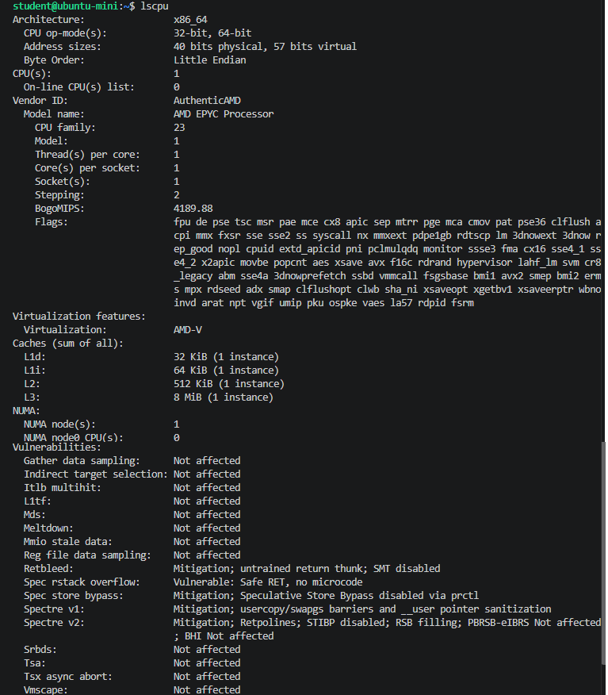

Main Memory
The free -h command summarizes system memory in human-readable units and displays swap space allocation. The guest reported 457 MiB of total usable RAM, approximately 168 MiB of used RAM, 51 MiB of free RAM, and 289 MiB of available memory at the time of measurement. Total swap space was 0 B. Minor runtime fluctuations in memory utilization are expected. Although the Kubernetes VM configuration requests 512 MiB, the usable RAM reported by the guest OS is slightly lower due to memory reserved for virtual hardware overhead and kernel operations.
Figure 2
Main Memory Allocation (free -h)
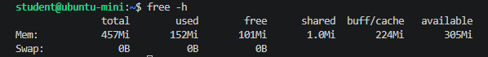
Input/Output Modules and Controllers
System I/O devices were inventoried using lspci -nnk, lsusb, and ip -br link. The lspci -nnk command lists PCI/PCIe devices along with their associated Linux kernel drivers. The output indicates emulated QEMU/KubeVirt hardware, including a Virtio 1.0 Ethernet controller utilizing virtio-pci, Virtio SCSI and block storage controllers using virtio-pci, PCI bridges, an AHCI SATA controller using ahci, an SMBus controller, and a basic VGA device. These represent virtual I/O interfaces rather than physical computer hardware. The lsusb command returned no active device rows, confirming that no USB devices were attached to the VM at the time of execution. The ip -br link command displayed the loopback interface (lo) and an active Ethernet network interface (enp1s0).

Figure 3
I/O Controller and Interface Overview (lspci -nnk, lsusb, and ip -br link)
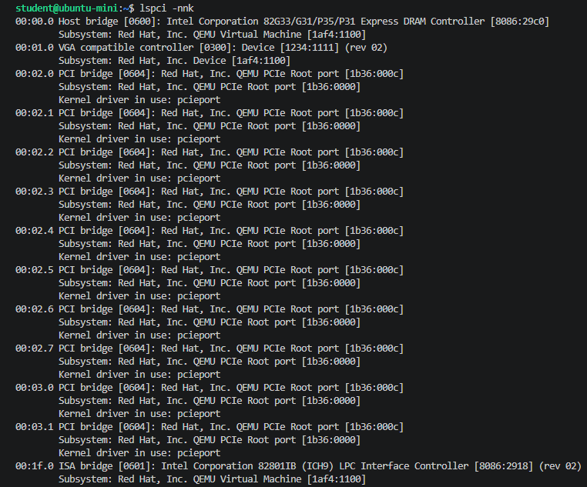
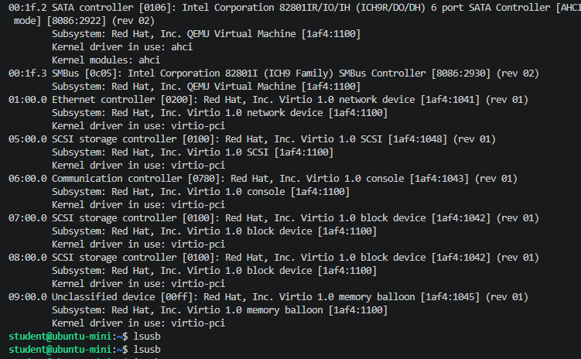

Storage Devices
Block devices, partition tables, filesystems, and mount points were enumerated using lsblk -o NAME,MODEL,SIZE,TYPE,FSTYPE,MOUNTPOINTS and df -hT. Initial baseline measurements recorded an 8 GiB virtual disk (vda) containing the root filesystem and boot partitions, alongside a 1 MiB ISO9660-formatted device (vdb) used for cloud-init configuration. Following initial inventory collection, the root disk was cloned and expanded to a 20 GiB persistent virtual disk (ubuntu-mini-root-20g). Virtual storage devices do not report physical drive models. Prior to disk expansion, df -hT indicated a root ext4 filesystem capacity of approximately 6.8 GiB, with 1.6 GiB used and 5.1 GiB available. Because root filesystems must expand during boot to consume newly allocated space, actual usable capacity should be verified against live output, see Figure 4.
Figure 4
Storage Device Hierarchy and Mounted Filesystems (lsblk and df -hT) 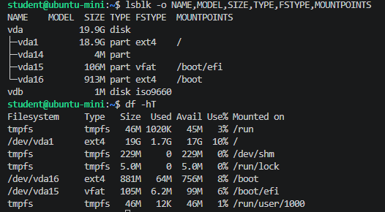
The shell commands utilized in this section are documented in the source repository file CSC507_M01_CT.md attached or see github link:
https://github.com/zxiong1008/CSC507/blob/main/CSC507_M01_CT.md
References
Colorado State University Global. (2026). Module 1 Overview: Introduction to Operating Systems https://csuglobal.instructure.com/courses/123286/pages/module-1-overview?module_item_id=6638002

