Process Management Utilities: A Comparative Analysis of Linux Shell Commands and Windows Task Manager
Zeng Xiong
Colorado State University Global
Foundations of Operating Systems
Dr. Schwartz
October 25, 2026

Process Management Utilities: A Comparative Analysis of Linux Shell Commands and Windows Task Manager
Modern operating systems rely heavily on robust process management to allocate computing resources, supervise thread lifecycles, and maintain overall system stability. Linux systems typically offer granular, text-based command-line utilities that interface directly with the kernel via POSIX standards and virtual filesystems. Conversely, Microsoft Windows provides graphical interfaces such as Task Manager, designed to aggregate telemetry and present actionable management workflows through visual abstractions. This paper examines core process management tasks across both paradigms to evaluate their operational intervention abilities and user accessibility. The code used are attached or posted here in this github repository: https://github.com/zxiong1008/CSC507/blob/main/CSC507_M02_CT.md.
Linux Process Management Utilities
Task 1: Snapshot View of Active Processes (ps)
The ps command queries the virtual /proc filesystem to return static snapshot metrics for currently running processes, detailing process identifiers (PIDs), CPU and memory consumption, terminal associations, and execution state codes.
$ ps aux | head -n 10
Figure 1
Execution of ps aux Command in Linux Terminal
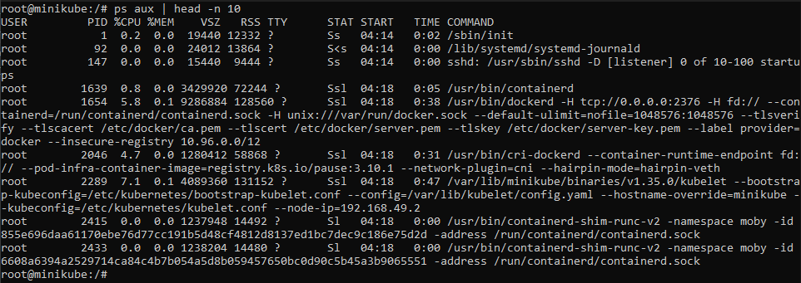
Note. Terminal output displaying running process states, PIDs, CPU %, and memory usage.
Task 2: Real-Time Dynamic Monitoring (top)
The top utility renders an interactive, self-updating view of processor activity, kernel load averages, physical and swap memory allocation, and individual thread states sorted dynamically by resource usage.
$ top
Figure 2
Live System Performance and Task Monitoring in top
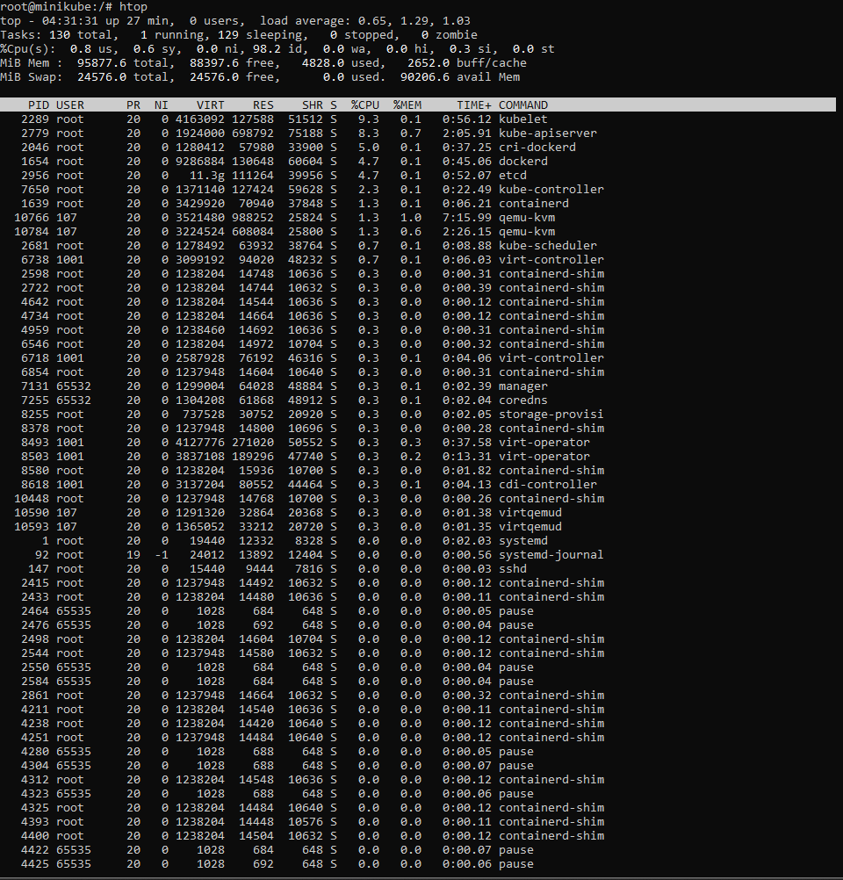
Note. Dynamic real-time telemetry displaying global load averages and per-thread resource consumption.
Task 3: Terminating a Process (kill)
Linux delivers inter-process communication signals using kill. Administrators can issue polite termination requests (SIGTERM) or enforce immediate kernel-level thread disposal via unconditional termination (SIGKILL).
$ kill -9 4463
Figure 3
Terminating a Process via Linux Signal Transmission
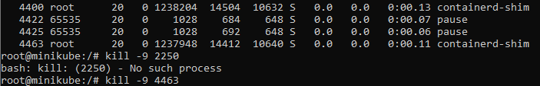
Note. Dispatch of the non-catchable SIGKILL signal terminating target process identifier 1234.
Task 4: Modifying Process Priority (renice)
The renice command adjusts the nice value of active processes on the Completely Fair Scheduler (CFS), shifting scheduling weight within the standard range from -20 to 19.
$ renice -n 5 -p 4425
Figure 4
Adjusting Process Scheduling Priority with renice
Note. Re-prioritization of an existing process by modifying its CFS niceness score.
Task 5: Filtering Processes by Name (pgrep)
The pgrep utility examines running process tables using regular expressions, rapidly extracting matching numerical PIDs and command names without requiring compound pipelines.
$ pgrep -l dockerd
Figure 5
Filtering Active System Processes Using pgrep
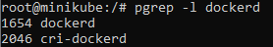
Note. Automated pattern matching returning process identifier and executable command name.
Windows Process Management Utilities
Task 1: Active Process View (Processes Tab)
Windows Task Manager presents active applications, background services, and sub-threads in a hierarchical view, categorizing resource footprints across CPU, RAM, disk, and network interfaces.
Figure 6
Windows Task Manager Processes Tab Overview
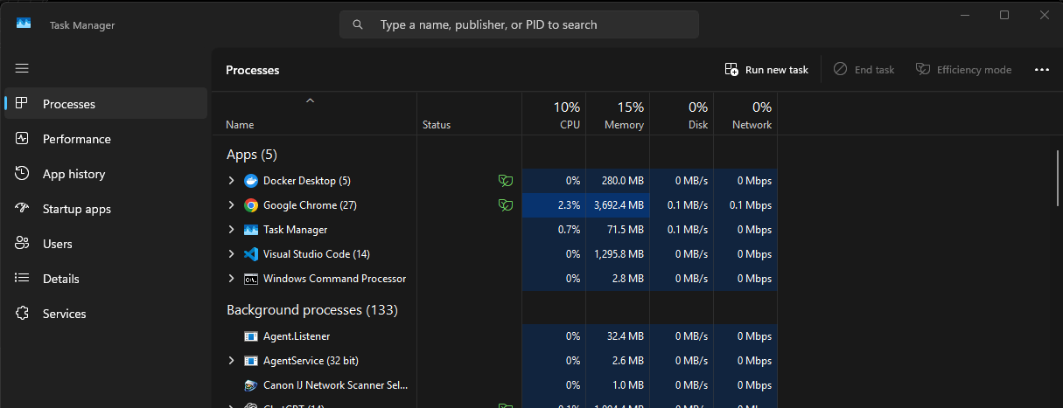
Note. Consolidated user and system process hierarchy with associated resource telemetry columns.
Task 2: Real-Time Performance Monitoring (Performance Tab)
The Performance tab delivers graphical time-series visualizations of hardware utilization, displaying thread counts, handle allocations, clock frequencies, and memory cache breakdowns.
Figure 7
Real-Time Hardware Performance Telemetry in Windows
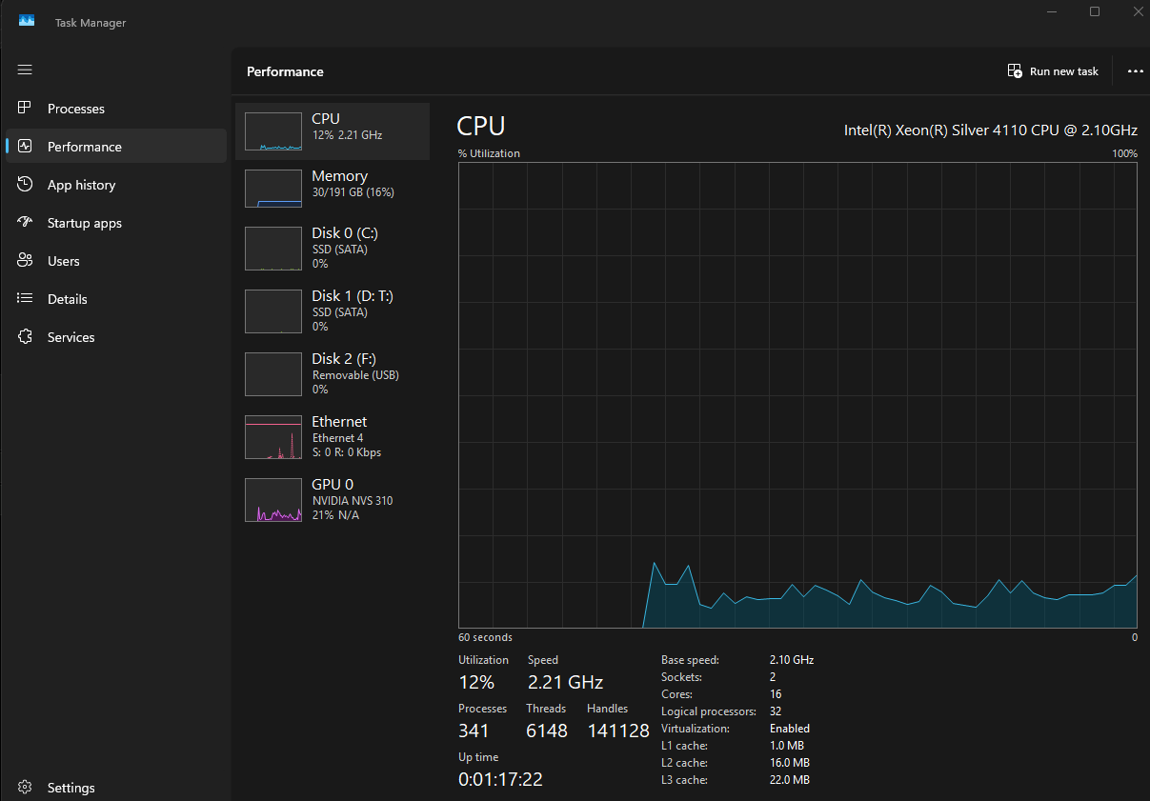
Note. Visual telemetry graphs depicting CPU, committed memory, and disk read/write throughput.
Task 3: Terminating Processes (End Task)
Invoking End Task directs Windows to query the target thread message queue with WM_CLOSE, falling back to forceful execution termination via the Win32 TerminateProcess API call if unresponsive.
Figure 8
Intervening in Running Tasks via End Task Function
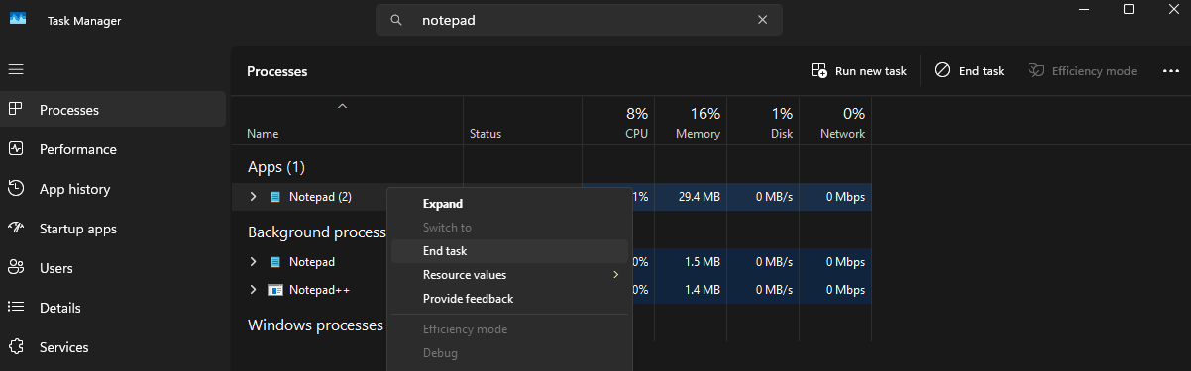
Note. Immediate process termination initiated through graphical context menu actions.
Task 4: Setting Priority and CPU Affinity
The Details tab allows administrators to adjust process scheduling priority classes and restrict execution to specific logical processor cores via affinity bitmasks.
Figure 9
Configuring Execution Priority Levels in Task Manager Details
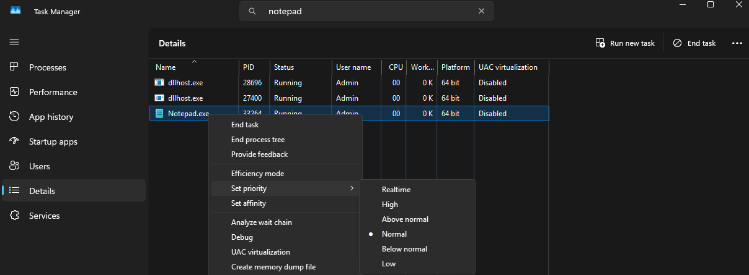
Note. Priority class reassignment and processor core affinity configuration options.
Task 5: Startup Application Management
The Startup Apps view monitors binaries registered in initialization registries and directories, evaluating measured boot impact and enabling rapid toggle overrides.
Figure 10
Managing Startup Application Impact and Configurations
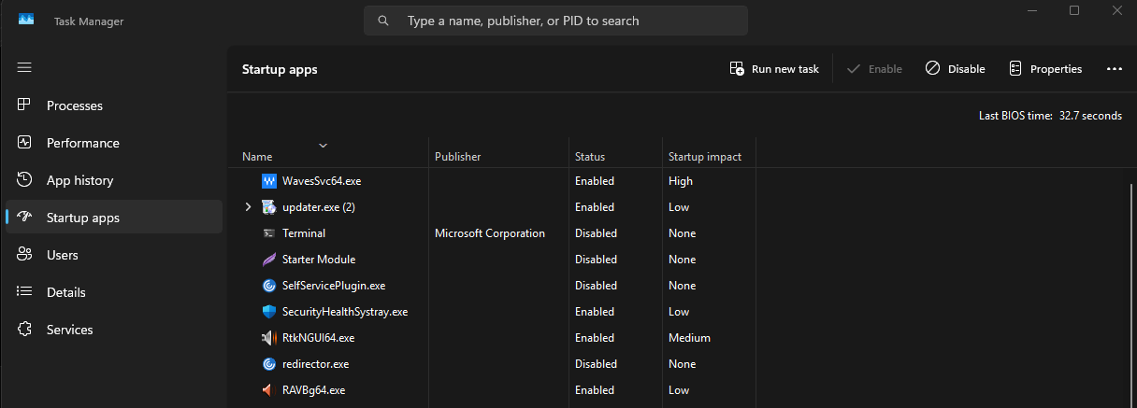
Note. Diagnostic assessment of startup binary impact scores and initialization state toggles.
Conclusion
Both Linux shell utilities and Windows Task Manager serve vital roles in modern systems administration. While Task Manager democratizes resource visualization and rapid interactive remediation, Linux shell tools provide unmatched modularity, programmatic precision, and automation depth necessary for managing scalable operating environments.
References
Colorado State University Global. (2026). Module 2 Overview: Agile Planning Levels & Techniques https://csuglobal.instructure.com/courses/123286/pages/module-2-overview?module_item_id=6638053
Bovet, D. P., & Cesati, M. (2005). Understanding the Linux kernel (3rd ed.). O'Reilly Media.
Love, R. (2010). Linux kernel development (3rd ed.). Addison-Wesley Professional.
Russinovich, M. E., Solomon, D. A., & Ionescu, A. (2012). Windows internals, Part 1: Covering Windows Server 2008 R2 and Windows 7 (6th ed.). Microsoft Press.
Silberschatz, A., Galvin, P. B., & Gagne, G. (2018). Operating system concepts (10th ed.). John Wiley & Sons.

