Module 2: Portfolio Milestone
Zeng Xiong
Colorado State University Global
Foundations of Operating Systems
Dr. Schwartz
October 25, 2026

Module 2: Portfolio Milestone
This milestone demonstrates file manipulation and random number generation using both Bash Shell Scripting and a Python Program in a Linux environment, see attached for code or github repository link: https://github.com/zxiong1008/CSC507/blob/main/CSC507_M02_PM.md
Step 1: Bash Script Implementation (numbers.sh)
- Display a random integer on the screen: echo $RANDOM
- Write a random integer into a file named file1.txt: echo $RANDOM > file1.txt
- Append a new random integer to the end of file1.txt: echo $RANDOM >> file1.txt
- Delete the file file1.txt: rm file1.txt
- Create a script named numbers.sh that repeats steps 1–4 a total of 1000 times using a "for" loop.
- Grant execute permissions to the script: chmod +x numbers.sh
- Execute the script: ./numbers.sh

Step 2: Python Program Implementation (generate_numbers.py)
To replicate the shell functionality, a Python script was created to output $1,000$ random numbers to file2.txt.
- Write a Python program to accomplish this same task and generate file2.txt. You should end up with two files (file1.txt and file2.txt), each containing 1,000 lines of random numbers.
- Conduct a line and word count on your programs, scripts, and text documents (feel free to sort them into separate directories for better organization).
- wc *
Figure 1
Bash script output
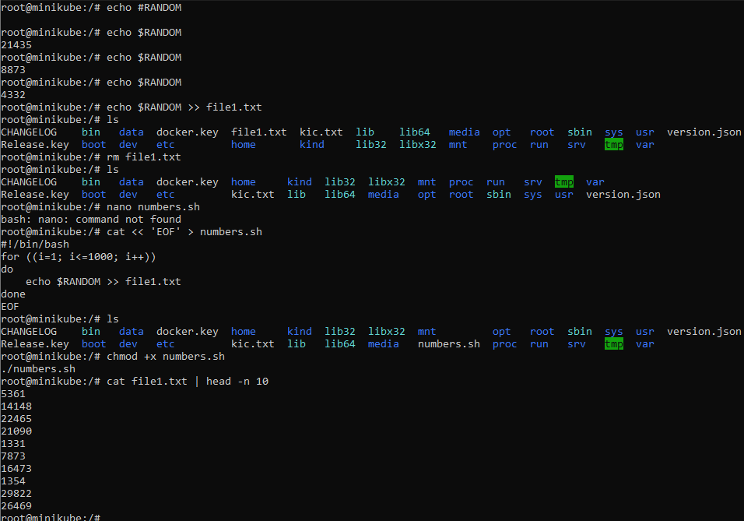
Figure 2
Python script output including word and line count
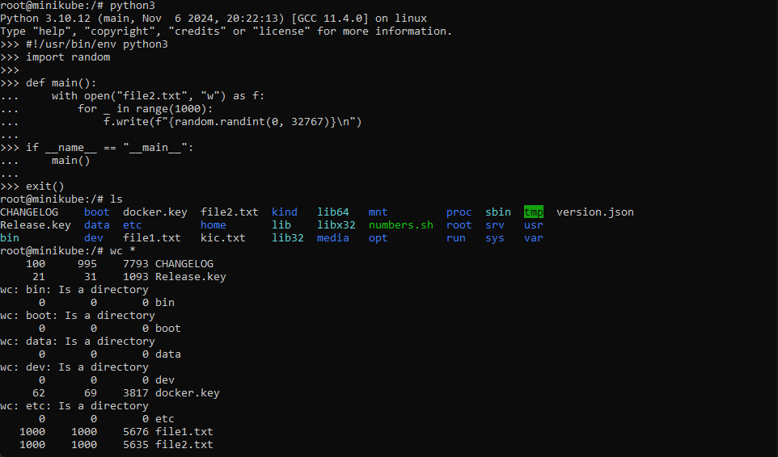
References
Colorado State University Global. (2026). Module 2 Overview: Agile Planning Levels & Techniques https://csuglobal.instructure.com/courses/123286/pages/module-2-overview?module_item_id=6638053
Simpson, S. (2025, July 1). Learning bash scripting [Video]. LinkedIn Learning. https://www.linkedin.com/learning-login/share?account=2245842&forceAccount=false&redirect=https%3A%2F%2Fwww.linkedin.com%2Flearning%2Flearning-bash-scripting-26210777%2Flearning-bash-scripting%3Ftrk%3Dshare_video_url%26shareId%3DR1bJqP8IRpSGJhY29zt8Xg%253D%253D
Simpson, S. (2025, July 1). Working with while and until loops [Video]. LinkedIn Learning. https://www.linkedin.com/learning-login/share?account=2245842&forceAccount=false&redirect=https%3A%2F%2Fwww.linkedin.com%2Flearning%2Flearning-bash-scripting-26210777%2Fworking-with-while-and-until-loops%3Ftrk%3Dshare_video_url%26shareId%3DQFyE0luaToeV9U33HNIp1g%253D%253D

